Supporting Information
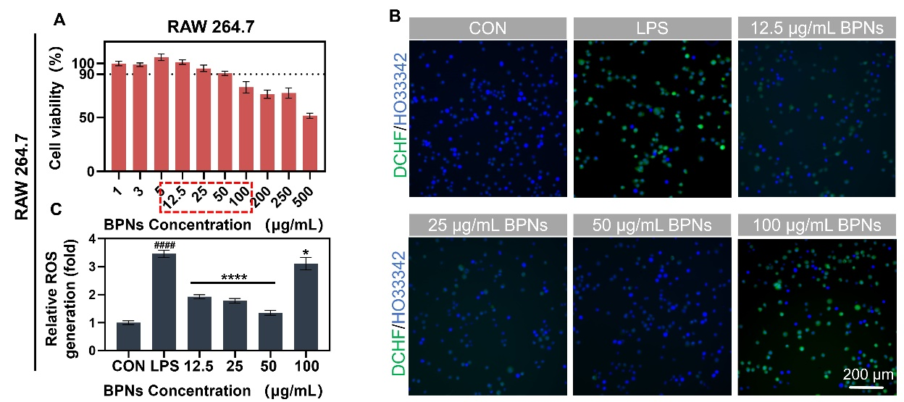
Figure S1. Effects of BPNs on cell viability and ROS generation in RAW 267.4 cells. (A) Cell viability of RAW 267.4 cells treated with different concentrations of BPNs (1–500 µg/mL) for 24 hours, assessed by CCK-8 assay. (B) Representative images of ROS generation, visualized by DCFH-DA (green) and HO33342 (blue) staining. (C) Quantification of relative ROS generation. Data are presented as mean±SD (n = 3). Statistical significance: *p < 0.05, ****p < 0.0001 compared to LPS group, ####p < 0.0001 compared to CON group.

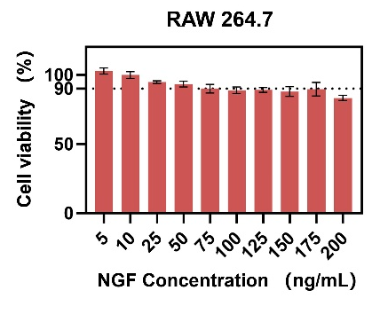
Figure S2. Effects of NGF on cell viability in RAW 267.4 cells. Data are presented as mean±SD (n = 3).

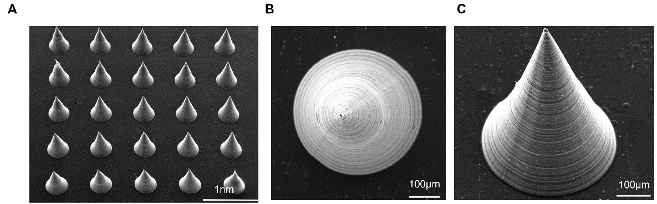
Figure S3. Scanning electron microscopy (SEM) images of BPNs&NGF@MNs (BNMNs). (A) SEM image of an array of BNMNs. (B and C) SEM images of individual BNMNs viewed at different angles.

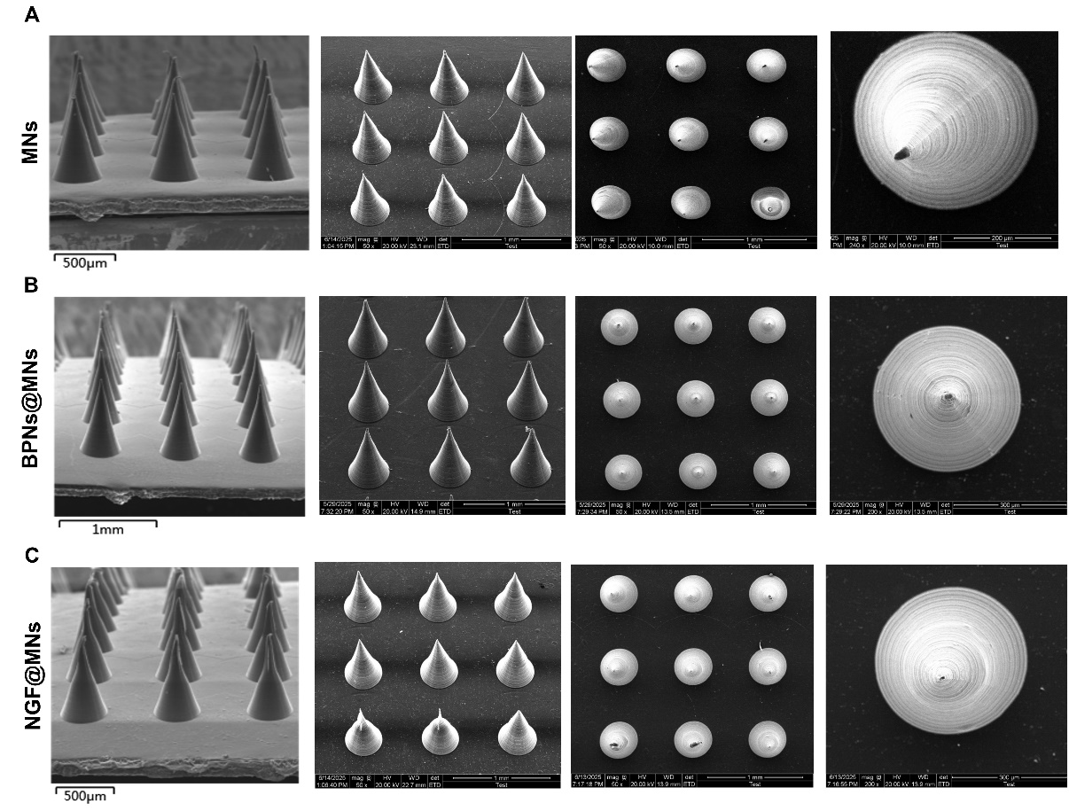
Figure S4. SEM images of (A) blank microneedle (MNs), (B) BPNs@MNs (BMNs), and (C) NGF@MNs (NMNs).

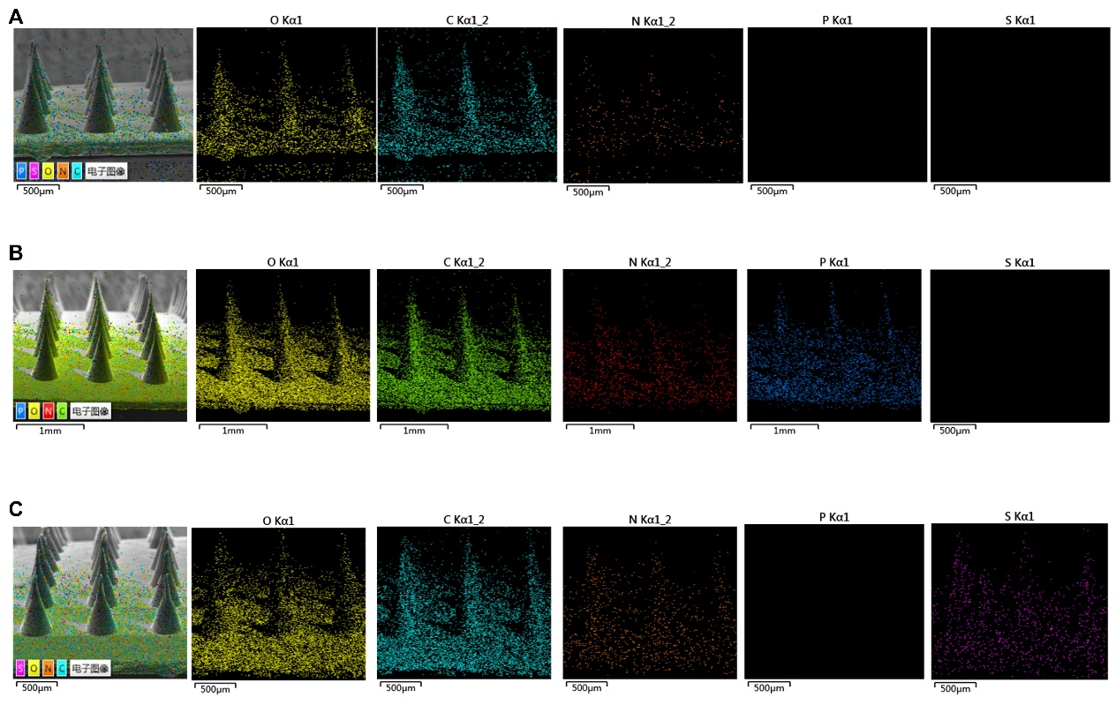
Figure S5. Energy Dispersive X-ray Spectroscopy (EDS) elemental maps of (A) MNs, (B) BMNs and (D) NMNs.

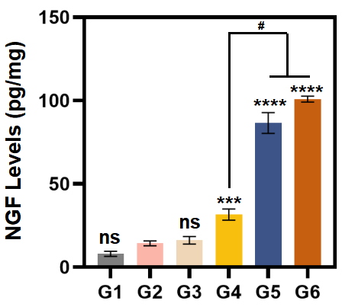
Figure S6 Local NGF levels at the site of facial nerve injury/perineural region on day 7 across the different treatment groups. Data are presented as mean ± SD (n=3). ns, not significant; ***p < 0.001, ****p < 0.0001 compared with G2 groups.
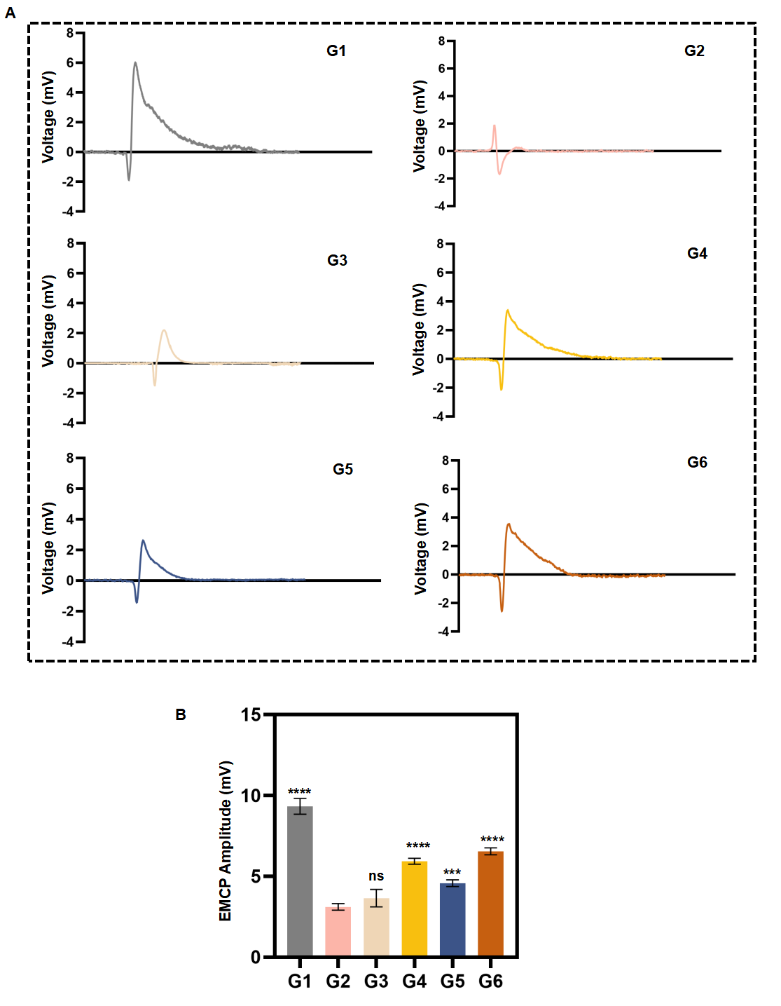
Figure S7 Electrophysiological assessment of facial nerve functional recovery after different treatments on day 7 after injury. (A) Representative evoked muscle compound potential (EMCP) waveforms recorded from facial muscles after facial nerve stimulation in each group. (B) Quantitative analysis of EMCP amplitude. Data are presented as mean ± SD (n=3). ns, not significant; ***p < 0.001, ****p < 0.0001 compared with G2 groups.

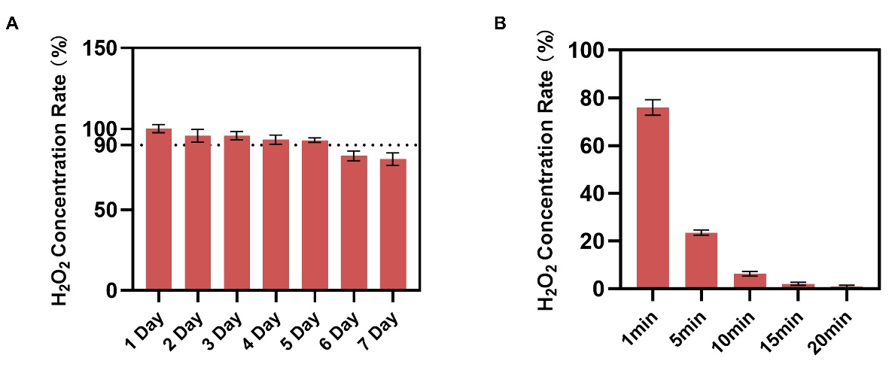Figure S8. H₂O₂ Concentration Rate Over Time in Different Treatment Conditions. (A) H₂O₂ concentration rate over 7 days. (B) H₂O₂ concentration rate in complete medium under varying treatment times (1 min to 20 min). Data are presented as mean±SD (n = 6).

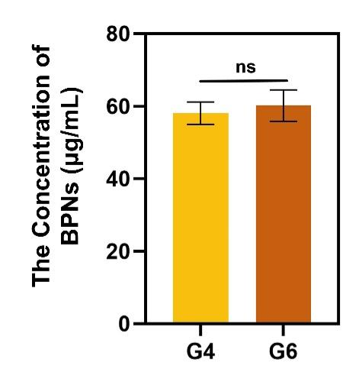
Figure S9. The concentration of BPNs (μg/mL) in groups G4 and G6. Data are presented as mean ± SD (n=3). Significant differences are ns between the two groups.

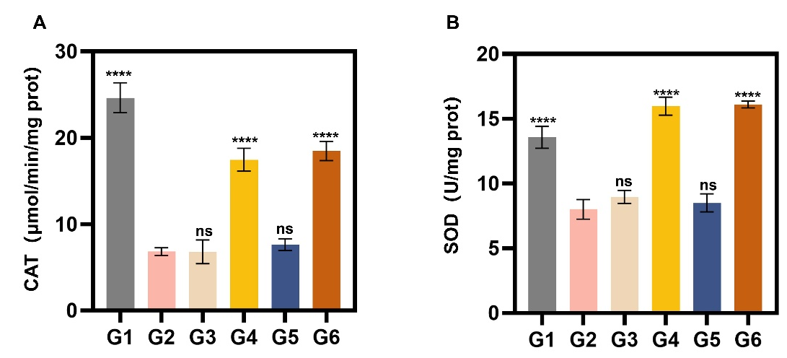
Figure S10. Activity of Catalase (CAT) and Superoxide Dismutase (SOD) Across Different Treatment Groups. (A) CAT activity (μmol/min/mg protein) and (B) SOD activity (U/mg protein) in different treatment groups (G1–G6). Data are presented as mean ± SD (n=3). Significant differences are indicated as **** p < 0.0001, with no significance (ns) observed compared with G2 groups.

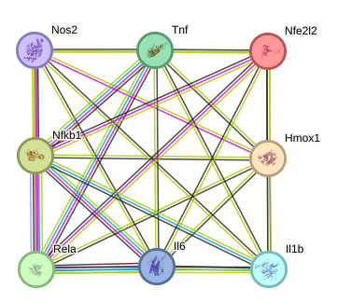
Figure S11 Protein–protein interaction (PPI) network of differentially expressed genes associated with ROS regulation and NF-κB signaling.

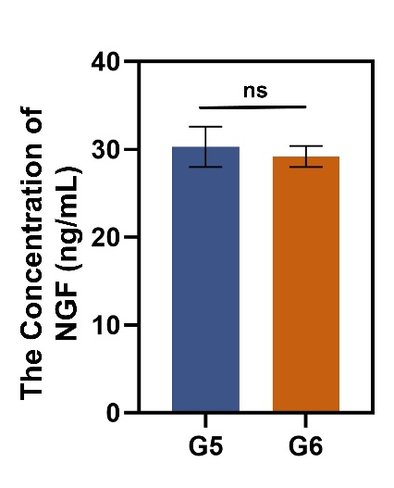
Figure S12. The concentration of NGF (ng/mL) in groups G4 and G6. Data are presented as mean ± SD (n=3). Significant differences are ns between the two groups.

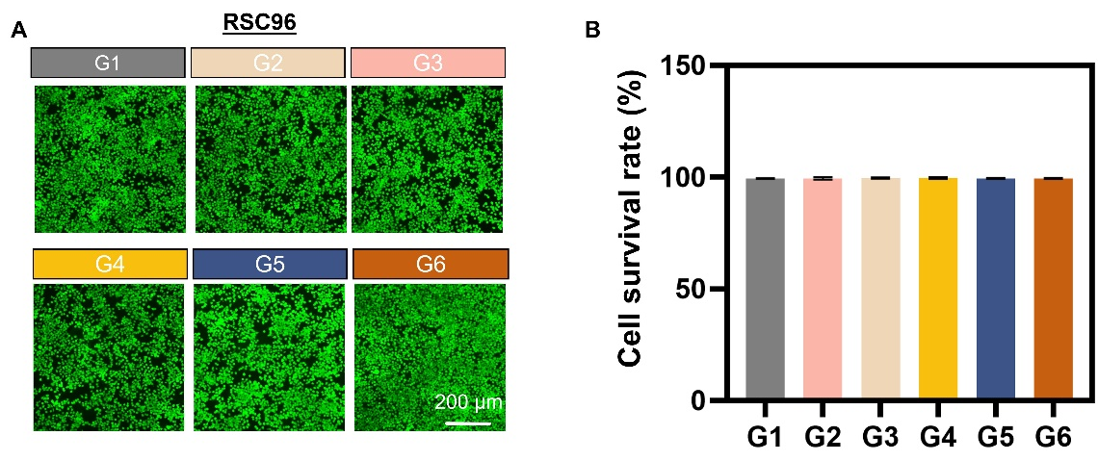
Figure S13. Live/Dead staining of RSC96 cells across different treatment groups. (A) Representative images of Live/Dead staining, with live cells stained green and dead cells stained red. (B) Quantification of cell survival rate. Data are presented as mean ± SD (n = 3).

