Supporting Information
Antitumoral activities of λ‑Carrageenan Oligosaccharide- Based Nanoparticles
Jennifer Saliba^{ŧ}, Manon Porta Zapata^{ŧ}, Claudia Miranda-Perez de Alejo, Rachida Mersni, Ainhize Urkola-Arsuaga, Benjamin Musnier, Julien Cherfan, Alma Sanchez Tellez, Thierry Maugard, Denis Biard, Luc Bousset, Kevin Baranger, Céline Trinh Le Vi Kieu, Véronique Gigoux, Jesùs Ruiz-Cabello, Ingrid Fruitier-Arnaudin, Susana Carregal-Romero*, Hugo Groult*
ŧ Jennifer Saliba and Manon Porta Zapata contributed equally to this work
* Corresponding authors:
Hugo Groult, Laboratoire LIENSs, UMR CNRS 7266 - La Rochelle Université, 17000 La Rochelle, France. E-mail: hugo.groult@univ-lr.fr
Susana Carregal-Romero, Center for Cooperative Research in Biomaterials (CIC biomaGUNE), Basque Research and Technology Alliance (BRTA), 20014 Donostia, Spain. E-mail: scarregal@cicbiomagune.es

- Figure S1: Quantification of Fe and Mn internalization in MDA-MB-231 cells after exposure with λ-COS NP
- Figure S2: Kinetic of the migration inhibition on MDA-MB-231 measured at different time points after incubation with candidates (λ-CAR, λ-COS, and λ-COS NP)
- Figure S3: High field (7T) MRI biodistribution in an NP-treated mouse after NP administration
- Figure S4: Representative liver section from an NP-treated mouse stained with Prussian blue for iron oxide core detection
- Figure S5: Representative tumor section from 2 NP-treated mice stained with Prussian blue for iron oxide core detection
- Figure S6: Histological examination of tumor, brain, kidney, spleen, liver and lung tissues using H&E staining
- Figure S7: Toxicological endpoints measurements, (A) Dosage of alanine aminotransferase (ALT), (B) Dosage of aspartate aminotransferase (AST), (C) Dosage of urinary albumin (ALB) and (D) Dosage of urinary total protein (TP) content

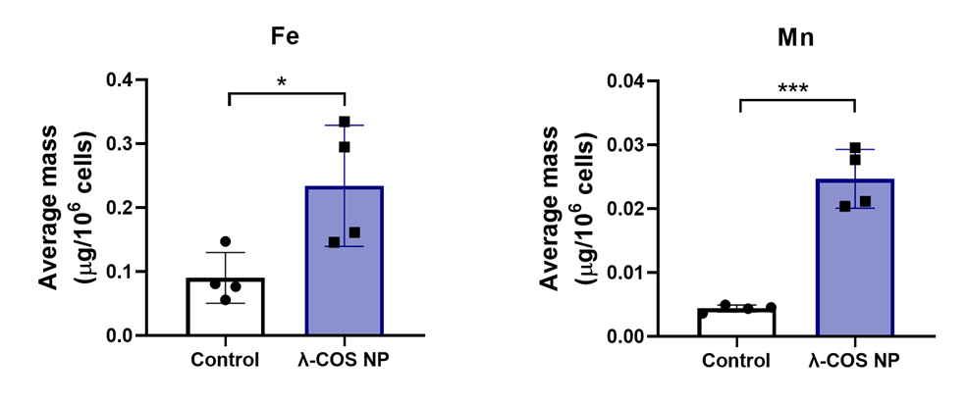
Figure S1: Quantification of Fe and Mn internalization in MDA-MB-231 cells after 72h of exposure with λ-COS NP or untreated cells as Control (n = 4).

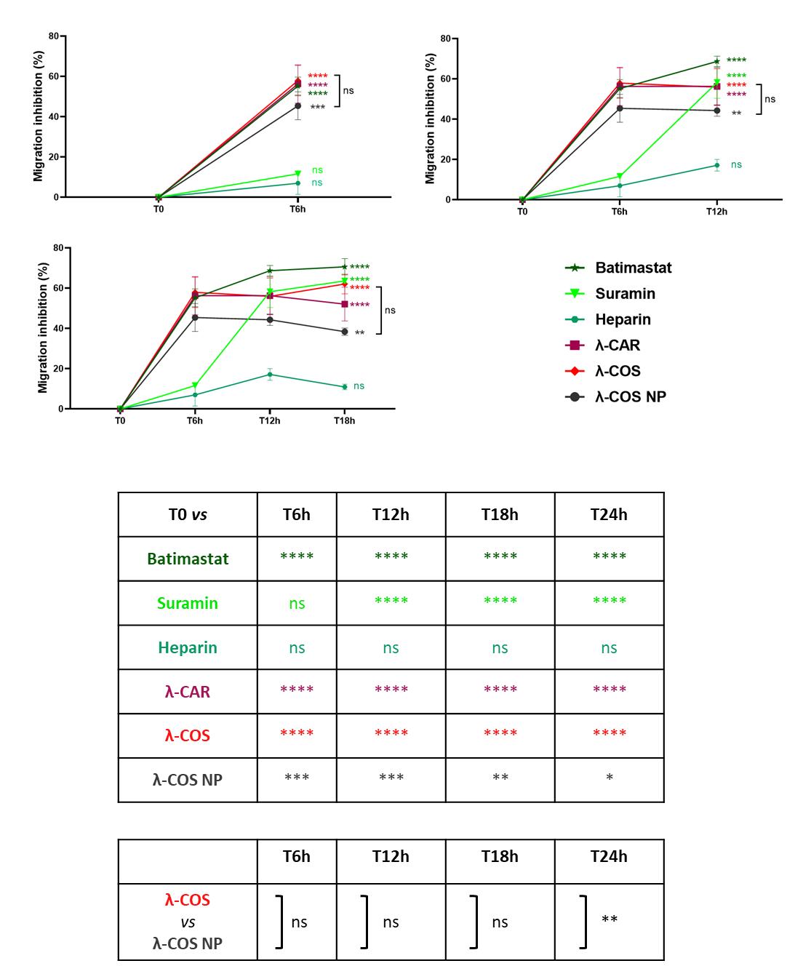
Figure S2: Kinetic of the migration inhibition on MDA-MB-231 measured at different time points after incubation with candidates (λ-CAR, λ-COS, and λ-COS NP) or positive controls known to inhibit cancer cell migration (Batimastat®, suramin, and heparin) and corresponding statistical difference between T0h and time point or between candidates λ-COS and λ-COS NP at the same time point. Stars (*, **, ***) indicate significant differences between the candidate and the control, and brackets indicate significant differences (or not: ns) between candidates.
Values represent the mean ± SEM of triplicates (n = 3), N = 2. p values were calculated using two-way ANOVA with Tukey’s multiple comparison test. p values were calculated using one-way ANOVA with Dunnett’s multiple comparison test.

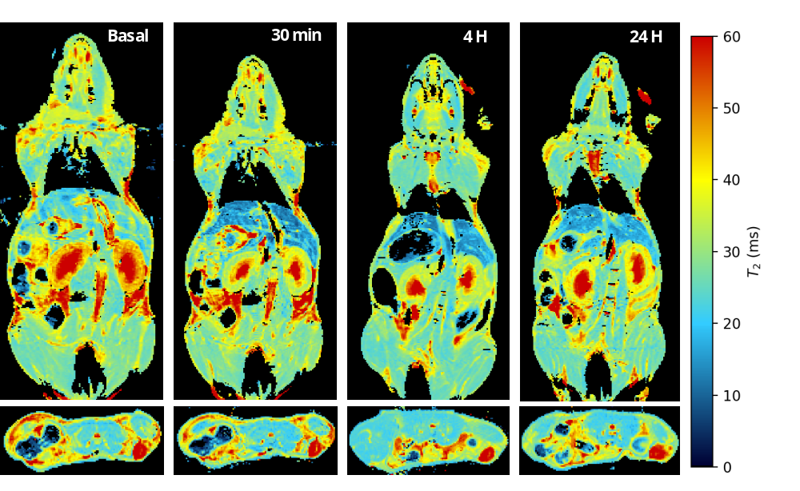
Figure S3: High field (7T) MRI biodistribution in an NP-treated mouse acquired immediately after NP administration of the dose (100 µL at 1 mg.mL⁻¹ of Fe), with T₂-relaxometric maps from cross-sections obtained using an MSME sequence (TE varied in 20 steps from 8 to 160 ms, TR = 4000 ms, FA 90°).

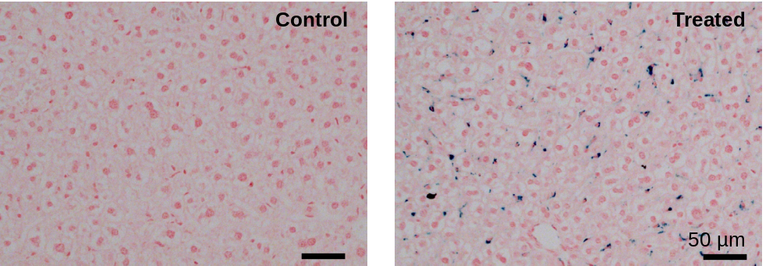
Figure S4: Representative liver section from an NP-treated mouse stained with Prussian blue for iron oxide core detection.

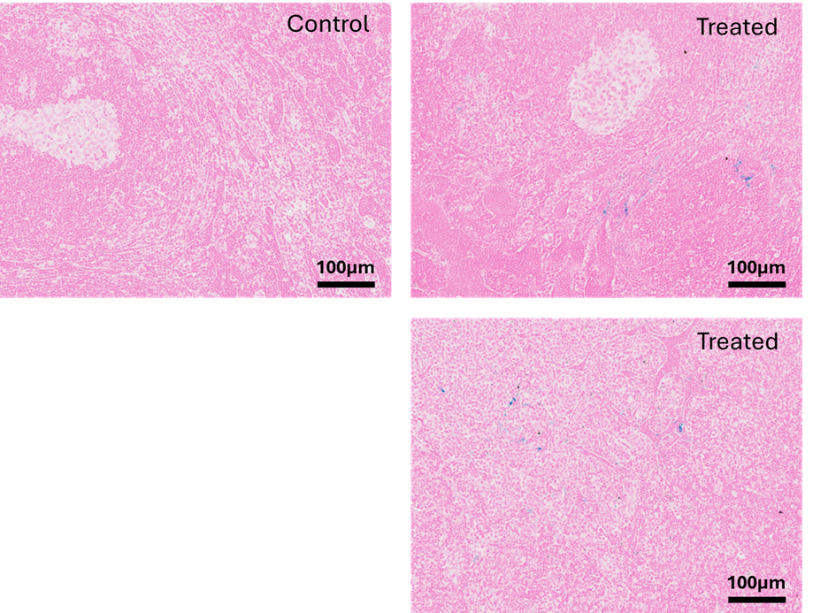
Figure S5: Representative tumor section from 2 NP-treated mice stained with Prussian blue for iron oxide core detection.

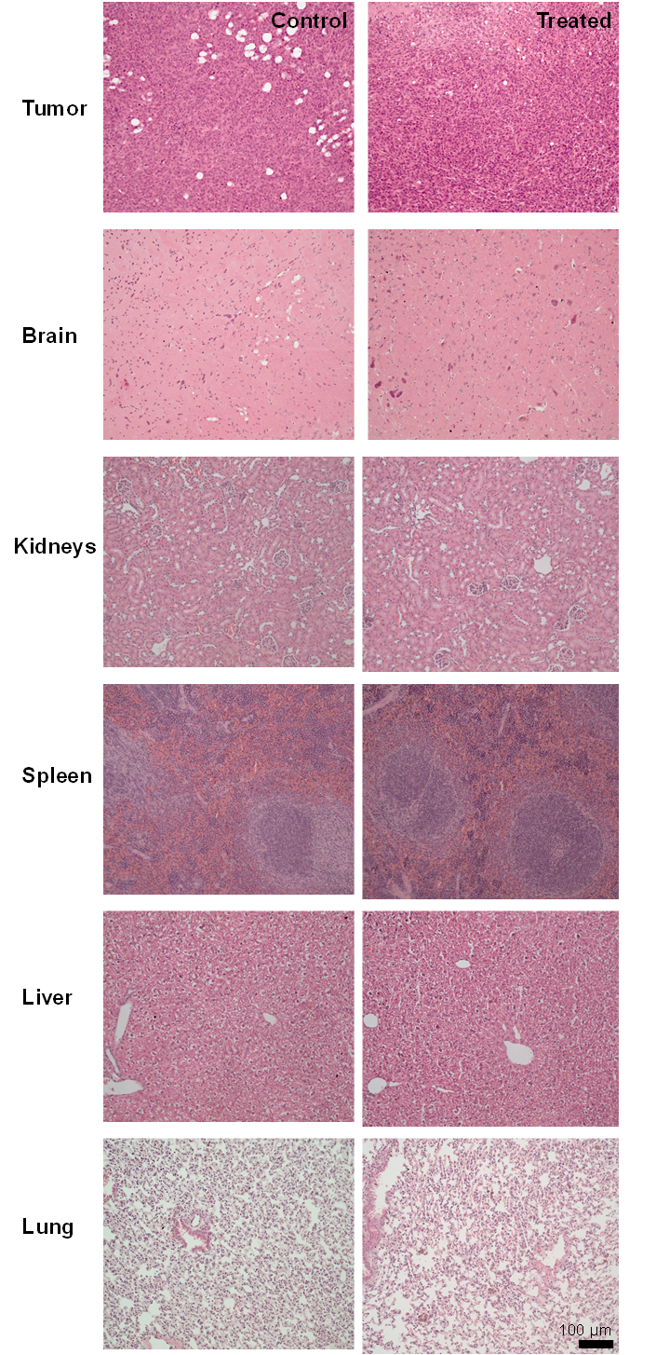
Figure S6: Histological examination of tumor, brain, kidney, spleen, liver and lung tissues using H&E staining.

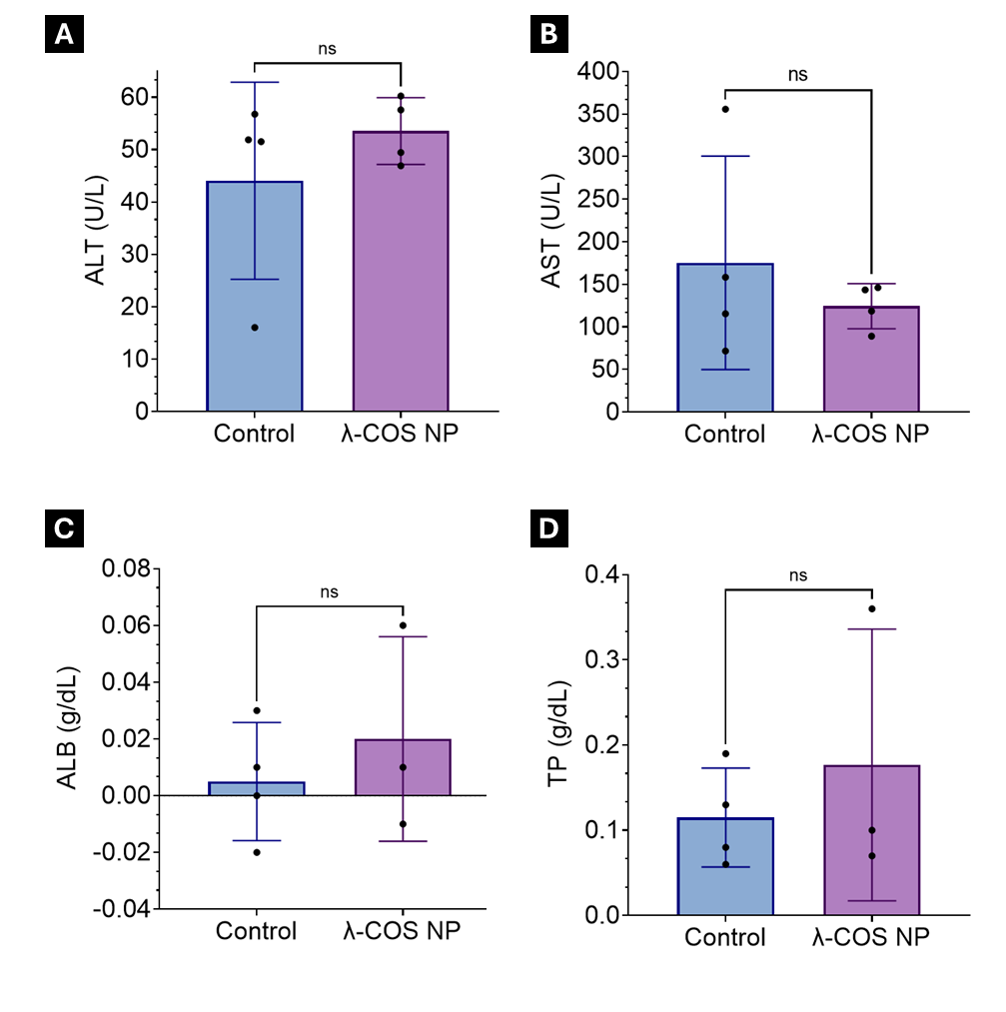
Figure S7: Toxicological endpoints measurements, (A) Dosage of alanine aminotransferase (ALT), (B) Dosage of aspartate aminotransferase (AST), (C) Dosage of urinary albumin (ALB) and (D) Dosage of urinary total protein (TP) content. All dosages were realized in control group (n = 4) and in a NP-treated group (n = 4) following a single administration and collection of samples 48h after. Statistical differences have been evaluated between both groups using Welch’s t-test and reveal non-significant difference (ns).

