1 Supplementary experimental methods

1.1 LC–MS Operating Procedure
The LC–MS analysis was performed using an ultra-high-performance liquid chromatography system coupled to a Q Exactive quadrupole Orbitrap mass spectrometer (Thermo Fisher Scientific; Shanghai Majorbio Bio-Pharm Technology Co., Ltd.). Briefly, 200 μL of liquid sample was transferred into a 1.5 mL centrifuge tube, followed by the addition of 800 μL of extraction solvent (acetonitrile:methanol = 1:1, v/v) containing four internal standards, including L-2-chlorophenylalanine (0.02 mg/mL). The mixture was vortexed for 30 s and then subjected to ultrasonication at 5 °C for 30 min (40 kHz). Samples were incubated at −20 °C for 30 min and subsequently centrifuged at 13,000 × g for 15 min at 4 °C. The supernatant was collected and dried under a gentle stream of nitrogen. The residue was reconstituted in 180 μL of reconstitution solution (acetonitrile:water = 1:1, v/v), followed by ultrasonication at 5 °C for 5 min (40 kHz). After centrifugation at 13,000 × g for 10 min at 4 °C, the supernatant was transferred to autosampler vials with inserts for LC–MS analysis. An aliquot of 3 μL was injected and separated on a BEH C18 column (100 mm × 2.1 mm i.d., 1.7 μm) prior to mass spectrometric detection. Mobile phase A consisted of 2% acetonitrile in water containing 0.1% formic acid, and mobile phase B consisted of acetonitrile containing 0.1% formic acid. The flow rate was set at 0.40 mL/min, and the column temperature was maintained at 40 °C. Mass spectrometric data were acquired in both positive and negative ion modes over a mass range of m/z 70–1050. The spray voltage was set to 3500 V in positive mode and −3000 V in negative mode. The sheath gas flow was 50 psi, and the auxiliary gas flow was 13 psi. The ion source temperature was maintained at 450 °C. Stepped normalised collision energies (NCE) of 20, 40, and 60 were applied. The MS1 and MS2 resolutions were set to 70,000 and 17,500, respectively.

1.2 Transwell Assay
A Transwell migration assay was performed to evaluate the effects of TNVs on the migratory capacity of MC3T3-E1 cells. MC3T3-E1 cells were suspended in serum-free medium and seeded into the upper chambers of Transwell inserts at a density of 2 × 10⁴ cells per well. The lower chambers were filled with serum-free α-MEM medium (Gibco, USA) supplemented with different concentrations of TNVs (10, 20, and 30 μg/mL). After incubation at 37 °C in a humidified atmosphere containing 5% CO₂ for 48 h, the inserts were removed and gently washed three times with PBS. Cells were then fixed with 4% paraformaldehyde for 15 min and stained with 0.1% crystal violet for 20 min, followed by thorough rinsing with PBS to remove excess dye. Non-migrated cells on the upper surface of the membrane were carefully removed using a cotton swab. Migrated cells on the lower surface of the membrane were imaged using an optical microscope, and quantitative analysis was performed by counting the cells using ImageJ software. All experiments were conducted independently in triplicate.

2 Supplementary experimental results

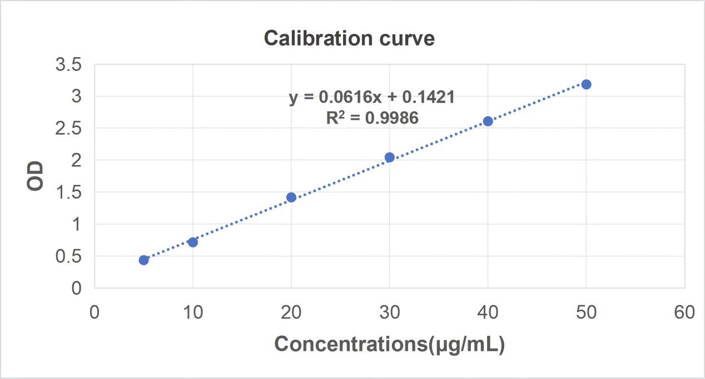
Fig. S1 Calibration Curve of Curcumin Measured at 425 nm by UV–Visible Spectrophotometry. Each data point represents the mean value of six replicates. The regression equation was y = 0.0616x + 0.1421 (R² = 0.9986).

Table S1 Primer Sequences Used for Real-Time Quantitative PCR (RT-qPCR).
This table lists the target genes, corresponding gene IDs, forward and reverse primer sequences (5′–3′), and expected amplicon sizes used for RT-qPCR analysis.
Target genes | ID | Forward primer sequence (5'-3')  Reverse primer sequence (5'-3') | Product size(bp)
GAPDH | 14433 | GCACCGTCAAGGCTGAGAAC | 20
GAPDH | 14433 | TGGTGAAGACGCCAGTGGA | 19
IL-1β | 16176 | TTGAAGTTGACGGACCCCA | 19
IL-1β | 16176 | GAGTGATACTGCCTGCCTGAAG | 22
IL-6 | 16193 | GTTCTCTGGGAAATCGTGGA | 20
IL-6 | 16193 | TGTACTCCAGGTAGCTATGG | 20
TNFa | 21926 | CCAAATGGCCTCCCTCTCAT | 20
TNFa | 21926 | TGGTGGTTTGCTACGACGTG | 20
PAD4 | 18602 | CGTGAGGCTCTTCTCCGATT | 20
PAD4 | 18602 | GCTCTCCACATAGGCATTCTG | 21
ELANE | 50701 | GGATCTTCGAGAATGGCTTTG | 21
ELANE | 50701 | GCACGTTGGCGTTAATGGT | 19
MPO | 17523 | ATGCCCACCGAATGACAAG | 19
MPO | 17523 | GACGCCATCTTCATACTCTGC | 21
Ctsg | 13035 | CCCTGGTATGTAGCAATGTGG | 21
Ctsg | 13035 | TATCTTGGTGCAAAGCGTCTC | 21

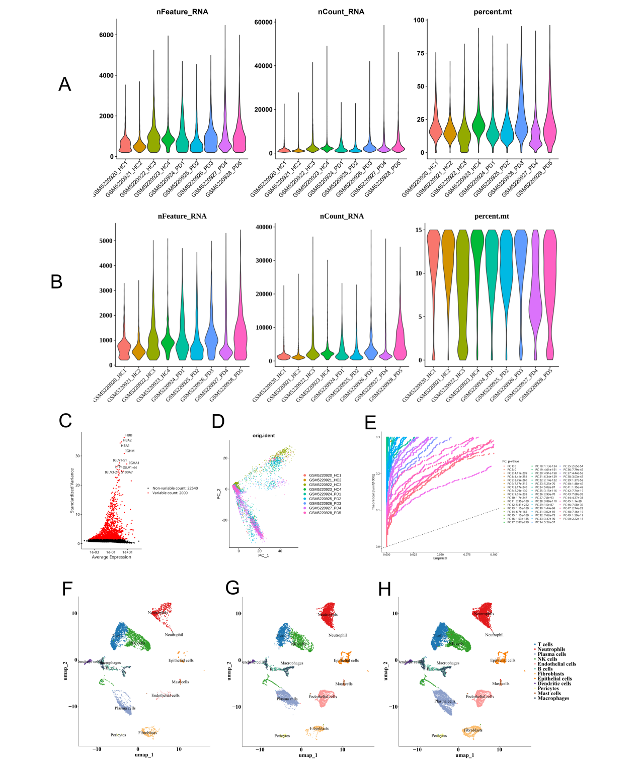
Fig. S2 Quality control, dimensionality reduction, and cell type annotation of single-cell RNA-seq data. (A) Violin plots showing the distributions of the number of detected genes per cell (nFeature_RNA), total UMI counts per cell (nCount_RNA), and the percentage of mitochondrial gene expression (percent.mt) for each sample prior to quality control filtering. (B) Violin plots showing nFeature_RNA, nCount_RNA, and percent.mt for each sample after quality control filtering, indicating improved data quality and reduced technical noise. (C) Identification of highly variable genes across all cells. The plot displays average gene expression versus dispersion, with highly variable genes highlighted in red and non-variable genes shown in black. (D) Principal component analysis (PCA) of the integrated dataset based on highly variable genes, with cells coloured by sample identity. (E) Elbow plot showing the standard deviation of each principal component (PC), used to determine the number of PCs retained for downstream analyses. (F–H) Uniform Manifold Approximation and Projection (UMAP) visualisation of the integrated single-cell dataset. Cells are coloured by inferred cell type annotations, including T cells, neutrophils, plasma cells, NK cells, endothelial cells, fibroblasts, epithelial cells, dendritic cells, pericytes, mast cells, and macrophages. Comparable clustering patterns across panels indicate stable and robust cell type identification.

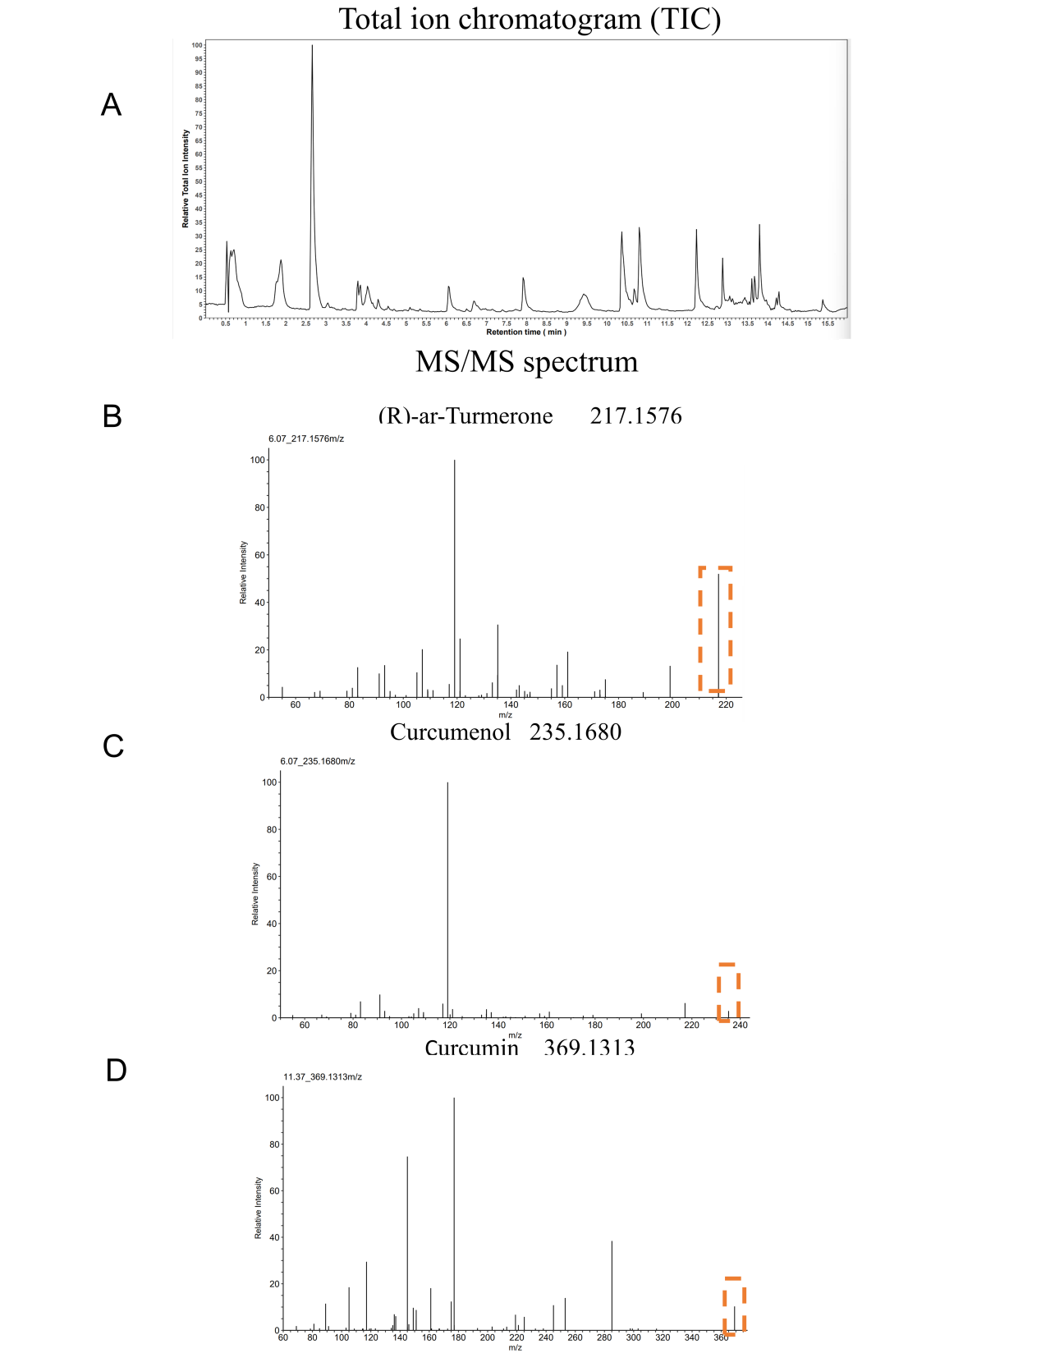
Fig. S3 LC–MS/MS Analysis and Compound Identification. (A) Total ion chromatogram (TIC) of the analysed sample, showing the overall chromatographic profile across the retention time range. (B) MS/MS fragmentation spectrum of (R)-ar-turmerone detected at m/z 217.1576. The dashed box highlights the precursor ion region used for compound identification. (C) MS/MS fragmentation spectrum of curcumenol detected at m/z 235.1680. The dashed box indicates the precursor ion signal. (D) MS/MS fragmentation spectrum of curcumin detected at m/z 369.1313, with the precursor ion highlighted by the dashed box.

Table S2 Molecular Docking Results of Curcumenol, (R)-ar-Turmerone, and Curcumin with PAD4, ELANE, and MPO. This table summarises the predicted binding energies, hydrogen bond interactions (including interacting residues and bond lengths), and hydrophobic interactions between each compound and the target proteins. Protein identifiers are provided as PDB and UniProt accession numbers. Binding energies are reported in kcal/mol.
Protein | PDB/  UniProt ID | Compound | Binding energy (kcal/mol) | H-bonds (residue, length [Å] | Hydrophobic interactions (residues)
PAD4 | Q9UM07 | Curcumenol | -6.7 |  | PHE-368,LEU-447,GLN-397,ASP-405,HIS-444
PAD4 | Q9UM07 | (R)-ar-Turmerone | -6.6 | PRO-396,2.6 | PHE-368,PHE-450,LEU-477,ALA-446,HIS-444
PAD4 | Q9UM07 | Curcumin | -6.9 | THR-268，2.8；ARG-335，3.0，3.4；LYS-461，3.2 | LEU552
ELANE | P08246 | Curcumenol | -7.2 | ILE-160 , 1.9 , 3.1 | ASN-162,ALA-152
ELANE | P08246 | (R)-ar-Turmerone | -5.6 |  | ARG-31,ASN-162,ILE-160,VAL-30
ELANE | P08246 | Curcumin | -7.4 | ARG-323 2.2 ;  THR-159 2.7 ,2.9;  ARG-31 2.2 | VAL-30,ARG-31,ILE-160,ALA-28
MPO | P05164 | Curcumenol | -7.2 | ILE-160,3.1 | ASN-162,ALA-152
MPO | P05164 | (R)-ar-Turmerone | -6.3 | THR-159,2.9 ,2.5 , 3.2 | ASN-162,ARG-31,LEU-22,THR-31,ILE-160
MPO | P05164 | Curcumin | -7.4 | ARG-323 ，2.2, 2.4 | VAL-30,ARG-31

Fig. S4 Effects of TNV treatment on MC3T3-E1 cell viability. (A) Representative fluorescence images of MC3T3-E1 cells treated with different concentrations of TNVs (TNV10, TNV20, TNV30 and TNV50 represent TNVs at concentrations of 10, 20, 30, and 50 μg/mL, respectively.) or control (CTR) for 8, 24, and 48 hours. Live cells were stained green, whereas dead cells were stained red. (B–D) Quantitative analysis of cell viability by CCK-8 assay at 8 h (B), 24 h (C), and 48 h (D) after treatment. Data are expressed as mean ± SD (n=4). Statistical analysis indicates no significant differences (ns) among groups at each time point.

Fig. S5 Effect of TNVs on MC3T3-E1 cell migration. (A) Representative wound-healing images of MC3T3-E1 cells treated with different concentrations of TNVs (TNV10, TNV20 and TNV30 represent TNVs at concentrations of 10, 20, and 30 μg/mL, respectively. ) at 0, 6, 12, 24, and 48 h. (B) Quantitative analysis of wound closure/migration rates at different time points (0, 6, 12, 24, and 48 h) for each group (n=3). (C) Relative cell migration quantified from Transwell assays (n = 3). (D) Representative crystal violet-stained images of migrated MC3T3-E1 cells in the transwell assay under different TNV treatments at magnifications of 10× and 20×. Data are presented as mean ± SD. Statistical significance is indicated as follows: ns, not significant; *p < 0.05, **p < 0.01, ***p < 0.001, ****p < 0.0001.

Fig. S6 In vivo biosafety evaluation of TNVs. (A) Haematoxylin and eosin (H&E) staining of major organs (heart, liver, spleen, lung, and kidney) from control (CTR), ligature-induced periodontitis (LIP), and TNVs-treated (LIP + TNVs) groups, showing no apparent histopathological abnormalities. (B) Body weight changes of mice in different treatment groups during the experimental period. (C) Hemolysis assay of TNVs at different concentrations (10, 20, and 30 μg/mL), with distilled water and PBS used as positive and negative controls, respectively. Representative images of erythrocyte suspensions and quantitative analysis of hemolysis percentage are shown (n=6). (D) Serum biochemical analysis of liver and kidney function markers, including alanine aminotransferase (ALT), aspartate aminotransferase (AST), creatinine (CREA), urea (UREA), and CREA/UREA ratio. (E) Hematological analysis of blood routine parameters, including hemoglobin (HGB), lymphocyte percentage (LY%), lymphocyte count (LY), monocyte percentage (MO%), monocyte count (MO), neutrophil percentage (NE%), neutrophil count (NE), platelet count (PLT), red blood cell count (RBC), and white blood cell count (WBC). Data are presented as mean ± SD (n=6). Statistical significance was analyzed by one-way ANOVA. ns indicates no significant difference.

Fig. S7 Cellular uptake of TNVs (30 μg/mL) by MC3T3-E1 and dHL60 cells.
(A) Confocal laser scanning microscopy (CLSM) images demonstrating the uptake of PKH26-labelled TNVs (30 μg/mL; red) by MC3T3-E1 cells following 12 h incubation. Cell nuclei were stained with DAPI (blue), while the actin cytoskeleton was stained with phalloidin (green). Scale bars = 20 μm. (B) CLSM images demonstrating the uptake of PKH26-labelled TNVs (30 μg/mL; red) by dHL60 cells following 12 h incubation. Cell nuclei were stained with DAPI (blue), while the cell membrane/cytoskeleton was stained with phalloidin (green). Scale bars = 3 μm. (C, D) Flow cytometric analysis of the time-dependent cellular uptake of TNVs (30 μg/mL) by MC3T3-E1 cells (C) and dHL60 cells (D) at different incubation time points (0, 1, 4, 6, 12, and 24 h). Percentages indicate PKH26-positive cells. (E) Quantitative analysis of TNV uptake efficiency in MC3T3-E1 and dHL60 cells over time. Data are presented as the mean ± standard deviation (SD). ****P < 0.0001.
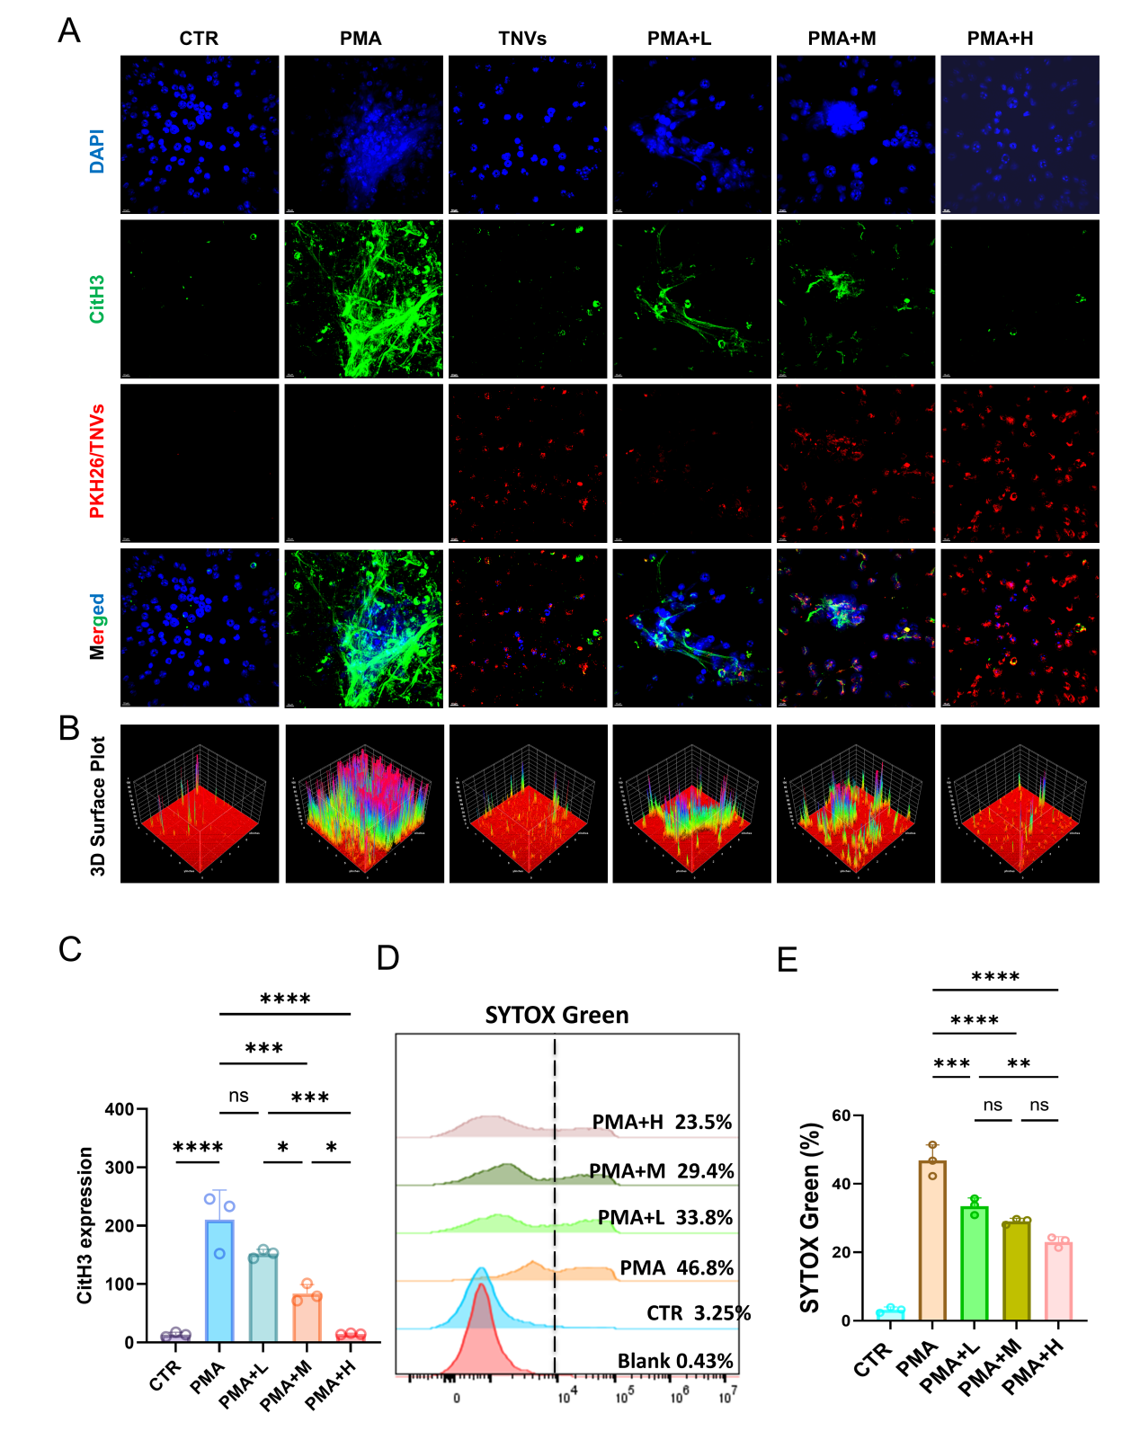
Fig. S8 Effects of TNVs on PMA-Induced Neutrophil Extracellular Trap (NET) Formation. (A) Representative immunofluorescence images of neutrophils under different treatment conditions, including CTR, PMA, TNVs alone, and PMA combined with low (L), medium (M), or high (H) doses of TNVs. L, M, and H represent TNVs at concentrations of 10, 20, and 30 μg/mL, respectively. Nuclei were stained with DAPI (blue), NETs were visualised by citrullinated histone H3 (CitH3, green), and TNVs were labelled with PKH26 (red). Merged images are shown in the bottom row. (B) Three-dimensional (3D) surface plots showing the spatial distribution and intensity of fluorescence signals corresponding to NET structures under the indicated conditions. (C) Quantification of CitH3 expression levels under different treatments. Data are presented as mean ± SD (n=3). Statistical significance is indicated as follows: ns, not significant; *p < 0.05, **p < 0.01, ***p < 0.001, ****p < 0.0001. (D) Flow cytometric analysis of NET formation using SYTOX Green staining. Representative histograms are shown, with the percentage of SYTOX Green–positive cells indicated for each group. (E) Quantification of SYTOX Green–positive cells under the indicated conditions. Data are presented as mean ± SD (n=3), with statistical significance indicated as in (C).

Fig. S9 Effects of TNVs on H₂O₂-Induced Reactive Oxygen Species (ROS) Generation in MC3T3-E1 Cells. (A) Representative fluorescence microscopy images of MC3T3-E1 cells under different treatment conditions, including control (CTR), H₂O₂ alone, and H₂O₂ combined with different concentrations of TNVs (L, M, and H represent TNVs at concentrations of 10, 20, and 30 μg/mL, respectively). Nuclei were stained with Hoechst (blue), and intracellular ROS levels were detected using DCFH-DA (green). Merged images are shown in the bottom row. (B) Flow cytometric analysis of intracellular ROS generation in MC3T3-E1 cells using DCFH-DA staining. Representative histograms are shown, with the percentage of ROS-positive cells indicated for each group. (C) Quantification of intracellular ROS levels expressed as relative fluorescence intensity based on DCFH-DA staining. Data are presented as mean ± SD (n=3). Statistical significance is indicated as follows: *p < 0.05, **p < 0.01, ***p < 0.001, ****p < 0.0001.

Fig. S10 Effects of TNVs on NET formation with ROS modulators. (A) Representative fluorescence microscopy images of primary murine neutrophils under different treatment conditions, including CTR, ION, ION + H₂O₂, ION + TNVs, ION + NAC, ION + TNVs + NAC, and ION + TNVs + H₂O₂. Cell nuclei were stained with DAPI (blue), and extracellular DNA associated with NET formation was stained with SYTOX Green (green). Merged images are shown in the bottom row. (B) Quantitative analysis of the SYTOX Green-positive area under the indicated treatment conditions. Data are presented as the mean ± standard deviation (SD). Statistical significance is indicated as *P < 0.05, **P < 0.01, ***P < 0.001, and ****P < 0.0001.

Fig. S11 Effects of TNV-derived components on NET formation. (A) Representative fluorescence microscopy images of primary murine neutrophils under different treatment conditions, including CTR, ION, ION + TNVs, ION + Cur, ION + CUM, ION + Tur, and ION + Mix. Cell nuclei were stained with DAPI (blue), and extracellular DNA associated with NET formation was stained with SYTOX Green (green). Merged images are shown in the bottom row. (B) Quantitative analysis of the SYTOX Green-positive area under the indicated treatment conditions. Data are presented as the mean ± standard deviation (SD). Statistical significance is indicated as *P < 0.05, **P < 0.01, ***P < 0.001, and ****P < 0.0001.

Fig. S12 Ex Vivo Fluorescence Biodistribution of DiR and DiR-Loaded TNVs in Major Organs. Representative ex vivo fluorescence images of major organs collected at 6h(A), 24h(B), and 48h(C) after intravenous injection of free DiR or DiR-TNVs, respectively. Organs are shown from left to right as follows: maxilla, brain, heart, liver, spleen, lung, and kidney. Fluorescence signals were acquired using an in vivo imaging system and are presented as pseudocolour overlays on greyscale images. Radiant efficiency is expressed as (p/s/cm²/sr)/(μW/cm²), and the same colour scale was applied to all images to enable direct comparison between groups and time points.

Fig. S13 Quantitative Analysis of Ex Vivo Fluorescence Signals in Major Organs Following Administration of DiR or DiR-Loaded TNVs. Quantification of average radiant efficiency in the brain, heart, spleen, lung, and kidney at 6, 24, and 48 h after intravenous injection of free DiR or DiR-TNVs. Individual data points represent values from independent experiments (n=4). Statistical significance between two groups was analysed using an unpaired t-test. ns, not significant; *p < 0.05, **p < 0.01, ***p < 0.001, ****p < 0.0001.

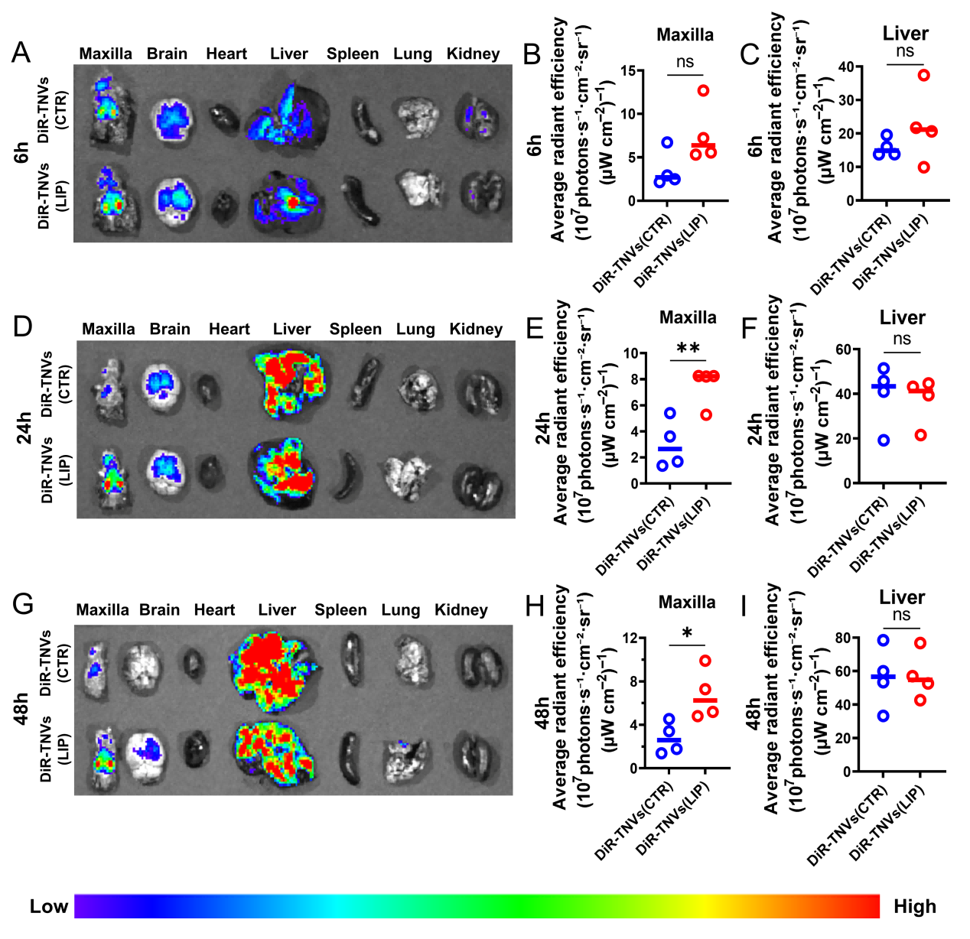
Fig. S14 Ex vivo fluorescence biodistribution of DiR-labelled TNVs in healthy mice and mice with ligature-induced periodontitis (LIP). (A, D, G) Ex vivo fluorescence imaging of major organs, including the maxilla, brain, heart, liver, spleen, lung, and kidney, harvested from CTR and LIP mice at 6 h (A), 24 h (D), and 48 h (G) following administration of DiR-labelled TNVs. (B, E, H) Quantitative analysis of the average radiant efficiency of DiR-labelled TNVs in the maxilla at 6 h (B), 24 h (E), and 48 h (H). (C, F, I) Quantitative analysis of the average radiant efficiency of DiR-labelled TNVs in the liver at 6 h (C), 24 h (F), and 48 h (I). Data are presented as the mean ± standard deviation (SD). Statistical significance is indicated as *P < 0.05 and **P < 0.01; ns, not significant.

Fig. S15 Representative western blot analysis of NET-related proteins in independent samples. (A–E) Western blot analysis of myeloperoxidase (MPO), peptidylarginine deiminase 4 (PAD4), neutrophil elastase (ELANE), and citrullinated histone H3 (CitH3) in five independent biological samples from control (CTR), ligature-induced periodontitis (LIP), and TNVs treatment (LIP + TNVs) groups. β-Actin was used as the loading control. Molecular weights are indicated on the right. Panels A–E represent five independent biological samples.

