Fig. S1. Surface area of ​​MPDA nanoparticles. The surface area of ​​MPDA nanoparticles determined by nitrogen adsorption testing was 593 m²/g.

Fig. S2. Representative images show the macroscopic structure and injectable morphology of the hydrogel.
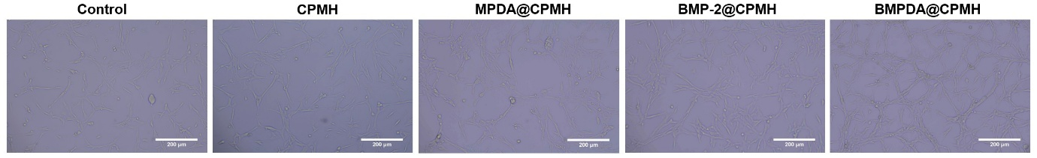
Fig. S3. HUVEC tube formation assay. The HUVEC tube formation assay demonstrates that BMPDA@CPMH hydrogel maximally promotes endothelial cell proliferation and angiogenesis, further strengthening the evidence for bone-angiogenic coupling.

