Targeting Microglial circMBNL1 Unlocks a Novel Nanomedicine Therapeutic Strategy for Major Depressive Disorder
Xiaoyu Yu^{1, #}, Yan Lu^{2, #}, Zhiren Tan¹, Shulei Gao¹, Long Ye³, Xiaoyan Luo¹, Jian Xie¹, Yuhao Miao¹, Bing Wang¹, Chenrui Liang¹, Ying Liu¹, Jilong Wang^{4, *}, Yinchu Ma^{1, *}, Yingli Luo^{1, *}

¹ Wuxi School of Medicine, Jiangnan University, Wuxi 214122, China;
² Department of Anesthesiology, Shanghai First Maternity and Infant Hospital, Tongji University School of Medicine, Shanghai 201204, China;
³ Department of Hematology, Affiliated Hospital of Jiangnan University, Wuxi 214122, China;
⁴ School of Basic Medical Sciences, Wenzhou Medical University, Wenzhou 325000, China;

#These authors contributed equally in this study.
*Corresponding Authors: wangjilong@ucas.ac.cn (Jilong Wang), myc2022@jiangnan.edu.cn (Yinchu Ma), lyl22@jiangnan.edu.cn (Yingli Luo)

Supporting Figures
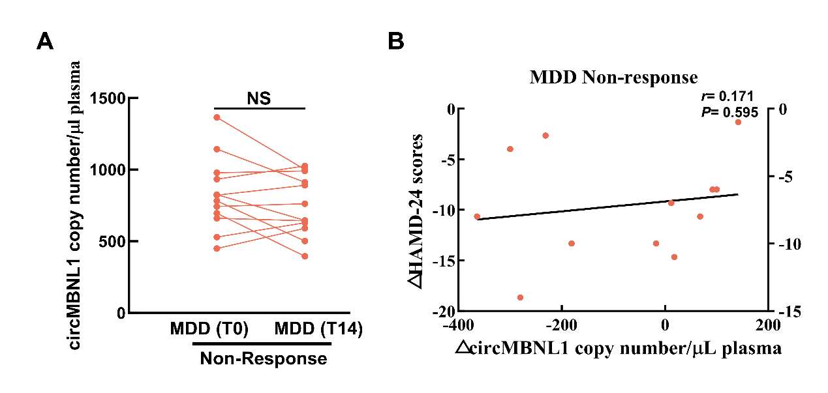
Supplementary Figure 1. The expression level of plasma circMBNL1 in MDD patients in no-response to anti-depressive treatment. (A) Plasma circMBNL1 expression level in MDD patients in non-response at day 0 and day 14 of anti-depressive treatment (n=12 for each group). (B) Correlation between Δ circMBNL1 and ΔHAMD-24 scores in MDD patients in non-response.

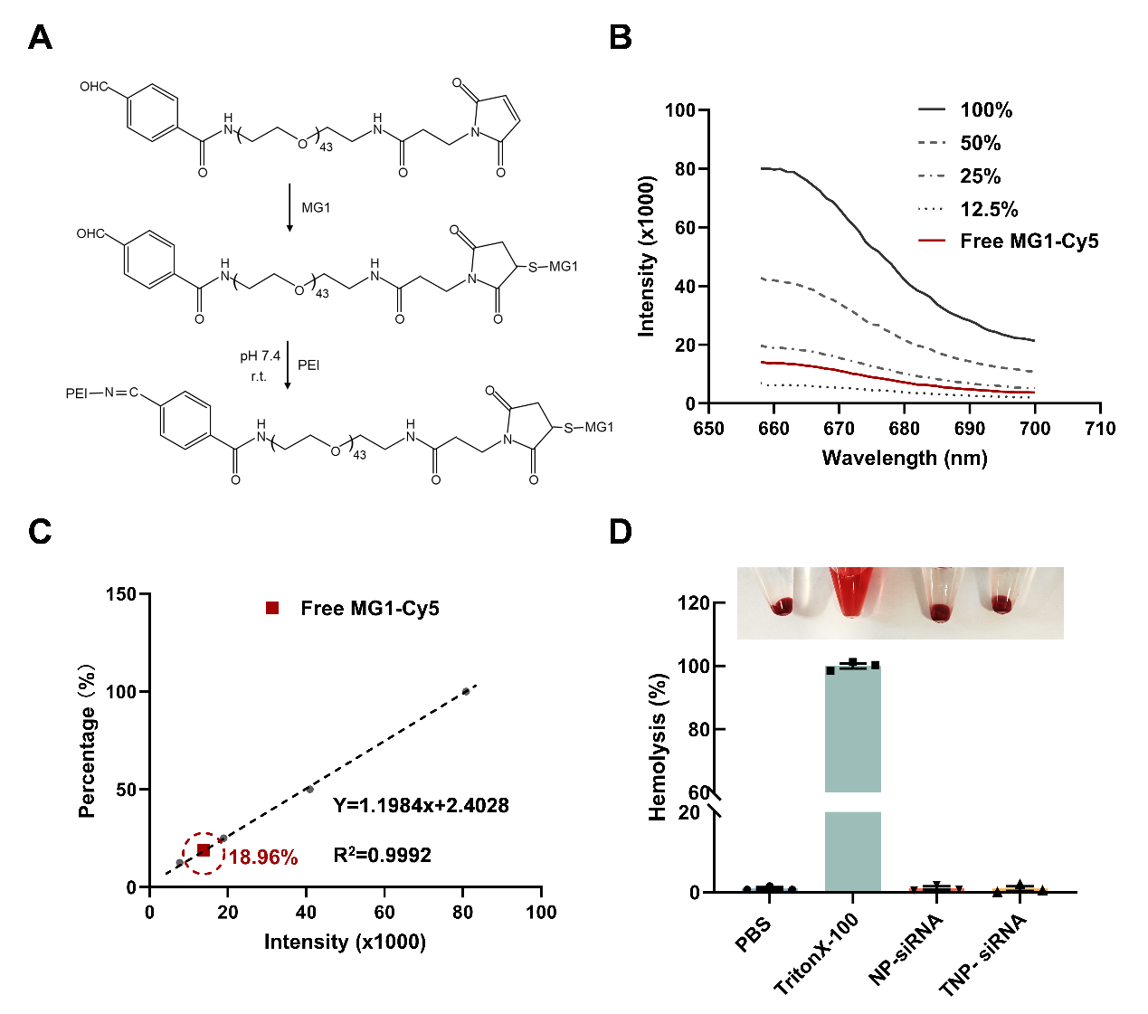
Supplementary Figure 2. Preparation and characterization of NP-siRNA and TNP-siRNA. (A) Synthesis route of aldehyde group-modified MG1-PEG-CHO and the further reaction with PEI. (B) Fluorescence spectra of different concentrations of Cy5-MG1-PEG-CHO (black lines), unconjugated Cy5-MG1-PEG-CHO (Free MG1-Cy5) in supernatant fluid after TNP-siRNA formulation (red line). The initial input amount of Cy5-MG1-PEG-CHO (1.0 mg, 1.2 mL) was set to 100%. (C) The amount of Cy5-MG1-PEG-CHO conjugated in TNP-siRNA was calculated by the subtraction method. The gray dashed line represents the linear regression curve of Cy5 concentration percentage versus fluorescence intensity. The red square indicates the percentage position of Cy5 fluorescence in the supernatant. The calculated percentage of unconjugated Cy5-MG1-PEG-CHO in the supernatant was 18.96% of the initial feed amount. Using the subtraction method, the conjugation efficiency of Cy5-MG1-PEG-CHO was determined to be 81.04%, which represented the effective grafting efficiency of the MG1 peptide. (D) Hemolysis test of NP-siRNA and TNP-siRNA.

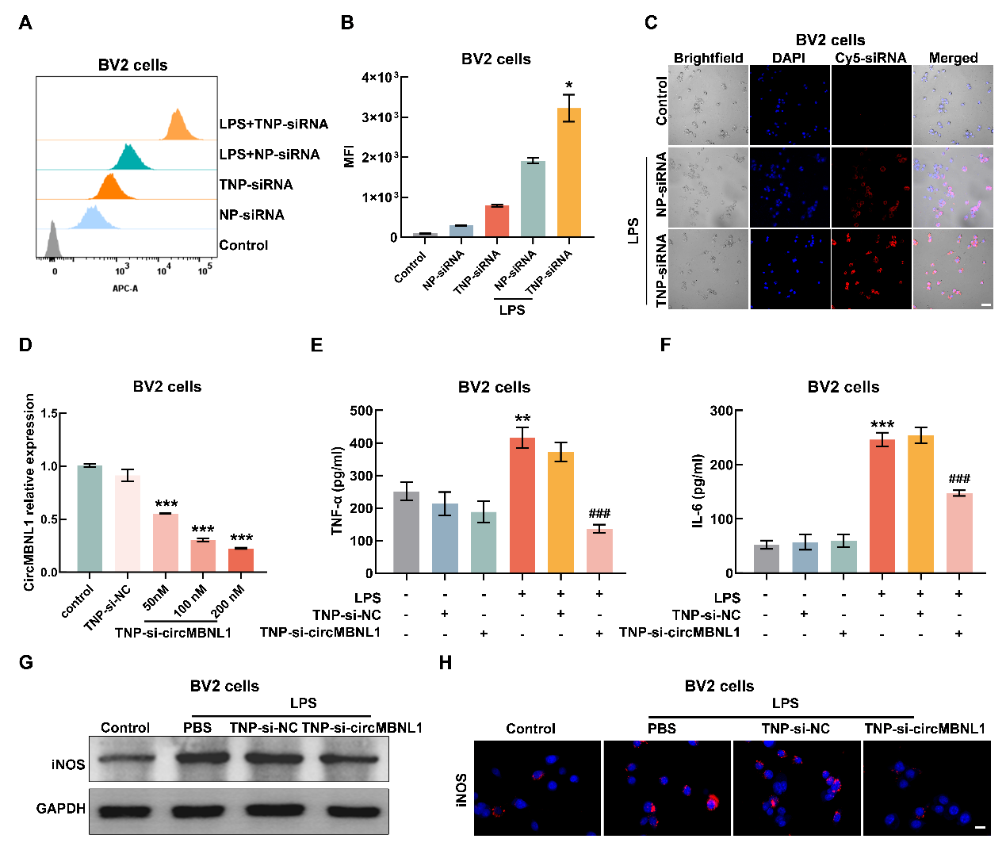
Supplementary Figure 3. In vitro transfection efficiency of TNP-si-circMBNL1. (A) Flow cytometry analysis of BV2 cells after treatment for 4 h. (B) Fluorescent intensity of Cy5-siRNA in BV2 cells after treatment by NP and TNP formulations. *P <0.05 versus the LPS + NP-siRNA group. (C) The CLSM images of BV2 cells after treatment for 4 h. TNP in red (labeled with Cy5-siRNA) and nuclei in blue (labeled with DAPI). The scale bar: 50 µm. (D) The levels of circMBNL1 in BV2 cells after LPS pre-treatment was determined by RT-qPCR after transfection with different amounts of TNP-si-circMBNL1 (50 nM, 100 nM, and 200 nM of siRNA per well) for 24 h. ***P <0.001 versus the Control group. (E-F) Relative expression levels of TNF-α (E) and IL-6 (F) in LPS-stimulated BV2 cells after treatment by TNP-si-circMBNL1 (100 nM of siRNA per well) for 24 h. **P < 0.01, and ***P < 0.001 versus the Control group; ###P < 0.001 versus the LPS group. (G) The western blot analysis of iNOS expression in LPS-stimulated BV2 cells after treatment by TNP-si-circMBNL1 for 24 h. (H) Represented immunostaining images of iNOS (Alexa Fluor 594, red) in LPS-stimulated BV2 cells after treatment by TNP-si-circMBNL1 for 24 h. Nuclei were counterstained with DAPI (blue). The scale bar: 20 μm.

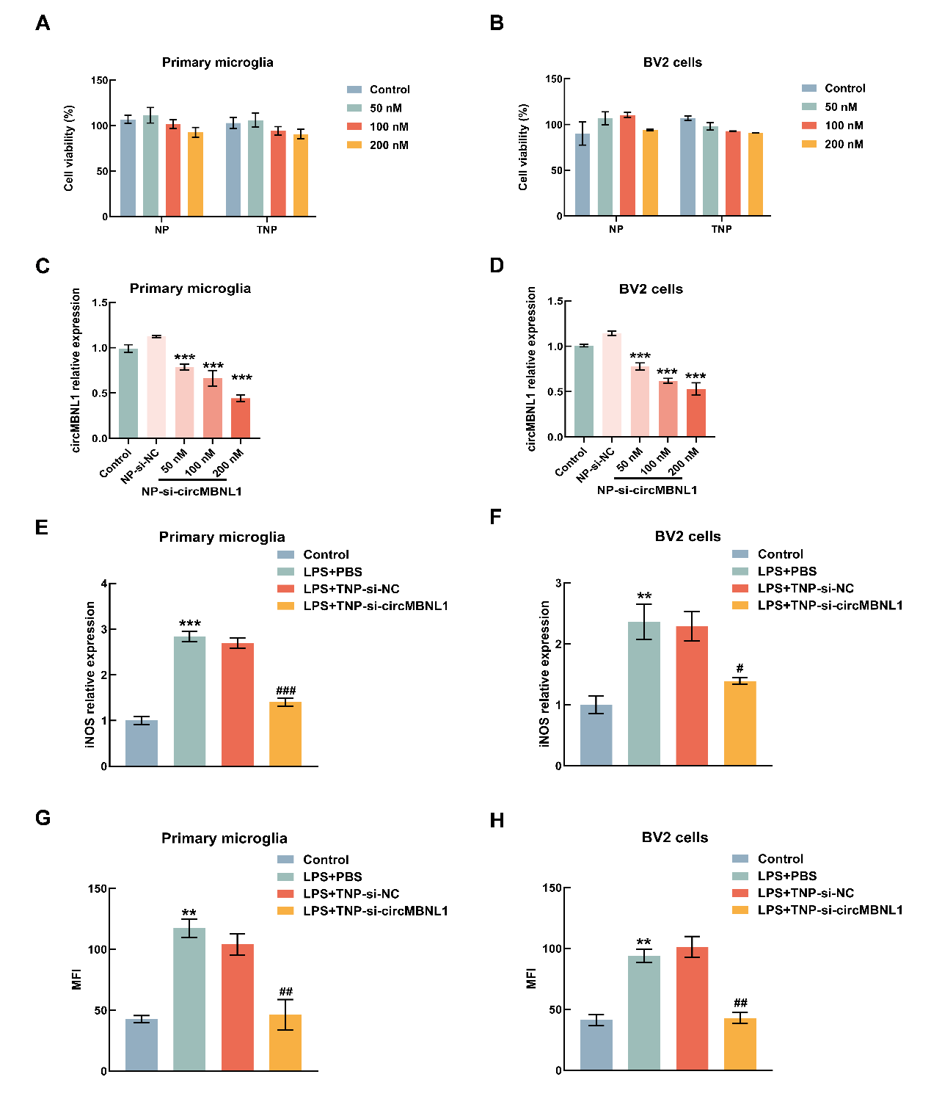
Supplementary Figure 4. In vitro transfection efficiency and cytotoxicity of TNP-si-circMBNL1. (A-B) Cell viability of primary microglia (A) and BV2 cells (B) treated with the indicated concentrations of NP-siRNA or TNP-siRNA for 12 h. (C-D) The levels of circMBNL1 in primary microglia (C) and BV2 cells (D) after LPS pretreatment was determined by RT-qPCR after transfection with different amounts of NP-si-circMBNL1 (50 nM, 100 nM, and 200 nM of siRNA per well) for 24 h. ***P <0.001 versus the Control group. (E-F) Quantitative analysis of iNOS protein expression in LPS-stimulated primary microglia (E) and BV2 cells (F) following TNP-si-circMBNL1 treatment. **P < 0.01, and ***P < 0.001 versus the Control group; #P < 0.05, and ###P < 0.001 versus the LPS+PBS group. (G-H) Quantitative analysis relative fluorescence intensity of iNOS in LPS-stimulated primary microglia (G) and BV2 cells (H) following TNP-si-circMBNL1 treatment. **P < 0.01 versus the Control group; ##P < 0.01 versus the LPS+PBS group.
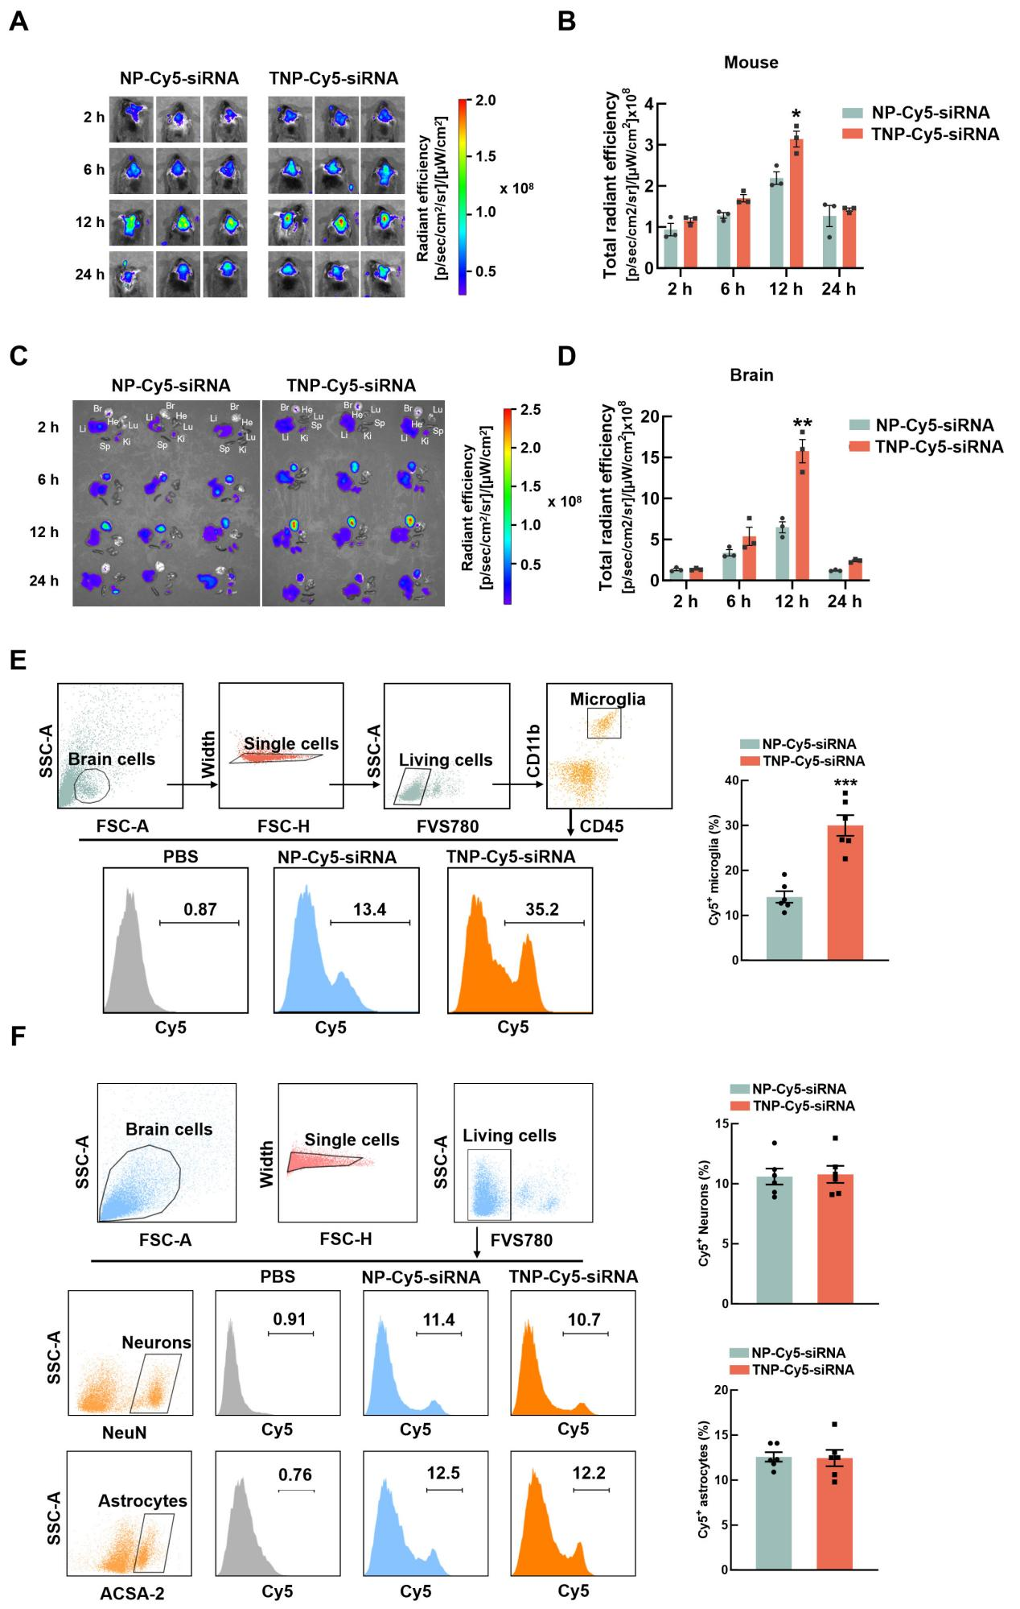
Supplementary Figure 5. TNP exhibited significant targeting specificity toward microglia in vivo. (A) Representative in vivo fluorescence imaging of Cy5-siRNA in mouse bodies after intranasal administration of TNP-Cy5-siRNA or NP-Cy5-siRNA. (B) Fluorescent imaging and quantification of Cy5-labeled NP and Cy5-labeled TNP in mouse brains at 0, 6, 12, and 24 h after intranasal administration TNP-Cy5-siRNA or NP-Cy5-siRNA. (n=3 for each group). *P < 0.05, and, **P < 0.01 versus the NP-Cy5-siRNA group. (C) Representative in vivo fluorescence imaging of Cy5-siRNA in major organs (heart, liver, spleen, lung, kidney) of mice after intranasal administration of TNP-Cy5-siRNA or NP-Cy5-siRNA. (D) Fluorescent imaging and quantification of Cy5-labeled NP and Cy5-labeled TNP in mouse major organs at 0, 6, 12, and 24 h after intranasal administration TNP-Cy5-siRNA or NP-Cy5-siRNA. (E) FCM analysis of Cy5⁺ microglia cells in mouse brains after intranasal administration TNP-Cy5-siRNA or NP-Cy5-siRNA. (n=6 for each group). ***P < 0.001 versus the NP-Cy5-siRNA group. (F) FCM analysis of Cy5⁺ neurons and Cy5⁺ astrocytes in mouse brains after intranasal administration TNP-Cy5-siRNA or NP-Cy5-siRNA. (n=6 for each group).

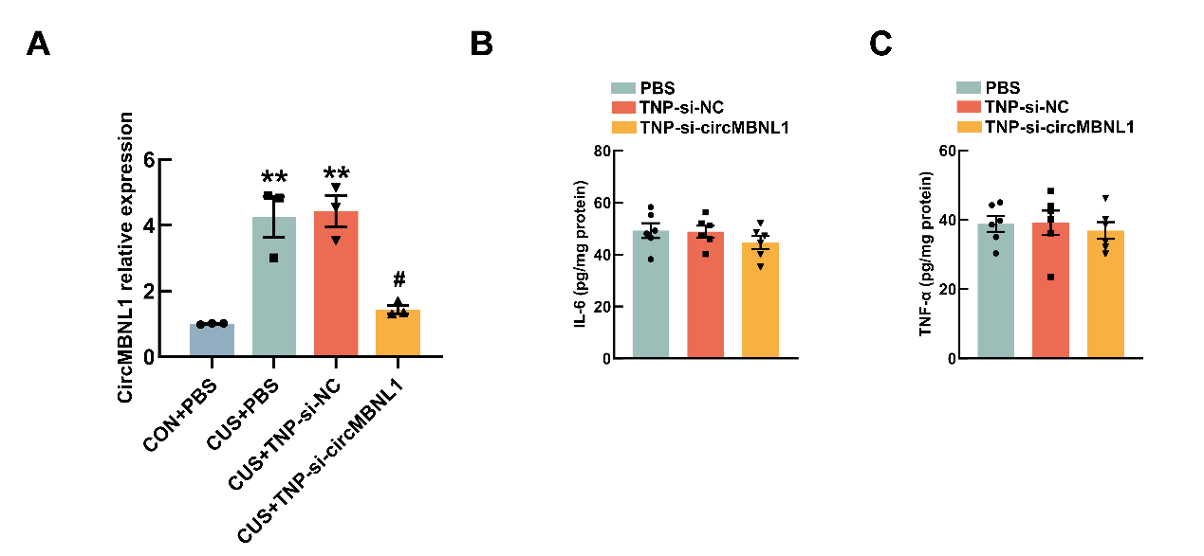
Supplementary Figure 6. The measurement of the expression of circMBNL1 in the brain tissues and proinflammatory cytokines levels in plasma of the mice treated with TNP-siRNA. (A) The levels of circMBNL1 in mouse brains after CUS pretreatment was determined by qPCR after intranasal administration of TNP-si-circMBNL1 for 24 h. (C-D) Levels of IL-6(C), and TNF-α(D) measured by ELISA in plasma of mice treated PBS, TNP-si-NC or TNP-si-circMBNL1.
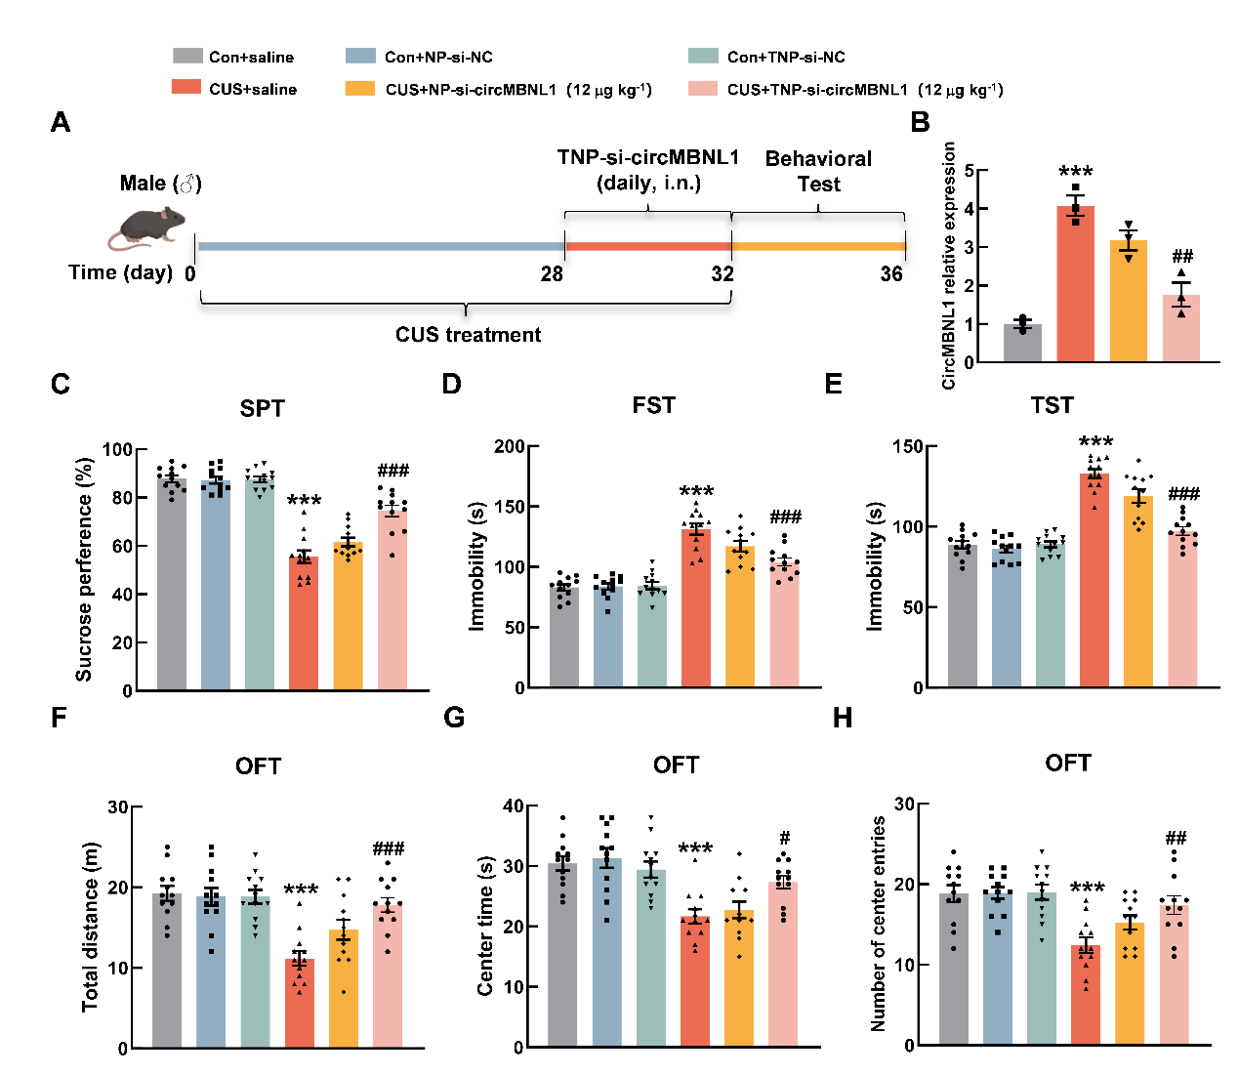
Supplementary Figure 7. TNP mediated microglia-targeted delivery of si-circMBNL1 and alleviated depressive-like behaviors in mice. (A) Schematic illustration of the experimental design in male mice. (B) The levels of circMBNL1 in mouse brains after CUS pretreatment was determined by qPCR after intranasal administration of NP-si-circMBNL1 or TNP-si-circMBNL1 for 24 h. ***P < 0.01 versus the Control + saline group; ##P < 0.01 versus the CUS + saline group. (C-H) Mouse depressive-like behaviors were measured by the SPT (C), FST (D), TST (E) and OFT (F-H) (n=12 for each group). ***P < 0.001 versus the Control + saline group; #P < 0.05, ##P < 0.01, and ###P < 0.001 versus the CUS + saline group.

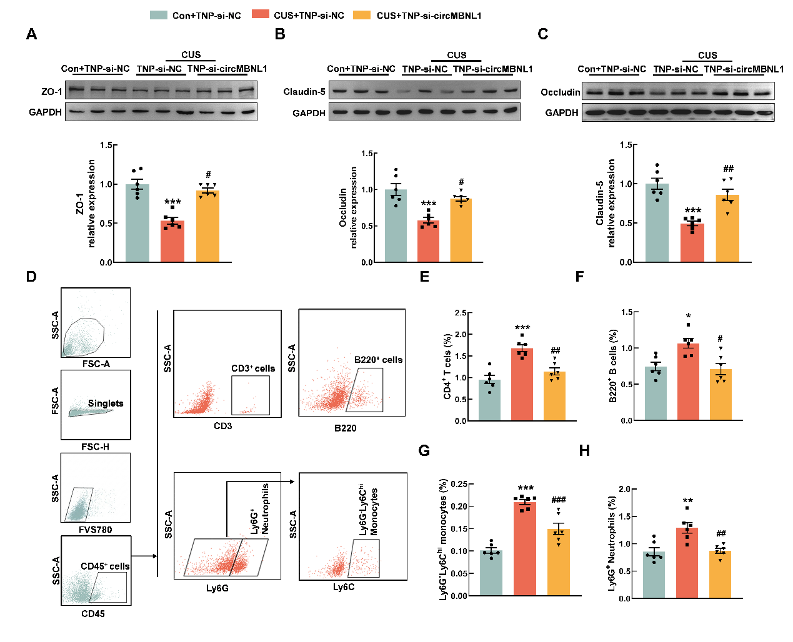
Supplementary Figure 8. TNP-si-circMBNL1 attenuated CUS-induced BBB damage and peripheral immune cell infiltration. (A-C) Representative western blots of TJPs including ZO-1 (A), Claudin-5 (B), and Occludin (C) in the hippocampus of CUS mice treated with/without TNP-si-circMBNL1. (D) Representative gating strategy for flow cytometric analysis of immune cells in the mouse brain with treatment of TNP-si-NC or TNP-si-circMBNL1 (n=6 for each group). CD45⁺ immune cells were gated based on CD45 staining. (E-H) Cell surface antibodies were used to identify different cell types: CD4⁺T cells (E), B220⁺B cells (F), Ly6G⁻Ly6C^{hi} macrophages/monocytes (G), and Ly6G⁺ neutrophils (H). *P < 0.05, **P < 0.01, and ***P < 0.001 versus the Control + TNP-si-NC group; #P < 0.05, ##P < 0.01, and ###P < 0.001 versus the CUS + TNP-si-NC group.

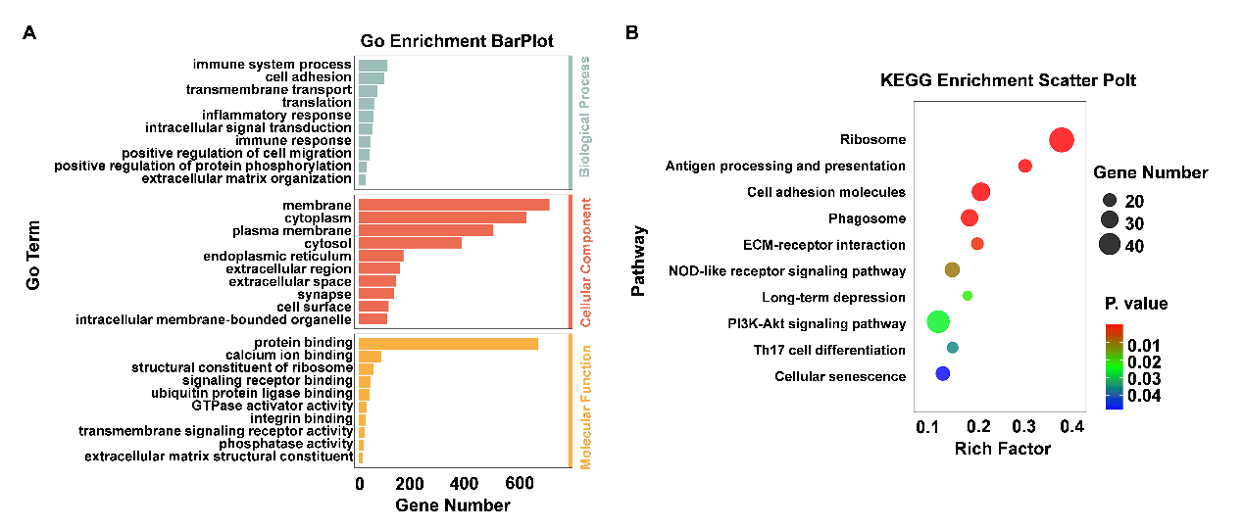
Supplementary Figure 9. Functional enrichment analysis revealing the differential expression patterns between Control and CUS mice. (A) GO enrichment analysis of DEGs between CUS+TNP-si-NC group and Con+TNP-si-NC group. (B) KEEG enrichment analysis of DEGs between CUS+TNP-si-NC group and Con+TNP-si-NC group.
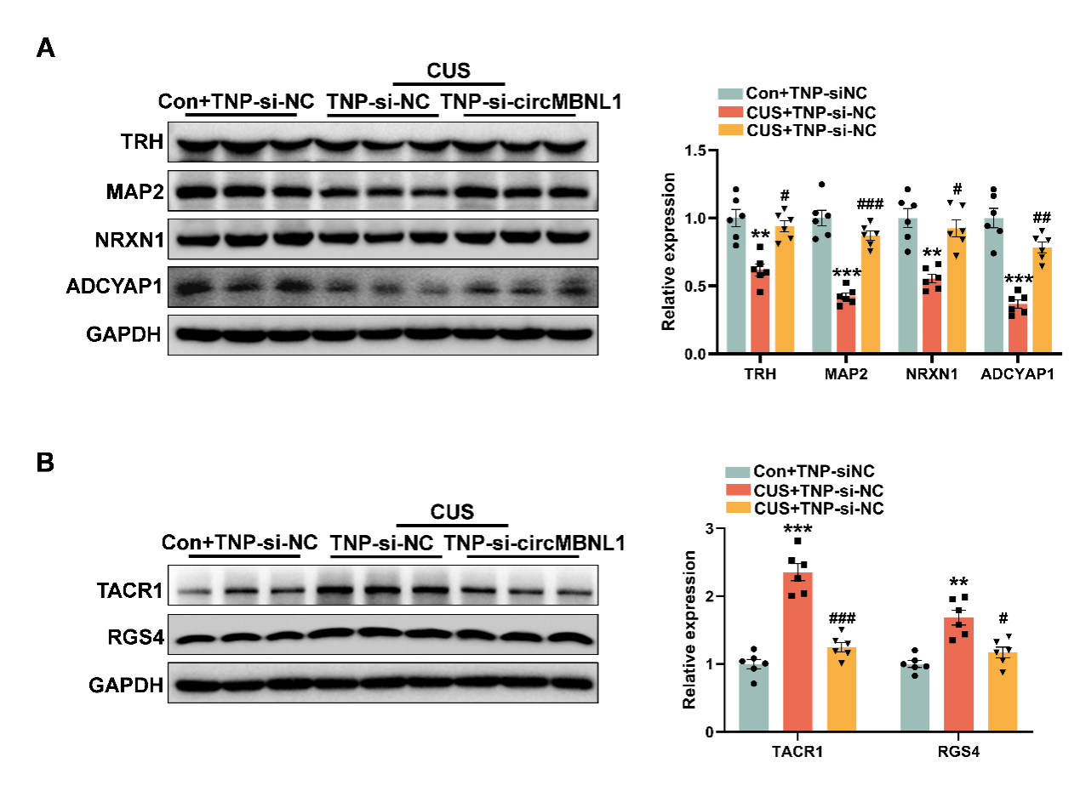
Supplementary Figure 10. Relative expression levels of depression-associated hub genes. (A) Relative protein expression of TRH, MAP2, NRXN1, and ADCYAP1 between CUS + TNP-si-NC group and CUS + TNP-si-circMBNL1 group. (B) Relative protein expression of TACR1, RGS4, TRH, MAP2, NRXN1, and ADCYAP1 between CUS + TNP-si-NC group and CUS + TNP-si-circMBNL1 group (n=6 for each group). **P < 0.01, and ***P < 0.001 versus the CUS + TNP-si-NC group.

