Supporting Information

Fig. S1. Concentration-dependent cytotoxicity of different formulations toward tumor cells. (A) Concentration-dependent cytotoxicity of celastrol (cel), curcumin (Cur), britannin (Brn) and tetrahydropalmatine (THP) toward H1975 cell line. (B) Concentration-dependent cytotoxicity of different formulations toward LCC cell line. NP+NIR: mPDA-Fe-Cel plus NIR.

Fig. S2. Time-dependent hydrodynamic size distribution of mPDA–Fe–Cel particles over 48 h measured by DLS.

Fig. S3. Flow-cytometric apoptosis assays of LLC cells after treated with PBS, NIR-Only, mPDA-Fe, mPDA-Fe+NIR, Cel, mPDA-Fe-Cel or NP plus NIR. NP+NIR: mPDA-Fe-Cel plus NIR. Data are represented as mean ± SD (n=3). p values were calculated using one-way ANOVA followed by appropriate post hoc multiple-comparison analysis. **p < 0.01, ***p < 0.001.

Fig. S4. In-vitro evaluation of mPDA-Fe-Cel nanoparticles against LLC cells. (A) intracellular ROS and (B) Fe²⁺ level imaged by confocal microscopy, (C) intracellular GSH content of LLC cells after treated with PBS, Cel, mPDA-Fe, mPDA-Fe-Cel or mPDA-Fe-Cel+Fer-1. Data are represented as mean ± SD (n=3). p values were calculated using one-way ANOVA followed by appropriate post hoc multiple-comparison analysis. ***p < 0.001, ****p < 0.0001.
Fig. S5. Heat map of gene expressions in cells treated with PBS, Cel, or NIR (mPDA-Fe-Cel plus NIR).

Fig. S6. The Gene Ontology (GO) analysis results revealed both downregulated (A-C) and upregulated (D-E) Biological Process (BP), Molecular Function (MF), and Cellular Component (CC) terms across the PBS, Cel, and NIR group. NP+NIR: mPDA-Fe-Cel plus NIR.

Fig. S7. Kyoto Encyclopedia of Genes and Genomes (KEGG) pathway enrichment indicated corresponding upregulated pathways following comparison between the respective groups. NP+NIR: mPDA-Fe-Cel plus NIR.

Fig. S8. Combination of mPDA-Fe-Cel and photothermal effect induces immunogenic cell death and activates immune responses in H1975 cells. A) Fluorescence images showing CRT expression in H1975 cells treated with PBS, NIR-Only, mPDA-Fe, Cel, or NP+NIR. (B) Fluorescence images showing HMGB1 expression in H1975 cells upon various treatments. (C) Quantitative analysis of ATP release from H1975 cells across different treatment groups. NP+NIR: mPDA-Fe-Cel plus NIR. Data are represented as mean ± SD (n=3). p values were calculated using one-way ANOVA followed by appropriate post hoc multiple-comparison analysis in (D) and (E). **p < 0.01, ***p < 0.001, ns, not significant.
Fig. S9. Flow cytometry plots and quantitative analysis of bone marrow-derived dendritic cell (BMDC) maturation after co-culture with LLC cells treated with PBS, NIR-Only, mPDA-Fe, Cel, or mPDA-Fe-Cel plus NIR. NP+NIR: mPDA-Fe-Cel plus NIR. Data are represented as mean ± SD (n=3). p values were calculated using one-way ANOVA followed by appropriate post hoc multiple-comparison analysis **p < 0.01, ***p < 0.001.

Fig. S10. In vivo fluorescence imaging and biodistribution of mPDA–Fe–Cel following intravenous administration. Representative whole-body fluorescence images of LLC tumor-bearing mice acquired at different time points (2–48 h) after intravenous injection of fluorescently labeled mPDA–Fe–Cel particles. Ex vivo fluorescence imaging of major organs and tumor tissue collected at 48 h post-injection is shown below. Detectable fluorescence signals were observed in tumor tissue, together with signals in the kidney and, to a lesser extent, the lung.

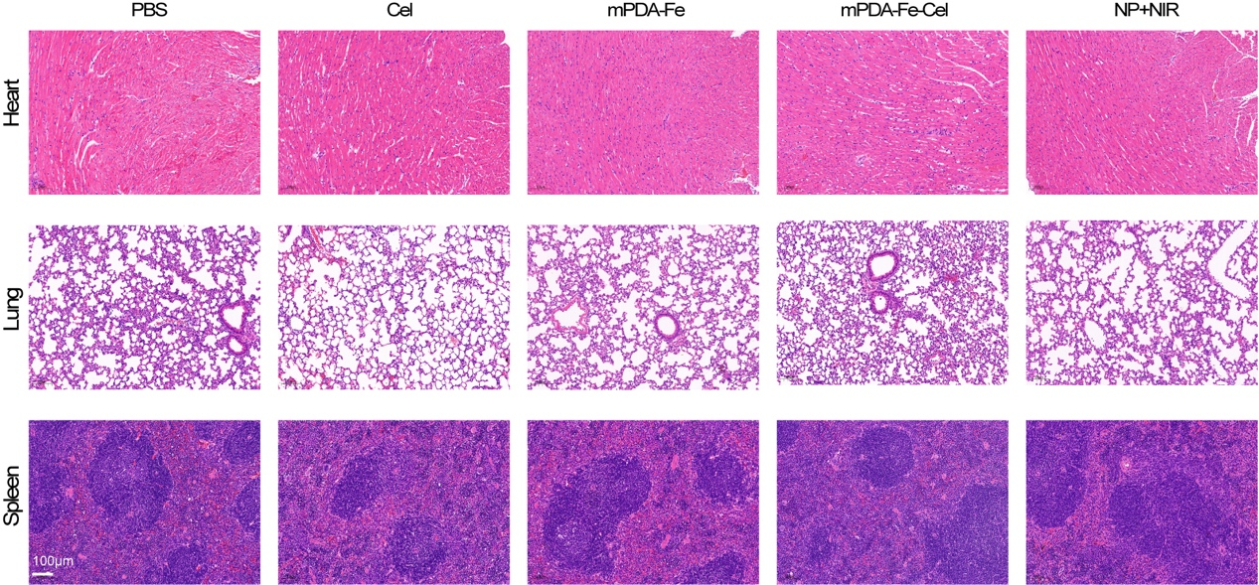
Fig. S11. H&E staining of heart, lung and spleen tissues from mice bearing LLC lung cancer after different treatment. NP+NIR: mPDA-Fe-Cel plus NIR.

Fig. S12. Immune effects of mPDA-Fe-Cel in in subcutaneous LLC lung cancer model. (A) Flow cytometry analysis of CD11c⁺MHCI⁺ cells in tumor tissues upon various treatments. (B) Flow cytometry analysis of CD80⁺CD86⁺ cells in tumor tissues upon various treatments. NP+NIR: mPDA-Fe-Cel plus NIR.

Figure S13. Representative flow-cytometry gating strategies.
Panel A：Tumor-infiltrating T-cell gating
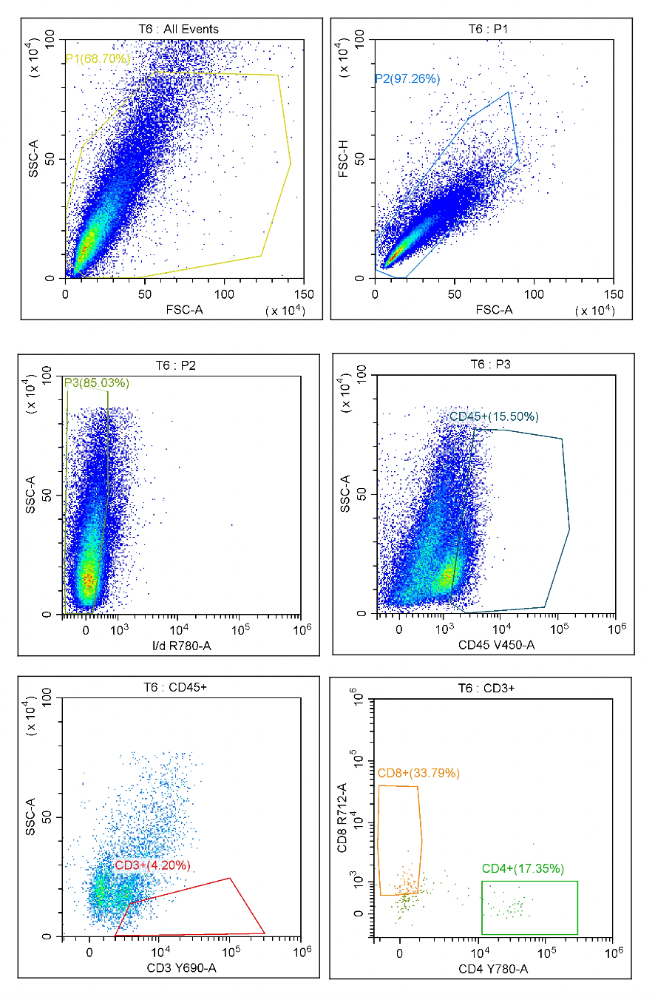

Panel B: Tumor-infiltrating DC gating
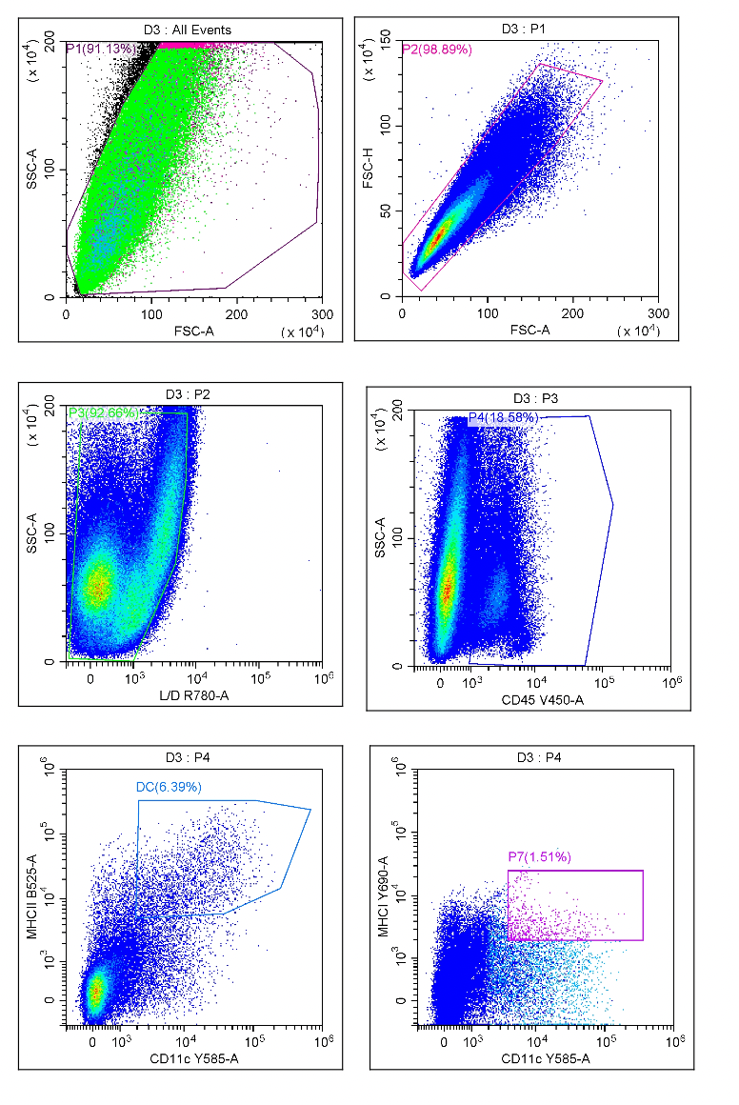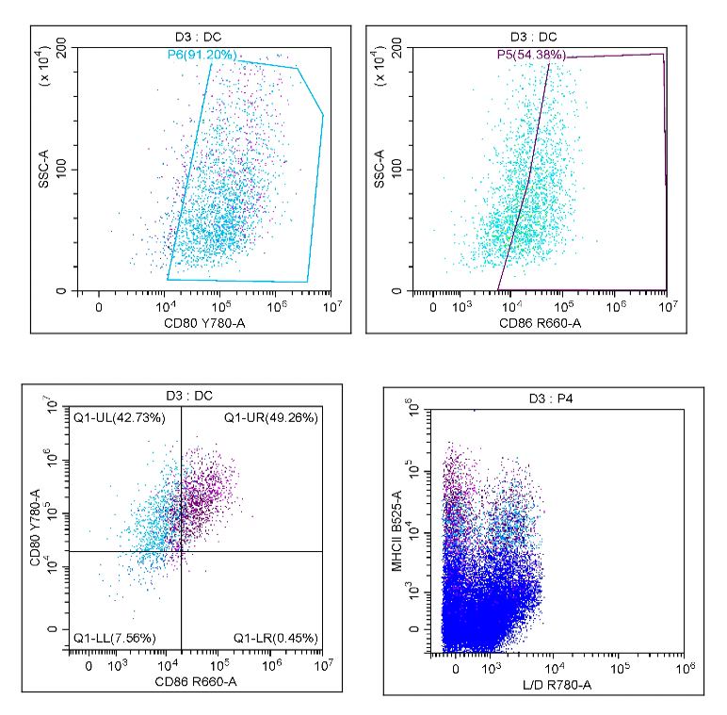

Panel C: BMDC maturation gating
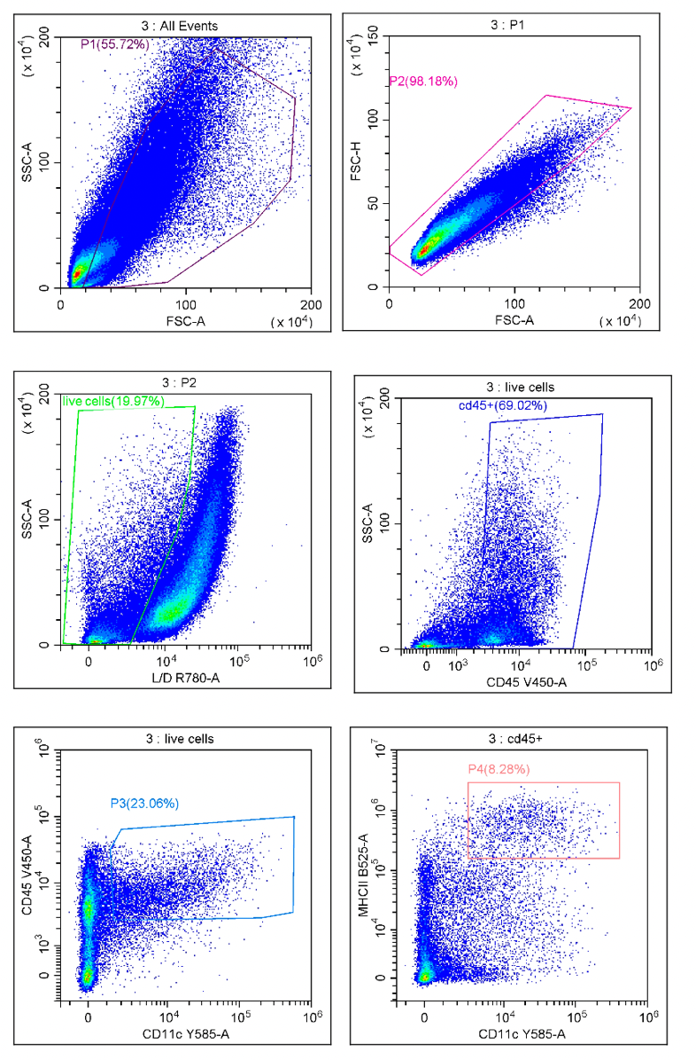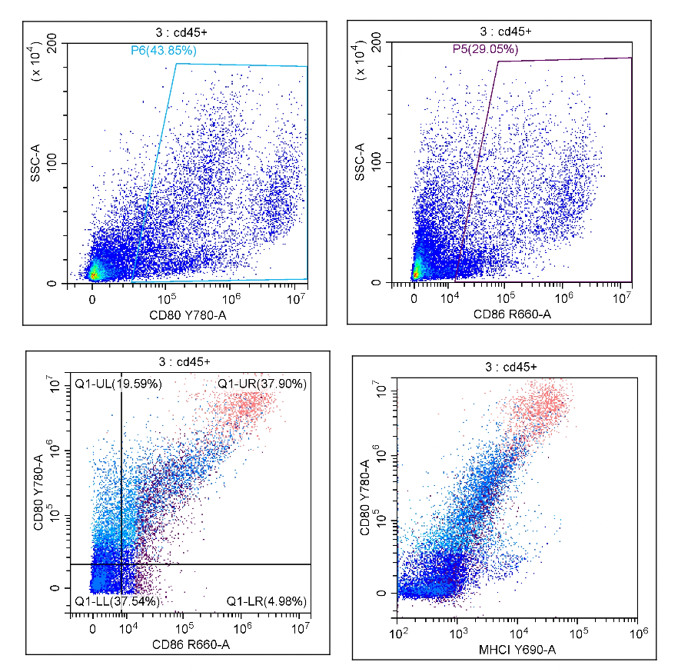
Fig. S14. Independent validation cohort confirming the antitumor efficacy of mPDA-Fe-Cel plus NIR treatment in LLC tumor-bearing mice. Tumor photographs, tumor-growth curves, and body-weight changes are shown for mice treated with PBS, Cel, mPDA-Fe, mPDA-Fe-Cel, or NP+NIR (mPDA-Fe-Cel plus NIR). Data are represented as mean ± SD (n = 4 mice per group). Statistical significance was evaluated using one-way ANOVA followed by appropriate post hoc multiple-comparison analysis. ***p < 0.001, ns, not significant.

Table S1. Celastrol loading content in independently synthesized batches of mPDA–Fe–Cel formulations
Batch | Cel loading (%)
1 | 9.8
2 | 10.2
3 | 10.1
4 | 10.0
5 | 10.1

