Disrupting Intestinal Cell Pyroptosis-NETs Crosstalk Reverse Mucosal Damage and Restore Treg/Th17 Equilibrium in Ulcerative Colitis via a Calcium Pectate Microsphere Composite Hydrogel
Yun Huang ^{#, a}, Shuangyan He ^{#, a}, Jia Liu ª, Yalan Chen ª, Wen Chen ª, Mohan Ding ª, Zhi Zheng ª, Hua Wei ^{*, a}, Cui-Yun Yu^{*, b}

ª Hunan Province Cooperative Innovation Center for Molecular Target New Drug Study, School of Pharmaceutical Science, Hengyang Medical School, University of South China, Hengyang 421001, China
^{b} Affiliated Hospital of Hunan Academy of Chinese Medicine, Hunan Academy of Chinese Medicine, Changsha 410013, China

# These authors contributed equally to this work.
* Corresponding author.
E-mail addresses: weih@usc.edu.cn (H. Wei); yucuiyunusc@hotmail.com (C.-Y. Yu).

- Methods
  - Materials
Pectin (9000-69-5, Solarbio), BBR (2086-83-1, Beijing HWRK Chem Co., Ltd.), DNase I (Bide Pharmatech Co., Ltd), poly(allylamine hydrochloride) (PAH, average MW 50 kDa, Bide Pharmatech Co., Ltd), 2-(2-(2-Chloro-3-(2-(3,3-dimethyl-1-propylindolin-2-ylidene)ethylidene) cyclohex-1-en-1-yl)vinyl)-3,3-dimethyl-1-propyl-3H-indol-1-ium iodide (IR-780 iodide, Bide Pharmatech Co., Ltd), Phorbol 12-myristate 13-acetate (Phorbol myristate acetate, PMA, Bide Pharmatech Co., Ltd), Inulin(Meilun Bio), Dextran sulfate sodium salt (DSS, 9011-18-1, LOT: J0120F, MW 36000-50000, Meilun Bio), Perfect Start Green qPCR SuperMix (TransGen Biotech).
  - Animal
C57BL/6j mice (male; 4-6 weeks; 18-25 g) were supplied by Hunan Slack Jingda Experimental Animal Co., Ltd. (Hunan, China). All animals were kept in the Laboratory Animal Centre in specific pathogen-free (SPF) conditions (temperature ~22 °C, humidity ~50%, and 12-h light- dark cycle, 4 per cage), with free access to food and water. Animal experiments were approved by the Experimental Animal Ethics Committee of the University of South China, Hunan, People’s Republic of China (approval 4304079008946) and complied with the National Institutes of Health and University of South China guidelines on the care and use of animals for scientific purposes.
  - GEO Dataset Collection and Processing
Gene expression profiles of active disease samples and matched controls were retrieved from the public Gene Expression Omnibus (GEO) database. Sample comparisons were grouped for disease versus control, or disease versus disease, using the data in the original peer-reviewed study. Only datasets with clear sample grouping, complete clinical annotation, and reliable high-throughput detection platforms were included for subsequent analysis. Relevant covariates and confounders were adopted directly from the published data. The separate gene expression datasets were utilized from GSE:75214. Principal component analysis (PCA) was performed to verify the rationality of sample grouping and to remove outlier samples. GSDMD expression in colonic mucosal tissues was compared between groups. Correlation analysis between GSDMD and MPO was performed to assess the association between pyroptosis and neutrophil activation. The correlation analyses were performed by determining the Spearman correlation significance and Spearman r.
  - Neutrophil Isolation
Mouse peripheral blood neutrophils were separated by a mouse peripheral blood neutrophil isolation Solution kit (Solarbio, China) by following the manufacturer's instructions. In brief, fresh peripheral blood was obtained from healthy mice and collected using Vacutainer tubes with heparin as the anticoagulant. Peripheral blood was diluted at a 1:1 ratio (v/v) with PBS, then carefully added Reagent A and Reagent C in sequence. Following centrifugation at 800 × g for 25 min at room temperature, the neutrophil-rich interphase layer was cautiously harvested and washed with red blood cell lysis buffer (Solarbio). Following washing with cell wash solution (5 mL), the neutrophils were obtained by centrifugation (250 × g, 10 min). Final resuspension of the purified neutrophils was performed in complete RPMI-1640 medium to facilitate subsequent culture.
  - NETs formation
To induce pyroptosis, incubate NCM460 cells with lipopolysaccharide (LPS,1 μg/mL) for 6 h prior to the experiment. The LPS-containing medium was removed by changing the solution, and fresh medium was added to continue the culture for 24 h. Collect cell culture supernatant (CCS) for later use.
Isolated neutrophils were seeded in coverslips (5×10⁵ cells per well) and allowed to adhere for 30 min. Whereafter, PMA (100 nM) or CCS was added to stimulate for 4 h to induce NETs formation. Then, cells were washed three times with ice-cold PBS buffer, followed by fixation with ice-cold paraformaldehyde at room temperature. After three washes, blocking buffer (5% FBS and 0.3% Triton X-100 in PBS) was added for blocking at room temperature for 1 h, followed by incubation with anti-MPO antibody (1:100, Zenbio) overnight at 4°C. Following three washes with PBST (0.1% Triton X-100 in PBS), the cells were incubated with Anti-rabbit 488 secondary antibody (1:200, HUABIO) at room temperature for 2 h. Washing three times with PBST, the cells were sealed with mounting medium containing DAPI and imaged using an inverted fluorescence microscope.
The NETs formation was quantified by detecting the content of double-stranded DNA (dsDNA). Cell supernatants were collected after induction, and dsDNA in the supernatants was extracted using a DNA extraction kit (RC323-01, Vazyme). Subsequently, the DNA concentration was determined with a micro ultraviolet spectrophotometer.
  - Pyroptosis Assay
NETs formation was induced by stimulating neutrophils with PMA (100 nM) as previously described. To obtain NETs, the medium was collected and subjected to centrifugation (250 × g, 5 min) for the removal of intact cells. The DNA content of NETs was quantified, and NETs at the concentrations of 0.5, 1.0, and 2.0 μg DNA/mL were added to the pre-treated NCM460 cells (LPS, 1 μg/mL, 6 h) for co-culture 24 h. Pyroptosis of NCM460 cells was finally observed under a phase-contrast microscope, and proteins were extracted for further analysis.
  - Neutrophil Depletion Assay
Male mice were injected with either anti-Ly6G (anti-Ly6G; n = 5) or Isotype Control (anti-IgG2; n = 5) Abs (100 µg/dose) intraperitoneally at days -2, 0, and 2. Mice were administered a 3% (w/v) DSS aqueous solution to induce colitis. The newly prepared DSS drinking water was replaced every 2 days. On day 7, the experiment was terminated. Mice were sacrificed, serum was harvested, and the spleen and colorectum were dissected for follow-up experiments. The serum levels of neutrophil elastase (NE), IL-17A, IL-6, and IL-1β in mice were detected using commercial ELISA kits. The percentage of neutrophils in the spleen and colorectal tissues was determined by flow cytometry (FCM). Pyroptosis of colonic epithelial cells was examined by Western blotting.
  - Preparation of BBR@CP particles and BCPD Microparticles
BBR-calcium pectinate microspheres (BBR@CP particles) were prepared via a cross-linking method. 4% pectin solution (w/v, 25 mL) and BBR (250 mg) were mixed and stirred overnight to ensure a complete dispersion. Then the resulting mixture was dropped into a 0.1 M calcium chloride dihydrate solution through a 26-gauge 1-mL syringe. The solution was stirred for 20 min and left undisturbed for 24 h. Microspheres were collected from the reaction system by centrifugation (12,000 × g) for 20 min, washed, and centrifuged to obtain BBR@CP particles.
After mixing and stirring the BBR@CP particles and PAH solution (1 mg/ml in 10 mM of HEPES buffer, pH 7.0) for 20 min, they were centrifuged and then washed three times (3,000 rpm, 30 s) with HEPES buffer to remove free PAH, resulting in positively charged PAH-coated BBR@CP cores. Following this, the particles were resuspended in 10 mM HEPES containing DNase I (2,000 Kunitz units/mg) and incubated at 37 °C for 1 h. After washing, BCPD microparticles were obtained, and the Zeta potential was analyzed using the Zetasizer Nano ZS90 (Malvern).
For FTIR spectroscopy analysis, the lyophilized samples were mixed with KBr powder and then placed in a hydraulic press to form the pellets. The spectra were acquired over the wavelength range of 400-4000 cm⁻¹.
  - Preparation and Characterization of Inulin Hydrogel and BCPD@gel
An inulin hydrogel was prepared by the physical crosslinking method. 600 mg of inulin was dissolved in distilled water (1.0 mL). Following 10 min of heating at 80°C, the solution was cooled to room temperature to form the hydrogel. The inulin hydrogel was stirred continuously for 10 min at room temperature to mix uniformly with BCPD microparticles, followed by static incubation for 2 h to form BCPD@gel.
For scanning electron microscopy (SEM) analysis, the inulin hydrogel was lyophilized using a freeze dryer. The lyophilized samples were sputter-coated with gold for 30 s and visualized using a SEM5000X field-emission scanning electron microscope (China Instrument Quantum Co., China).
Rheological studies of both inulin hydrogel and BCPD@gel were performed on an MCR 102e rheometer equipped with a 25 mm diameter sandblasted parallel plate geometry.
  - BBR release in simulated gastrointestinal fluids
BCPD and BCPD@gel (equal amounts of BBR) were placed in dialysis bags (MWCO 3500 Da) and incubated in a water bath shaker at 37 °C and 100 rpm. The samples were first exposed to artificial gastric fluid at pH 1.2 for 2 h, subsequently transferred to artificial intestinal fluid at pH 6.8 and pH 7.8 for incubation periods of 4 h and 6 h, respectively. At hourly intervals, 500 μL of the test solution was drawn, and then supplemented with an equivalent volume of the corresponding pH buffer solution. Finally, the UV absorption of BBR was detected by a UV spectrophotometer at 263 nm, and the release percentage was calculated according to the UV standard curve.
  - DNase I Activity Analysis
DNase I activity was assessed by agarose gel electrophoresis. dsDNA substrates (1 μg) were co-incubated with PBS, DNase I, BBR@CP particles encapsulated in inulin hydrogel (BCP@gel), BCPD@gel, and BCPD@gel + DNase inhibitor (pre-treated with DNase inhibitor, 30 min), respectively, at 37 ℃ for 30 min. After incubation, the supernatant was collected by centrifugation and subjected to 3% agarose gel electrophoresis. Briefly, a 3% agarose gel containing GelRed nucleic acid dye was prepared. The samples were mixed with DNA loading buffer (6X) and electrophoresed at 120 V for 30 min. After electrophoresis, the gel was imaged using a gel documentation system.
  - Western Blot Assay
Colonic tissue samples were treated with radioimmunoprecipitation (RIPA) buffer containing protease inhibitors (Meilun Bio) to obtain total protein extracts. The protein samples were resolved by sodium dodecyl sulfate-polyacrylamide gel electrophoresis (SDS-PAGE) and subsequently transferred onto polyvinylidene fluoride (PVDF) membranes. The PVDF membranes were blocked with 5% skim milk. Following this, the membranes were incubated with primary antibodies overnight at 4 °C on a shaker. The membranes were incubated with secondary antibodies for 2 h at room temperature following three washes with Tris-buffered saline containing Tween 20 (TBST) on a shaker. After three additional TBST washes, visualization of protein bands was achieved using Meilunbio® fg super sensitive ECL luminescence reagent. Protein band intensity was semi-quantified using ImageJ software. The antibodies were commercially available, including anti-ZO-1 antibody (Bioss), anti-E-Cadherin antibody (immunoway), anti-Occludin antibody (Diagbio), anti-caspase1 antibody (Affinity), anti-GSDMD antibody (HUABIO), anti-NLRP3 antibody (Affinity), anti-GAPDH antibody (Zenbio), anti-β-actin antibody (Zenbio), anti-MPO antibody (Zenbio), and Goat Anti-Rabbit IgG H&L (HRP) (Zenbio).
  - In vivo Retention Experiment
To evaluate BCPD@gel for the colonic retention characteristics, IR780 was loaded into CP microspheres to substitute for BBR. The detailed steps can be referred to as the preparation method of BCPD. DSS-induced colitis mice were administered with IR780@CP/DNase I or IR780@CP/DNase I@gel by oral gavage. Animals were euthanized for gastrointestinal tissue collection to perform ex vivo imaging of the digestive tract at 1, 3, 6, 12, 24, and 48 h post-administration, respectively. Tissue fluorescence was captured using a multifunctional imager (Fusion FX7.Edge Spectra, VILBER), with subsequent quantification of regional fluorescence intensities performed through imaging system software.
  - Prophylactic and Therapeutic Effects of BCPD@gel
In all randomly assigned C57BL/6j mice, the control group received distilled water, and the experimental group received a 3% (w/v) DSS aqueous solution to induce colitis. The newly prepared DSS drinking water was replaced every 2 days. After 7 days, the mice were given distilled water instead of DSS to drink. To assess the prophylactic efficacy of BCPD@gel, the experimental group was divided into DSS, BBR, DNase I + BBR, BCPD, Inulin, and BCPD@gel (n = 5, 50 mg/kg BBR). Oral administration was administered on days 1, 3, and 5. To assess the therapeutic efficacy of BCPD@gel, the experimental group was divided into DSS, DNase I + BBR, BCPD, Inulin, and BCPD@gel (n = 5, 50 mg/kg BBR). From days 8-10, each experimental group received oral administration daily. Body weight and disease activity index (DAI) scores were recorded throughout the experiment. The experiment was terminated immediately once mice showed lethargy, a hunched back, and severe hematochezia. Mice were euthanized, followed by dissection of the colon and spleen, which were photographed immediately. Colonic tissues were preserved for subsequent experimental analyses, and the spleen index was calculated based on the measured spleen weight. spleen index = spleen weight/body weight × 100%.
  - RNA extraction and quantitative real-time PCR (qRT-PCR) analysis
The distal colon tissue samples (20 mg) from DSS-induced colitis mice were homogenized and ground for RNA extraction. Total RNA was extracted using the RNA extraction kit described in the materials, followed by reverse transcription and quantitative real-time PCR (qRT-PCR) to measure the mRNA expression of key inflammatory factors: IL-6, IL-1β, and IL-10‌. The mRNA levels were standardized to β-actin, and relative expression was calculated using the 2^{−ΔCt} method. The primary primers used for the target gene include: primer sequences of IL-6, forward primer 5'-TCCTACCCCAATTTCCAATGCT-3' and reverse primer 5'-CGCACTAGGTTTGCCGAGTA-3'; primer sequences of IL-1β, forward primer 5'-GAAATGCCACCTTTTGACAGTG-3' and reverse primer 5'-TGGATGCTCTCATCAGGACAG-3'; primer sequences of IL-10, forward primer 5'-GCTCTTACTGACTGGCATGAG-3' and reverse primer 5'-CGCAGCTCTAGGAGCATGTG-3'.
  - 16S rRNA Amplicon Sequencing and Fecal Metabolomics Analysis:
Microbial RNA was isolated from murine fecal samples and subjected to 16S rRNA sequencing. Community composition and biodiversity were analyzed, with alpha diversity measured via the Shannon index and beta diversity represented by PCoA based on the Jaccard distance. Taxa at the phylum and genus levels were characterized according to their relative abundance.
For metabolomic profiling, fecal samples were analyzed via the LC-MS/MS system quadrupole electrostatic field orbit trap Orbitrap mass spectrometer (Thermo Fisher Scientific), following established methodologies. Metabolite intensities were log2-transformed before statistical evaluation. Differentially abundant metabolites were determined by integrating fold-change and Variable Importance in Projection (VIP) criteria. Functional annotation of these metabolites was performed via the KEGG database.
  - Flow Cytometry
When therapy ended, all mice were sacrificed, and their colon tissues were harvested for flow cytometry analysis. Neutrophil cells (CD11b⁺ Ly6G⁺) within colon tissue were detected. Antibodies used for FCM included PE/Cyanine7 Anti-Mouse CD45 Antibody (F1136H, Elabscience), PE Anti-Mouse CD11b Antibody (F1081D, Elabscience), and APC Anti-Mouse Ly6G Antibody (F1120E, Elabscience). Following final staining, colon tissue cells were gently resuspended in phosphate-buffered saline (PBS) and measured using a flow cytometer (Novocyte 3000, Agilent). Data was processed with the NoVo Express software (Version 1.6.1, Agilent).
  - Fecal microbiota transplantation (FMT)
FMT was performed according to the modified method described previously. Briefly, 8- to 10-week-old male C57BL/6 mice received antibiotic cocktails (vancomycin, 100 mg/kg; neomycin sulfate, 200 mg/kg; metronidazole, 200 mg/kg; and ampicillin, 200 mg/kg) intragastrically once a day for 5 days for gut microbiota depletion. Feces from donor mice (DSS and DSS + BCPD@gel groups) were collected and resuspended in PBS at 0.125 g/mL, then 0.15 mL of this suspension was administered to mice by oral gavage once a day for a continuous 5 days.
  - Statistical Analysis
All experimental data were processed and analyzed with GraphPad Prism 8.0.2. One-way analysis of variance (ANOVA) was used for comparisons among multiple groups, followed by Tukey’s post-hoc test. Two-way ANOVA was applied to analyze the effects of two independent variables and their interaction. Student’s t-test was used for comparisons between two groups. A threshold of P < 0.05 was set to determine statistical significance. Each experiment was repeated at least 3 times. Unless otherwise specified, data are presented as mean ±standard deviation (SD). The SD is indicated by error bars for each group of data.

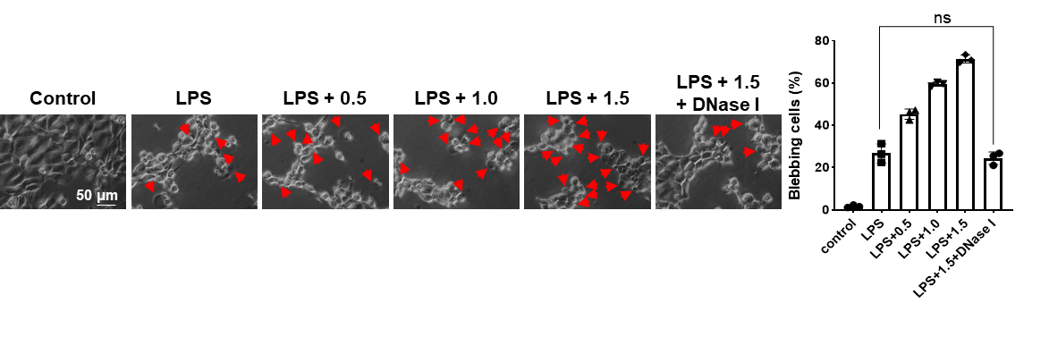
Figure S1. Phase-contrast microscopy demonstrated a dose-dependent increase in pyroptotic features (red arrows) in NCM460 cells as NET concentrations increased.‌ NET concentrations are shown as DNA concentration (μg/mL). Scale bar: 50 μm. n = 3. Statistical analysis was performed using one-way ANOVA with the Tukey test. All data are expressed as mean ± SD. ^{ns} p > 0.05, *p < 0.05, **p < 0.01, ***p< 0.001, ****p < 0.0001.
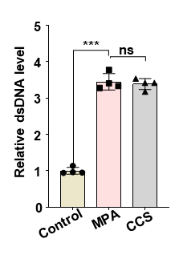
Figure S2. Relative levels of dsDNA in cell supernatants. The dsDNA levels were normalized to those in the control group. Data are presented as mean ± SD (n = 4). Statistical analysis was performed using one-way ANOVA with the Tukey test. ^{ns} p > 0.05, ***p< 0.001.

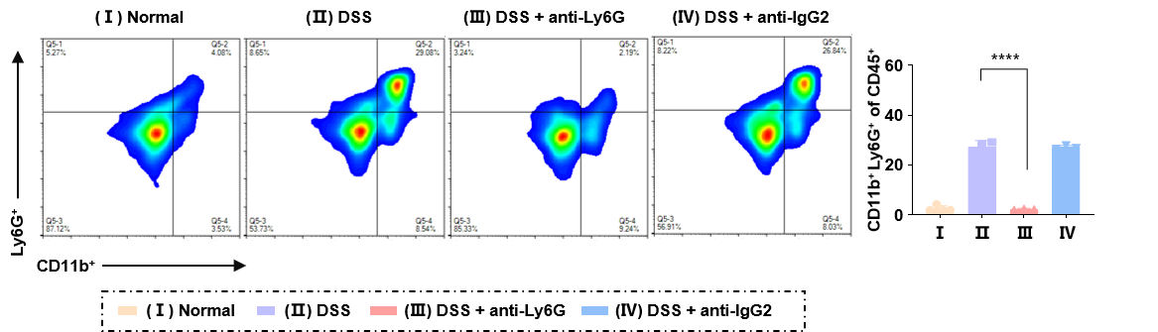
Figure S3. Representative FCM images and corresponding quantitative results of neutrophils in colonic tissues. CD45⁺CD11b⁺Ly6G⁺ cells were identified as neutrophils via flow cytometry. n = 3. Statistical analysis was performed using one-way ANOVA with the Tukey test. All data are expressed as mean ± SD. ^{ns} p > 0.05, *p < 0.05, **p < 0.01, ***p< 0.001, ****p < 0.0001.
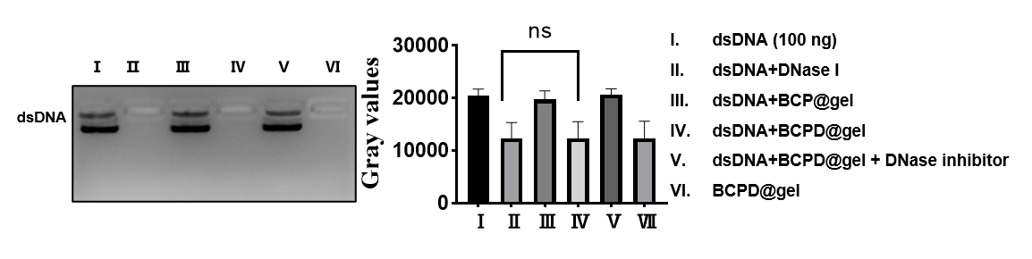
Figure S4. Representative agarose gel electrophoresis of DNase I activity. Double-stranded DNA (dsDNA, 100 ng per lane) was separated by 3% agarose gel electrophoresis at 120 V for 45 min.

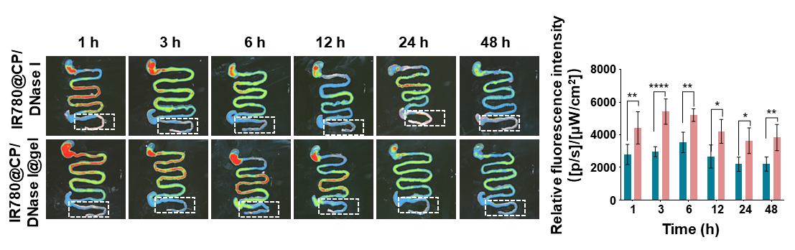
Figure S5. Quantitative analysis of intestinal retention and relative fluorescence intensity within 48 h post oral administration of IR780@CP/DNase I microspheres and IR780@CP/DNase I@gel in healthy mice. All data were expressed as mean ± SD. Statistical analysis was performed using Student’s t-test. *p< 0.05, **p < 0.01, ***p< 0.001, ****p < 0.0001.
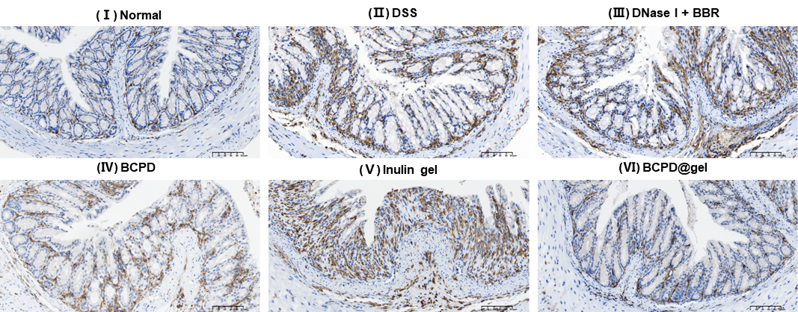
Figure S6. Representative IHC staining of colon sections. Macrophages (F4/80, brown), nucleus (hematoxylin, blue). Scale bar: 100 μm. n = 3.
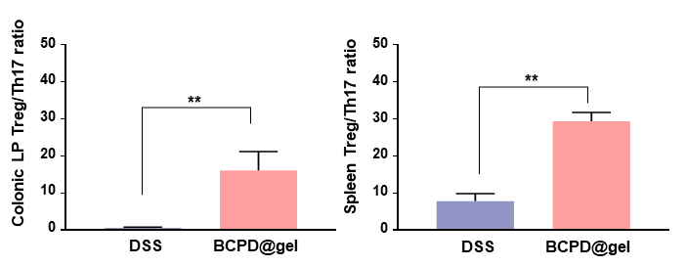
Figure S7. The ratio of Treg/Th17 in colonic LP and spleen. n = 3. All data were expressed as mean ± SD. Statistical analysis was performed using Student’s t-test. *p < 0.05, **p < 0.01, ***p< 0.001, ****p < 0.0001.

