Hydrogen peroxide self-supplied nanozyme system for synergistic prostate cancer therapy via ferroptosis/pyroptosis and Ca²⁺ overload-induced apoptosis
Sixu Chen^{1†}, Linnan Yang^{1,2†}, Peng Wang^{3†}, Chenghao Wen^{4†}, Zhaoxu Shi¹, Rui Tan¹, Wenrui Guan¹, Guowen Jiang¹, Pengfei Zhang¹, Chaozhao Liang¹, Xianwen Wang⁵, Yunjiao Zhang^{6*}, Guilong Zhang^{3*}, Li Zhang^{1,2,5*}

¹ Department of Urology, the First Affiliated Hospital of Anhui Medical University, Anhui Province Key Laboratory of Urological and Andrological Diseases Research and Medical Transformation, Hefei 230022, China.
² Center for Scientific Research of the First Affiliated Hospital of Anhui Medical University, Hefei 230088, China.
³ School of Pharmacy, Shandong Technology Innovation Center of Molecular Targeting and Intelligent Diagnosis and Treatment, Shandong Medical and Pharmaceutical University, Yantai 264003, China.
⁴ Department of Urology, The Second People's Hospital of Hefei, Hefei 230011, China.
⁵ School of Biomedical Engineering, Anhui Medical University, Hefei 230032, China.
⁶ School of Medicine, South China University of Technology, Guangzhou 510006, China.

*Correspondence:
zhangyunjiao@scut.edu.cn (Yunjiao Zhang), glzhang@bzmc.edu.cn (Guilong Zhang), lzhang@ahmu.edu.cn (Li Zhang).
† These authors contributed equally to this work.

Supplementary Methods
Ion release profiles
PFCB was dispersed in phosphate buffer solutions at pH 5.5, 6.5, and 7.4, respectively, and incubated at 37 °C with gentle shaking. At predetermined time points of 6 h, 12 h, and 24 h, the suspension was collected and centrifuged at 12,000 rpm for 5 min. The supernatant was subsequently analyzed by ICP-MS to quantify the released Fe and Ca ions.

Lysosomes disruption assay
Lysosomes disruption was assessed using acridine orange (AO) staining. Following seeding onto 24-well plates (1 × 10⁵ cells per well), PC-3 cells were incubated overnight. Afterward, cells were treated with Fe₃O₄, FC, FCB, or PFCB at equivalent concentrations (Fe: 25 μg/mL) for 24 h. PC-3 cells were then washed twice with PBS and incubated with AO (5 μM) for 20 min in dark. After incubation, the cells were washed twice with PBS followed by fresh PBS supplement. The images were documented by using the fluorescence microscope (IX73, Olympus, Japan).

Survival analysis in tumor-bearing mice
To establish the murine prostate cancer model, 8 × 10⁵ RM-1 cells resuspended in 100 μL sterile PBS were subcutaneously injected into the right flank of each male C57BL/6J mouse. When the tumor volume reached approximately 200 mm³, the mice were randomly divided into five groups and intravenously injected with normal saline (NS) or Fe₃O₄, FC, FCB, and PFCB at equivalent ion concentration (Fe: 10 mg/kg), respectively. The treatments were administered every 2 days for a total of four injections. After the fourth injection on Day 6, each administration was discontinued, and tumor volumes were continuously measured every 2 days until Day 20. Tumor length and width were measured using precision digital calipers, and tumor volume was calculated according to the formula: volume = 0.5 × length × width². For survival rate analysis, mice were continuously monitored after treatment. When the tumor volume reached 1500 mm³, the mouse was considered to have reached the humane endpoint and humane euthanasia was performed. The survival rates of mice were recorded until Day 20, starting from the first treatment at Day 0.

Hemolysis assay
Hemolytic activity of PFCB was evaluated by monitoring the hemoglobin release from mouse red blood cells (RBCs). RBCs isolated from C57BL/6J mice were diluted with PBS to form a suspension. Various doses of PFCB, dispersed in PBS, were added to the RBC suspension to achieve the predetermined concentrations (Fe: 6.25, 12.5, 25, 50 μg/mL). Following a 6-hour incubation at room temperature, the samples were centrifuged at 12,000 × g for 5 min. PBS and deionized water were used as negative and positive controls, respectively. The optical density (OD) of the supernatants was measured at 545 nm by using the microplate reader (Infinite M Nano, Tecan, Switzerland).

In vivo biocompatibility evaluation
Biochemical markers that serve as indicators of hepatic and renal function underwent quantitative analyses utilizing the automated biochemical analyzer (Chemray 420, Rayto Life, China). Once major organ specimens had been harvested from the mice received corresponding treatments, they were immediately subjected to a standardized histological workflow. For the purpose of histopathological evaluation, these as-prepared tissue sections were examined with a digital slide scanning system (KF-PRO-005-EX, Konfoong, China).

Supplemental Table
Table S1. The main materials and agents used in the experiments.
Materials | Catalog number | Company
Ferric acetylacetonate | 14024-18-1 | Chemical Book  (Wuhan, China)
Ethylene glycol | ZY131118 | ZYBio  (Shanghai, China)
Diethylene glycol | D110833 | Aladdin  (Shanghai, China)
Sodium acrylate | S742463 | Macklin  (Shanghai, China)
Anhydrous ethanol | E708068 | Macklin  (Shanghai, China)
H₂O₂ | H112519 | Aladdin  (Shanghai, China)
Glacial acetic acid | A433222 | Aladdin  (Shanghai, China)
Sodium acetate | S431676 | Aladdin  (Shanghai, China)
Methanol | 67-56-1 | YongDa  (Tianjin, China)
Trichloromethane | 67-66-3 | ZhanYun  (Wuxi, China)
Calcium chloride | C805225 | Macklin  (Shanghai, China)
PEG 200 | P3015 | SigmaAldrich  (Shanghai, China)
DSPE-PEG-NH2 | - | Macklin  (Shanghai, China)
Ammonia water | A291779 | Aladdin  (Shanghai, China)
BzATP | HY-18745 | MedChemExpress (Shanghai, China)
TMB | T100416 | Aladdin  (Shanghai, China)
MB | M13438 | Aladdin  (Shanghai, China)
PC-3 cells | CL-0185 | Pricella Biotechnology  (Wuhan, China)
Fetal bovine serum | C04001 | VivaCell  (Shanghai, China)
RPMI-1640 medium | A1049101 | GlpBio  (Gaithersburg, USA)
RM-1 cells | CL-0198 | Pricella  (Wuhan, China)
DMEM medium | PM150210B | Pricella  (Wuhan, China)
Trypsin | C0203 | Beyotime  (Jiangsu, China)
Penicillin/streptomycin | C0222 | Beyotime  (Jiangsu, China)
MTT | E-CK-A341 | Elabscience  (Wuhan, China)
DMSO | D8372 | Chemical Book  (Wuhan, China)
Anti-GAPDH antibody | AF7021 | Affinity  (Jiangsu, China)
Anti-β-actin antibody | 20536-1-AP | Proteintech  (Wuhan, China)
Anti-GPX4 antibody | ab125066 | Abcam  (London, UK)
Anti-pro-caspase-1 antibody | 31020-1-AP | Proteintech  (Wuhan, China)
Anti-cleaved caspase-1 antibody | 22915-1-AP | Proteintech  (Wuhan, China)
Anti-pro-IL-1β antibody | 16806-1-AP | Proteintech  (Wuhan, China)
Anti-IL-1β antibody | ab254360 | Abcam  (London, UK)
Anti-GSDMD antibody | ER1901-37 | Huabio  (Wuhan, China)
Anti-Bax antibody | 50599-2-Ig | Proteintech  (Wuhan, China)
Anti-Bcl-2 antibody | 12789-1-AP | Proteintech  (Wuhan, China)
Anti-pro-caspase-3 antibody | AF1261 | Beyotime  (Jiangsu, China)
Anti-cleaved caspase-3 antibody | AC033 | Beyotime  (Jiangsu, China)
HRP-conjugated goat anti-rabbit IgG | SA00001-2 | Proteintech  (Wuhan, China)
Anti-cleaved caspase-3 antibody  for IHC | GB11532-50 | Servicebio  (Wuhan, China)
Anti-GPX4 antibody  for IHC | GB115275-50 | Servicebio  (Wuhan, China)
Anti-GSDMD N-terminal antibody  for IHC | DF13758 | Affinity  (Jiangsu, China)
One-step color PAGE gel rapid preparation kit | PG214 | Epizyme  (Shanghai, China)
Ultra High Sensitivity ECL | GK1008 | GlpBio  (Montclair, USA)
BCA protein assay kit | C503021 | Sangon Biotech  (Shanghai, China)
GSH/GSSG colorimetric assay kit | E-BC-K097-M | Elabscience  (Wuhan, China)
GPX4 activity assay kit | E-BC-K883-M | Elabscience  (Wuhan, China)
MDA colorimetric assay kit | E-BC-K025-M | Elabscience  (Wuhan, China)
Acridine orange hydrochloride | HY-101896 | MedChemExpress  (Shanghai, China)
DCFH-DA | S1105S | Beyotime  (Jiangsu, China)
C11-BODIPY^{581/591} | GC40165 | GlpBio  (Montclair, USA)
Cytotoxicity LDH assay kit | GK10003 | GlpBio  (Montclair, USA)
Human IL-1β ELISA kit | E-HSEL-H0001 | Elabscience  (Wuhan, China)
Human HMGB-1 ELISA kit | E-EL-H1554 | Elabscience  (Wuhan, China)
Fluo-4 AM | 273221-67-3 | MedChemExpress (Shanghai, China)
Mitochondrial membrane potential assay kit (JC-1) | E-CK-A301 | Elabscience  (Wuhan, China)
Annexin V-FITC/PI apoptosis kit | E-CK-A211 | Elabscience  (Wuhan, China)
RWPE-1 cells | CL-0200 | Pricella  (Wuhan, China)
Recombinant human epidermal growth factor | 105-04 | Sciencell  (California, USA)
Keratinocyte Medium | 2101 | Sciencell  (California, USA)
Isopropyl alcohol (IPA) | I766839 | Macklin  (Shanghai, China)
Tert-butyl alcohol (TBA) | T819473 | Macklin  (Shanghai, China)

Supplemental Figures
Fig. S1 Full XPS spectrum of FC.
Fig. S2 Non-linear least squares fitting (NLLSF) analysis of Fe 2p XPS spectrum of FC.

Fig. S3 Release profiles of Fe (A) and Ca (B) ions from PFCB after incubation in phosphate buffer at pH 5.5, 6.5, and 7.4 for indicated time points (n = 3). The mean values are shown and error bars represent ± SD.

Fig. S4 Schematic illustration of the POD-like activities exhibited by PFCB.

Fig. S5 Levels of GSH (A) and GSSG (B) in PC-3 cells treated with different nanoparticles (n = 5). The mean values are shown and error bars represent ± SD.

Fig. S6 Fluorescent intensities of PC-3 cells stained with DCFH-DA after treatment with different nanoparticles.
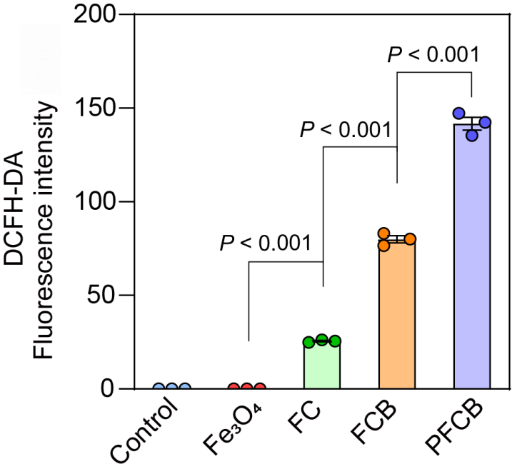
Fig. S7 The corresponding quantification of DCFH-DA fluorescent intensities in Fig. 3O (n = 3). The mean values are shown and error bars represent ± SD.

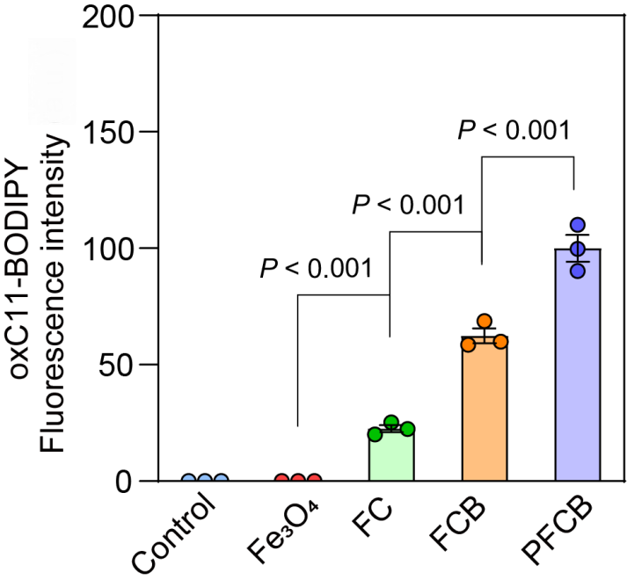
Fig. S8 The corresponding quantification of oxC11-BODIPY fluorescent intensities in Fig. 3P (n = 3). The mean values are shown and error bars represent ± SD.
Fig. S9 Fluorescent microscopy images of RWPE-1 cells stained with C11-BODIPY^{581/591} probe after treatment with Fe₃O₄, FC, FCB, and PFCB (equivalent Fe concentration of 25 μg/mL). Scale bars, 100 μm.

Fig. S10 Fluorescent images of PC-3 cells stained with AO after treatment with different nanoparticles. Scale bars, 20 μm.

Fig. S11 Representative bright-field microscopy images of RWPE-1 cells after treatment with Fe₃O₄, FC, FCB, and PFCB (equivalent Fe concentration of 25 μg/mL). Scale bars, 20 μm.

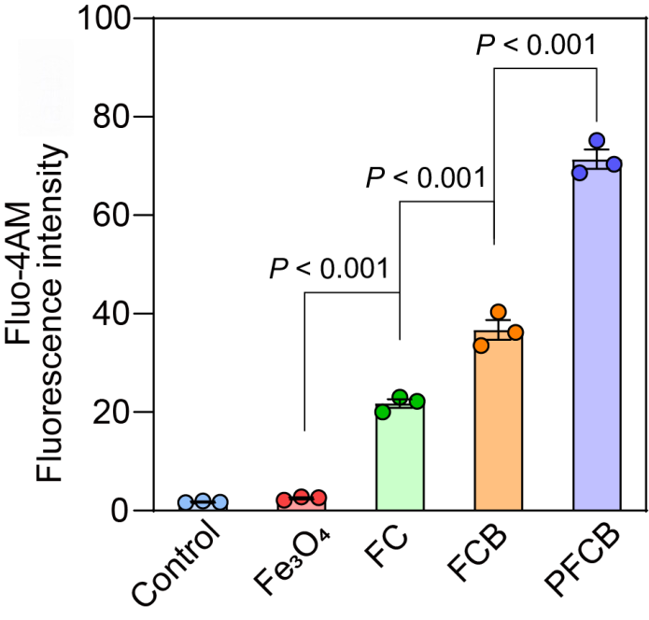
Fig. S12 The corresponding quantification of Fluo-4 AM fluorescent intensities in Fig. 5A (n = 3). The mean values are shown and error bars represent ± SD.

Fig. S13 Survival analysis of RM-1 tumor-bearing mice. (A) Schematic illustration of the treatment schedule for RM-1 tumor-bearing mice. Upon the tumor volume reaching around 200 mm³, mice were randomly separated into five groups and treated with NS, Fe₃O₄, FC, FCB, and PFCB (equivalent Fe concentration of 10 mg/kg for the latter four groups). All therapeutic agents were intravenously injected every two days for a total of four injections, after which treatment was discontinued and the mice were continuously observed until Day 20. (B) Survival rates of RM-1 tumor-bearing mice received aforementioned treatments (n = 5).

Fig. S14 Hemolysis rate analysis of PFCB. Absorbance of blood supernatants at 545 nm after incubation with various concentrations of PFCB (equivalent Fe concentration of 6.25, 12.5, 25 and 50 μg/mL, respectively) for 6 h (A) and the corresponding calculation of the hemolysis rate (B) (n = 5). The mean values are shown and error bars represent ± SD. P ≥ 0.05 was considered not statistically significant (ns).

Fig. S15 Histopathological examination of the major organs from tumor-bearing mice after intravenous injection of normal saline (NS), Fe₃O₄, FC, FCB and PFCB (equivalent Fe concentration of 10 mg/kg for the latter four groups) for 8 d. Scale bars, 200 μm.

Fig. S16 Biocompatibility profile of Fe₃O₄, FC, FCB and PFCB. (A-D) Liver and renal function of tumor-bearing mice after intravenous injection of NS, Fe₃O₄, FC, FCB and PFCB (equivalent Fe concentration of 10 mg/kg for the latter four groups) for 8 d, which was assessed by alanine aminotransferase (ALT) (A), aspartate aminotransferase (AST) (B), blood urea nitrogen (BUN) (C) and creatinine (CREA) (D) (n = 5). The mean values are shown and error bars represent ± SD. P ≥ 0.05 was considered not statistically significant (ns).

