Additional file 2: Supplementary materials

Effects and Mechanism of Carrier-Free Self-Assembled Nanoparticles of Natural Products in Attenuating Pulmonary Edema

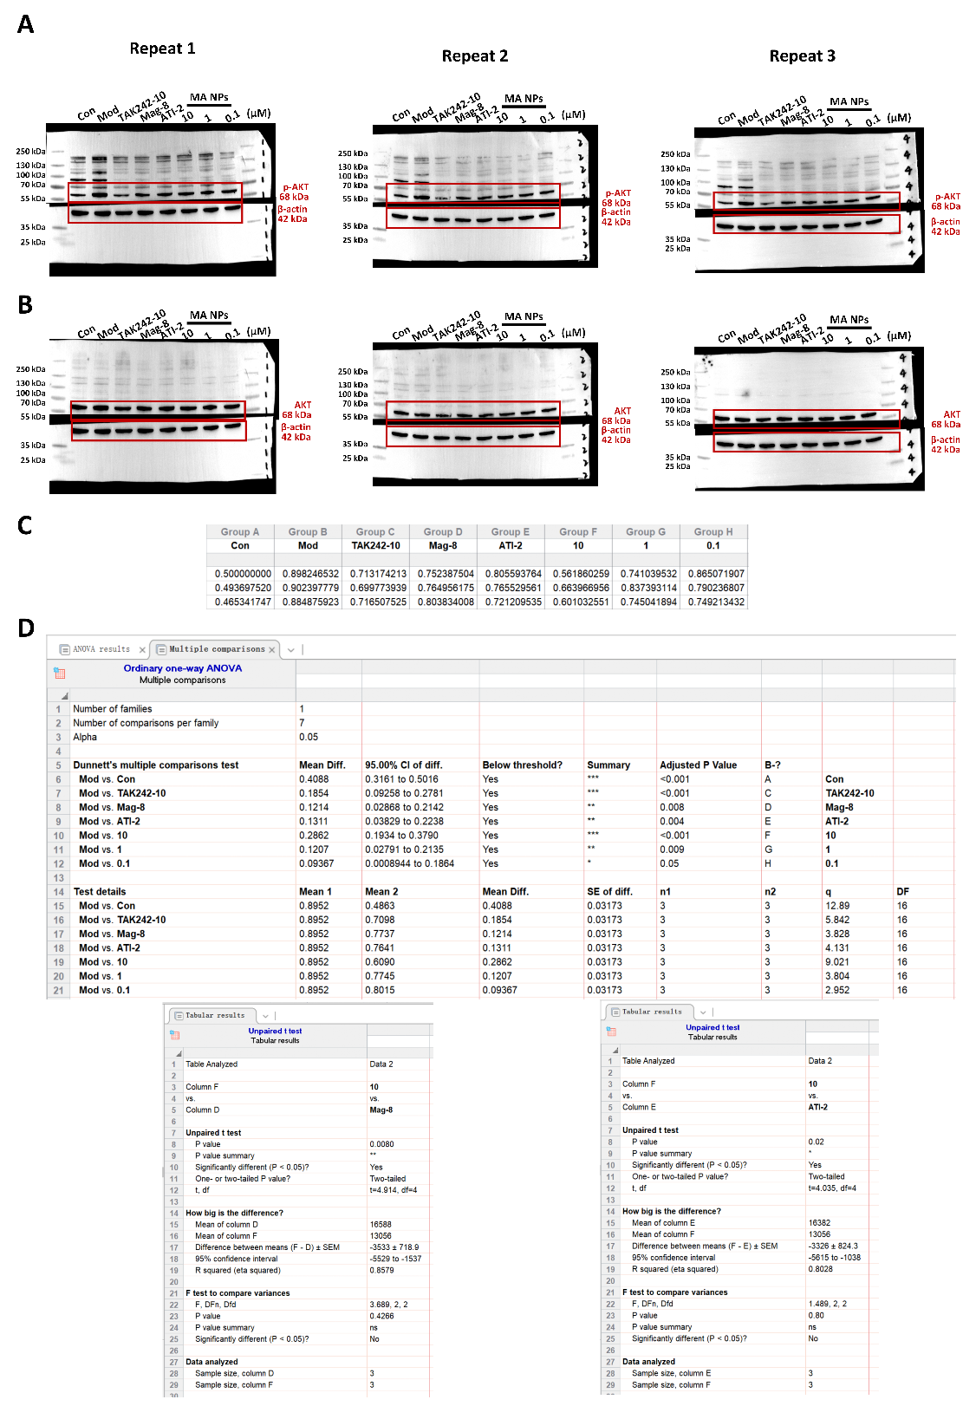
Description on Western Blotting imaging, use of markers and statistical method
In this section, we have provided all the original blots. Each experiment was repeated three times. We have marked the molecular weight markers on the Western blotting images in the final figures of the manuscript. The molecular weight marker that we have used in the current study was purchased from Thermo Fisher Scientific (Cat. 26616/26619, Shanghai, China). We have used the Chemiluminescence imaging system (Cat. Tanon-5200, Shanghai, China). Image software was used for all sensitivity analysis, and we adopt the relative quantitative statistics and normalized the value.

Fig. 6D-S. (A) Full-size Western blot images of p-AKT and the respective images of β-actin, used as the loading control. (B) Full-size Western blot images of AKT and the respective images of β-actin, used as the loading control. The “Repeat 1” was used in Fig. 6D of the manuscript. (C) The quantitative analysis of grayscale values of the bands in (A) by image software. (D) The result of statistical tests.
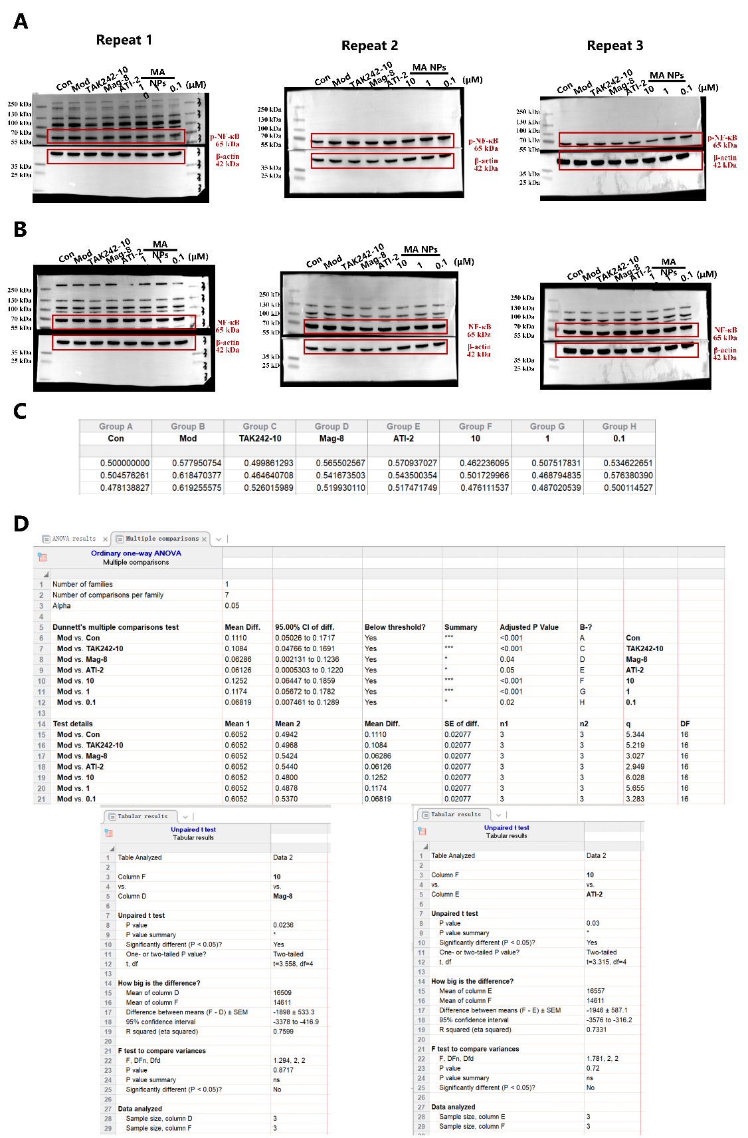
Fig. 6E-S. (A) Full-size Western blot images of p-NF-κB and the respective images of β-actin, used as the loading control. (B) Full-size Western blot images of NF-κB and the respective images of β-actin, used as the loading control. The “Repeat 1” was used in Fig. 6E of the manuscript. (C) The quantitative analysis of the ratios of grayscale values of p-NF-κB /NF-κB by image software. (D) The result of statistical tests.
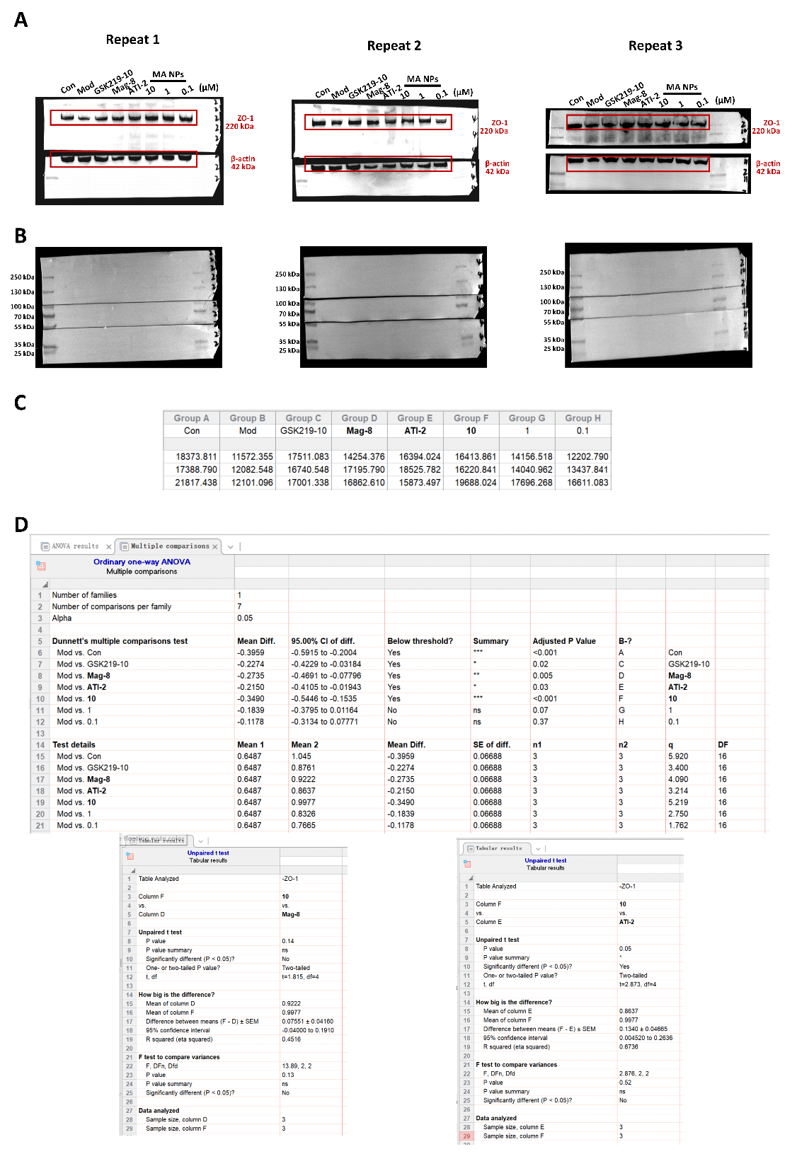
Fig. 7D-S. (A) Western blot images of ZO-1 and the respective images of β-actin, used as the loading control. (B) Full-size Western blot images. The “Repeat 1” was used in Fig. 7D of the manuscript. (C) The quantitative analysis of the ratios of grayscale values of ZO-1by image software. (D) The result of statistical tests.

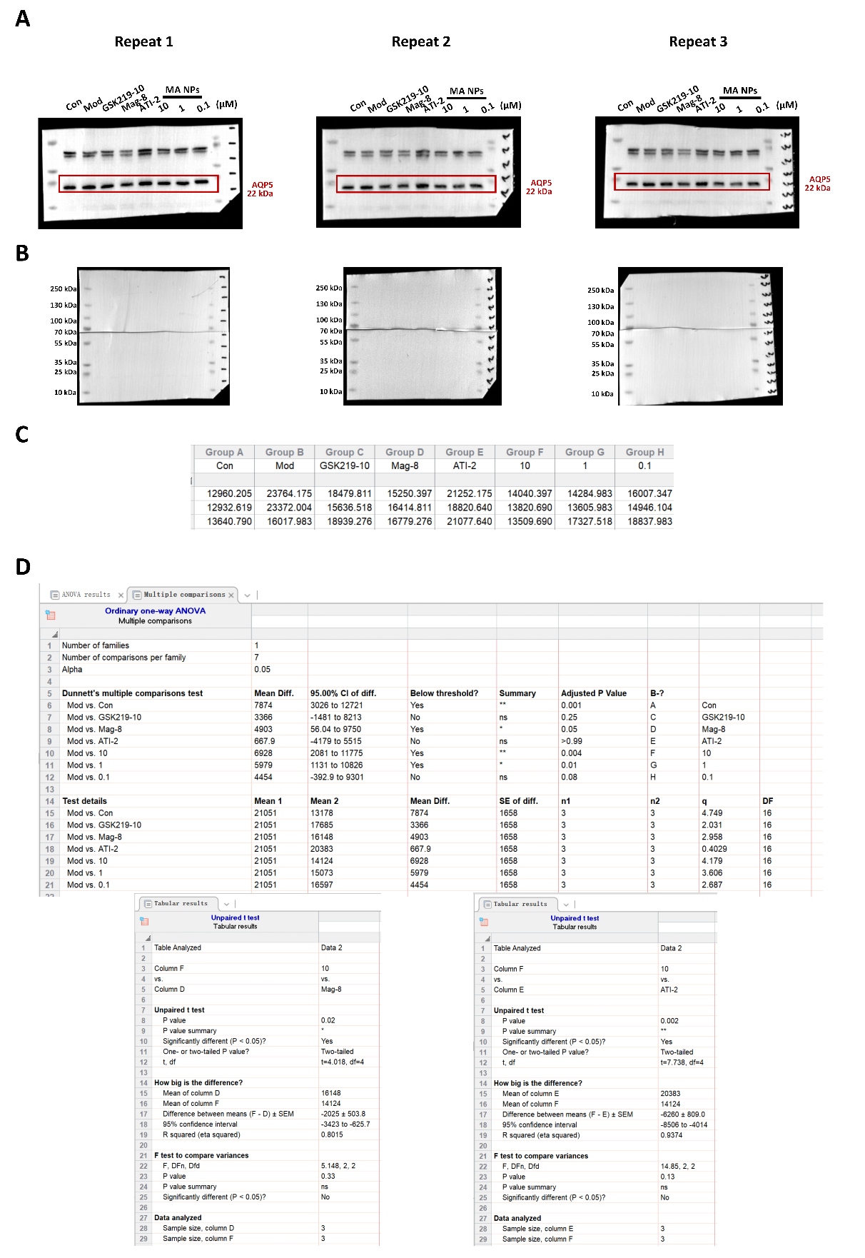
Fig. 8E-S. (A) Western blot images of AQP5. (B) Full-size Western blot images. The “Repeat 1” was used in Fig. 8E of the manuscript. (C) The quantitative analysis of the ratios of grayscale values of AQP5by image software. (D) The result of statistical tests.

