Additional file 1: Supplementary materials

Effects and Mechanism of Carrier-Free Self-Assembled Nanoparticles of Natural Products in Attenuating Pulmonary Edema

Jin Yan¹, Kaixin Liu¹, Yuqi Yan¹, Zhenzhen Wang¹, Junfang Wang¹, Yingbo Wang¹, Yuanyuan Hou¹, Erwei Hao², Xiaotao Hou²*, Jie Gao¹*, Gang Bai¹*

- State Key Laboratory of Medicinal Chemical Biology, College of Pharmacy and Tianjin Key Laboratory of Molecular Drug Research, Nankai University, Tianjin 300350, China
- Guangxi Key Laboratory of Efficacy Study on Chinese Materia Medica, Guangxi University of Chinese Medicine, Nanning 530200, China

1. Synthesis and identification of Al-Mag and Ve-ATI Probes
Magnolol (266.3 mg, 1.5 mmol) and sodium bicarbonate (252.0 mg, 3.0 mmol) were added to dry N,N-dimethylformamide (5 mL). The mixture was cooled in an ice bath, and propargyl bromide (181.95 mg, 1.5 mmol) was added dropwise. After the addition, the ice bath was removed. The reaction mixture was stirred at room temperature and monitored by TLC, reaching completion in 12 hours. The mixture was then acidified with 1 mol/L hydrochloric acid and extracted with dichloromethane. The aqueous layer was extracted twice with dichloromethane. The combined organic layers were dried over anhydrous sodium sulfate and concentrated under reduced pressure to obtain the crude product. Then, the probe Mag modified with alkyne (Al-Mag) was obtained by column chromatography, appearing as a brown oily substance (243.7 mg, 79%).
Proton NMR results: ¹H NMR (400 MHz, CDCl₃) δ 7.19 (dd, J = 8.4, 2.3 Hz, 1H), 7.14 (d, J = 2.3 Hz, 1H), 7.12 - 7.07 (m, 2H), 7.04 (d, J = 2.3 Hz, 1H), 6.93 (d, J = 8.2 Hz, 1H), 6.07 - 5.87 (m, 2H), 5.28 - 4.87 (m, 4H), 4.67 (d, J = 2.4 Hz, 2H), 3.38 (d, J = 6.6 Hz, 2H), 3.36 (d, J = 6.7 Hz, 2H), 2.51 (t, J = 2.4 Hz, 1H).The synthesis route is provided in Fig. S1A, and the NMR results are presented in Fig. S1B.
Fig. S1 Synthesis and identification of Al-Mag. (A) Synthesis route of Al-Mag. (B) NMR Spectrum of Al-Mag.

The synthesis of Ve-ATI is provided in Fig. S2A. First, the starting material ATI (1.0 g, 4.34 mmol) is dissolved in 1,4-dioxane (22 mL), and selenium dioxide (SeO₂, 481.83 mg, 4.34 mmol) is added at 60°C. After the reaction is complete, the product, an allylic alcohol intermediate (product 1), is isolated by column chromatography. Next, n-butyl vinyl ether (1.5 g, 12.9 mmol) reacts with p-toluenesulfonyl chloride (TsCl, 2.457 g, 12.9 mmol) under nitrogen protection, with triethylamine (Et₃N, 2.61 g, 25.8 mmol) and catalytic 4-dimethylaminopyridine (DMAP, 0.316 g, 2.6 mmol) added, and stirred at room temperature overnight. After purification by column chromatography, the sulfonate intermediate (product 2) is obtained. Finally, product 1 (826 mg, 3.35 mmol), product 2 (2.438 g, 10.06 mmol), cesium carbonate (Cs₂CO₃, 4.37 g, 13.41 mmol), and potassium carbonate (K₂CO₃, 1.719 g, 13.41 mmol) are dissolved together in DMF and reacted at 80°C overnight. The reaction mixture is purified by column chromatography to ultimately yield the target compound vinyl ether-modified ATI (Ve-ATI) probe, and the NMR results are presented in Fig. S2B.
Proton NMR results: ¹H NMR (400 MHz, CDCl₃) δ 8.15 - 8.02 (m, 4H), 7.26 (s, 5H), 6.56 -6.45 (m, 1H), 5.67 (d, J = 4.7 Hz, 2H), 5.41 (d, J = 4.6 Hz, 1H), 5.02 - 4.96 (m, 1H), 4.57 (q, J = 4.7 Hz, 2H), 4.23 (ddd, J = 14.0, 4.7, 2.4 Hz, 1H), 4.07 (ddd, J = 7.5, 4.9, 2.5 Hz, 1H), 4.02 (q, J = 4.7 Hz, 2H), 3.49 (d, J = 5.1 Hz, 6H), 2.82 (d, J = 13.6 Hz, 1H), 2.72 (dt, J = 17.0, 4.3 Hz, 1H), 2.54 (t, J = 15.5 Hz, 1H), 2.13 - 2.04 (m, 2H), 2.04 (s, 1H), 1.94 - 1.88 (m, 3H), 1.43 (d, J = 5.3 Hz, 1H), 1.36 - 1.22 (m, 4H), 1.01 (d, J = 4.6 Hz, 3H), 0.86 (s, 1H).
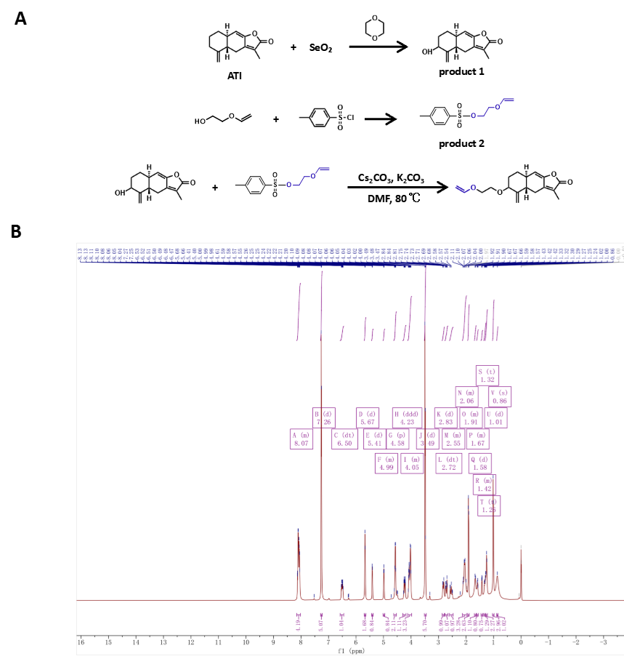

Fig. S2 Synthesis and identification of Ve-ATI Probe. (A) Synthesis route of Ve-ATI. (B) NMR Spectrum of Ve-ATI.
2. Histopathological scoring for H&E-stained sections
Histologic lung injury score (H&E; 0–5) was adapted from Szapiel [1] (alveolitis/inflammation) and Ashcroft [2] (fibrosis/architectural remodeling). Scoring integrates (i) severity and extent of interstitial/alveolar inflammation, (ii) degree of fibrosis and structural distortion, and (iii) estimated percent parenchyma involved.
0 (Normal): Preserved alveolar architecture; thin, uniform septa; no relevant inflammatory infiltrates; no septal expansion, fibrosis, or distortion.
1 (Minimal, <10%): Focal mild perivascular/peribronchiolar cuffing (typically ≤1–2 cell layers) and/or scattered interstitial inflammatory cells; focal mild septal thickening; no definite fibrotic bands or architectural damage.
2 (Mild, 10–25%): Multifocal interstitial inflammation with more consistent septal thickening; overall architecture largely preserved; early repair changes (focal fibroblast proliferation and/or pale extracellular matrix) without well-formed fibrotic bundles.
3 (Moderate, 26–50%): Patchy to near-diffuse alveolitis/interstitial inflammation with marked septal thickening; may show intra-alveolar exudate and increased macrophages, focal consolidation or collapse; definite fibrotic foci/bands with mild–moderate architectural distortion.
4 (Severe, 51–75%): Diffuse or confluent disease with prominent inflammation and widened interstitium; extensive consolidation/collapse with remodeling; broad fibrotic bands and clear structural disruption, with bronchiolization and/or early honeycomb/traction-type changes.
5 (End-stage, >75%): Predominant dense fibrosis with near-complete remodeling and alveolar obliteration; scar-like parenchyma with overt honeycombing and marked distortion; inflammatory activity may be variable but fibrosis dominates.

3. In vitro synergistic effect and cytotoxicity of Mag and ATI
To systematically evaluate the potential synergy between Mag and ATI, a dose matrix of Mag and ATI at concentrations of 8, 4, 2, 1 μM was designed for each drug, yielding various molar ratios. The combination effects on the inhibition of TNF‑α, IL‑1β, and IL‑6 release, as well as the protection of transepithelial electrical resistance (TEER), were assessed in LPS‑treated MLE‑12 cells. The combination index (CI) values were calculated using the Chou‑Talalay method. As shown in Fig. S3A–D, CI values were below 1 for both the 8 μM + 2 μM and 4 μM + 1 μM combinations (both giving a 4:1 molar ratio) across all tested indicators, formally confirming a synergistic effect at these ratios.
Cytotoxicity was evaluated in preliminary experiments by CCK‑8 assay in MLE‑12 cells treated with Mag or ATI (0.1–100 μM) for 24 h. As shown in Fig. S3E and F, neither compound exhibited significant cytotoxicity across the entire concentration range, and the highest concentrations used in subsequent functional assays (Mag 8 μM, ATI 2 μM, and MA NPs 10 μM) all fell within this safe range.
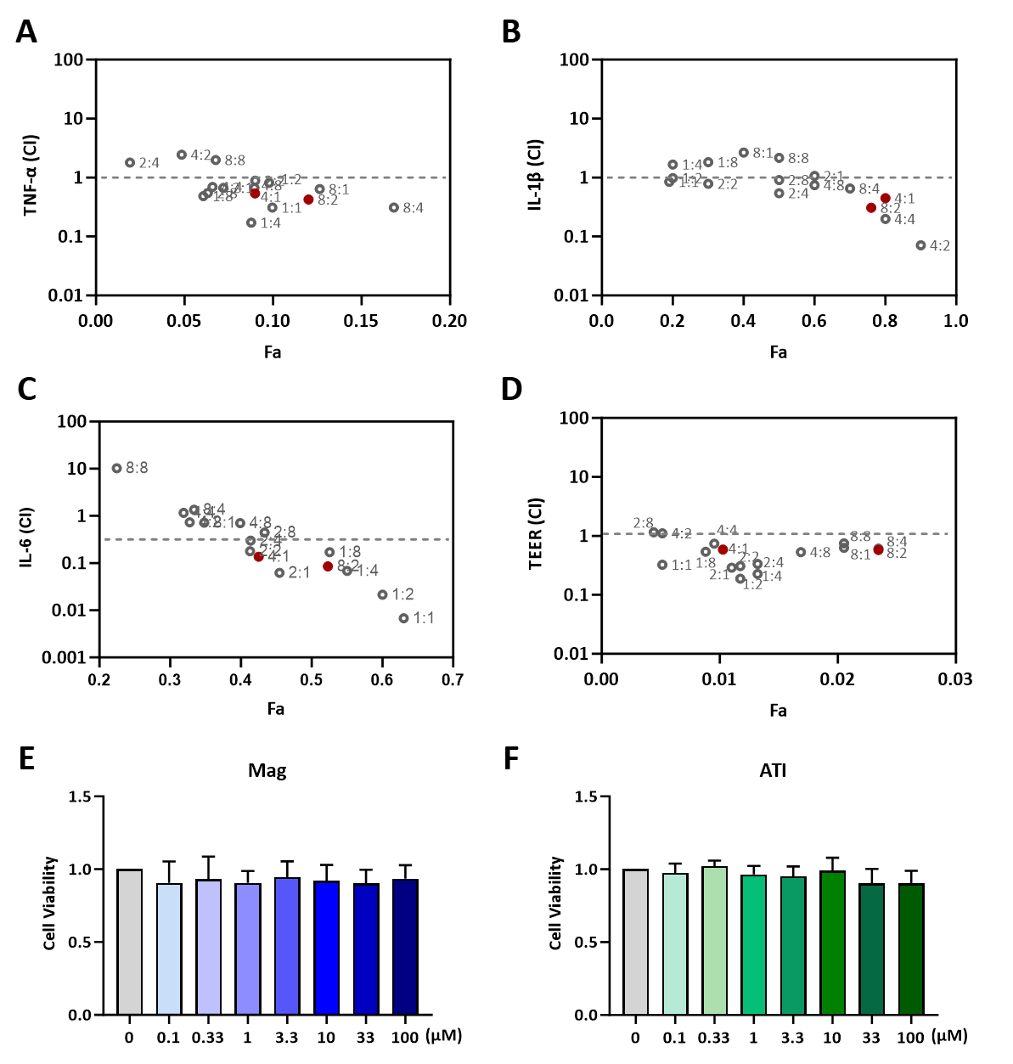
Fig. S3 In vitro synergy effect and cytotoxicity of Mag and ATI. (A–C) CI values for the inhibition of TNF‑α, IL‑1β, and IL‑6 release. (D) CI values for TEER protection. CI < 1 indicates synergy. [The red dots indicate the combination ratios of Mag:ATI = 8 μM:2 μM (4:1) and 4 μM:1 μM (4:1)] (E) Cytotoxicity evaluation of Mag in MLE‑12 cells by CCK‑8 assay. (F) Cytotoxicity evaluation of ATI in MLE‑12 cells by CCK‑8 assay (n=3).

4. Drug loading parameters and structural confirmation of MA NPs
To clarify the composition of MA NPs, we determined the drug loading of MA NPs. After removal of free drugs by ultrafiltration, the nanoparticles were lyophilized and weighed, and the drug content was analyzed by HPLC. The drug loading (DL%) and encapsulation efficiency (EE%) of MA NPs were calculated according to previously reported methods [3,4]. The drug loading (DL%) of Mag and ATI in MA NPs was calculated as the mass percentage of each drug relative to the total mass of the nanoparticles.
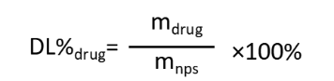
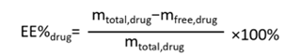
where m_{free,drug} is the mass of drug in the supernatant after ultrafiltration, m_{total,drug} is the total mass of drug added during preparation, m_{NPs} is the mass of lyophilized nanoparticles, m_{drug} is the mass of drug in the lyophilized nanoparticles.
The results showed that the mass percentages of Mag and ATI in MA NPs were 81.7 ± 0.356% and 18.2 ± 0.129%, respectively, giving a total drug loading of 100%. This value far exceeds the typical drug loading of conventional polymeric nanoparticles, which is generally below 10 wt% as summarized in a recent review [5], clearly supporting the claim of “ultrahigh drug loading”. While the encapsulation efficiencies were 97.6 ± 0.658% and 97.9 ± 1.43%, respectively (Table. S1).

Table. S1 Drug loading parameters of Mag and ATI
Drug loading parameters | Mag | ATI
quality of the feed material | 8.32 mg | 1.84 mg
quality of nanoparticles | 9.921±0.061 mg
quality within nanoparticles | 8.119 ± 0.05471 mg | 1.802 ± 0.02633 mg
drug loading (DL%) | 81.7 ± 0.356% | 18.2 ± 0.129%
encapsulation efficiency (EE%) | 97.6 ± 0.658% | 97.9 ± 1.43%

5. MA NPs maintain structural integrity and colloidal stability in protein-containing biological fluids
When nanoparticles are exposed to protein‑containing biological fluids, a protein corona rapidly forms on their surface, altering their size, surface charge, and colloidal stability in protein‑containing media [6,7]. To evaluate the structural integrity of MA NPs in a protein‑rich environment, complementary characterizations were performed from two perspectives: release kinetics and colloidal stability. The time‑dependent drug release profiles of MA NPs in biologically relevant media, including PBS and serum, were first compared. As shown in Fig. S4A, the drug release rate of MA NPs in PBS showed no difference from that in water. In contrast, the drug release rate of MA NPs in medium containing 50% FBS was significantly slower than that in PBS (0.5–12 h). If the co‑assembled structure had disintegrated, a burst release would have been observed [8]. The observed retardation of release instead indicates the formation of a physical barrier by the protein corona on the nanoparticle surface, ruling out structural disintegration and directly supporting the integrity of the co‑assembled structure. The size and zeta potential changes of MA NPs during 24 h of incubation in mouse serum and bronchoalveolar lavage fluid (BALF) were further monitored (Fig. S4B, C). In the initial period (0–30 min) after exposure to serum or BALF, a slight decrease in size and a reduction in absolute zeta potential were observed, which are classic features of rapid protein corona formation [9]. In serum, MA NPs exhibited significant aggregation after 2 h (reaching micron scale at 4 h). In BALF, the nanoparticles showed only minor fluctuations, and the size returned to approximately 305 nm at 24 h, close to the initial level. Together, the release kinetics and particle size data suggest that MA NPs form a stable protein corona and maintain co‑assembled structural integrity in protein‑containing physiological environments, supporting the rationale of the formulation design.
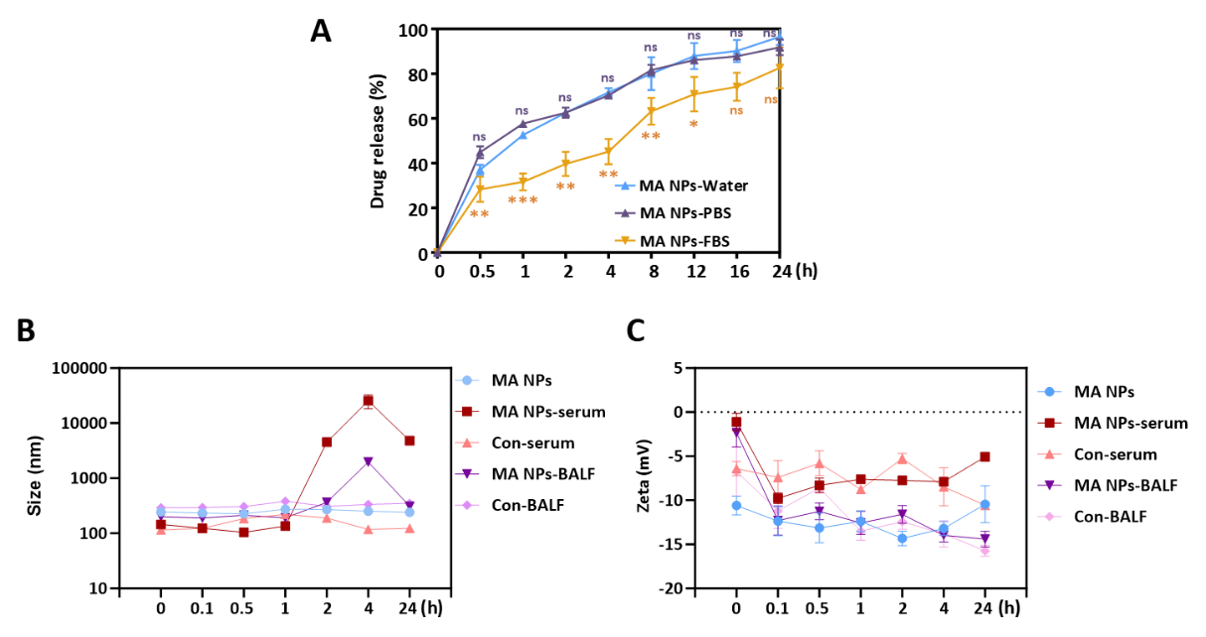
Fig. S4 MA NPs maintain structural and colloidal integrity in protein-containing biological fluids. (A) Drug release profiles of MA NPs in PBS and 50% FBS. (B) Hydrodynamic diameter stability of MA NPs during 24 h incubation with serum or BALF. (C) Zeta potential of MA NPs during 24 h incubation with serum or BALF. ***p< 0.001, **p< 0.01, *p< 0.05 vs. the data at the corresponding time in MA NPs-PBS group (n=3).

6. NMR confirmation of MA NPs co‑assembly structure
To further verify the composition and assembly of MA NPs, we measured the ¹H NMR and ¹³C NMR spectra of Mag, ATI, and MA NPs. The presence of both Mag and ATI in the MA NPs was confirmed by the appearance of their characteristic proton and carbon signals in the spectra of the nanoparticles. Notably, after nanoparticle formation, the characteristic phenolic hydroxyl proton signals of Mag completely disappeared, indicating that these groups are involved in intermolecular interactions during co‑assembly. Furthermore, compared with the free drugs, the corresponding proton signals in MA NPs shifted upfield (Fig. S5), and the corresponding carbon signals shifted downfield (Fig. S6). These spectral changes provide strong evidence for the formation of a co‑assembled structure, confirming that Mag and ATI are not simply mixed but rather integrated into a unified nanoparticle architecture.
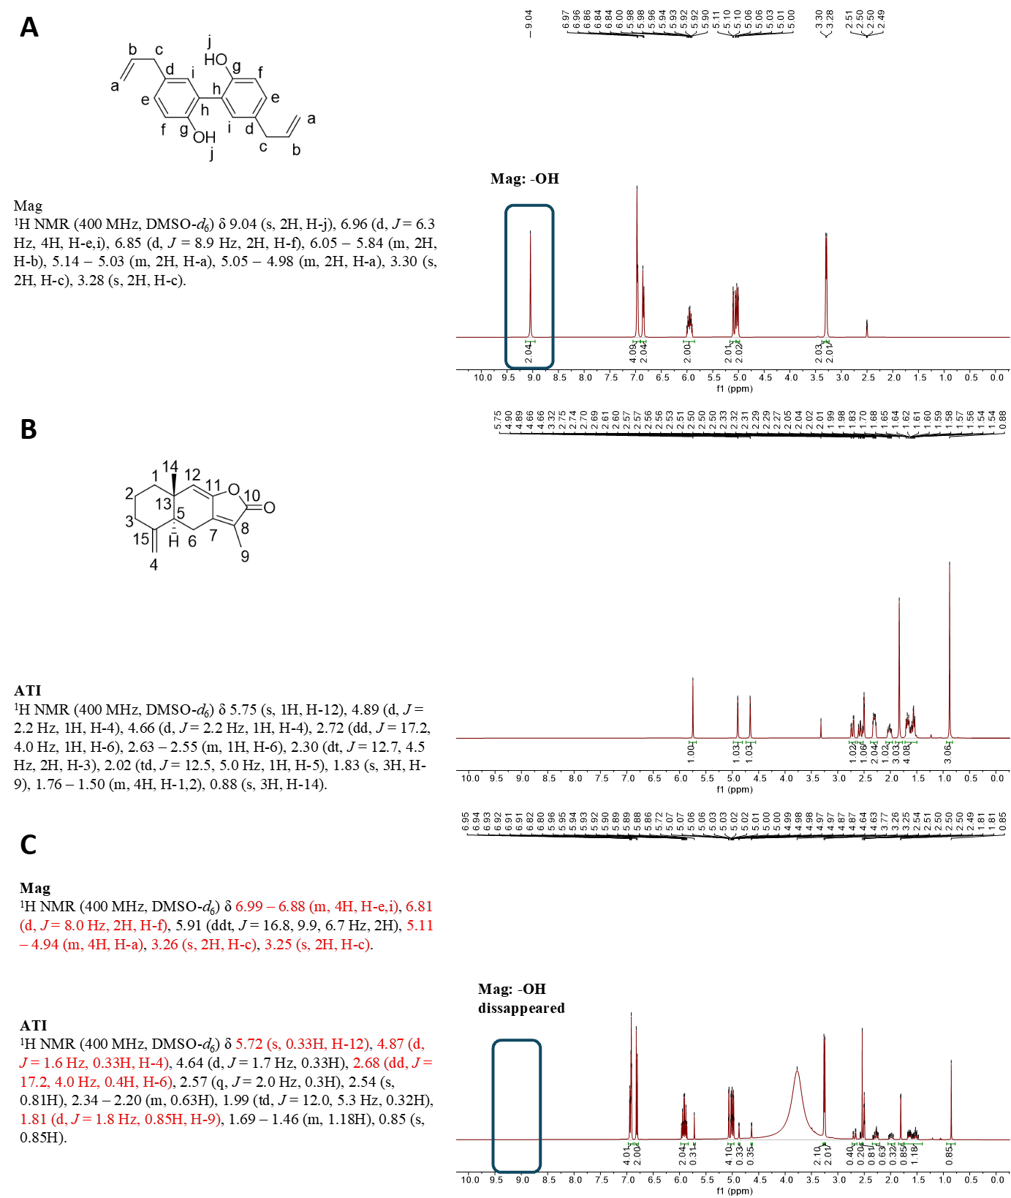
Fig. S5 ¹H NMR analysis. (A) ¹H NMR spectrum and assignment of Mag. (B) ¹H NMR spectrum and assignment of ATI. (C) ¹H NMR spectrum and assignment of MA NPs. (Red labels indicate upfield shifts of the corresponding protons.)

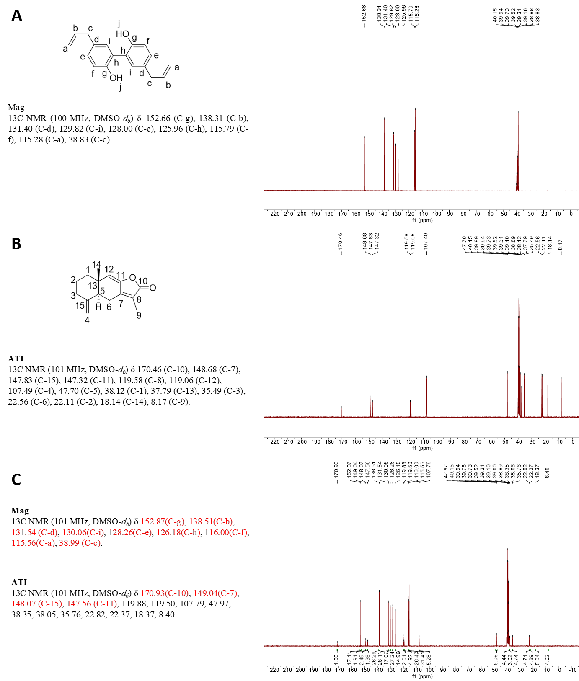
Fig. S6 ¹³C NMR analysis. (A) ¹³C NMR spectrum and assignment of Mag. (B) ¹³C NMR spectrum and assignment of ATI. (C) ¹³C NMR spectrum and assignment of MA NPs. (Red labels indicate downfield shifts of the corresponding carbons.)

7. Detection of sodium and potassium in urine
Following the establishment of the lung injury model via intratracheal instillation of LPS (10 mg/kg) and subsequent pharmacological intervention, mice were housed in metabolic cages for a 24-h urine collection. Urinary levels of sodium and potassium were determined using commercial biochemical kits (Cat. Nos. C002-1-1 and C001-2-1, respectively; Nanjing Jiancheng Bioengineering Institute, China). As shown in Fig. S7A and B, MA NPs treatment significantly enhanced sodium excretion while attenuating potassium loss, a trend comparable to that observed in the Spi positive control group. These findings align with the serum electrolyte profiles reported in the main text, confirming that MA NPs exert their diuretic effects through a potassium-sparing natriuretic mechanism.
Fig. S7 Detection of sodium and potassium in urine. (A) Sodium content in urine. (B) Potassium content in urine. ***p< 0.001, *p< 0.05 vs. Mod group (n=6).

8. Efficacy evaluation of MA NPs and p-MA NPs
ELISA and transepithelial electrical resistance (TEER) assays were employed to evaluate the biological equivalence of p-MA NPs and MA NPs regarding their anti-inflammatory effects and protection of cellular barrier integrity.
8.1 ELISA assays
MLE-12 cells were evenly seeded in a 96-well plate and divided into four groups: Con, Mod, MA NPs (10 μM), and p-MA NPs (10 μM). The cells received a 6-hour drug pretreatment followed by LPS stimulation. Subsequently, cell culture supernatants were collected and centrifuged. The levels of TNF-α, IL-6, and IL-1β were quantified using ELISA kits according to the manufacturer's instructions. As shown in Figs. S8A-C, there was no statistically significant difference between p-MA NPs and MA NPs on levels of TNF-α, IL-1β, and IL-6, indicating that they show bioequivalence in anti-inflammatory effects.
8.2 TEER assays
To assess cell barrier integrity, transwell inserts were measured using a Millicell ERS-2 Volt-Ohmmeter (Millipore, MA, USA). MLE-12 cells were seeded on collagen-coated 0.4 μm pore filters in 24-well plates and cultured for 5-7 days to form a confluent monolayer. TEER stabilized over 2 days, confirming barrier formation. The modeling and administration methods were the same as described in the "Trans-epithelial electrical resistance (TEER) measurement" subsection of the Materials and methods in the main text. During treatment, 1.4 mL of drug-containing medium was added to the basolateral chamber and 600 μL to the luminal chamber. Then the TEER was measured at various time points. As shown in Figs. S8D and E, p-MA NPs have no statistically significant difference in protective effects on the cellular barrier compared to MA NPs, indicating that they are biologically equivalent in protecting barrier integrity.
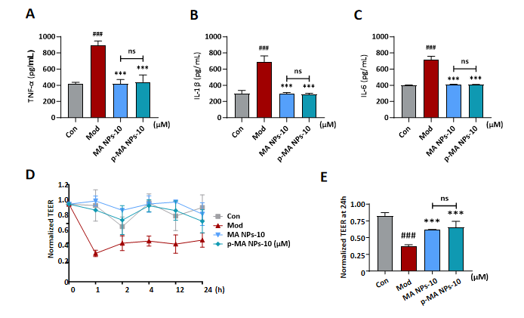
In summary, p-MA NPs can be used in the subsequent mechanistic investigations as a substitute for MA NPs.
Fig. S8 Efficacy evaluation of MA NPs and p-MA NPs. (A–C) Levels of TNF-α, IL-1β, and IL-6 in cell culture supernatant measured by ELISA. (D) TEER in cell monolayers over time. (E) Normalized TEER values derived from the data in (D). ###p< 0.001 vs. Con group; ***p< 0.001 vs. Mod group; ns, not significant (n=6).

9. Localization and statistics of p-MA NPs
To assess nanoparticle biodistribution in vivo, mice received MA NPs, p-MA NPs, Al-Mag, or Ve-ATI (10 mg/kg, i.p.) three times at 8-hour intervals. Two hours after the final dose, the tissues were collected and processed for detecting MA-probe, Al-Mag, or Ve-ATI via click chemistry. As shown in Fig. S9A, compared with the MA NPs control group, the significant fluorescence aggregation was confirmed in the lungs (merged yellow), both pseudo-red (Al-Mag/BDP) and pseudo-green (Ve-ATI/AMPD) demonstrated the same result. For precise localization of MA NPs in the lung, sections were co-stained with antibodies against E-cadherin (alveolar epithelial cell marker) or α-SMA (smooth muscle cell marker) before the click reaction. The fluorescence values of the organs from the p-MA NPs group were divided by the corresponding fluorescence values from the MA NPs group to obtain normalized fluorescence intensity (Fig. S9B). To further explore which cells can take up the MA NPs in the lungs, immunofluorescence staining was carried out on mouse lung paraffin sections to detect various cell markers (Fig. 4F, G in the main text). According to the PCC values, compared with the smooth muscle cell marker α-SMA, p-MA nanoparticles (Al-Mag and Ve-ATI) show a higher level of colocalization with the alveolar epithelial cell marker E-Cadherin (Fig. S9C). Fig. S9D shows the localization of p-MA NPs, Ve-ATI, and Al-Mag in mouse lung sections, with their corresponding parent drugs used as controls. The results indicate that compared to administering Al-Mag or Ve-ATI alone, more Al-Mag and Ve-ATI targets the lungs when formulated into MA NPs (Fig. S9E).
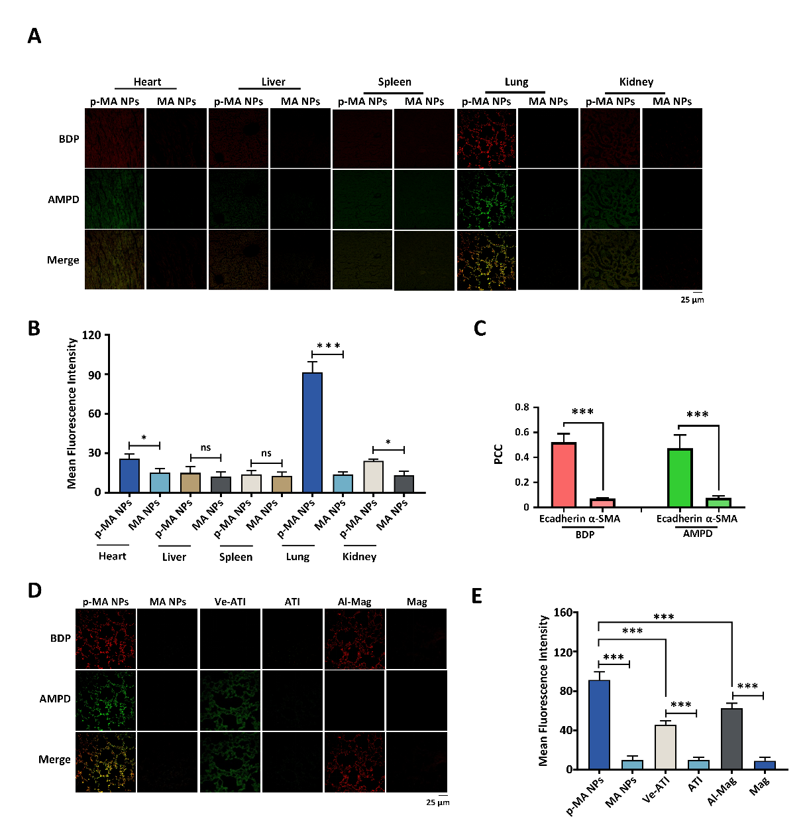
Fig. S9 Localization and statistics of p-MA NPs. (A) Results of click reaction in tissue sections of various organs of mice in p-MA NPs group and MA NPs group. (B) Fluorescence intensity statistics of (A). (C) PCC statistics of p-MA NPs with α-SMA and E-Cadherin in lung tissues. (D) Results of click reaction in lung sections of mice treated with p-MA NPs, Ve-ATI, Al-Mag, or their corresponding parent drugs (MA NPs, ATI, Mag) as controls. (E) Fluorescence intensity statistics of (D). ***p < 0.001, *p < 0.05, ns, not significant (n=3).
10. MA NPs improve RVD function in MLE-12 cells
AQP5 is expressed in alveolar epithelial cells, where it participates in pulmonary water clearance, and its dysfunction is critically involved in the pathogenesis of pulmonary edema [10]. Functionally, AQP5 deficiency leads to impaired regulatory volume decrease (RVD) in response to hypotonic stress, as demonstrated in lung epithelial cells where knockdown of AQP5 significantly reduces cell volume recovery capacity [11]. Since RVD reflects the activity of aquaporins [12,13], we employed hypotonic stimulation (240 mOsm) to evaluate AQP5 activity following LPS challenge and MA NPs treatment by measuring the cell volume recovery rate (% recovery) and water permeability (Pf). Calcein-AM is a volume-sensitive dye. Time-lapse images were captured using a live-cell imaging system (Thunder), and hypotonic solution was added at the 15th second of recording. The results showed that LPS treatment severely impaired RVD; under hypotonic conditions, cells swelled and could not recover their normal volume, whereas MA NPs treatment effectively preserved RVD function (Fig. S10).
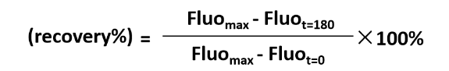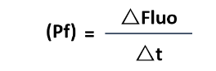
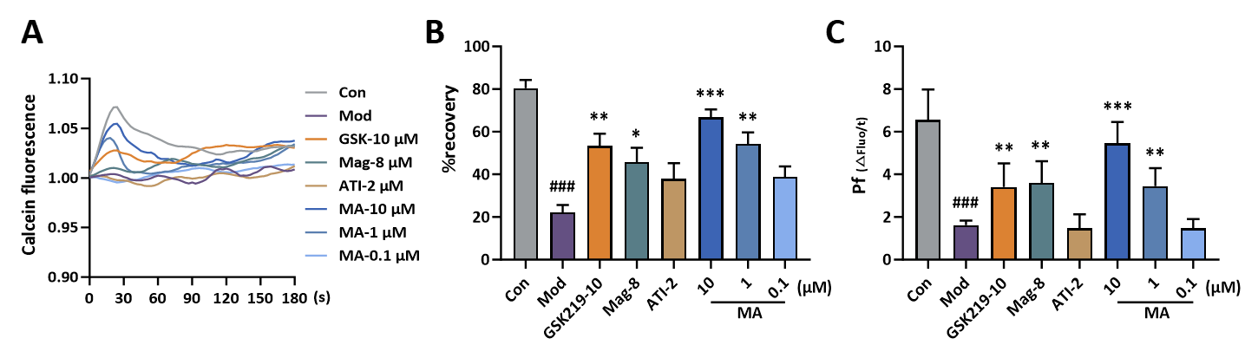
Fig. S10 Maintenance of RVD in LPS-treated MLE-12 cells by MA NPs. (A) Time course of cell volume changes. (B) Cell volume recovery rate (%). (C) Osmotic water permeability (Pf) at 15s. ###p < 0.001 vs. Con group; ***p < 0.001, **p < 0.01, *p < 0.05 vs. Mod group (n=3).

11. In vivo safety study of MA NPs
To evaluate the biosafety of MA NPs, mice were randomly divided into three groups: a control group, a low-dose MA NPs group (3.3 mg/kg), and a high-dose MA NPs group (10 mg/kg). To assess acute toxicity under intensive dosing, mice received intraperitoneal administration twice within 24 hours, with the second dose given 8 hours after the first. The control group was administered an equal volume of saline on the same schedule. All mice were sacrificed 24 hours after the initial administration, and major organs and serum were collected for analysis. Organs were embedded in paraffin, sectioned, and stained with H&E.
As shown in Fig. S11A, no significant histopathological differences were observed between the nanoparticle-treated groups and the control group, indicating no overt organ toxicity induced by MA NPs. Serum levels of creatinine (CRE), blood urea nitrogen (BUN), aspartate aminotransferase (AST), and alanine aminotransferase (ALT) were measured using biochemical assay kits. The results demonstrated that MA NPs did not cause significant liver or kidney toxicity (Fig. S11B).

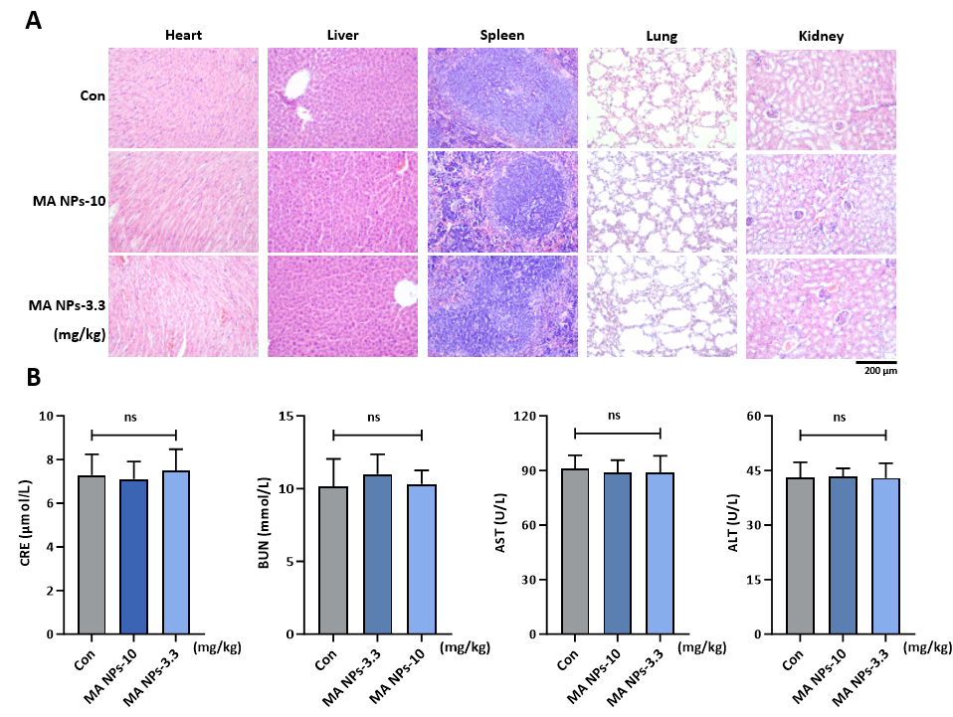
Fig. S11 In vivo safety study of MA NPs. (A) H&E staining of major organs (200×). (B) Detection of serum CRE, BUN, AST, and ALT levels; ns, not significant (n=6).

12. MA NPs alleviate hydrochloric acid aspiration-induced pulmonary inflammation in mice
To further evaluate therapeutic efficacy, a hydrochloric acid (HCl) aspiration-induced lung injury model was established. Mice were randomly assigned to six groups: Con, Mod, Dex (30 mg/kg), MA NPs (40 mg/kg, 20 mg/kg, and 10 mg/kg). Acute lung injury was induced by intratracheal instillation of HCl (0.1 M, 1.5 mL/kg), while the Con group received saline as a sham treatment. Drug administration, dose calculation, and the vehicle control of MA NPs were performed as described for the LPS model in main text. For s acute phase evaluation, mice were sacrificed at 24 h post‑injury (Fig. S12A). At the endpoint, lung edema (LW/BW and W/D ratios), BALF total protein and cytokines (TNF‑α, IL‑1β, IL‑6), and pulmonary function parameters [forced vital capacity (FVC), dynamic compliance (Cdyn), airway resistance (Re) and lung resistance (RL)] were assessed as detailed above. Histopathological changes and collagen deposition were evaluated by H&E and Masson's trichrome staining.
As shown in Fig. S12, compared with the Con group, the Mod group exhibited significantly increased lung wet/dry (W/D) ratio and lung weight/body weight (LW/BW) ratio, elevated bronchoalveolar lavage fluid (BALF) levels of pro‑inflammatory cytokines (TNF‑α, IL‑1β, IL‑6) and total protein, and marked deterioration of lung function parameters (decreased FVC and Cdyn; increased R_{e} and R_{L}). H&E staining revealed alveolar wall thickening, edema, and inflammatory infiltration, while Masson staining showed no obvious collagen deposition, consistent with acute‑phase pathology. In contrast, treatment with MA NPs dose‑dependently reversed all these alterations: the W/D and LW/BW ratios were significantly reduced (Fig.S12B, C), BALF cytokine and total protein levels were decreased (Fig.S12J–M), lung function parameters were substantially restored (Fig.S12F–I), and H&E staining showed alleviated lung tissue injury (Fig.S12 D). Masson's trichrome staining revealed no significant difference in collagen deposition among the groups (Fig. S12D, E). These results indicate that MA NPs effectively suppress inflammation, reduce vascular leakage and pulmonary edema, and protect respiratory mechanics during the acute phase of HCl‑induced lung injury.
In addition, the biosafety of MA NPs at 20 and 40 mg/kg was preliminarily assessed using a one‑week i.p. injection regimen (once daily for 7 days). No obvious histopathological abnormalities were observed in major organs (heart, liver, spleen, lung, kidney) after H&E staining (Fig. S12N). Notably, the safety of MA NPs at 10 mg/kg had already been confirmed in the previous in vivo efficacy study (Fig. S11A). Together, these data indicate that MA NPs are well tolerated up to 40 mg/kg under the tested dosing regimen.
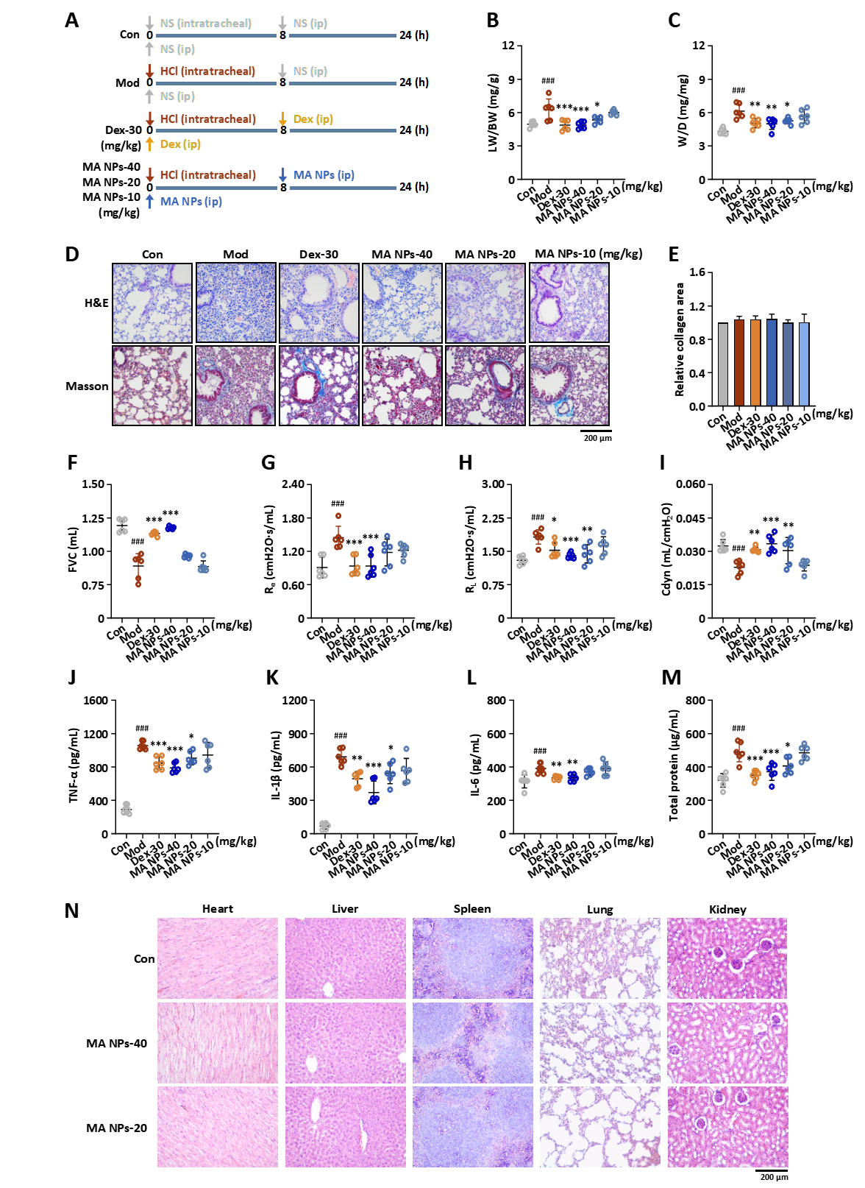
Fig. S12 MA NPs alleviate hydrochloric acid aspiration-induced pulmonary inflammation in mice during acute phase. (A) Treatment timeline for 24 h. (B) LW/BW ratio. (C) W/D ratio. (D) Representative H&E-stained and Masson’s trichrome-stained lung sections. (E) Relative collagen area (Masson’s trichrome staining, normalized to Con group). (F–I) Parameters of lung function (FVC, R_{e}, R_{L} and Cdyn). (J–M) TNF-α, IL-1β, and IL-6 levels in BALF. (N) H&E staining of major organs (200×). ###p < 0.001 vs. Con group; ***p < 0.001, **p < 0.01, *p < 0.05 vs. Mod group (n=6).
References:
1. Szapiel SV, Elson NA, Fulmer JD, Hunninghake GW, Crystal RG. Bleomycin-induced interstitial pulmonary disease in the nude, athymic mouse. Am Rev Respir Dis. 1979;120(4):893-9.
2. Ashcroft T, Simpson JM, Timbrell V. Simple method of estimating severity of pulmonary fibrosis on a numerical scale. J Clin Pathol. 1988;41(4):467-70.
3. Lin B, Lin P, Zhang X, Liao Y, Yu Y, Xu X, Wang X. Carrier-free, hyaluronic acid-modified self-assembled doxorubicin and chlorin e6 nanoparticles enhance combined chemo- and photodynamic therapy in vivo. Int J Nanomedicine. 2024;19:14105-14124.
4. Chen S, Huang H, Li Q, Cai J, Miao Z, Xie P, Tang S, He D. Carrier-free nanoparticles based on self-assembly of 5-FU and copper-genistein complexes for the combined treatment of hepatocellular carcinoma. Drug Deliv Transl Res. 2025;15(4):1299-1316.
5. Liu Y, Yang G, Jin S, Xu L, Zhao CX. Development of high‑drug‑loading nanoparticles. Chempluschem. 2020;85(9):2143-2157.
6. Behzadi S, Serpooshan V, Sakhtianchi R, et al. Protein corona change the drug release profile of nanocarriers: the “overlooked” factor at the nanobio interface. Colloids Surf B Biointerfaces. 2014;123:143-149.
7. Richter-Bisson ZW, Hedberg YS. Revisiting the Vroman effect: Mechanisms of competitive protein exchange on surfaces. Colloids Surf B Biointerfaces. 2025;255:114927.
8. Zhdanov VP. Formation of a protein corona around nanoparticles. Curr Opin Colloid Interface Sci. 2019;41:95-103.
9. Tenzer S, Docter D, Kuharev J, et al. Rapid formation of plasma protein corona critically affects nanoparticle pathophysiology. Nat Nanotechnol. 2013;8(10):772-781.
10. Wu M, Miao Z, Liu F, Dai S, Li Y, Zhou T, et al. Aquaporins: a novel perspective in the treatment of lung diseases. Inflammation Research. 2025;74:151.
11. Chen Z, Zhang Z, Gu Y, Bai C. Impaired migration and cell volume regulation in aquaporin -deficient SPC-A1 cells. Respiratory Physiology & Neurobiology. 2011;176(3):110-117.5.
12 Liu X, Bandyopadhyay BC, Nakamoto T, Singh B, Liedtke W, Melvin JE, et al. A role for AQP5 in activation of TRPV4 by hypotonicity: concerted involvement of AQP5 and TRPV4 in regulation of cell volume recovery. J Biol Chem. 2006;281(22):15485-95.
13. Mola MG, Sparaneo A, Li Y, et al. The speed of swelling kinetics modulates cell volume regulation and calcium signaling in astrocytes: A different point of view on the role of aquaporins. Glia. 2016;64(1):139-54.

