Supporting Information

Enzyme-Enhanced Albumin-Stabilized Nanopolymers for Cascade Catalysis-Driven Ferroptosis-Immunotherapy

Peng Yu, Shuchun Yu, Xiaoping Yin, Zihao Zhou, Yixuan Chen, Xuehong Zheng, Jitao Ling, Panpan Xia, Yuhong Dai, Weiwei Zeng,* and Jing Zhang*

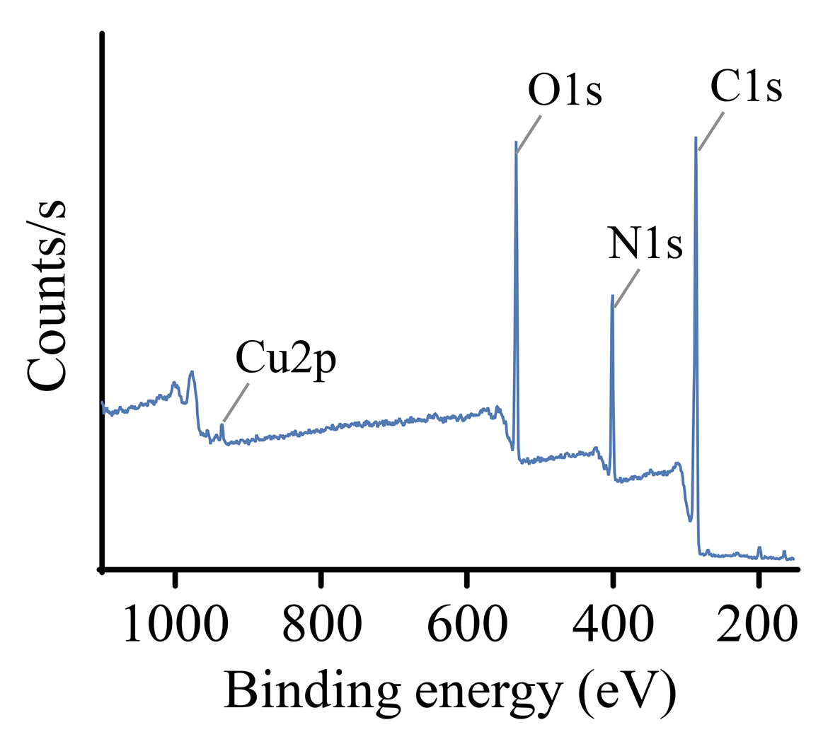
Fig. S1. XPS spectra of BCuP.

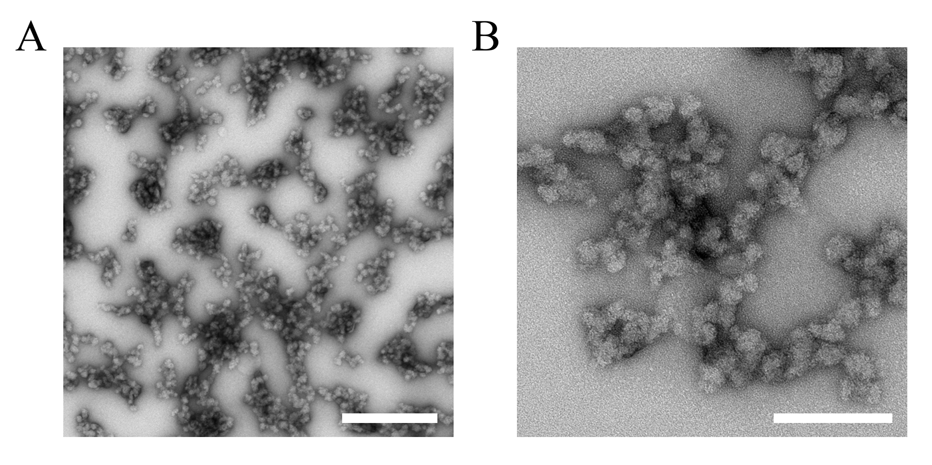
Fig. S2. TEM images of BCuP@G. (A) Low magnification, scale bar: 300 nm. (B) High magnification, scale bar: 100 nm.

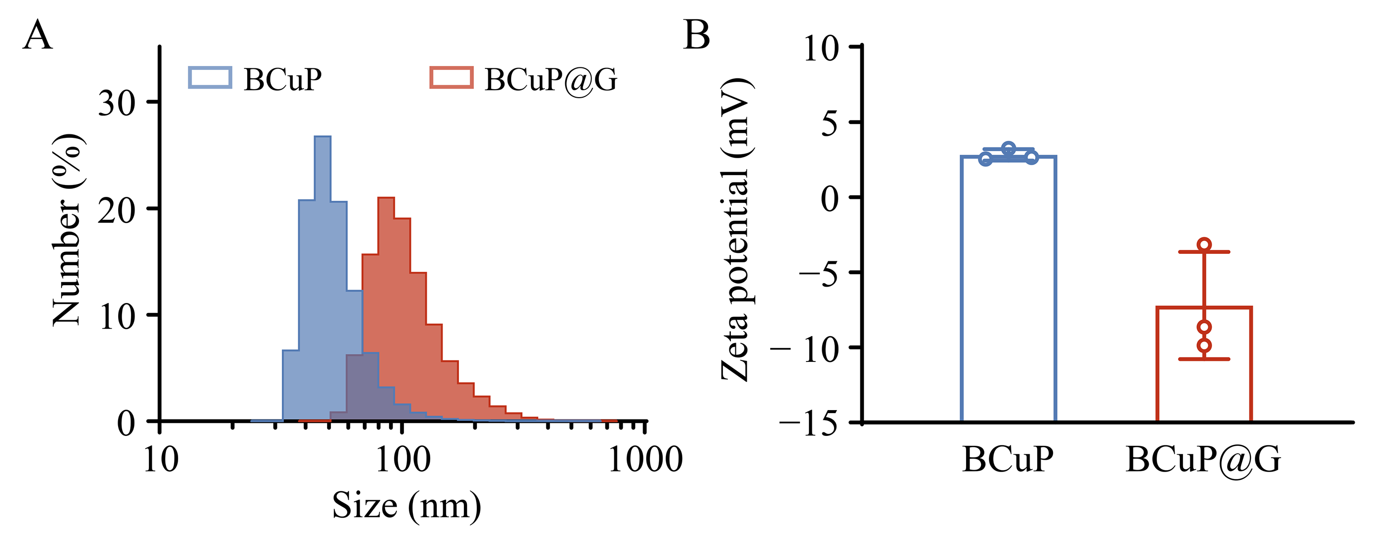
Fig. S3. (A) Hydrodynamic particle sizes and (B) zeta potentials of BCuP and BCuP@G.

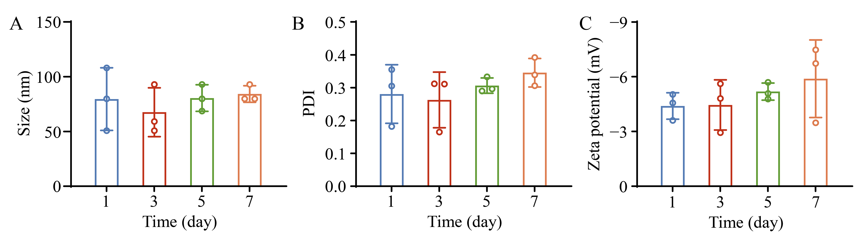
Fig. S4. (A) Hydrodynamic particle sizes, (B) PDI, and (C) zeta potentials of BCuP@G incubated for different periods in serum-containing DMEM medium.

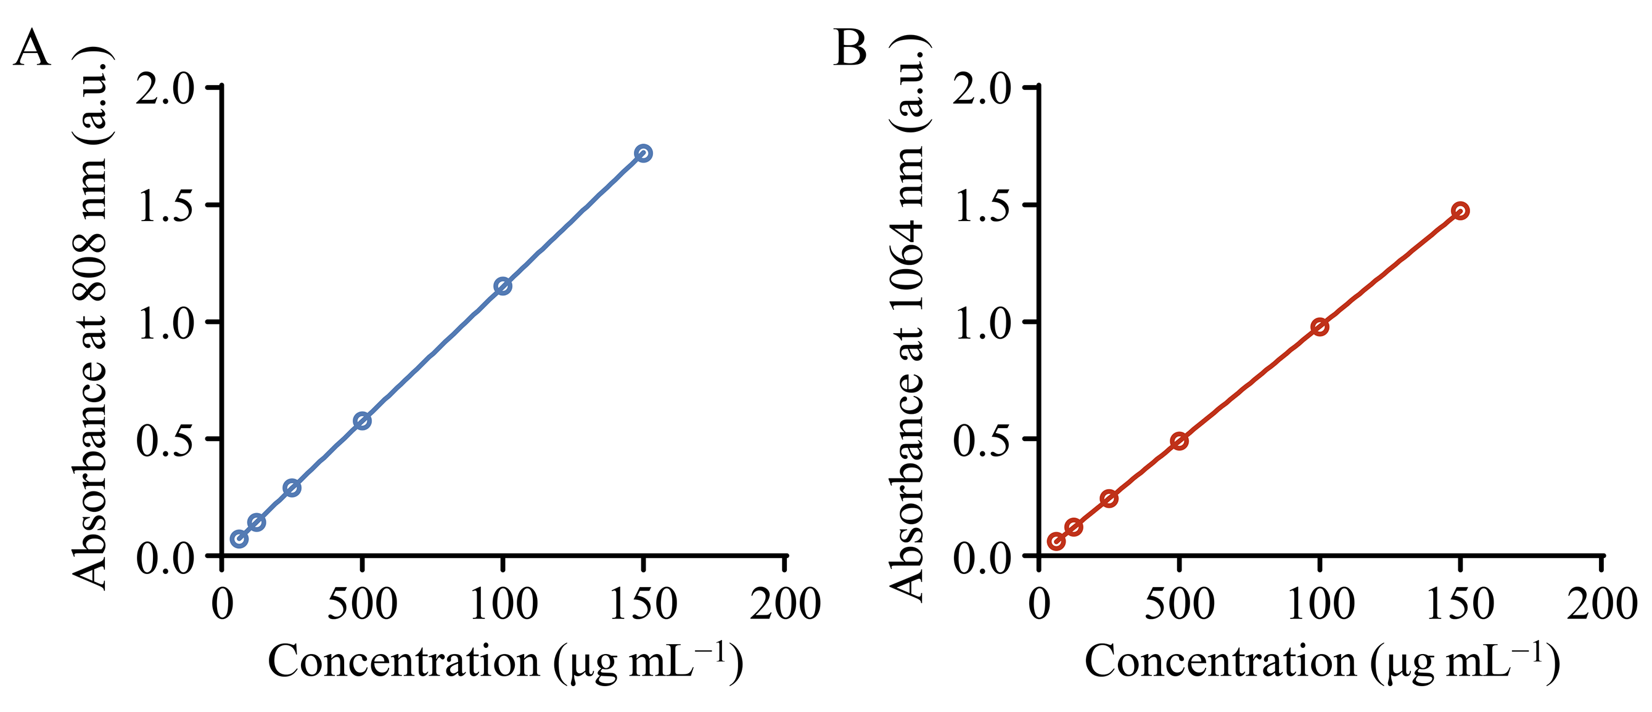
Fig. S5. Linear relationship between concentration and absorbance of BCuP@G at (A) 808 and (B) 1064 nm.

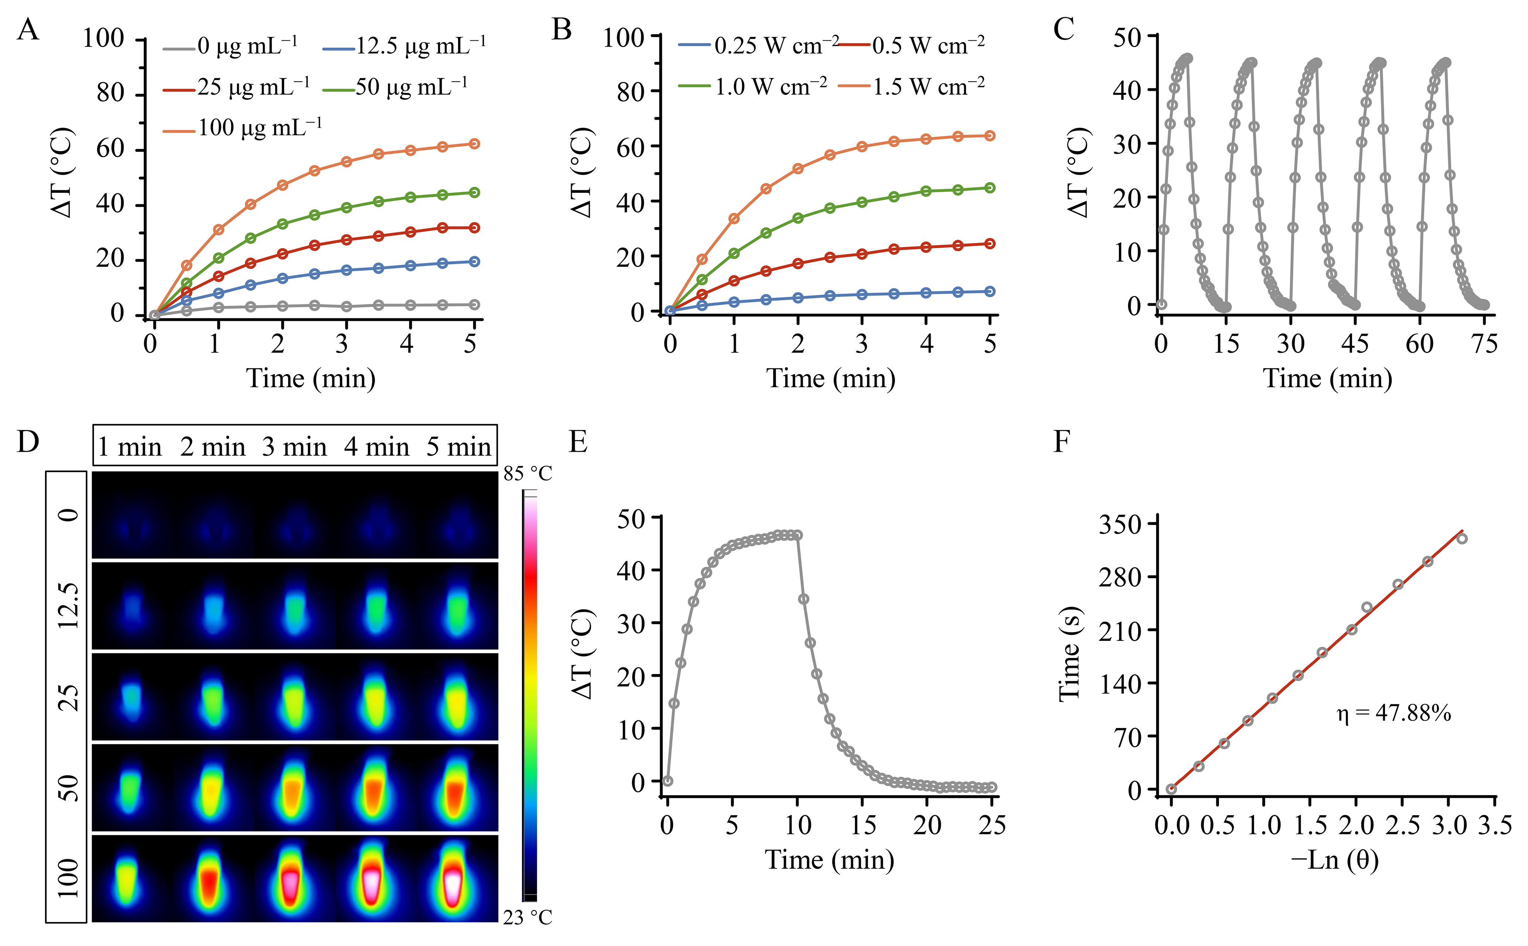
Fig. S6. (A) The photothermal profiles of BCuP@G with various concentrations upon 808 nm laser (1 W cm⁻²) irradiation. (B) The photothermal profiles of BCuP@G at different laser power densities (0.25, 0.5, 1.0, and 1.5 W cm⁻²). (C) Photothermal stability of BCuP@G (50 μg mL⁻¹) under five successive laser on/off cycles (808 nm, 1 W cm⁻²). (D) Thermal images of BCuP@G with various concentrations during 5 min of laser irradiation (808 nm, 1 W cm⁻²). (E) Photothermal heating and cooling curves of BCuP@G under 808 nm laser irradiation and (F) corresponding linear relationship between time and −lnθ from the cooling period.

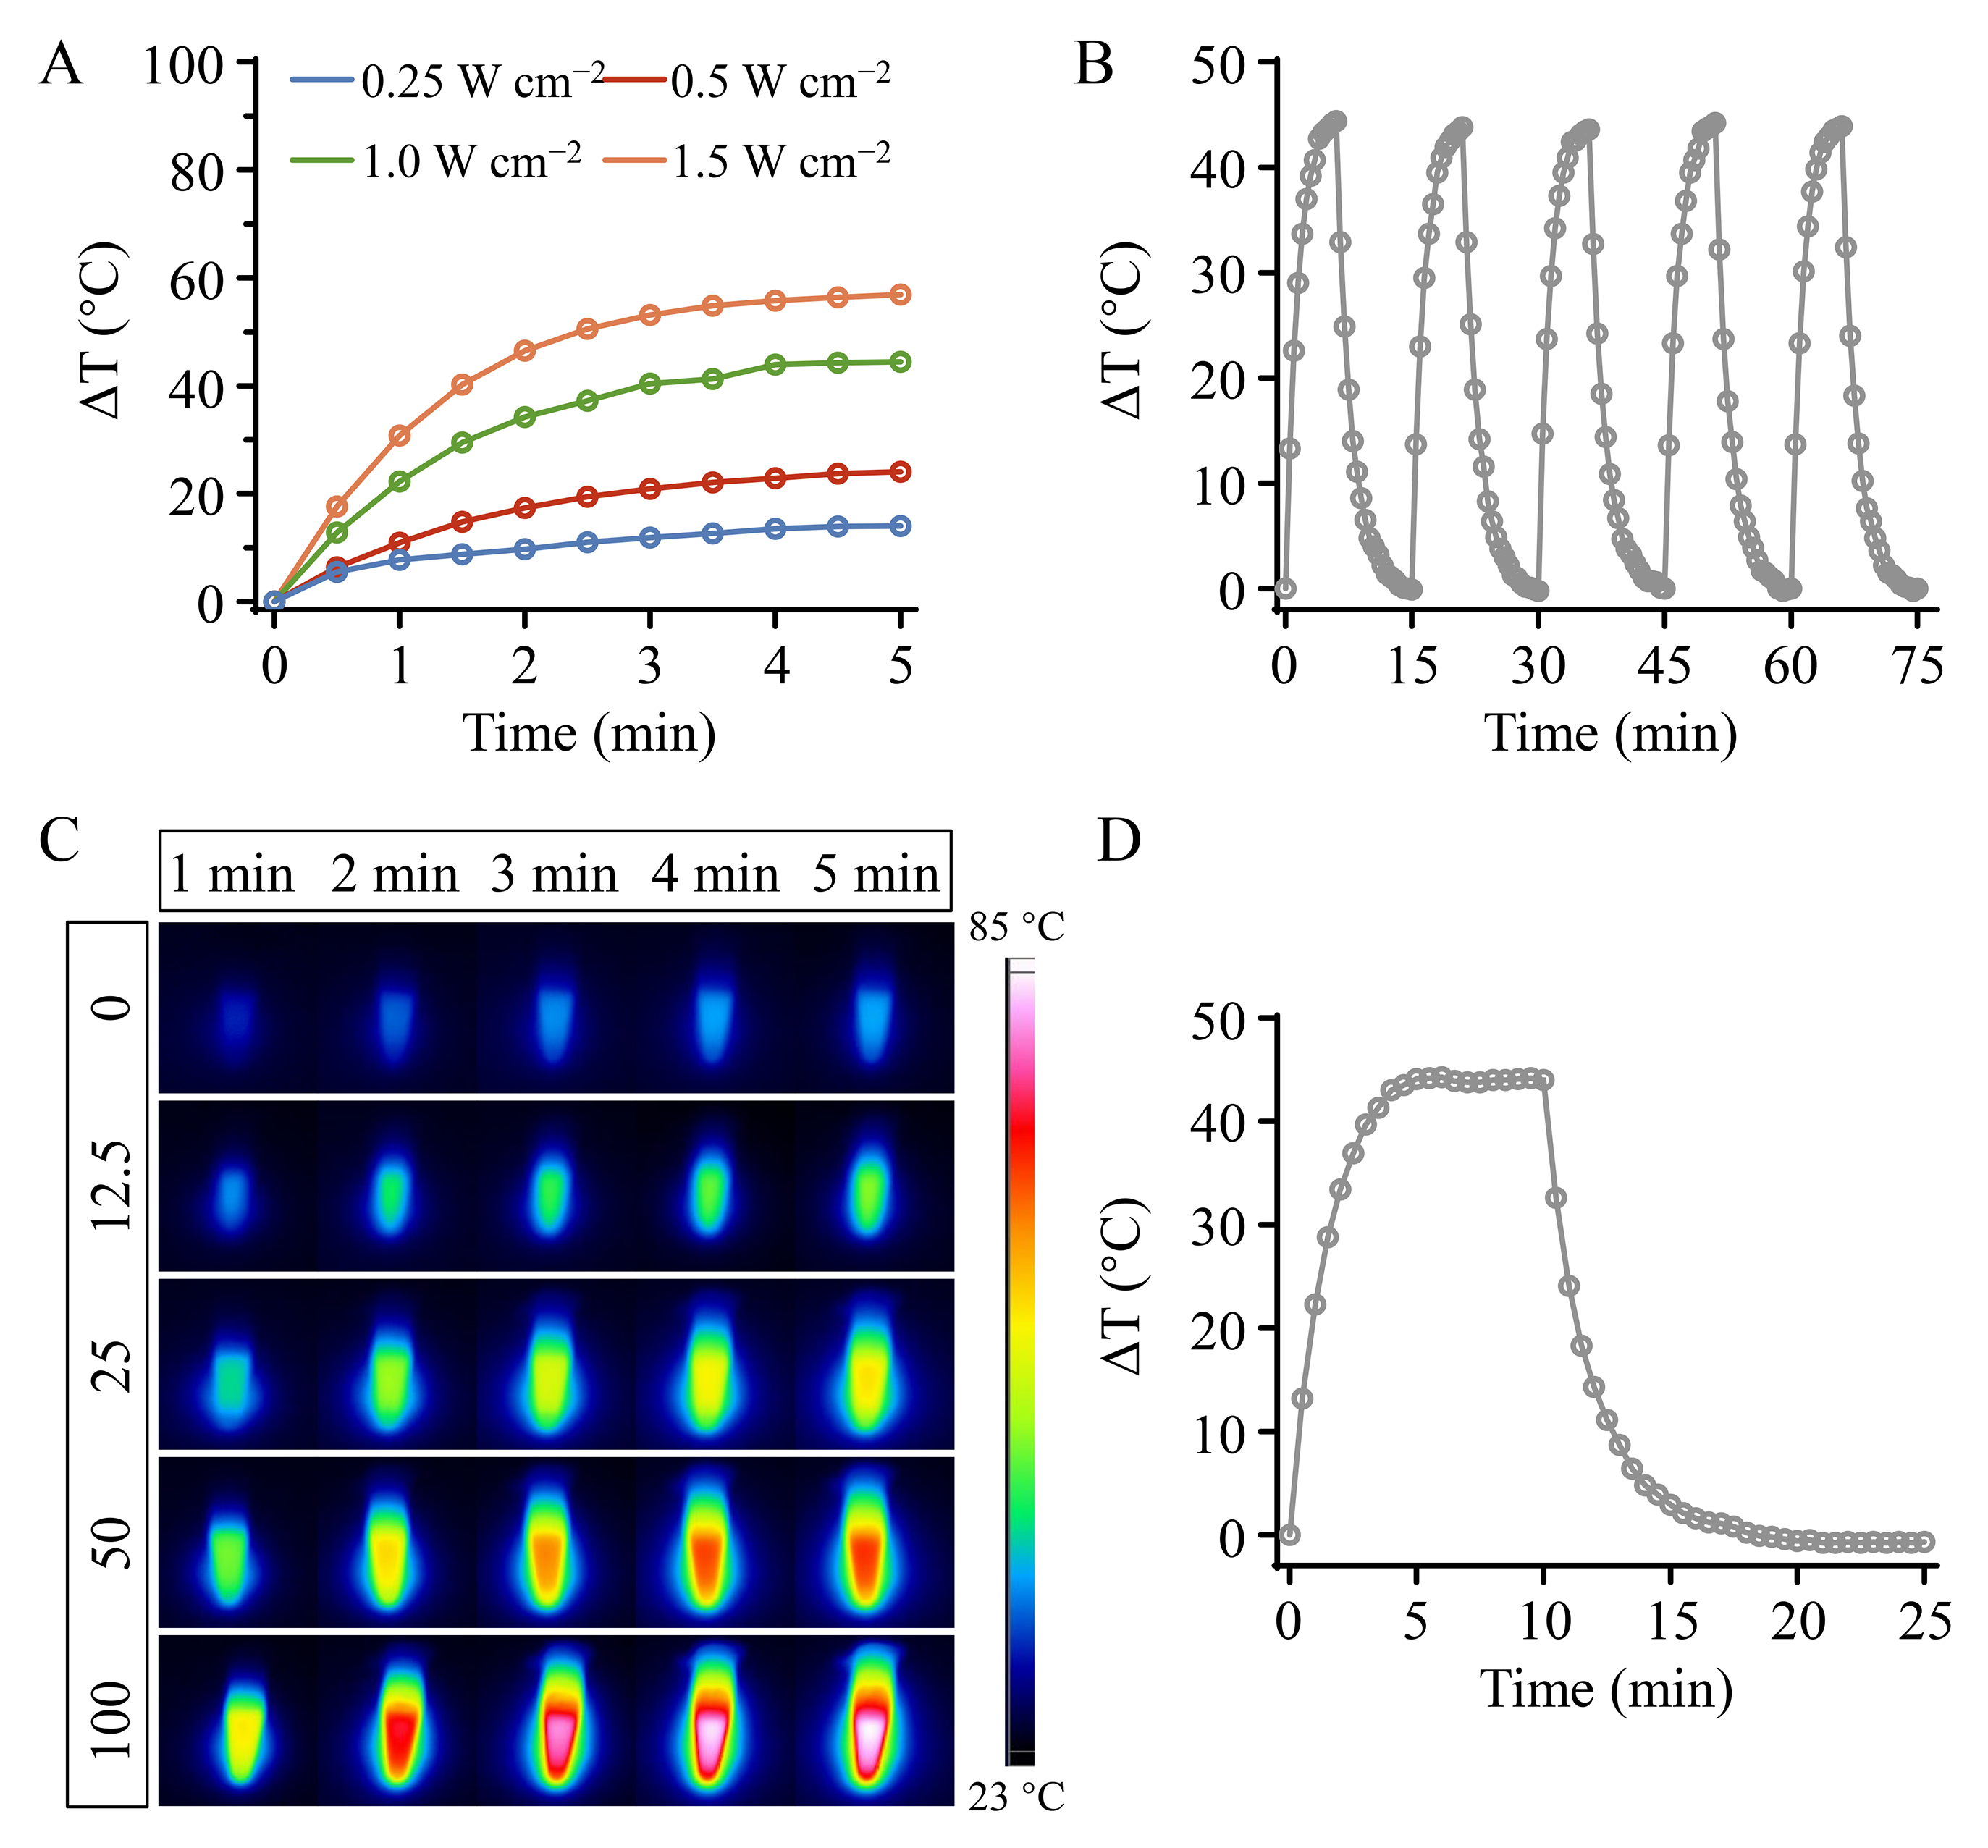
Fig. S7. (A) The photothermal profiles of BCuP@G at different laser power densities (0.25, 0.5, 1.0, and 1.5 W cm⁻²). (B) The photothermal stability of BCuP@G over five laser on/off cycles (1064 nm, 1 W cm⁻²). (C) The infrared thermal images of BCuP@G with various concentrations during 5 min of irradiation. (D) Photothermal heating and cooling curves of BCuP@G under 1064 nm laser irradiation.

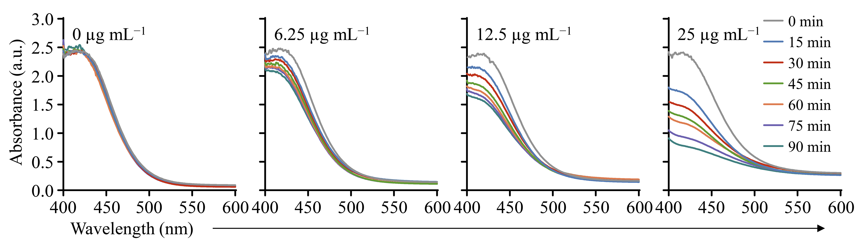
Fig. S8. GSH depletion profile treated with BCuP@G at different concentrations (0, 6.25, 12.5, and 25 µg mL⁻¹).

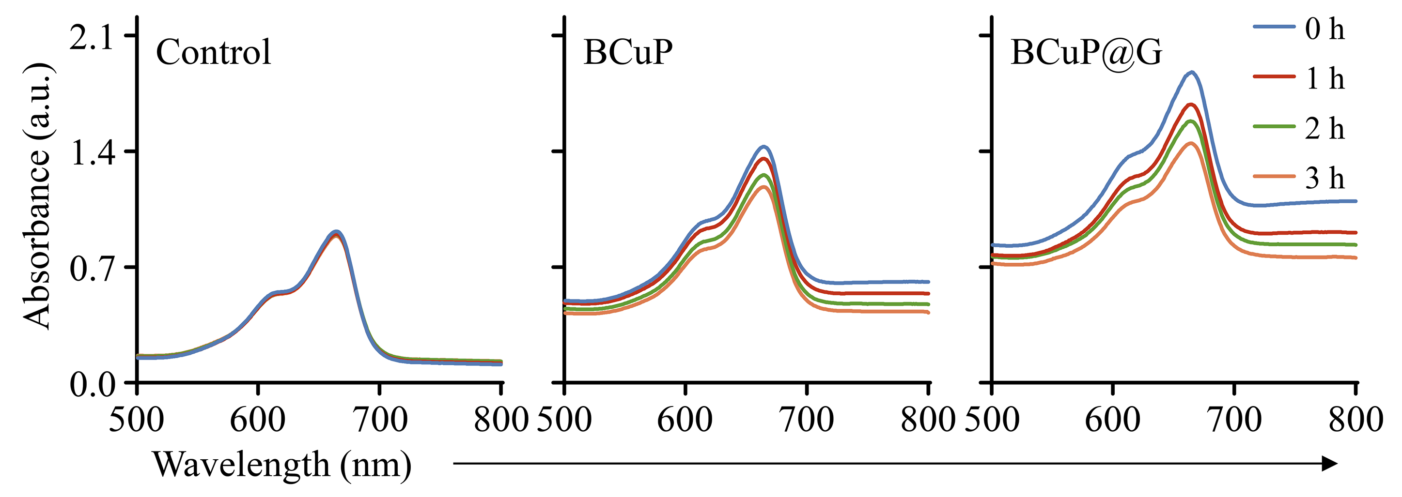
Fig. S9. MB degradation profile treated with different preparations.

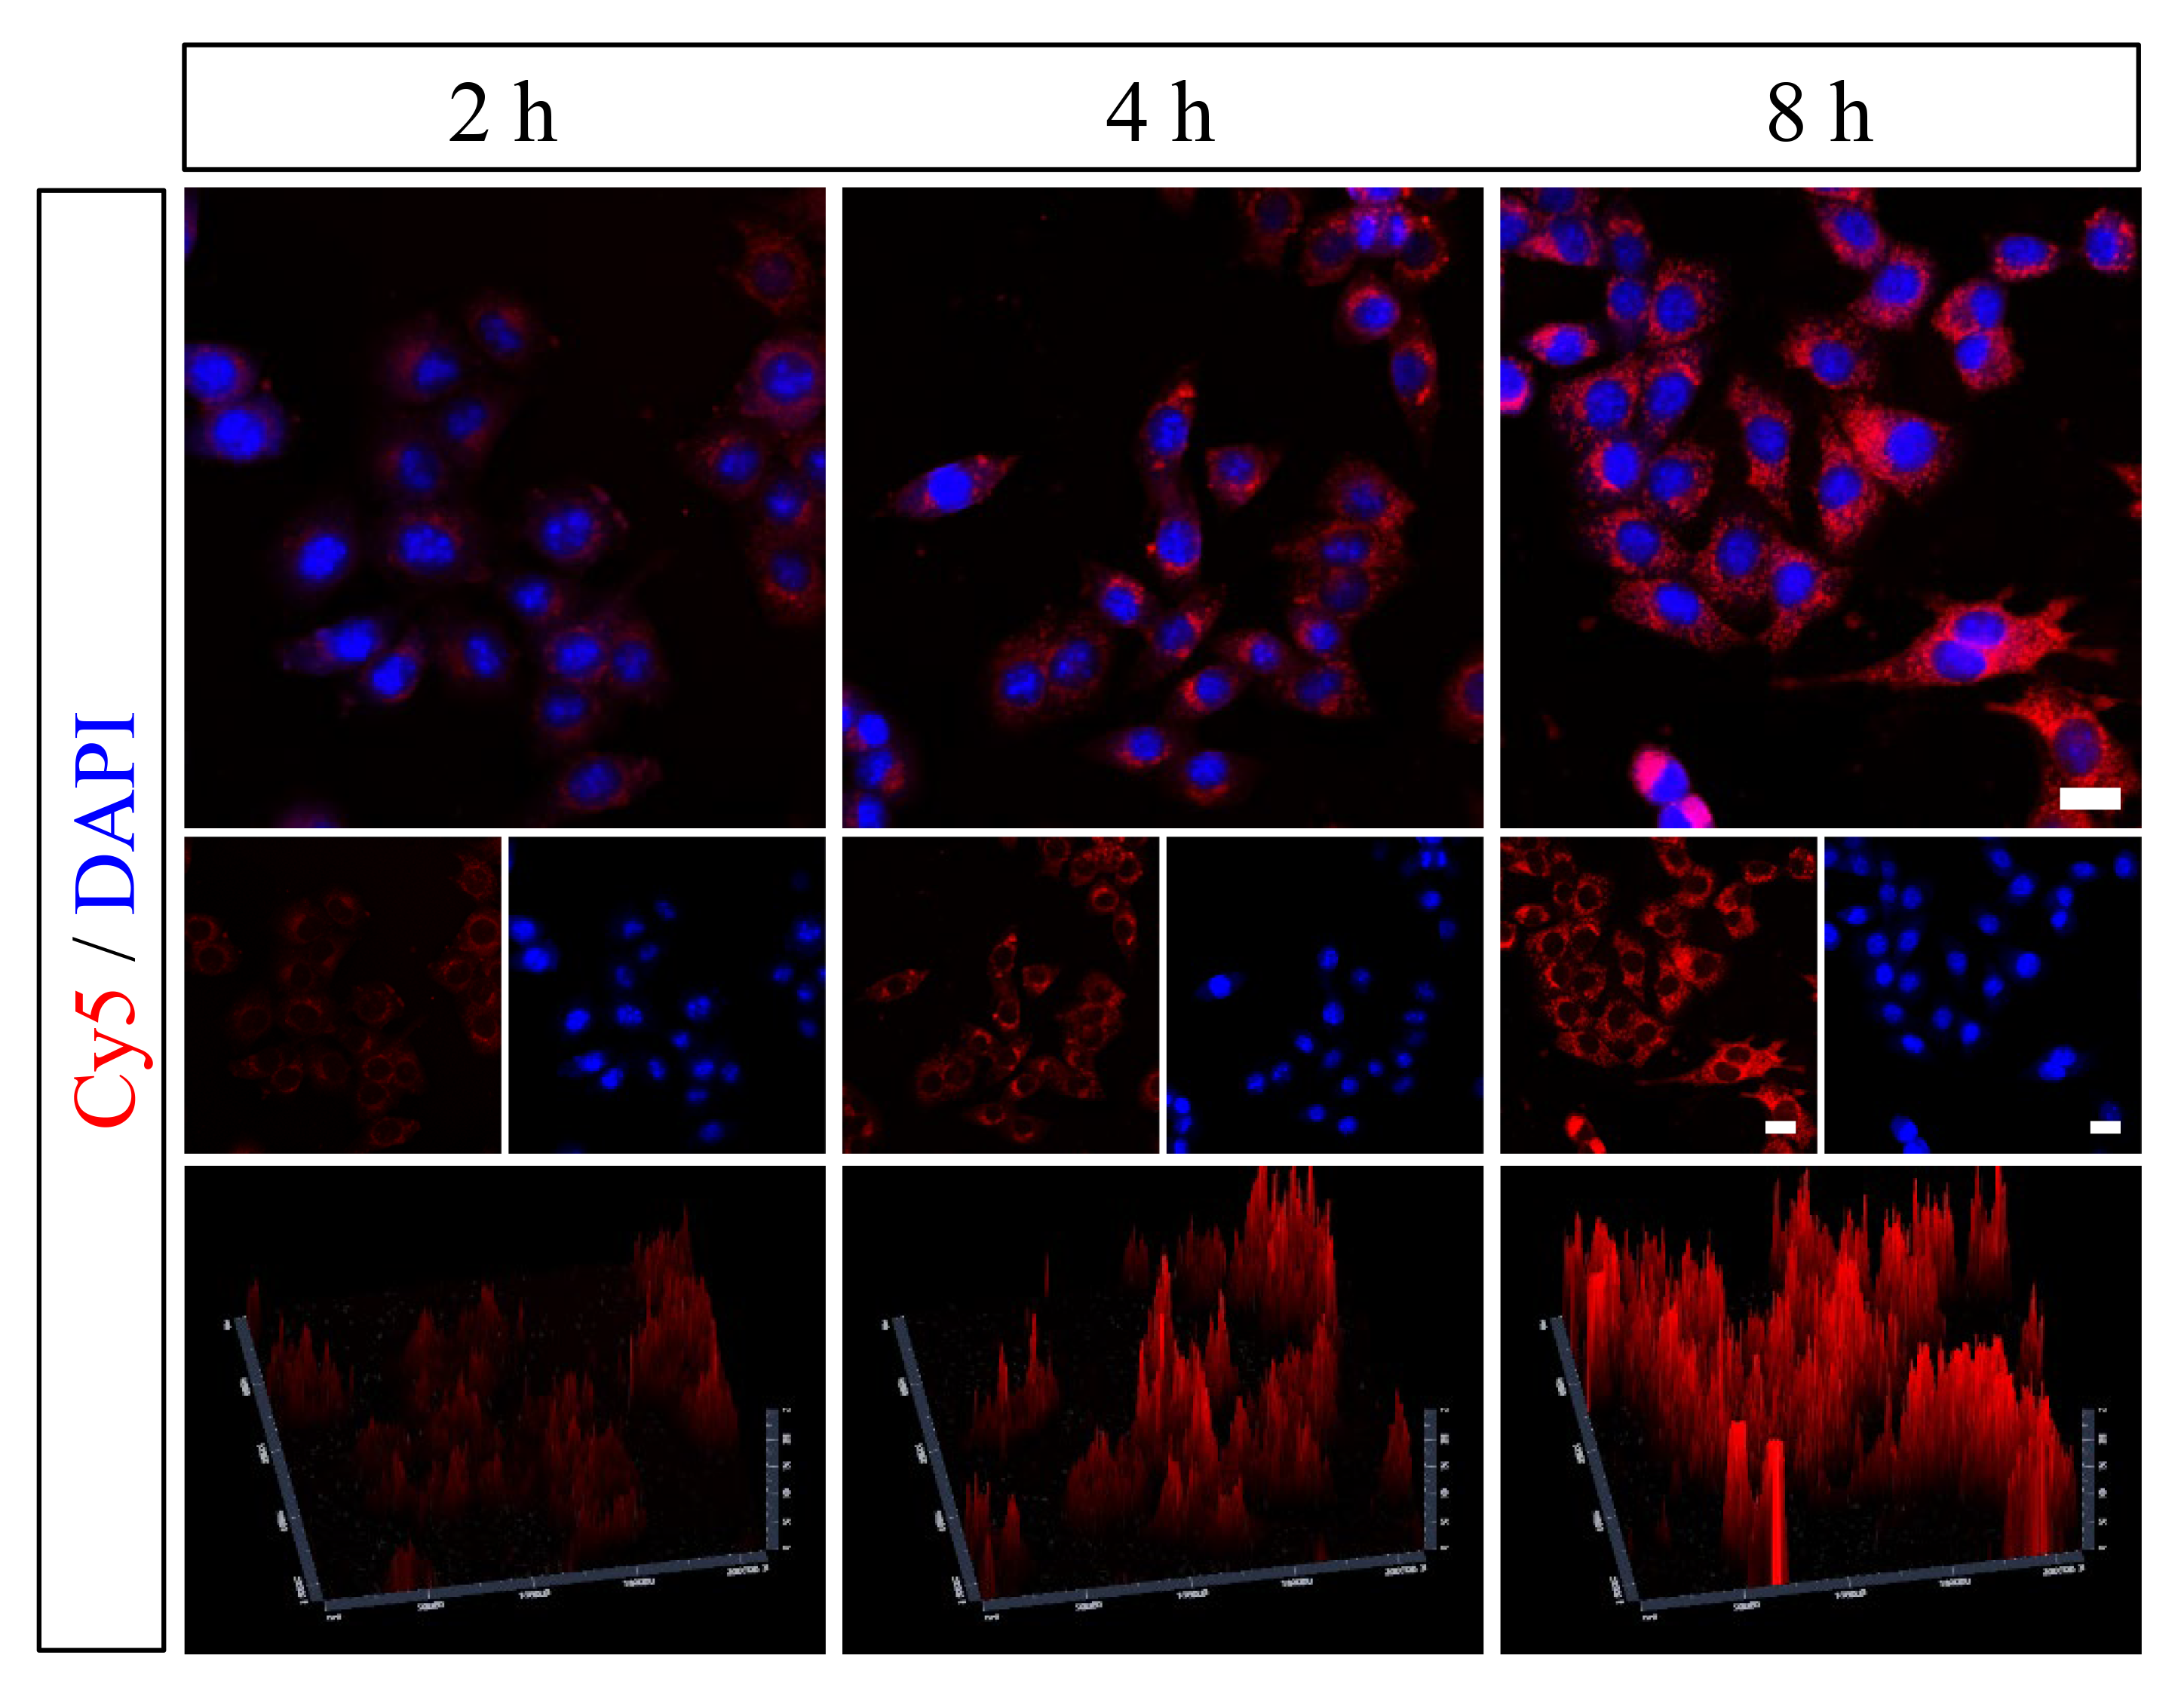
Fig. S10. CLSM images of 4T1 cells co-incubated with Cy5-labeled BCuP@G for different times (2, 4, and 8 h), scale bar: 20 µm.

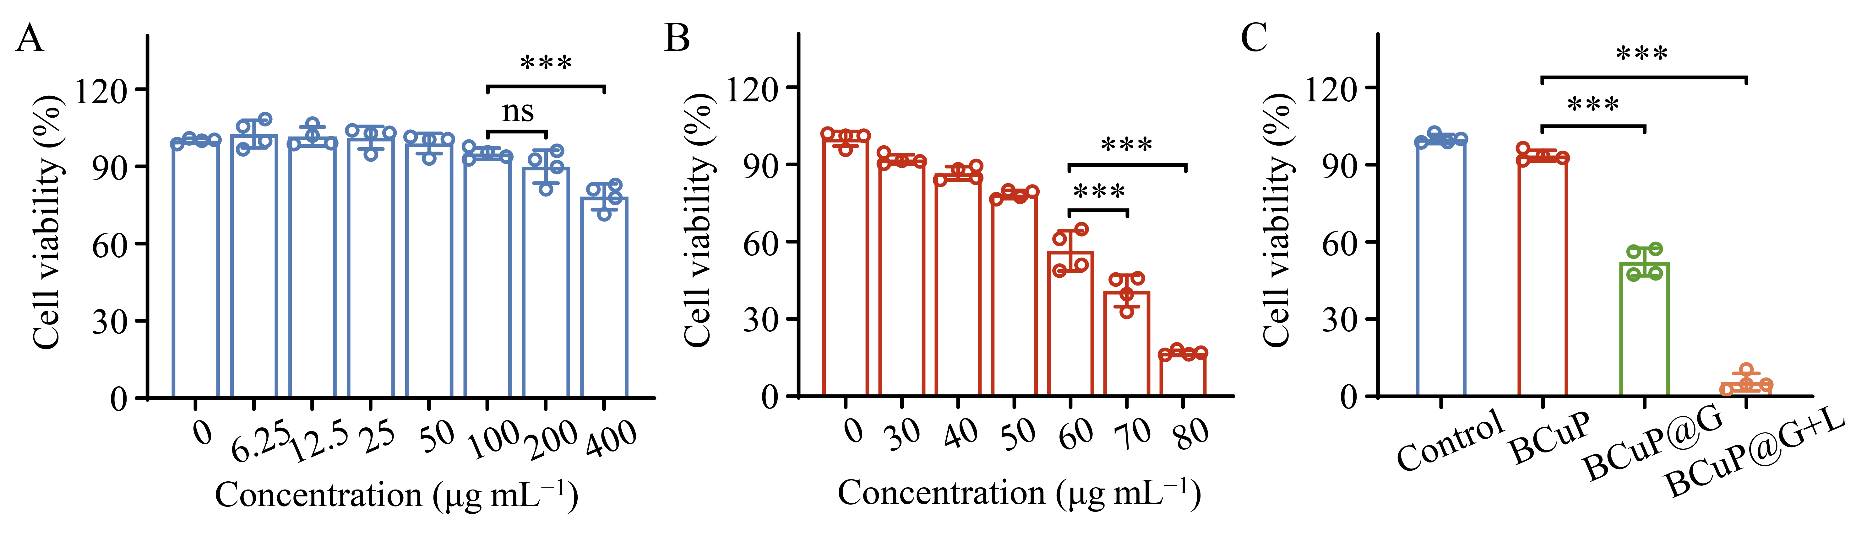
Fig. S11. Cytotoxicity of (A) BCuP and (B) BCuP@G at various concentrations toward MCF-7 cells without laser irradiation. (C) Relative viability of MCF-7 cells after various treatments. Data are expressed as means ± SD (n = 4). Statistical significances were calculated via one-way ANOVA (with Tukey’s HSD post hoc test). *p < 0.05, **p < 0.01, and ***p < 0.001.

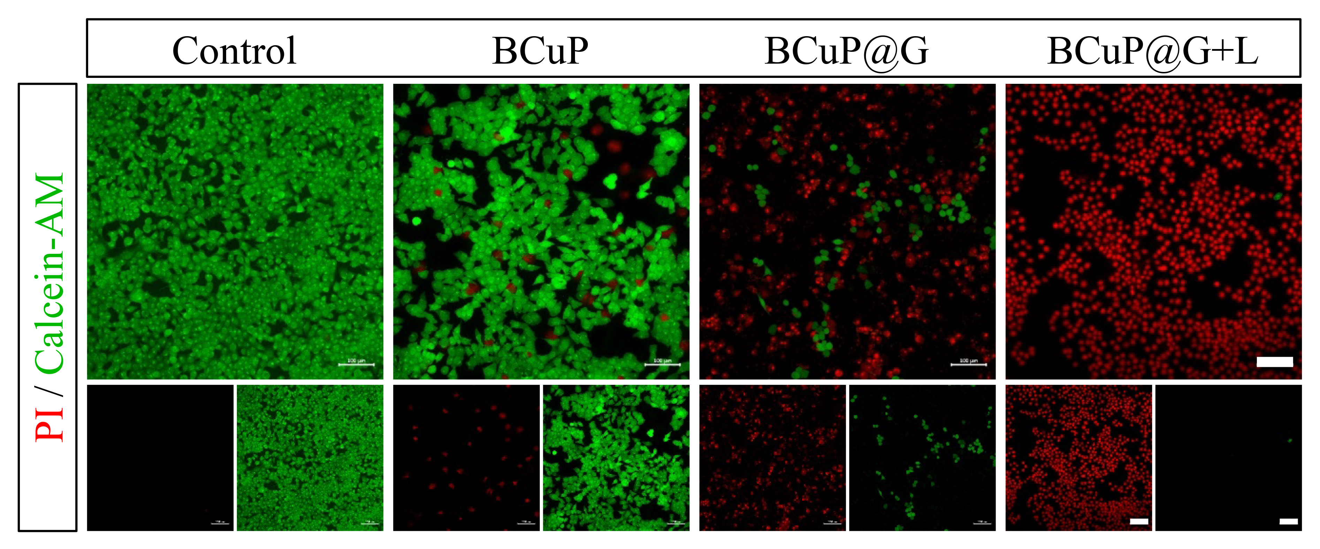
Fig. S12. Calcein-AM/PI staining of 4T1 cells after different treatments, scale bar: 100 µm.

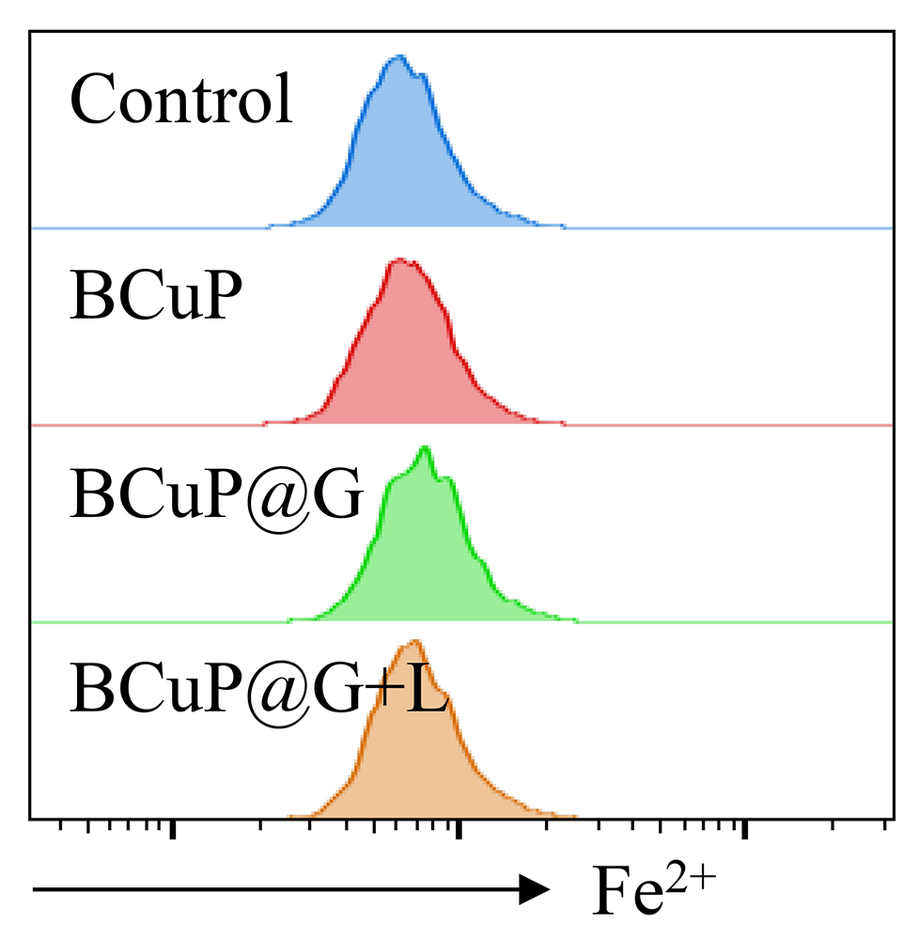
Fig. S13. Flow cytometry analysis of intracellular Fe²⁺ levels in 4T1 cells after different treatments.

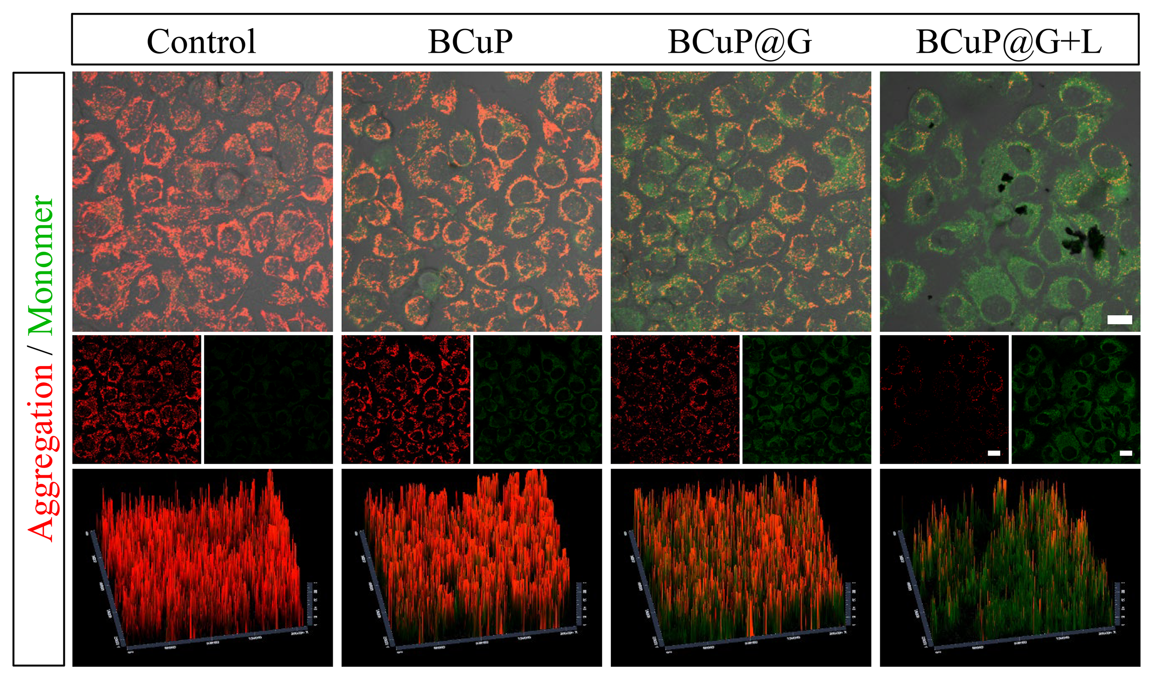
Fig. S14. Mitochondrial membrane potential changes in 4T1 cells after different treatment, scale bar: 20 µm.

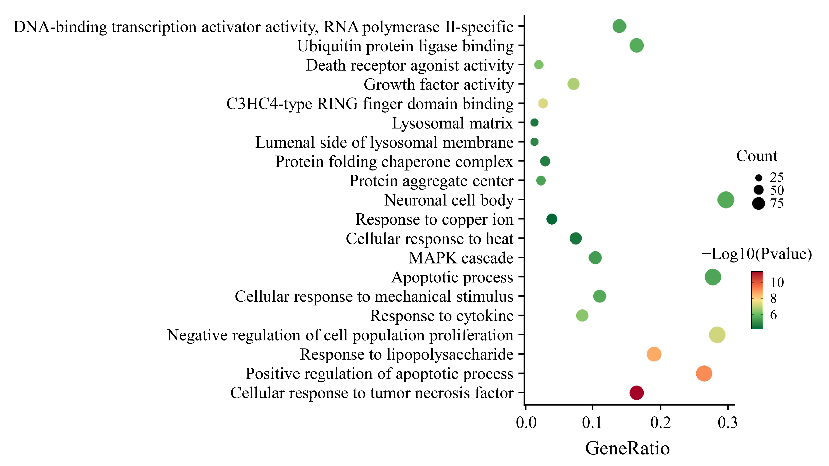
Fig. S15. GO analysis of DEGs in the BCuP@G + L group versus control group.

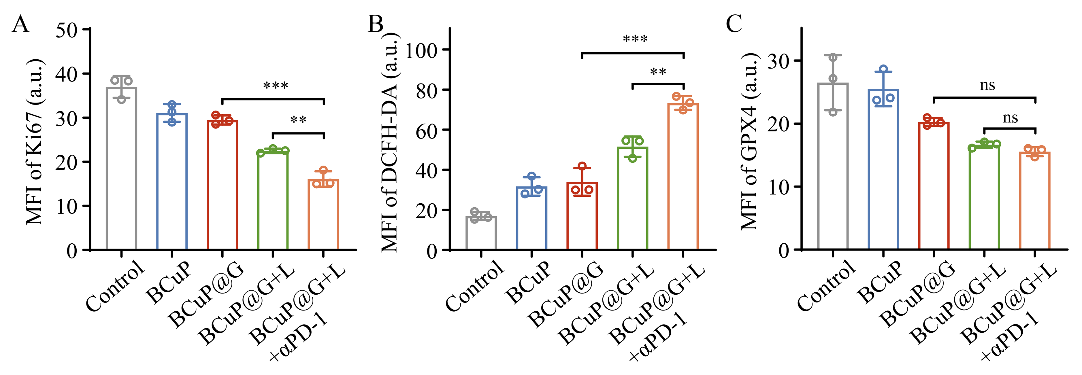
Fig. S16. Quantitative analysis of (A) Ki67, (B) DCFH-DA, and (C) GPX4 fluorescence signals after different treatments. Data are expressed as means ± SD (n = 3). Statistical significances were calculated via one-way ANOVA (with Tukey’s HSD post hoc test). *p < 0.05, **p < 0.01, and ***p < 0.001.

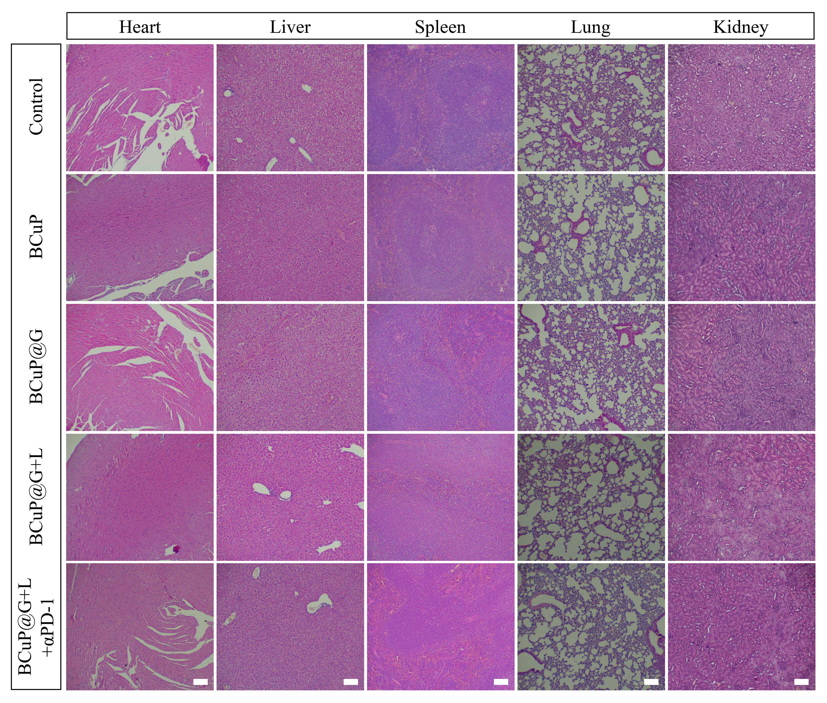
Fig. S17. Histopathological examinations of major organs from mice with different treatments by HE staining, scale bar: 100 μm.

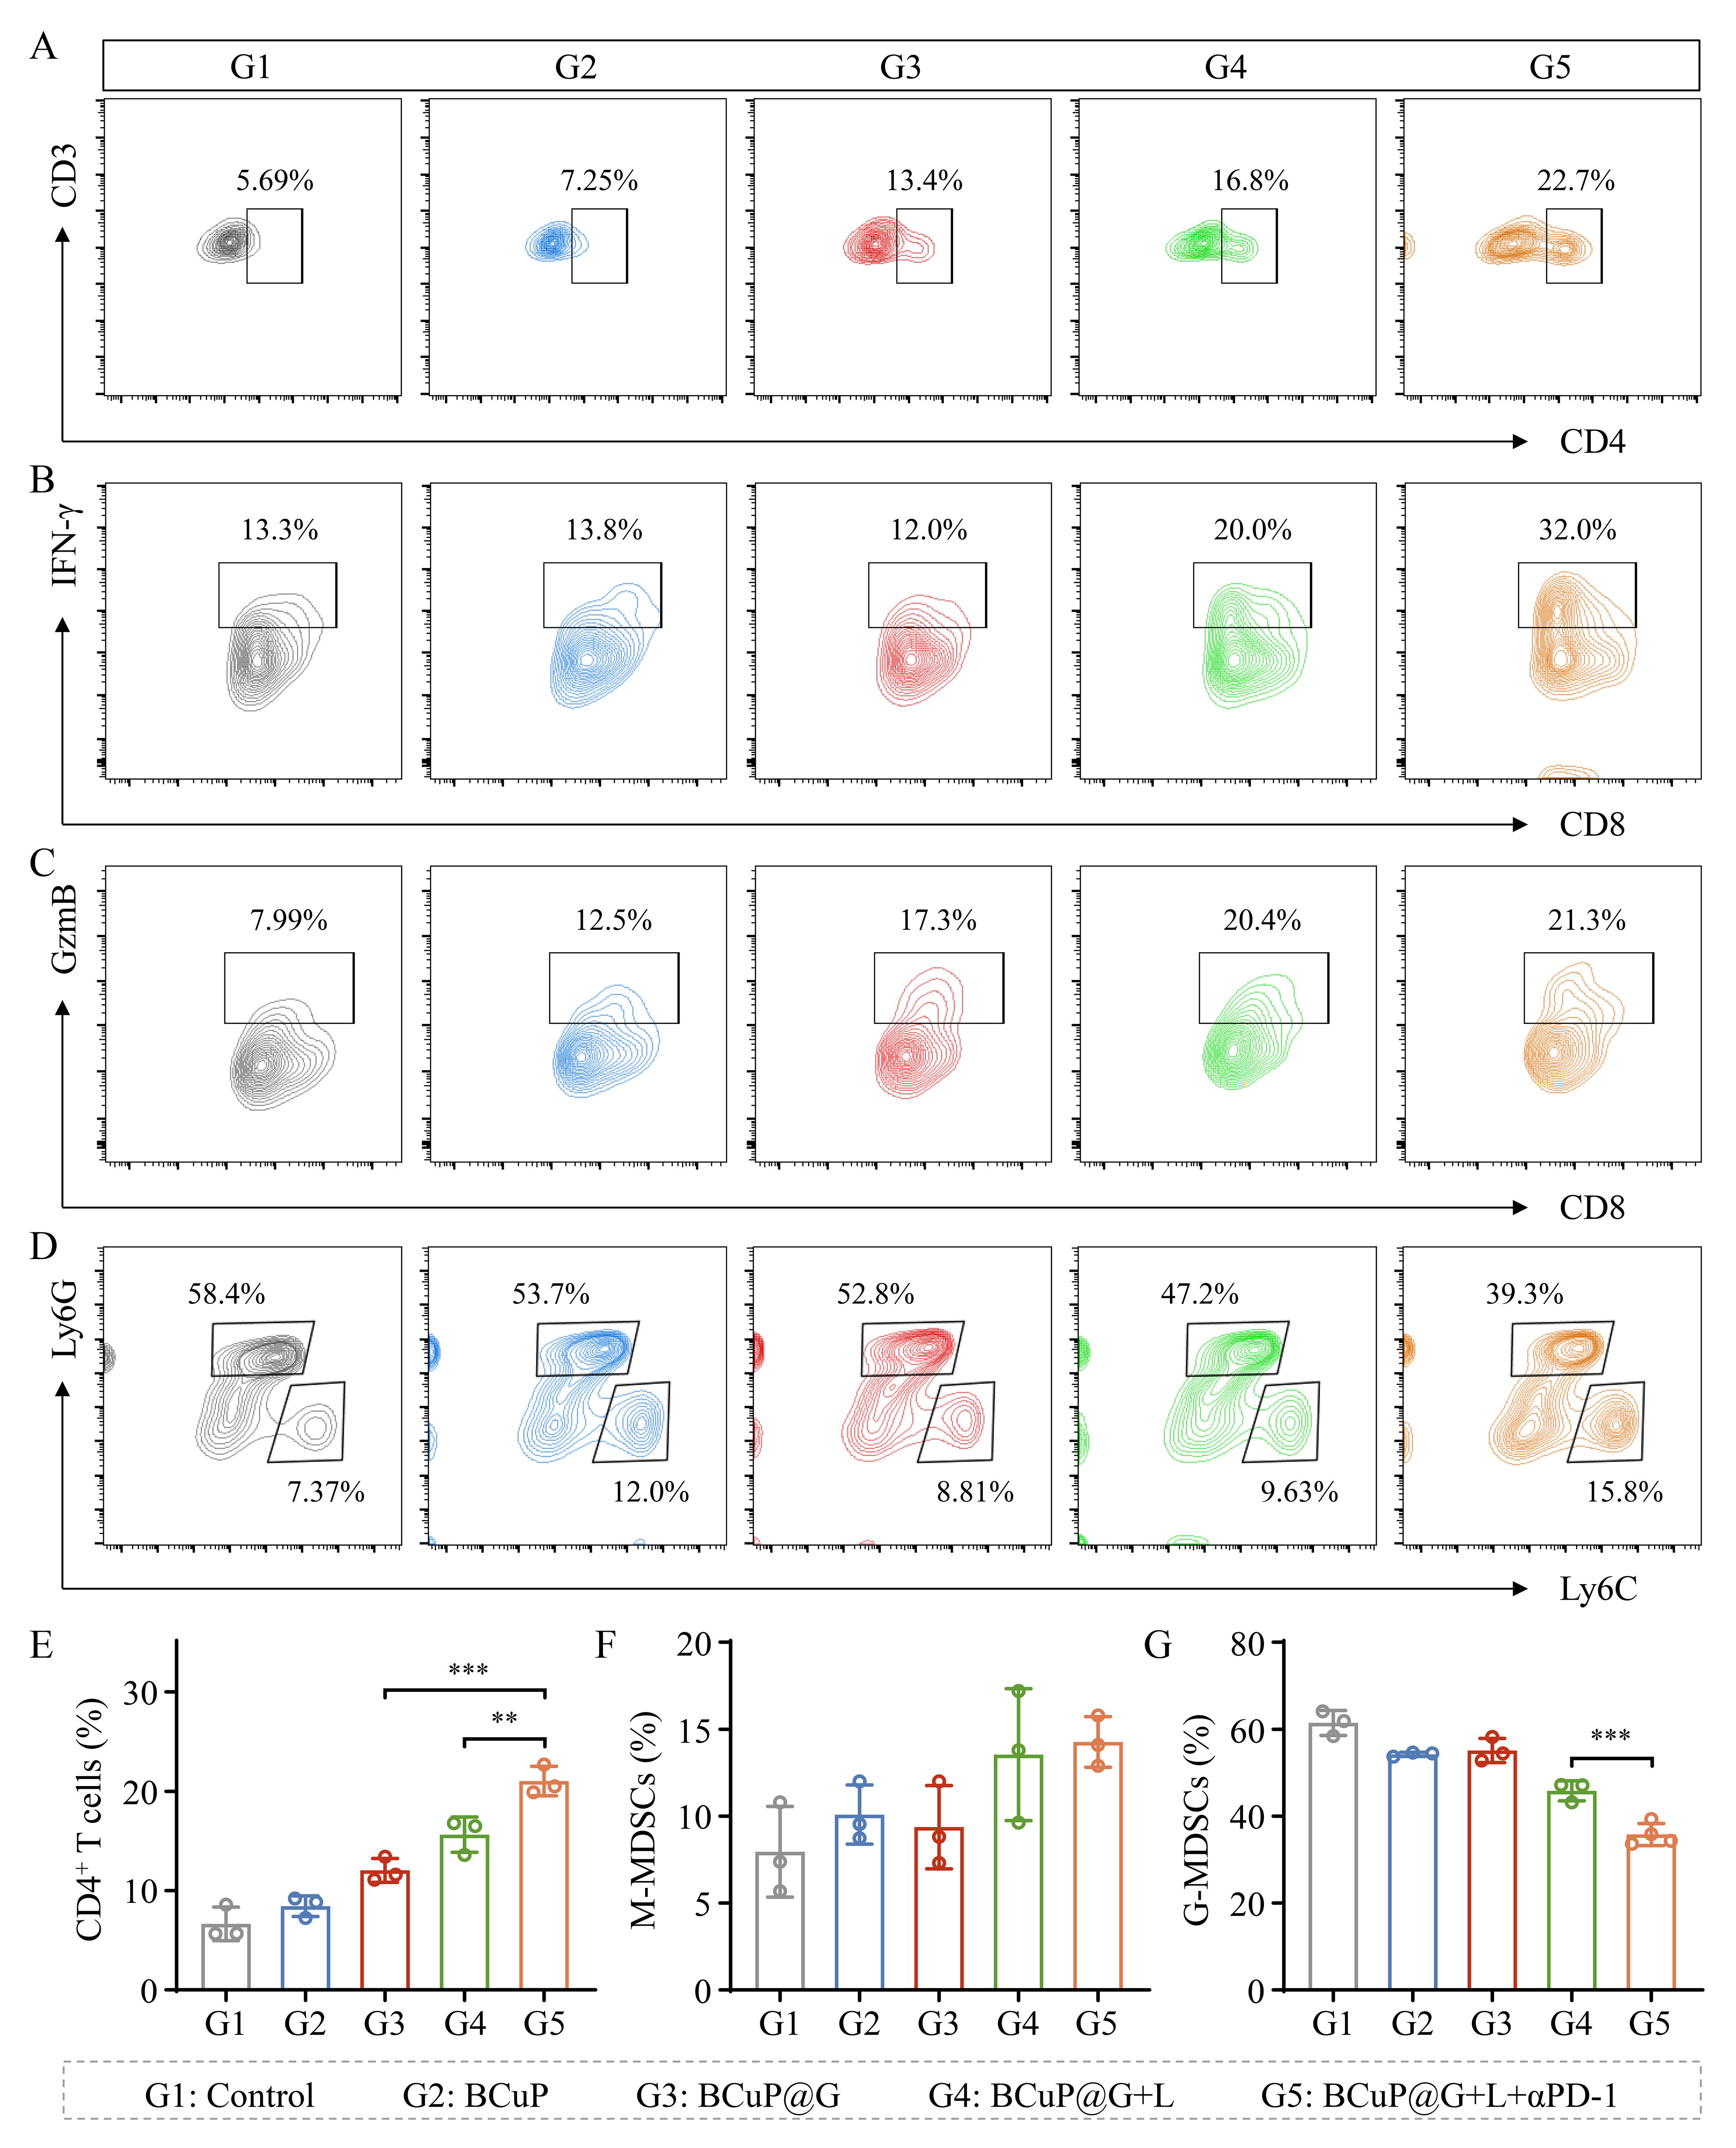
Fig. S18. (A) Flow cytometric analysis and (E) corresponding quantification of tumor-infiltrating CD4⁺ T cells after different treatments. Flow cytometric analysis of tumor-infiltrating (B) IFN-γ⁺CD8⁺ and (C) GzmB⁺CD8⁺ T cells after different treatments. (D) Flow cytometric analysis and (F, G) corresponding quantification of tumor-infiltrating M-MDSCs and G-MDSCs after different treatments. Data are expressed as means ± SD (n = 3). Statistical significances were calculated via one-way ANOVA (with Tukey’s HSD post hoc test). *p < 0.05, **p < 0.01, and ***p < 0.001.

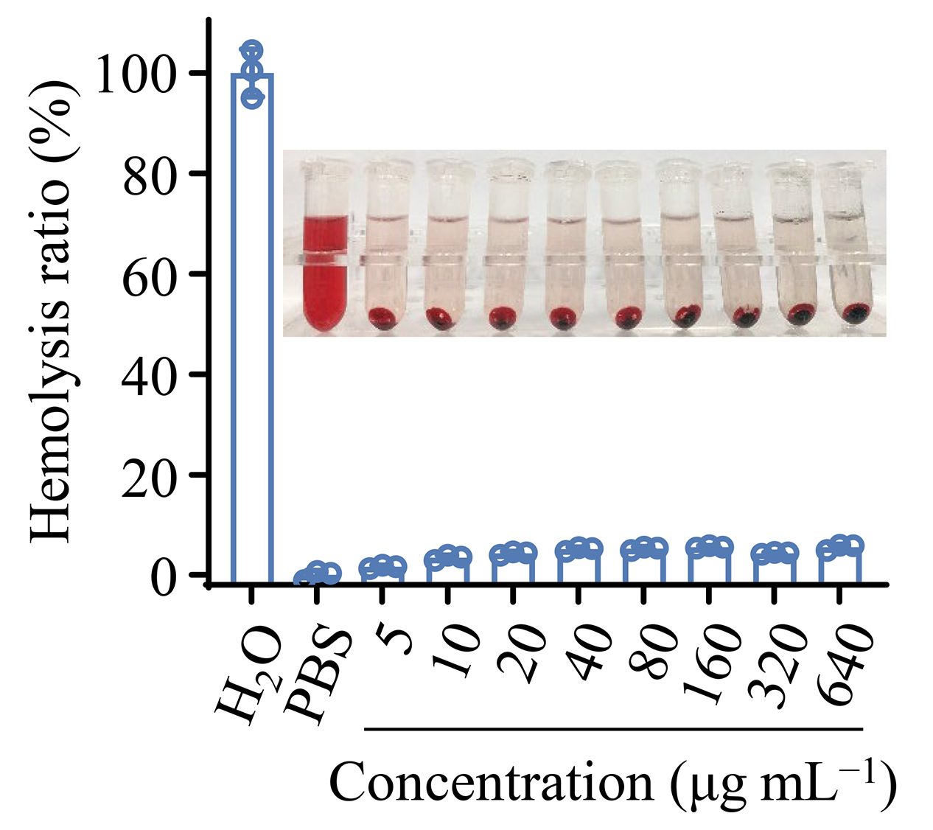
Fig. S19. Hemolysis assay of BCuP@G with different concentrations.

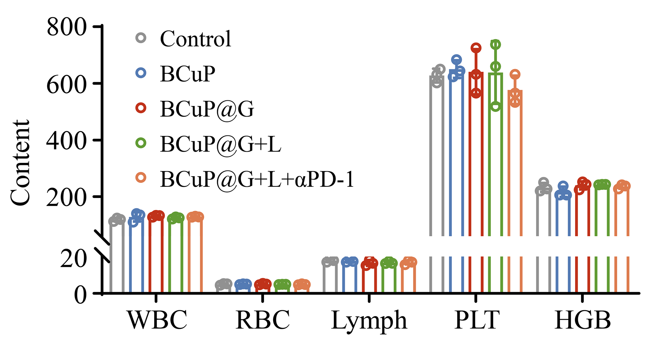
Fig. S20. Hematology analysis of mice with different treatments.

