Supplemental information
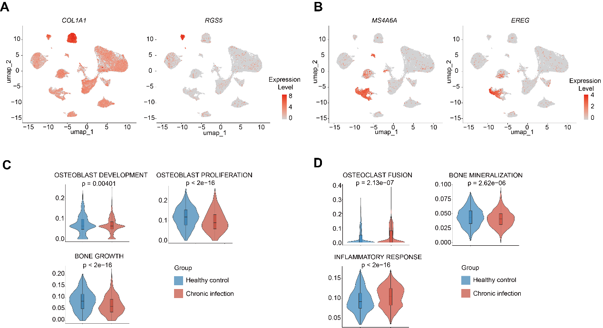
Figure S1. Marker genes of fibroblast-like cells and monocytic cells. (A, B) UMAP plot with colour-coded expression (grey to red) of markers of fibroblast-like cells (A) and monocytic cells (B). (C, D) Gene set scores of the indicated gene sets in cells from healthy controls and patients with chronic infection. The significance of differences between groups was evaluated using the Wilcoxon rank-sum test (C, D). The median values and interquartile ranges are presented.
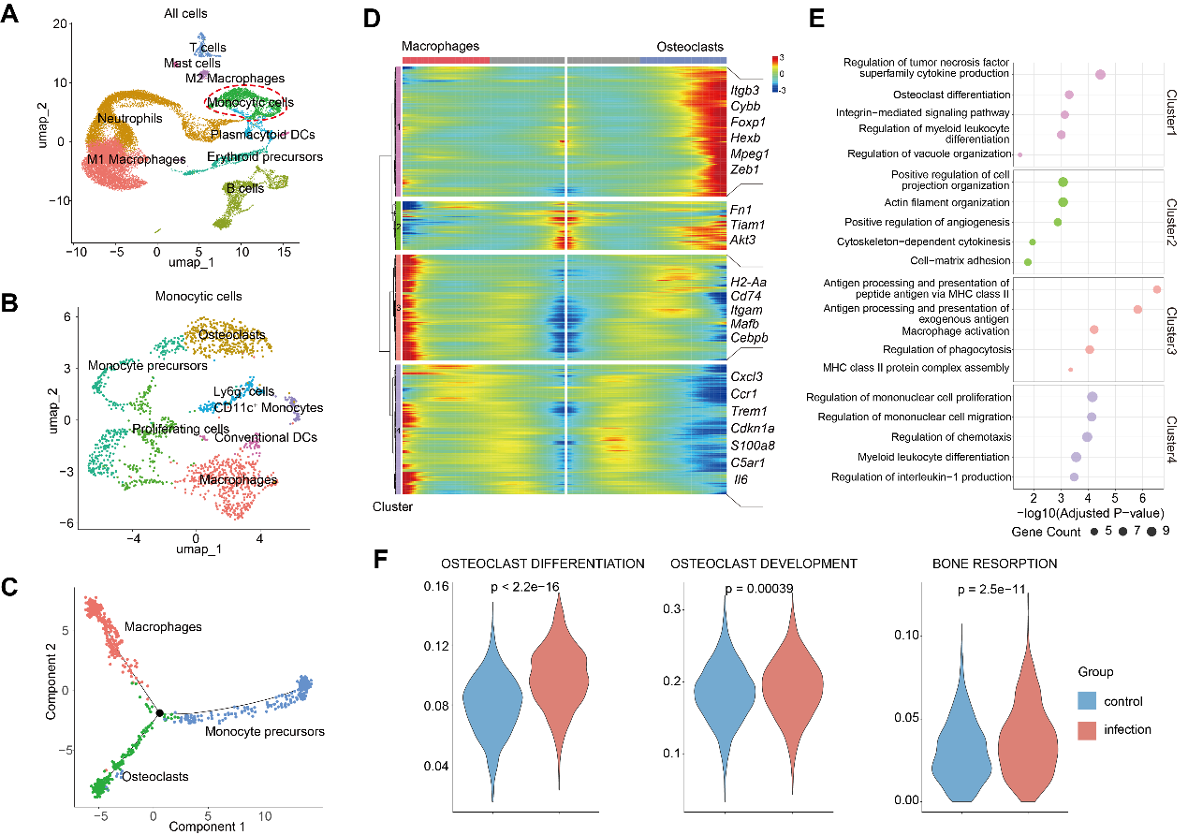
Figure S2. Single-cell sequencing analysis of the microenvironment in osteomyelitis. (A) UMAP plot of cells isolated from control and osteomyelitis samples. The cells within the red dashed lines were further divided into subgroups. DCs: dendritic cells. (B) UMAP plot of monocytic cells. (C) Monocle pseudotime analysis showing the progression of monocyte precursors, macrophages, and osteoclasts. (D) Pseudotemporal depiction of differentially expressed genes in the three branches shown in (C) starting from monocyte precursors and leading to the differentiation of macrophages (left) and osteoclasts (right). Genes were catalogued into 4 major clusters, with representative genes in each cluster listed along the right margin. (E) GO analysis of differentially expressed genes associated with the four gene clusters in (D). (F) Gene set scores of the indicated gene sets in cells from control and infected samples. The significance of differences between groups was evaluated using the Wilcoxon rank-sum test (F).
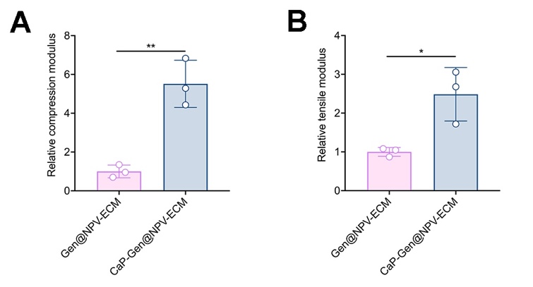
Figure S3. Mechanical properties of the hydrogels. (A) Relative compression moduli of Gen@NPV-ECM and CaP-Gen@NPV-ECM (n = 3). (B) Relative tensile moduli of Gen@NPV-ECM and CaP-Gen@NPV-ECM (n = 3). The significance of differences between two groups was evaluated using a two-tailed Student’s t test (A, B). The mean values and SDs are presented.
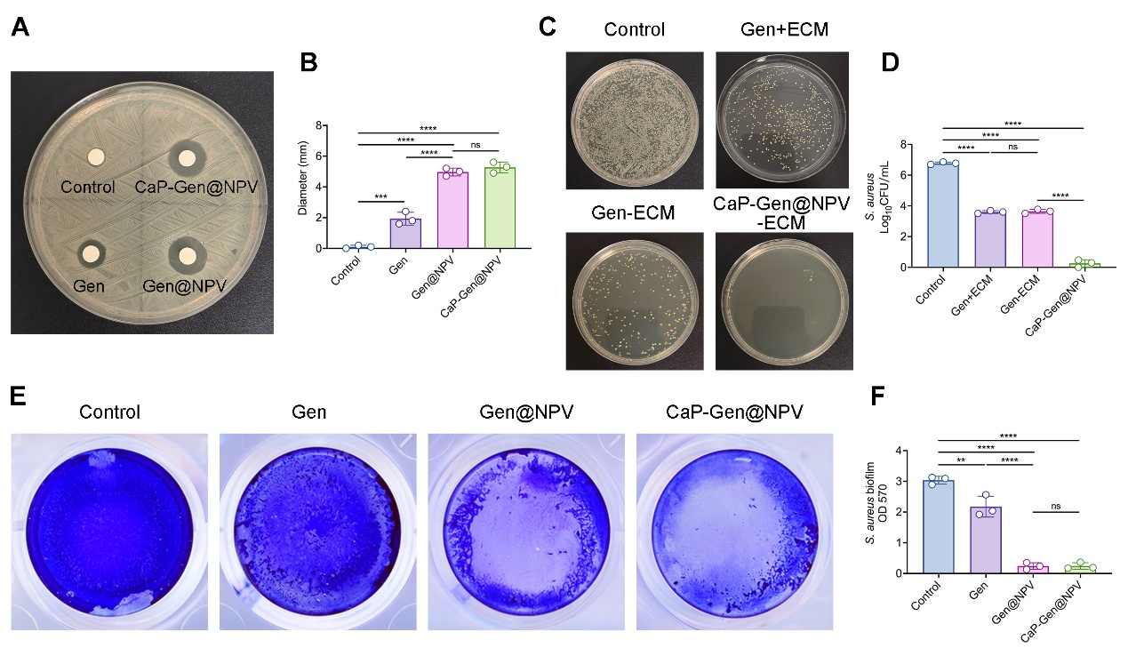
Figure S4. Antibacterial activity of CaP-Gen@NPVs compared with gentamicin. (A) Inhibition zones of S. aureus in each group. (B) Statistical analysis of the inhibition zone diameters in (A) (n = 3). (C) Images of agar plate cultures of S. aureus. (D) Quantification of the number of S. aureus determined by measuring the absorbance at 600 nm (OD600) (n = 3). (E) Crystal violet assay of the biofilm activity of S. aureus. (F) Quantification of the biofilm activity of S. aureus (n = 3). The significance of differences between groups was evaluated using one-way ANOVA with Tukey’s post hoc analysis (B, D, and F). The mean values and SDs are presented.
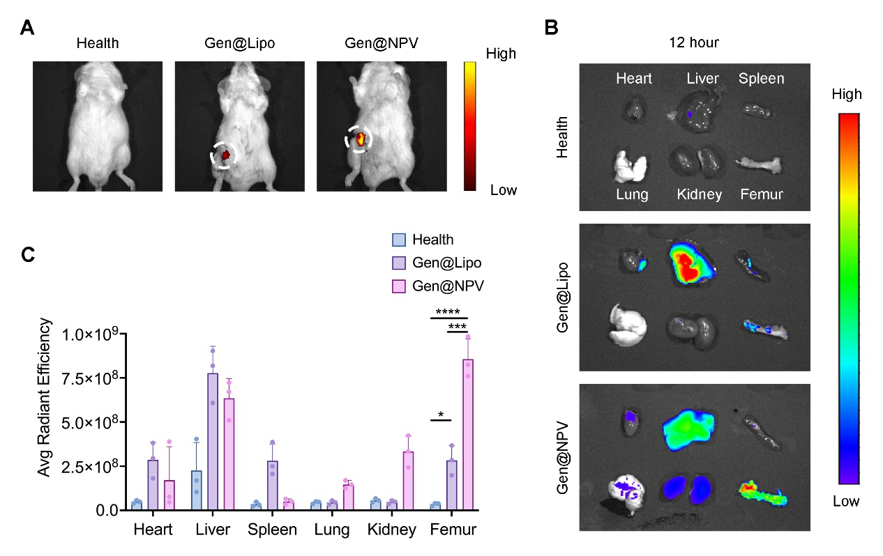
Figure S5. The targeting ability of NPVs. (A, B) In vivo live imaging (A) and ex vivo tissue imaging (B). (C) Statistical analysis of fluorescence intensity in ex vivo tissue images (n = 3 per group). The significance of differences between groups was evaluated using one-way ANOVA with Tukey’s post hoc analysis (C). The mean values and SDs are presented.
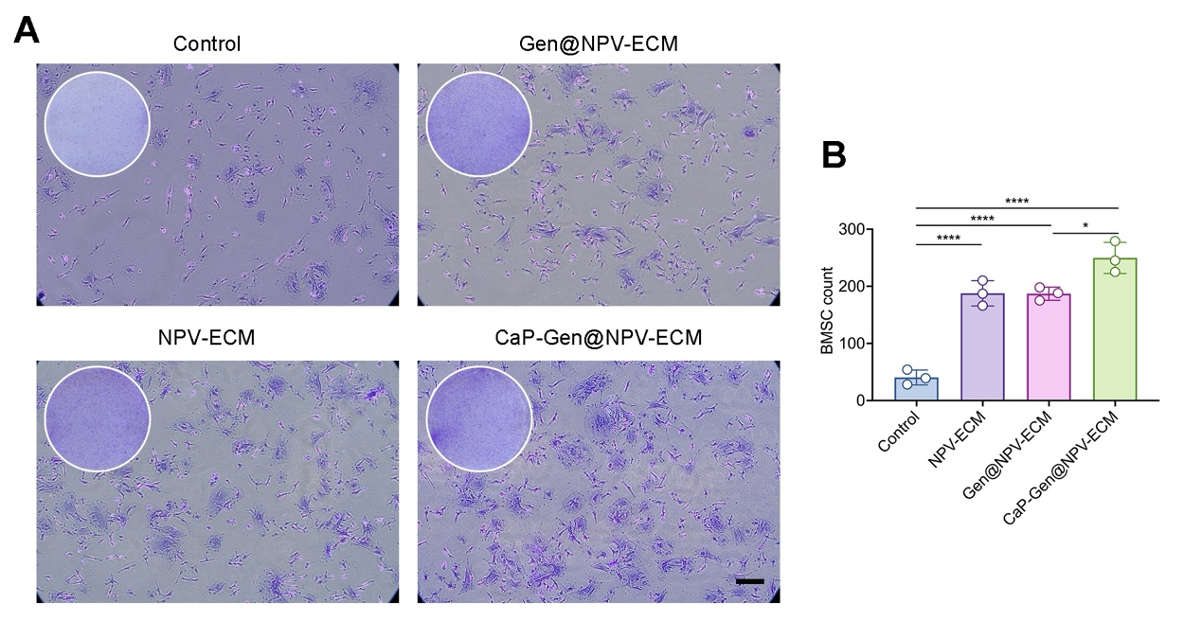
Figure S6. Promotion of cell proliferation by the CaP-Gen@NPV-ECM extract. (A) Representative crystal violet staining images of BMSCs (scale bar = 50 μm). (B) Quantitative analysis of BMSCs (n = 3). The significance of differences between groups was evaluated using one-way ANOVA with Tukey’s post hoc analysis (B). The mean values and SDs are presented.
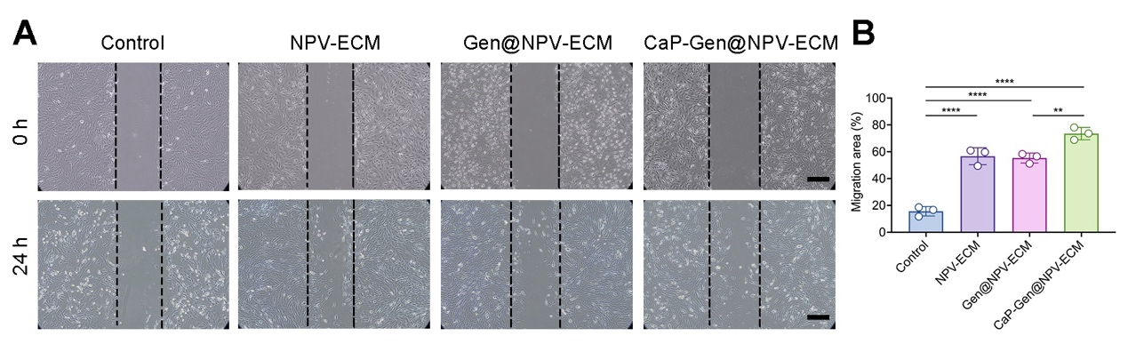
Figure S7. Promotion of cell migration by the CaP-Gen@NPV-ECM extract. (A) Representative images of the BMSC scratch assay for evaluating migration (scale bar = 200 μm). (B) Quantitative analysis of the scratch area (n = 3). The significance of differences between groups was evaluated using one-way ANOVA with Tukey’s post hoc analysis (B). The mean values and SDs are presented.
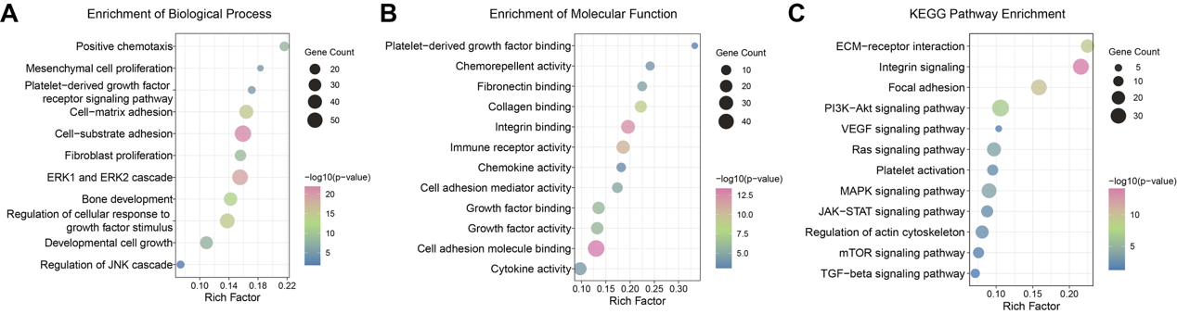
Figure S8. Enrichment analysis of the differentially expressed genes between the NPV-ECM and induced groups. (A) GO enrichment analysis of biological processes. (B) GO enrichment analysis of molecular functions. (C) KEGG enrichment analysis.
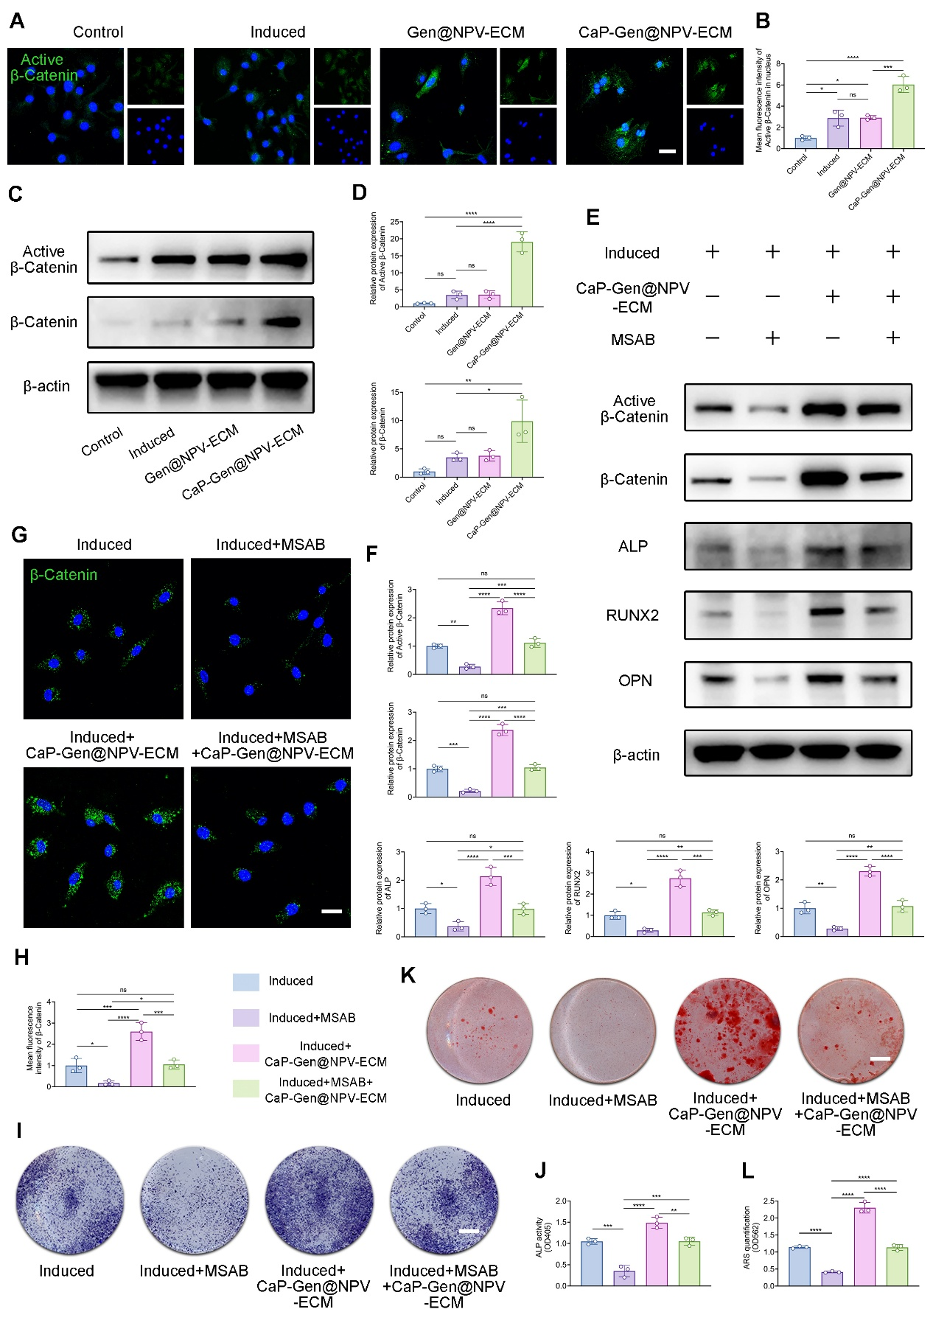
Figure S9. Activation of the Wnt/β-catenin signalling pathway by CaP-Gen@NPV-ECM. (A) Immunofluorescence staining of active β-catenin (scale bar = 10 μm). (B) Quantitative analysis of active β-catenin fluorescence intensity in (A) (n = 3). (C) Western blot analysis of β-catenin expression in BMSCs. (D) Quantitative analysis of the band grey values in (C) (n = 3). (E) Western blot results of β-catenin and osteoblast-related proteins in the MSAB inhibition assay. (F) Quantitative analysis of the band grey values in (E) (n = 3). (G) Immunofluorescence staining of β-catenin in the MSAB inhibition assay (scale bar = 10 μm). (H) Quantitative analysis of β-catenin fluorescence intensity in (G) (n = 3). (I) ALP staining of BMSCs in the MSAB inhibition assay (scale bar = 3 mm). (J) Quantification of ALP staining by determination of the OD405 (n = 3). (K) Alizarin Red staining in the MSAB inhibition assay (scale bar = 3 mm). (L) Quantification of Alizarin Red staining by measurement of OD562 (n = 3). The significance of differences between groups was evaluated using one-way ANOVA with Tukey’s post hoc analysis (B, D, F, H, J, and L). The mean values and SDs are presented.
Table S1 Comparison of CaP-Gen@NPV-ECM with representative antibacterial bone scaffolds.
System | Core Component | Main Mechanism | Key Advantage of CaP-Gen@NPV-ECM | Ref.
ZIF-8@CuO/PLGA | ZIF-8 metal-organic framework encapsulating CuO nanoparticles within a PLGA scaffold | pH-responsive ion release and NIR-triggered photothermal/photodynamic therapy; osteogenesis via ROS scavenging and recruiting ions for mineralization. | Offering superior biocompatibility and bacterial targeting ability as an antibiotic carrier; achieving bidirectional regulation of bone metabolism—actively inhibiting osteoclasts while promoting osteogenesis. | ¹
PVA/GG_ZnBG | 3D bioprinted PVA/GG hydrogel scaffold laden with zinc-doped BG microparticles | Sustained release of Zn²⁺ ions provides antibacterial activity and promotes osteogenic differentiation. | Offering a more direct and efficient method for killing bacteria; specifically inhibiting excessive activation of osteoclasts while promoting osteogenesis; demonstrating comprehensive effects in more complex animal models. | ²
CH/FeCu@SiO₂ | A CH scaffold integrated with copper-doped iron goethite nanoparticles and a mesoporous silica layer | NIR-activated mild hyperthermia and Cu/Fe ion release synergistically enable antibacterial action; ROS scavenging promotes M2 macrophage polarization and osteogenesis. | Lower immunogenicity and higher bacterial targeting ability; inhibiting osteoclastogenesis and promoting osteogenesis simultaneously; integrating with in situ mineralized CaP for structural and signalling biomimicry. | ³
AIE NPs@BP NSs@FSs | AIEgens-loaded nanoparticles, black phosphorus nanosheets, and PCL/PLGA polymer fibers | Photothermal bacterial ablation by AIE NPs upon NIR-II irradiation; ROS scavenging and M2 macrophage polarization by BP NSs. | No external device stimulation required; antibiotic-loaded NPVs for more direct and efficient action in deep-seated infections; inhibiting osteoclasts while promoting osteogenesis. | ⁴
GPI hydrogels | Cationic peptide bundles crosslinked with gelatin and oxidized sodium alginate via Schiff base reactions, supplemented with icariin | pH-triggered release of peptide bundles disrupting bacterial membranes; the gel network recruiting osteoblasts; icariin promoting osteogenic differentiation of osteoblasts. | Providing bacterial targeting and low immunogenicity for enhanced clinical safety; enabling sustained Ca²⁺ release to actively drive osteogenic differentiation; suppressing infection-induced osteoclast overactivation and restoring the osteoblast-osteoclast balance. | ⁵
GHMs@G1-N-A/T | Vanillin-crosslinked gelatin microspheres with n-HA/MgO₂, linked via a gelatinase-cleavable peptide to aptamer-functionalized gelatin nanospheres carrying telavancin. | Aptamer-guided recognition of bacteria; acidic pH-triggered MgO₂-derived ROS generation; bacterial gelatinase-mediated cleavage of the peptide linker to release antibiotics; sustained release of Mg²⁺/Ca²⁺ promoting angiogenesis and bone regeneration. | Employing natural platelet-derived nanovesicles, eliminating the need for complex synthetic modifications; addressing the osteoblast-osteoclast imbalance characteristic of infectious bone defects; biomimetically recapitulating bone's natural composite and structure by in situ mineralized CaP. | ⁶
CTMN@PTLH | Polymer microspheres (PTMC/PLLA) incorporating tea polyphenol-magnesium (TP-Mg) nanoparticles stabilized by γ-cyclodextrin | Providing structural support for bone defect repair; releasing TP and Mg²⁺ via surface degradation; promoting osteogenesis, antibacterial activity, and M2 macrophage polarization. | Delivering antibiotic in a pathogen-specific way by NPVs; simultaneously enhancing osteogenesis while attenuating osteoclast-mediated bone resorption; minimizing immunogenicity and avoiding synthetic polymer-associated degradation concerns. | ⁷
sp-EMS | Biomimetic self-assembly of mineralized collagen fibrils and silver ultrathin nanowires (Ag uNWs) to form self-promoted electroactive mineralized scaffold | Ag⁺ ions and ROS providing antibacterial activity; electrical stimulation from Ag uNWs generating a sustained microcurrent that activates voltage-gated calcium channels (VGCCs), enhancing osteogenic differentiation. | Enabling more precise antibiotic delivery and potent biofilm eradication; counteracting the pathological osteoclast overactivation beyond promoting osteogenesis; avoiding the potential long-term tissue accumulation and toxicity risks of synthetic materials. | ⁸
PEG-EGaIn-Col-Ap-lamellar | Gallium-indium liquid metal nanocapsules stabilized by PEG and coated onto a collagen-apatite lamellar matrix | Ga³⁺ potentially disrupting bacterial iron metabolism and physically damaging cell membranes; promoting osteogenesis via Ga³⁺ release. | Offering a natural system derived from platelets with high biosafety and potential for clinical translation; simultaneously suppressing osteoclast overactivation and promoting osteoblast differentiation; mimicking bone components and enabling sustained Ca²⁺ release to actively enhance osteogenesis. | ⁹
Oriented porous scaffolds with CS/HAP/CNT-TCNCs | CS/HAP matrix with CNTs dispersed by TCNCs. | CNT-mediated photothermal antibacterial effect; radial structure of the material mediating cell migration and infiltration. | Enabling bacteria targeting and controlled antibiotic release; simultaneously suppressing osteoclast overactivation while promoting osteogenesis; exhibiting therapeutic action without external energy input. | ¹⁰
ZIF-8, Zeolitic imidazolate framework-8; PLGA, Poly(lactic-co-glycolic acid); NIR, near‐infrared; ROS, reactive oxygen species; PVA, polyvinyl alcohol; GG, gellan gum; BG, bioactive glasses; CH, chitosan-hydroxyapatite; PCL, polycaprolactone; n-HA, nano-hydroxyapatite; PTMC, polytrimethylene carbonate; PLLA, polylactic acid; PEG, polyethylene glycol; CS, chitosan; HAP, hydroxyapatite; CNT, carbon nanotube; TCNC, tunicate cellulose nanocrystal
Table S2 Summary of PCR primers.
Gene Name | Primer sequence (5' to 3')
β-actin | F: GTGACGTTGACATCCGTAAAGA
β-actin | R: GCCGGACTCATCGTACTCC
Nfatc1 | F: GGAGAGTCCGAGAATCGAGAT
Nfatc1 | R: TTGCAGCTAGGAAGTACGTCT
Mmp9 | F: GCAGAGGCATACTTGTACCG
Mmp9 | R: TGATGTTATGATGGTCCCACTTG
c-fos | F: CGGGTTTCAACGCCGACTA
c-fos | R: TGGCACTAGAGACGGACAGAT
Atp6v0d2 | F: CTGGTTCGAGGATGCAAAGC
Atp6v0d2 | R: GTTGCCATAGTCCGTGGTCTG
Acp5 | F: CACTCCCACCCTGAGATTTGT
Acp5 | R: CCCCAGAGACATGATGAAGTCA
Ctsk | F: CTCGGCGTTTAATTTGGGAGA
Ctsk | R: TCGAGAGGGAGGTATTCTGAGT
Alpl | F: GCTGATCATTCCCACGTTTT
Alpl | R: CTGGGCCTGGTAGTTGTTGT
Runx2 | F: GCCGGGAATGATGAGAACTA
Runx2 | R: GGACCGTCCACTGTCACTTT
Bglap | F: GCGCTCTGTCTCTCTGACCT
Bglap | R: TTTGTAGGCGGTCTTCAAGC
Sp7 | F: GAGGAAGAAGCCCATTCACA
Sp7 | R: GCAGGCAGGTGAACTTCTTC
Col1a1 | F: GAGCGGAGAGTACTGGATCG
Col1a1 | R: TACTCGAACGGGAATCCATC
Spp1 | F: TGCACCCAGATCCTATAGCC
Spp1 | R: CTCCATCGTCATCATCATCG

Reference
1. Li, W. et al. Intelligent responsive zeolitic imidazolate framework-8@copper oxide nanocomposite 3D-printed scaffolds for efficient repair of infected bone defects. ACS Nano 19, 35154–35180 (2025).
2. Loukelis, K. et al. 3D bioprinted constructs enriched with zinc-doped bioactive glass promote antibacterial activity and osteochondral tissue regeneration. Adv. Healthcare Mater. 15, e03186 (2026).
3. Li, X. et al. Diatom-inspired scaffold for infected bone defect therapy: achieving stable photothermal properties and coordinated antibacterial-osteogenic functions. Adv. Mater. 38, e09997 (2026).
4. Yang, Q. et al. NIR-II responsive multifunctional scaffold enabling “kill-modulation-build” synergistic therapy for infectious bone defects. Adv. Sci. 12, e08948 (2025).
5. Sun, Y. et al. Adaptive cationic peptide bundles hydrogel for the repair of infected mandibular defects. Biomaterials 325, 123613 (2026).
6. Zhang, R. et al. Multifunctional, enzyme/pH-responsive gelatin microspheres with aptamer-targeted antibacterial and ionic-mediated dual therapy for infected bone defects. Biomaterials 326, 123642 (2026).
7. He, J. et al. Synergistic integration of bio-mineralized nanoparticles and porous microsphere scaffolds for dual bioactive delivery in bone regeneration. J. Controlled Release 386, 114097 (2025).
8. Li, Z. et al. Self-promoted electroactive biomimetic mineralized scaffolds for bacteria-infected bone regeneration. Nat. Commun. 14, 6963 (2023).
9. Mwangi, K. H. et al. Microanatomy related biocidal activity at cellular resolution and bone reconstruction potential of PEG EGaIn nanocapsules. npj Biofilms Microbiomes 11, 123–138 (2025).
10. Yu, H. et al. Oriented nano-homogeneous biomimetic scaffolds regulate cell alignment and promote endogenous bone regeneration. Small e14683 (2026).

