Supplementary Figure 1
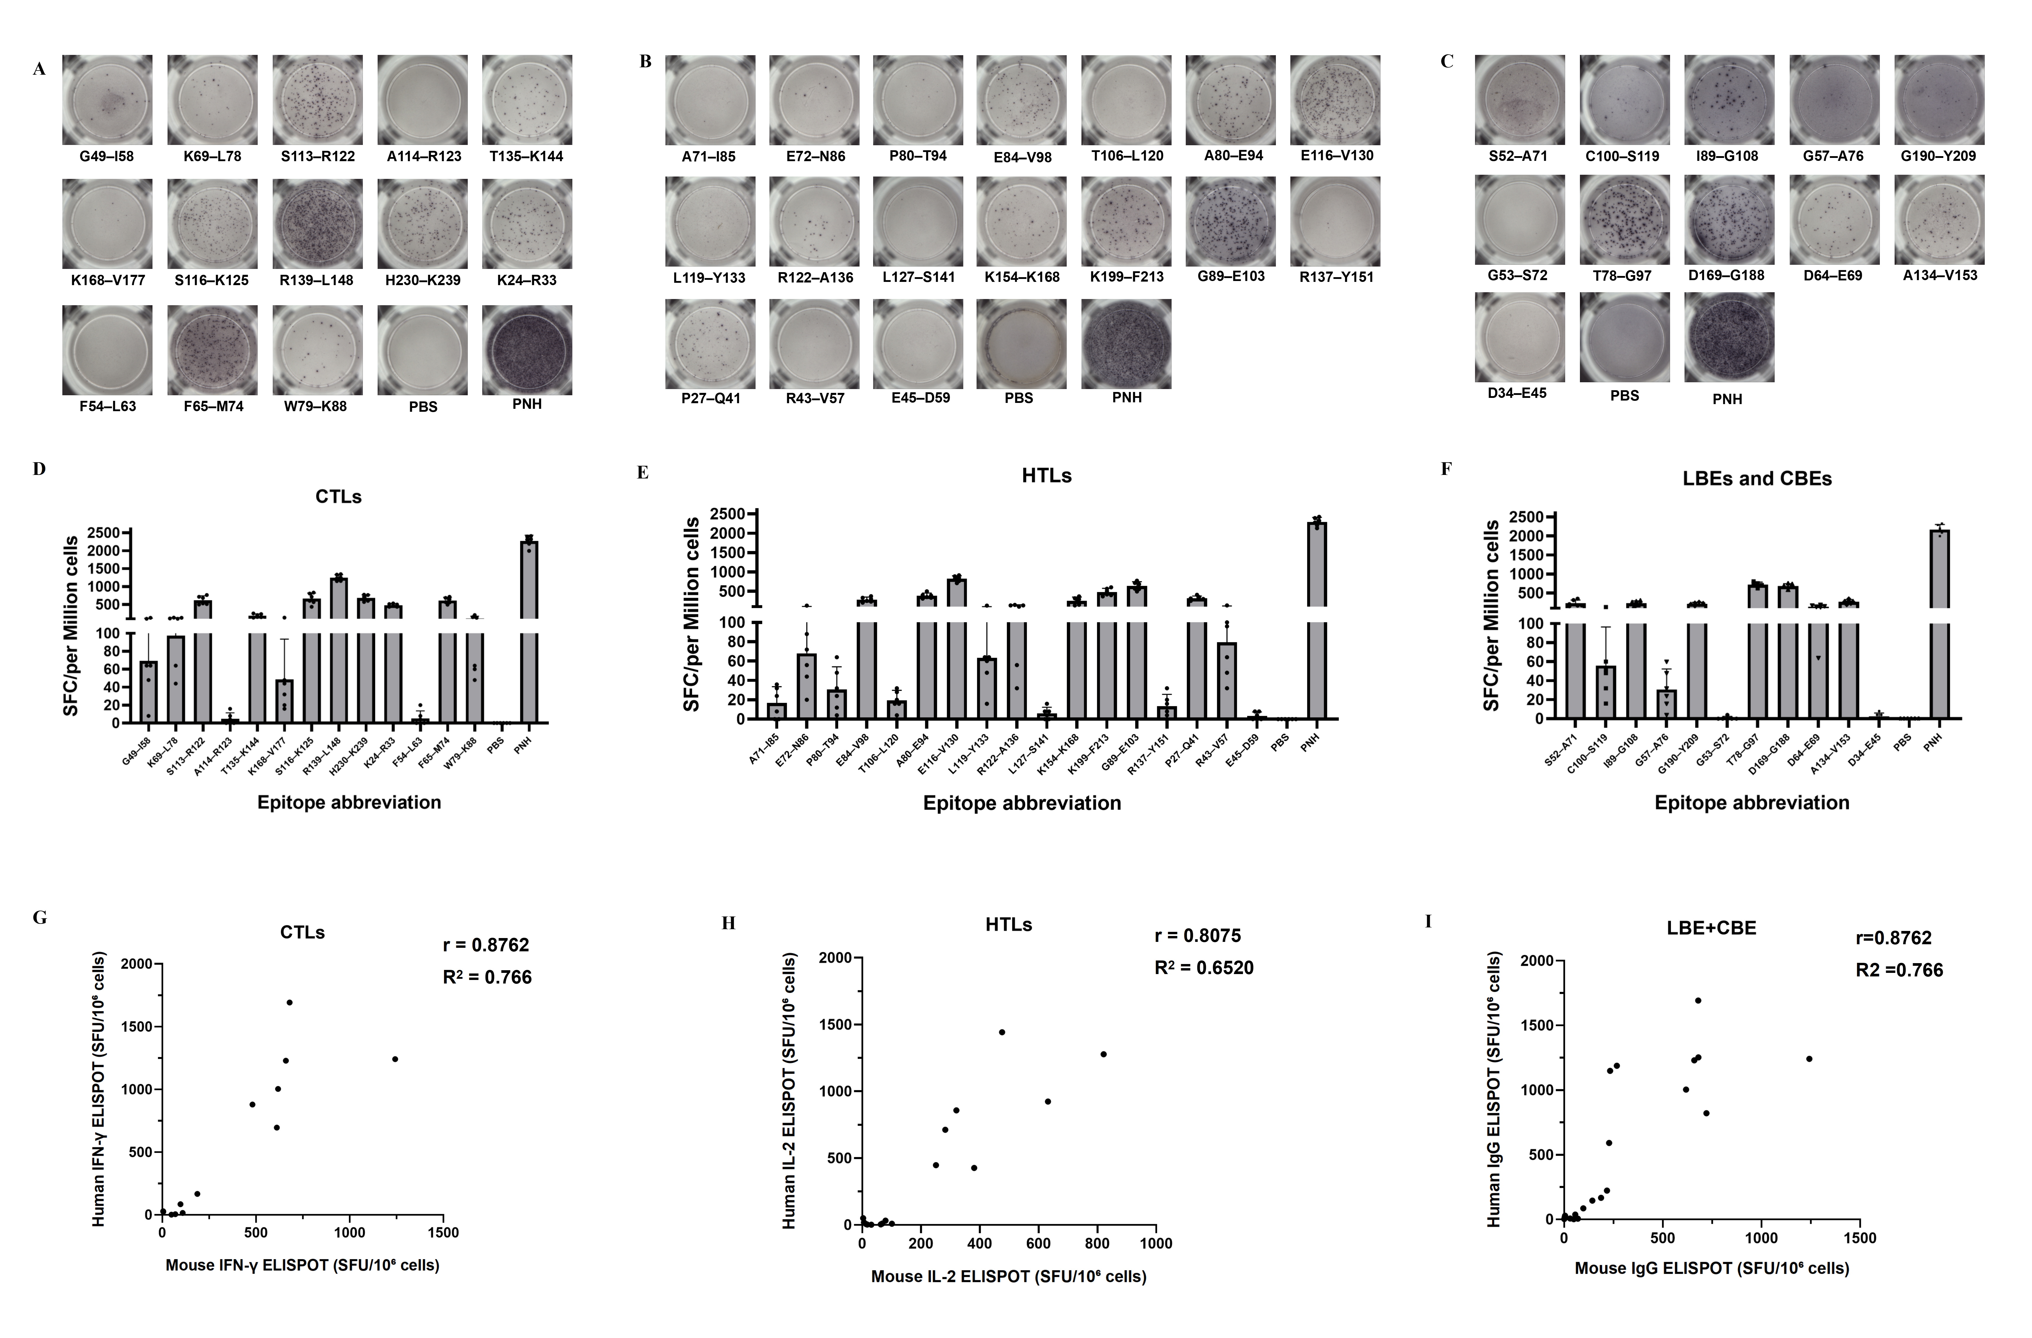
S1. ELISPOT analysis of antigen-specific T cell responses in mice. (A) Representative images showing IFN-γ secretion by cytotoxic T lymphocytes (CTLs) upon peptide stimulation. (B) IL-4 secretion profiles of helper T lymphocytes (HTLs). (C) Comparative spot formation between LBEs and CBEs. (D-F) Quantitative analysis of spot‑forming units (SFU) per 10⁶ CTLs (D), HTLs (E), and LBEs/CBEs (F). (G-I) Correlation of CTL, HTL, and LBE/CBE responses between human and mice samples. Data are mean ± SD (n = 6).

Supplementary Figure 2
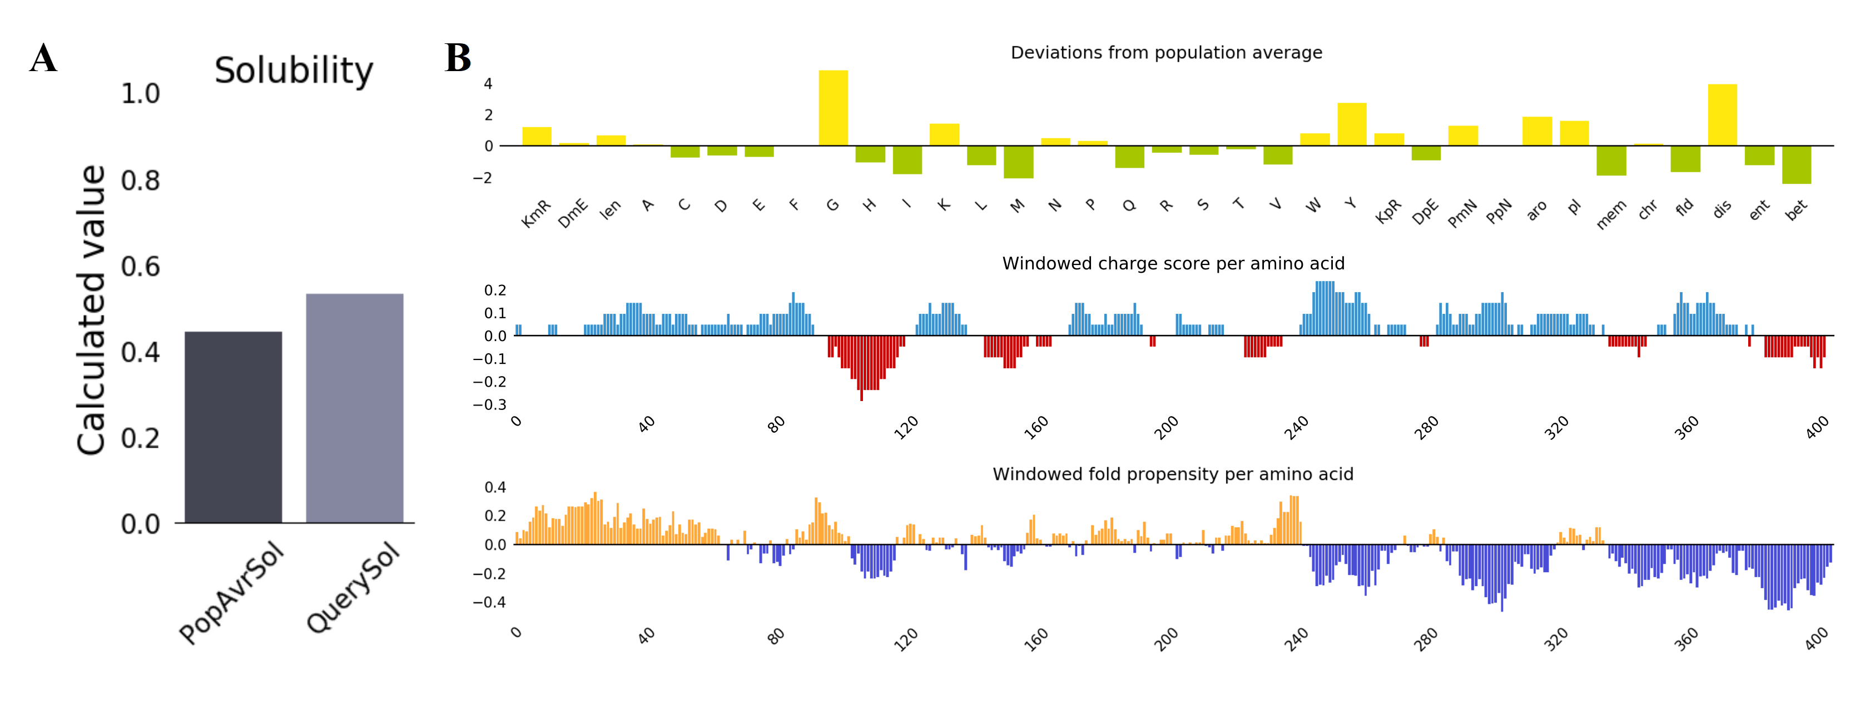
S2. Biophysical surface properties of the vaccine protein. (A) Solubility validation: comparison of experimental and predicted solubility. The red dashed line marks the classification threshold (58%); the gray band indicates the population benchmark (PopAvrSol = 0.45); the QuerySol gradient (warmer hues >0.45) is displayed. (B) Molecular surface mapping: electrostatic potential (blue: > +0.5 kT·e⁻¹; red: < –0.5 kT·e⁻¹) and hydrophobicity (yellow: > 3.0 on the Wimley‑White scale).

Supplementary Text S3: Molecular dynamics simulation and binding free energy analysis of CKS9-MEV-DCpep with TLRs
RMSD, Rg, and SASA analysis
All systems reached equilibrium within the first 50 ns of simulation. During the final 50 ns, RMSD fluctuations were larger for TLR-2 (0.76 nm) and TLR‑9 (0.75 nm), while TLR‑4 exhibited the smallest fluctuation (0.49 nm), indicating that the CKS9‑MEV‑DCpep/TLR‑4 complex had the most stable conformation (S3‑A). The radius of gyration (Rg) remained within narrow ranges throughout the simulation; the TLR‑4 complex showed the smallest variation (0.15) compared to TLR‑2 (0.25) and TLR‑9 (0.21) (S3‑B). Solvent‑accessible surface area (SASA) analysis revealed a similar trend: the SASA value for TLR‑4 (62.54 nm²) was lower than those for TLR‑2 (74.98 nm²) and TLR‑9 (82.60 nm²), suggesting a more compact complex without significant structural expansion or aggregation (S3‑C).
Hydrogen bond analysis
The average number of hydrogen bonds during the 100‑ns simulation was highest for TLR‑4 (21.77), followed by TLR‑2 (17.96) and TLR‑9 (11.05), indicating a more robust hydrogen‑bond network in the TLR‑4 complex (S3‑D).
Free‑energy landscape and 3D energy maps
Free‑energy landscape plots based on RMSD, Rg, and Gibbs free energy showed dominant low‑energy regions (blue) for all three systems, confirming stable dominant conformations. However, the shape and location of these low‑energy regions differed: TLR‑2 displayed a concentrated low‑energy basin (limited conformational diversity), TLR‑4 showed a relatively focused yet slightly more diverse ensemble, and TLR‑9 exhibited a dispersed low‑energy region (highest conformational variability), reflecting differences in conformational dynamics upon ligand binding (S3‑E). Corresponding 3D energy maps visually illustrated this heterogeneity (S3‑F).
MMPBSA binding free energy and residue decomposition
MMPBSA calculations on the last 20 ns of the trajectories yielded binding free energies of –170.16 kcal/mol (TLR‑2), –184.26 kcal/mol (TLR‑4), and –126.17 kcal/mol (TLR‑9) (S3‑G). The strongly negative values confirm high binding affinity for all three TLRs, with the lowest (most favorable) energy for TLR‑4, indicating the strongest affinity. Residue‑wise energy decomposition further supported this conclusion: TLR‑4 possesses more residues with substantial contributions to binding, providing a molecular‑level explanation for its superior binding capability (S3‑H). Collectively, CKS9‑MEV‑DCpep can stably bind to TLR‑2, TLR‑4, and TLR‑9 and possesses the potential to activate innate immune responses.
Supplementary Figure 3
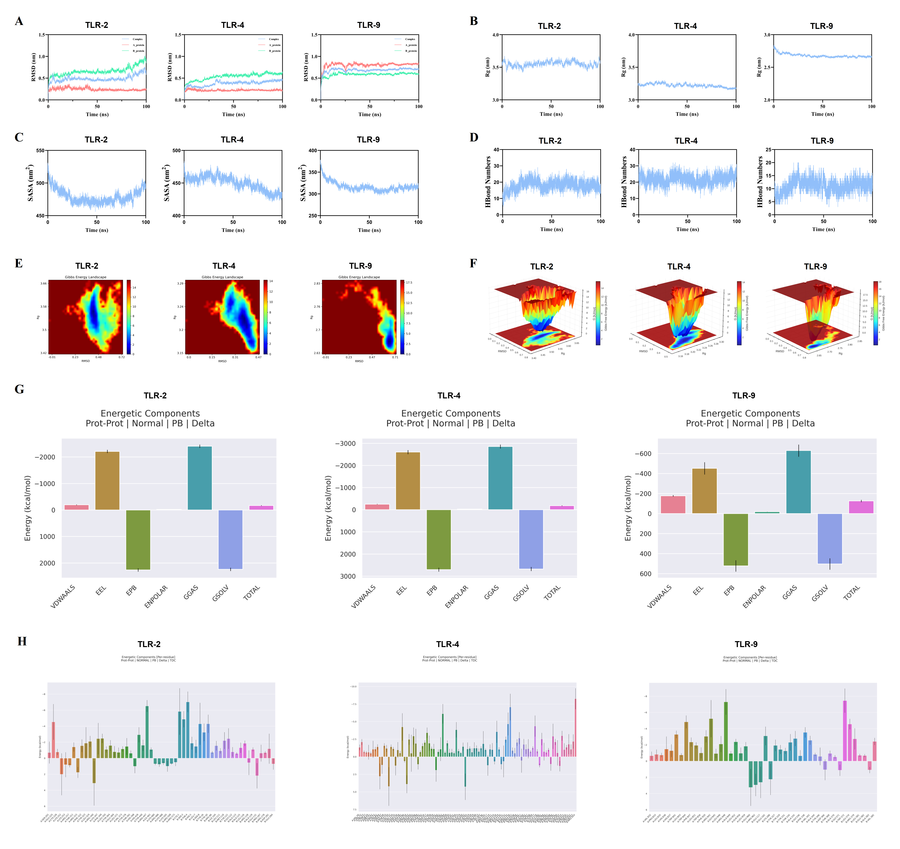
S3. Bioinformatics analysis of the Brucella candidate vaccine CKS9‑MEV‑DCpep. (A) RMSD curve: conformational fluctuations of the vaccine molecule over simulation time. (B) Radius of gyration (Rg) curve: changes in overall structural compactness. (C) SASA curve: dynamic changes in solvent‑accessible surface area. (D) Ligand‑protein hydrogen bond number curve: stability of hydrogen bond interactions during receptor binding. (E) 2D free energy landscape: thermodynamic distribution of vaccine conformations (red: high free energy; blue: low free energy). (F) 3D free energy landscape: three‑dimensional thermodynamic distribution of dominant conformations. (G) MMPBSA binding energy component plot: contributions of individual energy components to vaccine‑receptor complex formation. (H) MMPBSA residue energy decomposition plot: energy contributions of each amino acid residue to binding interactions.

Supplementary Text S4. Computational immune simulation of CKS9‑MEV‑DCpep over 350 days
A 350‑day computational immune simulation was performed to model the host immune response to CKS9‑MEV-DCpep, encompassing B cells, T cell subsets (Th, Tc), antibodies, cytokines, and antigen‑presenting cells (macrophages and dendritic cells).
B cell dynamics
B‑cell populations exhibited complex fluctuating changes: they peaked around day 50, gradually declined, and then showed minor oscillations, reflecting a cyclic “activation‑proliferation‑depletion” process (S4‑A). Regarding state transitions, the “active state” dominated the early stage, while the “internalized state,” “presenting state‑1,” and “presenting state‑2” displayed a fluctuating upward trend in the later stage; changes in the “proliferative state” directly mirrored B‑cell proliferative activity (S4‑B).
Antibody kinetics
Antibody kinetic analysis showed an initial rapid increase in IgM, followed by a gradual rise in IgG subclasses, consistent with antibody class switching during B‑cell differentiation and maturation (S4‑C).
T helper cell responses
Th cell counts first expanded rapidly, then contracted, and finally stabilized. The “active state” and “proliferative state” peaked early and then underwent gradual adaptive regulation (S4‑D, E). Cytokine levels (IFN‑γ, IL‑4) peaked early and then exhibited an oscillating downward trend, reflecting their regulatory roles in immune cell crosstalk and Th‑cell differentiation (S4‑F). Analysis of Th subset proportions revealed a gradual enrichment of the Th1 phenotype (S4‑G).
Cytotoxic T cell responses
Tc cell populations remained stable with small fluctuations, and no significant changes in cell states were observed (S4‑H, I).
Antigen‑presenting cells (macrophages and dendritic cells)
For APCs, the “internalized state,” “presenting state‑1,” and “presenting state‑2” all increased in the early stage, underscoring their core role in antigen processing and presentation. Subsequent state changes suggest that macrophages and dendritic cells contribute to maintaining immune homeostasis through functional adaptive adjustments (S4‑J, K).
Supplementary Figure 4
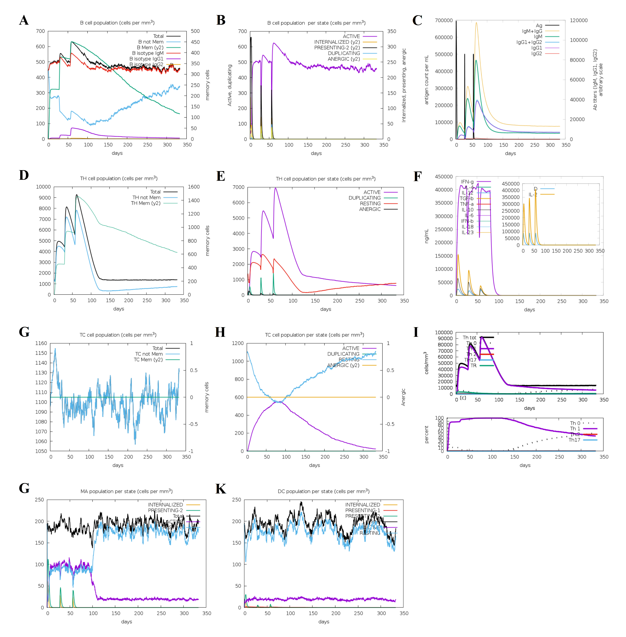
S4. Longitudinal immune profiling based on a 350‑day computational simulation. (A) B cell dynamics: total density, memory subset distribution, and isotype (IgM/IgG1/IgG2) profile. (B) B cell state distribution: active (Act), MHC‑II‑presenting (Pres II), antigen‑internalized (Intern), duplicating (Dup), and anergic. (C) Antibody kinetics: serum immunoglobulin levels and antigen‑binding capacity over time. (D) CD4⁺ T cell dynamics: total count and memory subset distribution. (E) CD4⁺ T cell state distribution: active (Act), resting, anergic, and duplicating (Dup). (F) Cytokine flux (IL‑2, IL‑4, IL‑6, IFN‑γ, TNF‑α; pg/mL); inset shows danger signal D. (G) CD8⁺ T cell dynamics: absolute counts and memory differentiation. (H) CD8⁺ T cell state distribution: active (Act), resting, anergic, and duplicating (Dup). (I) T cell heterogeneity: naïve/effector/memory subset ratios and counts. (J) Macrophage activity: population density and functional state distribution (Intern, Pres II, active, resting). (K) Dendritic cell function: MHC‑I/II presentation efficiency and activation status.

Supplementary Figure 5
S5. The Gating Strategy of M Cell Flow Cytometry.
- Primary Cell Population Screening (FSC-A vs SSC-A): Based on forward scatter area (FSC-A, reflecting cell size) and side scatter area (SSC-A, reflecting granularity), major cell populations are distinguished and cell debris is excluded.
- Exclusion of Adherent Cells (FSC-A vs FSC-H): Using the linear relationship between forward scatter area (FSC-A) and forward scatter height (FSC-H), doublet or multicellular adhesion events are identified and excluded (adherent cells show non-diagonal distribution in the scatter plot).
- Viable Cell Screening and Immune Cell Exclusion (Live⁺/CD45⁻): Live⁺: Viable cells with intact membrane integrity are selectively retained through staining with viability dyes. CD45⁻: CD45-positive immune cells are excluded.
- Positive Labeling of Target Cells (EpCAM⁺/UAE-1⁺): EpCAM⁺: Positive for epithelial cell adhesion molecule, used to screen epithelial-derived cells. UAE-1: Combined with EpCAM⁺ to further enrich M cells.

Supplementary Figure 6
S6. The Gating Strategy of Vaccine⁺ M cells Flow Cytometry.
- Primary Cell Population Screening (FSC-A vs SSC-A).
- Exclusion of Adherent Cells (FSC-A vs FSC-H).
- Viable Cell Screening and Immune Cell Exclusion (Live⁺/CD45⁻).
- Positive Labeling of Target Cells (EpCAM⁺/UAE-1⁺).
- Vaccine⁺ Subpopulation Quantification Protocol Within the EpCAM⁺/UAE-1⁺ target cell gate, a home-made rabbit polyclonal antibody labeled with BV711 (targeting the vaccine antigen) is used to detect Vaccine⁺ M cells, and their in vitro phagocytic capacity is quantitatively analyzed by flow cytometry.

Supplementary Figure 7
S7. The Gating Strategy of Vaccine⁺ DCs Flow Cytometry.
- Primary Cell Population Screening (FSC-A vs SSC-A).
- Exclusion of Adherent Cells (FSC-A vs FSC-H).
- Quantification of Vaccine⁺ DCs. Within the surface marker⁺ DC gate (identified via a cell membrane integrity dye, corresponding to cellular immunofluorescence), the Vaccine⁺ DC population is detected to achieve accurate quantification of phagocytic function based on antigen internalization.

Supplementary Figure 8
S8. Gating Strategy for DC Subsets (cDC1, cDC2, pDC) Flow Cytometry
- Primary Cell Population Screening (FSC-A vs SSC-A).
- Exclusion of Adherent Cells (FSC-A vs FSC-H).
- Further gating is performed as follows: CD11c⁺ CD8α⁺ cell population is gated as cDC1; CD11c⁺ CD11b⁺ population is gated as cDC2; CD11c⁺ B220⁺ cells are gated as pDC.

Supplementary Figure 9
S9. Gating Strategy for Mature DC Flow Cytometry
- Primary Cell Population Screening (FSC-A vs SSC-A).
- Exclusion of Adherent Cells (FSC-A vs FSC-H).
- Further gating is performed as follows: CD11c⁺ MHC-II⁺ cell population is gated as Mature DC.

Supplementary Figure 10
S10: Gating Strategy for B cell Flow Cytometry
- Primary Cell Population Screening (FSC-A vs SSC-A).
- Exclusion of Adherent Cells (FSC-A vs FSC-H).
- Screening of Live cell: Live cell dyes are used to delineate the viable cell population.
- Exclusion of T Cell: Contamination Within the viable cell gate, CD3⁻ cells are selected .
- Targeting B Cells: From the CD3⁻ cell population, B220⁺ cells (a B cell-specific marker) are screened to obtain the target mature B cells.

Supplementary Figure 11
S11: Gating Strategy for TFH Flow Cytometry
- Primary Cell Population Screening (FSC-A vs SSC-A).
- Exclusion of Adherent Cells (FSC-A vs FSC-H).
- Screening of Live cell: Live cell dyes are used to delineate the viable cell population.
- Enrichment of CD4⁺ T Cells: Within the viable cell gate, the CD4⁺ T cell population is screened using anti-CD4 antibody labeling (Note: TFH is a subset of CD4⁺ T cells, and this step is critical for enrichment).
- Identification of TFH-Specific Phenotype: From the CD4⁺ cell population, CXCR5⁺ PD-1⁺ double-positive cellsare gated and screened via CXCR5/PD-1 double staining, which are defined as follicular helper T cells (TFH).

Supplementary Figure 12
S12: Gating Strategy for GCB Flow Cytometry
- Primary Cell Population Screening (FSC-A vs SSC-A).
- Exclusion of Adherent Cells (FSC-A vs FSC-H).
- Screening of Live cell: Live cell dyes are used to delineate the viable cell population.
- Exclusion of T Cell: Contamination Within the viable cell gate, CD3⁻ cells are selected .
- Enrichment of B Cells: From the CD3⁻ cell population, B220⁺ cells are screened via labeling with anti-B220 antibody to obtain mature B cells.
- Identification of Germinal Center B Cells (GCB) Within the B220⁺ cell population, FAS⁺GL7⁺ double-positive cells are gated and screened through FAS/GL7 double staining, which are defined as GCB.

Supplementary Figure 13
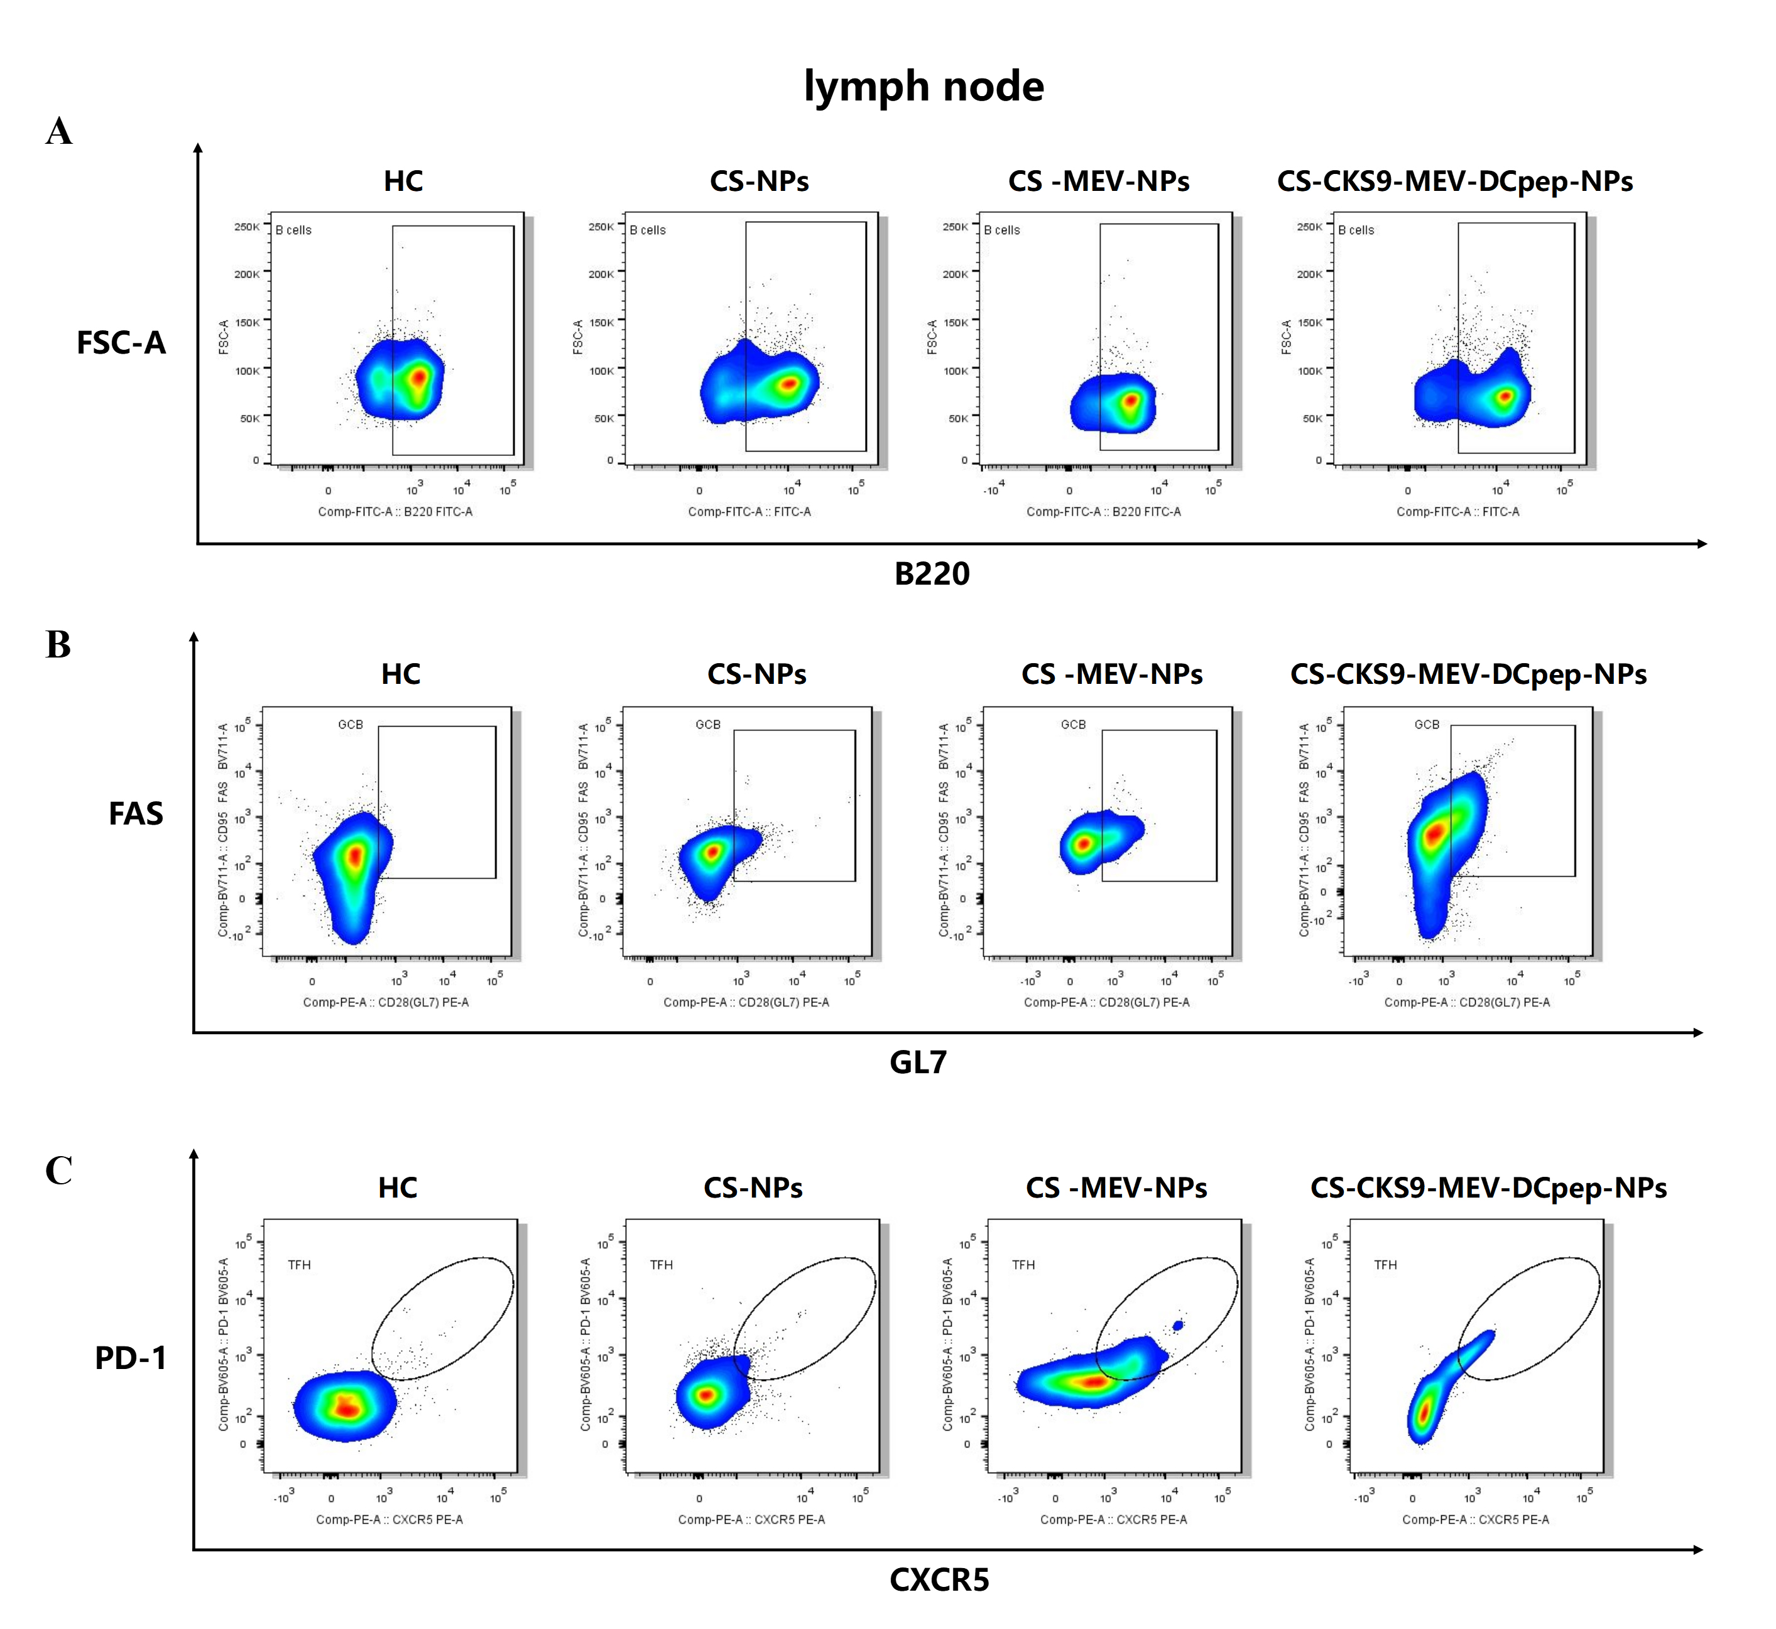
S13. Flow cytometric analysis of lymph node immune subsets at 2 weeks post-immunization. (A) B cell populations. (B) Germinal center B (GCB) cells. (C) T follicular helper (TFH) cells.

Supplementary Figure 14
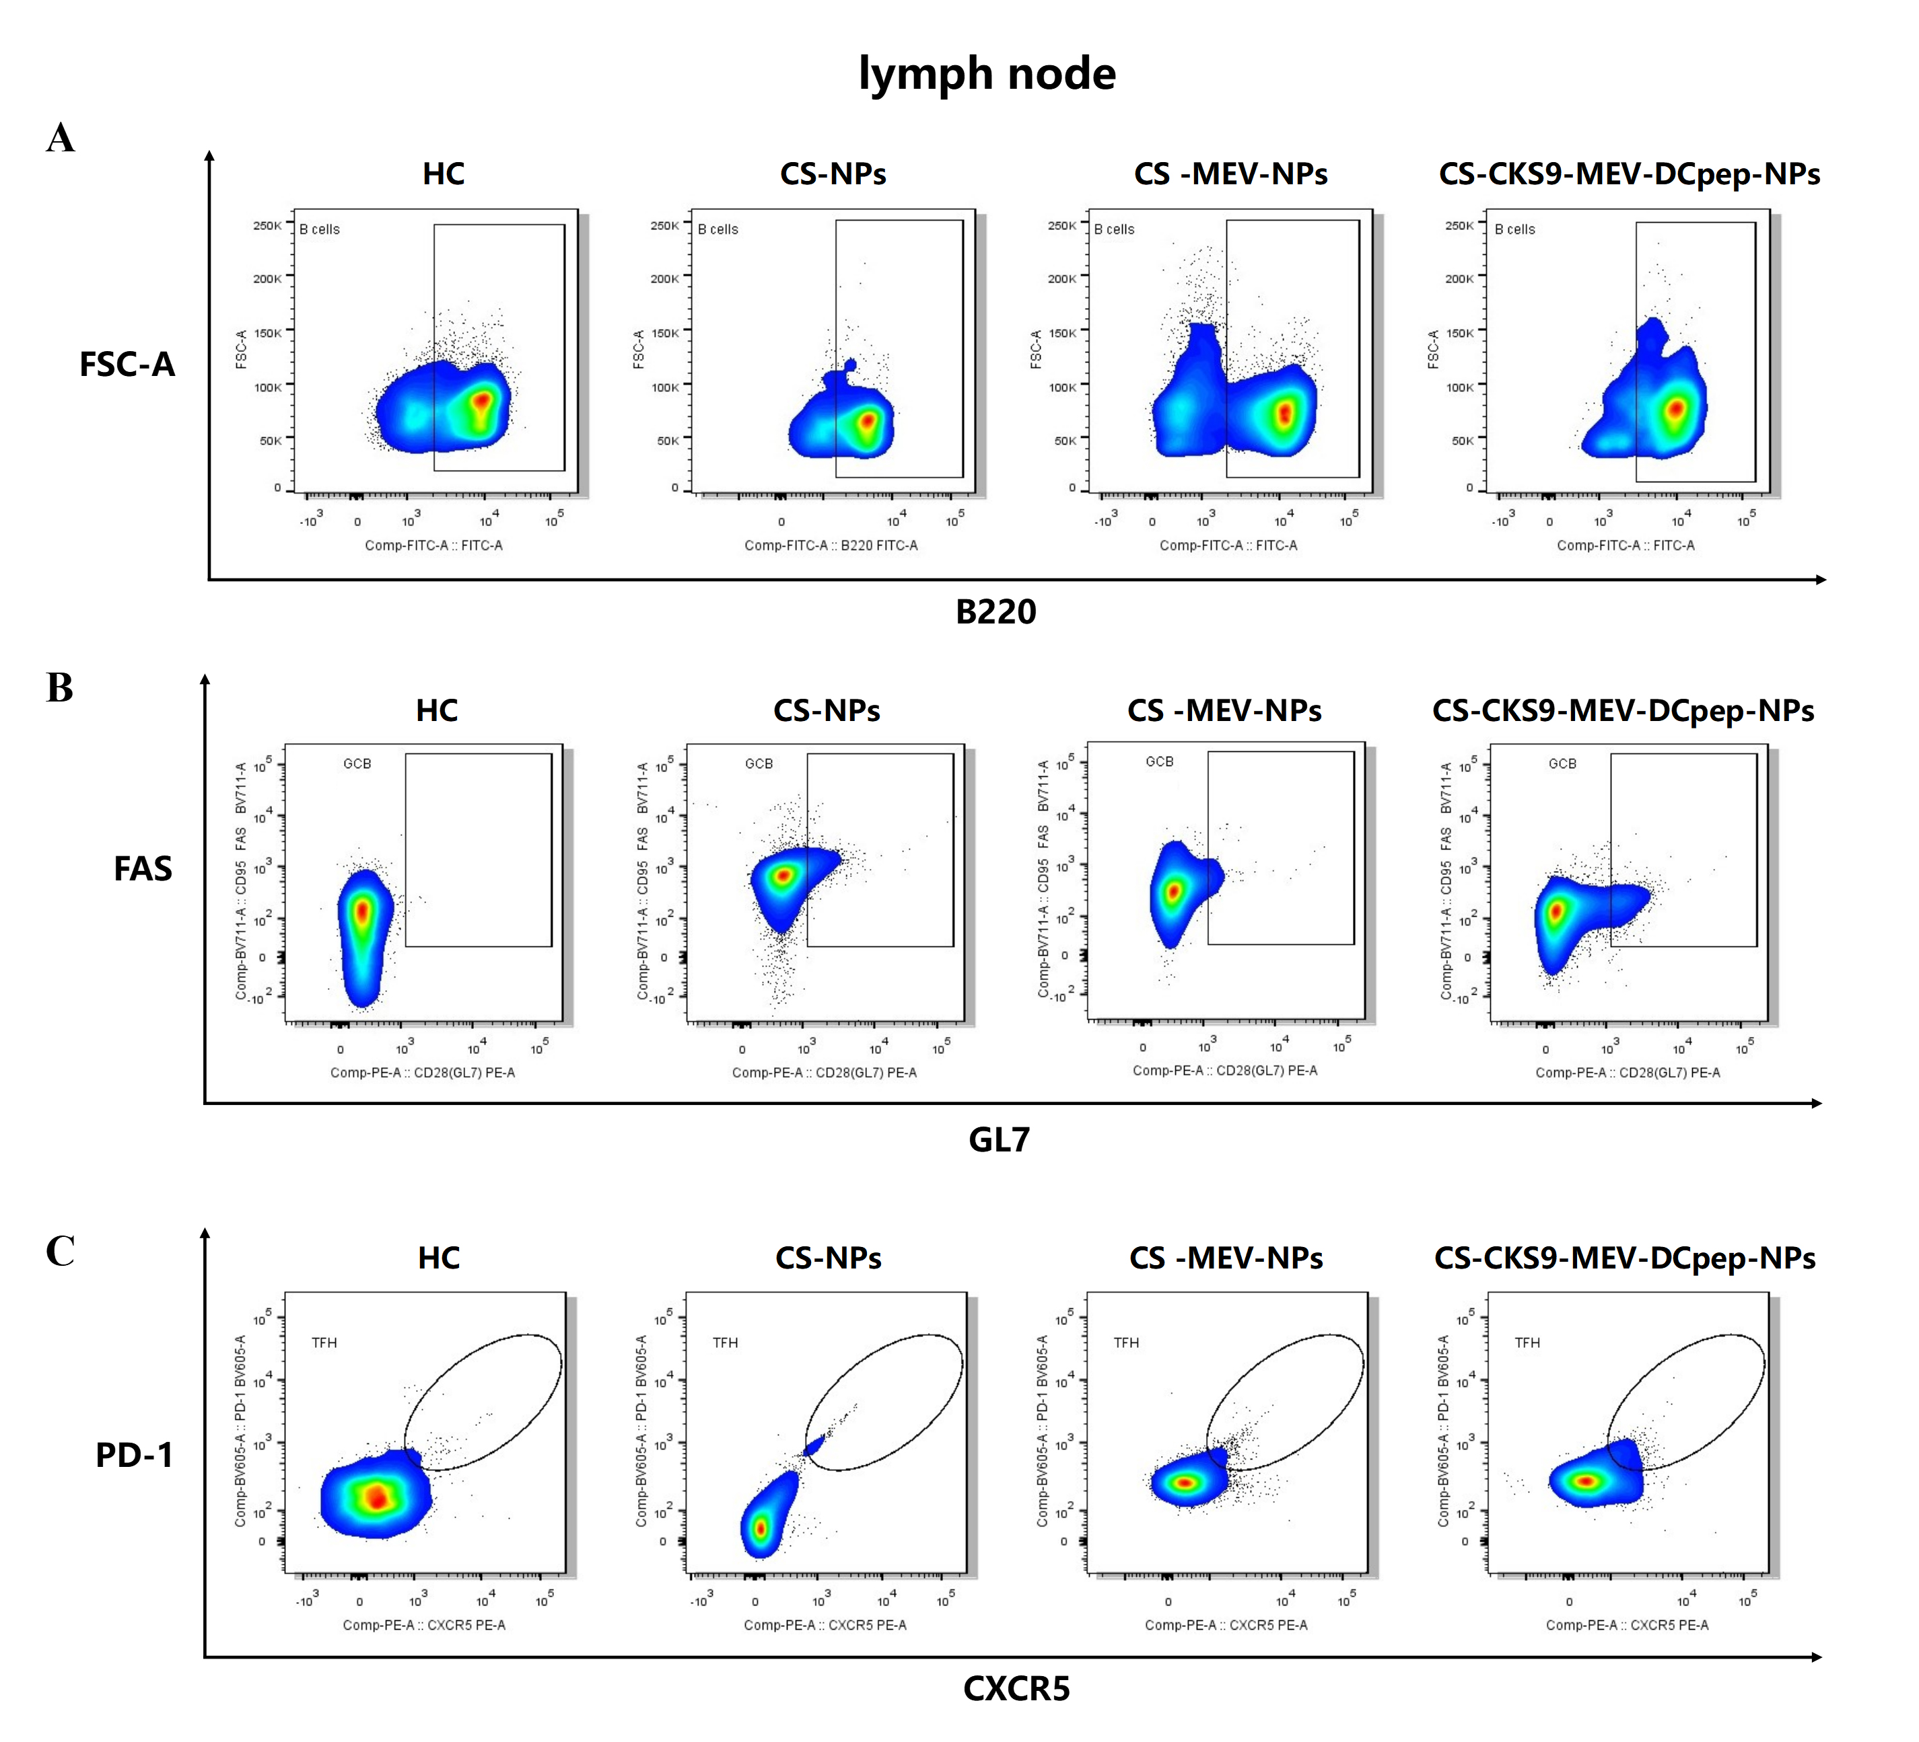
S14. Flow cytometric analysis of lymph node immune subsets at 24 weeks post-immunization. (A) B cell populations. (B) Germinal center B (GCB) cells. (C) T follicular helper (TFH) cells.

Supplementary Figure 15
S15: Gating Strategy for ILC Flow Cytometry
- Primary Cell Population Screening (FSC-A vs SSC-A).
- Exclusion of Adherent Cells (FSC-A vs FSC-H).
- Screening of Live cell: Live cell dyes are used to delineate the viable cell population.
- CD45+ Leukocyte Sorting: Enrichment of Immune Cells
- Lin⁻Lineage-Negative Cell Sorting: CD3, B220, CD14, CD11b, FcεR1α
- ILC Identification (CD90.2⁺CD127⁺): Specific Circumscription of ILC Population

Supplementary Figure 16
S16: Gating Strategy for ILC1 Flow Cytometry
- Primary Cell Population Screening (FSC-A vs SSC-A).
- Exclusion of Adherent Cells (FSC-A vs FSC-H).
- Screening of Live cell: Live cell dyes are used to delineate the viable cell population.
- CD45⁺ Leukocyte Sorting: Enrichment of Immune Cells
- Lin⁻Lineage-Negative Cell Sorting: CD3, B220, CD14, CD11b, FcεR1α
- ILC Identification (CD90.2⁺CD127⁺): Specific Circumscription of ILC Population
- ILC1 Identification(CD49a⁺): Specific Circumscription of ILC1 Population

Supplementary Figure 17
S17: Gating Strategy for Mature DCs Flow Cytometry
- Primary Cell Population Screening (FSC-A vs SSC-A).
- Exclusion of Adherent Cells (FSC-A vs FSC-H).
- Screening of Live cell: Live cell dyes are used to delineate the viable cell population.
- CD45+ Leukocyte Sorting: Enrichment of Immune Cells
- Lin⁻Lineage-Negative Cell Sorting: CD3, Ly-6G/Ly-6C, CD11b, B220, TER-119
- Mature DC Identification (CD11c⁺MHC-II⁺): Specific Circumscription of ILC Mature DCs Population

Supplementary Figure 18
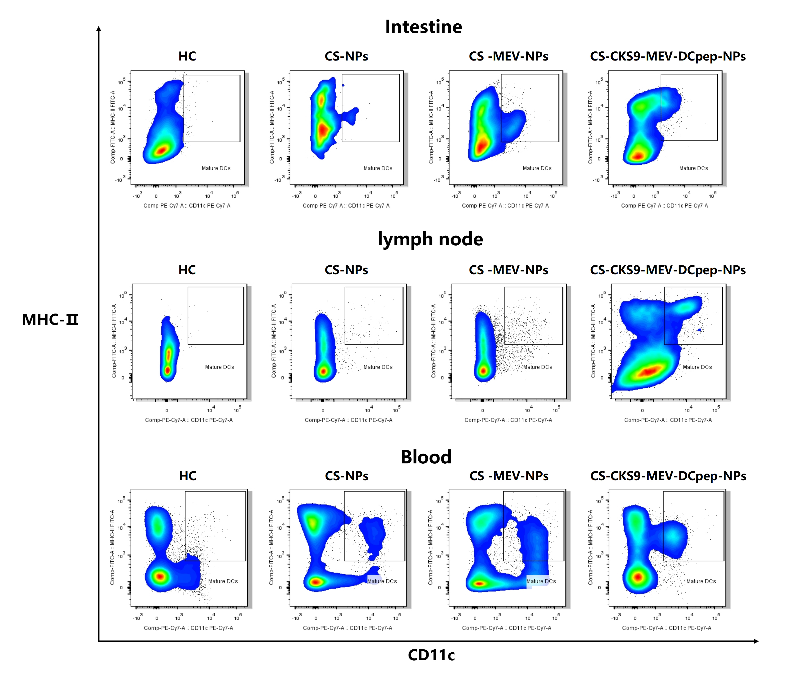
S18. Tissue distribution of myeloid dendritic cells (mDCs) at 2 weeks post-immunization. mDC populations were assessed in lymph nodes, peripheral blood, and intestinal tissue at 2 weeks after the final immunization.

Supplementary Figure 19
S19: Gating Strategy for CD4⁺ and CD8⁺ T cells Flow Cytometry
- Primary Cell Population Screening (FSC-A vs SSC-A).
- Exclusion of Adherent Cells (FSC-A vs FSC-H).
- Screening of Live cell: Live cell dyes are used to delineate the viable cell population.
- CD4⁺ T cells Identification (CD4⁺) and CD8⁺ T cells Identification (CD8⁺)

Supplementary Figure 20
S20. Analysis of T Cell Subsets in Lymph Node and Blood at 2 Weeks Post-Immunization. Flow cytometric analysis of T cell subsets (CD3⁺, CD4⁺ and CD8⁺ T cells) in (A) lymph node and (B) peripheral blood at two weeks after the final immunization.
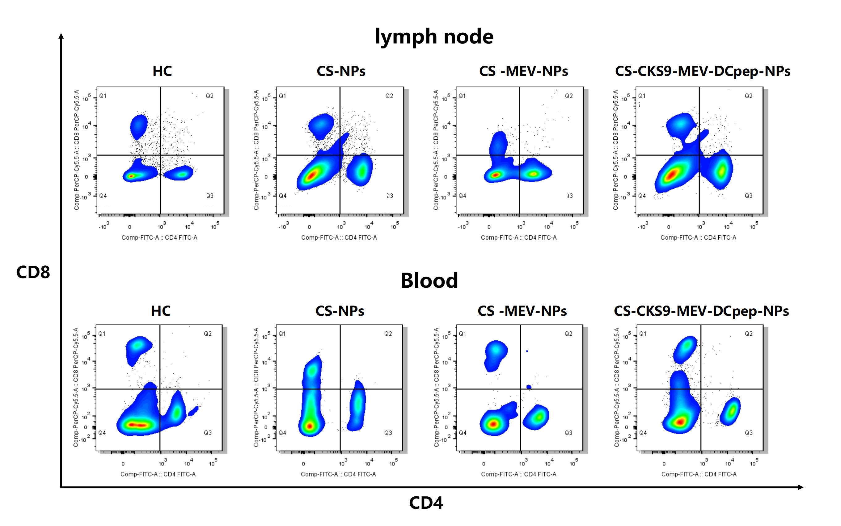
Supplementary Figure 21
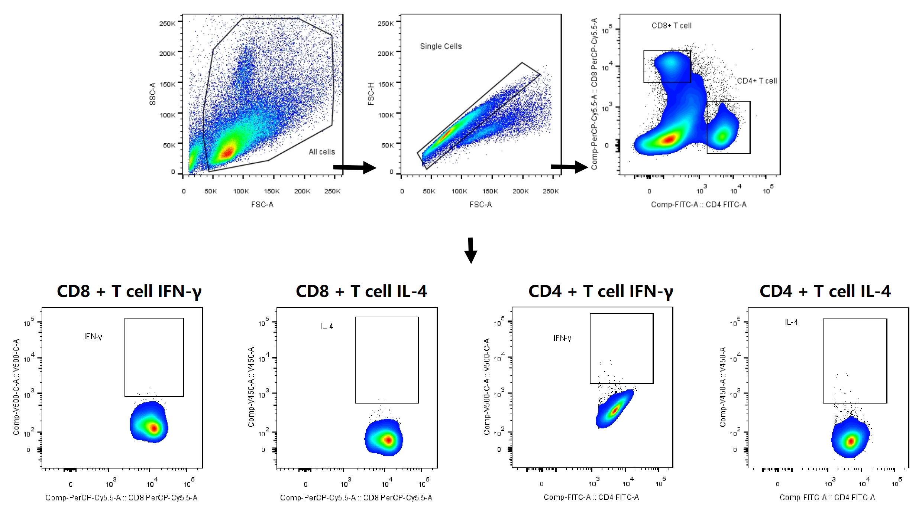
S21: Gating Strategy for Detection of IFN‑γ and IL‑4 in CD4⁺ and CD8⁺ T Cells by Flow Cytometry
- Primary Cell Population Screening (FSC-A vs SSC-A).
- Exclusion of Adherent Cells (FSC-A vs FSC-H).
- Screening of Live cell: Live cell dyes are used to delineate the viable cell population.
- CD4⁺ T cells Identification (CD4⁺) and CD8⁺ T cells Identification (CD8⁺)
- Cytokine analysis: Within each subset (CD4⁺ or CD8⁺), evaluate the expression of IFN‑γ and IL‑4 by gating on cytokine‑positive cells.

Supplementary Figure 22
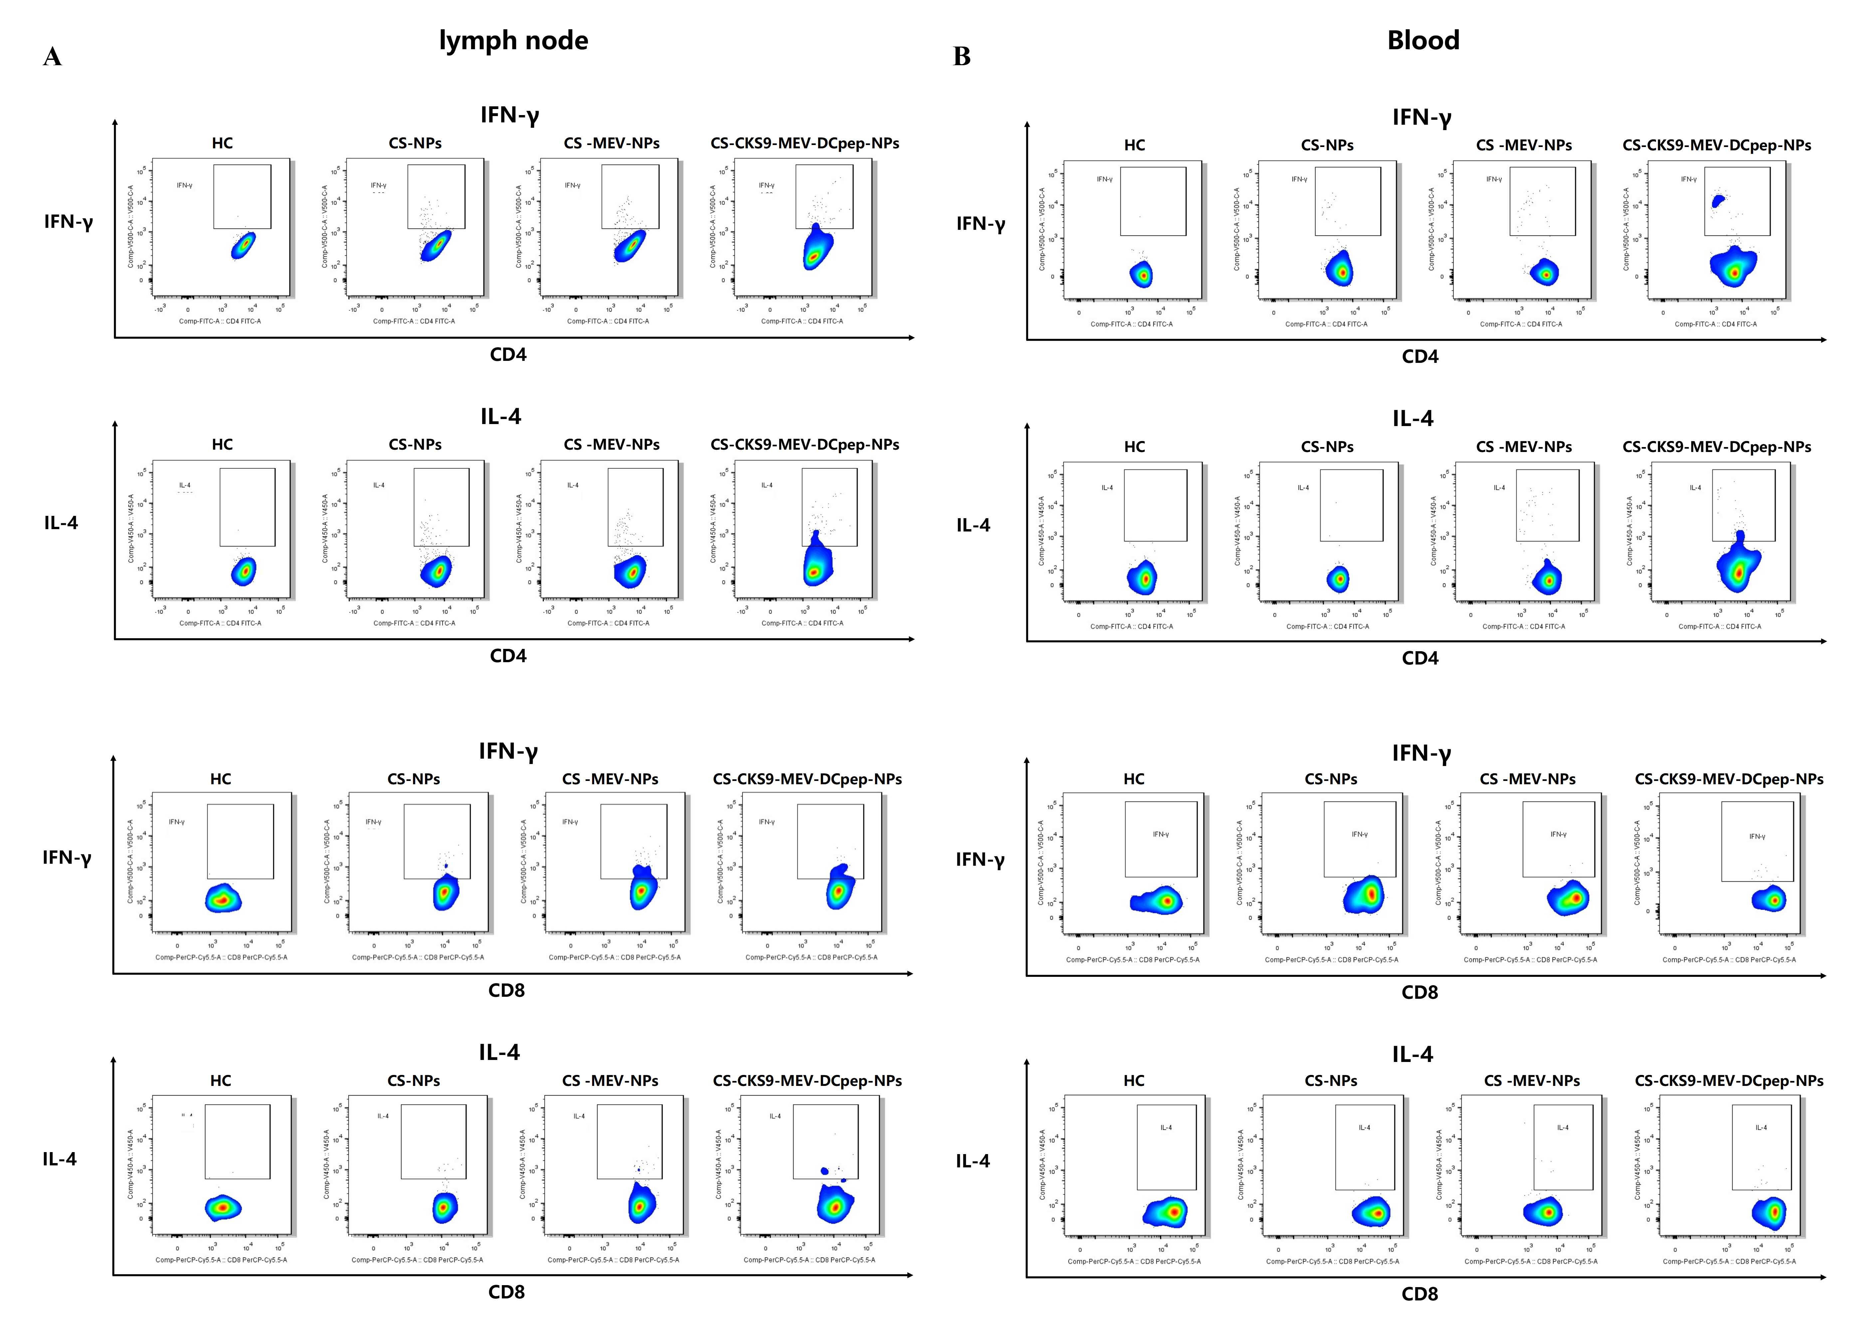
S22. Cytokine‑producing T cell subsets in lymphoid and peripheral compartments at 2 weeks post‑immunization. Flow cytometric analysis of (A) CD4⁺ and (B) CD8⁺ T cells producing IFN‑γ or IL‑4 in lymph nodes and peripheral blood.

Supplementary Figure 23
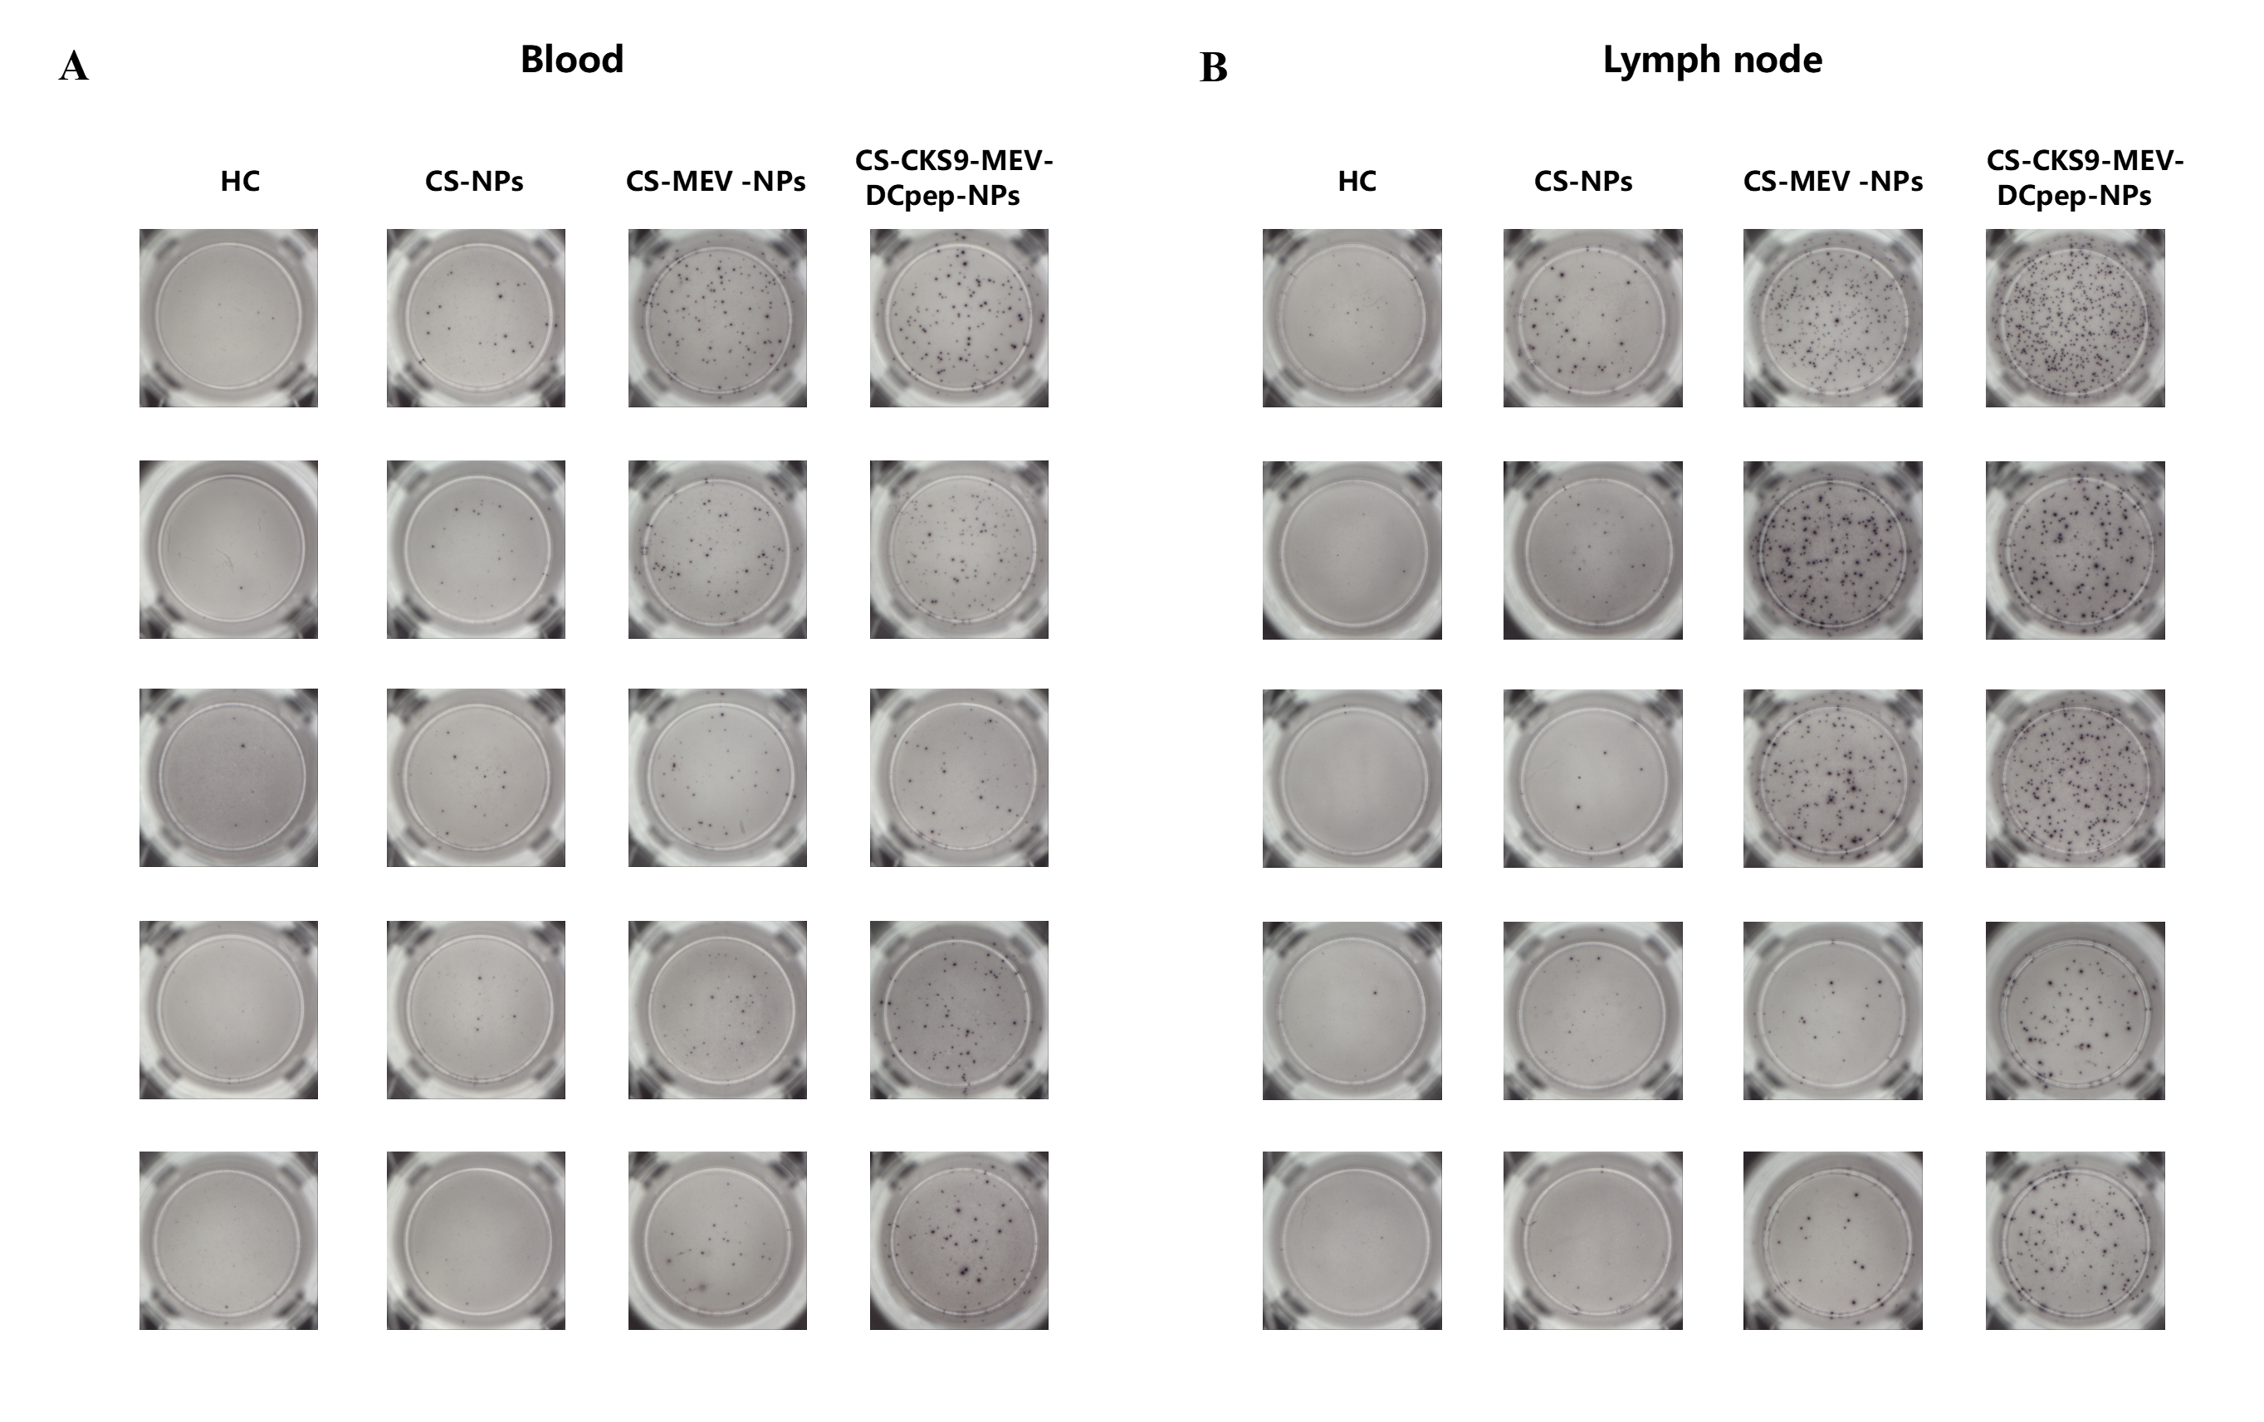
S23. Representative ELISpot images of cytokine and effector molecule secretion at 2 weeks post‑immunization. Detection of IFN‑γ, TNF‑α, IL‑2, perforin, and granzyme B in (A) lymph nodes and (B) peripheral blood.

Supplementary Figure 24
S24: Gating Strategy for CD4⁺ (TEM/TCM) and CD8⁺ (TEM/TCM) Flow Cytometry
- Primary Cell Population Screening (FSC-A vs SSC-A).
- Exclusion of Adherent Cells (FSC-A vs FSC-H).
- Screening of Live cell: Live cell dyes are used to delineate the viable cell population.
- CD3⁺ Leukocyte Sorting: Enrichment of T Cells
- CD4⁺ T cells: Enrichment of CD4⁺ T cells: TEM Identification (CD44⁺CD62L⁻); TCM Identification (CD44⁺CD62L⁺)
- CD8⁺ T cells Identification (CD8⁺): TEM Identification (CD44⁺CD62L⁻); TCM Identification (CD44⁺CD62L⁺)

Supplementary Figure 25
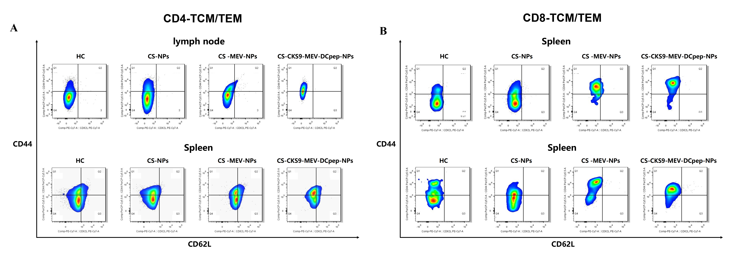
S25. Memory T cell subsets in lymphoid tissues at 2 weeks post‑immunization. (A) CD8⁺ and CD4⁺ effector memory (TEM) and central memory (TCM) cells in lymph nodes. (B) CD8⁺ TEM and TCM cells in the spleen.

Supplementary Figure 26
S26. Long‑term analysis of memory T cell subsets in lymphoid tissues at 24 weeks post‑immunization. (A) CD8⁺ and CD4⁺ TEM and TCM cells in lymph nodes. (B) CD4⁺ and CD8⁺ TEM and TCM cells in the spleen.

Supplementary Figure 27
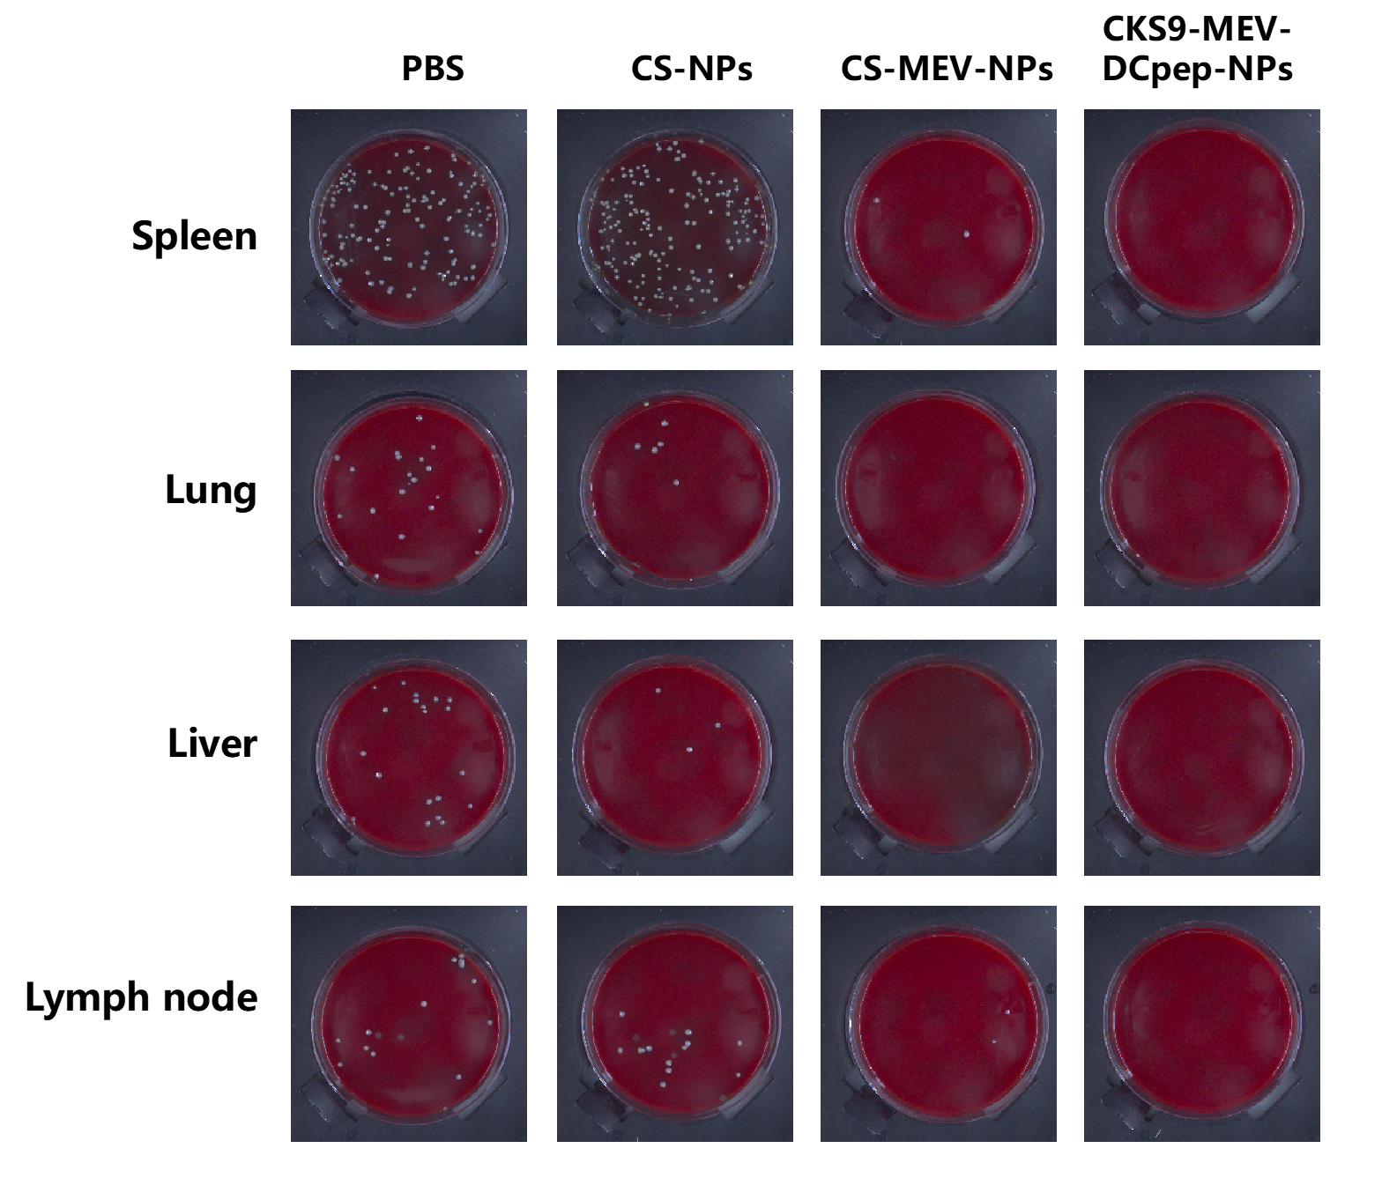
S27. Colony morphology from organ homogenates in the chronic phase. Tissue bacterial load.

Supplementary Figure 28
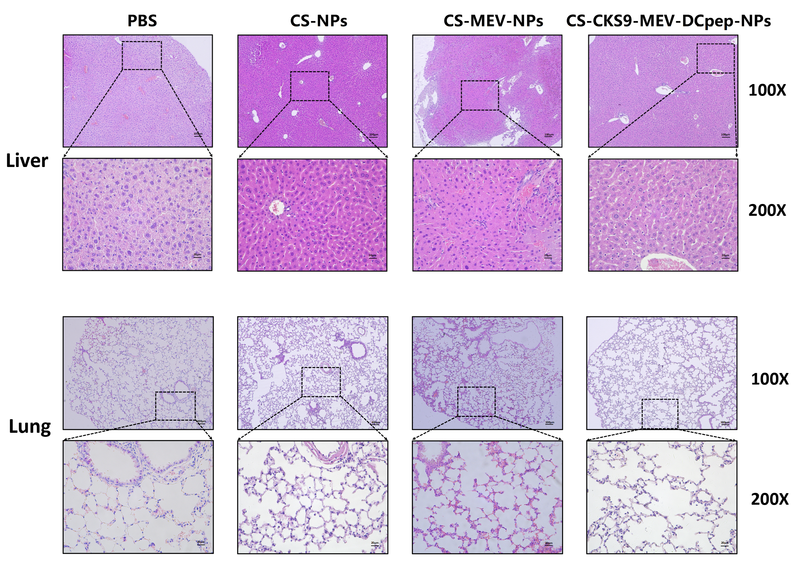
S28. H&E staining of liver and lung tissues at two weeks post-immunization (representative images).
Supplementary Figure 29
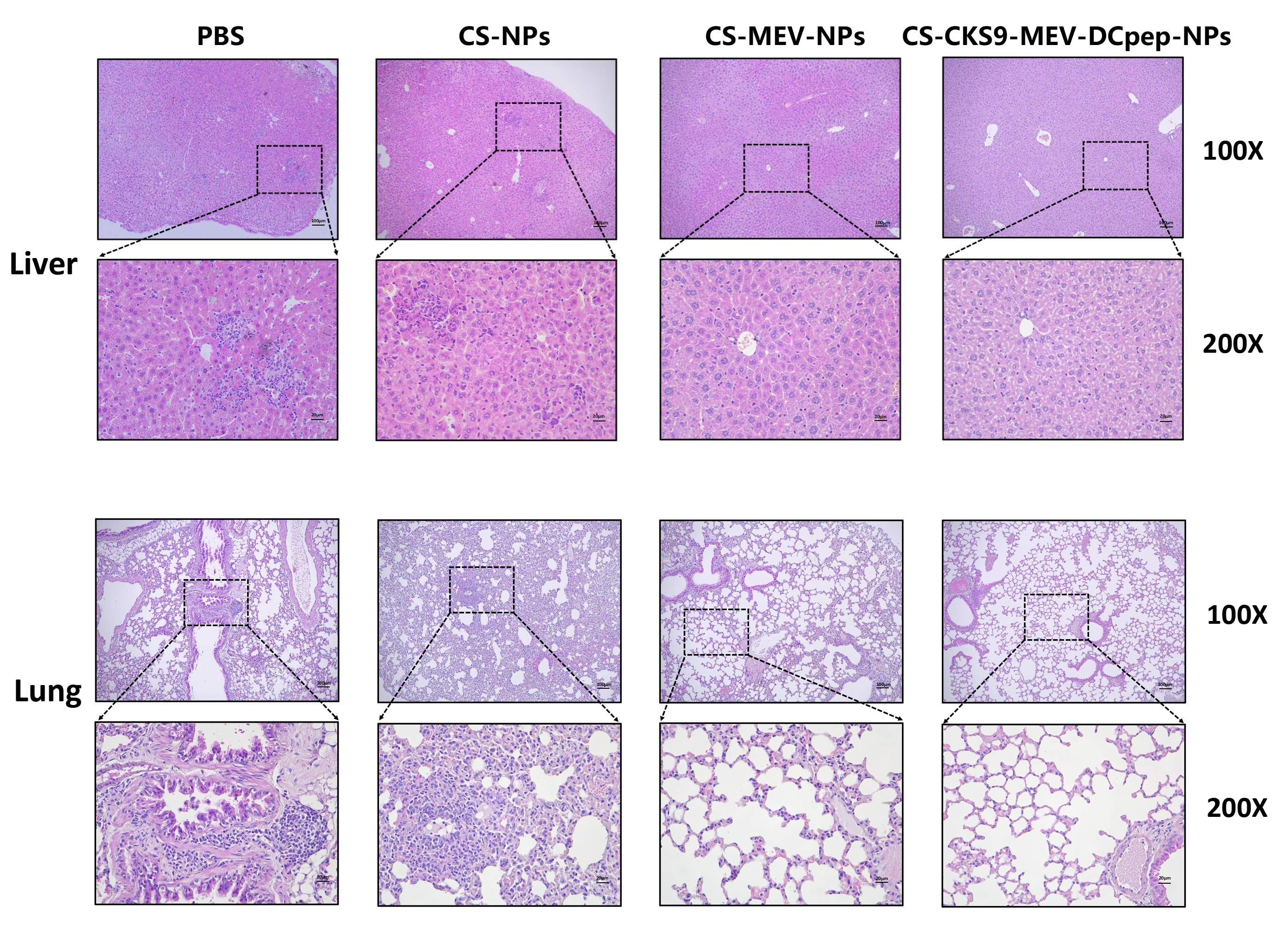
S29. H&E staining of liver and lung tissues in the chronic phase (representative images).

Supplementary Figure 30
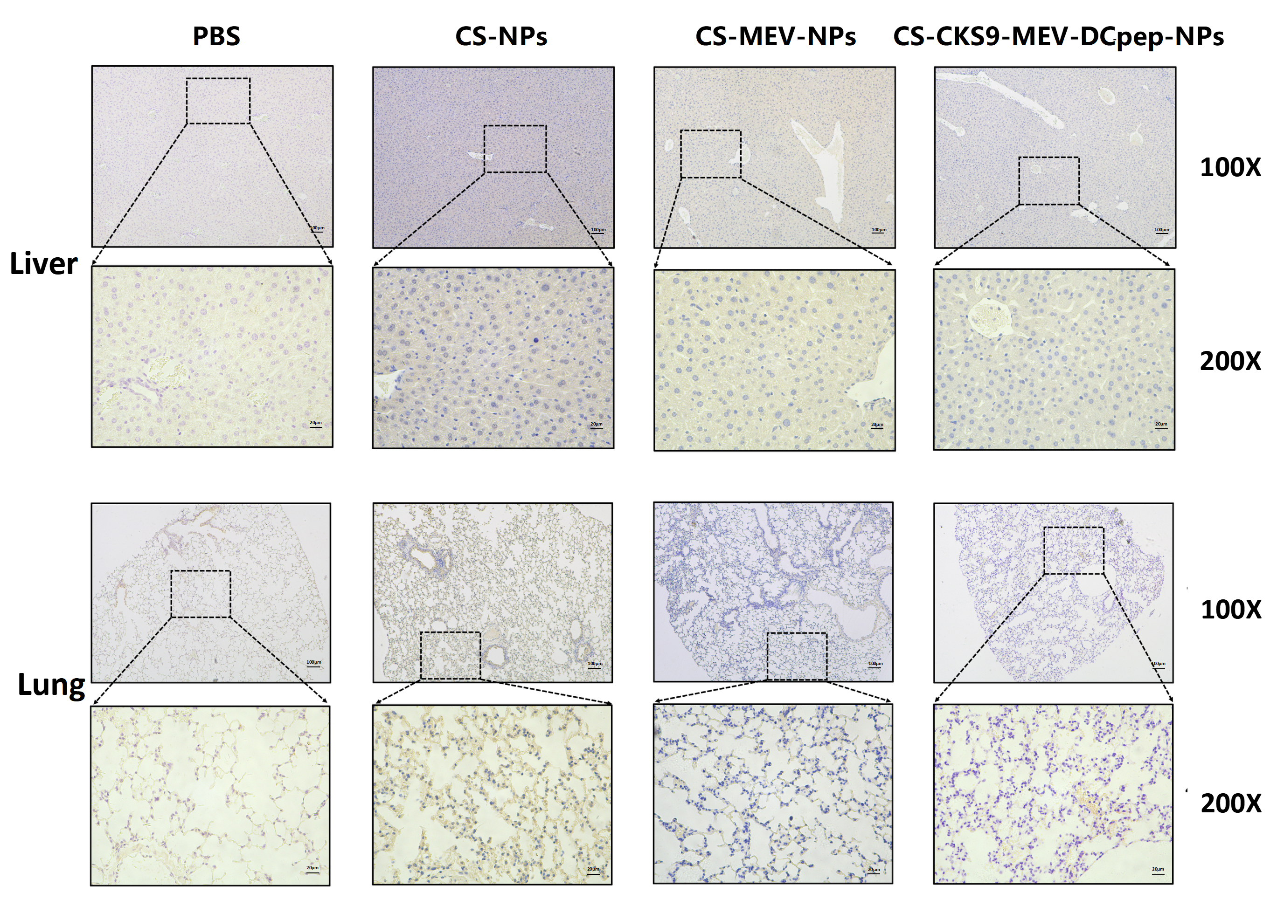
S30. IHC detection of Brucella at two weeks post-immunization. Representative images of liver and lung tissues.

Supplementary Figure 31
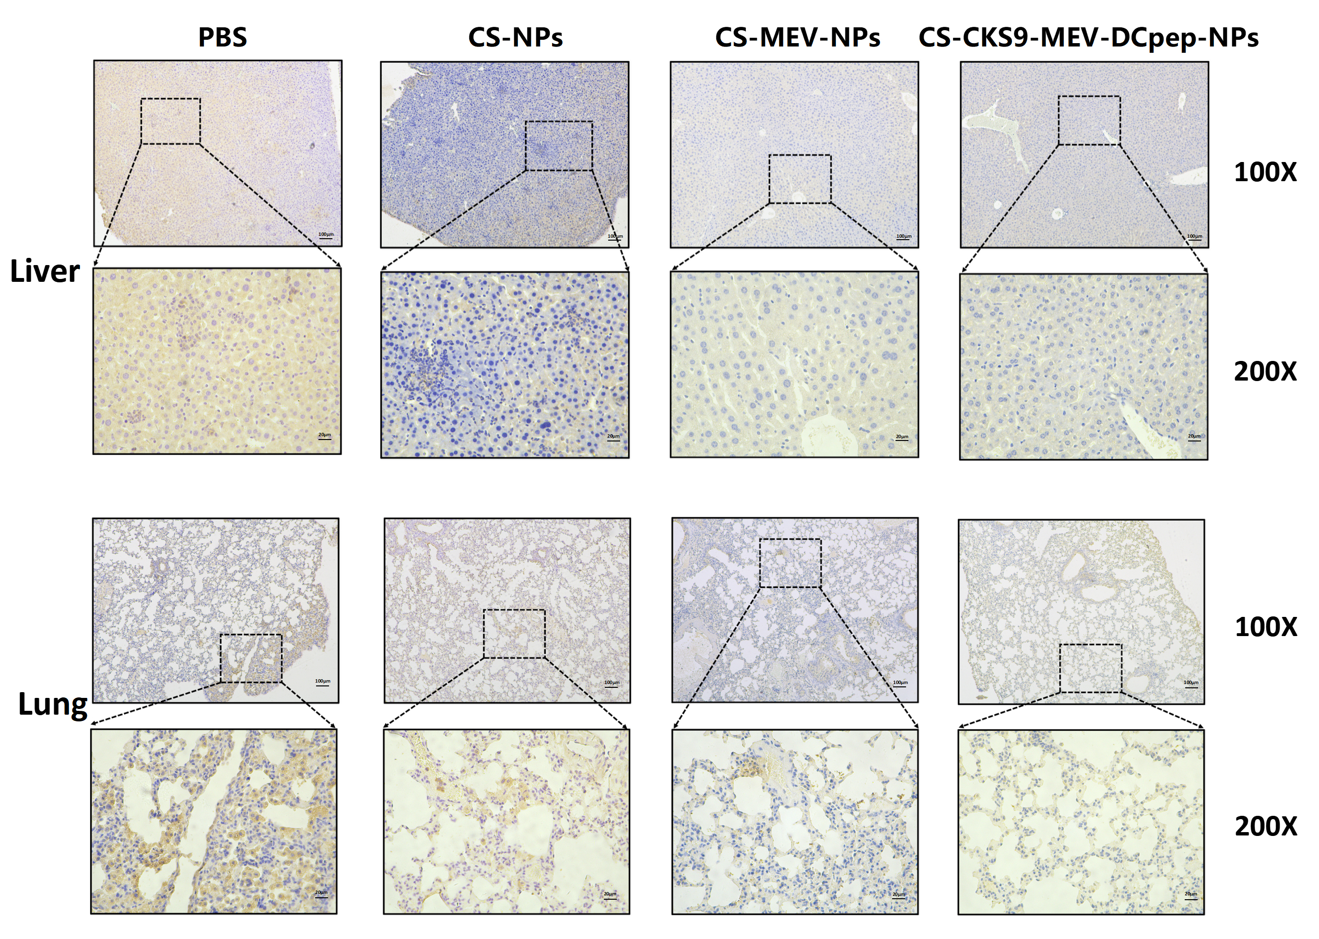S31. IHC detection of Brucella in the chronic phase. Representative images of liver and lung tissues.

