pH-Responsive Chitosan–Mesoporous Organosilica Nanoplatform: Enhancement of Biocompatibility and Tumor Eradication for Precision Colorectal Cancer Chemotherapy

Juan Shao ^{1, 2, 3,†}, Wenjing Li ^{4,†}, Chuxin Zhang ^{2, 3,†}, Jiaxing An ^{2, 3}, Huimei Yu ⁵, Yitao Yan ⁶, Xu Li ^{2, 3}, Wenbo Zhang ⁷, Yingying Wei ⁷, Weiwei Kang ⁴, Keming Yun ^{2, 3}, Ruiping Zhang ^{1,*}, Jie Zheng ^{2, 4, 5, 8,*}, Zhongyuan Guo ^{2, 3, 4,*}

¹ The Fifth Clinical Medical College of Shanxi Medical University/Shanxi Provincial People's Hospital Affiliated to Shanxi Medical University, Taiyuan 030001, PR China.
² School of Forensic Medicine, Shanxi Medical University, Jinzhong, 030600, PR China.
³ Shanxi Key Laboratory of Forensic Medicine, Jinzhong 030600, PR China.
⁴ Academy of Medical Sciences, Shanxi Medical University, Jinzhong, 030600, PR China.
⁵ School of Industry, Shanxi Medical University, Jinzhong, 030600, PR China.
⁶ The First Clinical Medical School, Shanxi Medical University, Taiyuan, 030001, PR China.
⁷ Shanxi Province Cancer Hospital/Shanxi Hospital Affiliated to Cancer Hospital, Chinese Academy of Medical Sciences/Cancer Hospital Affiliated to Shanxi Medical University, Taiyuan, 030001, PR China.
⁸ School of Nursing, Shanxi Medical University, Taiyuan, 030001, PR China.

† These authors contribute equally.
∗ Corresponding author.
Zhongyuan Guo, E-mail: guozhongyuan@sxmu.edu.cn
Address: 98 Daxue Street, School of Forensic Medicine, Shanxi Medical University, Jinzhong, Shanxi Province, People’s Republic of China
Jie Zheng, E-mail: zhengjie@sxmu.edu.cn
Ruiping Zhang, E-mail: zrp_7142@sxmu.edu.cn

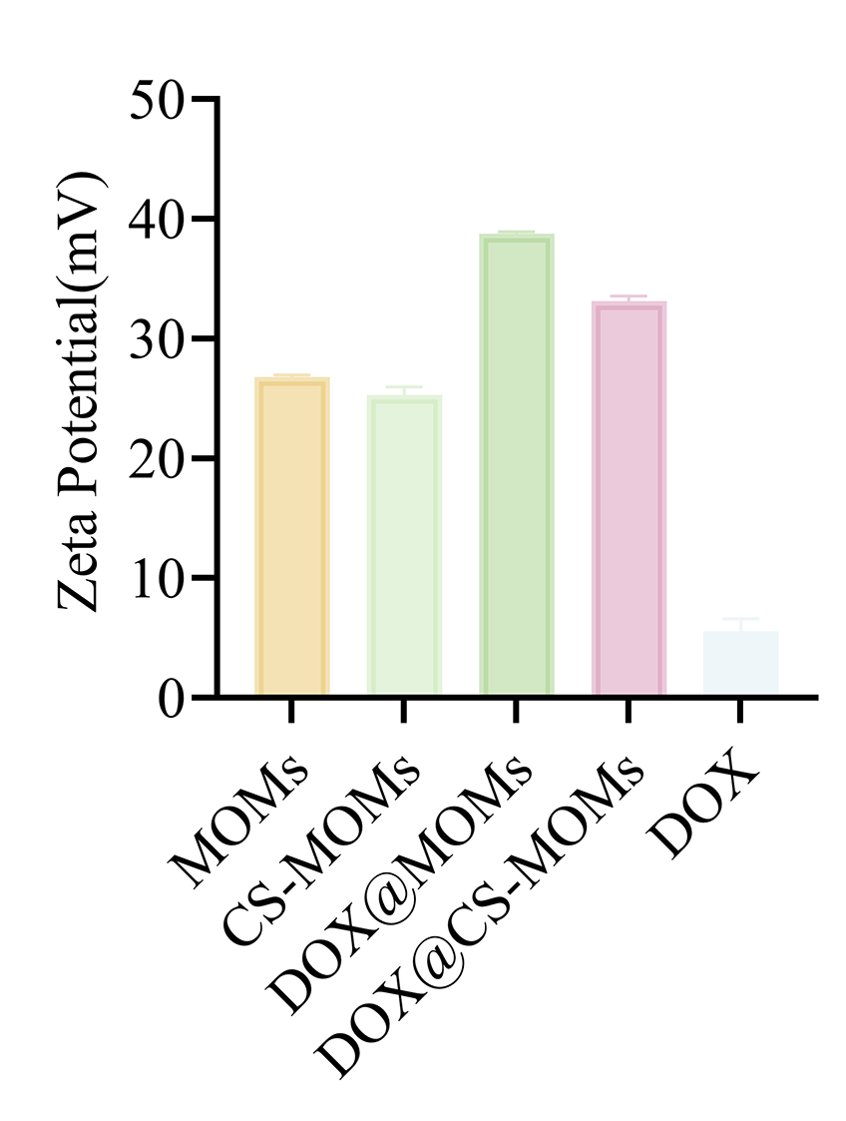
Figure S1. Zeta potential of MOMs, CS-MOMs, DOX@MOMs, DOX@CS-MOMs and DOX. Data are presented as mean ± SD (n ≥ 3).

Figure S2. Biocompatibility evaluation of empty carriers. (a) Cell viability determined by CCK-8 assay and (b) LDH release levels after 24 h of treatment with MOMs and CS-MOMs. Data are presented as mean ± SD (n ≥ 3). Statistical significance relative to the Control group is indicated by ***p < 0.001 and ****p < 0.0001.

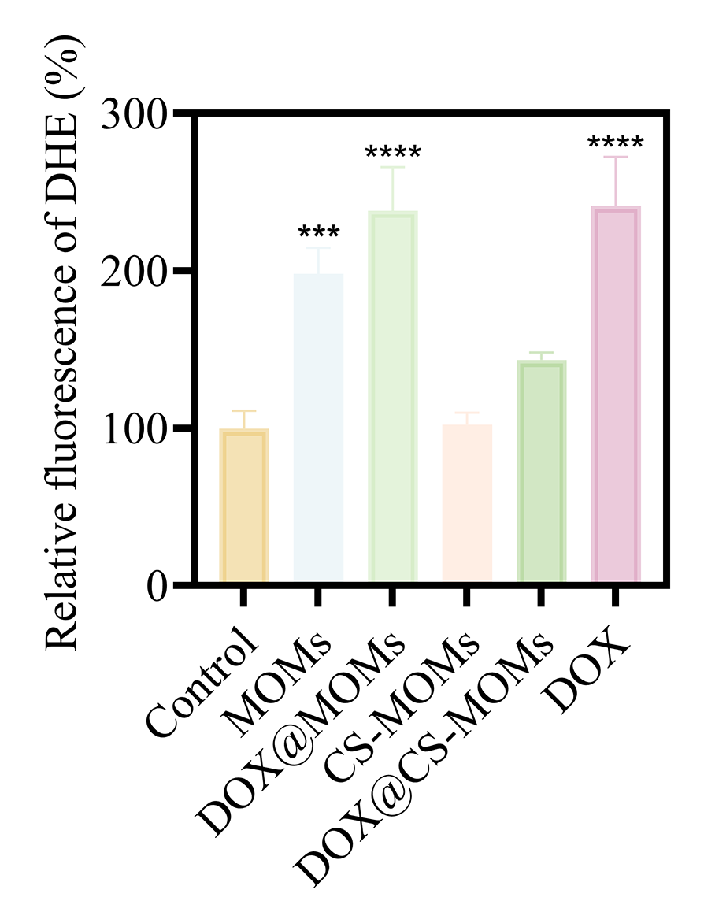
Figure S3. Quantitative analysis of intracellular superoxide fluorescence intensity visualized by DHE staining. Data are presented as mean ± SD (n ≥ 3). Statistical significance relative to the Control group is indicated by ***p < 0.001 and ****p < 0.0001.

Figure S4. Histological safety evaluation using special staining techniques. AB/PAS staining of liver and kidney tissues to assess mucin/glycogen integrity. Masson’s trichrome staining of kidney and spleen tissues to monitor collagen fiber changes. Oil Red O staining of liver tissues to visualize lipid accumulation. Nissl staining of brain tissues to examine neuronal structure and integrity. Scale bar = 100 μm.
Figure S5. Quantitative analysis results of organ function markers: liver function markers (ALT, DBIL, γ-GT), cardiac function markers (cTnT, cTnl), kidney function markers (BUN), pro-inflammatory cytokines (TNF-α), ALB, TC, LDH. Data are presented as mean ± SD (n ≥ 3). Statistical significance relative to the Control group is indicated by *p < 0.05, **p < 0.01, ***p < 0.001, and ****p < 0.0001.

Table S1. Textural parameters of MOMs and CS-MOMs
Thermophysical | BET Surface Area | t-Plot Micropore Area | t-Plot External Surface Area | t-Plot micropore volume | Adsorption average pore width (4V/A by BET)
MOMs | 905.48 m²/g | 696.77 m²/g | 208.72 m²/g | 0.48 cm³/g | 2.98 nm
CS-MOMs | 855.38 m²/g | 733.50 m²/g | 121.89 m²/g | 0.46 cm³/g | 2.87 nm

Table S2: Primer Sequences for RT-qPCR
Species | Gene | Primer (5’-3’)
Human | Occludin | Forward: AGAGTTGACAGTCCCATGGC  Reverse: AGTCATCCACAGGCGAAGTT
Human | ZO-1 | Forward: TAGAAGATAGCCCTGCAGCC  Reverse: GTCAAGCAGGAAAAGGACGG
Human | Bax | Forward: AGATCATGAAGACAGGGGCC  Reverse: AGACACTCGCTCAGCTTCTT
Human | Bcl-2 | Forward: CGTGGAAAGCGTAGACAAGG  Reverse: TGCTGCATTGTTCCCATAGAG

