Supporting Information for Mitochondrial ‘Attack-and-Trap’ Strategy Potentiates cGAS-STING Signaling to Stimulate Durable Antitumor Immunity against Glioblastoma
Zijian Zhang¹, Min Zhuang¹, Li Han¹, Chuanshi He¹, Likun Cui², Quan Dai², Ziyue Hu², Yan Chen³, Jinshun Xu^{**1,2}, Man Lu^{*1,2}

¹ Department of Ultrasound, Sichuan Clinical Research Center for Cancer, Sichuan Cancer Hospital &Institute, Sichuan Cancer Center, School of Medicine, University of Electronic Science and Technology of China
² Department of Ultrasound, Center for Translational Research in Cancer, Sichuan Clinical Research Center for Cancer, Sichuan Cancer Hospital & Institute, Affiliated Cancer Hospital of University of Electronic Science and Technology of China, Chengdu, China
³ Department of Pharmacy, Center for Translational Research in Cancer, Sichuan Clinical Research Center for Cancer, Sichuan Cancer Hospital & Institute, Affiliated Cancer Hospital of University of Electronic Science and Technology of China, Chengdu, China

*Corresponding author
**Corresponding author
Email: luman@uestc.edu.cn (Man Lu); xujinshun@uestc.edu.cn (Jinshun Xu)

Supplementary Figures
Figure S1. Time-dependent DPBF absorption spectra of HM-NPs@CM nanoliposome under US irradiation (1.0 MHz, 1.5 W/cm², 10 min).

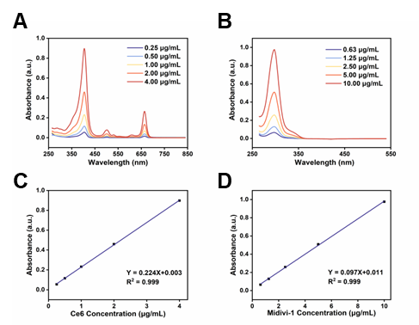
Figure S2. The UV-Vis absorbance spectrum of Ce6 (A) and Mdivi-1 (B) in DMSO with different concentrations, and the standard curve line of Ce6 (C) and Mdivi-1 (D) according to the peak absorptions.

Figure S3. Cumulative in vitro release kinetics of Ce6 from HM-NPs@CM in different environments.

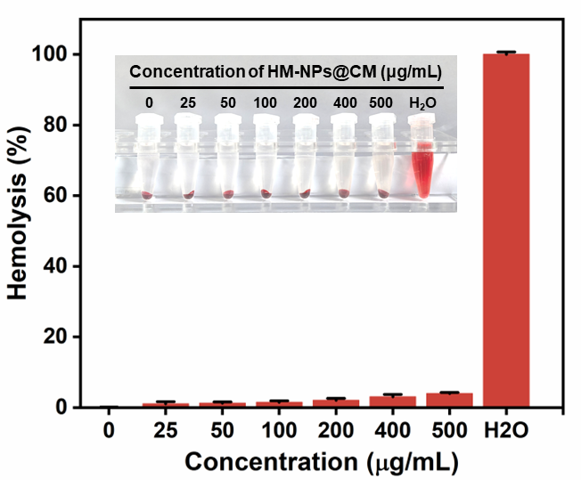
Figure S4. Hemolysis test of HM-NPs@CM in different concentrations. (mean ± s.d. n=3)

Figure S5. Cell viability of bEnd.3 cells after incubated with HM-NPs@CM for 24 h in the dark. (mean ± s.d. n=6)

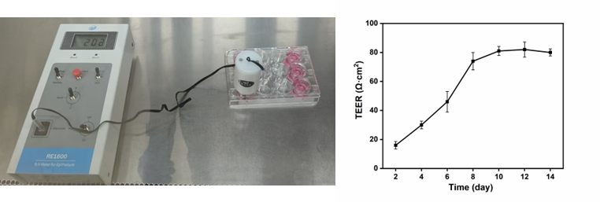
Figure S6. Transendothelial Electrical Resistance (TEER) values of a bEnd.3 cell monolayer cultured in a Millipore Transwell 12-well Millicell Hanging Cell Culture Insert. (mean ± s.d. n=3)

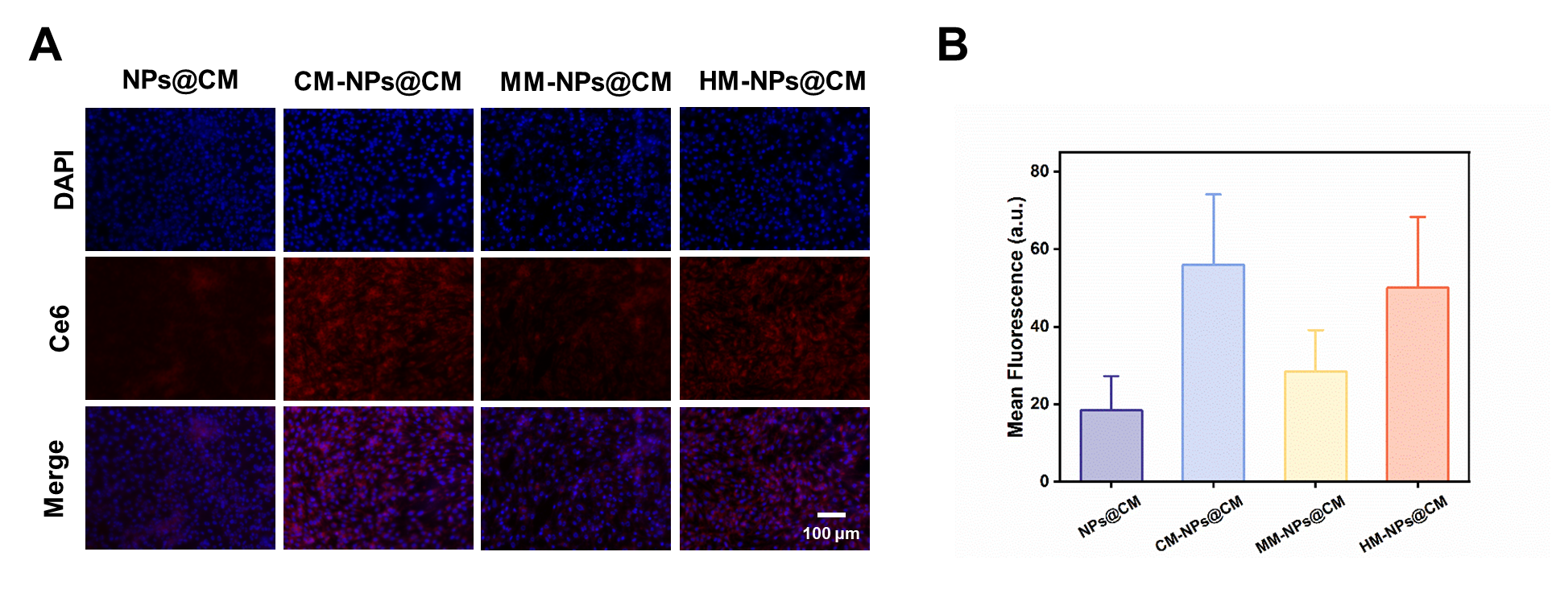
Figure S7. A) Fluorescence images indicating the cellular uptake behaviors of different Ce6-loaded nanoliposomes in bEnd.3 cells. Scale bar: 100 μm. B) Quantification of the mean fluorescence intensity (MFI) of the bEnd.3 cells after different treatments using ImageJ software.

Figure S8. Transport ratios of different nanoliposomes’ accumulation in GL261 cells after penetrating the BBB model in vitro.

Figure S9. Quantitation of different Ce6-loaded nanoliposomes distribution in GL261 multicellular spheroids after 6 h incubation (Ce6 concentration was 10 μg/mL). Scale bar=100 μm (mean ± s.d. n=3)

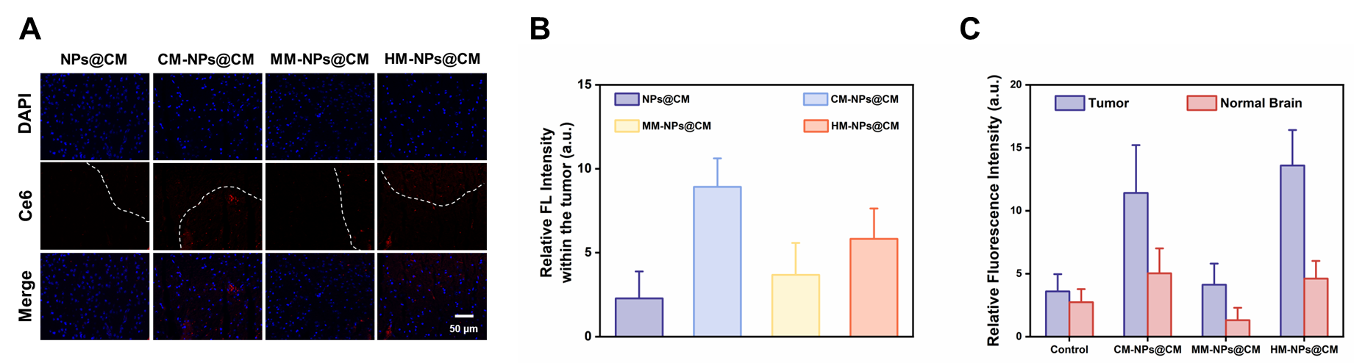
Figure S10. A) Representative fluorescence images and semiquantitative statistical results of Ce6 (red) in brains harvested from mice bearing GBM cells. White dashed lines divide brain sections into tumor areas and nontumor areas. B) Quantification of Ce6 accumulation in orthotopic GBM tissue excised from mice 6 h post tail vein injection of with different Ce6-loaded nanoliposomes. C) Tumor-to-normal brain (T/N) distribution calculated by the relative fluorescence intensity of the tumor area relative to the normal brain parenchyma. (n=3)

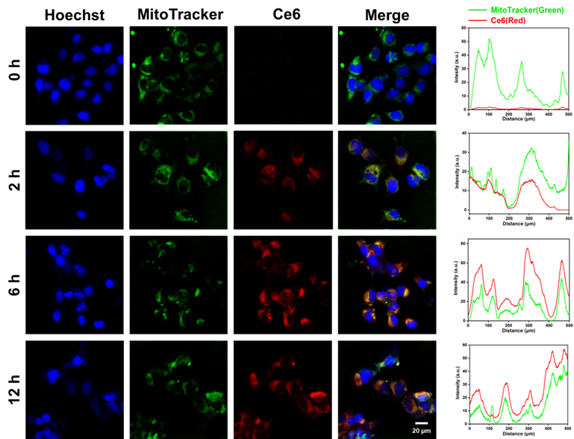
Figure S11. CLSM images of GL261 cells treated with HM-NPs@CM for 0, 2, 6, 12 h, respectively. Corresponding colocalization analysis of HM-NPs@CM (red) and mitochondria (green).

Figure S12. GL261 cell viability with various treatments (PBS, Ce6, Mdivi-1, HM-NPs@C, and HM-NPs@CM) in the presence or absence of US irradiation (1.0 MHz, 1.5 W cm⁻², 50% duty cycle, 1 min). (1: Control, 2: Ce6, 3: Mdivi-1, 4: HM-NPs@C, 5: HM-NPs@CM).

Figure S13. Corresponding quantification of ROS production in different groups with or without US (mean ± s.d. n=3). (1: Control, 2: Ce6, 3: Mdivi-1, 4: HM-NPs@C, 5: HM-NPs@CM).

Figure S14. Volume changes of GL261 multicellular spheroids after different treatments for 5 days.

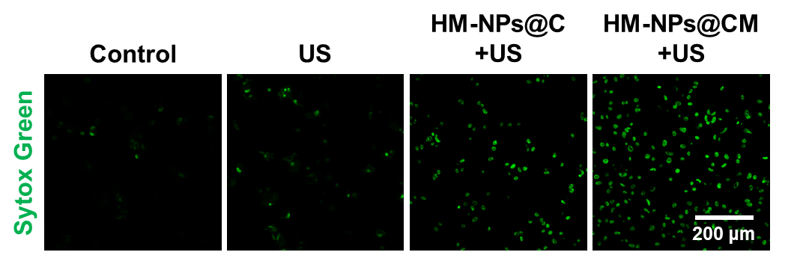
Figure S15. Sytox Green staining of GL261 with different treatments.

Figure S16. The mtDNA release from GL261 cells after different treatments. (mean ± s.d. n = 3)

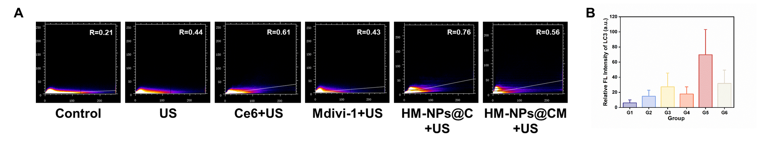
Figure S17. A) Quantitative analysis of LC3 fluorescence in GL261 cells treated with different groups. (mean ± s.d. n=3) B) Corresponding colocalization analysis of autophagic substrate LC3 (green) and mitochondrial marker TOMM20 (red). (G1: Control, G2: US, G3: Ce6+US, G4: Mdivi-1+US, G5: HM-NPs@C+US, G6: HM-NPs@CM+US).

Figure S18. The concentrations of cGAMP in GL261 cells treated with different groups. (mean ± s.d. n=3). (G1: Control, G2: US, G3:Ce6+US, G4: Mdivi-1+US, G5: HM-NPs@C+US, G6: HM-NPs@CM+US).

Figure S19. Quantitative analysis of pSTING fluorescence in GL261 cells treated with different groups. (mean ± s.d. n=3). (G1: Control, G2: US, G3:Ce6+US, G4: Mdivi-1+US, G5: HM-NPs@C+US, G6: HM-NPs@CM+US).

Figure S20. Semi-quantitative analysis of CRT exposure on GL261 cell surface. (mean ± s.d. n=3). (G1: Control, G2: US, G3:Ce6+US, G4: Mdivi-1+US, G5: HM-NPs@C+US, G6: HM-NPs@CM+US).

Figure S21. Quantification of the extracellular levels of HMGB1 of the GL261 cells after different treatments. (mean ± s.d. n=3). (G1: Control, G2: US, G3:Ce6+US, G4: Mdivi-1+US, G5: HM-NPs@C+US, G6: HM-NPs@CM+US).

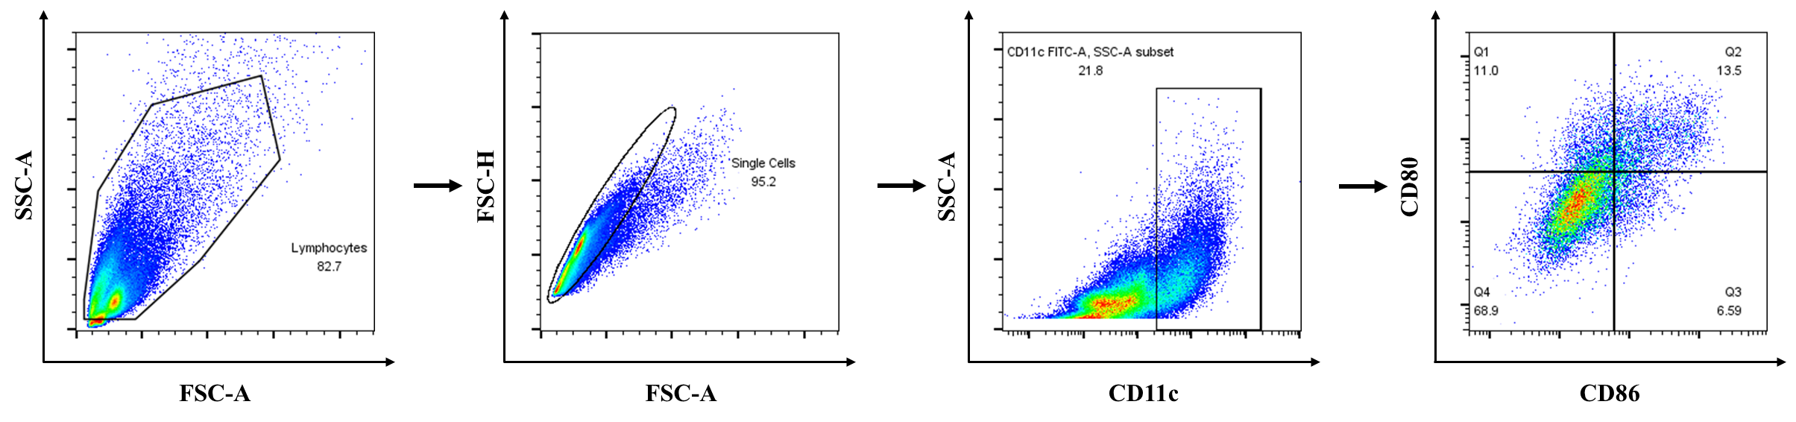
Figure S22. Flow cytometry gating strategy for BMDC maturation in the transwell model.
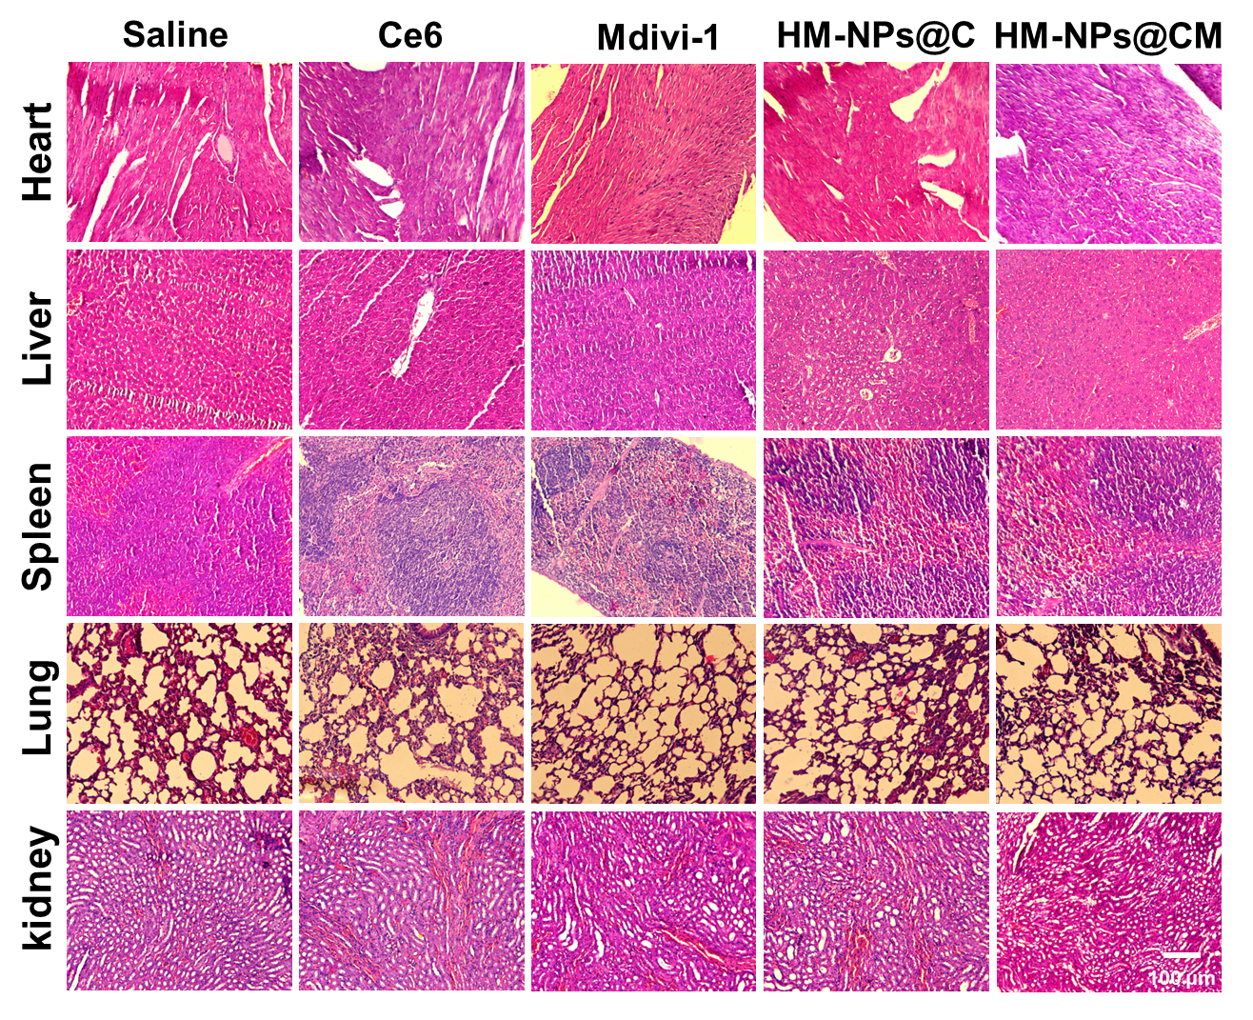
Figure S23. Representative H&E staining images of the main organs of mice at the end of treatments. (n=3)

Figure S24. Serum biochemical parameters, including AST, ALT, the AST/ALT ratio, urea, and creatinine (Cr), in mice at the end of treatment. Data are presented as mean ± s.d. (n = 3 biologically independent mice).
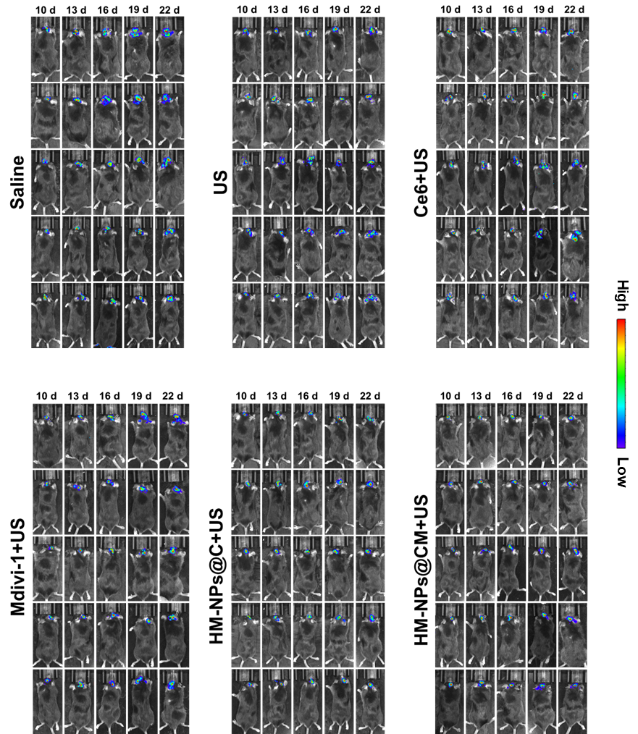
Figure S25. Bioluminescence images of mice bearing orthotopic GL261-luc tumors receiving different treatments at the indicated time points.

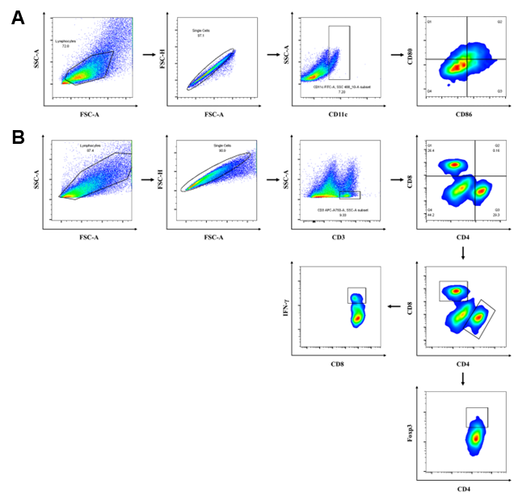
Figure S26. A) Flow cytometry gating strategy for DC maturation in tumors. B) The detailed gate strategy of CD3⁺ CD4⁺ CD8⁻ and CD3⁺ CD4⁻ CD8⁺ T cell in tumors. Flow cytometry gating strategy of IFN-γ⁺ CD8⁺ T cell and Treg cells in tumors.

Figure S27. Tumor volumes of orthotopic GBM for each group of tumor-bearing mice. (mean ± s.d. n=3). (G1: Control, G2: US, G3:Ce6+US, G4: Mdivi-1+US, G5: HM-NPs@C+US, G6: HM-NPs@CM+US).

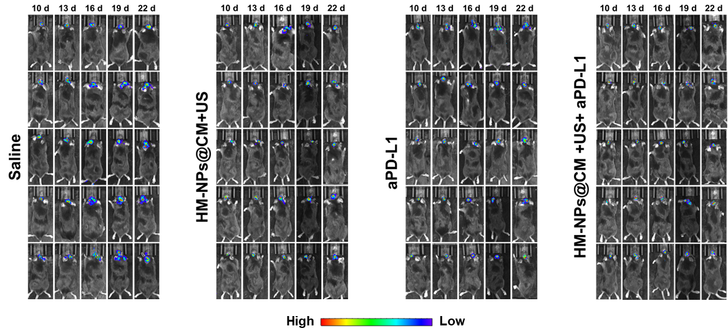
Figure S28. Bioluminescence images of mice bearing orthotopic GL261-luc tumors receiving different treatments at the indicated time points.

Figure S29. Tumor volumes of orthotopic GBM for each group of tumor-bearing mice.

Figure S30. Body weight change curves of the mice in each experimental group during treatment. (mean ± s.d. n=6)

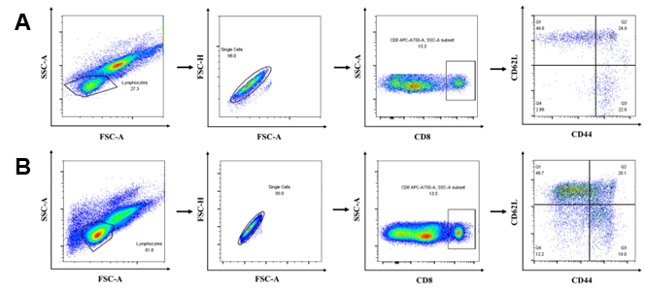
Figure S31. Flow gating strategy for CD8⁺ CD44⁺ CD62L⁻ effector memory T cells (Tem) and the CD8⁺ CD44⁺ CD62L⁺ central memory T cells (Tcm) in peripheral blood A) and spleen B).

Figure S32. Quantitative analysis data of bioluminescence intensity of the GL261-luc at different time points.

Figure S33. Body weight change curves of the mice in each experimental group during treatment. (mean ± s.d. n=5)

Supplementary Table
Ce6-to-lipid ratio | DLC | DLE
1:10 | 1.97% | 93.6%
1:20 | 3.44% | 97.3%
1:30 | 2.75% | 94.1%
Table S1. The DLCs and DLEs of different weight ratios of Ce6 and lipid contents.

Mdivi-1-to-lipid ratio | DLC | DLE
1:10 | 2.13% | 90.4%
1:20 | 2.84% | 95.2%
1:30 | 2.47% | 84.3%
Table S2. The DLCs and DLEs of different weight ratios of Mdivi-1 and lipid contents.

Supplementary Equation
$$Transport Ratio \left(\%\right)=\frac{F_{B}\left(t\right)}{F_{A}\left(0\right)}×100\%$$
(F_{B} (t): The fluorescence intensity value (RFU) measured in the basolateral side (B-side, receiver side) at the experimental end time point;
F_{A}(0): The initial fluorescence intensity value (RFU) in the apical side (A-side, donor side) at the beginning of the experiment (t=0).)
Equation S1. Formulas to calculate the transport ratio in the BBB model.

DLC(%) = (amount of loaded drug)/(amount of loaded NPs)×100%
DLE(%) = (amount of loaded drug)/(total amount of feeding drug)×100%
Equation S2. Formulas to calculate loaded Ce6 and Mdivi-1 (DLC and DLE) in HM-NPs@CM.

