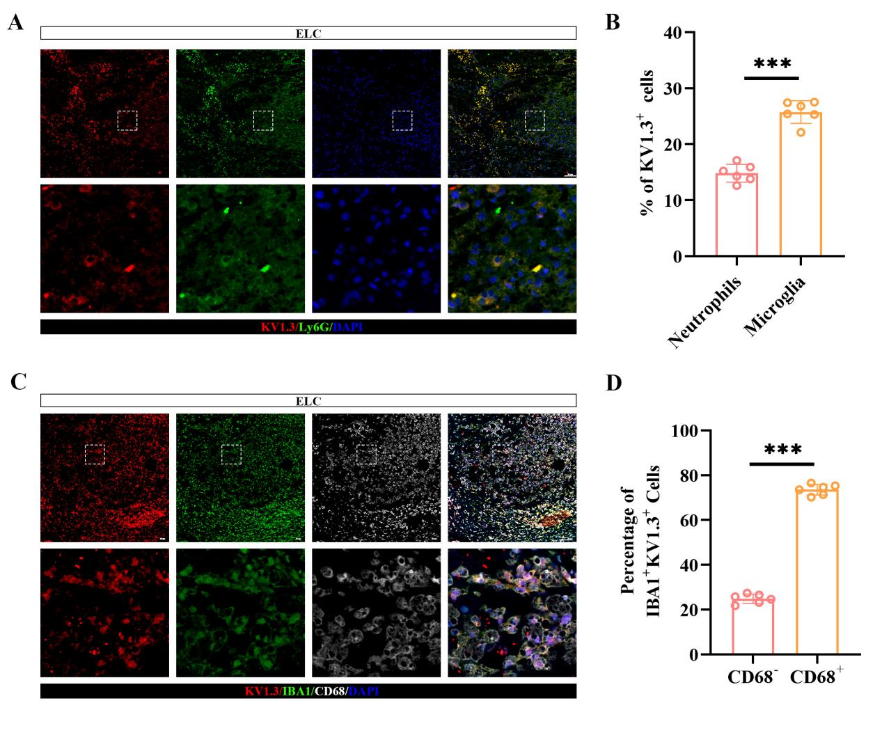
Figure S1. KV1.3 is expressed in activated microglia.（A,B）Representative immunofluorescence images showing co-localization of KV1.3 with Ly6G(neutrophils) markers at 3 dpi, along with quantification (n=6; scale bar: 50 µm). （C,D）Representative immunofluorescence staining of KV1.3 with IBA1 andCD68 in the ELC at 3 dpi. (n=6; scale bar: 50 µm).

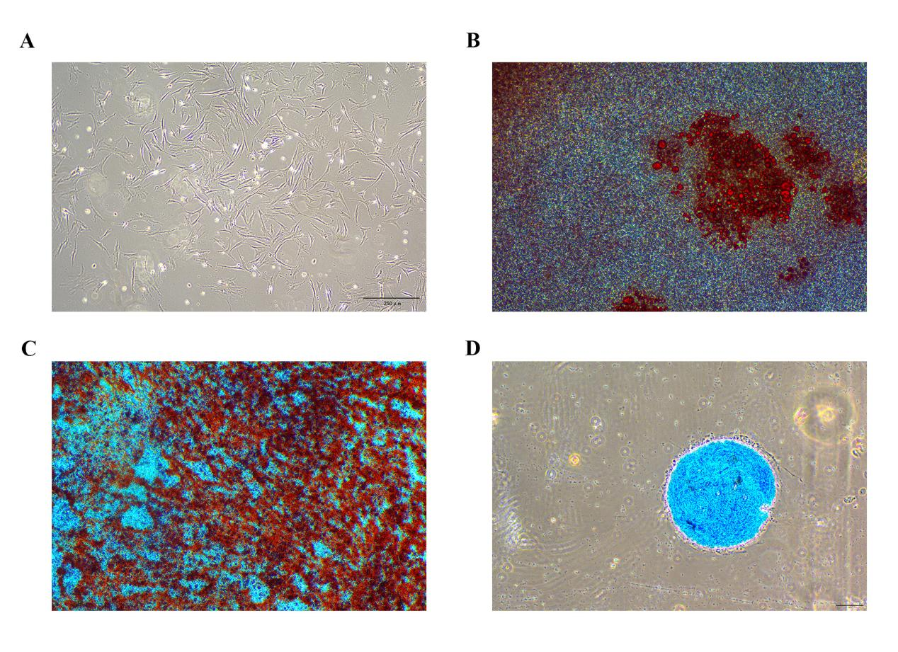
Figure S2. Isolation and trilineage differentiation of BMSCs. (A) Phase-contrast micrograph showing the typical fibroblast-like morphology of primary BMSCs (scale bar: 250 μm). (B) Adipogenic differentiation confirmed by Oil Red O staining of lipid droplets (scale bar: 250 μm). (C) Osteogenic differentiation evidenced by Alizarin Red S staining of calcium deposits (scale bar: 250 μm). (D) Chondrogenic differentiation demonstrated by Alcian Blue staining of proteoglycans (scale bar: 250 μm).

Figure S3. Phenotypic characterization of BMSCs by flow cytometry. (A) Expression analysis of the mesenchymal marker CD73 (n = 3). (B) Expression analysis of the mesenchymal marker CD90 (n = 3). (C) Expression analysis of the mesenchymal marker CD105 (n = 3). (D) Expression analysis of the hematopoietic marker CD34 (n = 3). (E) Expression analysis of the pan-leukocyte marker CD45 (n = 3). (F) Expression analysis of the B-lymphocyte marker CD19 (n = 3).

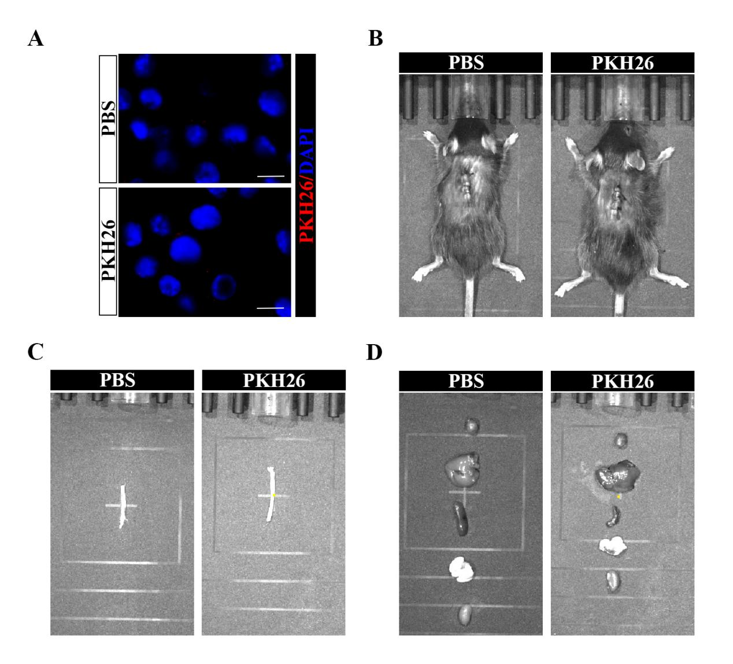
Figure S4. PKH26 dye-only controls show negligible fluorescence in vitro and in vivo. (A) BV-2 cells incubated with PKH26 dye-only show no intracellular fluorescence ((n = 3; scale bar: 20 μm). (B) In vivo imaging of mice injected with PKH26 dye-only reveals minimal systemic signal. (C, D) Ex vivo imaging of spinal cord (C) and major organs (D) harvested 12 h post-injection confirms no specific tissue accumulation. ( n = 3).

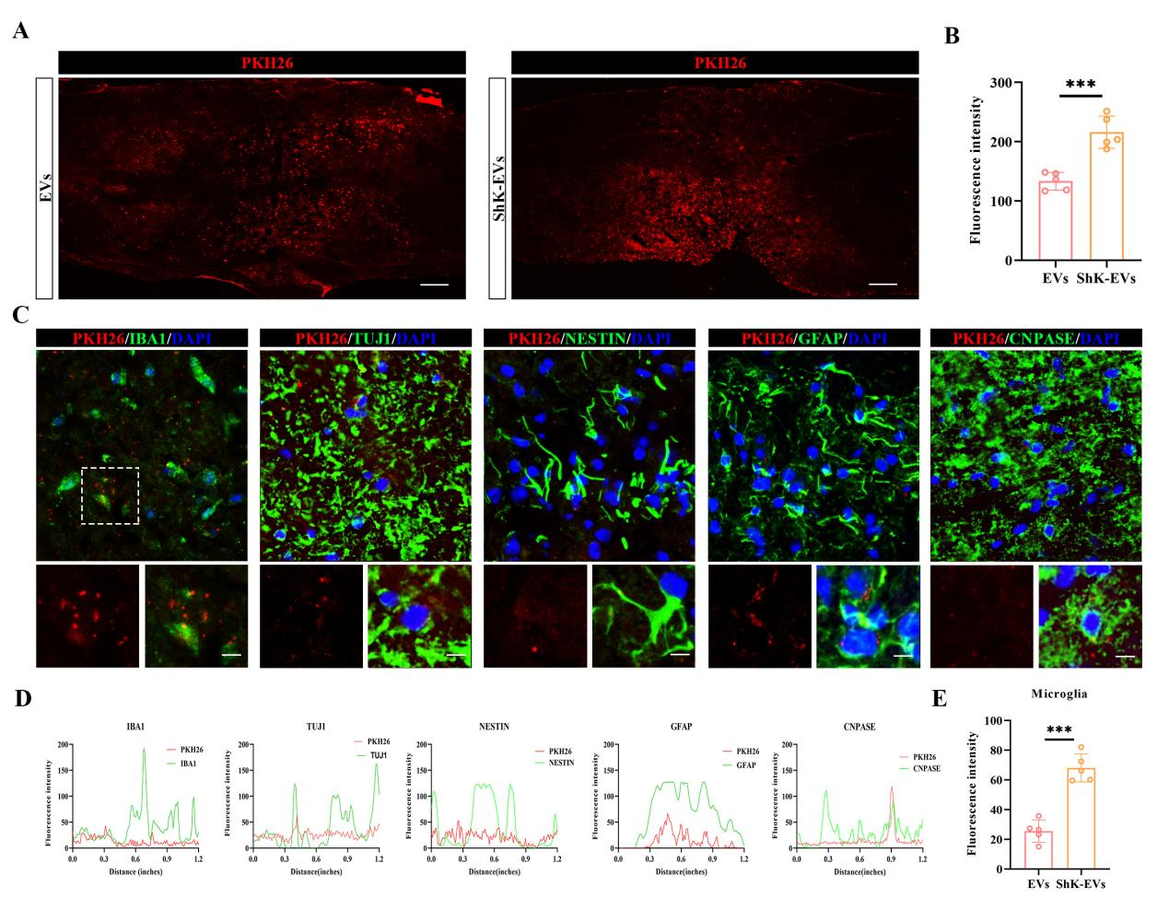
Figure S5. Accumulation and cell type co-localization of PKH26-labeled EVs and ShK-EVs in the injured spinal cord. (A) Ex vivo fluorescence images of spinal cord sections harvested 24 h after injection of PKH26-labeled EVs or PKH26-labeled ShK-EVs. Scale bar: 200 μm. (B) Quantification of fluorescence intensity in spinal cord sections from (A). n = 5. (C, D) Immunofluorescence analysis of PKH26-labeled ShK-EVs co-localized with IBA1⁺ microglia, TUJ1⁺ neurons, NESTIN⁺ neural stem cells, GFAP⁺ astrocytes, and CNPASE⁺ oligodendrocytes at the lesion site 24 h after SCI. Scale bar: 20 μm. n = 5. (E) Quantification of PKH26 fluorescence intensity in IBA1⁺ microglia. n = 5.

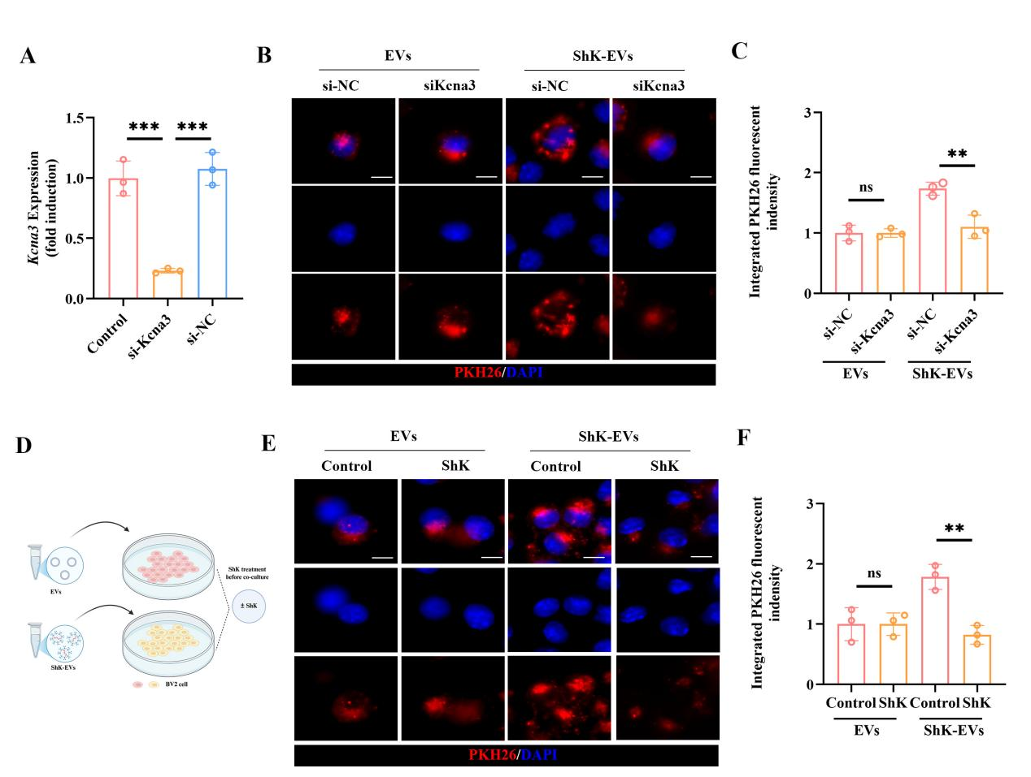
Figure S6. Kv1.3 is required for ShK-EV uptake by BV-2 microglia. (A) Kcna3 mRNA expression by qPCR after siKcna3 or siNC transfection. n = 3.
(B, C) Representative images (B) and quantification (C) of PKH26-labeled ShK-EV uptake in siNC vs. siKcna3-treated cells. Scale bar: 20 μm. n = 3. (D) Schematic of free ShK competition assay. (E, F) Representative images (E) and quantification (F) of PKH26-labeled ShK-EV uptake with or without free ShK pre-incubation. Scale bar: 20 μm. n = 3.
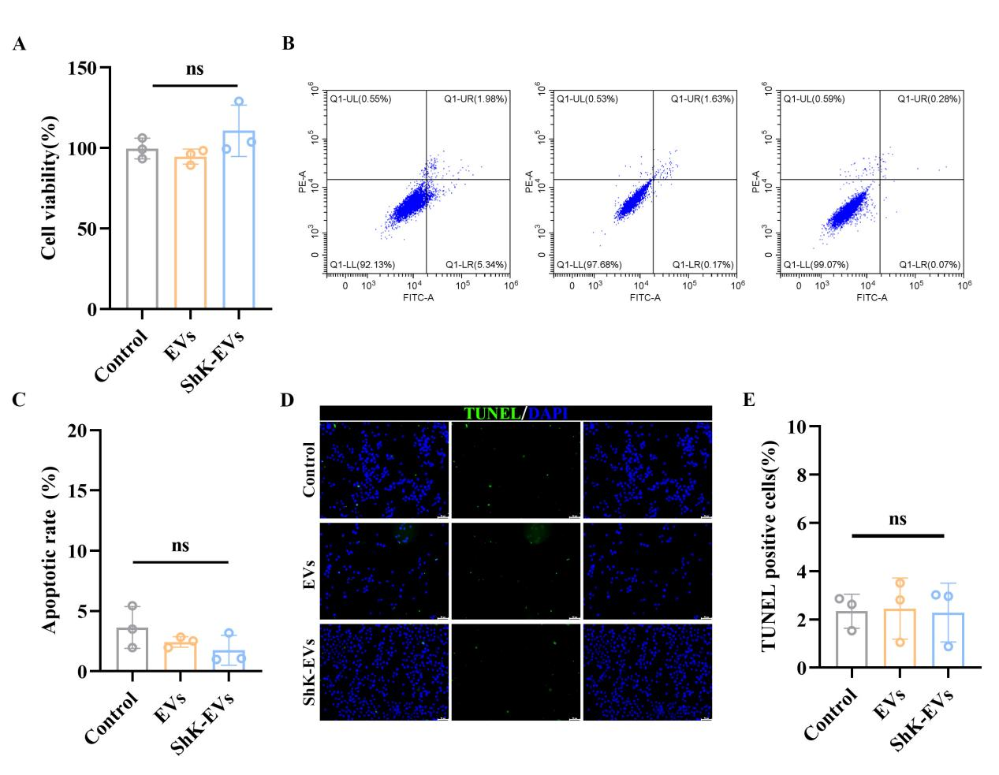
Figure S7. Cytotoxicity assessment of ShK-EVs on BV2 microglial cells in vitro. (A) Cell Counting Kit-8 (CCK-8) assay indicating that neither ShK-EVs nor EVs affected the viability of BV2 cells. (B, C) Flow cytometric analysis of BV2 cell apoptosis and corresponding quantification (n = 3). (D, E) TUNEL staining images and quantitative analysis of apoptotic BV2 cells (n = 3; scale bar: 50 μm).
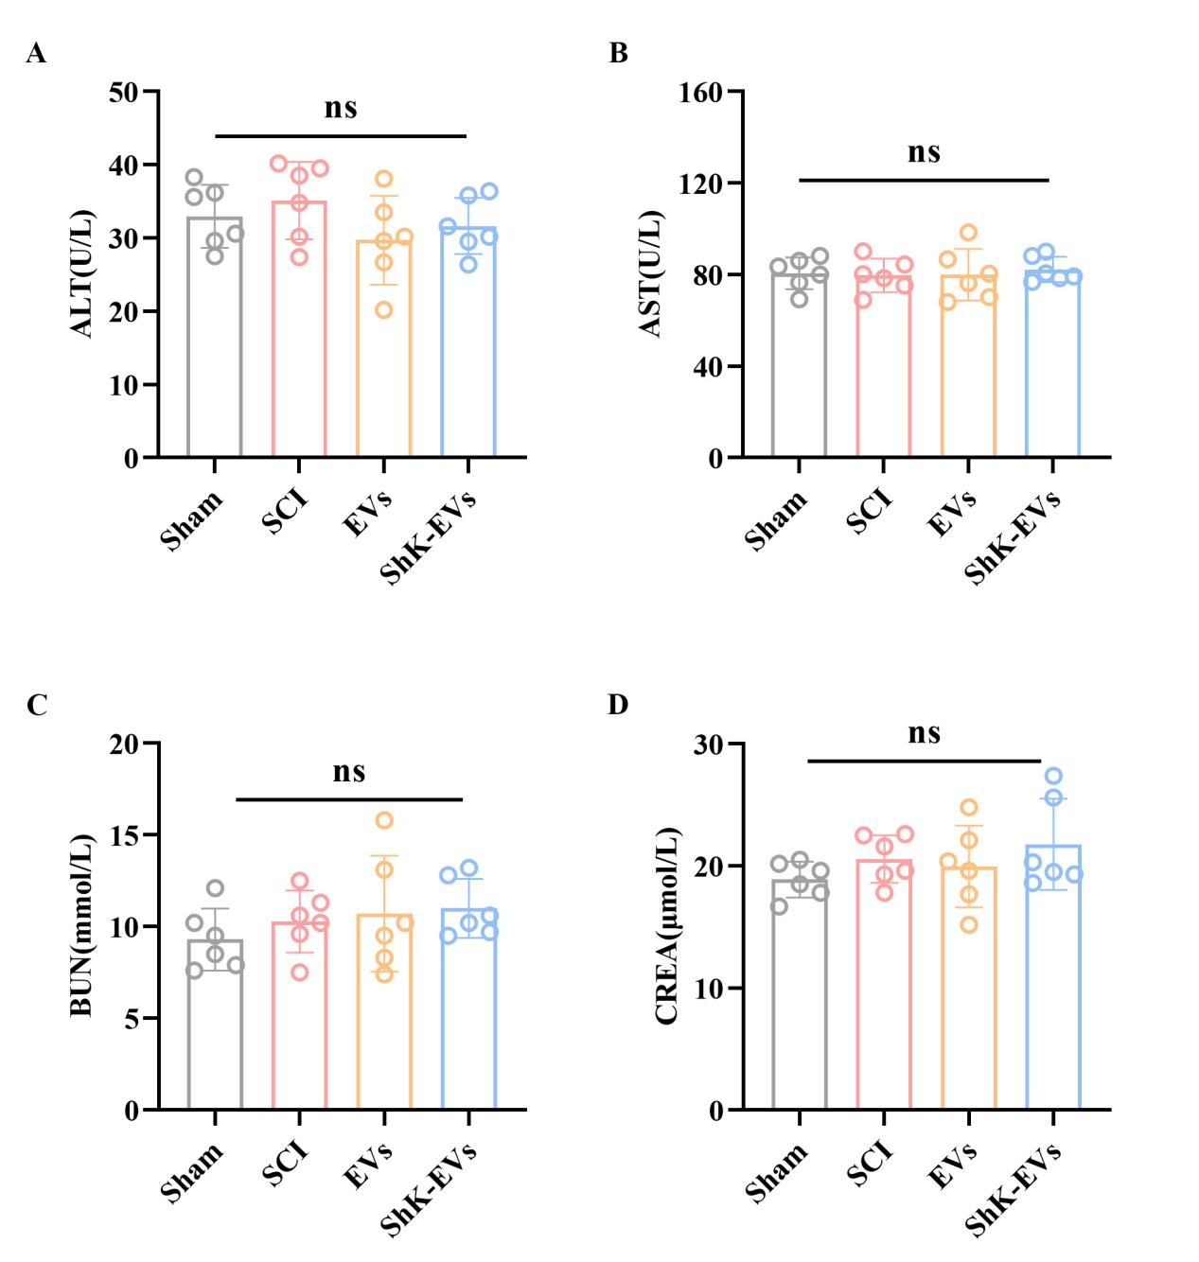
Figure S8. Systemic safety profile of ShK-EVs: analysis of blood biochemical parameters. (A) Serum alanine aminotransferase (ALT) levels two weeks post-injection (n = 6). (B) Serum aspartate aminotransferase (AST) levels two weeks post-injection (n = 6). (C) Serum blood urea nitrogen (BUN) levels two weeks post-injection (n = 6). (D) Serum creatinine (CREA) levels two weeks post-injection (n = 6). All panels (A–D) compare the ShK-EV and control EV treatment groups.

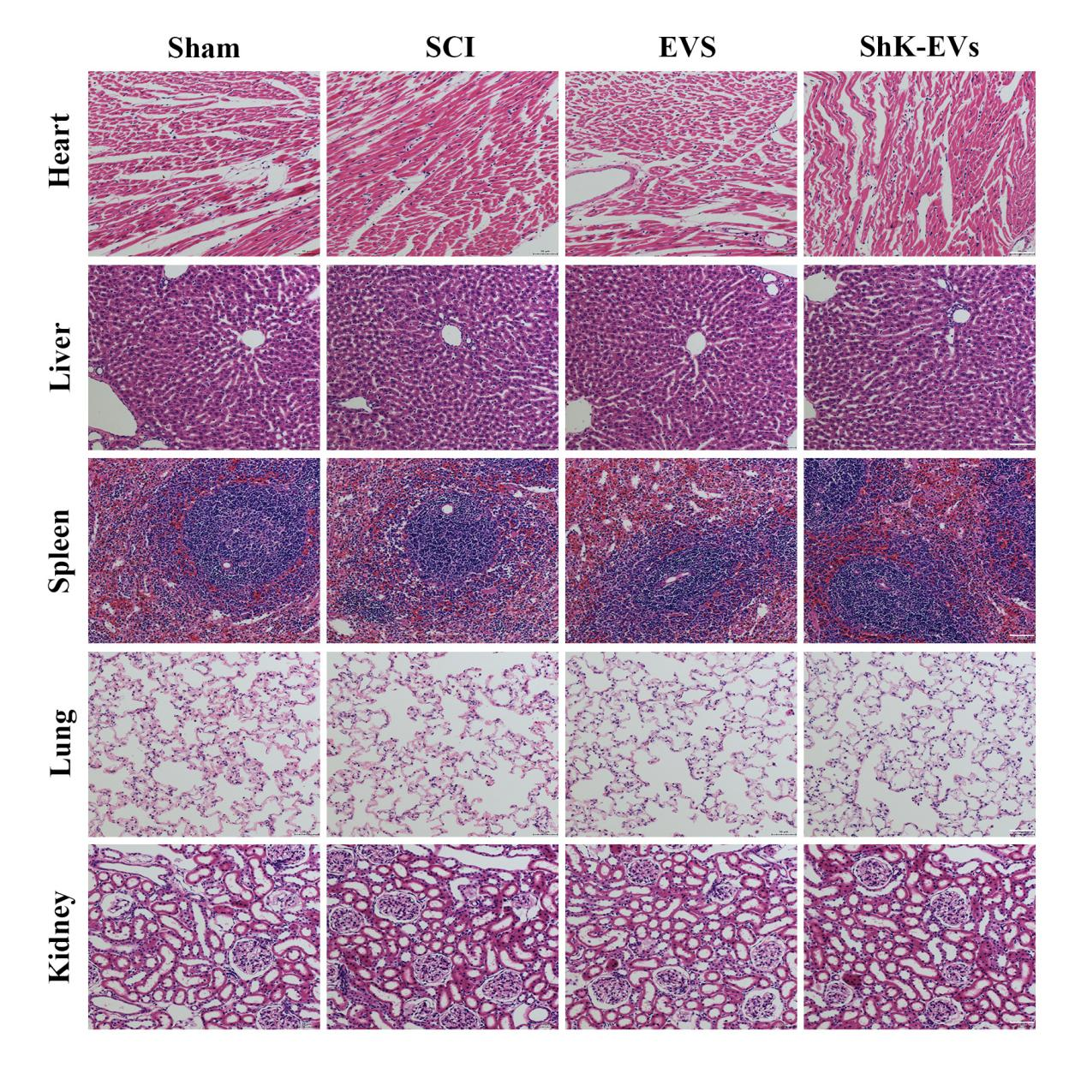
Figure S9. Histological safety assessment of ShK-EVs in major organs. Hematoxylin and eosin (H&E) staining of the heart, liver, spleen, lungs, and kidneys revealed no discernible histopathological alterations in ShK-EV or EV-treated mice at 2 weeks after SCI (n = 6; scale bar: 50 μm).
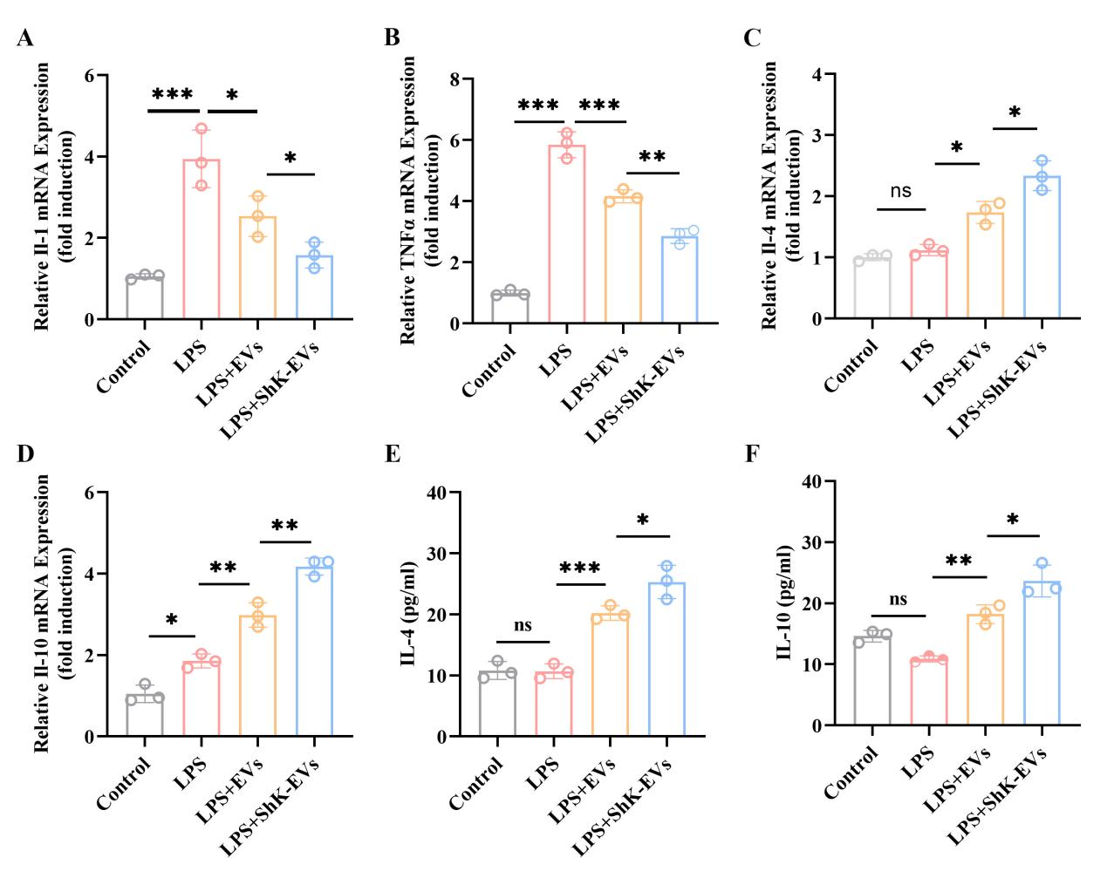
Figure S10. ShK-EVs modulate the inflammatory gene expression profile in microglia. (A) RT-qPCR analysis of Il1b mRNA levels (n = 3). (B) RT-qPCR analysis of Tnf mRNA levels (n = 3). (C) RT-qPCR analysis of Il4 mRNA levels (n = 3). (D) RT-qPCR analysis of Il10 mRNA levels (n = 3). (E) Concentrations of the anti-inflammatory cytokines IL-4 cell culture supernatants, as measured by ELISA (n = 3). (F) Concentrations of the anti-inflammatory cytokines IL-10 cell culture supernatants, as measured by ELISA (n = 3). All analyses include cells from the following treatment groups: Control, LPS, LPS + EVs, and LPS + ShK-EVs.
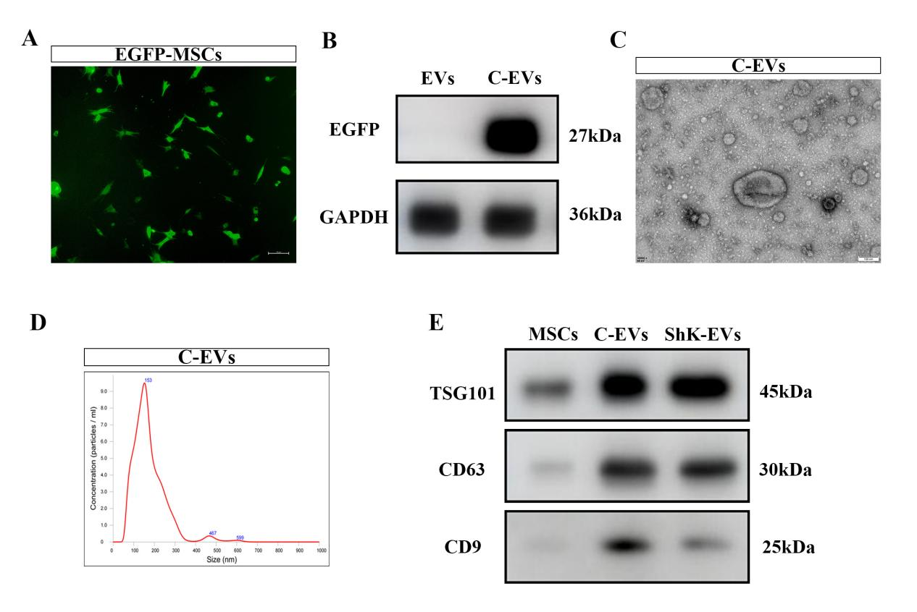
Figure S11. Characterization of control LAMP2b-EGFP-EVs (C-EVs) without ShK peptide.
(A) Fluorescence images of MSCs transfected with the LAMP2b-EGFP expression vector (without ShK). Scale bar: 50 μm. (B) Western blot analysis of EGFP protein expression in C-EVs. (C) Transmission electron microscopy images of C-EVs. Scale bar: 100 nm. (D) Nanoparticle tracking analysis (NTA) showing the size distribution of C-EVs. (E) Western blot analysis of EV marker proteins (CD9, CD63, TSG101) in C-EVs. All experiments were performed with at least three independent preparations.

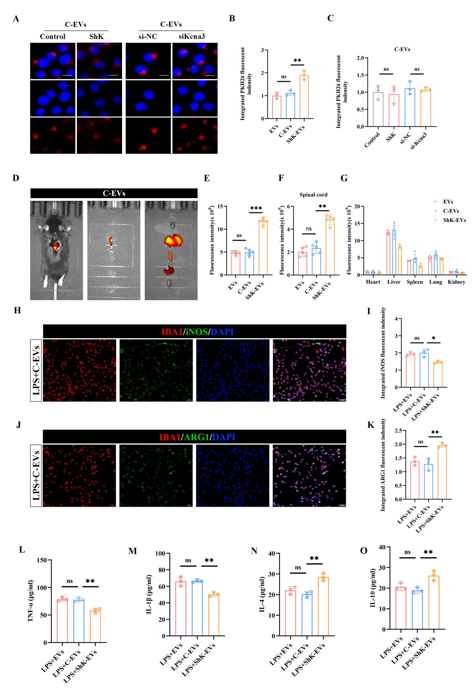
Figure S12. Specificity of ShK-EV targeting and functional effects assessed using control LAMP2b-EGFP-EVs (C-EVs). (A) Representative fluorescence microscopy images of PKH26-labeled C-EV uptake in BV-2 microglia under conditions of free ShK peptide competition (10 μM) or siKcna3 transfection. Scale bar: 20 μm. (B) Quantification of PKH26 fluorescence intensity comparing EVs, C-EVs, and ShK-EVs under baseline conditions.n = 3. (C) Quantification of PKH26 fluorescence intensity from (A). n = 3. (D) Ex vivo fluorescence images of spinal cord and major organs harvested 24 h after intravenous injection of PKH26-labeled C-EVs. (E) Quantification of in vivo fluorescence intensity (whole-body imaging) for C-EVs. n = 5 . (F) Quantification of ex vivo fluorescence intensity in spinal cord for C-EVs, unmodified EVs, and ShK-EVs. n = 5.(G) Quantification of ex vivo fluorescence intensity in major organs (heart, liver, spleen, lung, kidney) for C-EVs, unmodified EVs, and ShK-EVs. n = 5. (H) Representative immunofluorescence images of iNOS (green) and IBA1 (red) in BV2 cells treated with C-EVs. Scale bar: 50 μm. (I) Quantification of iNOS fluorescence intensity normalized to IBA1⁺ area from (H). n = 3. (J) Representative immunofluorescence images of ARG1 (green) and IBA1 (red) in BV2 cells treated with C-EVs. Scale bar: 50 μm. (K) Quantification of ARG1 fluorescence intensity normalized to IBA1⁺ area from (J). n = 3. (L–O) ELISA quantification of TNF-α, IL-1β, IL-4, and IL-10 levels in culture supernatants of BV-2 microglia treated with EVs, C-EVs, or ShK-EVs under LPS stimulation. n = 3 .
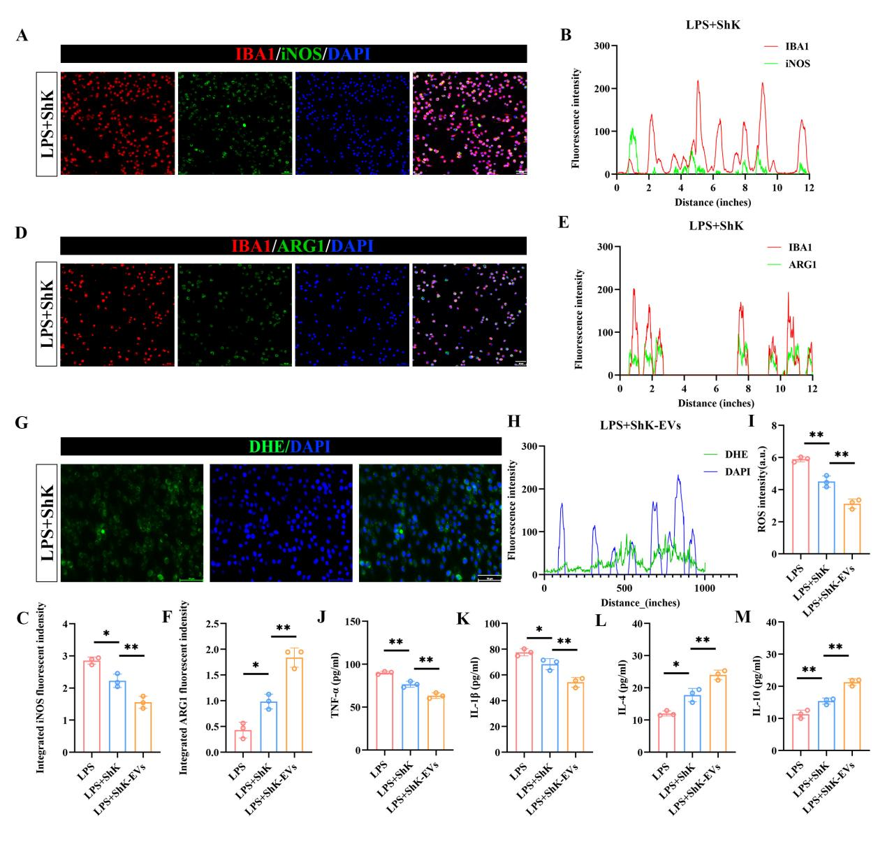
Figure S13. In vitro comparison of free ShK peptide in LPS-stimulated BV-2 microglia. (A) Representative immunofluorescence images of iNOS (green) and IBA1 (red) under different treatment conditions . Scale bar: 50 μm. (B, C) Quantification of iNOS⁺/IBA1⁺ fluorescence intensity (B) and iNOS fluorescence intensity normalized to IBA1⁺ area (C). n = 3. (D) Representative immunofluorescence images of ARG1 (green) and IBA1 (red). Scale bar: 50 μm. (E, F) Quantification of ARG1⁺/IBA1⁺ fluorescence intensity (E) and ARG1 fluorescence intensity normalized to IBA1⁺ area (F). n = 3 .(G) Representative dihydroethidium (DHE) staining images indicating reactive oxygen species (ROS) levels. Scale bar: 50 μm. (H, I) Quantification of DHE fluorescence intensity n = 3 .(J–M) ELISA quantification of cytokine levels in culture supernatants, including TNF-α, IL-1β, IL-4, IL-10. n = 3.

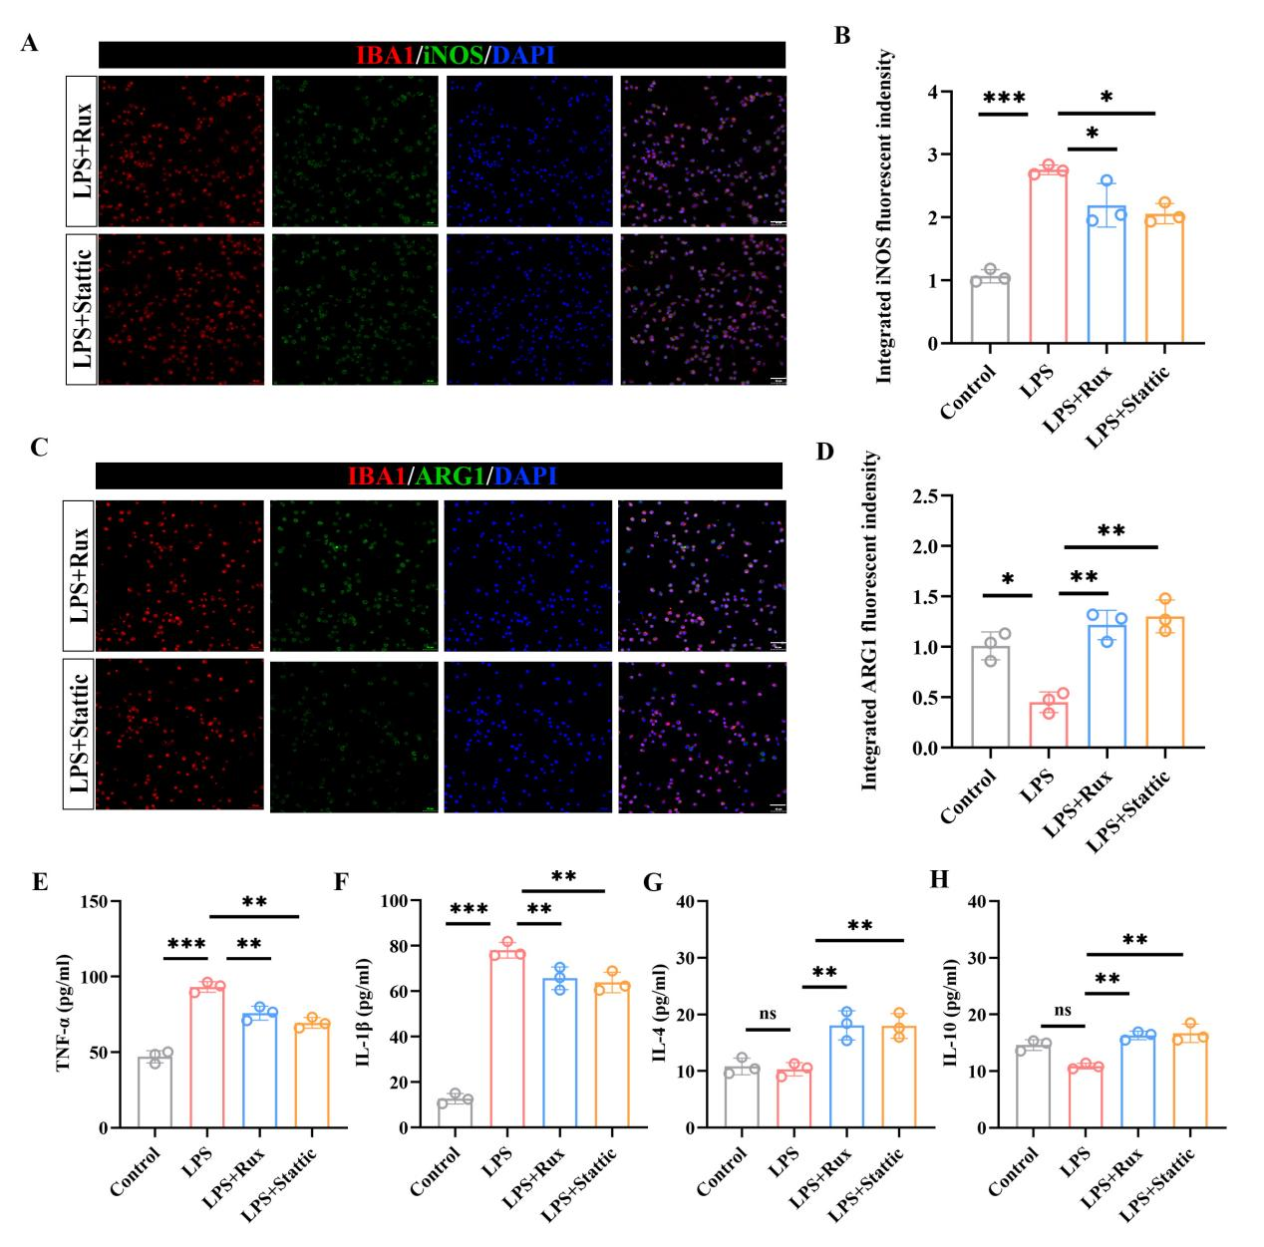
Figure S14. JAK/STAT inhibition phenocopies the anti-inflammatory effects of ShK-EVs in BV-2 microglia. (A) Representative immunofluorescence images of iNOS (green) and IBA1 (red) after treatment with Ruxolitinib or Stattic. Scale bar: 50 μm. (B) Quantification of iNOS⁺/IBA1⁺ cell percentage from (A). n = 3 . (C) Representative immunofluorescence images of ARG1 (green) and IBA1 (red). Scale bar: 50 μm. (D) Quantification of ARG1⁺/IBA1⁺ cell percentage from (C). n = 3 .(E–H) ELISA quantification of TNF-α, IL-1β, IL-4, and IL-10 levels in culture supernatants. n = 3.

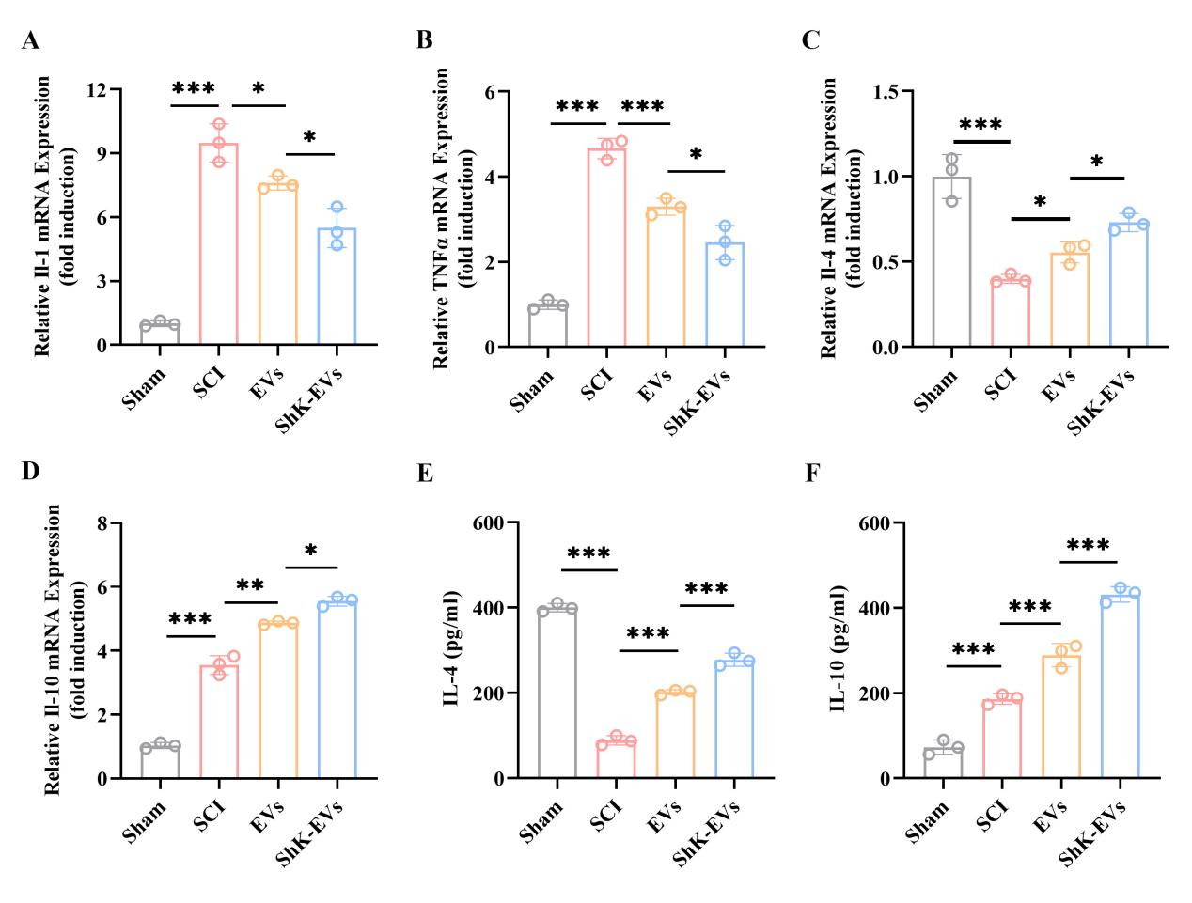
Figure S15. ShK-EVs modulate the expression of inflammatory genes in the injured spinal cord. (A) RT-qPCR analysis of Il1b mRNA levels at 7 dpi (n = 3). (B) RT-qPCR analysis of Tnf mRNA levels at 7 dpi (n = 3). (C) RT-qPCR analysis of Il4 mRNA levels at 7 dpi (n = 3). (D) RT-qPCR analysis of Il10 mRNA levels at 7 dpi (n = 3). (E) The levels of the anti-inflammatory factor IL-4 in the injured local areas of each group were detected by ELISA (n=3). (F) The levels of the anti-inflammatory factor IL-10 in the injured local areas of each group were detected by ELISA (n=3). All analyses were performed on tissue from the lesion site and include the following experimental groups: Sham, SCI, EVs, and ShK-EVs.

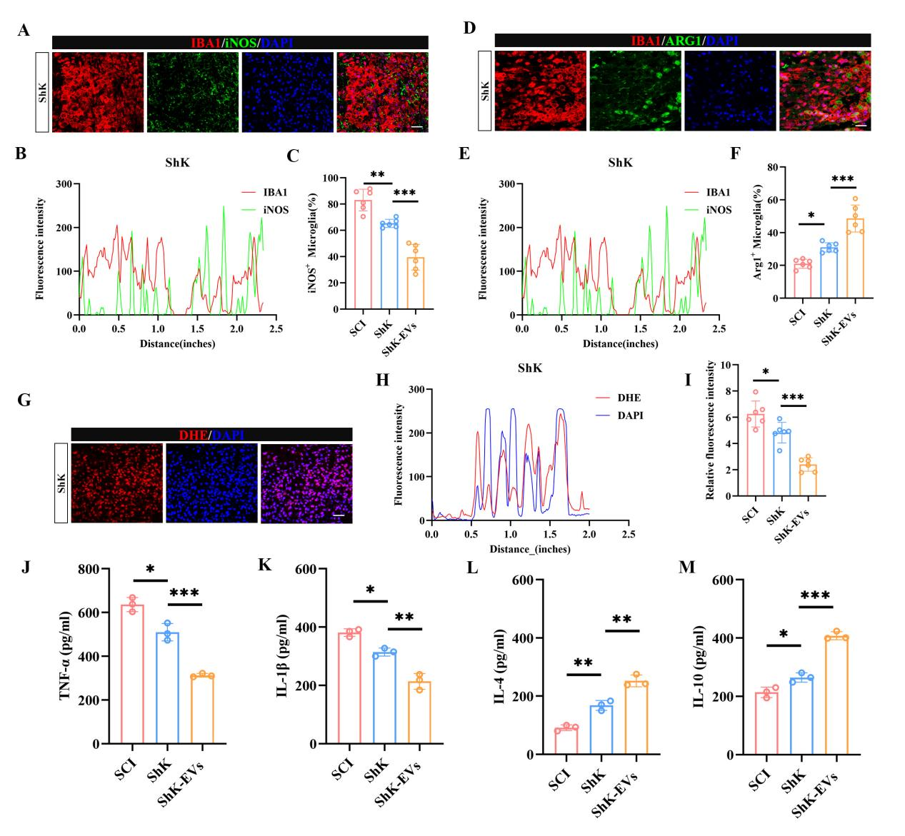
Figure S16. In vivo comparison of free ShK peptide and ShK-EVs after SCI. (A) Representative immunofluorescence images of IBA1 (red) and iNOS (green) in spinal cord sections. Scale bar: 50 μm. (B) Quantification of iNOS fluorescence intensity normalized to IBA1⁺ area. n = 6. (C) Percentage of iNOS⁺/IBA1⁺ cells. n =6. (D) Representative immunofluorescence images of IBA1 (red) and ARG1 (green). Scale bar: 50 μm. (E) Quantification of ARG1 fluorescence intensity normalized to IBA1⁺ area. n = 6. (F) Percentage of ARG1⁺/IBA1⁺ cells. n =6. (G) Representative DHE staining images at the lesion site. Scale bar: 50 μm. (H, I) Quantification of DHE fluorescence intensity n =6. (J–M) ELISA quantification of TNF-α, IL-1β, IL-4, and IL-10 levels in spinal cord homogenates. n = 3.

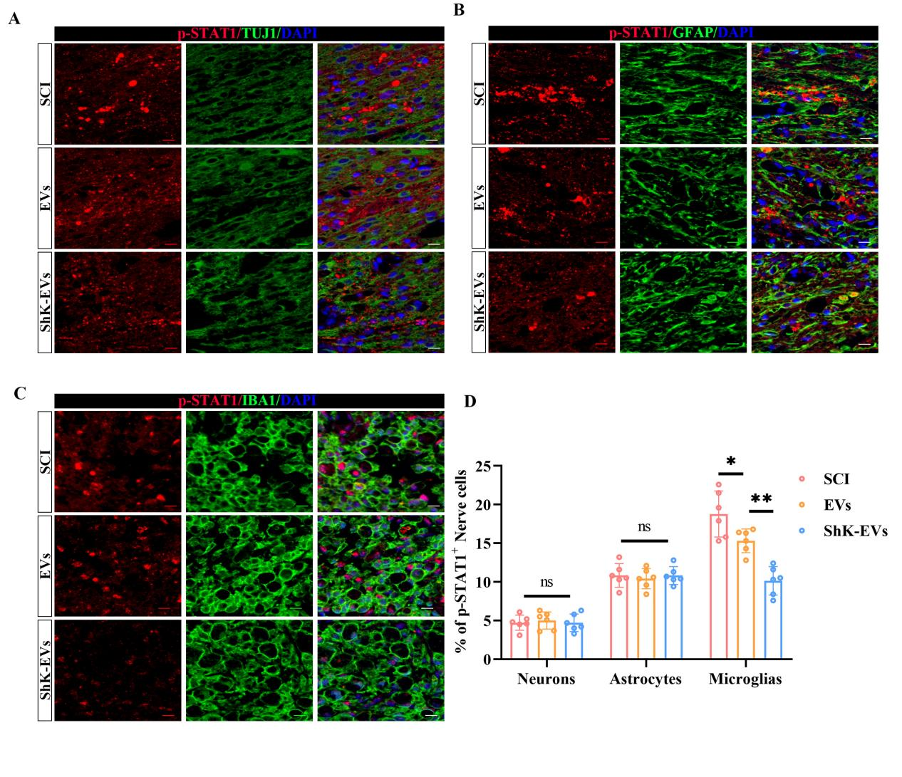
Figure S17. Cell type specific analysis of p-STAT1 expression in the injured spinal cord after ShK-EVs treatment. (A) Representative immunofluorescence images of p-STAT1 (red) and TUJ1 (green) in spinal cord sections at 7 dpi. Scale bar: 100 μm.(B) Representative immunofluorescence images of p-STAT1 (red) and GFAP (green). Scale bar: 100 μm. (C) Representative immunofluorescence images of p-STAT1 (red) and IBA1 (green). Scale bar: 100 μm. (D) Quantification of p-STAT1 fluorescence intensity normalized to each cell type marker (TUJ1, GFAP, IBA1) from (A–C). n =6.

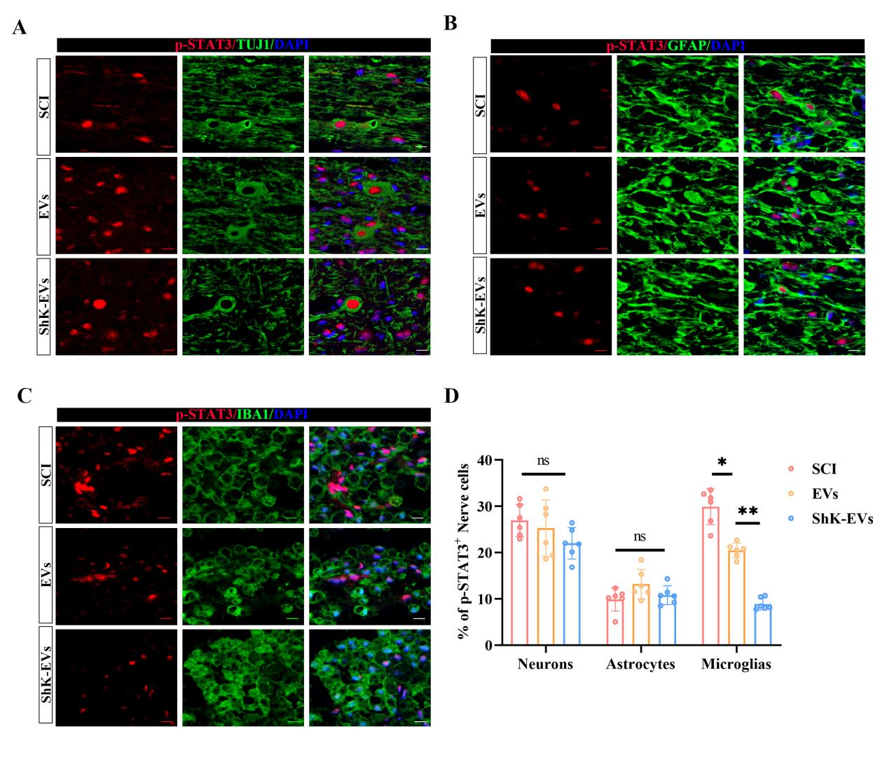
Figure S18. Cell type specific analysis of p-STAT3 expression in the injured spinal cord after ShK-EVs treatment. (A) Representative immunofluorescence images of p-STAT3 (red) and TUJ1 (green) in spinal cord sections at 7 dpi. Scale bar: 100 μm.(B) Representative immunofluorescence images of p-STAT3 (red) and GFAP (green). Scale bar: 100 μm. (C) Representative immunofluorescence images of p-STAT3 (red) and IBA1 (green). Scale bar: 100 μm. (D) Quantification of p-STAT3 fluorescence intensity normalized to each cell type marker (TUJ1, GFAP, IBA1) from (A–C). n =6.

Table S1 Primer sequences for mRNA detection
Gene | Sequence
Tnf-α-F | GCCTCCCTCTCATCAGTTCTATG
Tnf-α-R | ACCTGGGAGTAGACAAGGTACAA
Il1β-F | CAGCACATCAACAAGAGCTTCAG
Il1β-R | GAGGATGGGCTCTTCTTCAAAGA
Il4-F | TCGAATGTACCAGGAGCCATATC
Il4-R | ACTCTCTGTGGTGTTCTTCGTTG
Il10-F | CAGAGAAGCATGGCCCAGAAATC
Il10-R | GCTCCACTGCCTTGCTCTTATTT
iNOS-F | TTTGCTCATGACATCGACCAGAA
iNOS-R | CGTTTCGGGATCTGAATGTGATG
Kcna3-F | CTGCTGGGAAGACTTGAGACC
Kcna3-R | TGAGAGAATGCAGCCCACTTG
Arg1-F | TCTGCCAAAGACATCGTGTACAT
Arg1-R | CGACATCAAAGCTCAGGTGAATC
gapdh-F | GGCATTGTGGAAGGGCTCAT
gapdh-R | AGATCCACGACGGACACATT
Shk-F | TGCTTTCTGTGTCTAGAGCGT
Shk-R | AGAGTCAGCAGCACATTCCTC
mmu-miR-100-5p-RT | GTCGTATCGACTGCAGGGTCCGAGGTATTCGCAGTCGATACGACCACAAG
mmu-miR-100-5p-F | GGCAACCCGTAGATCCGAA
mmu-miR-1249-3p-RT | GTCGTATCGACTGCAGGGTCCGAGGTATTCGCAGTCGATACGACTGAAGA
mmu-miR-1249-3p-F | ACGCCCTTCCCCCCCT
mmu-miR-126a-5p-RT | GTCGTATCGACTGCAGGGTCCGAGGTATTCGCAGTCGATACGACCGCGTA
mmu-miR-126a-5p-F | GGCGGCCATTATTACTTTTGG
mmu-miR-127-3p-RT | GTCGTATCGACTGCAGGGTCCGAGGTATTCGCAGTCGATACGACAGCCAA
mmu-miR-127-3p-F | GCTCGGATCCGTCTGAGC
mmu-miR-1291-RT | GTCGTATCGACTGCAGGGTCCGAGGTATTCGCAGTCGATACGACAACTGC
mmu-miR-1291-F | GGCATGGCTCTTACTGAAGACTA
mmu-miR-140-3p-RT | GTCGTATCGACTGCAGGGTCCGAGGTATTCGCAGTCGATACGACCCGTGG
mmu-miR-140-3p-F | GCGGCTACCACAGGGTAGAA
mmu-miR-150-5p-RT | GTCGTATCGACTGCAGGGTCCGAGGTATTCGCAGTCGATACGACCACTGG
mmu-miR-150-5p-F | GGCTCTCCCAACCCTTGTA
mmu-miR-181a-5p-RT | GTCGTATCGACTGCAGGGTCCGAGGTATTCGCAGTCGATACGACACTCAC
mmu-miR-181a-5p-F | GGCAACATTCAACGCTGTCG
mmu-miR-296-3p-RT | GTCGTATCGACTGCAGGGTCCGAGGTATTCGCAGTCGATACGACGGAGAG
mmu-miR-296-3p-F | CGAGGGTTGGGTGGAGG
mmu-miR-298-5p-RT | GTCGTATCGACTGCAGGGTCCGAGGTATTCGCAGTCGATACGACGGGAAG
mmu-miR-298-5p-F | CGGCAGAGGAGGGCTGTT
mmu-miR-31-3p-RT | GTCGTATCGACTGCAGGGTCCGAGGTATTCGCAGTCGATACGACGATGGC
mmu-miR-31-3p-F | CGGCTGCTATGCCAACATATT
mmu-miR-3110-5p-RT | GTCGTATCGACTGCAGGGTCCGAGGTATTCGCAGTCGATACGACGAGCCT
mmu-miR-3110-5p-F | GGCTTCTGCCTCCCCTGA
mmu-miR-339-5p-RT | GTCGTATCGACTGCAGGGTCCGAGGTATTCGCAGTCGATACGACCGTGAG
mmu-miR-339-5p-F | GCTCCCTGTCCTCCAGGAG
mmu-miR-378a-3p-RT | GTCGTATCGACTGCAGGGTCCGAGGTATTCGCAGTCGATACGACCCTTCT
mmu-miR-378a-3p-F | CGGCACTGGACTTGGAGTC
mmu-miR-379-5p-RT | GTCGTATCGACTGCAGGGTCCGAGGTATTCGCAGTCGATACGACCCTACG
mmu-miR-379-5p-F | GGCGGCTGGTAGACTATGGAA
mmu-miR-6239-RT | GTCGTATCGACTGCAGGGTCCGAGGTATTCGCAGTCGATACGACCACCGA
mmu-miR-6239-F | GCGGCTAGCGTTGGATCAC
mmu-miR-708-3p-RT | GTCGTATCGACTGCAGGGTCCGAGGTATTCGCAGTCGATACGACCTAGAA
mmu-miR-708-3p-F | GCGGCCAACTAGACTGTGAGC

