Figure S1. TA-Ce-Lut-NIR restores intracellular ATP levels in HaCaT keratinocytes (n = 6).
Figure S2. TA-Ce-Lut-NIR restores intracellular ATP levels in RAW264.7 macrophages (n = 6).
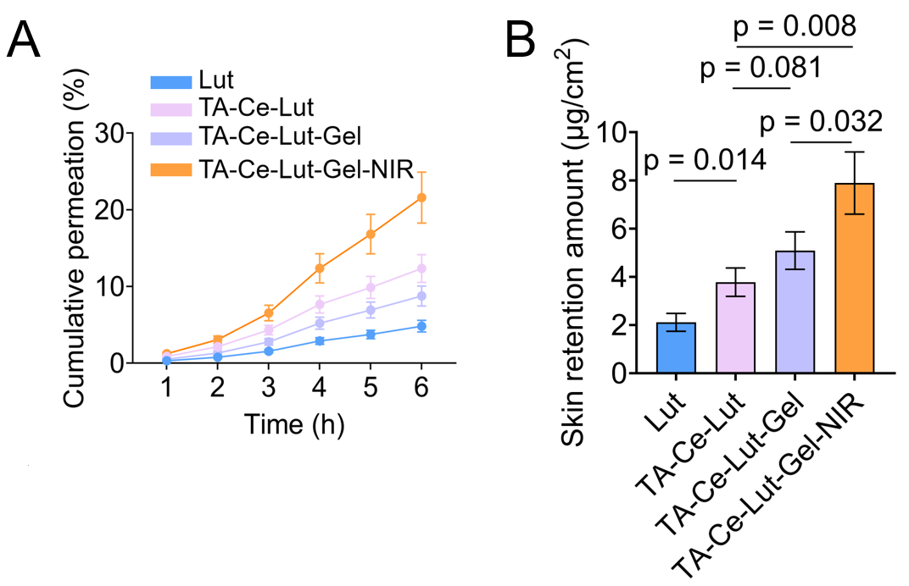
Figure S3. In vitro transdermal permeation and skin retention evaluation of different formulations. (A) Cumulative permeation profiles (%) of Lut, TA-Ce-Lut, TA-Ce-Lut-Gel, and TA-Ce-Lut-Gel-NIR across excised mouse skin over 6 hours (n = 3). (B) The skin retention amount (μg/cm²) of Lut for different groups at the end of the permeation study (n = 3). The TA-Ce-Lut-Gel-NIR group was irradiated with an 808 nm laser (1.0 W/cm², 5 min).
Figure S4. GO enrichment analysis bubble plot, highlighting key terms associated with the TRAF6/NF-κB/STAT3 signaling pathway (red underlines).
Figure S5. GO enrichment analysis bar chart, highlighting key terms associated with the TRAF6/NF-κB/STAT3 signaling pathway (red underlines).

