Supporting Information

Harnessing CSC Recruitment: Photo-Triggered “Self-Exploding” Macrophages for Targeted Metastasis Inhibition

Teng Wang ª, Yu Wang ^{b}, Bingjie Wang ^{b}, Yanguo Su ^{b}, Tianze Jiang ^{b}, Wenhua Xu ^{a,}*, Xia Zhao ^{b,c,}*, Jiaojiao Tao ^{b}, Chenshuai Shi ^{b}, Xiang Xu ^{b}, Jinlong Xu ^{b}.

ª Institute of Regenerative Medicine and Laboratory Technology Innovation, Qingdao University, Qingdao, 266071, China
^{b} Key Laboratory of Marine Drugs, Ministry of Education, Shandong Provincial Key Laboratory of Glycoscience and Glycotherapeutics, School of Medicine and Pharmacy, Ocean University of China, Qingdao 266003, China
^{c}Laboratory for Marine Drugs and Bioproducts, Qingdao Marine Science and Technology Center, Qingdao 266237, China

* Corresponding author: Institute of Regenerative Medicine and Laboratory Technology Innovation, Qingdao University, Qingdao, 266071, China. E-mail address: qd.wh@qdu.edu.cn (W. Xu).

Figure S1. Hydrodynamic size (diameter, nm) of C-H NPs

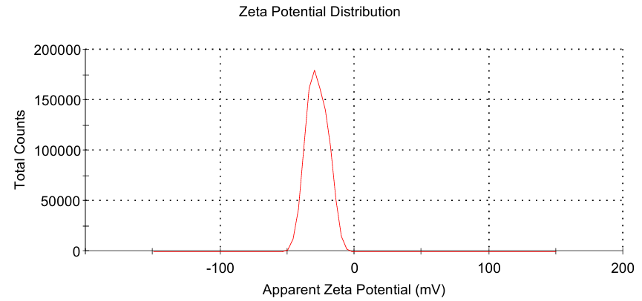
Figure S2. Zeta potentials of C-H NPs

Figure S3. Standard curve of HK

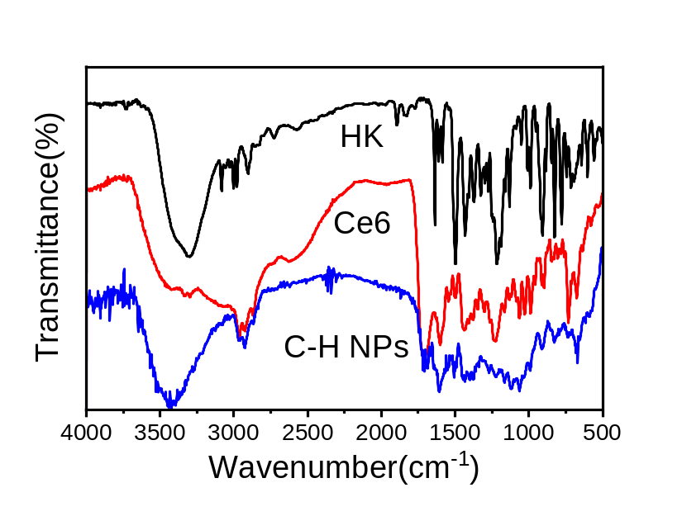
Figure S4. FT-IR spectra of HK, Ce6 and C-H NPs.

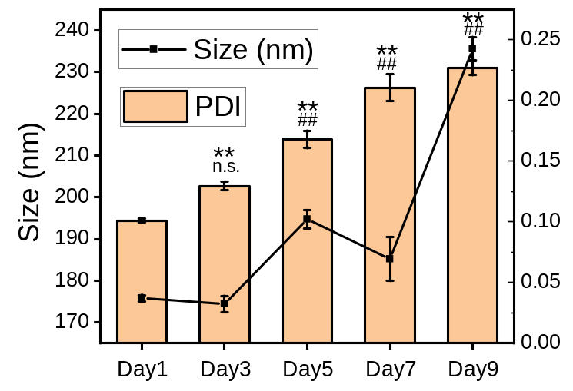
Figure S5. Size and PDI of C-H NPs within 9 days. Data are shown as mean ± SD (n = 3). Statistical significance was determined by one‑way ANOVA with Tukey’s post hoc test compared to Day 1. For PDI: **P < 0.01, For size: ##P < 0.01.

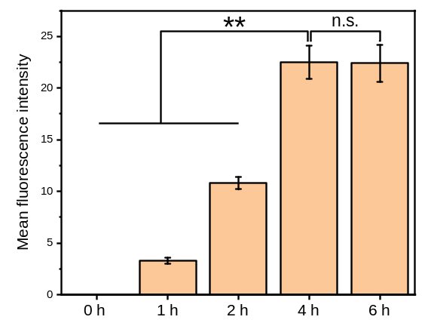
Figure S6. Mean fluorescence intensity of Ce6 in RAW264.7 cells. Data are shown as mean ± SD (n = 3). Statistical significance was determined by one‑way ANOVA with Tukey’s post hoc test. **P < 0.01.

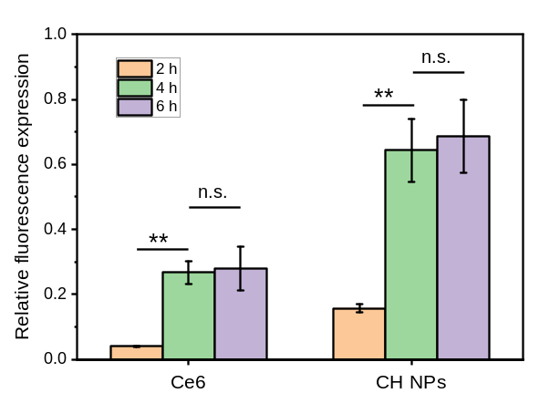
Figure S7. Relative fluorescence expression. Data are shown as mean ± SD (n = 3). Statistical significance was determined by one‑way ANOVA with Tukey’s post hoc test compared to 2 h. **P < 0.01.

Figure S8. Standard curve of Ce6

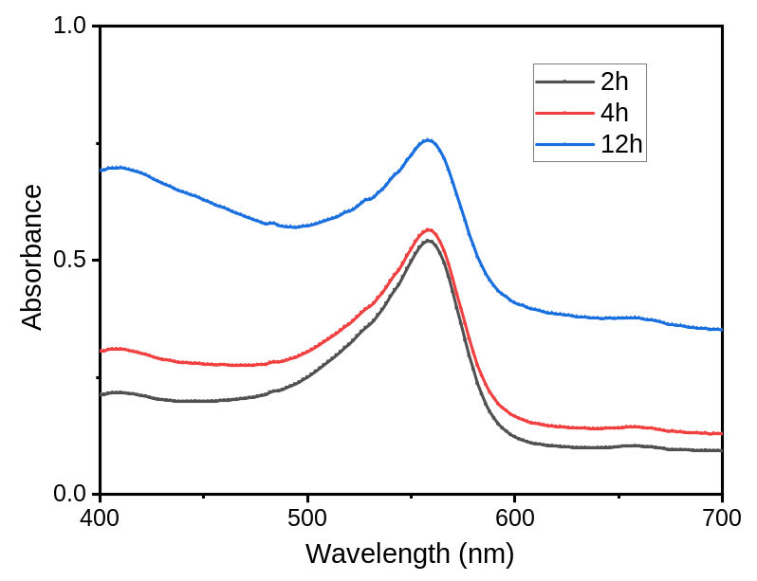
Figure S9. UV-vis absorption spectra of release medium of C-H@M2 at 2h, 4h and 12h.

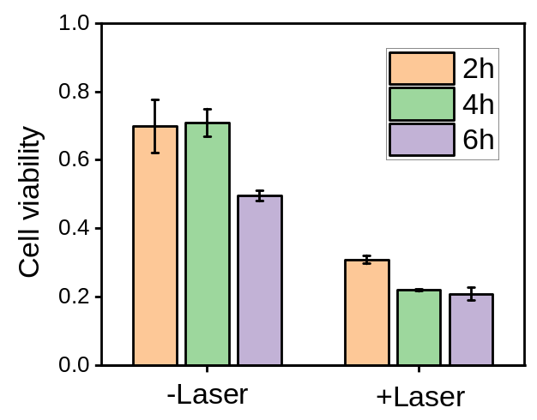
Figure S10. Cytotoxicity against 4T1 cells with C-H NPs released from C-H@M2.

Figure S11. Live/dead cell staining of C-H@M2 after irradiated with laser for 2 min (Scale bar = 50 μm)

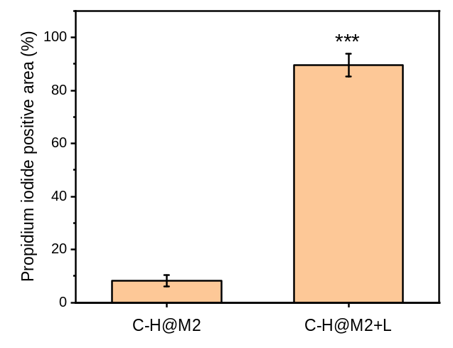
Figure S12. Semiquantitative analysis of Propidium iodide positive area. Data are shown as mean ± SD (n = 3). Statistical significance was determined by two‑tailed Student’s t‑test. ***P < 0.001.

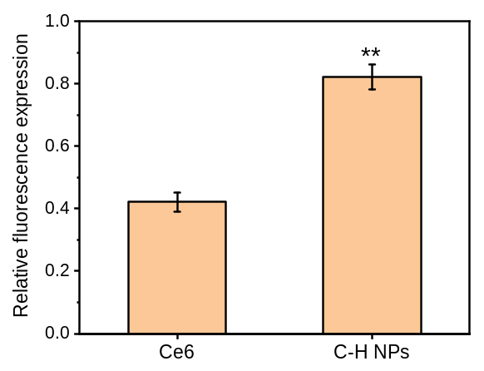
Figure S13. Relative fluorescence expression of Ce6 in 4T1 cells. Data are shown as mean ± SD (n = 3). Statistical significance was determined by two‑tailed Student’s t‑test. **P < 0.01.

Figure S14. Flow cytometry analysis of CSCs biomarkers (CD44 / CD24) subpopulation in 4T1 cells and 4T1-CSCs. (A) Representative flow cytometry plots of CD44 and CD24 expression in 4T1 cells and 4T1-CSCs. (B) Quantification of CD44⁺CD24⁻ subpopulation. Data are mean ± SD (n = 3 independent experiments). One‑way ANOVA with Tukey’s post hoc test. ***P < 0.001, compared with unstained and 4T1 group.

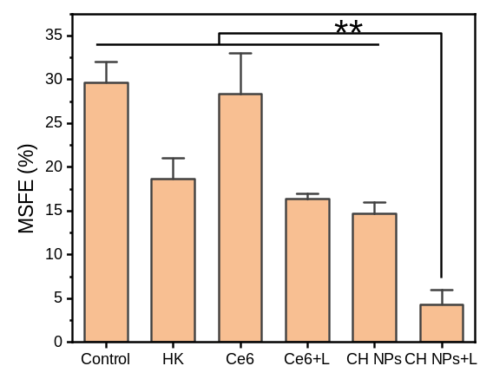
Figure S15. Quantitative analysis of mammosphere-forming efficiency (MSFE) on 4T1-CSCs treated with different formulations.

Figure S16. CCL2 blockade reduces C-H@M2 migration toward CSC-conditioned medium. (A) Representative images of migrated C-H@M2 stained with crystal violet. (Scale bar = 50 μm). (B) Quantification of migrated cells per high-power field. Data are shown as mean ± SD (n = 3). Data are mean ± SD (n = 3 independent experiments). One‑way ANOVA with Tukey’s post hoc test. *P < 0.05, **P < 0.01, compared with Control.

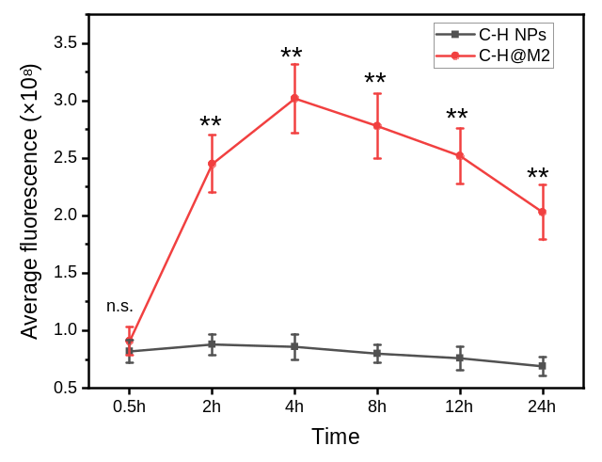
Figure S17. Average fluorescence of tomor in vivo at different times treated with C-H NPs and C-H@M2. Data are shown as mean ± SD (n = 3). Statistical significance was determined by two‑tailed Student’s t‑test. **P < 0.01.

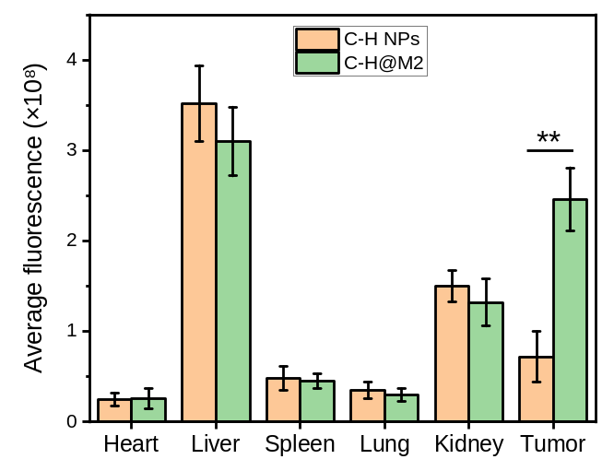
Figure S18. Average fluorescence of mice tissue at 24 h treated with C-H NPs and C-H@M2. Data are shown as mean ± SD (n = 3). Statistical significance was determined by two‑tailed Student’s t‑test. **P < 0.01.

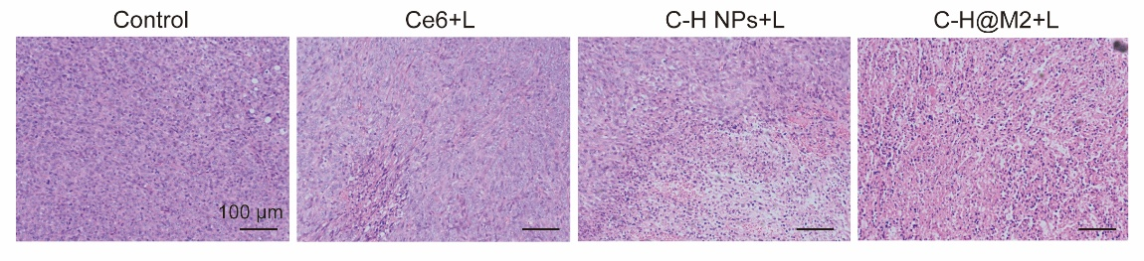
Figure S19. H&E staining of tumor tissues from different treatment groups. (scale bar: 100 µm)

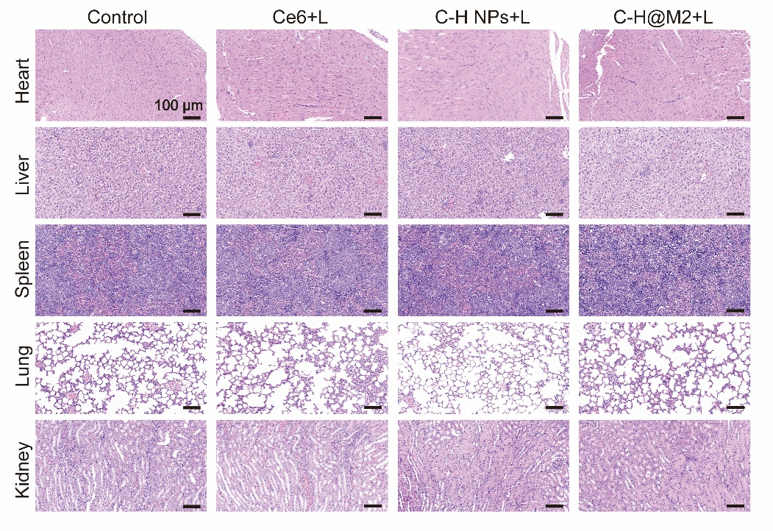
Figure S20. H&E analysis of the major organs of mice after therapeutic experiments (scale bar: 100 µm)

Figure S21. Serum biochemistry analysis. (A) Biochemical parameters of ALT in the serum of mice after the treatment; (B) Biochemical parameters of AST in the serum of mice after the treatment; (C) Biochemical parameters of BUN in the serum of mice after the treatment; (D) Biochemical parameters of creatinine in the serum of mice after the treatment. All data are shown as mean ± SD (n = 3 biologically independent experiments). Statistical significance was determined by one‑way ANOVA with Tukey’s post hoc test for multiple comparisons.

Figure S22. Inflammatory cytokine analysis. (A) Serum IL‑6 levels measured by ELISA at 12, 24, and 48 h post‑injection; (B) Serum TNF‑α levels measured by ELISA at 12, 24, and 48 h post‑injection. All data are shown as mean ± SD (n = 3 biologically independent experiments). Statistical significance was determined by one‑way ANOVA with Tukey’s post hoc test for multiple comparisons.

Figure S23. Relative fluorescence expression of ALDH1 in lungs. (A) Immunofluorescence images of ALDH1 in lungs with different treatments (Scale bar = 50 μm). (B) Semiquantitative analysis of ALDH1 in immunofluorescence staining. Data were represented as mean ± SD (n = 3), **P < 0.01.

