Supporting Information
Radioactive Copper (⁶⁴Cu)-Enabled Theranostic Delivery Modulates Cuproptosis-Associated Signaling for Cancer Treatment
Wenyu Song^{1,2,3,4}‡, Ruochen Tan^{1,2,3}‡, Yuan Feng ^{1,2,3}, Xiaoyan Li⁴, Sophia J. Lee⁴, Jonathan W Engle⁴, Weibo Cai^{4,*}, Xiaoli Lan^{1,2,3,*}, and Xiao Zhang^{1,2,3,*}
¹ Department of Nuclear Medicine, Union Hospital, Tongji Medical College, Huazhong University of Science and Technology, Wuhan 430022, Hubei Province, China
² Hubei Key Laboratory of Molecular Imaging, Wuhan 430022, Hubei Province, China
³ Key Laboratory of Biological Targeted Therapy (Huazhong University of Science and Technology), Ministry of Education, Wuhan 430022, Hubei Province, China
⁴ Department of Radiology and Department of Medical Physics, University of Wisconsin – Madison, Madison, WI 53705, USA

Corresponding Author
*Email: wcai@uwhealth.org (W. Cai); LXL730724@hotmail.com (X. Lan); zhangxiao199204@foxmail.com (X. Zhang)

Content list.
1. The TEM of nanoparticle only with DSPE-PEG2000-NH2-c(RGDyK). (Figure S1)
2. (UV-vis) spectra of the Elescomol and ES-Cu[Ⅱ] (Figure S2)
3. IC₅₀ of treatment with TTM. (Figure S3)
4. The images of ROS (Figure S4)
5. The CLSM images of tumor spheroids in 3D dimension (Figure S5)
6. Colony formation assay of RGD-targeted positive cell line treated with nanoparticle. (Figure S6-7)
7. The images of JC-1 (Figure S8)

- The TEM of nanoparticle only with DSPE-PEG2000-NH2-c(RGDyK).
Figure S1. Representative transmission electron microscopy (TEM) of Nanoparticle only with DSPE-PEG2000-NH2-c(RGDyK). Scale bar: 200 and 500 nm.

2. (UV-vis) spectra of the Elescomol and ES-Cu[Ⅱ]
Figure S2. (UV-vis) spectra of the Elescomol and ES-Cu[Ⅱ] with the characteristic absorption peaks at 390nm and 355nm. Based on the above results, the Absorbance-Concentration Curve can be calculated (R² > 0.99).

3. IC₅₀ of treatment with TTM.

Figure S3. IC₅₀ values for 0.6 μM ES-Cu[Ⅱ], ES-Cu[Ⅱ]+TTM, ES-Cu[Ⅱ]@NP and ES-Cu[Ⅱ]@NP+TTM after 24 h treatment;

4. The images of ROS

Figure S4. Representative confocal microscopy images of ROS in U87-MG cells stained with Hydro-Cy3 fluorescent probes (red) and DAPI (blue) after 24 h treatments. Scale bars: 50 μm.

5. The CLSM images of tumor spheroids in 3D dimension

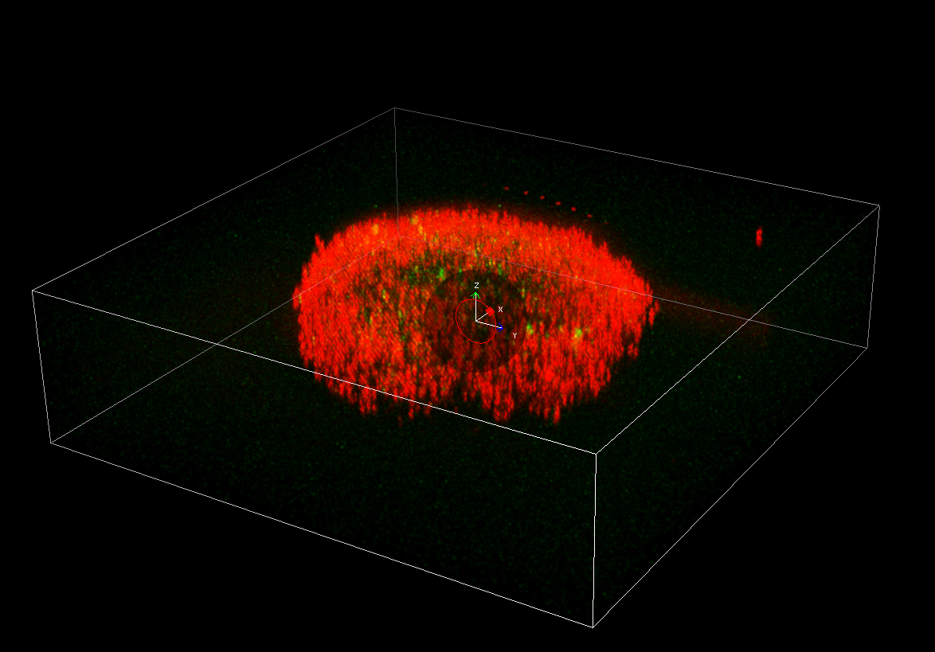
Figure S5. Representative CLSM images of U87-MG cells multicellular tumor spheroids stained with Calcein-AM (live cells, green) and Propidium Iodide (dead cells, red) after treated with ES-Cu@NP (Including the X, Y and Z axes).

- Colony formation assay of RGD-targeted positive cell line treated with nanoparticle.

Figure S6. Colony formation assay of RGD-targeted positive cell line treated with PBS, Elescomol, ES-Cu[Ⅱ], ES-Cu[Ⅱ]+TTM and ES-Cu[Ⅱ]@NP. Cells were seeded at a density of 600 cells/well in 6-well plates and cultured for 7 days in the presence of 2 μM. Cells were fixed with 4% paraformaldehyde for 30 min and stained with 0.1% crystal violet. Colonies containing more than 50 cells were counted under a microscope. Data are shown as the mean ± SD (n = 3); ns, not significant; *p < 0.05; **p < 0.01; ***p < 0.001; ****p < 0.0001.

Figure S7. Colony formation assay of RGD-targeted positive cell line treated with PBS and ES-⁶⁴Cu[Ⅱ]@NP. Cells were seeded at a density of 600 cells/well in 6-well plates and cultured for 7 days in the presence of 2 μM and 1μCi. Cells were fixed with 4% paraformaldehyde for 30 min and stained with 0.1% crystal violet. Colonies containing more than 50 cells were counted under a microscope. Data are shown as the mean ± SD (n = 3); ns, not significant; *p < 0.05; **p < 0.01; ***p < 0.001; ****p < 0.0001.

7. The images of JC-1

Figure S8. Mitochondrial membrane potential determined by JC-1 staining. U87-MG cells were incubated with PBS, Elescomol, ES-Cu[Ⅱ], ES-Cu[Ⅱ]+TTM, ES-Cu[Ⅱ]@NP and ES-Cu[Ⅱ]@NP+TTM. Cells with normal membrane potential exhibited red fluorescence (Aggregates), while cells with depolarized mitochondria showed green fluorescence (Monomers). Images were captured using an excitation wavelength of 488 nm and emission filters of 488/50 nm (green) and 580/50 nm (red).

7.

