Supporting Information

Engineered Nanocomplex for Targeted Delivery of Beclin1 Peptide Enables Autophagy-Mediated Tumor Suppression and Immune Activation
Se-Youl Chaeª, Jiwon Wooª, Yejin Ryuª, and Dal-Hee Min^{a, b, *}
ª Department of Chemistry, Seoul National University, Seoul 08826, Republic of Korea
^{b} Institute of BioTherapeutics Convergence Technology, Lemonex Inc., Seoul, 06665, Republic of Korea
*Email: dalheemin@snu.ac.kr

Characteristics of BALL
Surface area | 377.5 m²/g
Pore volume | 1.5 mL/g
Pore diameter | 17.2 nm
Zeta potential | 11.9 (±0.8) mV
Hydrodynamic size | 221.7 nm

Table S1. Characterization of BALL. Surface area, pore volume, and pore diameter were calculated by BJH method. Zeta potential and hydrodynamic size was determined by dynamic light scattering.
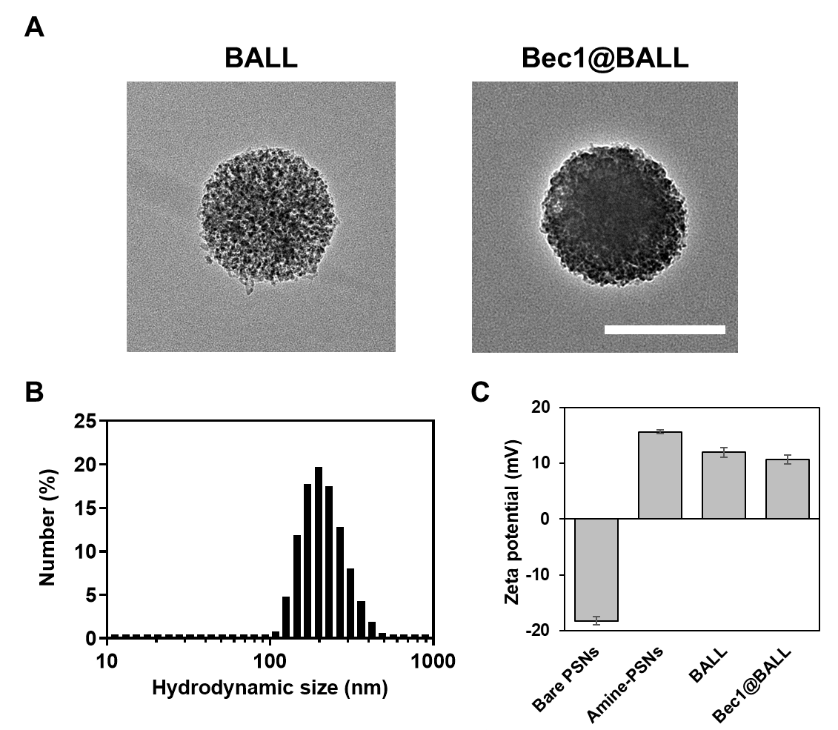
Figure S1. Characterization of BALL and Bec1@BALL. (A) Representative TEM images of BALL and Bec1@BALL (scale bar = 200 nm). (B) Hydrodynamic size distribution of Bec1@BALL measured by dynamic light scattering. (C) Zeta potential measurements of PSNs at different modification stages.

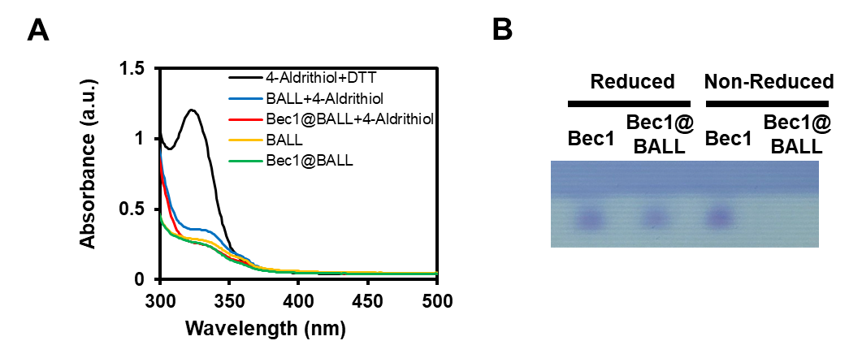
Figure S2. Verification of covalent conjugation via disulfide bonds in Bec1@BALL. (A) UV-Vis spectra obtained for the 4-aldrithiol assay. (B) Reduced and non-reduced SDS-PAGE analyses.

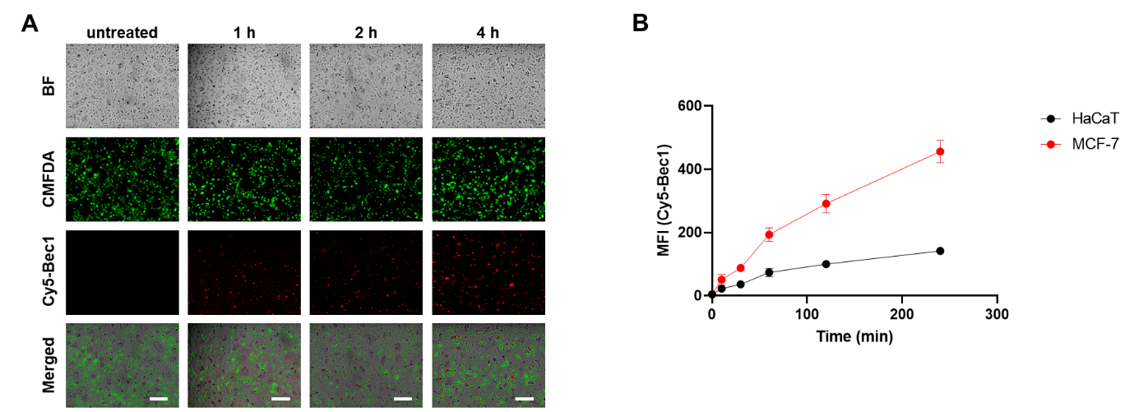
Figure S3. Selective cellular uptake of Bec1@BALL in co-culture system. (A) Fluorescence images of co-cultured HaCaT and MCF-7 cells (CMFDA-labeled MCF-7: green, Cy5-Bec1: red, scale bar = 100 µm). (B) Quantitative analysis of mean fluorescence intensity (MFI) in HaCaT and MCF-7 cells over time.

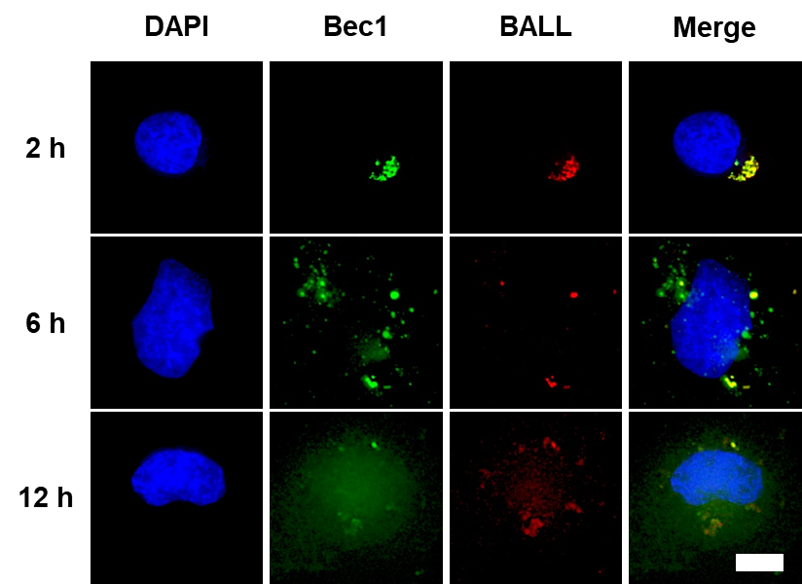
Figure S4. Kinetic intracellular distribution of Bec1 and BALL (DAPI: blue, TAMRA-Bec1: green, Cy5-BALL: red, scale bar = 10 µm).

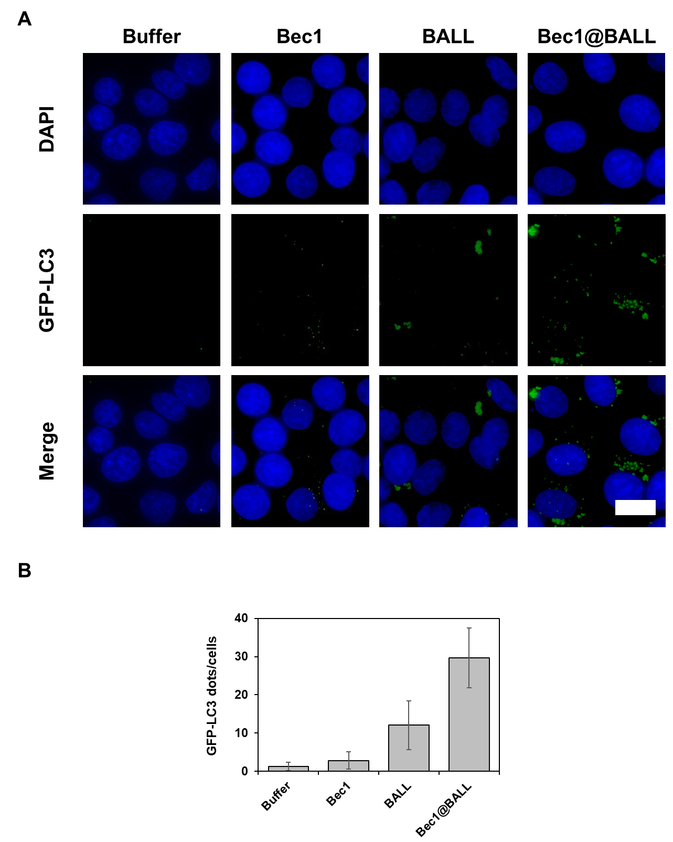
Figure S5. Autophagosome formation induced by Bec1@BALL. (A) Fluorescence images of MCF-7 cells expressing GFP-LC3 treated with buffer, Bec1, BALL, and Bec1@BALL (DAPI: blue, GFP-LC3: green, scale bar = 20 µm). (B) Quantitative analysis of GFP-LC3 puncta for each group (n = 100).
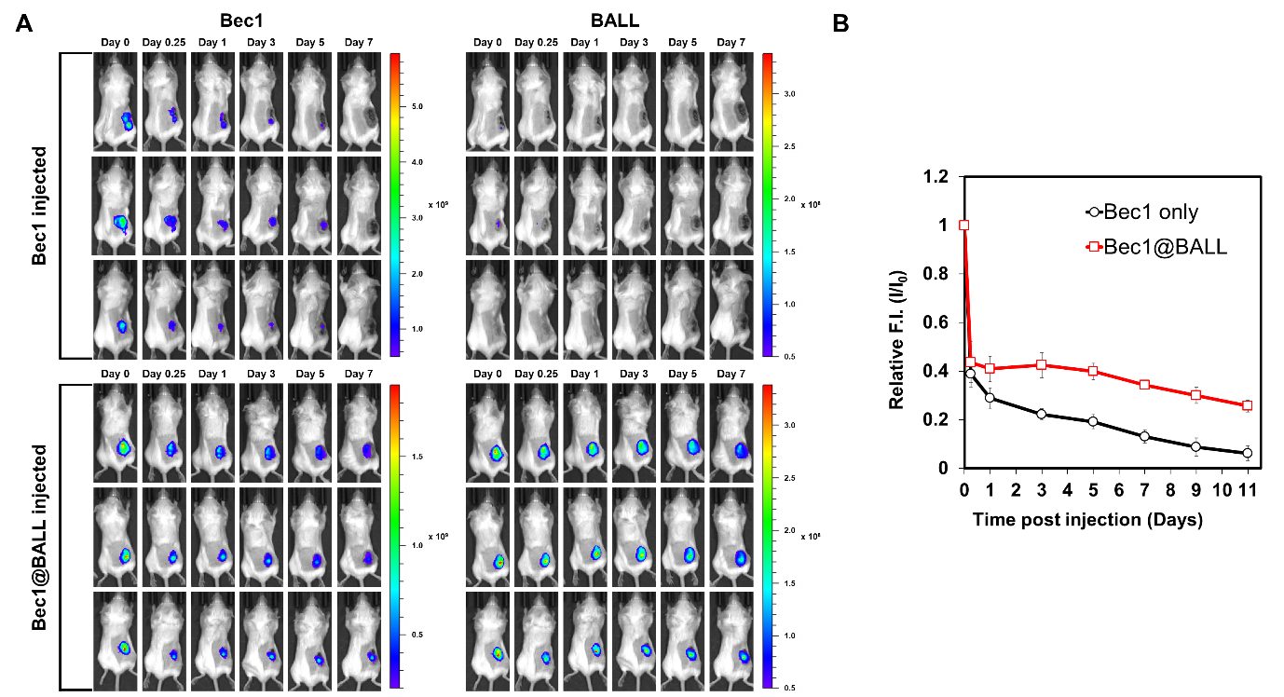
Figure S6. In vivo biodistribution of Bec1 and BALL. (A) Whole body fluorescence images of mice injected with Cy5-Bec1 and Cy7-BALL. (B) Quantitative analysis of the relative fluorescence intensity of Cy5-Bec1 at the injection site.

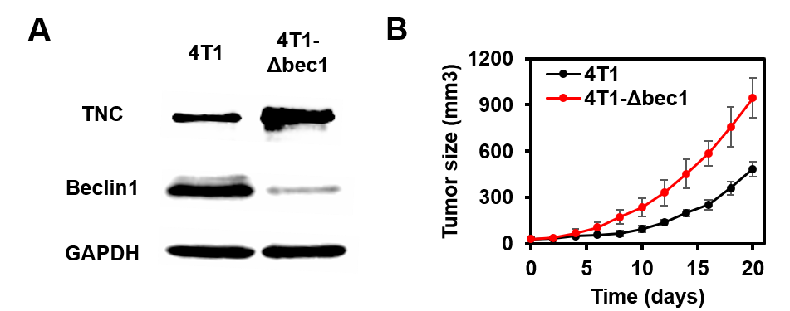
Figure S7. TNC accumulation and tumor growth in Beclin1-deficient 4T1 cells. (A) TNC, Beclin1, and GAPDH protein expression level in 4T1 and 4T1-Δbec1 cells. (B) Tumor size of mice inoculated by 4T1 cells and 4T1-Δbec1 cells.

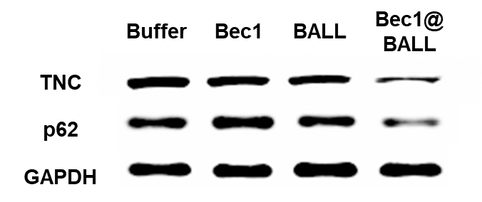
Figure S8. Western blot analysis of TNC, p62, and GAPDH protein expression level after treatment of buffer, Bec1, BALL, and Bec1@BALL.

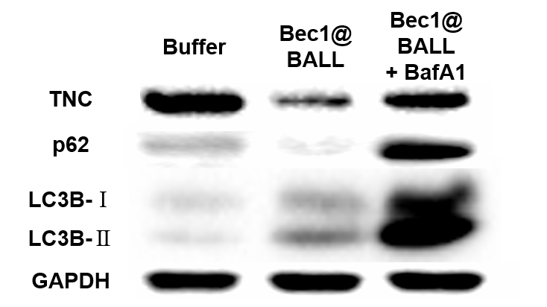
Figure S9. Western blot analysis of autophagic flux. Expression levels of TNC, p62, LC3B, and GAPDH in 4T1 cells treated with buffer, Bec1@BALL, and Bec1@BALL co-treated with Bafilomycin A1 (BafA1).

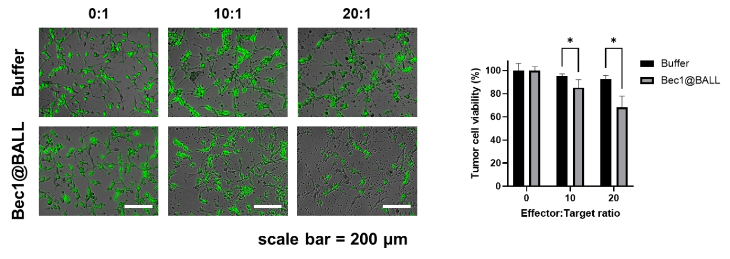
Figure S10. T cell mediated cytotoxicity against tumor cells following Bec1@BALL treatment. (A) Fluorescence images of tumor cells (green) incubated with T cells at different Effector:Target ratios after treatment with buffer or Bec1@BALL (scale bar = 200 µm). (B) Corresponding quantitative analysis of tumor cell viability.

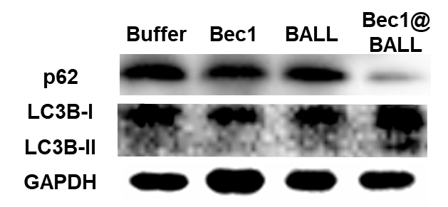
Figure S11. Expression levels of p62, LC3B, and GAPDH in 4T1-Δbec1 tumor tissues extracted from mice treated with buffer, Bec1, BALL, and Bec1@BALL.

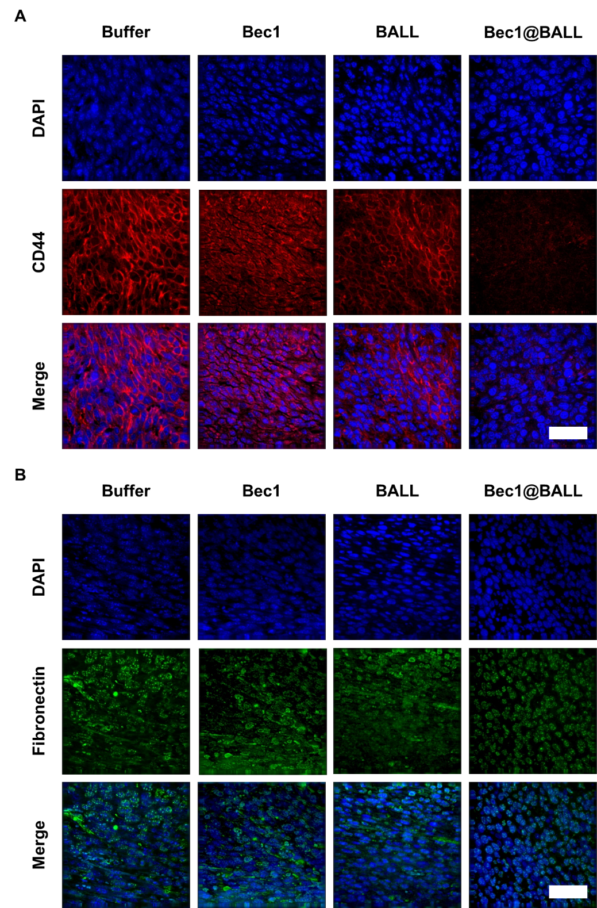
Figure S12. Immunofluorescence staining of EMT-related markers in 4T1-Δbec1 tumor tissues following treatment with buffer, Bec1, BALL, or Bec1@BALL. (A) Expression pattern of CD44 (DAPI: blue, CD44: red, scale bar = 50 µm). (B) Expression pattern of fibronectin (DAPI: blue, fibronectin: green, scale bar = 50 µm).
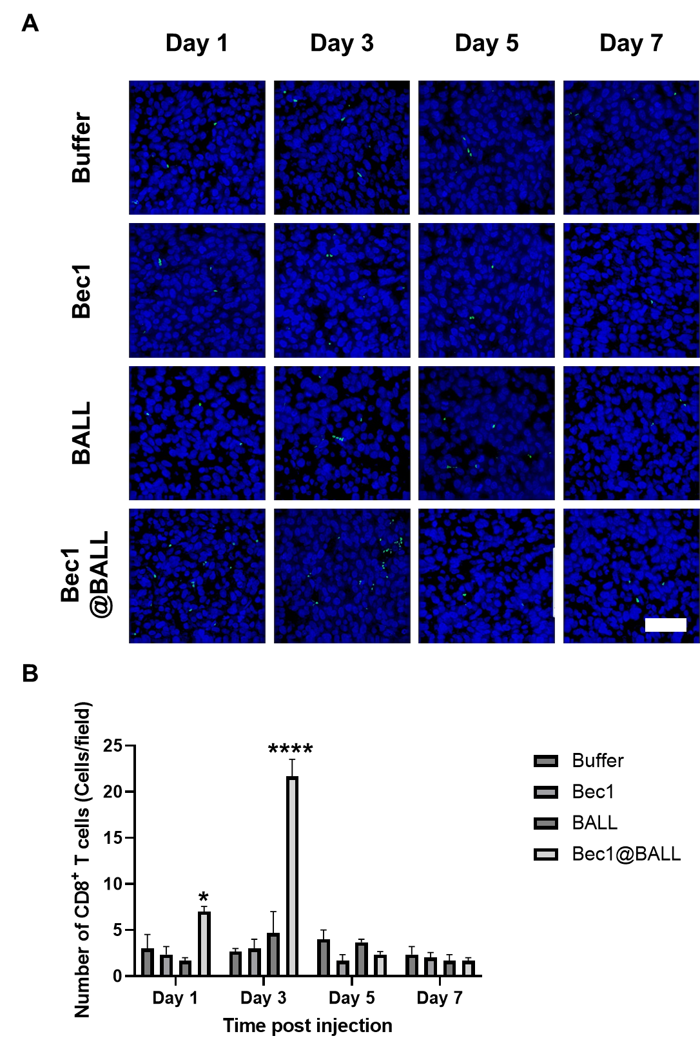
Figure S13. Kinetic distribution of CD8⁺ T lymphocytes in tumor tissues. (A) Immunofluorescence images of tumors over time following treatment with buffer, Bec1, BALL, and Bec1@BALL (DAPI: blue, CD8: green, scale bar = 50 µm). (B) Quantitative analysis of the number of CD8⁺ T cells per field.
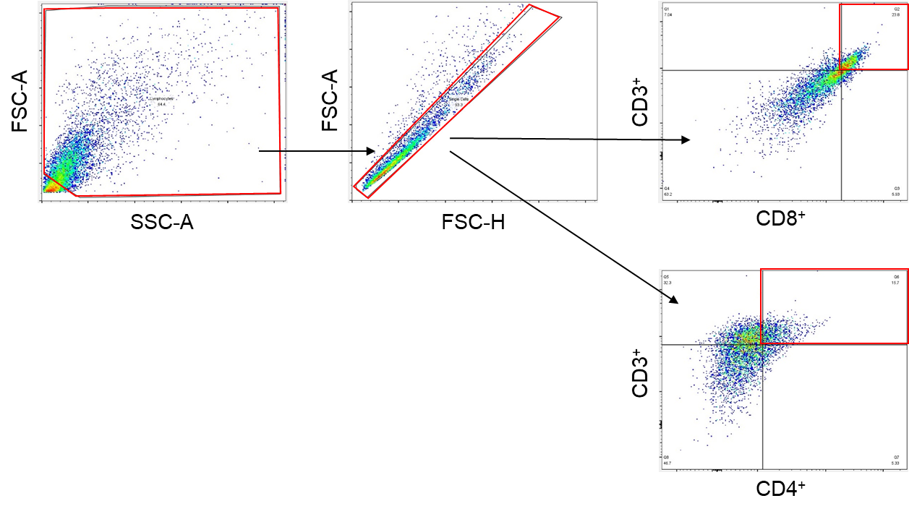
Figure S14. Gating strategy for identifying T cells in the tumor.

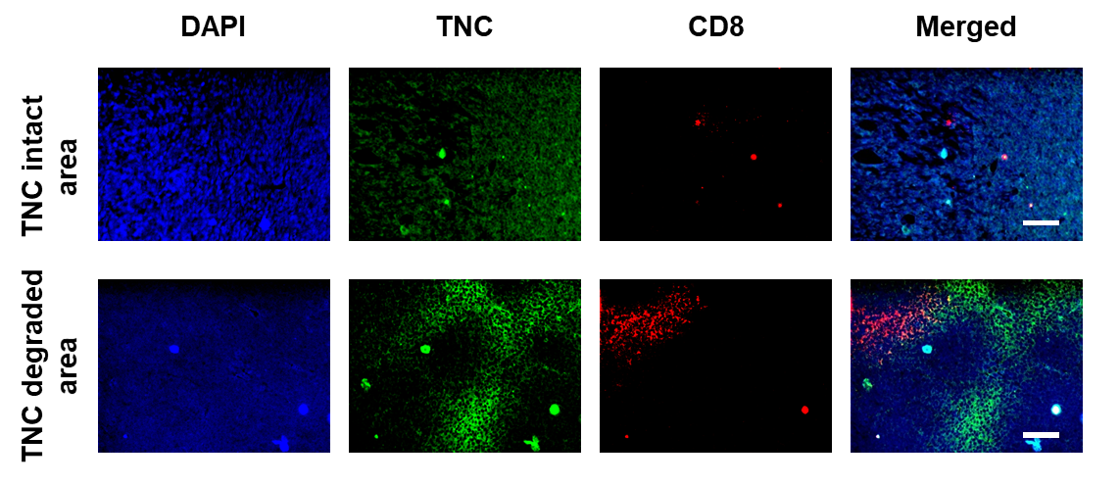
Figure S15. Immunofluorescence images of the TNC intact area and TNC degraded area in tumor tissues treated with Bec1@BALL (DAPI: blue, TNC: green, CD8: red, scale bar = 100 µm).

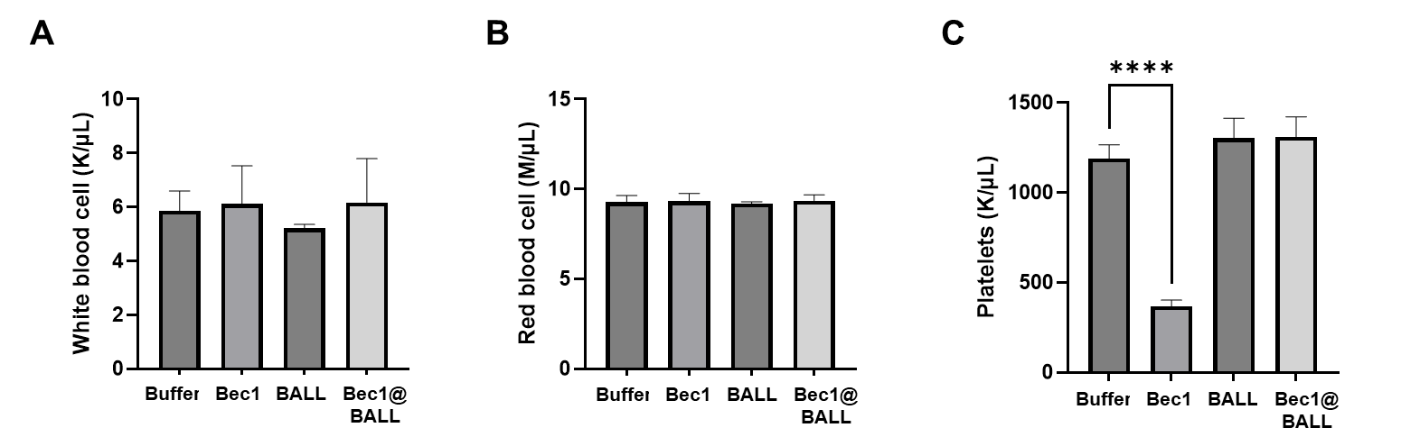
Figure S16. Hemocytometer results for (A) white blood cell counts, (B) red blood cell counts, and (C) platelet counts. Data are presented as mean with SD (n = 3).

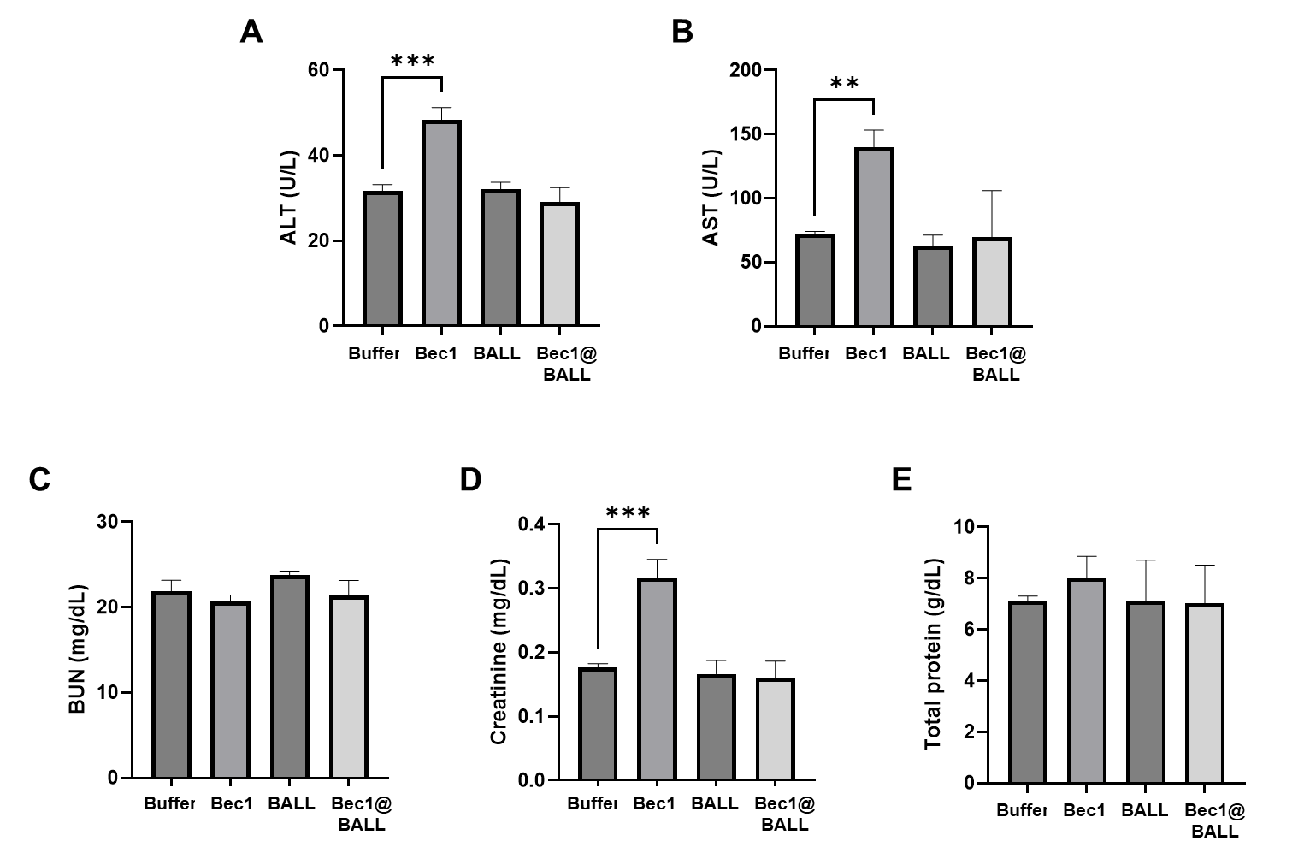
Figure S17. Measurement of in vivo toxicity markers (A) alanine aminotransferase (ALT), (B) aspartate aminotransferase (AST), (C) blood urea nitrogen (BUN), (D) creatinine, and (E) total protein in serum collected 5 days after administration. Data are presented as mean with SD (n = 3).

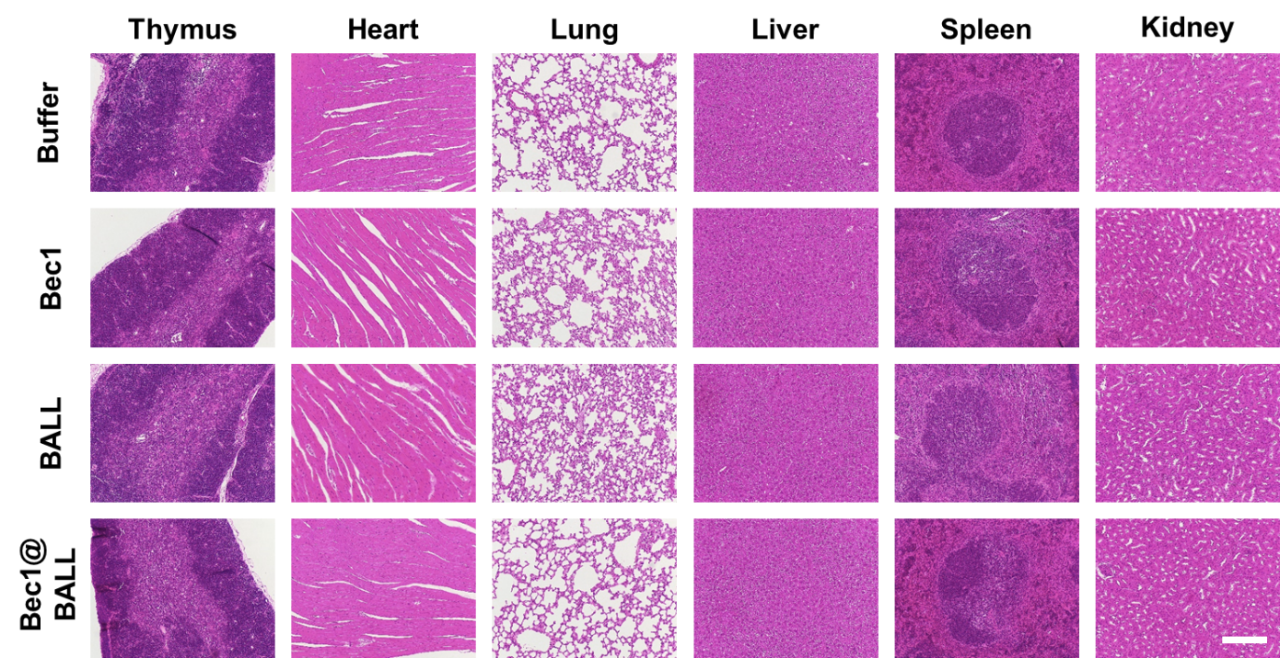
Tumor
Figure S18. Histological H&E images of major organs including thymus, lung, heart, liver, spleen, kidney, and tumor (scale bar = 200 µm).

