Doping‐Engineered Ferromagnetic Nanoparticles-Boosted Piezotronic Synergetic Catalysis Mediated Rapid Bactericidal Therapies

Ozlem Ates Sonmezoglu^{a*}, Alaa Kamo^{a,b}, Ahlem Sattuf^{a,b}, Mustafa Cicek^{c}, Ibrahim Cinar^{d,e}, Xiaolong Liang^{f}, Omar Elmazria^{e}, Savas Sonmezoglu^{b,e,g*}

ªDepartment of Bioengineering, Karamanoglu Mehmetbey University, 70100, Karaman, Türkiye
^{b}Nanotechnology R&D Laboratory, Karamanoglu Mehmetbey University, 70100, Karaman, Türkiye
^{c}Department of Biology, Karamanoglu Mehmetbey University, Karaman, Türkiye
^{d}Department of Medical Services and Techniques, Karamanoglu Mehmetbey University, 70100, Karaman, Türkiye
^{e}Université de Lorraine, CNRS, IJL UMR 7198, 54000 Nancy, France
^{f}Department of Ultrasound, Peking University Third Hospital, 100191, Beijing, China
^{g}Department of Metallurgical and Materials Engineering, Karamanoglu Mehmetbey University, 70100, Karaman, Türkiye

*Corresponding author e-mail: ozlemsonmezoglu@kmu.edu.tr, svssonmezoglu@kmu.edu.tr

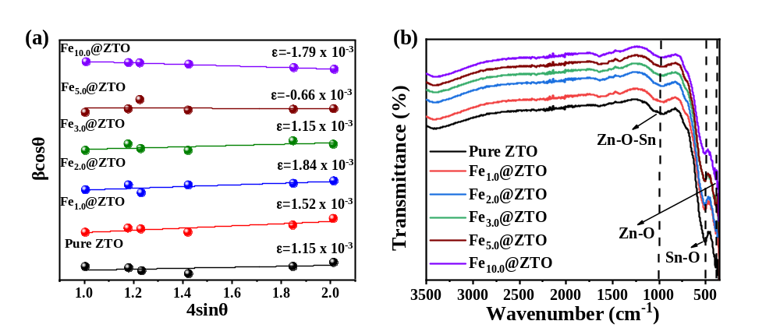
Figure S1: (a) Williamson Hall plot and (b) FT-IR spectra of pure and Fe-doped ZTO nanoparticles.
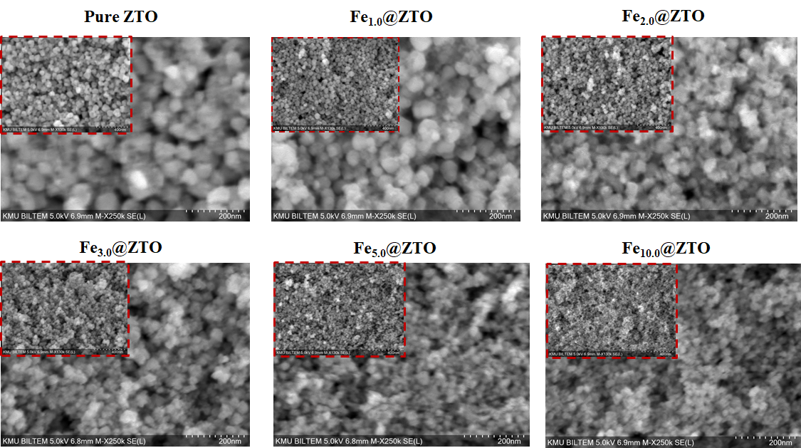
Figure S2: SEM images of pure and Fe-doped ZTO nanoparticles.

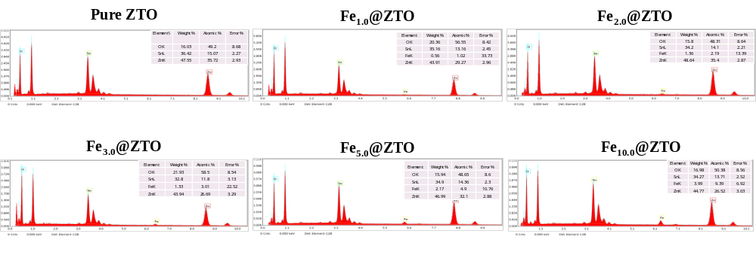
Figure S3: EDX spectra of pure and Fe-doped ZTO nanoparticles.

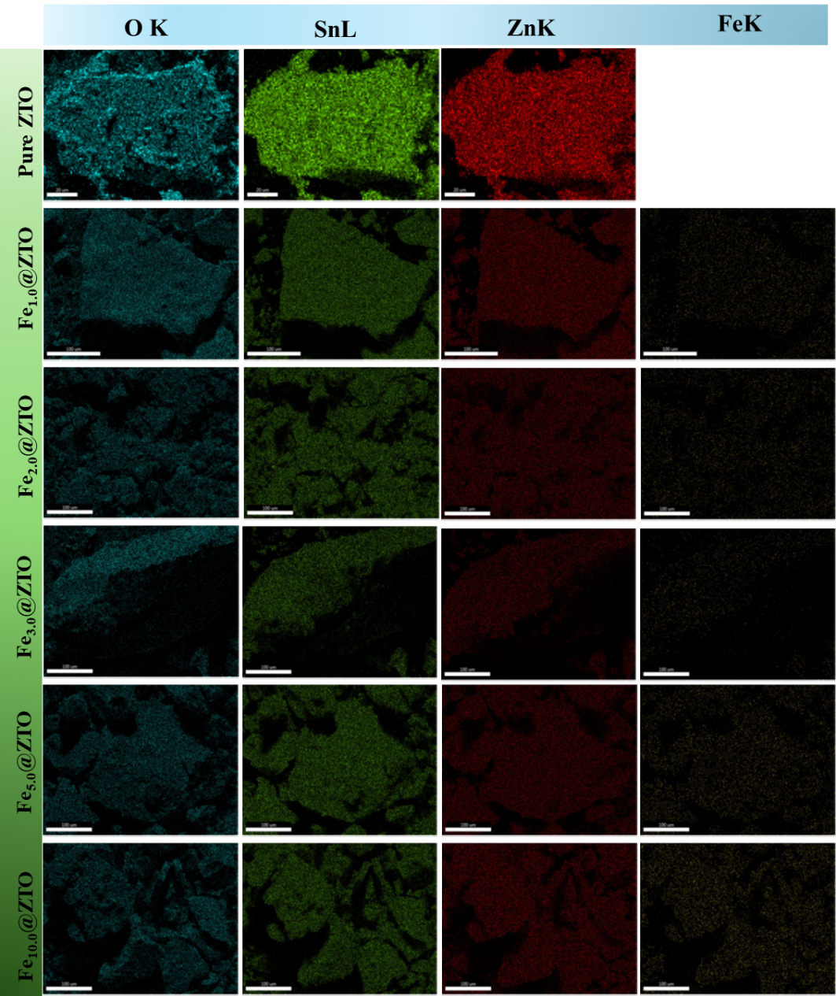
Figure S4: Elemental mapping of Zn, Sn, O and Fe in pure and Fe-doped ZTO nanoparticles.
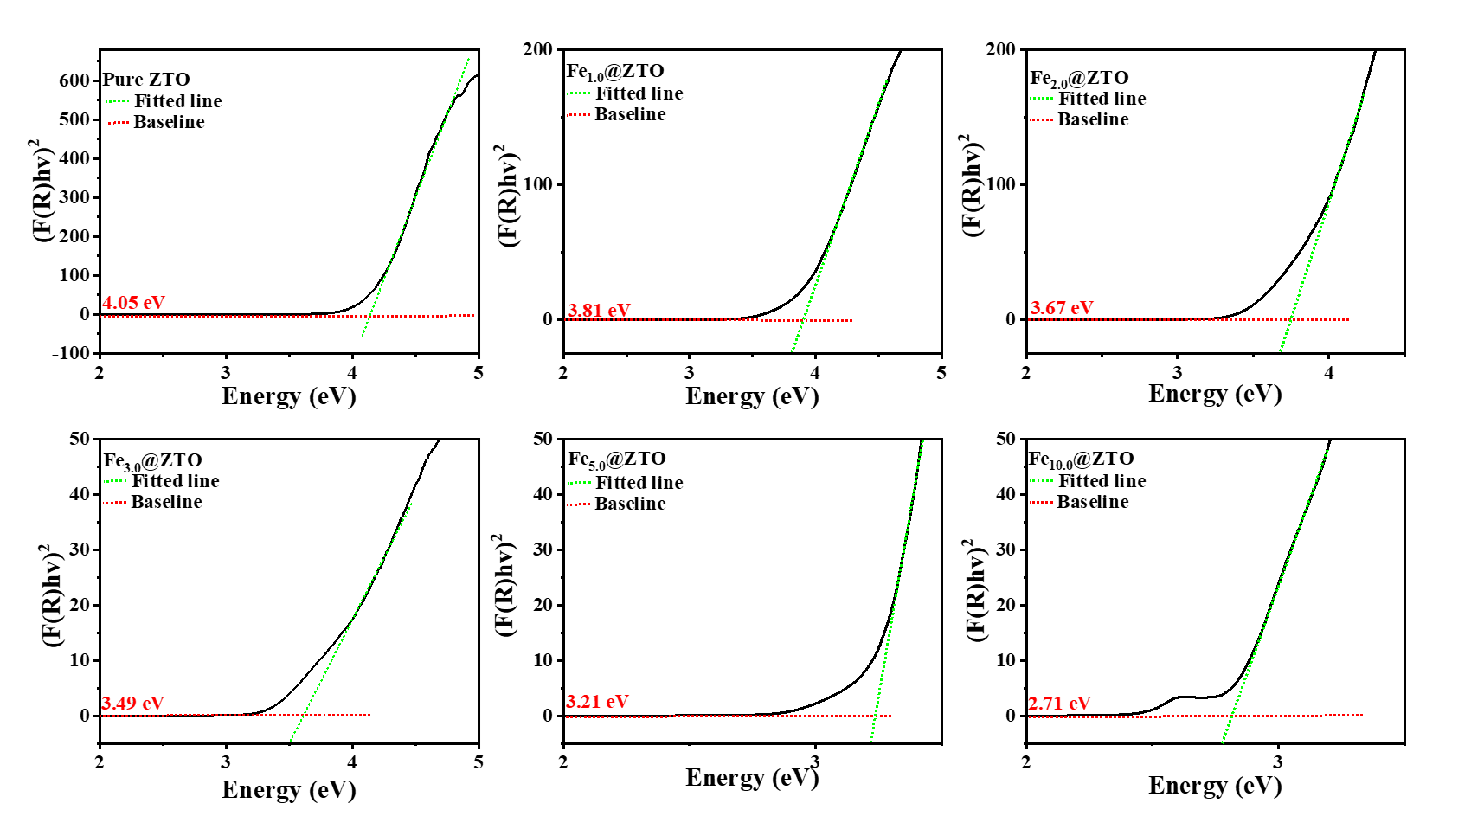
Figure S5: Band gaps of pure and Fe-doped ZTO nanoparticles.

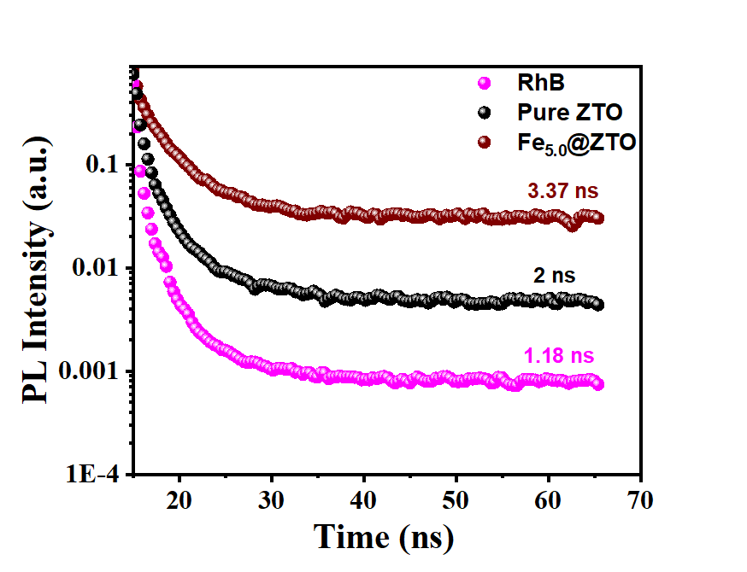
Figure S6: Time-resolved photoluminescence (TRPL) spectra of pure and Fe_{5.0}@ ZTO nanoparticles.
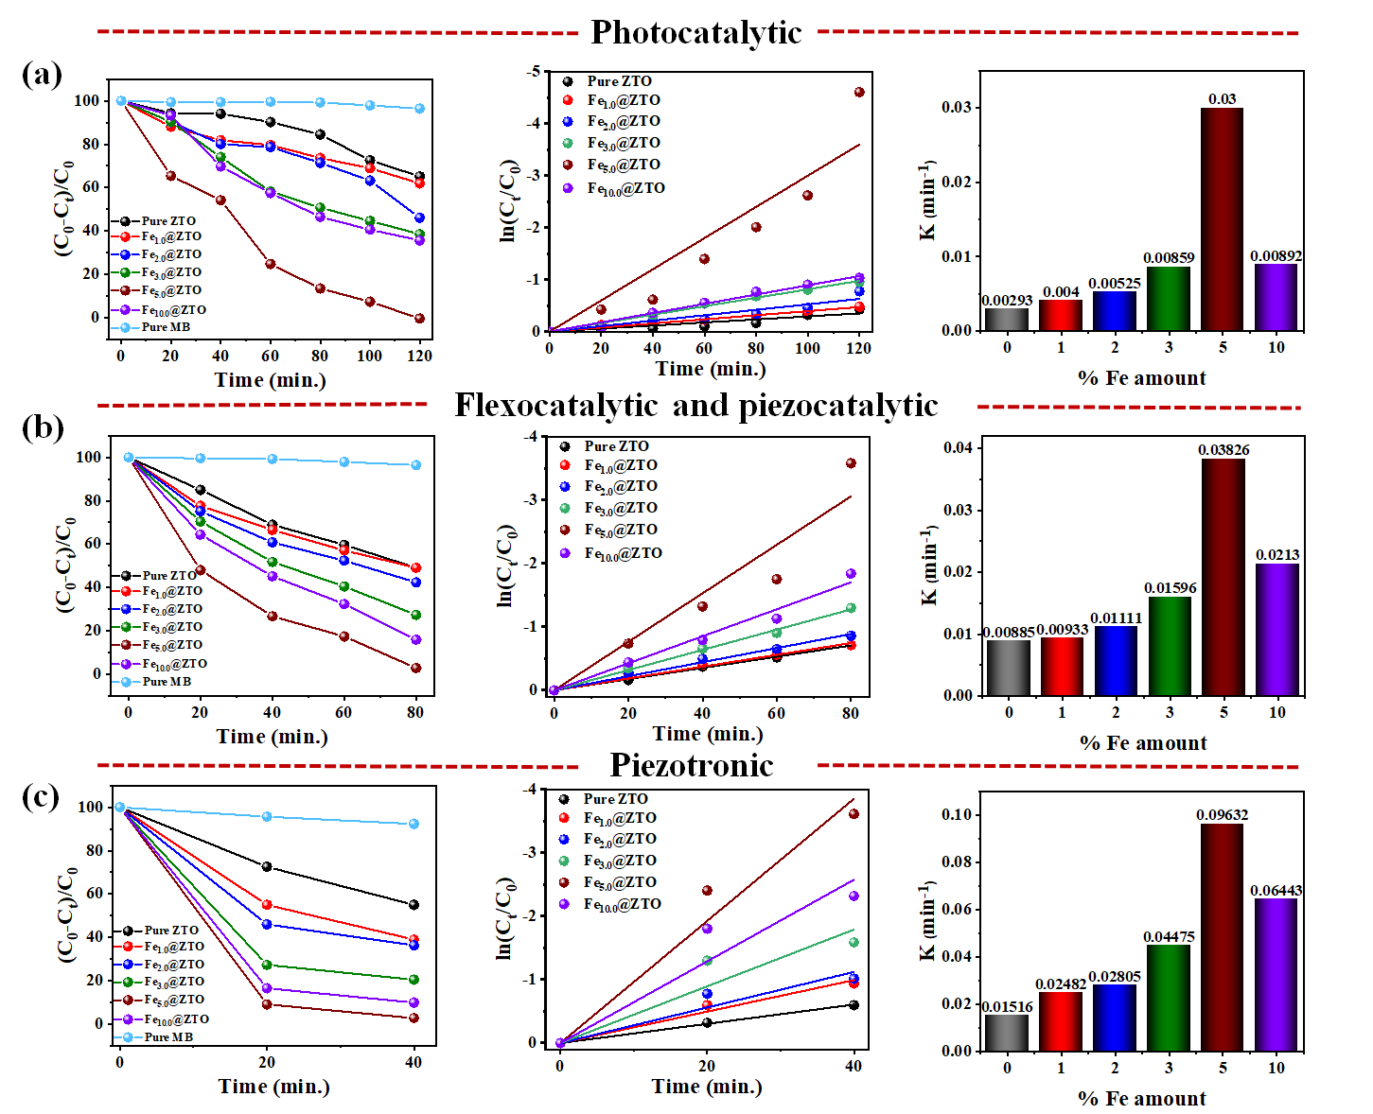
Figure S7: Degradation rate, pseudo-first-order fitting, and the corresponding rate constants for MB in the presence of pure and Fe-doped ZTO nanoparticles under (a) photocatalytic (visible light), (b) Ultrasound-induced catalytic (vibration), and (c) piezotronic (vibration + visible light) conditions. For the ultrasound-induced catalytic condition, pristine ZTO is discussed as flexocatalytic, whereas Fe-doped ZTO is discussed as piezocatalytic.

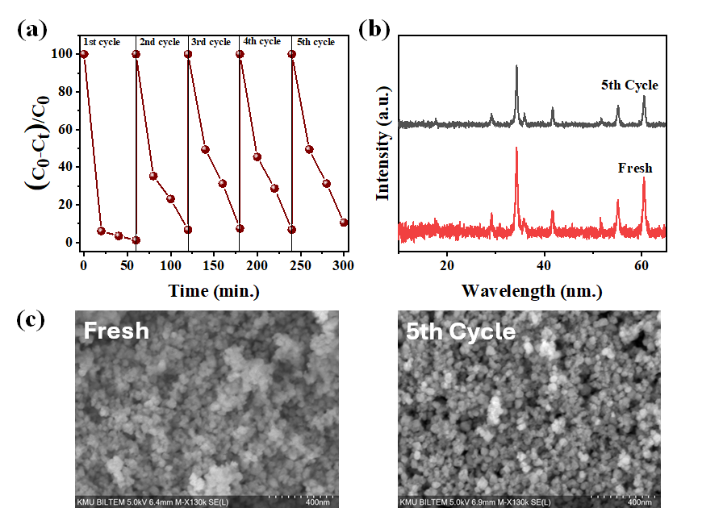
Figure S8: (a)The recycling degradation of RhB solution in the presence of Fe_{5.0}@ZTO nanoparticles under piezotronic conditions and (b) XRD patterns and (c) SEM images of Fe_{5.0}@ZTO before and after five cycles.

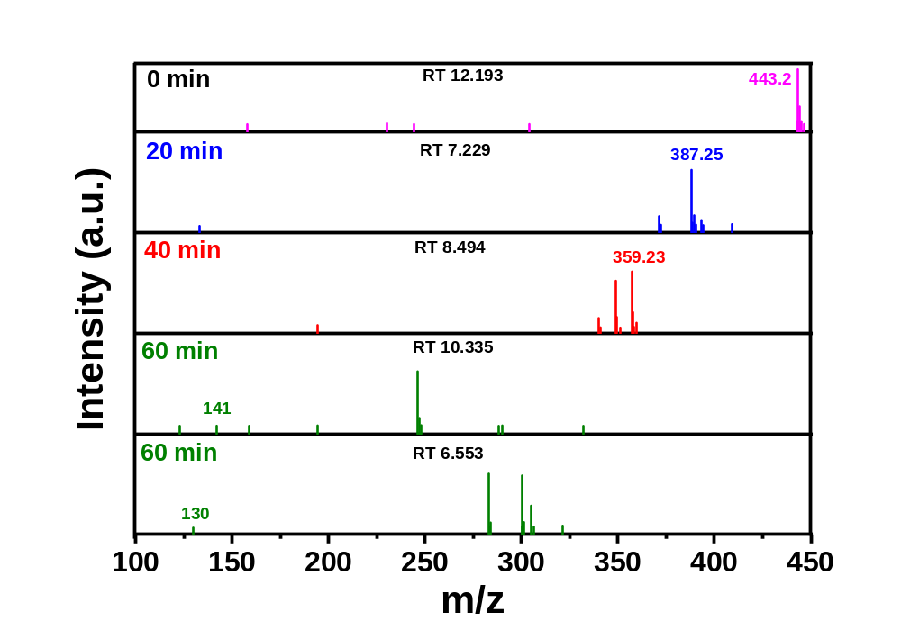
Figure S9: Mass spectrum from LC-MS/MS analyses of RhB after a certain period of VIS+US irradiation.

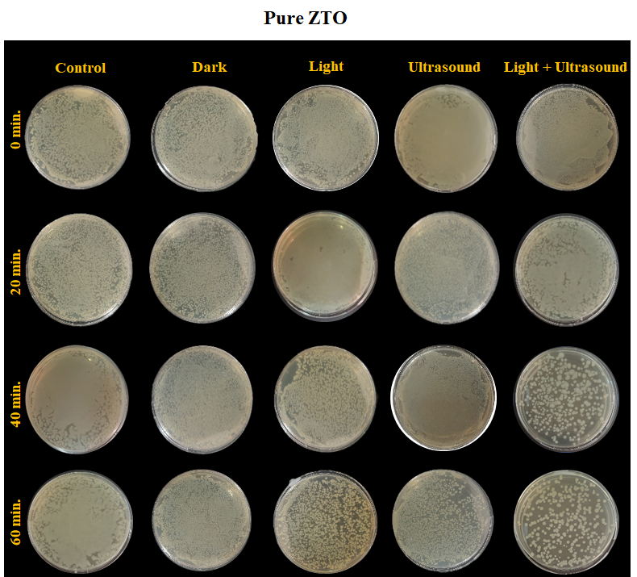
Figure S10: E. coli colonies treated with pure ZTO under different conditions.

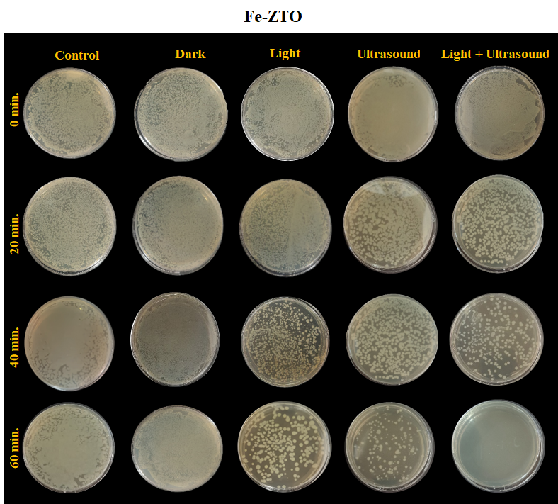
Figure S11: E. coli colonies treated with Fe_{5.0}@ZTO under different conditions.

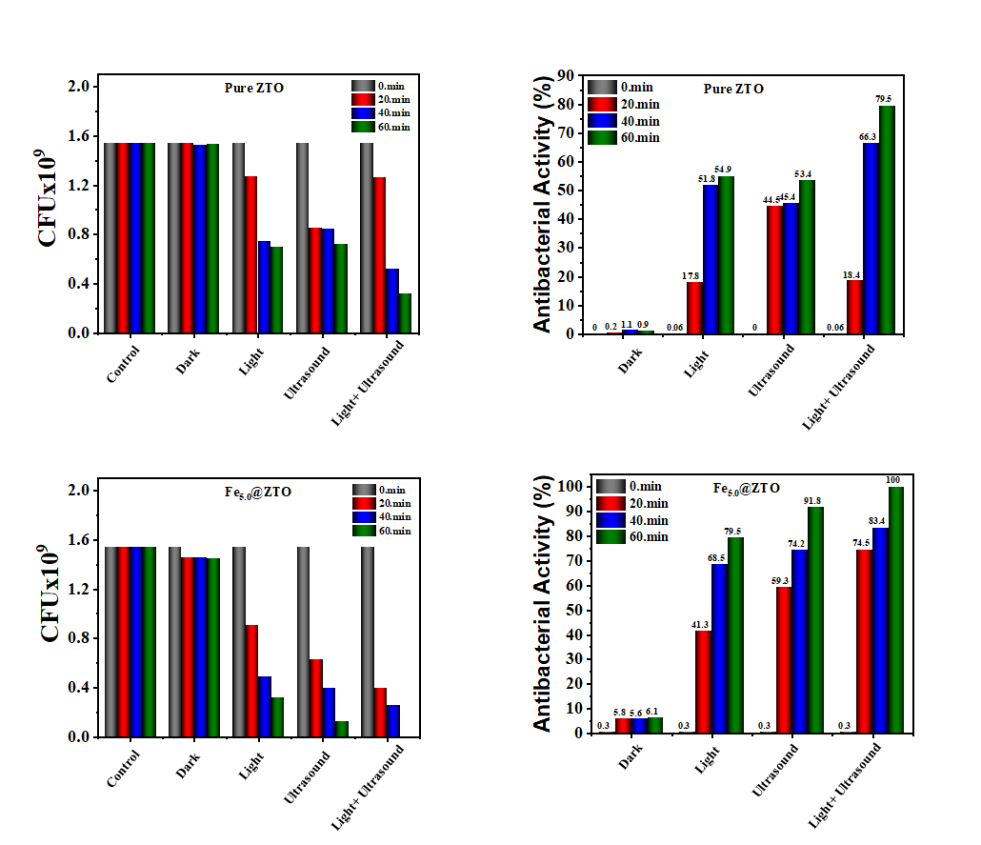
Figure S12: Colony-forming unit (CFU) numbers and antibacterial activity percentages against E. coli of pure ZTO and Fe_{5.0}@ZTO nanoparticles.
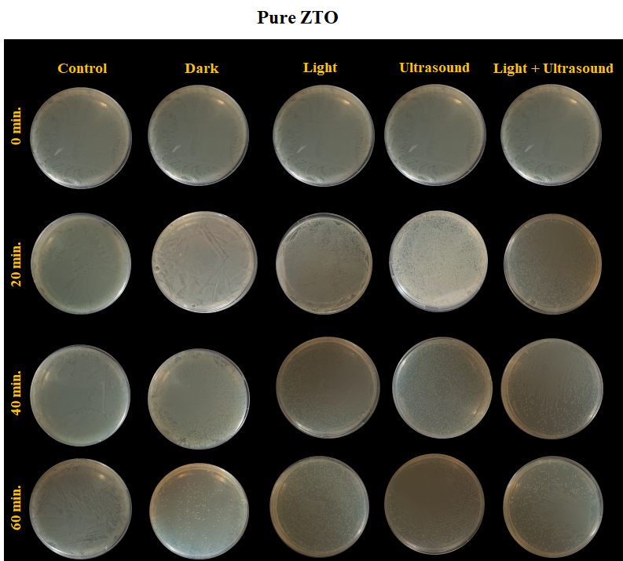
Figure S13: S. aureus colonies treated with pure ZTO under different conditions.
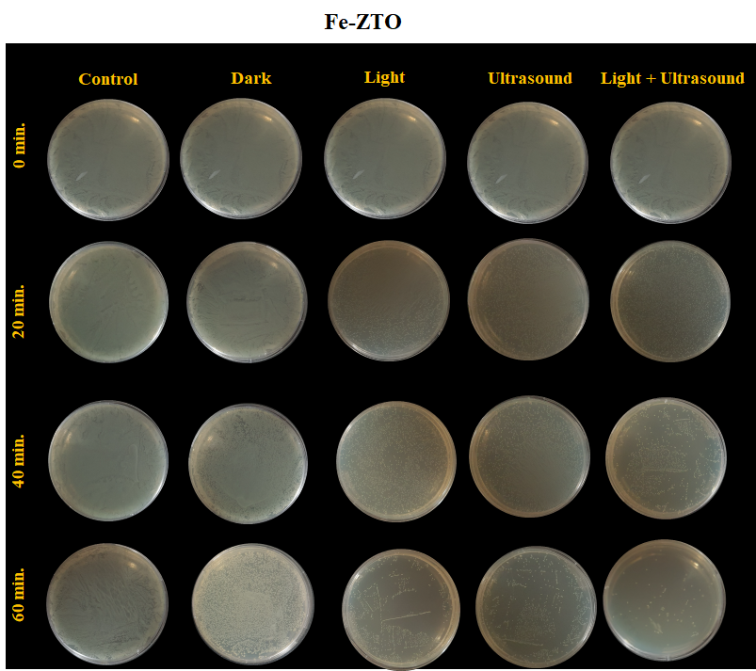
Figure S14: S. aureus colonies treated with Fe_{5.0}@ZTO under different conditions.
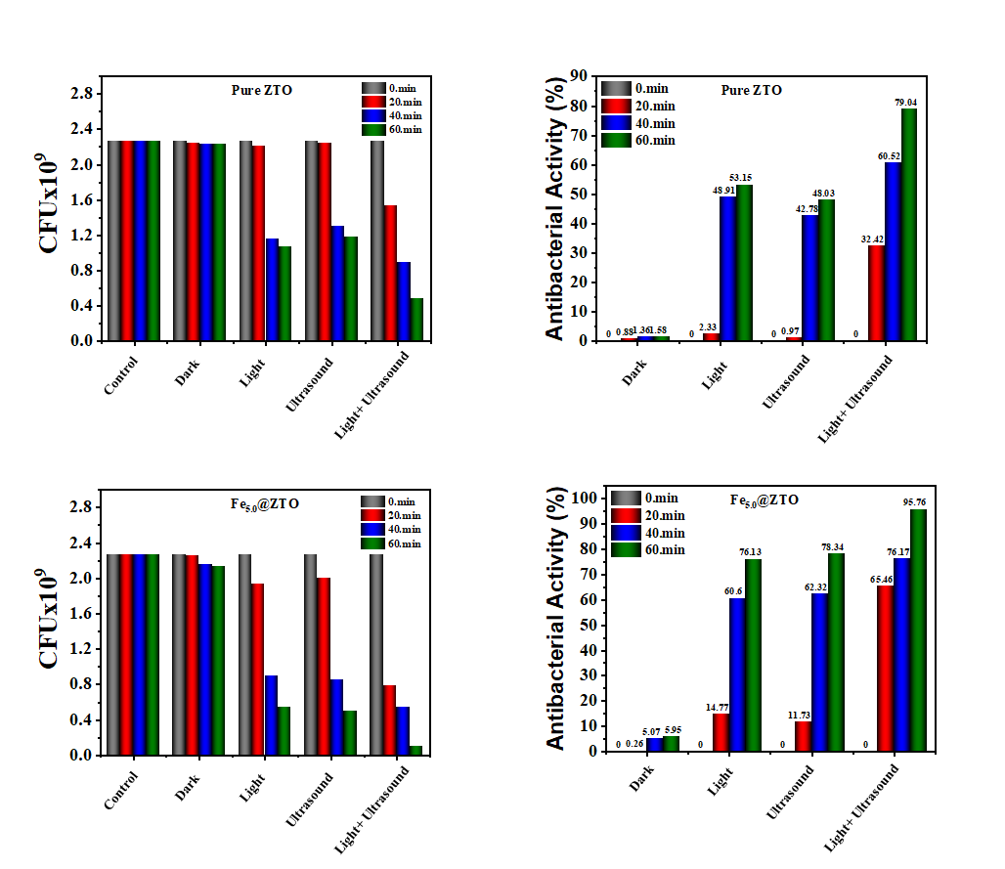

Figure S15: Colony-forming unit (CFU) numbers and antibacterial activity percentages against S. aureus of pure ZTO and Fe_{5.0}@ZTO nanoparticles.

Tablo S1: Brief summary on comparison of similar works in the literature on piezocatalytic degradation and antibacterial performance.
Piezocatalytic Performance

Nanoparticle | Pollutant | Time (min) | Conc. (mg/mL) | Piezo (%) | Piezotronic (%) | Ref
Bi₅Ti₃FeO₁₅ | RhB  Mixed dyes (RhB, MB, AO7, MO) | 20  40 | 1 | 98  100 | –  – | [1]
Bi₅Ti₃FeO₁₅/BiOCl | RhB  Mixed dyes (MB, MO, AO7, RhB) | 20  30 | 1 | 96  97 | –  – | [2]
Co-doped BiFeO₃ | RhB, MB, AO7 | 15 | 0.5 | 98.71, 76.32, 91.43 | – | [3]
BaTiO₃ nanorods | RhB, MB, MO, RB19 | 80 | – | 76.4, 81.7, 98.1, 85.9 | – | [4]
BiFeO₃/Chitosan composite | RhB | 80 | 1 | 87.80 | – | [5]
Ce-doped hollow BaTiO₃ | MB | 10 | 1 | 42.60 | – | [6]
(K,Na)NbO₃ (KNN) | RhB, MO | 40 | 4 | ≈99, 71 | – | [7]
NaNbO₃/ZnO | RhB, MB, RB | 60 | 1 | 97, 40, 73.75 | – | [8]
Ag/NaNbO₃ | RhB | 30 | 5 | 92.3 | 92.7 (25 min) | [9]
BaTiO₃ | MB | 75 | – | 82 | – | [10]
ZnO–GO | RhB, MO, MB | 30 | 2 | 42, 70, 98 | 57, 95, 99 | [11]
Ag@SrBi₂Ta₂O₉ | RhB | 30 | – | 75.04 | – | [12]
BaTiO₃/CuO | RhB, MO | 120 | 0.5 | 98.4, 65.3 | – | [13]
Fe-doped ZTO | RhB, MB | 80 | 0.9 | 95.9, 97.21 | 98.84 (60min), 97.3 (40 min) | This work

Antibacterial Performance

Nanoparticle | Bacteria | Time (min) | Conc. (mg/mL) | Activity | d33 | Ref
Bi₂WO₆-P  Bi₂WO₆-G | E. coli | 15 | 10 | ~93 (CFU), ~99 (live/dead assay)  ~40(CFU), ~38 (live/dead assay) | 9.6 pC/N  3.1 pC/N | [14]
BaTiO₃/Chitosan coating | Fusobacterium nucleatum | 3 | – | 90.41 | – | [15]
Bi₄O₅Br₂@Ru | MRSA, E. coli | – | – | 99% | – | [16]
SrTiZrO₃/HAp | S. aureus, E. coli | 15 | – | 99.3, 99.7 | – | [17]
Al-SrTiO₃/TiO₂ NT | P. gingivalis, F. nucleatum | 5 | – | 80.4, 82.1 | – | [18]
Se@BaTiO₃ | S. aureus | 15 | 2 | 99.23 | – | [19]
BiFeO₃/Chitosan composite | S. aureus | 30 | – | ~99 | – | [5]
Ce-doped hollow BaTiO₃ | P. aeruginosa, MRSA | 50 | 0.1 | 100 | 49.2 pm/V | [6]
(K,Na)NbO₃ (KNN) | S. aureus, E. coli | 5 | 0.2 | 100, 85 | – | [7]
ZnO@TiO_{2-x}N_{y} | S. aureus, E. coli | 60, 40 | – | 100, 95 (Piezotronic) | – | [20]
NaNbO₃/ZnO | E. coli | 60 | 1 | 100% (CFU), 21 mm (Zone) | – | [8]
Ag/NaNbO₃ | E. coli, S. aureus | 120 | – | 99.8, 97.7 | – | [10]
t-BaTiO₃ | E. coli | 180 | 2 | 95 | – | [21]
ZnO–GO | E. coli | 10 | 0.1gr | 2.1 cm (Zone) | – | [11]
Ag@SrBi₂Ta₂O₉ | E. coli K12 | 60 | – | 100 | – | [12]
BaTiO₃/CuO | E. coli | 120 | 1 | 99 | – | [13]
Fe-doped ZTO | E. coli,  S. aureus | 60 | 0.1 | 91.8% (piezocatalytic) 100 % (piezotronic)  78.37% (piezocatalytic) 95.76% (piezotronic) | 0.25 nA.V⁻¹ | This Work
– indicates that the data were not reported in the original studies.

References
[1] Zhu X, Wu X, Li Y, Shao W, Fu J, Lin Q, Tan J, Gao S, Zhang Y, Ye W. Bi₅Ti₃FeO₁₅ nanofibers for highly efficient piezocatalytic degradation of mixed dyes and antibiotics. ACS Applied Nano Materials. 2023;6(7):5602-5612. https://doi.org/10.1021/acsanm.3c00040.
[2] Zhu X, Zheng Y, Yu H, Liang B, Wu X, Li Y, Zhang Y, Ye W. Boosting piezocatalytic activity of Bi₅Ti₃FeO₁₅/BiOCl heterostructured nanocomposites for degrading multiple dyes and antibiotics. ACS Applied Nano Materials. 2024;7(2):1885-1895. https://doi.org/10.1021/acsanm.3c05180.
[3] Zhu J, Chen S, Ding S, Chen C. Efficient Piezocatalysis of BiFeO₃ Achieved via Defect Introduction through Doping. Journal of Alloys and Compounds. 2026:187044.
[4] Liu Y, Chen T, Zheng J, Zhu Z, Huang Z, Hu C, Liu B. Enhanced piezo-catalytic performance of BaTiO₃ nanorods combining highly exposed active crystalline facets and superior deformation capability: Water purification and activation mechanism. Chemical Engineering Journal. 2024;488:150768. https://doi.org/10.1016/j.cej.2024.150768.
[5] Liu Y, Roy J, Roy S, Hoque N A, Guo B. Highly efficient piezocatalytic composite with chitosan biopolymeric membranes and bismuth ferrite nanoparticles for dye decomposition and pathogenic S. aureus bacteria killing. Frontiers in Chemistry. 2024;12:1420040. https://doi.org/10.3389/fchem.2024.1420040.
[6] Wei J, Xia J, Liu X, Ran P, Zhang G, Wang C, Li X. Hollow-structured BaTiO₃ nanoparticles with cerium-regulated defect engineering to promote piezocatalytic antibacterial treatment. Applied Catalysis B: Environmental. 2023;328:122520. https://doi.org/10.1016/j.apcatb.2023.122520.
[7] Wang X, Wang N, Liao J, Wang X, Zou A, Chen Q, Li C B W, Zhang J, Wang D, Peng Y. Lead‐Free (K, Na)NbO₃ piezocatalyst with superior piezocatalysis and large‐scale production. Advanced Functional Materials. 2024;34(14):2313662. https://doi.org/10.1002/adfm.202313662.
[8] Sharma A, Bhardwaj U, Jain D, Kushwaha H S. NaNbO₃/ZnO piezocatalyst for non-destructive tooth cleaning and antibacterial activity. Iscience. 2022;25(9). https://doi.org/10.1016/j.isci.2022.104915
[9] Sun Q, Zhang D, Xue G, Liu Q, Zhou X, Pei Z, Luo H, Zhu L. Piezo-assisted photoelectric catalysis degradation for dyes and antibiotics by Ag dots-modified NaNbO₃ powders. Ceramics International. 2022;48(16):23182-23194. https://doi.org/10.1016/j.ceramint.2022.04.301.
[10] Kumar A, Sharma M, Vaish R, ben Ahmed S. Poling effect on piezocatalytic antibacterial and dye degradation activities of BaTiO₃ nanoparticles embedded cotton fabric. Journal of Alloys and Compounds. 2023;938:168530. https://doi.org/10.1016/j.jallcom.2022.168530.
[11] Ma W, Lv M, Cao F, Fang Z, Feng Y, Zhang G, Yang Y, Liu H. Synthesis and characterization of ZnO-GO composites with their piezoelectric catalytic and antibacterial properties. Journal of Environmental Chemical Engineering. 2022;10(3):107840. https://doi.org/10.1016/j.jece.2022.107840.
[12] Jiang G, Xie L, Huang W, Liu Y, Lu X, Xin Y, Zhou Z, Fan X. The influence of lowing the Schottky barrier on the reactive oxygen species formation in Ag@SrBi₂Ta₂O₉ piezocatalyst under ball milling. Chemical Engineering Journal. 2024;491:152085. https://doi.org/10.1016/j.cej.2024.152085.
[13] Singh R, Ali M, Sharma K, Dhyani P, Goyal C, Tripathi C S P, Guin D. Ultrasound-activated piezocatalytic degradation of Rhodamine B, Ofloxacin, and inactivation of E. coli by BaTiO₃/CuO nanocomposites. Journal of Environmental Chemical Engineering. 2024;12(6):114741. https://doi.org/10.1016/j.jece.2024.114741.
[14] DuBois D B, Tressel J, Hergenroeder D, Jones C, Yu B, Singewald K, Millhauser G L, Saltikov C, Chen S. Antibacterial activity of bismuth tungstate against Escherichia coli: Enhanced piezocatalysis by morphological engineering. Journal of Environmental Chemical Engineering. 2025:118871. https://doi.org/10.1016/j.jece.2025.118871.
[15] Wei Y, Hu X, Shao J, Wang S, Zhang Y, Xie W-Z, Wu Y-X, Zeng X-T, Zhang L-L. Daily sonic toothbrush triggered biocompatible BaTiO₃/chitosan multiporous coating with enhanced piezocatalysis for intraoral antibacterial activity. Materials Today Communications. 2024;38:107715. https://doi.org/10.1016/j.mtcomm.2023.107715.
[16] Peng C, Wu W, Huo H, Li J, Wang E. Defect-boosted piezoelectric and nanozymatic synergetic catalysis for deep bacterial abscess therapy. ACS Nano. 2025;19(23):21830-21843. https://doi.org/10.1021/acsnano.5c05806.
[17] Zhou X, Xie J, Zhou X, Ma T, Lu Y, Yang Y, Xie Z, Ling H, Xu R, Wu M. Single-atom Zr doped heterojunction enhanced piezocatalysis for implant infection therapy through synergistic metal immunotherapy with sonodynamic and physical puncture. Journal of Nanobiotechnology. 2025;23(1):243. https://doi.org/10.1186/s12951-025-03309-x.
[18] Pan Q, Zheng Y, Zhou Y, Zhang X, Yuan M, Guo J, Xu C, Cheng Z, Kheraif A A A, Liu M. Doping engineering of piezo‐sonocatalytic nanocoating confer dental implants with enhanced antibacterial performances and osteogenic activity. Advanced Functional Materials. 2024;34(21):2313553. https://doi.org/10.1002/adfm.202313553.
[19] Lei C, Lei J, Zhang X, Wang H, He Y, Zhang W, Tong B, Yang C, Feng X. Heterostructured piezocatalytic nanoparticles with enhanced ultrasound response for efficient repair of infectious bone defects. Acta Biomaterialia. 2023;172:343-354. https://doi.org/10.1016/j.actbio.2023.10.006.
[20] Guo S, Shu G, Luo H, Kuang X, Zheng L, Wang C, Zhou C-A, Song L, Ma K, Yue H. Low-Cytotoxic Core–Sheath ZnO NWs@ TiO_{2–x}N_{y} Triggered Piezo-photocatalytic Antibacterial Activity. ACS Applied Materials & Interfaces. 2024;16(19):24410-24420. https://doi.org/10.1021/acsami.4c04500.
[21] Feng J, Fu Y, Liu X, Tian S, Lan S, Xiong Y. Significant improvement and mechanism of ultrasonic inactivation to Escherichia coli with piezoelectric effect of hydrothermally synthesized t-BaTiO₃. ACS Sustainable Chemistry & Engineering. 2018;6(5):6032-6041. https://doi.org/10.1021/acssuschemeng.7b04666.

