Supporting Information
for
Skin-Mimetic Albumin Hydrogel as an Artificial Protein Skin with a Mitochondria-Targeted Bioenzymatic Cascade for Cross-Scale Redox Repair in Diabetic Wounds
Zheng Luo^{1,3,5}, Xiangyang Li¹, Cui Yang^{2,*}, Yuting Lin³, Xiyu Lai³, Jiajia Liu⁴, Ruoyu Li⁴, Karen Yuanting Tang⁵, Xian Jun Loh⁵, Yun-Long Wu^{3,*}, Chiyu Jia^{1,*}
¹ Center of Burn & Plastic and Wound Healing Surgery, The First Affiliated Hospital of University of South China, Hengyang Medical School, University of South China, Hengyang, Hunan, China.
² Department of cardiology, Xiangyang No.1 People’s Hospital, Hubei University of Medicine, Xiangyang, China.
³ State Key Laboratory of Vaccines for Infectious Diseases, Xiang An Biomedicine Laboratory, Fujian Provincial Key Laboratory of Innovative Drug Target Research, School of Pharmaceutical Sciences, Faculty of Medicine and Life Sciences, Xiamen University, Xiamen, China.
⁴ College of Chemistry and Chemical Engineering, Xiamen University, Xiamen, China
⁵ Institute of Materials Research and Engineering (IMRE), Agency for Science, Technology and Research (A*STAR), 2 Fusionopolis Way, Innovis #08-03, Singapore 138634, Republic of Singapore.

*Correspondence to: Yangcui2411@hbmu.edu.cn (C. Yang); 2023010003@usc.edu.cn (C. Jia); wuyl@xmu.edu.cn (Y.-L. Wu).

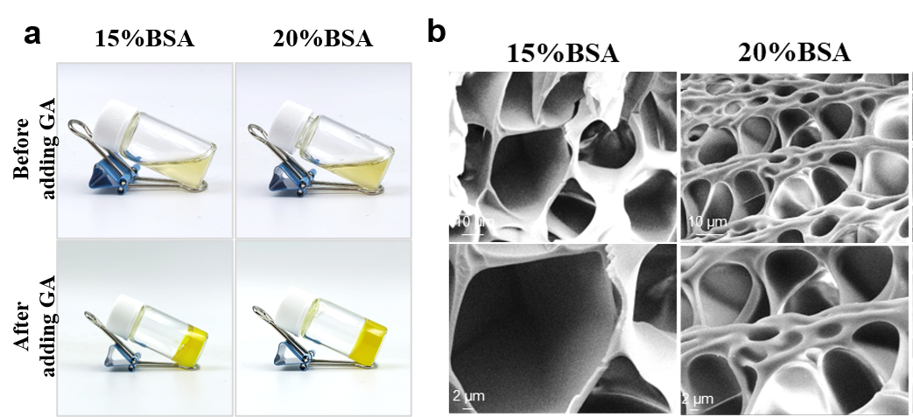
Figure S1. (a) Images of albumin (BSA) solutions with different proportions before and after the addition of 0.5% glutaraldehyde (GA) to the gelation state. (b) SEM images of albumin (BSA) hydrogels with different proportions.

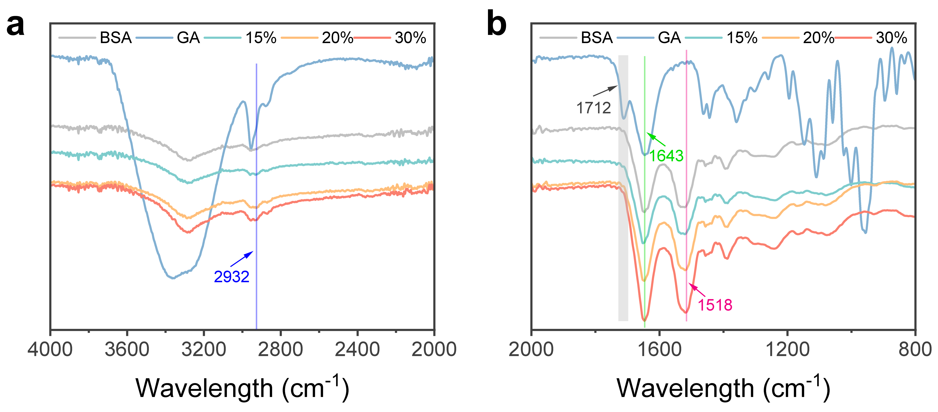
Figure S2. (a) Infrared spectra at 4000~2000 cm⁻¹ and (b) at 2000~800 cm⁻¹ of BSA protein hydrogel.

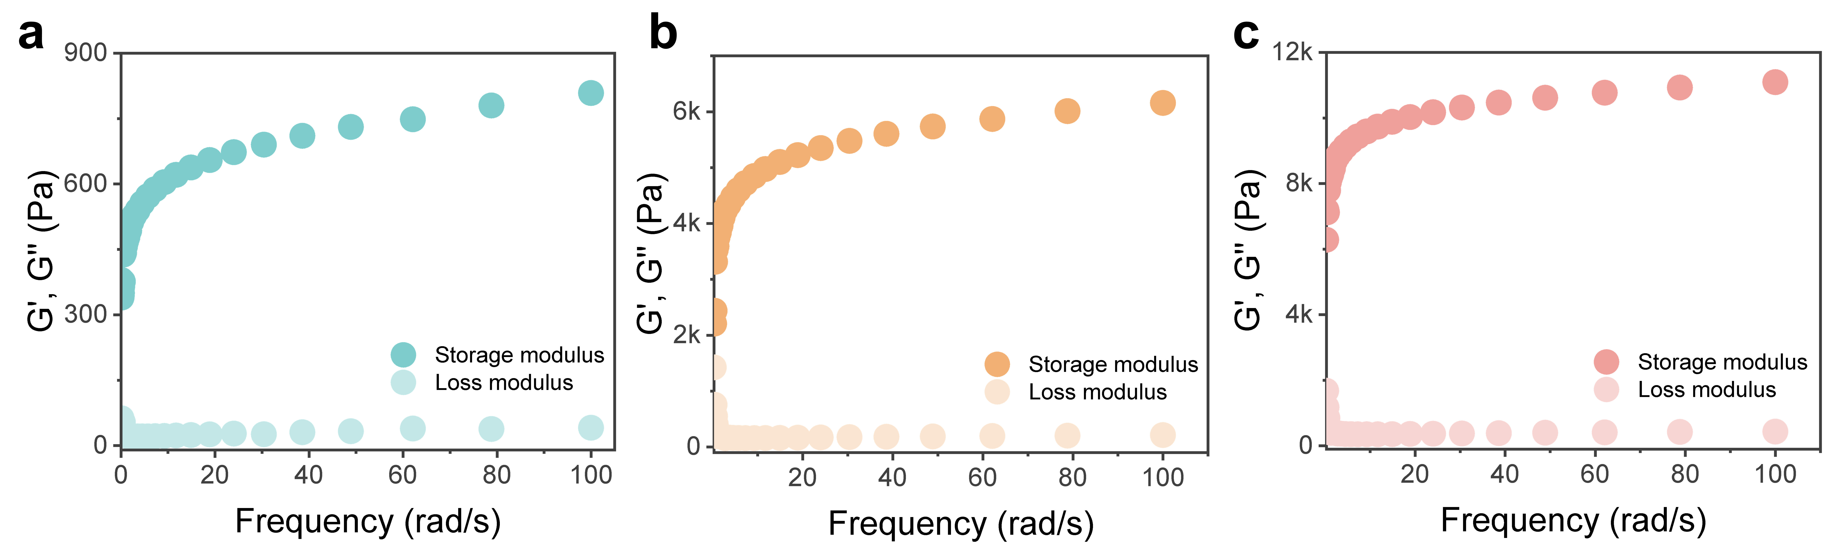
Figure S3. Storage modulus (G’) and loss modulus (G’’) of (a) 15%, (b) 20% and (c) 30% albumin hydrogel.

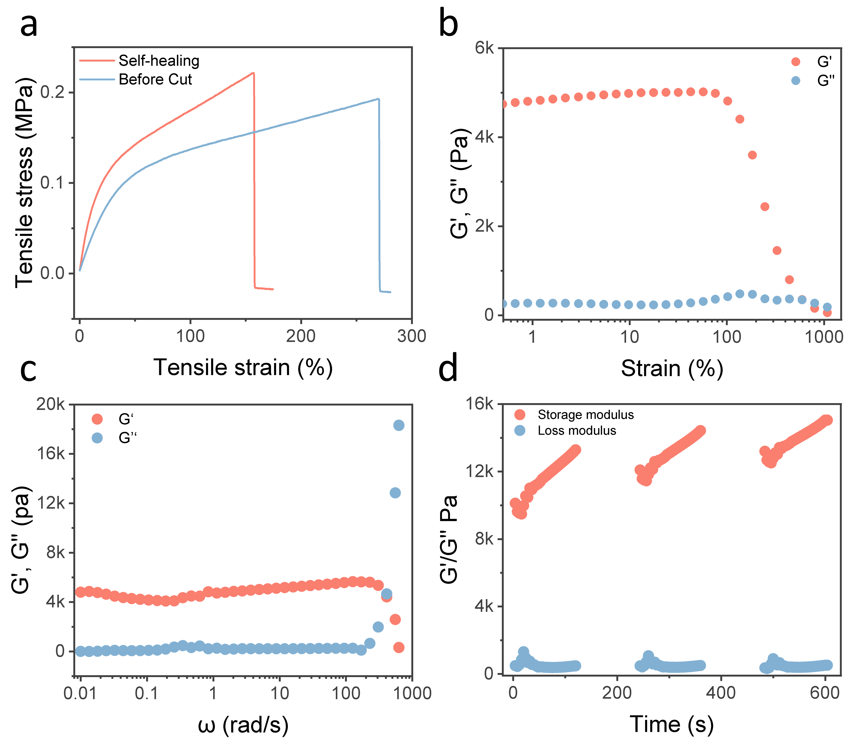
Figure S4. (a) Tensile stress–strain curves of the 30% BSA hydrogel in its pristine state and after cutting and self-healing. Storage modulus (G′) and loss modulus (G″) of the 30% BSA hydrogel measured by (b) oscillatory strain sweep over a strain range of 0.01–1000% at a fixed angular frequency of 5 rad/s or (c) an angular frequency sweep from 0.01 to 1000 rad/s at a fixed strain of 1%. (d) Self-healing properties of BSA hydrogels were observed in a series of continuous damage-recovery measurements. G′, G″ was measured as a function of time (s) with increasing angular frequency (0.01 -100 rad/s) (n = 3).

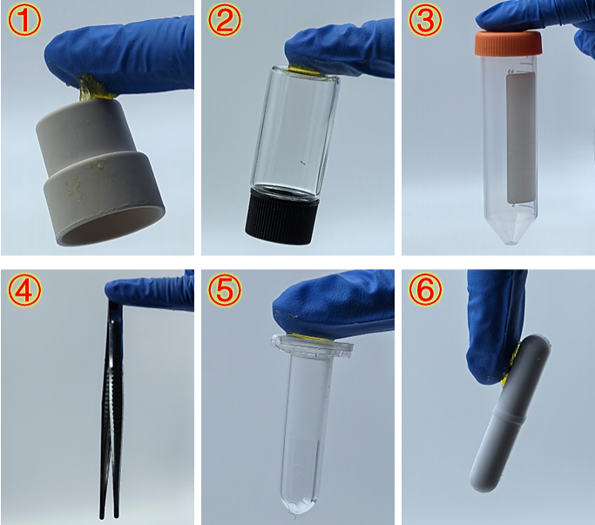
Figure S5. Adhesion of albumin hydrogel to different materials.

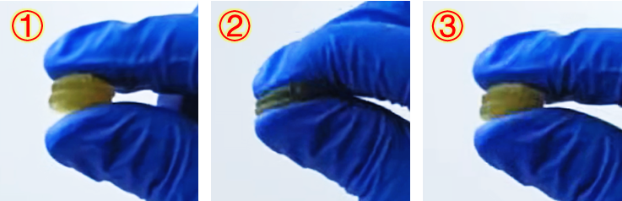
Figure S6. Changes in shape of albumin hydrogel before and after pressing.

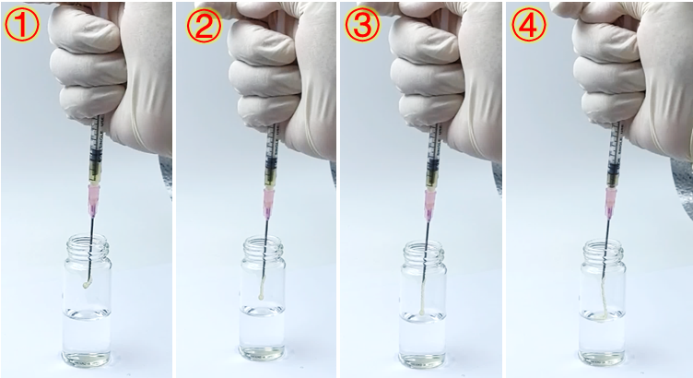
Figure S7. Injectability of albumin hydrogel.

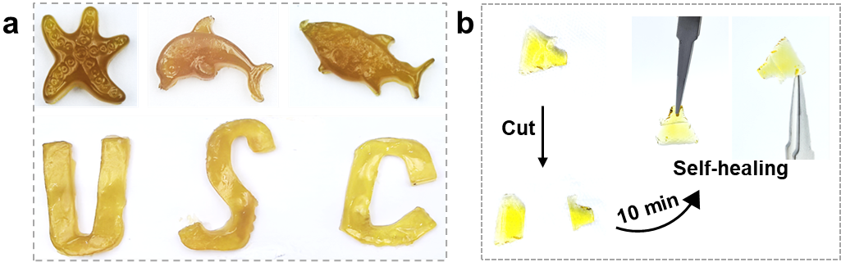
Figure S8. (a) The plasticity of albumin hydrogels: They can be transformed into various shapes according to the mold, such as five-pointed stars, fish, letters, etc. (b) Self-healing properties of albumin hydrogel.

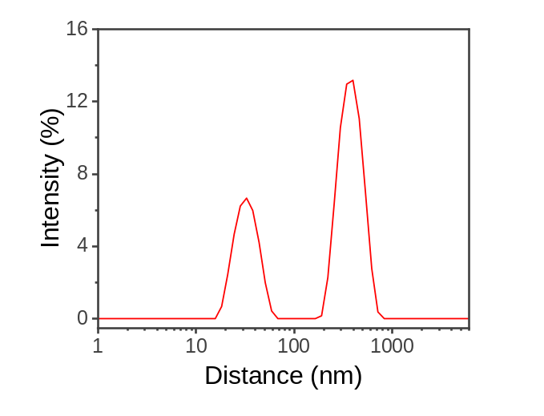
Figure S9. Hydration particle size of TPP-SC.

Figure S10. Photos of BTSC catalyzing the generation of O₂ bubbles from H₂O₂ at different time points.

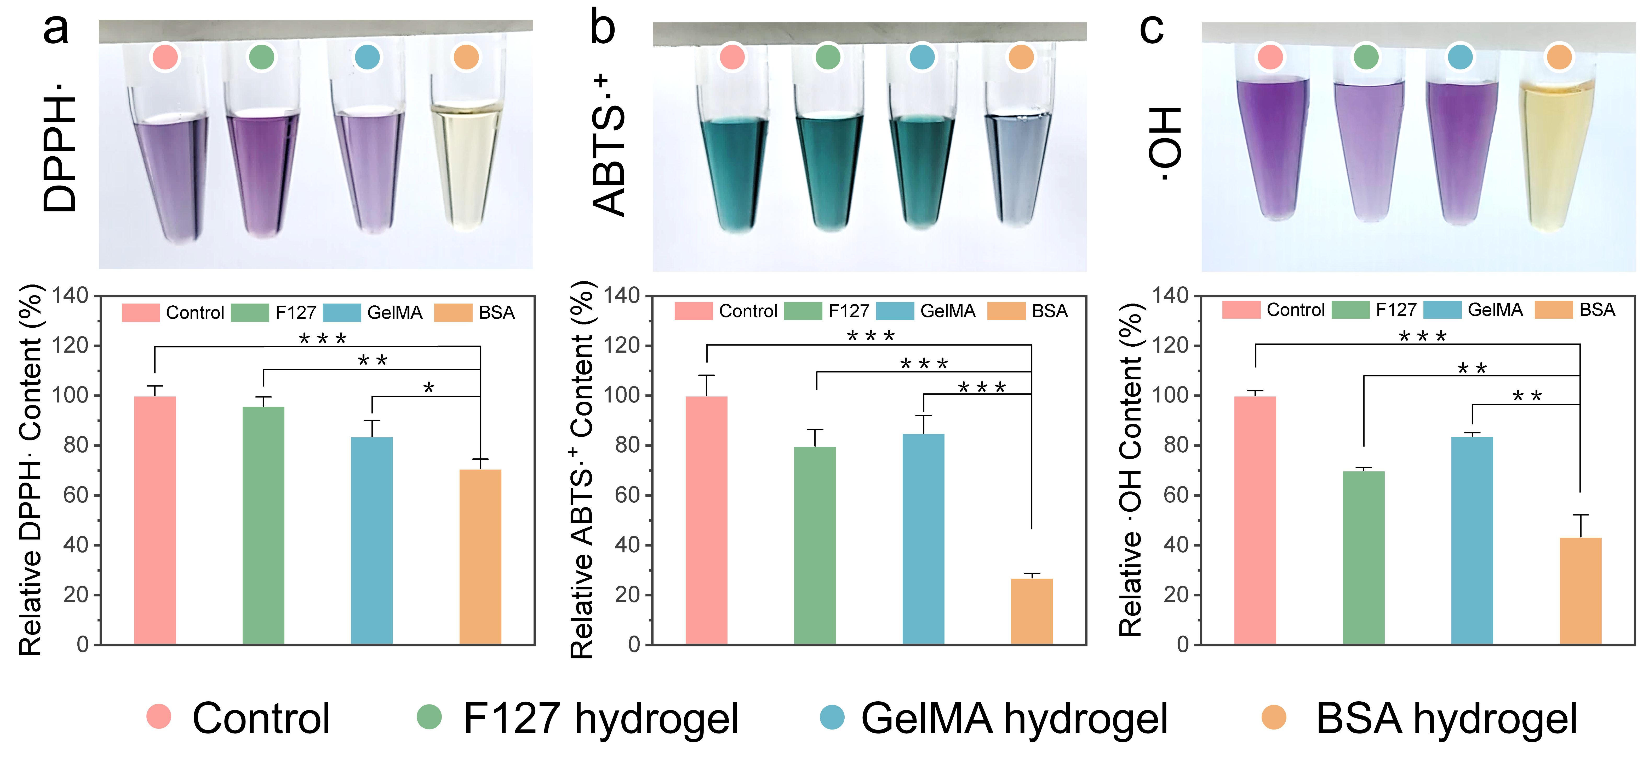
Figure S11. Different hydrogel scavenging efficiencies toward (a) DPPH·, (b) ABTS·⁺, and (c) ·OH. Data are presented as mean ± SD (n = 3). Statistical significance was determined by unpaired, two-tailed Student’s t-test. *p < 0.05, **p < 0.01, ***p < 0.001, ****p < 0.0001.

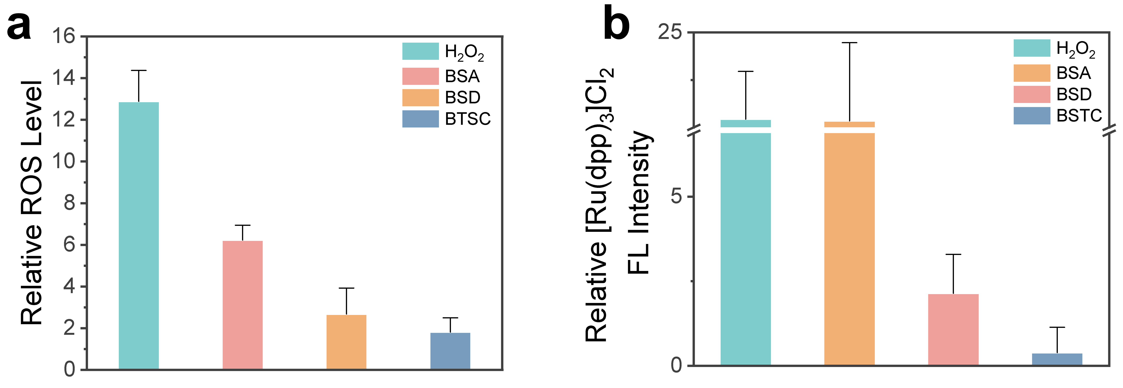
Figure S12. Semi-quantitative analysis of fluorescence intensity in (a) Fig. 4a and (b) Fig. 4b was performed, respectively.

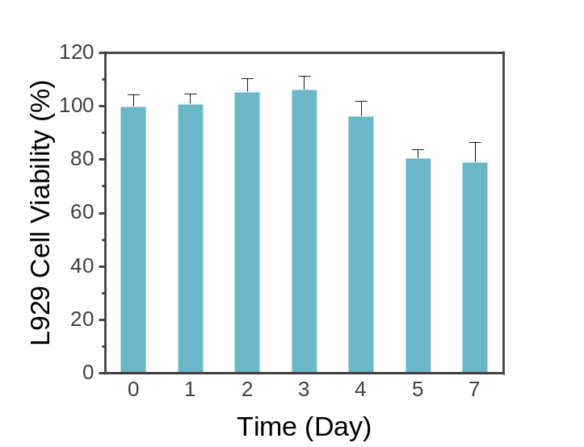
Figure S13. Cytotoxicity of BTSC extracts at different time points.

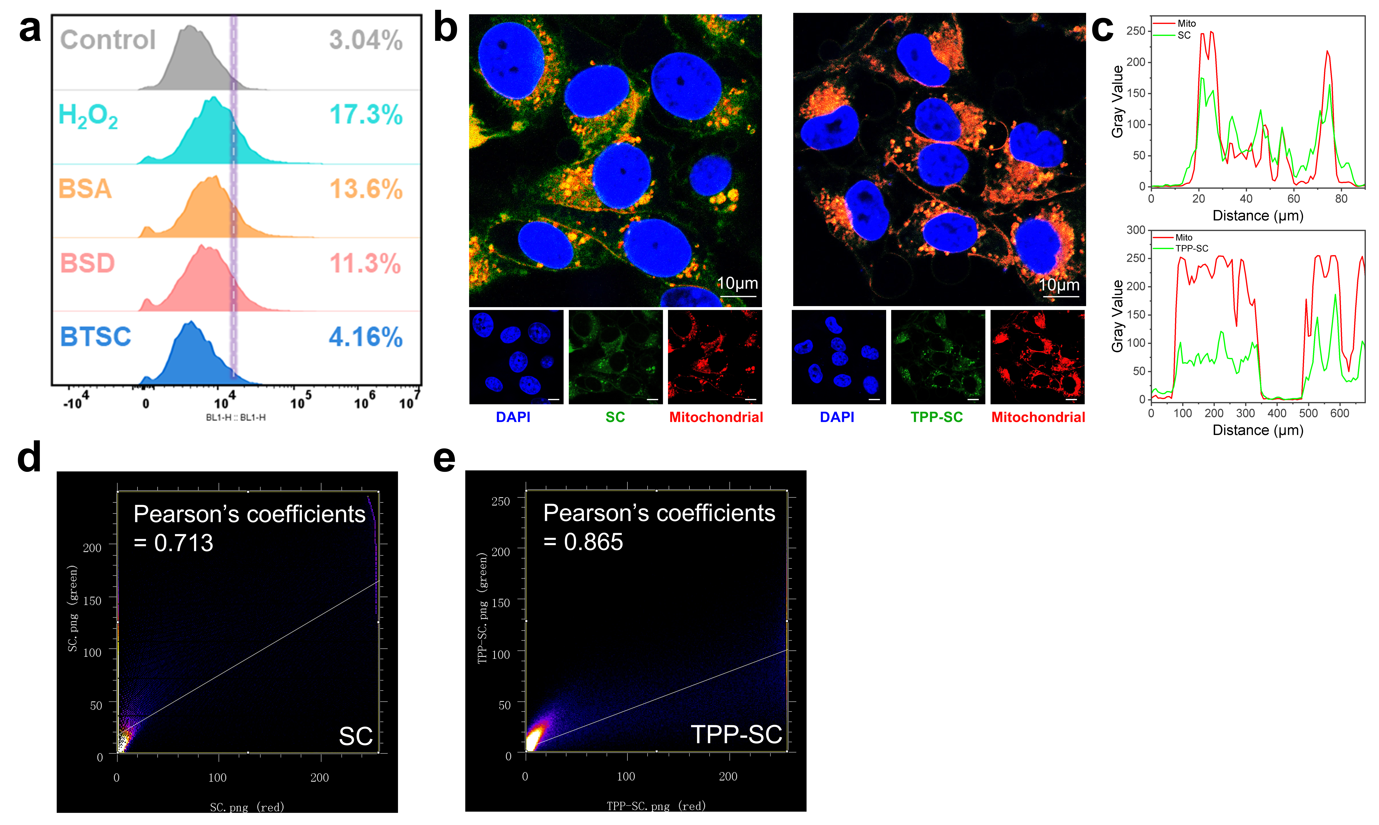
Figure S14. (a) Flow cytometry assessment of the effect of BTSCs on intracellular ROS clearance. Mitochondrial targeting of TPP-SC: (b) Fluorescence colocalization plot, (c) fluorescence colocalization curve. The mitochondrial colocalization of (d) SC and (e) TPP-SC was analyzed using the Colocalization Finder plugin in ImageJ.

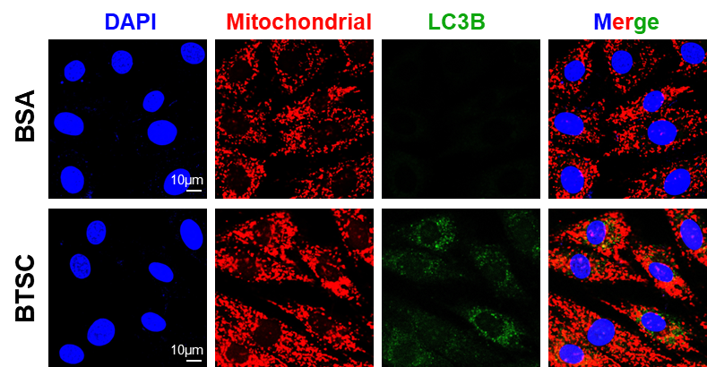
Figure S15. LC3B expression in fibroblasts after BTSC treatment.

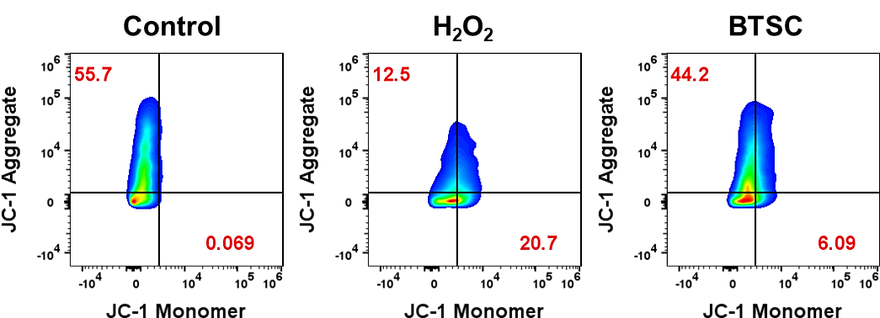
Figure S16. Flow cytometric analysis of JC-1-stained cells demonstrating that BTSC protects mitochondria from H₂O₂-induced oxidative damage.

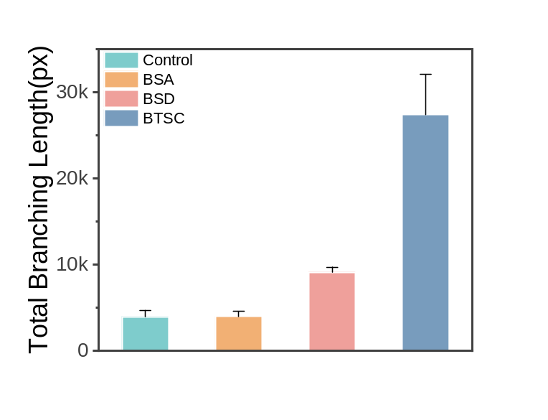
Figure S17. Quantitative analysis of the length of endothelial cell tube formation promoted by BTSC.

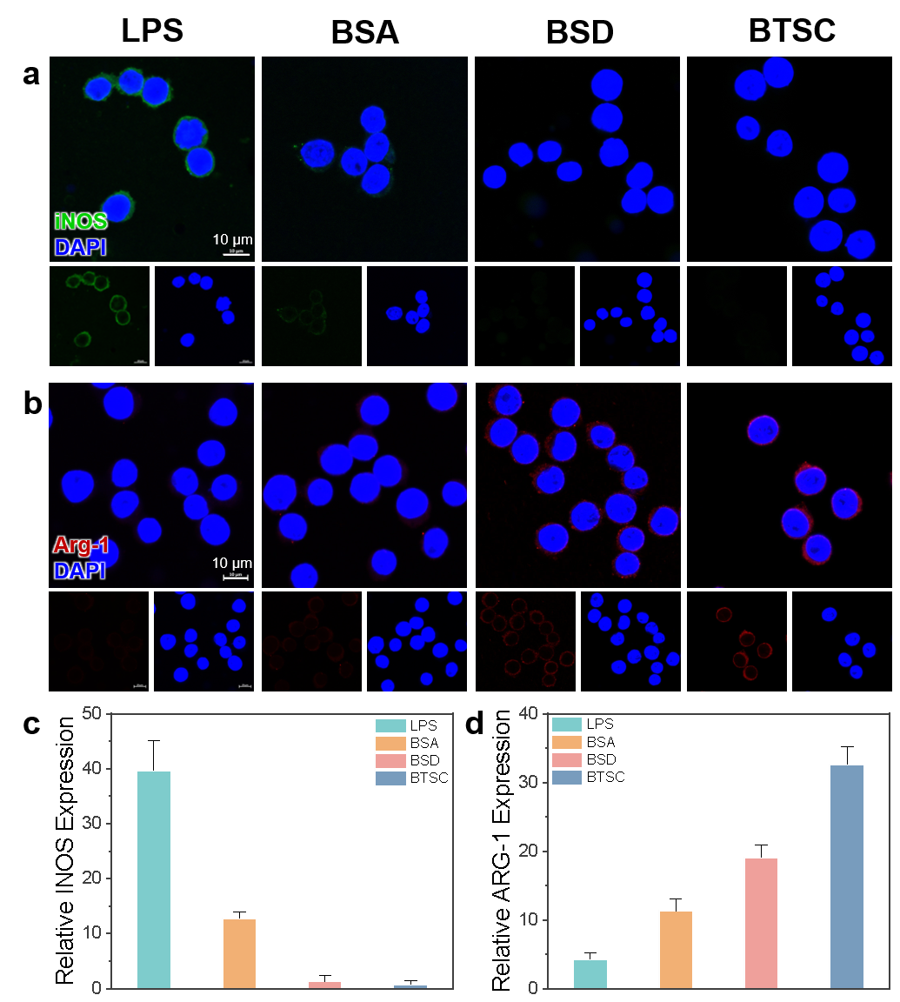
Figure S18. Macrophage expression of iNOS and ARG-1 after BTSC treatment. Immunofluorescence images of (a) M1 macrophage marker protein iNOS and (b) M2 macrophage marker protein ARG-1 in different treatment groups. Semi-quantitative analysis of the immunofluorescence intensity of (c) iNOS and (d) ARG-1 in different groups.

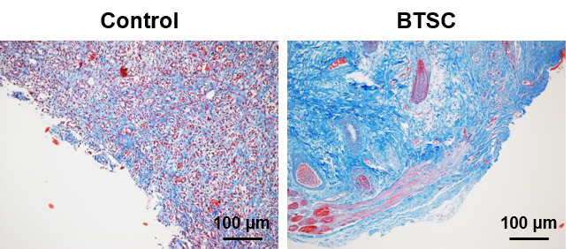
Figure S19. Masson staining images of skin wound tissue from different treatment groups.

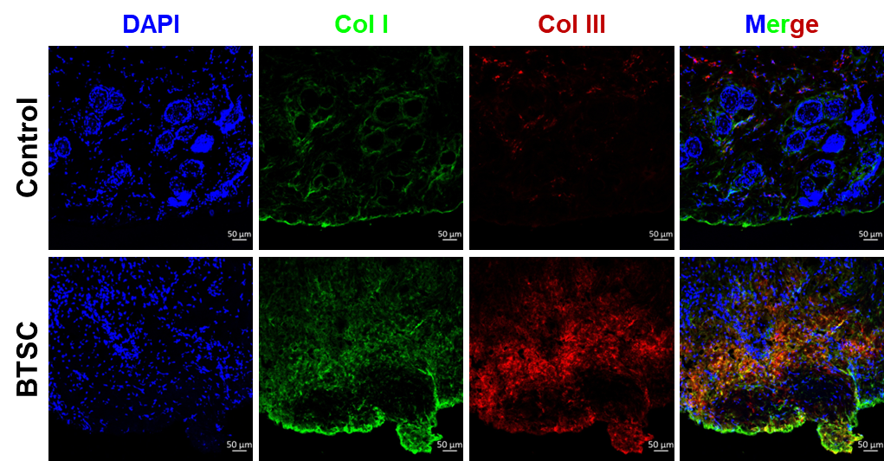
Figure S20. Immunofluorescence staining of collagen I and collagen III in skin wound tissues from different treatment groups.

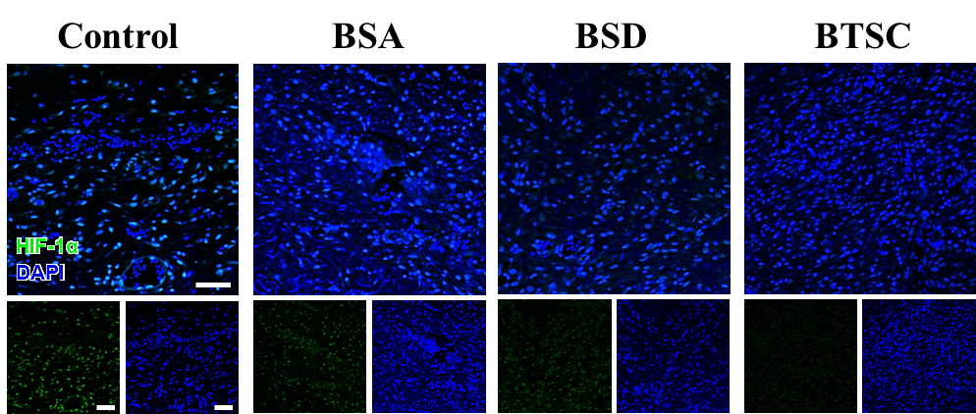
Figure S21. Immunofluorescence staining of HIF-1α in skin wound tissues from different treatment groups.

Figure S22. Wound enzyme activity and oxidative biomarkers after treatment with different BSA protein hydrogels: (a) CAT activity, (b) SOD activity, (c) MDA content. Data are presented as mean ± SD (n = 3). Statistical significance was determined by unpaired, two-tailed Student’s t-test. *p < 0.05, **p < 0.01, ***p < 0.001, ****p < 0.0001.

Figure S23 Representative fluorescence images of wound tissues stained with JC-1 at day 7 post-treatment in different treatment groups.

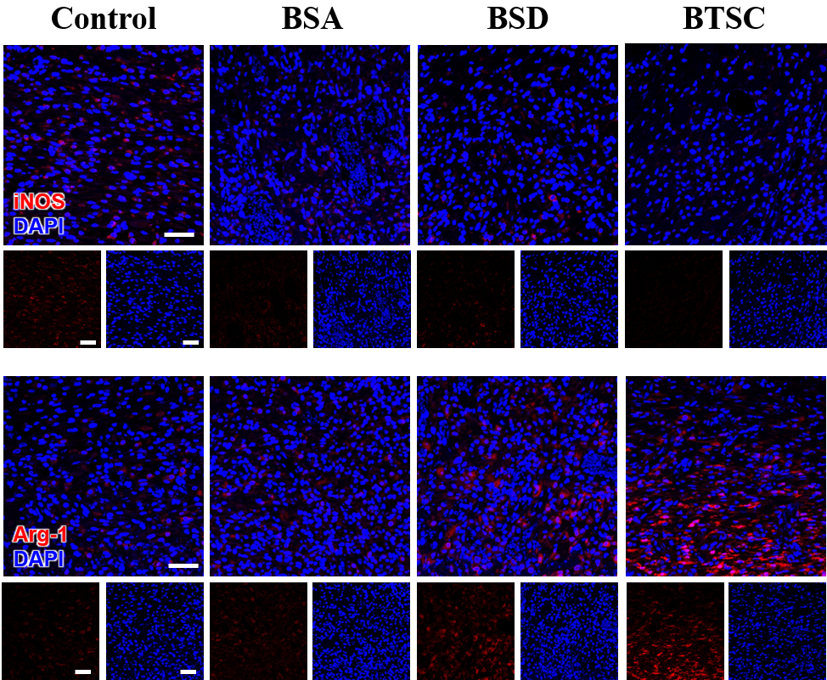
Figure S24. Immunofluorescence staining images of iNOS (M1 macrophage marker protein) and Arg-1 (M2 macrophage marker protein) in skin wound tissues from different treatment groups.

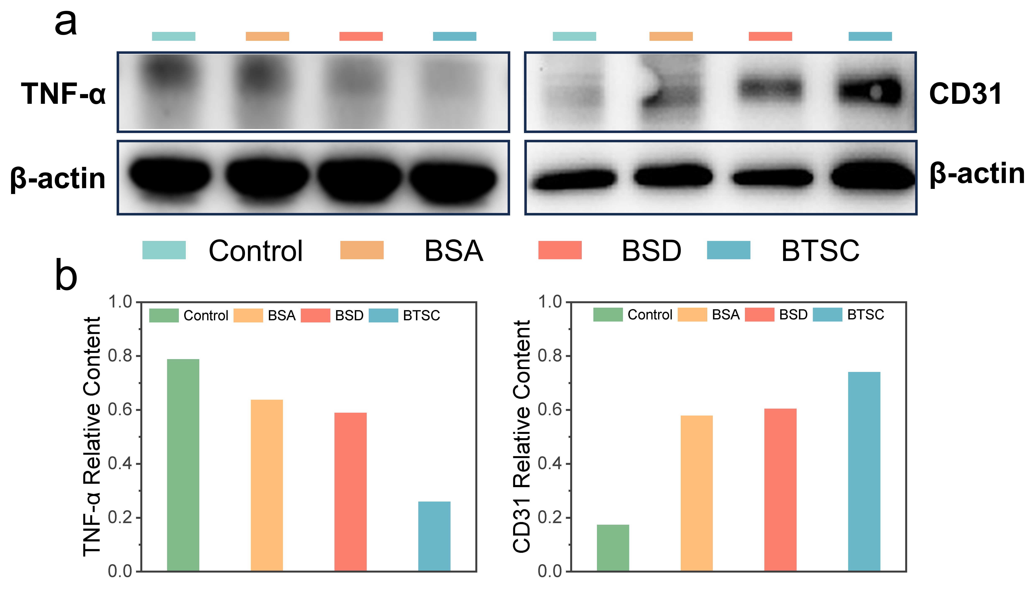
Figure S25 (a) Representative western blot images of TNF-α and CD31 in wound tissues from different treatment groups at day 14 post-treatment. (b) Densitometric quantification of TNF-α and CD31 protein bands in Fig R13a, normalized to the loading control.

Figure S26. (a) Images and (b) hemolysis rate of BTSC hemolytic reaction.

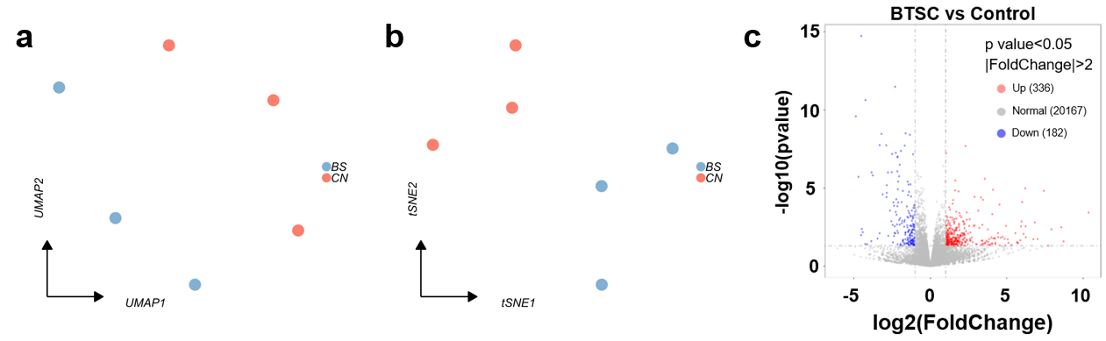
Figure S27. Clustering analysis of different dimensionality reduction methods was performed using CPM standardization methods: (a) UMAP and (b) t-SNE. (c) Histogram shows the number of genes that are upregulated (red) and downregulated (blue).

