Supporting Information

Ultrasound-Responsive ZnMo-Layered Double Hydroxide Nanosheets Induce PANoptosis for Sonodynamic Immunotherapy

Yu Yang^{1,2,†}, Tingting Hu^{3,†}, Yanfang Zhu⁴, Min Ge³, Linsen Zhan⁵, Zhichen Zhong⁶, Yi Yang⁴, Jing Wang², Hai Li⁶, Ruizheng Liang^{4,}*, Song Chen^{5,}*, Zhangping Li^{7,8,}*

†These authors contributed equally: Yu Yang and Tingting Hu

¹ Postdoctoral Research Station of Pharmacy, Hebei Medical University, Shijiazhuang 050017, P. R. China
² School of Pharmacy, National Key Laboratory of New Pharmaceutical Preparations and Excipients, Key Laboratory of Innovative Drug Development and Evaluation, Hebei Medical University, Shijiazhuang 050017, P. R. China
³ Department of Electrical Engineering & Department of Biomedical Engineering, City University of Hong Kong, Hong Kong SAR 999077, P. R. China.
⁴ State Key Laboratory of Chemical Resource Engineering, Beijing Advanced Innovation Center for Soft Matter Science and Engineering, Beijing University of Chemical Technology, Beijing 100029, P. R. China
⁵ Department of Orthopedics, The Quzhou Affiliated Hospital of Wenzhou Medical University, Quzhou People’s Hospital, Quzhou 324000, P. R. China
⁶ Key Laboratory of Flexible Electronics (KLOFE), Institute of Advanced Materials (IAM), Nanjing Tech University (NanjingTech), Nanjing 211816, P. R. China.
⁷ Department of Emergency Medicine, The Jinhua Affiliated Hospital of Wenzhou Medical University, Jinhua People’s Hospital, Zhejiang Jinhua 321000, P. R. China
⁸ Department of Emergency Medicine, The First Affiliated Hospital of Wenzhou Medical University, Zhejiang Wenzhou 325000, P. R. China

*Correspondence authors.
E-mail: liangrz@buct.edu.cn (R. Liang); chensong89@wmu.edu.cn (S. Chen); wzlzp@wmu.edu.cn (Z. Li)
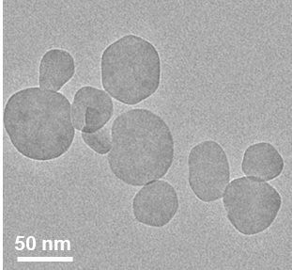
Figure S1. TEM characterization. TEM image of DR-ZnMo-LDH nanosheets.

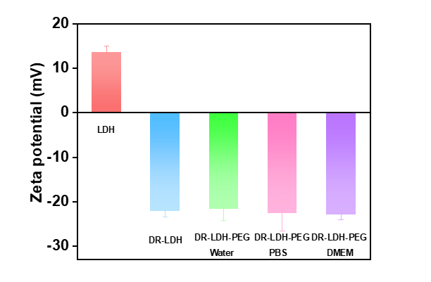
Figure S2. Zeta potentials characterization. Zeta potentials of ZnMo-LDH, DR-ZnMo-LDH and DR-ZnMo-LDH-PEG in different media (water, PBS, DMEM). Data are presented as mean values ± s.d. (n = 3).

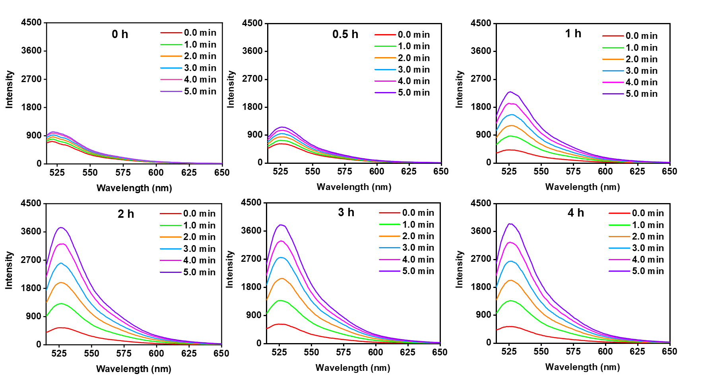
Figure S3. Detection of ROS via SOSG assay. Fluorescence spectra of SOSG treated with DR-ZnMo-LDH subjected to different etching times (0, 0.5, 1, 2, 3, 4 h).

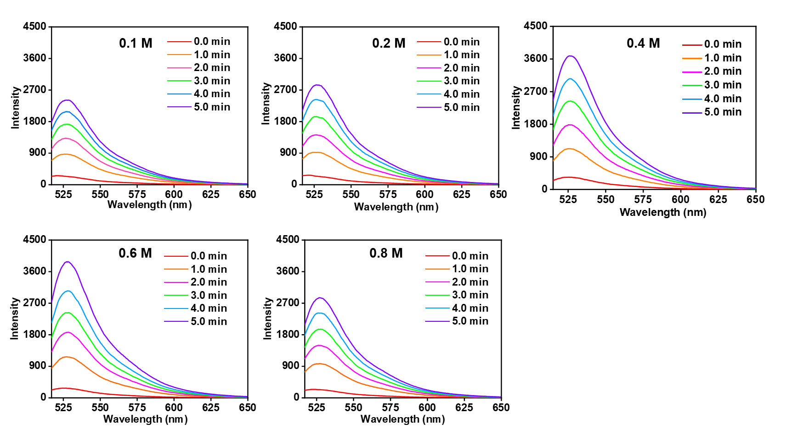
Figure S4. Detection of ROS via SOSG assay. Fluorescence spectra of SOSG treated with DR-ZnMo-LDH etched with different alkali concentrations (0.1, 0.2, 0.4, 0.6, 0.8 M NaOH).

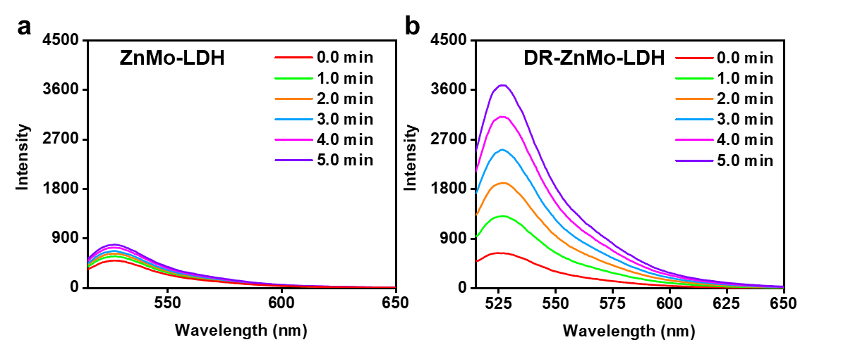
Figure S5. Detection of ROS via SOSG assay. Fluorescence spectra of SOSG treated with (a) ZnMo-LDH and (b) DR-ZnMo-LDH under US irradiation.

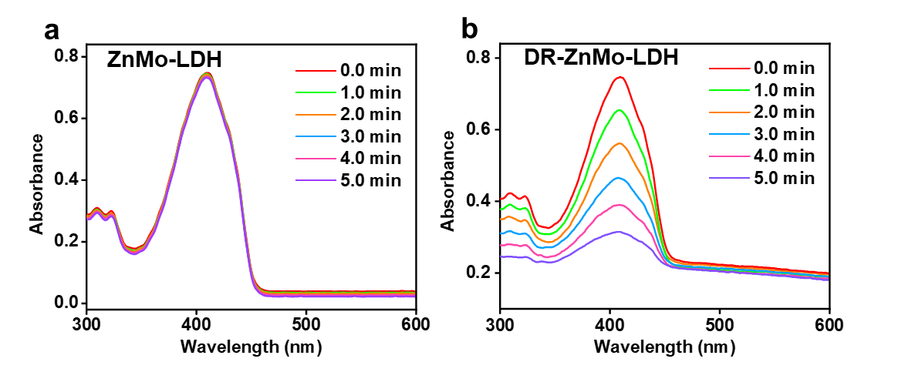
Figure S6. Detection of ROS via DPBF assay. UV–vis absorption spectra of DPBF treated with (a) ZnMo-LDH and (b) DR-ZnMo-LDH under US irradiation.

Table S1. Elemental content in ZnMo-LDH and DR-ZnMo-LDH.
Materials | Zn (W%) | Mo (W%)
ZnMo-LDH | 80.2% | 26.8%
DR-ZnMo-LDH | 59.6% | 20.3%

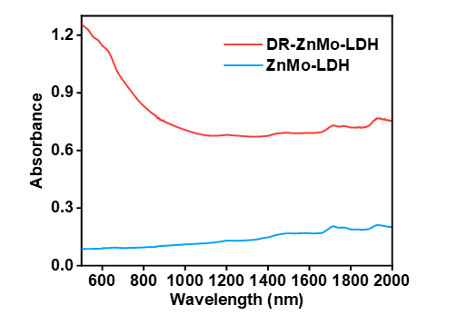
Figure S7. UV–vis–NIR diffuse reflection characterization. UV–vis–NIR diffuse reflectance spectra of the ZnMo-LDH and DR-ZnMo-LDH nanosheets.

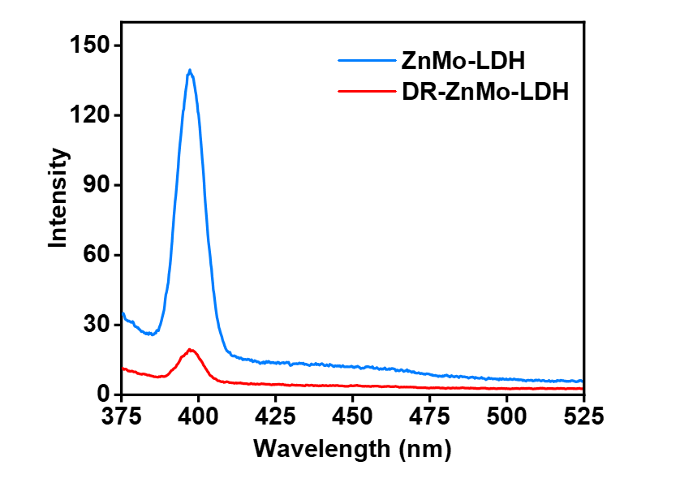
Figure S8. PL emission spectra of ZnMo-LDH and DR-ZnMo-LDH.

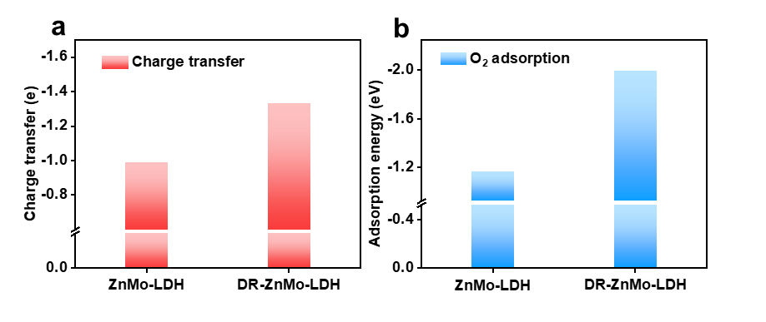
Figure S9. (a) Charge transfer and (b) adsorption energies of O₂ on ZnMo-LDH and DR-ZnMo-LDH.

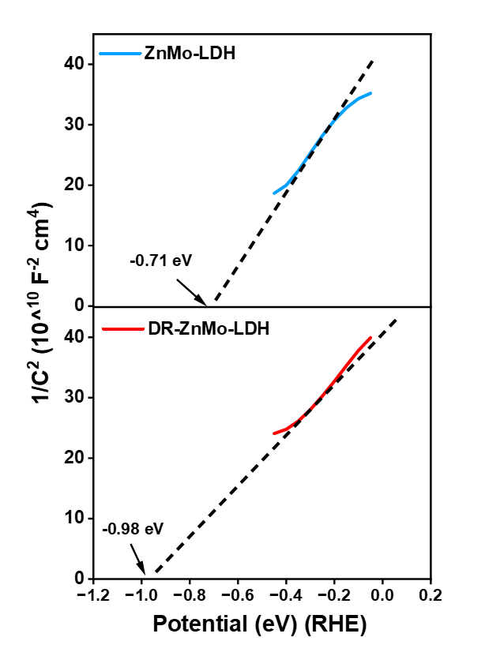
Figure S10. Mott-Schottky plots of the ZnMo-LDH and DR-ZnMo-LDH nanosheets.

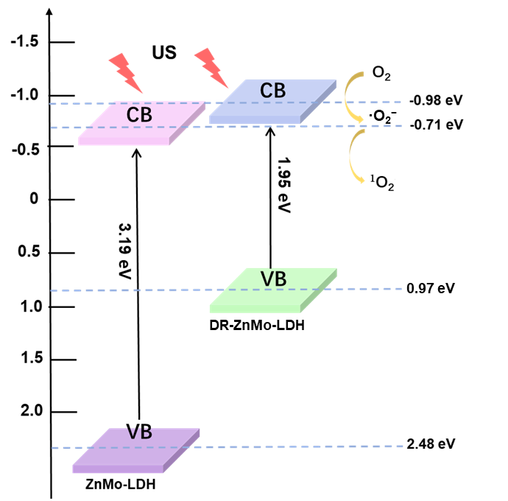
Figure S11. Band diagrams. The band structures of ZnMo-LDH and DR-ZnMo-LDH nanosheets.

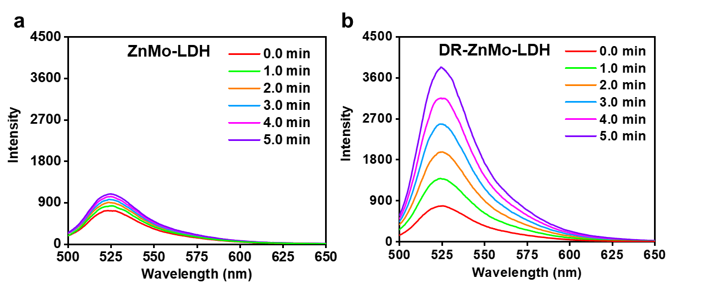
Figure S12. Detection of ROS via DHR 123 assay. Fluorescence spectra of DHR 123 treated with (a) ZnMo-LDH and (b) DR-ZnMo-LDH under US irradiation.

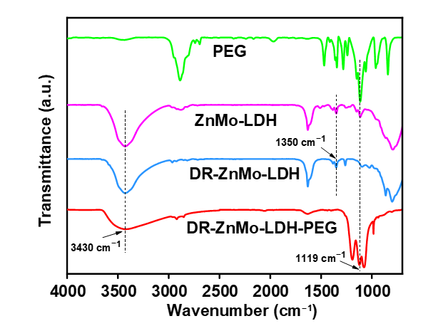
Figure S13. FT-IR characterization. FT-IR spectra of PEG, ZnMo-LDH, DR-ZnMo-LDH, and DR-ZnMo-LDH-PEG.

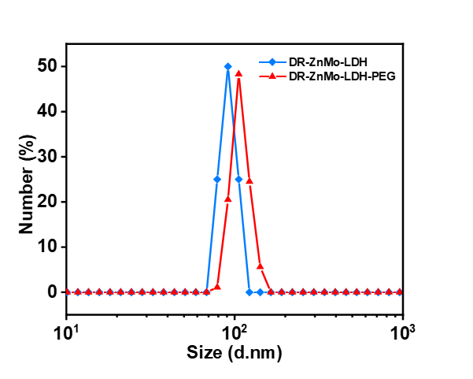
Figure S14. DLS characterization. Size distribution of DR-ZnMo-LDH and DR-ZnMo-LDH-PEG nanosheets.

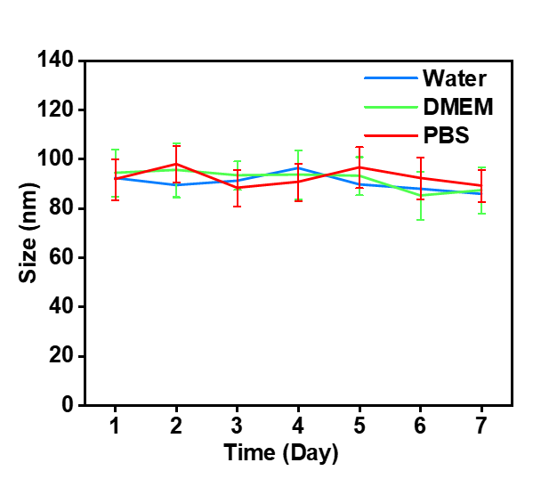
Figure S15. DLS characterization. Stability tests of the DR-ZnMo-LDH-PEG nanosheets in different media (water, DMEM and PBS) by monitoring their particle sizes for 7 days. Data are presented as mean values ± s.d. (n = 3).

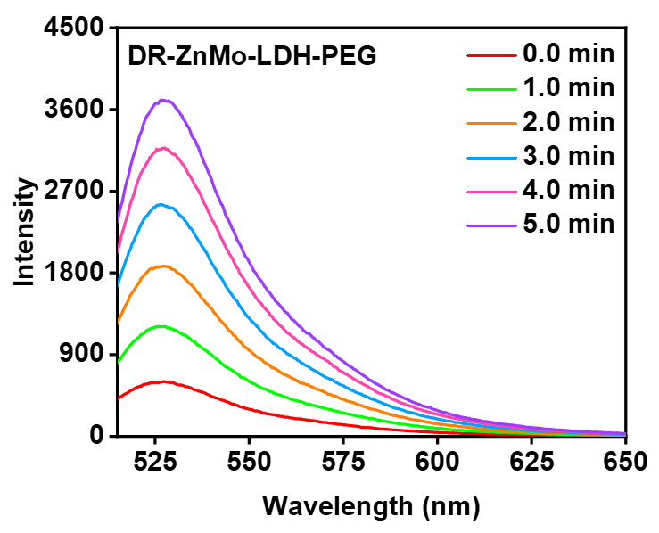
Figure S16. Fluorescence spectra of SOSG in the presence of DR-ZnMo-LDH-PEG nanosheets under US irradiation.

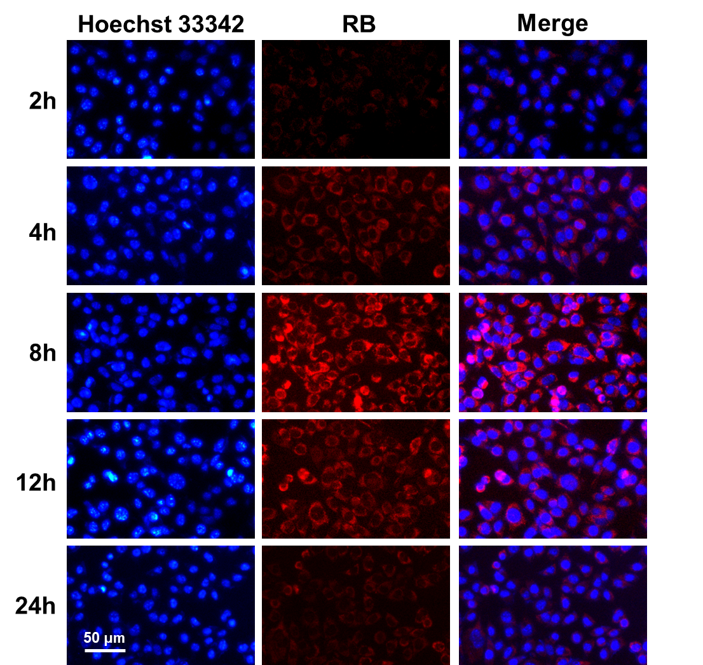
Figure S17. Cellular uptake of DR-ZnMo-LDH-PEG. Fluorescence images of 4T1 cells for analysis of intracellular uptake of RB-labeled DR-ZnMo-LDH-PEG nanosheets at varying incubation times.

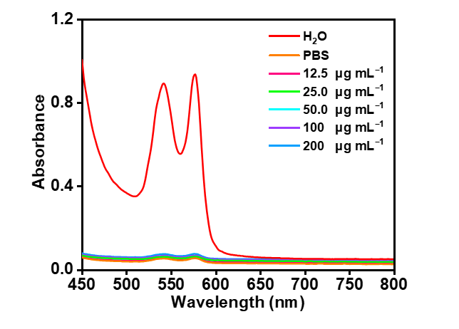
Figure S18. Hemolysis effect of red blood cells incubated with DR-ZnMo-LDH-PEG at different concentrations (12.5, 25, 50, 100, 200 μg mL⁻¹).

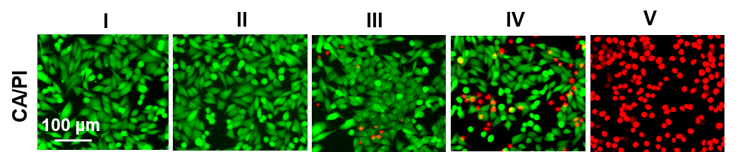
Figure S19. CA/PI staining of 4T1 cells in different treatment groups: I) control, II) US, III) DR-LDH, IV) LDH + US, V) DR-LDH + US.

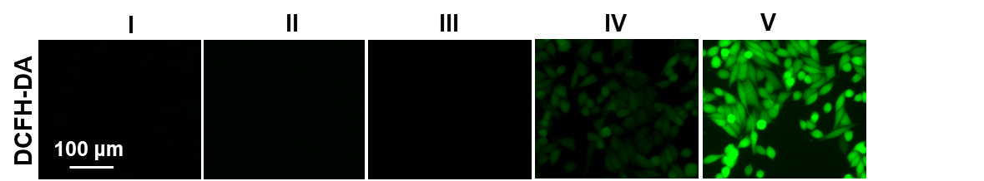
Figure S20. Analysis of ROS levels on 4T1 cells. DCFH-DA staining of 4T1 cells in different treatment groups: I) control, II) US, III) DR-LDH, IV) LDH + US, V) DR-LDH + US.

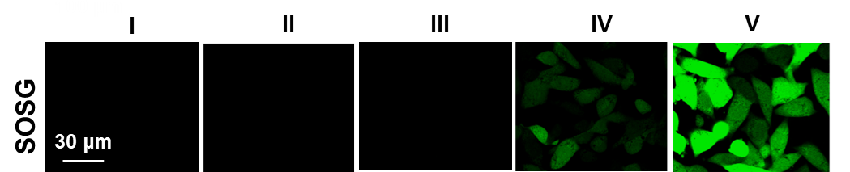
Figure S21. Analysis of ¹O₂ levels on 4T1 cells. SOSG staining of 4T1 cells in different treatment groups: I) control, II) US, III) DR-LDH, IV) LDH + US, V) DR-LDH + US.

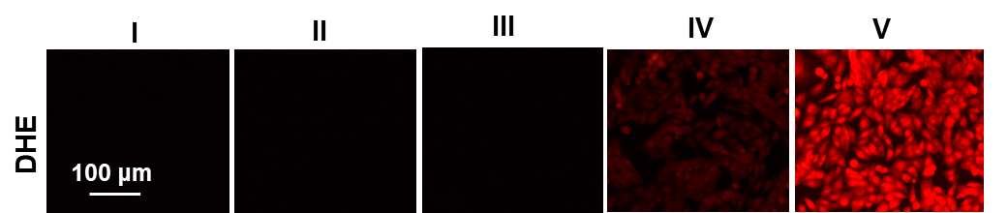
Figure S22. Analysis of ·O₂⁻ levels on 4T1 cells. DHE staining of 4T1 cells in different treatment groups: I) control, II) US, III) DR-LDH, IV) LDH + US, V) DR-LDH + US.

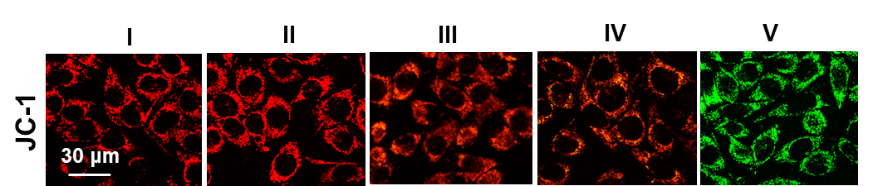
Figure S23. JC-1 staining of 4T1 cells in different treatment groups: I) control, II) US, III) DR-LDH, IV) LDH + US, V) DR-LDH + US.

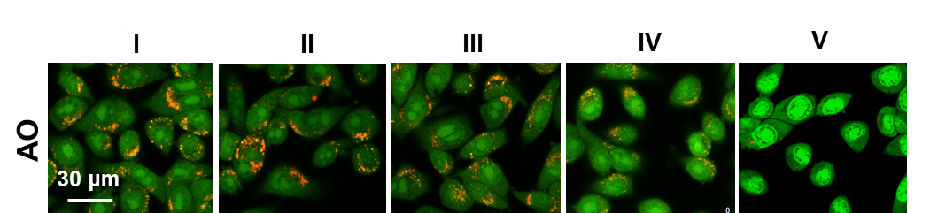
Figure S24. AO staining of 4T1 cells in different treatment groups: I) control, II) US, III) DR-LDH, IV) LDH + US, V) DR-LDH + US.

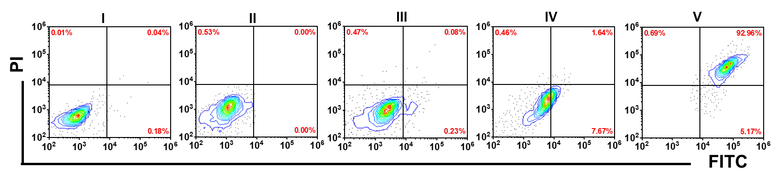
Figure S25. Flow cytometry analysis of 4T1 cells in different treatment groups: I) control, II) US, III) DR-LDH, IV) LDH + US, V) DR-LDH + US.

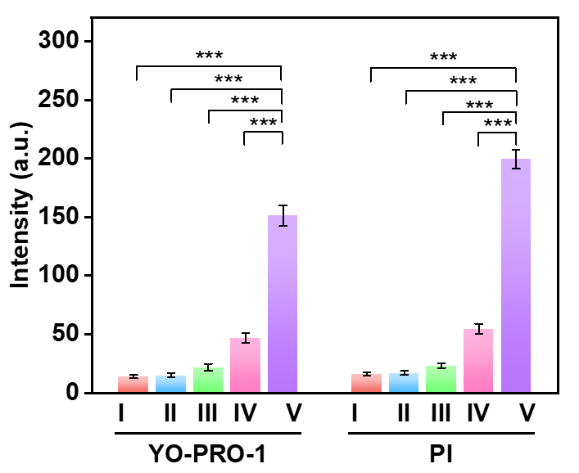
Figure S26. Quantitative analysis of YP1-PI staining of 4T1 cells in different treatment groups. Statistical analysis was performed via one-way ANOVA. ***p < 0.001.

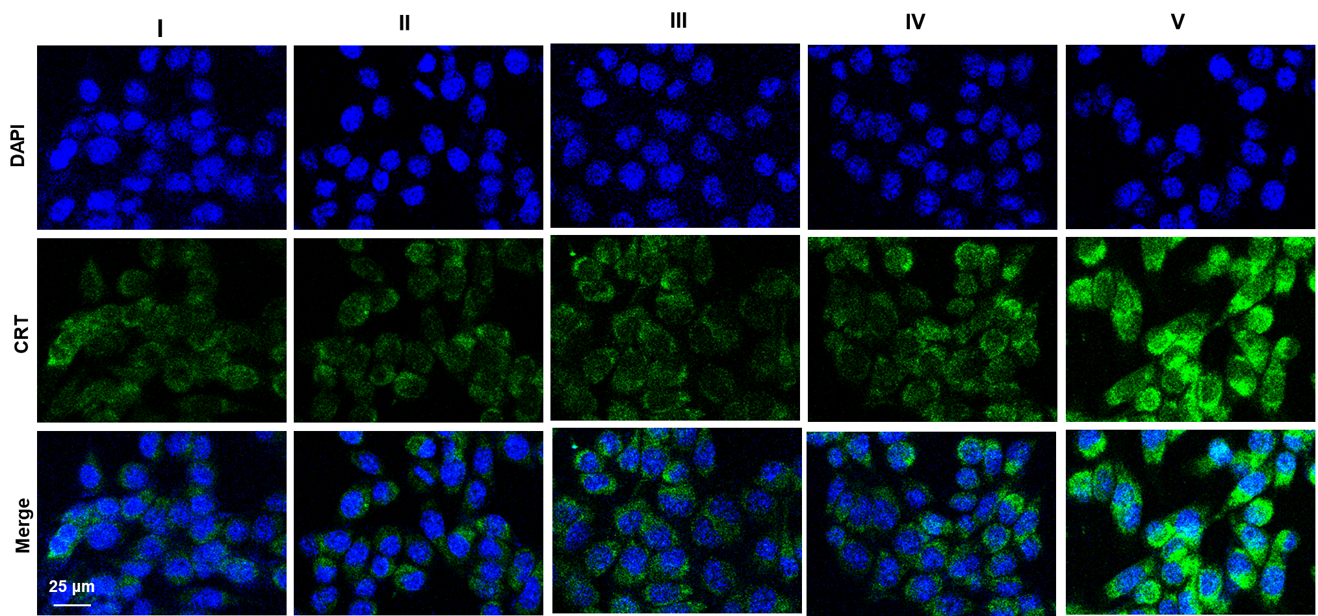
Figure S27. CRT staining of 4T1 cells in different treatment groups: I) control, II) US, III) DR-LDH, IV) LDH + US, V) DR-LDH + US.

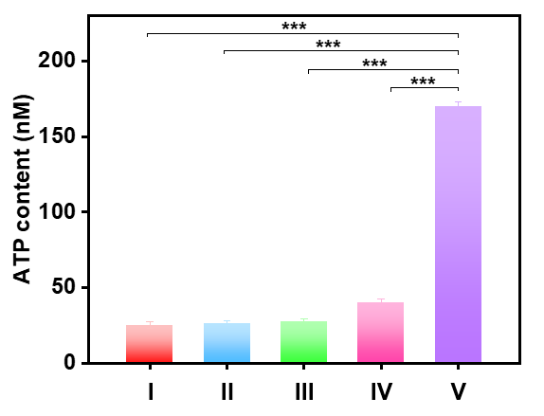
Figure S28. ATP release after different treatments: I) control, II) US, III) DR-LDH, IV) LDH + US, V) DR-LDH + US. Data are presented as mean values ± s.d. (n = 3). Statistical analysis was performed via one-way ANOVA. ***p < 0.001.

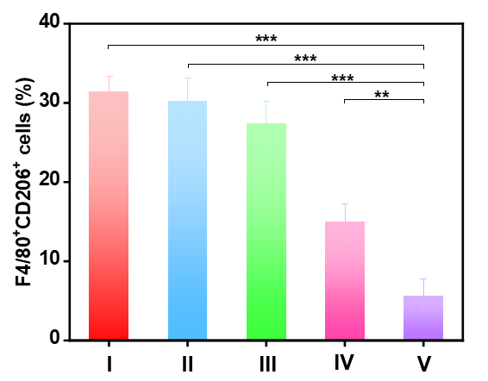
Figure S29. The quantification of TAM-M2 (CD206⁺CD11b⁺F4/80⁺) cells in different treatment groups: I) control, II) US, III) DR-LDH, IV) LDH + US, V) DR-LDH + US. Data are presented as mean values ± s.d. (n = 3). Statistical analysis was performed via one-way ANOVA. **p < 0.01 and ***p < 0.001.

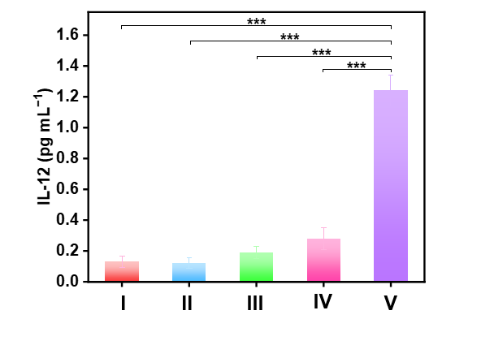
Figure S30. The quantitative analysis of IL-12 levels in the peripheral blood serum on day 3 after various treatments: I) control, II) US, III) DR-LDH, IV) LDH + US, V) DR-LDH + US. Data are presented as mean values ± s.d. (n = 3). Statistical analysis was performed via one-way ANOVA. ***p < 0.001.

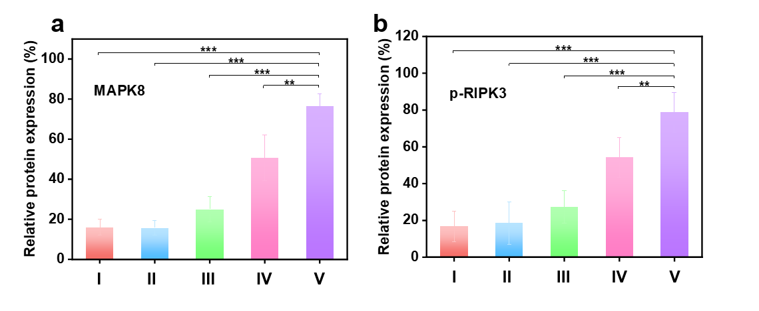
Figure S31. The quantitative analysis of (a) MAPK8 and (b) p-RIPK3 protein levels in 4T1 cells after different treatments: I) control, II) US, III) DR-LDH, IV) LDH + US, V) DR-LDH + US. Data are presented as mean values ± s.d. (n = 3). Statistical analysis was performed via one-way ANOVA. **p < 0.01 and ***p < 0.001.

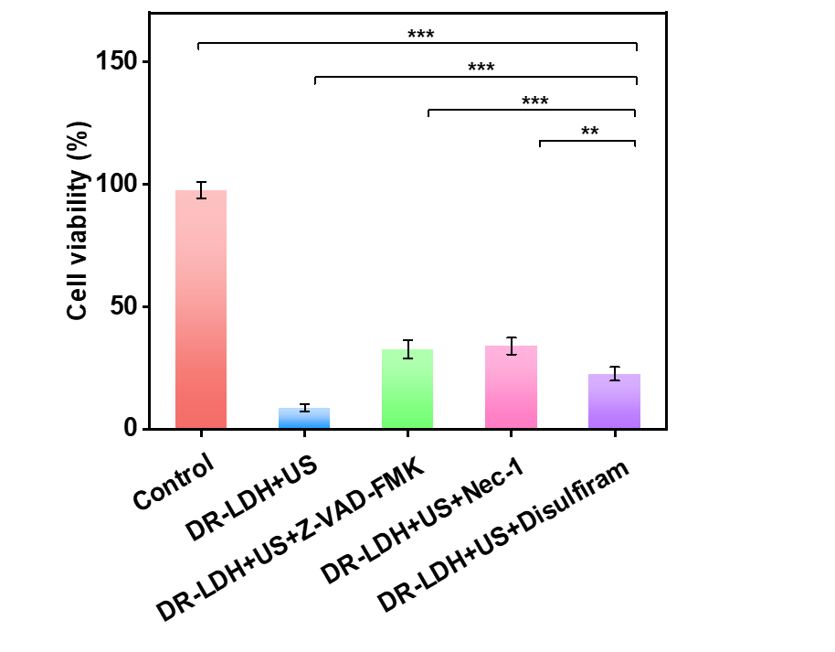
Figure S32. Relative cell viabilities after various treatments: Control, DR-LDH + US (40 kHz, 0.17 W cm⁻², 5 min), DR-LDH + US + Z-VAD-FMK, DR-LDH + US + necrostatin-1, and DR-LDH + US + disulfiram. Data are presented as mean values ± s.d. (n = 3). Statistical analysis was performed via one-way ANOVA. **p < 0.01 and ***p < 0.001.

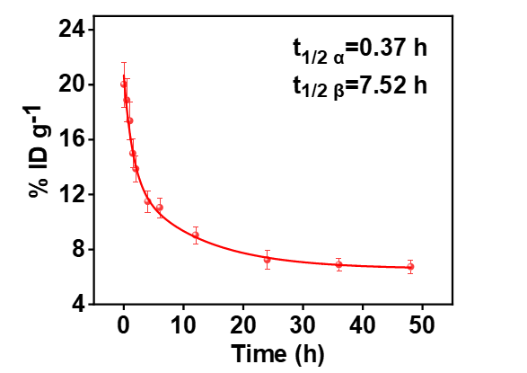
Figure S33. Blood circulation time of the DR-ZnMo-LDH-PEG in mice after intravenous injection. Data are presented as mean values ± s.d. (n = 3).

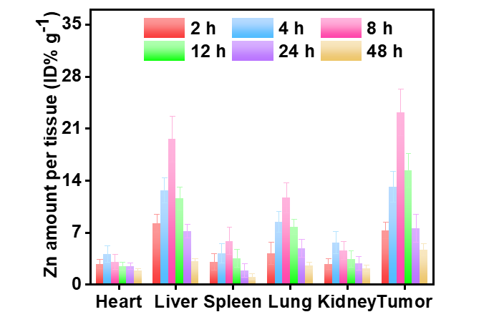
Figure S34. Biodistribution of the DR-ZnMo-LDH-PEG in mice after intravenous injection. Data are presented as mean values ± s.d. (n = 3).

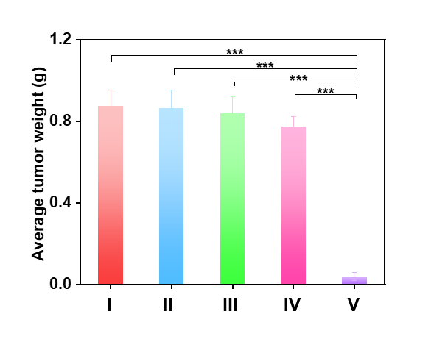
Figure S35. Tumor weight of mice from different treatment groups: I) control, II) US, III) DR-LDH, IV) LDH + US, V) DR-LDH + US. Data are presented as mean values ± s.d. (n = 6). Statistical analysis was performed via one-way ANOVA. ***p < 0.001.

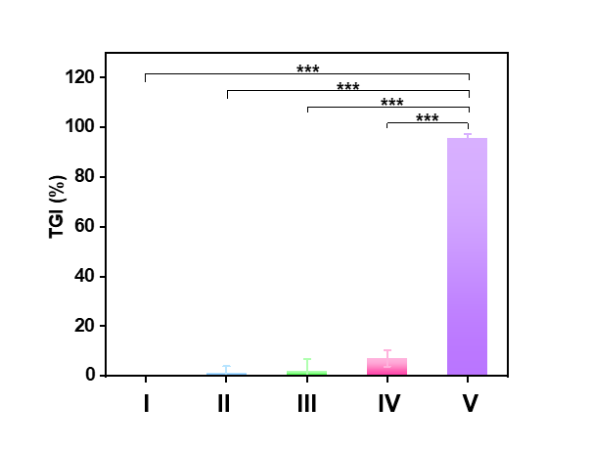
Figure S36. Tumor inhibition rates of mice from different treatment groups: I) control, II) US, III) DR-LDH, IV) LDH + US, V) DR-LDH + US. Data are presented as mean values ± s.d. (n = 6). Statistical analysis was performed via one-way ANOVA. ***p < 0.001.

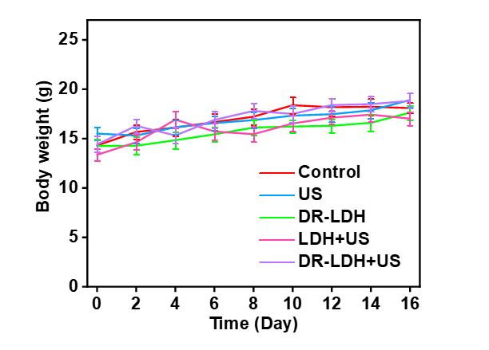
Figure S37. Body weights of mice from different treatment groups. Data are presented as mean values ± s.d. (n = 6).

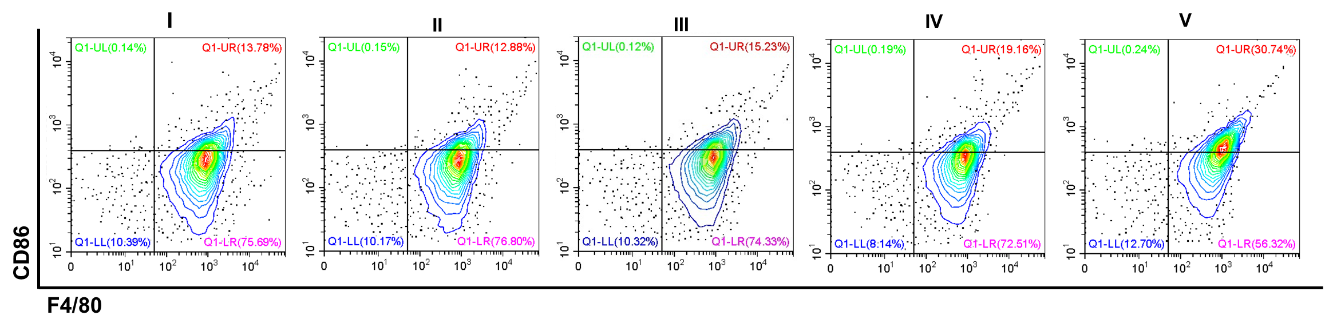
Figure S38. Representative flow cytometric analysis of TAM-M1 (CD86⁺CD11b⁺F4/80⁺) cells in different treatment groups: I) control, II) US, III) DR-LDH, IV) LDH + US, V) DR-LDH + US.

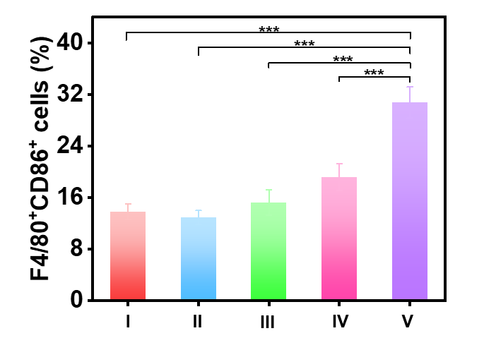
Figure S39. Quantitative analysis of TAM-M1 (CD86⁺CD11b⁺F4/80⁺) cells in different treatment groups: I) control, II) US, III) DR-LDH, IV) LDH + US, V) DR-LDH + US. Data are presented as mean values ± s.d. (n = 3). Statistical analysis was performed via one-way ANOVA. ***p < 0.001.

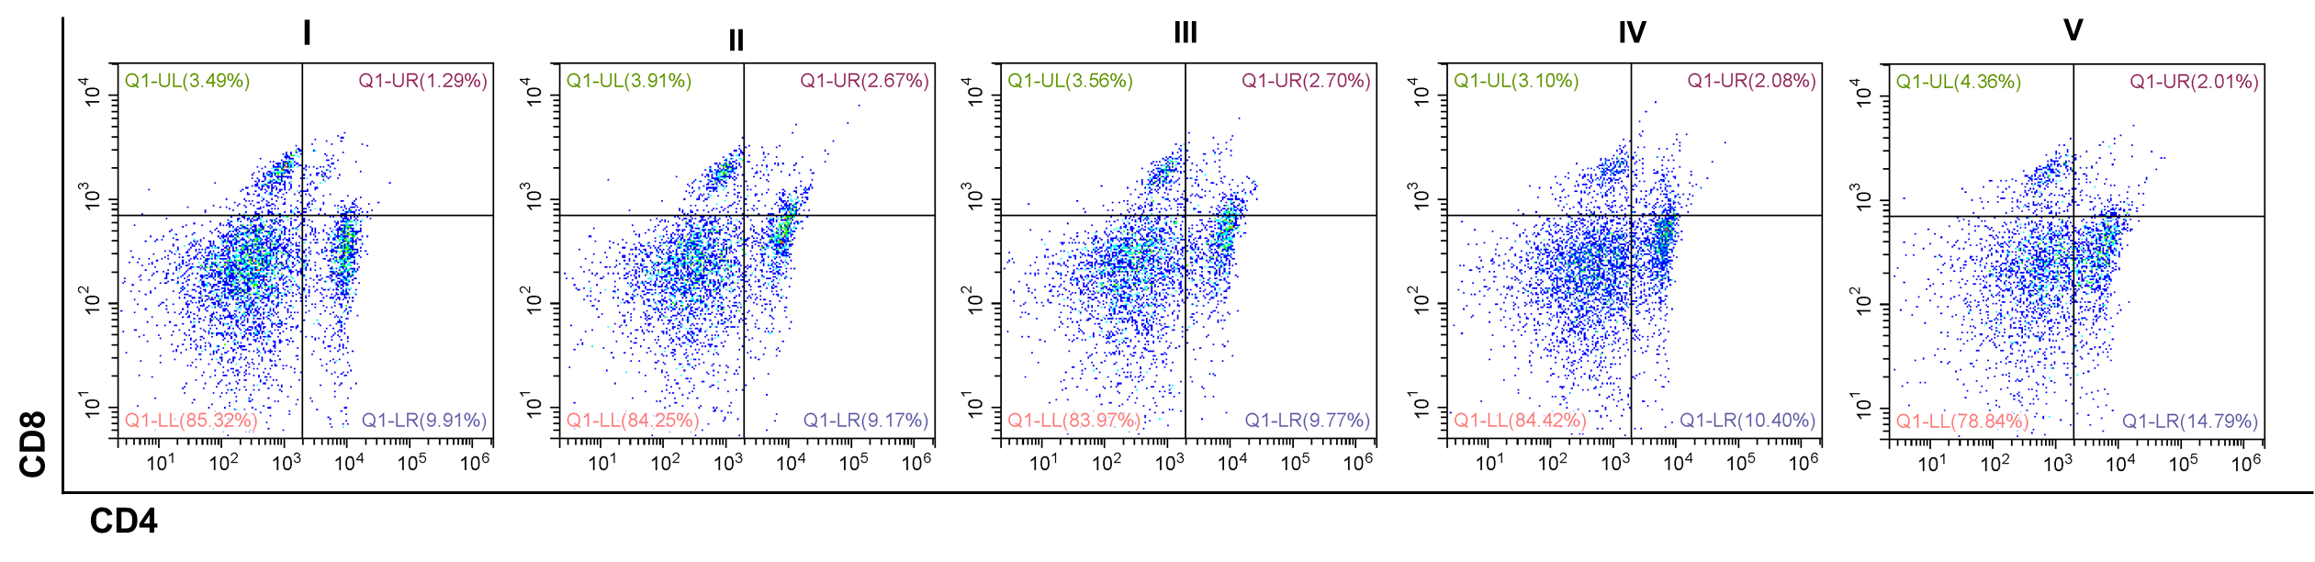
Figure S40. Representative flow cytometry analysis of CD4⁺ T cells in spleen tissues after different treatments: I) control, II) US, III) DR-LDH, IV) LDH + US, V) DR-LDH + US.

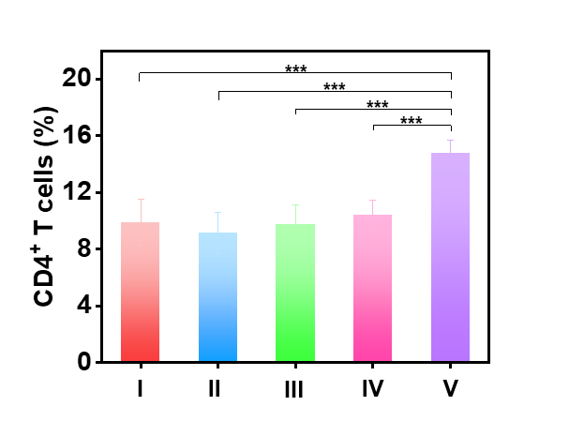
Figure S41. The corresponding percentages of CD4⁺ T cells (CD3⁺CD4⁺) in spleen tissues after different treatments: I) control, II) US, III) DR-LDH, IV) LDH + US, V) DR-LDH + US. Data are presented as mean values ± s.d. (n = 3). Statistical analysis was performed via one-way ANOVA. ***p < 0.001.

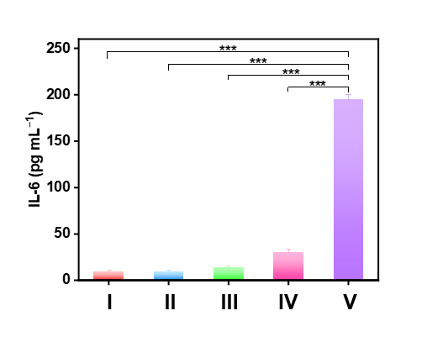
Figure S42. IL-6 levels in the peripheral blood serum on day 3 after different treatments: I) control, II) US, III) DR-LDH, IV) LDH + US, V) DR-LDH + US. Data are presented as mean values ± s.d. (n = 3). Statistical analysis was performed via one-way ANOVA. ***p < 0.001.

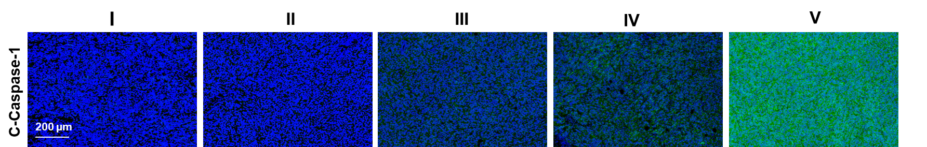
Figure S43. Representative staining images of C-Caspase-1 in tumor tissues after different treatments: I) control, II) US, III) DR-LDH, IV) LDH + US, V) DR-LDH + US.

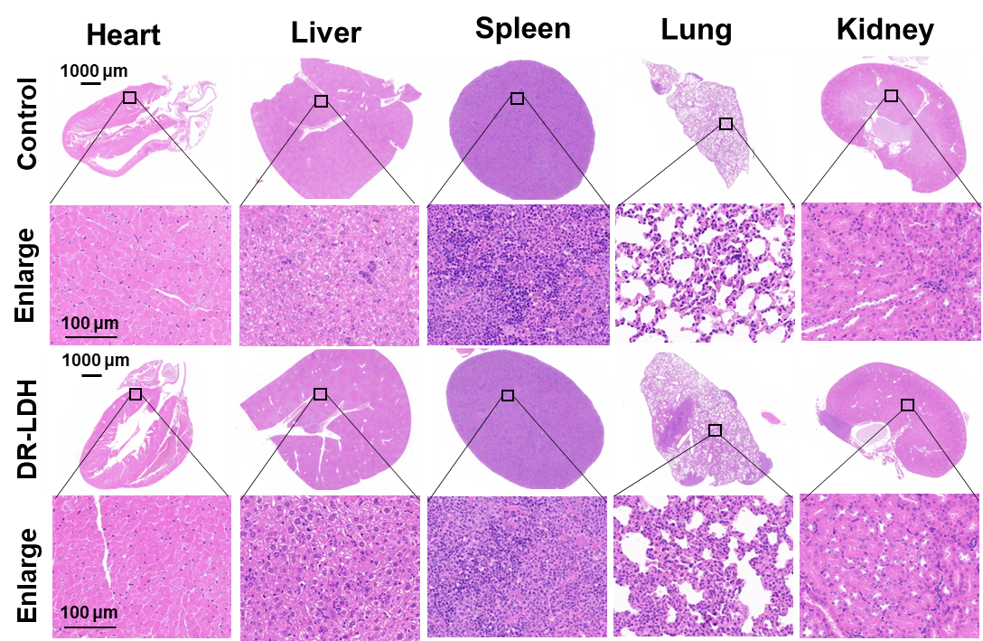
Figure S44. H&E staining analysis of major organs (heart, liver, spleen, lung, kidney) from different treatment groups.

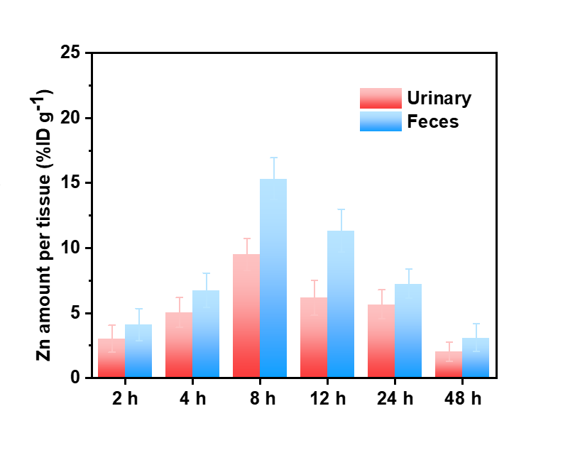
Figure S45. Metabolic behavior evaluation of DR-ZnMo-LDH-PEG. Metabolic behavior analysis of DR-ZnMo-LDH-PEG nanosheets. Data are presented as mean values ± s.d. (n = 3).

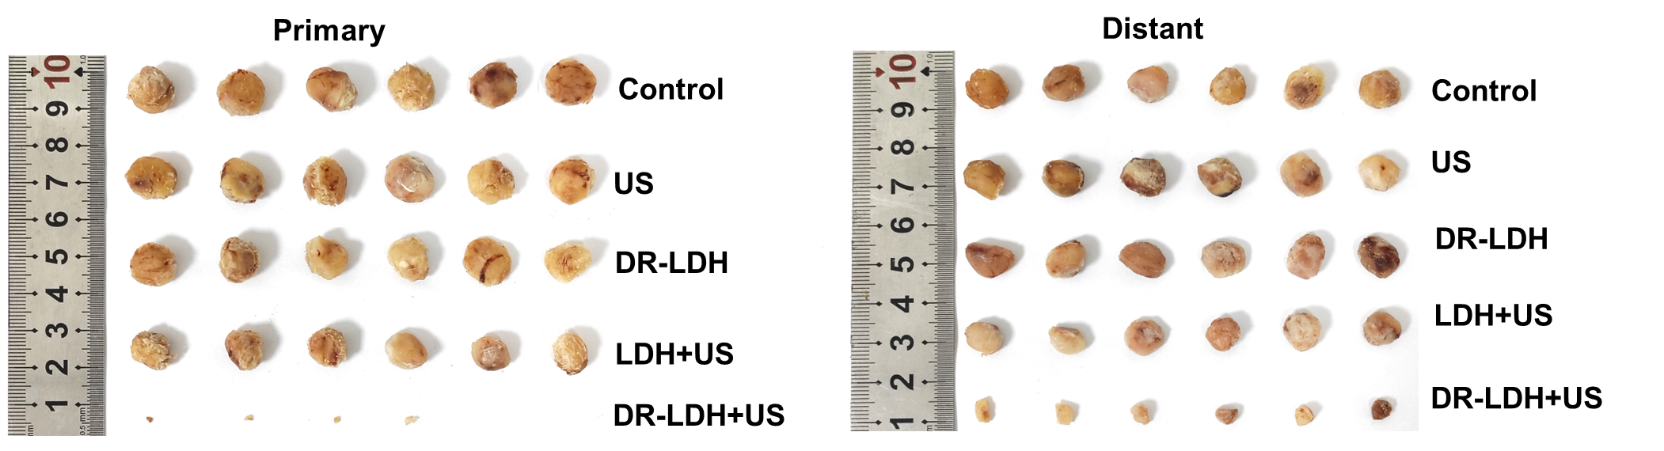
Figure S46. Photos of primary and distant tumors collected from different groups on day 16.

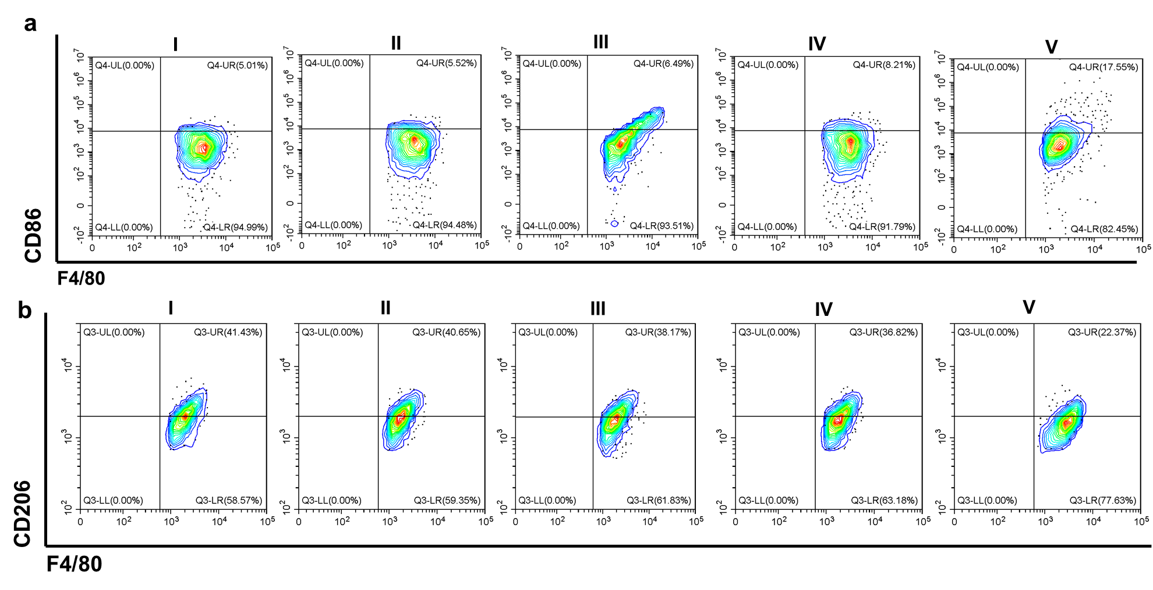
Figure S47. Representative flow cytometric analysis of (a) TAM-M1 (CD86⁺CD11b⁺F4/80⁺) and (b) TAM-M2 (CD206⁺CD11b⁺F4/80⁺) cells in different treatment groups: I) control, II) US, III) DR-LDH, IV) LDH + US, V) DR-LDH + US.

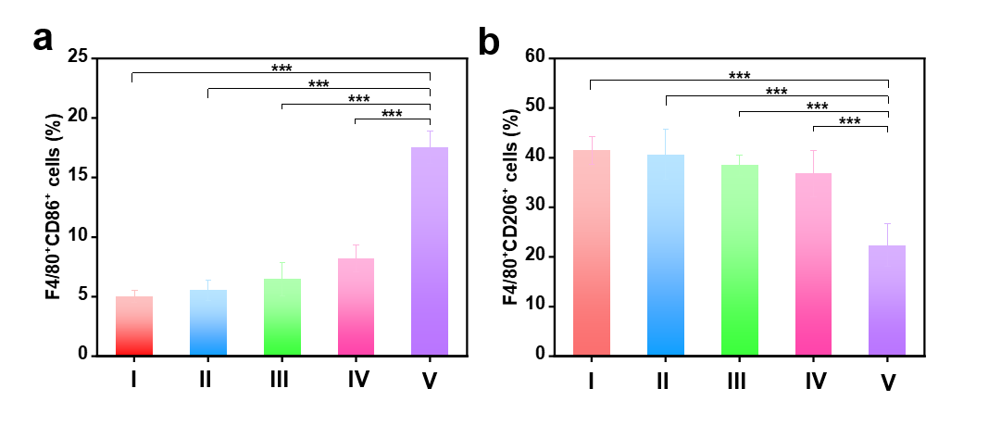
Figure S48. The quantification of (a) TAM-M1 (CD86⁺CD11b⁺F4/80⁺) and (b) TAM-M2 (CD206⁺CD11b⁺F4/80⁺) cells in different treatment groups: I) control, II) US, III) DR-LDH, IV) LDH + US, V) DR-LDH + US. Data are presented as mean values ± s.d. (n = 3). Statistical analysis was performed via one-way ANOVA. ***p < 0.001.

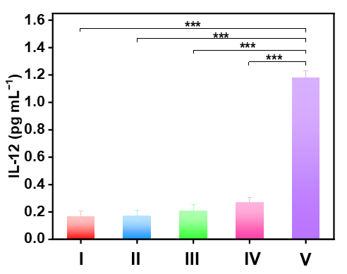
Figure S49. Profiles of IL-12 levels in the peripheral blood serum on day 3 after different treatments: I) control, II) US, III) DR-LDH, IV) LDH + US, V) DR-LDH + US. Data are presented as mean values ± s.d. (n = 3). Statistical analysis was performed via one-way ANOVA. ***p < 0.001.

