Cerium-Polyphenol Network Protects Against AMD-Associated RPE Degeneration via Blood-Retinal Barrier Immunomodulation

Xiaoxin Yang^{2,3,4}, Yu Wen⁹, Tiancheng Xie¹⁰, Yueru Jia^{5,6}, Yushu Xie⁴, Donghui Li^{6,11}, Xin Peng⁶, Chang Li^{1,7*}, Yini Wang^{5,6*}, Qichang Wang^{5,6,8*}, Jun Liu^{1*}

1. Department of Radiology, Second Xiangya Hospital, Central South University, 139 Renmin Middle Road, Changsha, 410011, Hunan Province, China
2. Department of Dermatology, Xiangya Hospital, Central South University, 87 Xiangya Road, Changsha, 410008, Hunan Province, China
3. Hunan Key Laboratory of Skin Cancer and Psoriasis, Hunan Engineering Research Center of Skin Health and Disease, Xiangya Hospital, Central South University, 87 Xiangya Road, Changsha, 410008, Hunan Province, China
4. National Clinical Research Center for Geriatric Disorders, Xiangya Hospital, 87 Xiangya Road, Changsha, 410008, Hunan Province, China
5. Aier Academy of Ophthalmology, Central South University, No.188, Furong South Road, Changsha, 410004, Hunan Province, China
6. Changsha Xiangjiang Aier Eye Hospital, Changsha, 410014, Hunan Province, China
7. Department of Medical Ultrasound, Hunan Cancer Hospital/The Affiliated Cancer Hospital of Xiangya School of Medicine, Central South University, Changsha, 410013, Hunan Province, China
8. Changsha Aier Eye Hospital, Changsha, 410015, Hunan Province, China
9. Furong Laboratory, Central South University, Changsha, 410008, Hunan Province, China
10. Xiangya School of Medicine, Central South University, Changsha, 410000, Hunan Province, China
11. Aier Eye Hospital, Jinan University, No.191, Huanshi Middle Road, Guangzhou, 510071, Guangdong Province, China

*Corresponding author: Chang Li (18051063324@163.com); Yini Wang (irenewyn@163.com); Qichang Wang (wqc1115@sina.com); Jun Liu (junliu123@csu.edu.cn)

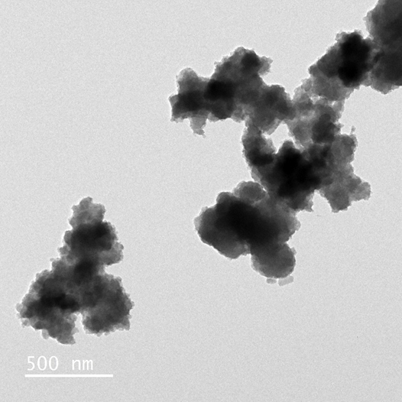
Figure S1. TEM image of CR.

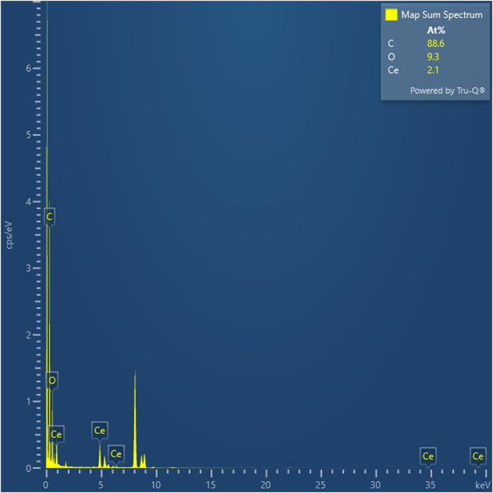
Figure S2. The composition of material was characterized by element mapping and Energy Dispersive Spectroscopy (EDS).

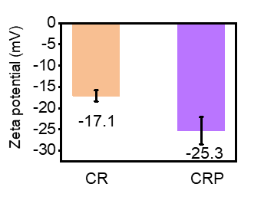
Figure S3. Zeta potentials of CR and CRP in water (n = 3). Data expressed as mean ± SEM.

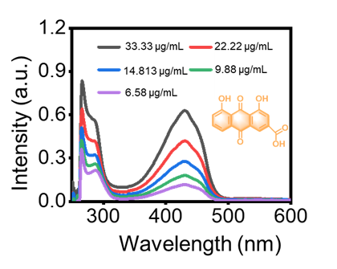
Figure S4. UV-vis spectroscopy analysis demonstrating specific absorbance peaks of Rhein in methanol, with a linear relationship between absorbance and concentration, equation: Y=51.823X-3.0638.

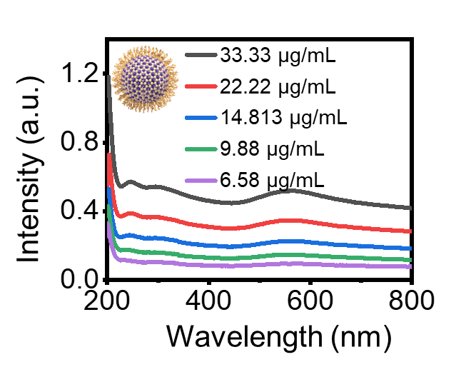
Figure S5. UV-vis-NIR spectra of samples at varied concentrations.

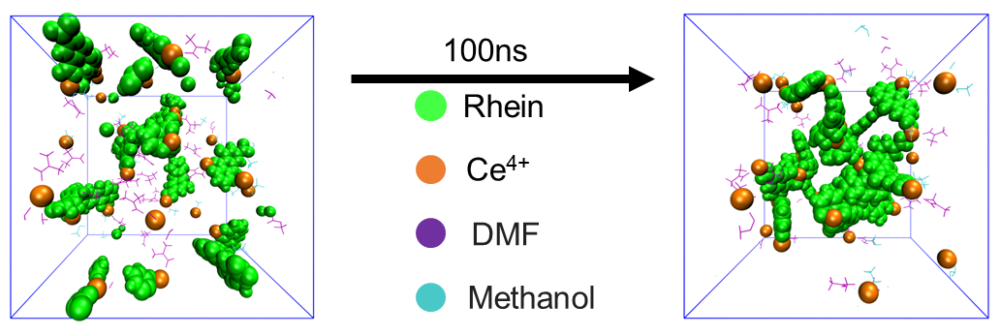

Figure S6. Detailed illustrations of the hydrogen bonds and electrostatic interactions within the CR.

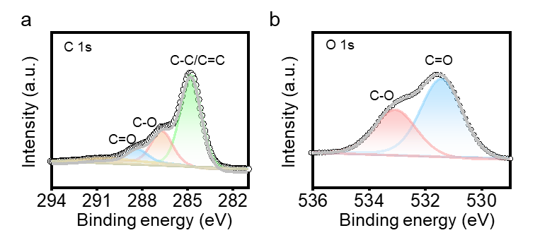
Figure S7. C 1s (a) and O 1s (b) XPS spectra of CR.

Table S1. Results of the fits of the XPS C1s region, values given in at% of total intensity
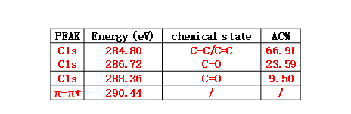

Table S2. Results of the fits of the XPS O1s region, values given in at% of total intensity.
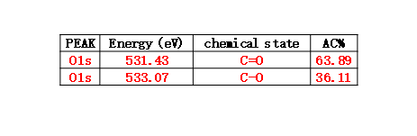
Table S3. Results of the fits of the XPS Ce3d region, values given in at% of total intensity.
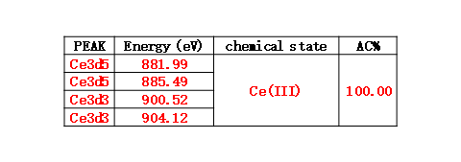

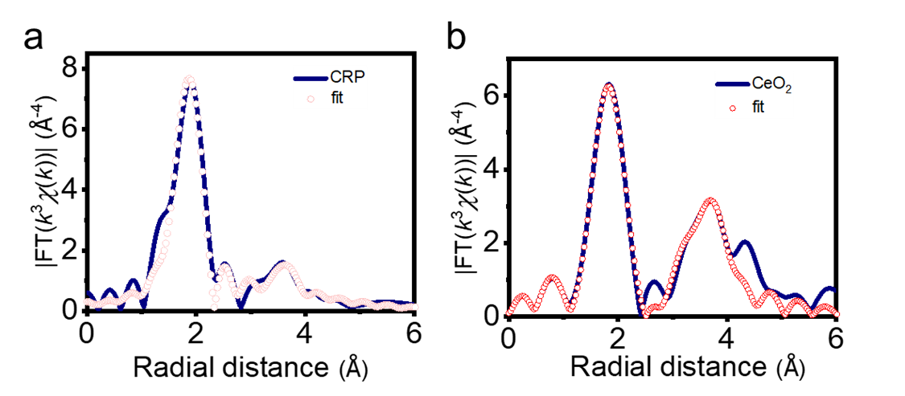
Figure S8. R-space fitting curve of (a) CRP and (b) CeO₂.

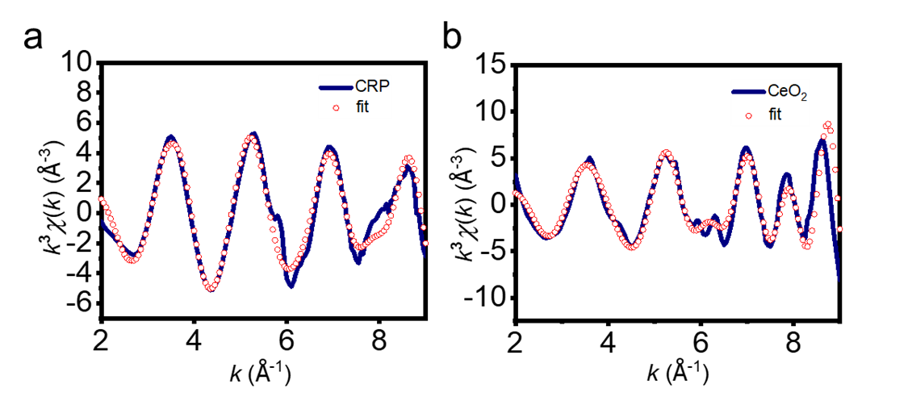
Figure S9. K-space fitting curve of (a) CRP and (b) CeO₂.

Table S4. EXAFS data fitting results of Samples
Sample | Path | CNª | R(Å)^{b} | σ² (Å²)^{c} | ΔE₀(eV)^{d} | R factor
Ce L3-edge (Ѕ₀²=0.823)
CeO₂ | Ce-O | 8.0* | 2.310±0.014 | 0.0100 | 6.0±1.3 | 0.0198
CeO₂ | Ce-Ce | 12.0* | 3.775±0.032 | 0.0130 | 1.4±3.3 | 0.0198
Ce | Ce-O | 4.3±0.3 | 2.458±0.014 | 0.0118 | 9.9±1.1 | 0.0092
Ce | Ce-Ce | 3.1±0.2 | 3.758±0.030 | 0.0116 | -9.9±1.2 | 0.0092

ªCN, coordination number; ^{b}R, the distance between absorber and backscatter atoms; ^{c}σ², the Debye Waller factor value; ^{d}ΔE₀, inner potential correction to account for the difference in the inner potential between the sample and the reference compound; R factor indicates the goodness of the fit. S0² was fixed to 0.823, according to the experimental EXAFS fit of CeO₂ by fixing CN as the known crystallographic value. * This value was fixed during EXAFS fitting, based on the known structure of CeO2. Fitting conditions: k range：2.0 - 9.5; R range: 1.0-4.0; fitting space: R space; k-weight = 3. A reasonable range of EXAFS fitting parameters: 0.700 < Ѕ₀² < 1.000; CN > 0; σ² > 0 Å²; |ΔE₀| < 15 eV; R factor < 0.02.

.
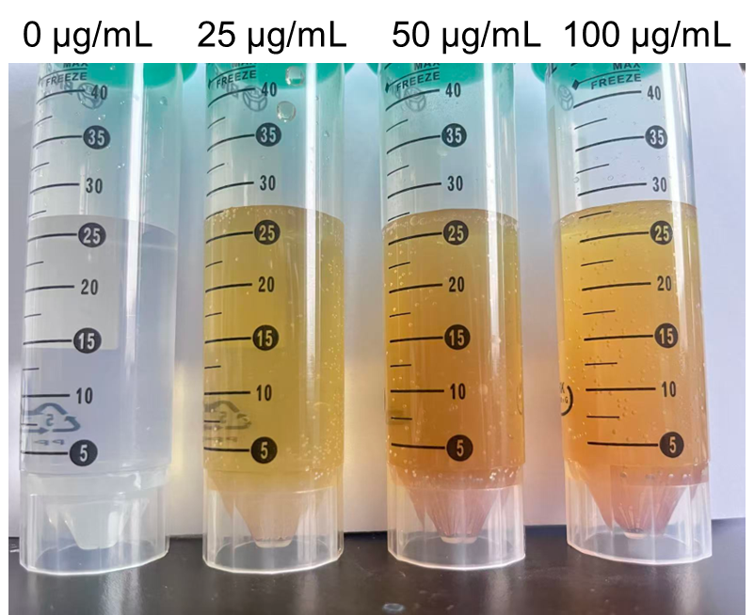
Figure S10. Digital photographs of H₂O₂ solutions in Figure 2b (2 h after the addition of 0-100 µg/mL CRP)

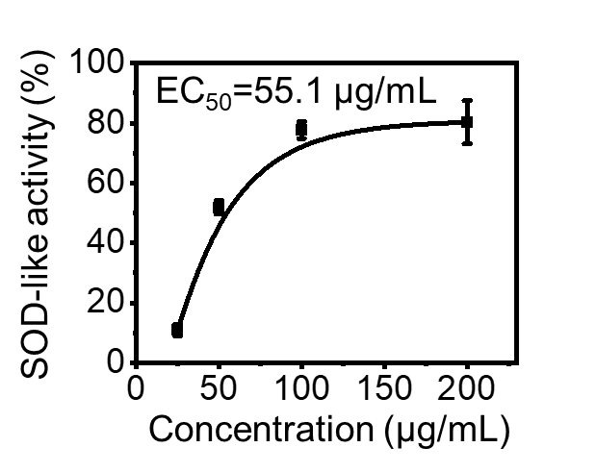
Figure S11. SOD-like activities of CRP of varied concentrations. Data were presented as mean ± S.D.

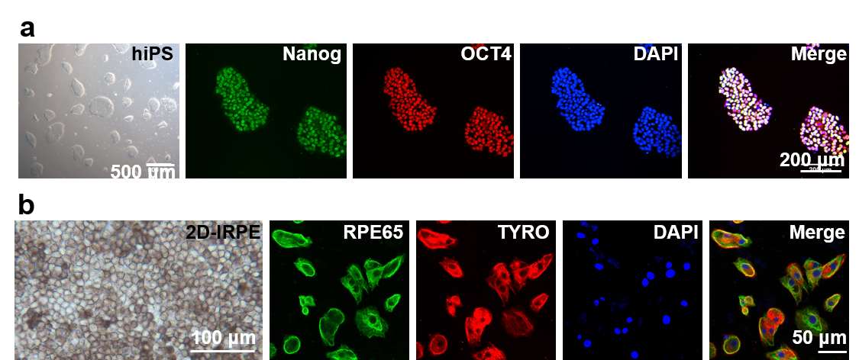
Figure S12. Characterization of hiPSC pluripotency and successful differentiation into iPSC-RPE. (A) Immunofluorescence staining of hiPSCs showing positive expression of pluripotency markers Nanog (green) and OCT4 (red), with nuclei counterstained by DAPI (blue). Scale bar: 200 μm. (B) Following directed differentiation, the resulting iPSC-RPE monolayer exhibited robust expression of RPE-specific markers RPE65 (green) and TYRO (red), indicating successful retinal pigment epithelium differentiation. Nuclear counterstaining was performed with DAPI (blue).

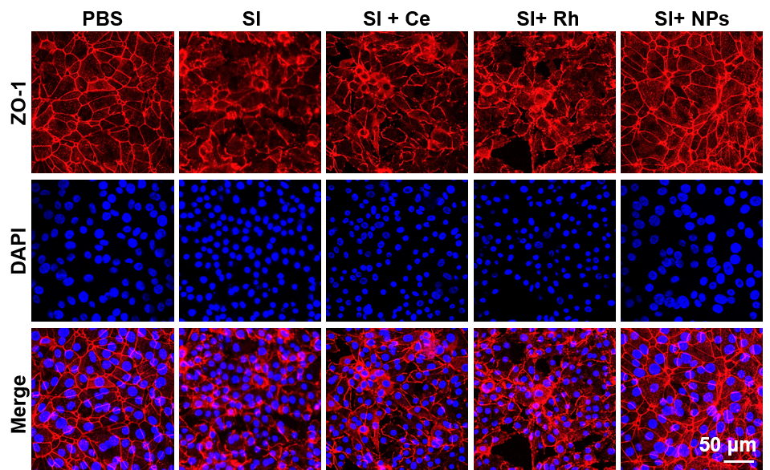
Figure S13. Immunofluorescence staining of ZO-1 in iPSC-RPE monolayer after different treatments, showing recovery of tight junction following CRP NPs treatment.

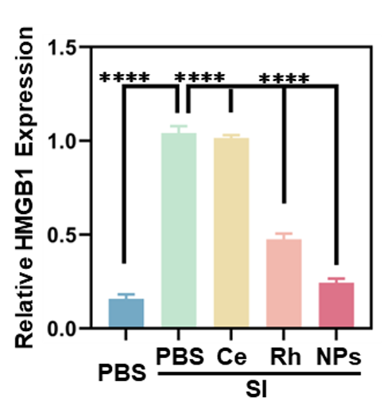
Figure S14. Relative expression of HMGB1. Data are presented as mean ± SD (n = 3). Statistical significance was determined by one-way ANOVA. *p < 0.05, **p < 0.01, ***p < 0.001; n.s., not significant.

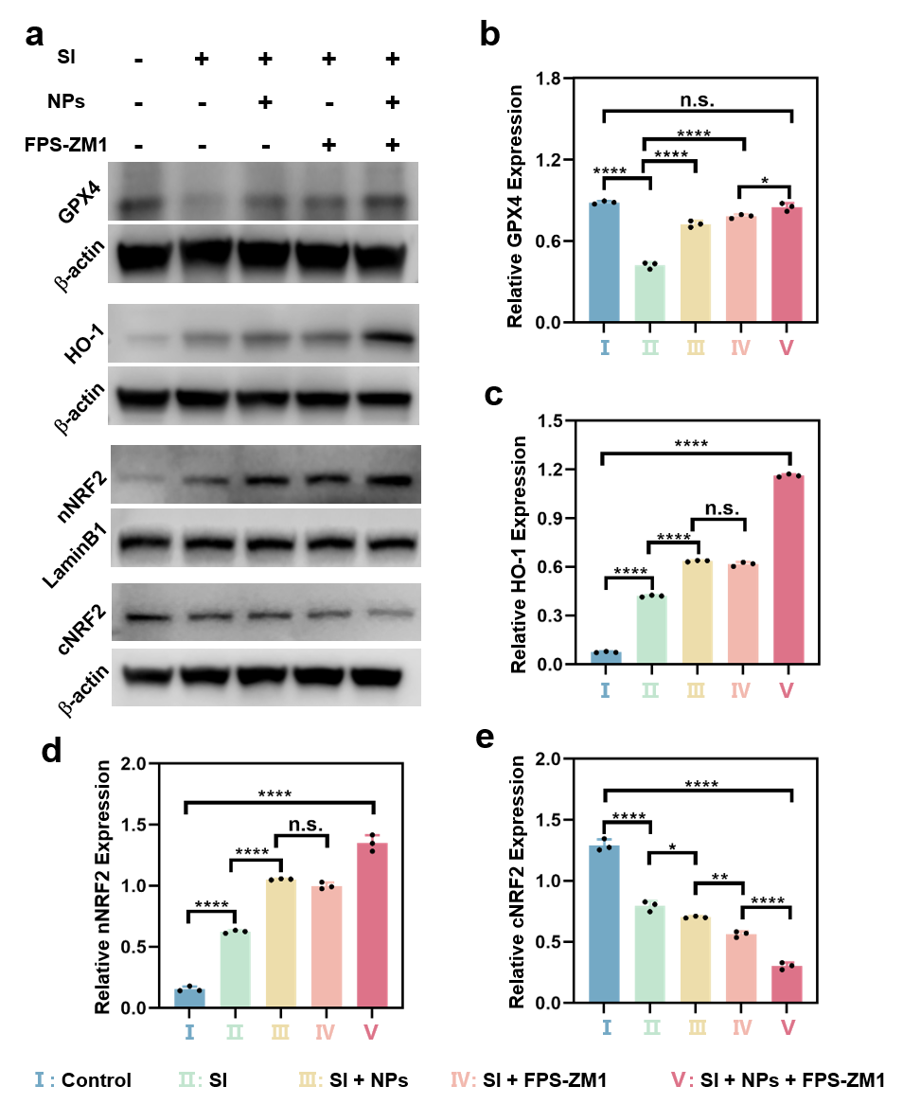
Figure S15. CRP NPs alleviate RAGE-mediated suppression of the Nrf2/HO-1 antioxidant axis in NaIO₃ (SI)-challenged ARPE-19 cells. (a) Representative Western blots of GPX4, HO‑1, nuclear Nrf2 (n‑Nrf2), and cytosolic Nrf2 (c‑Nrf2) in ARPE‑19 cells treated with SI alone or with CRP NPs, FPS‑ZM1, or both. (b–e) Densitometric quantification of GPX4 (b), HO‑1 (c), n‑Nrf2 (d), and c‑Nrf2 (e). Data are presented as mean ± SD (n = 3). Statistical significance was determined by one-way ANOVA. *p < 0.05, **p < 0.01, ***p < 0.001; n.s., not significant.

Figure S16. Immunomodulatory effects of CRP NPs on HMC3 cells. CLSM images of Arg-1 (red) and iNOS (green) in HMC3 cells.

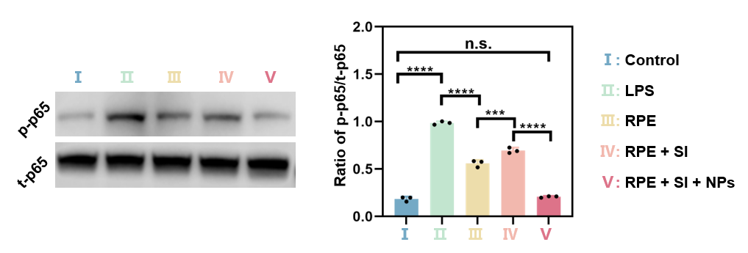
Figure S17. CRP NPs modulate the NF‑κB signaling axis in HMC3 cells. (a) Western blot images of phosphorylated p65 (p‑p65) and total p65 (t‑p65) in HMC3 cells treated with LPS, NaIO₃ (SI) or in combination with CRP NPs. (b) semiquantitative analysis of p-65/tp65. Data are presented as mean ± SD (n = 3). Statistical significance was determined by one-way ANOVA. *p < 0.05, **p < 0.01, ***p < 0.001; n.s., not significant.

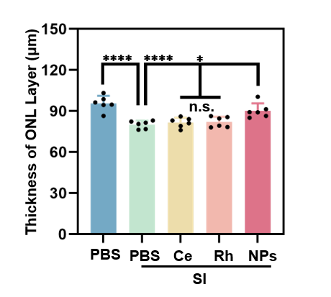
Figure S18. Quantitative analysis of the thickness of the ONL layer (n = 6 mice per group; one eye per mouse). For each eye, 3 non-adjacent sections were examined. ONL thickness was measured at 300 μm intervals across the retina, starting from the optic nerve head. Measurements from all sections were averaged to obtain a single value per mouse, which was then used for statistical analysis. Statistical significance was determined by one-way ANOVA. *p < 0.05, **p < 0.01, ***p < 0.001; n.s., not significant.

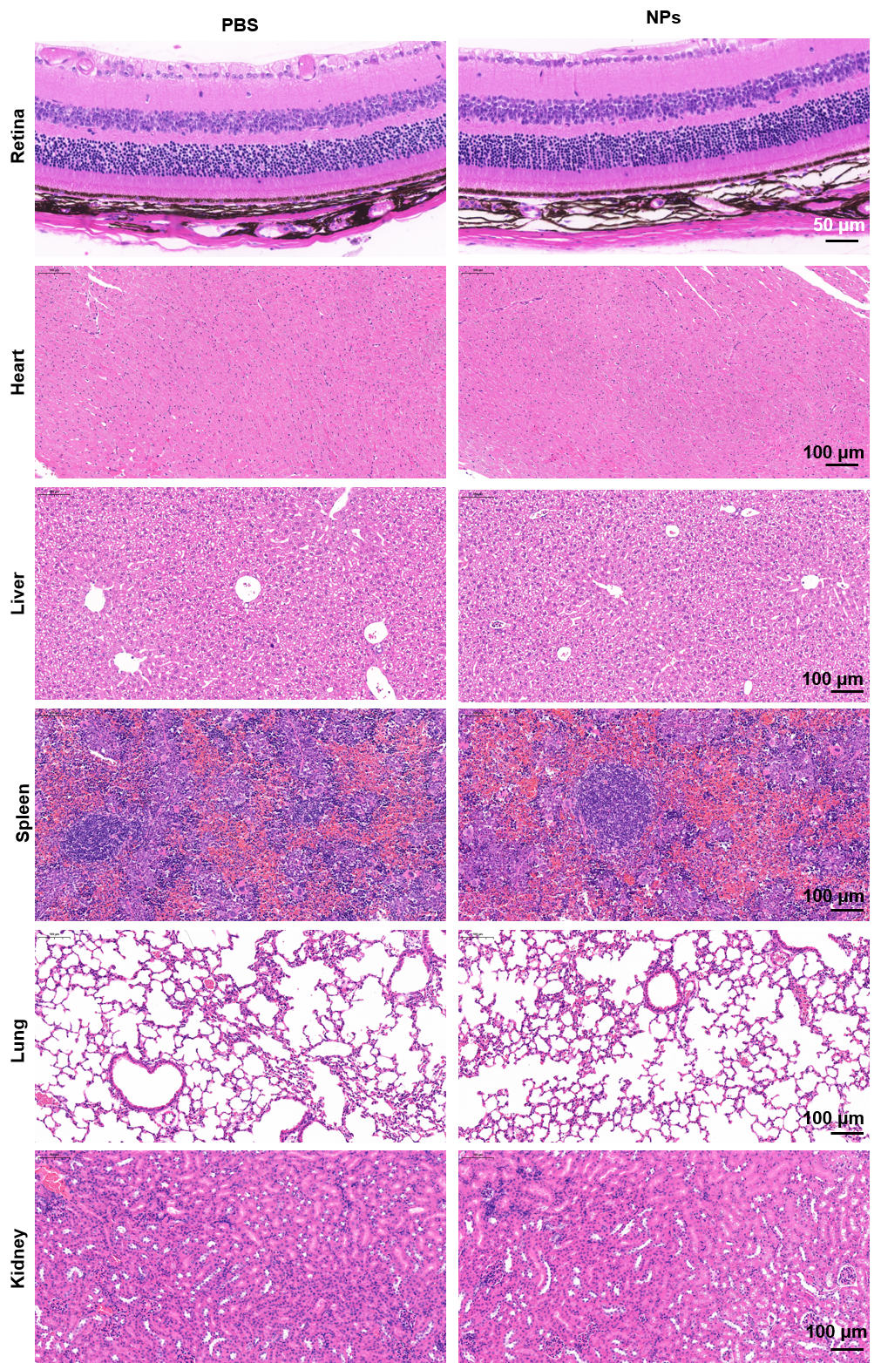
Figure S19. Biocompatibility assessment of CRP NPs in normal mice. Representative H&E-stained retinal, heart, liver, spleen, lung, and kidney sections at 14 days post-intravitreal injection of PBS or CRP NPs

Uncropped gels for Western Blot in Figure 3 (occludin, ZO-1, and claudin 5)
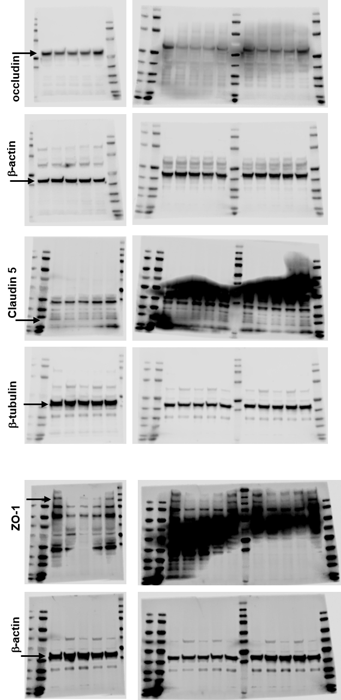

Uncropped gels for Western Blot in Figure 4 (GPX4)
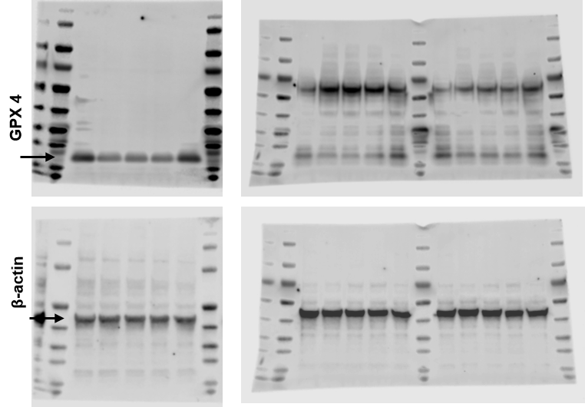

Uncropped gels for Western Blot in Figure 5 (RAGE and HMGB1)
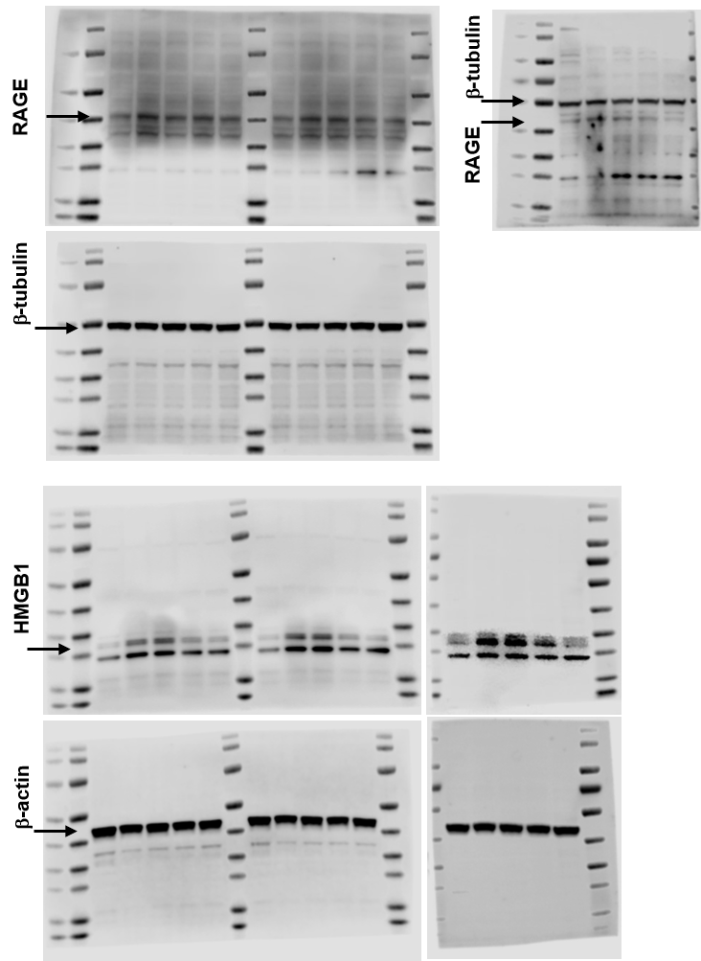

Uncropped gels for Western Blot in Figure S15 and Figure S17 (GPX4, HO-1, nNRF2, cNRF2, p-p65, and t-p65)
