Supplementary Materials for
Cartilage matrix-inspired engineered organoid precursors using digital light processing 3D bioprinting for articular cartilage regeneration
Xun Yuan^{1#}, Liwei Fu^{2#}*, Jiang Wu^{3,4,5#}, Zhengang Ding^{3,4,5#}, Yazhe Zheng^{3,4,5}, Zhichao Zhang^{3,4,5}, Zhixing Zhang^{3,4,5}, Chuanyang Long^{3,4,5}, Jianhao Wu^{3,4,5}, Xiang Sui^{3,4,5}, Shuyun Liu^{3,4,5}*, Quanyi Guo^{3,4,5}*
1: The Fourth People's Hospital of Guiyang, Guiyang 550002, Guizhou Province, People’s Republic of China
2: Department of Orthopedics, Peking University First Hospital, Beijing 100034, China
3: Institute of Orthopedics, Chinese PLA General Hospital; Beijing Key Laboratory of Regenerative Medicine in Orthopedics; Key Laboratory of Musculoskeletal Trauma & War Injuries PLA; No. 28 Fuxing Road, Haidian District, Beijing 100853, People’s Republic of China
4: Department of Orthopedics, The Fourth Medical Center, Chinese PLA General Hospital, Beijing 100048, People’s Republic of China
5: National Clinical Research Center for Orthopedics, Sports Medicine & Rehabilitation, Beijing 100853, People’s Republic of China
#These authors contributed equally to this work
*Corresponding author:
- Quanyi Guo, Email: doctorguo_301@163.com
- Shuyun Liu, Email: clear_ann@163.com
- Liwei Fu, Email: fuliwei1996@163.com
Supplementary experimental Section
1.Preparation and characterization of matrix bioinks
1.1 Extraction of Glycosaminoglycans (GAG)
The extraction and purification of GAG were conducted according to the method reported by Keiichi Takagaki et al. with appropriate modifications. Briefly, the articular cartilage was isolated from the trochlea and condyles of purchased pig knee joints, uniformly minced, and then pulverized using a grinder. The pulverized samples were immersed in a 4% acetic acid solution at 4°C with continuous stirring for 48 hours. The mixture was then filtered through a 150-μm stainless steel mesh to remove residual impurities. The filtrate was centrifuged (4°C, 10,000 rpm, 20 min) to collect the supernatant. Three volumes of ethanol saturated with sodium chloride were added to the supernatant, followed by another centrifugation step (4°C, 10,000 rpm, 20 min) to collect the precipitate. The precipitate was dissolved in a 4% acetic acid solution and dialyzed for 72 hours using a cellulose ester dialysis membrane with a molecular weight cut-off of 1000 kDa. Finally, the dialyzed sample was freeze-dried at -70°C for 24 hours to obtain the glycosaminoglycans (GAG).

1.2 Preparation of the Bioink
This study used recombinant humanized type II collagen (Rhcol II) (Jiangsu Chuangjian Medical Co., Ltd.) and glycosaminoglycan (GAG) as the main components. Precise amounts of the mixture, totaling 5 g, were weighed according to different mass ratios (Rhcol II:GAG = 10:0, 7:3, 5:5, 3:7, 0:10) and dissolved in 100 mL of PBS buffer to prepare a homogeneous series of bioink precursor solutions. Simultaneously, 50 g of HAMA sponge was dissolved in 500 mL of sterile PBS solution, and completely dissolved in a constant temperature water bath at 37°C. The solution was sterilized by filtration through a 0.22 μm microporous membrane to obtain a 10% (w/v) HAMA stock solution. Subsequently, the HAMA solution was mixed with the different bioink precursor solutions in a 1:1 volume ratio. The photoinitiator Lithium Phenyl (2,4,6-trimethylbenzoyl) phosphinate (LAP, Sigma-Aldrich) was added to the mixture to finally obtain the RGH bioinks with different formulations. Using aseptic techniques, the bioinks were aliquoted, sealed, and stored at 4°C for future use.

1.3 Photocuring Properties of the Bioink
To evaluate the photocrosslinking properties of the RGH bioinks with different formulations, 1 mL of each RGH bioink (containing Rhcol II and GAG at mass ratios of 10:0, 7:3, 5:5, 3:7, and 0:10) and HAMA bioink were added into curing molds, respectively. After exposure to blue light (wavelength: 405 nm) for 3 minutes, their crosslinking and curing status were observed and recorded.

1.4 Rheological Properties of the Bioink
To evaluate the printability of the bioink for DLP printing, its rheological properties were characterized using a Paar MCR 301 rotational rheometer. A dynamic frequency sweep was performed at 25°C, with the frequency range set from 10¹ to 10³ Hz and the angular frequency range from 10¹ to 10² rad/s, to measure the viscoelastic moduli of bioinks with different concentrations.

2. Isolation, Culture, and Identification of Umbilical Cord Mesenchymal Stem Cells
This study was approved by the Ethics Committee of Chinese PLA General Hospital. Human umbilical cord mesenchymal stem cells (hUCMSCs) were isolated and cultured according to the method before. Briefly, fresh umbilical cord tissue obtained from cesarean section was aseptically cut into segments approximately 5 cm in length. The segments were rinsed with PBS to remove residual amniotic fluid and blood. The cord was longitudinally incised, and the umbilical vein (one) and umbilical arteries (two) were separated and removed. The Wharton's jelly was carefully scraped and minced into fragments of approximately 1×1 mm³. The tissue fragments were placed in a T25 culture flask (Jet Biofil) containing DMEM basal medium supplemented with 10% fetal bovine serum (F101, Vazyme Biotech Co.,Ltd) and 1% penicillin-streptomycin, and cultured at 37°C in a 5% CO₂ incubator. The medium was changed every two days. When cells reached approximately 90% confluence, they were passaged at a 1:3 ratio. HUCMSCs at passages 3–4 (P3–P4) were used in the experiments.
To verify the multilineage differentiation potential of HUCMSCs, trilineage (adipogenic, osteogenic, and chondrogenic) differentiation experiments were conducted.
Adipogenic differentiation: 1×10⁵ HUCMSCs were seeded into a 6-well plate and cultured in mesenchymal stem cell adipogenic differentiation medium, which was changed every two days. After 7 days of induction, the cells were fixed with 4% paraformaldehyde and stained with Oil Red O to detect lipid droplet formation.
Osteogenic differentiation: A similar procedure was followed. HUCMSCs were cultured in osteogenic induction medium for 14 days and then stained with Alizarin Red S to assess calcium nodule formation.
Chondrogenic differentiation: 3×10⁵ HUCMSCs were suspended in a 15 mL centrifuge tube and centrifuged at 2000 rpm for 5 minutes to form a cell pellet. The pellet was first pre-cultured for 24 hours in DMEM basal medium containing 10% FBS (F101, Vazyme Biotech Co.,Ltd) and 1% penicillin-streptomycin. The medium was then replaced with chondrogenic induction medium and changed every two days. After 14 days of induction, the cell pellet was subjected to frozen sectioning and stained with Alcian Blue to detect glycosaminoglycan deposition in the cartilage matrix.

- Preparation and Characterization of COPs
3.1 Scaffold Printing
Based on previous design experience in cartilage tissue engineering scaffolds and a comprehensive histological and mechanical analysis of rabbit knee joint cartilage, this study determined the final scaffold parameters as follows: diameter of 3 mm, height of 1.5 mm, macropore diameter of 500 μm, and pore spacing of 450 μm. The overall geometry of the scaffold was first constructed using CAD software, and its internal porous structure was designed using Magics software. The generated model files were imported into 3D-Bioplotter software and converted into STL format for printing.
The scaffolds were fabricated using digital light processing (DLP) technology. Different ratios of RGH bioink were loaded into the printer's material cartridge. The printing parameters were set as follows: light intensity of 10 mW/cm², exposure time of 10s, and a base layer exposure time of 12s (for 5 layers). Ultimately, HAMA and RGH hydrogel scaffolds with different ratios were successfully printed at room temperature.
3.2 Macroscopic and Microscopic Observation of Scaffolds
To evaluate the macroscopic and microscopic structures of different scaffolds, observation was performed using an inverted microscope and a scanning electron microscope (SEM). The procedure was as follows: the hydrogel scaffolds were first observed under an inverted microscope for macroscopic morphological assessment. Subsequently, the hydrogel scaffolds were freeze-dried, fixed, and sputter-coated with gold, after which their microstructure was examined and images were acquired using SEM.
3.3 Porosity Measurement
The porosity of the scaffolds was determined using the ethanol displacement method. The procedure was as follows: a certain volume of anhydrous ethanol was first placed in a test tube, and its volume was recorded as V₀. The scaffold was immersed in the anhydrous ethanol until no bubbles emerged from the solution, followed by an additional 5 minutes of immersion to ensure the pores were fully filled with ethanol. The total volume of the liquid at this point was recorded as V₁. After removing the scaffold, the volume of the remaining ethanol was measured as V₂. The porosity was calculated using the following formula: Porosity = (V₀ − V₂) / (V₁ − V₂) × 100%. Three replicate samples were tested for each group of scaffolds.
3.4 Water Absorption Properties
The freeze-dried scaffolds were weighed and then statically immersed in PBS solution at 37°C. At predetermined time points, the scaffolds were removed, and the residual liquid on the surface was absorbed with filter paper before re-weighing. Each group included three parallel samples (n = 3). The water absorption rate was calculated using the following formula: Water absorption rate (%) = [(Ws − Wd) / Wd] × 100%, where Ws represents the weight of the swollen scaffold and Wd denotes the weight of the dry scaffold.
3.5 Mechanical Properties
To evaluate the biomechanical properties of the different 3D-printed cartilage-like biomimetic matrix scaffolds, samples with dimensions of 3.5 × 3.5 × 1.2 mm³ were prepared. The mechanical properties of the scaffolds were tested using a BOSE biomechanical testing machine. The compressive modulus was determined from the linear slope of the stress-strain curve.

- The mechanism of RGH-bioprinted COPs in promoting chondrogenic differentiation of hUCMSCs
To further investigate the mechanism by which RGH scaffolds with the optimal ratio (Rhcol II:GAG=7:3) promote the chondrogenic differentiation of human umbilical cord mesenchymal stem cells (hUCMSCs), this study performed eukaryotic reference-based transcriptome sequencing on both monolayer-cultured hUCMSCs (control group) and RGH scaffold-loaded hUCMSCs (experimental group) without using chondrogenic induction medium. Three biological replicates were set for each group, and the collected samples were sent to Tiangen Biotech (Shanghai) Co., Ltd. for sequencing analysis.

5. In vivo cartilage organoids formation using COPs
To further evaluate the chondrogenic potential of the RGH system in vivo, cartilage organoid precursors (COPs) derived from pure HAMA and RGH-loaded hUCMSCs were subcutaneously implanted into the dorsal region of nude mice. Briefly, after resuspending HAMA and RGH with hUCMSCs respectively, chondrogenic organoid precursors were constructed according to the method described in Section 2.1. Following a 5-day preculture in vitro, the COPs were implanted subcutaneously into the dorsal area of nude mice. Twelve- to eight-week-old male thymus-free mice were randomly divided into two groups: the HAMA-hUCMSCs group and the RGH-hUCMSCs group The experimental protocol was approved by the Laboratory Animal Welfare and Ethics Committee of Beijing Yumao Biotechnology Co., Ltd (YM-2025-0430). All animal studies were conducted in strict compliance with the ARRIVE 2.0 guidelines and were randomly assigned to treatment groups using a computer-generated sequence by an independent researcher. After 8 weeks of implantation, the samples were harvested and photographed with a digital camera for gross morphological observation. The COPs were then cryosectioned, fixed with 95% ethanol, and subjected to hematoxylin-eosin (HE) staining, Alcian blue staining, Safranin O staining, and type II collagen immunohistochemical staining to assess cartilage formation. All staining procedures were strictly performed according to the manufacturer's instructions.
To detect the expression of cartilage-related proteins, Western blotting was performed to analyze Sox9, type II collagen, and aggrecan. Total protein was extracted from the samples using a protein extraction kit. The protein samples were mixed with loading buffer, boiled, and separated by SDS-PAGE gel electrophoresis, followed by transfer onto a polyvinylidene fluoride (PVDF) membrane. The membrane was blocked with 5% skim milk and then incubated overnight at 4°C with the following primary antibodies: anti-β-actin (1:5000, Immunoway, USA), anti-type II collagen (1:1000, Novus, USA), anti-Sox9 (1:1000, Abcam, UK), and anti-aggrecan (1:2000, Invitrogen, USA). After washing three times with TBST buffer for 5 minutes each, the membrane was incubated with corresponding secondary antibodies for 1 hour. Protein bands were finally detected using an ECL enhanced chemiluminescence system.

6. COPs promote in situ articular cartilage repair
6.1 Rabbits AC defect model
All animal experimental procedures in this study were approved by the Institutional Animal Care and Use Committee of Chinese PLA General Hospital. Forty skeletally mature New Zealand white rabbits (male, 6 months old, weight 2.5–3.0 kg) were selected as the animal model and randomly divided into four groups (n=10 per group): (A) negative control group (defect only, no implantation); (B) HAMA group; (C) RGH/hUCMSC group; and (D) sham surgery group (joint opened without further intervention). Following standard sterile surgical preparation and anesthesia, one hind limb was randomly selected for hair removal, disinfection, and draping. A medial parapatellar approach was used to access the knee joint. The patella was laterally displaced to dislocate it, fully exposing the femoral trochlea while maintaining the knee in flexion. A full-thickness cartilage defect with a diameter of 3.5 mm and depth of 1.5 mm was created in the femoral trochlear groove, approximately 1 mm above the insertion site of the medial collateral ligament, using a corneal trephine. In the negative control group, only the defect was created without any additional treatment. In the experimental groups, the corresponding scaffolds (HAMA scaffold or RGH/hUCMSC scaffold) were implanted into the defect. In the sham surgery group, the joint was opened and the patella was dislocated and immediately reduced. After achieving hemostasis in the surgical area, the joint capsule and skin were sutured sequentially. The incision site was disinfected with iodophor and covered with sterile gauze. All rabbits received routine antibiotic and analgesic therapy for 7 days postoperatively and were allowed to move freely. The animals were euthanized at 6 and 12 weeks post-surgery, and knee joint samples were collected for further analysis.

6.2 Gross Observation and Scoring
After harvesting the rabbit femoral condyles, the defect repair areas were grossly examined and photographed. Subsequently, all images were randomly coded with group information concealed and independently evaluated by three researchers experienced in cartilage injury regeneration. Scoring was performed according to the International Cartilage Repair Society (ICRS) macroscopic assessment criteria (Table 2) under blinded conditions.

6.3 Micro-CT Analysis
Following gross observation, the femoral condyle samples were first subjected to Micro-CT scanning. Subsequently, coronal and sagittal plane images were reconstructed, and three-dimensional rendering was performed. A cylindrical region of interest (ROI) with a diameter of approximately 3.5 mm and height of approximately 1 mm, matching the volume of the original surgical defect, was then selected within the defect repair area of each sample. To accurately distinguish true subchondral bone tissue from newly formed calcified or dense cartilage tissue, specific segmentation criteria and global thresholding algorithms were applied. Grayscale thresholds were empirically set based on the density of native rabbit subchondral bone (typically defined within a specific Hounsfield Unit range corresponding to calcified bone). Tissues with mineral densities falling below this threshold were categorized as unmineralized or partially mineralized cartilage and were intentionally excluded from the bone analysis. The bone mineral density (BMD) and bone volume fraction (BV/TV) within each ROI were analyzed to evaluate the regeneration of subchondral bone in the trochlear defect model across different groups.

6.4 Histological Evaluation
Femoral condyle specimens were randomly selected from the four groups. After fixation in 4% paraformaldehyde for 5 days and decalcification in 10% EDTA for 6 weeks, the samples were trimmed, embedded in paraffin, and sectioned into 6 μm-thick slices. Sections were randomly chosen from each group and stained according to the respective kit instructions for H&E, Safranin O-Fast Green, Sirius Red, and Toluidine Blue staining. Stained sections were observed and photographed under a microscope. Additional sections were randomly selected from each group for Type II collagen immunohistochemical staining, performed as follows: after routine deparaffinization, sections were treated with hydrogen peroxide for membrane permeabilization, followed by antigen retrieval using pepsin and blocking with immunoblocking solution. Subsequently, sections were incubated overnight at 4 °C with Type II collagen antibody diluted at 1:200. After thorough washing, a secondary antibody was applied, and color development was performed using DAB. Sections were then dehydrated via conventional steps, mounted with neutral resin and coverslips, and observed under a microscope for imaging. All stained section images were anonymized by concealing group information and randomly provided to experienced pathological researchers for blinded scoring according to the O'Driscoll scoring system guidelines (Table 3).

6.5 Biomechanical and Biochemical Analysis
Biomechanical Testing:Femoral condyle specimens were randomly selected from each group at two time points for mechanical evaluation of the regenerated tissue in the cartilage defect area. A biomechanical testing system (Bose 5100) was used to perform compression tests. The applied force (F) and deformation (ΔL) were recorded, with S representing the contact area of the indenter, where L denotes the initial thickness of the sample.Young’s modulus (E), which reflects the stiffness and elastic properties of the material, was calculated using the following formula: E = (F × L) / (S × ΔL).
Biochemical Analysis:Following biomechanical testing, the regenerated cartilage tissue from the defect area was carefully excised. Glycosaminoglycan (GAG) content was measured using a dimethylmethylene blue (DMMB) colorimetric assay kit, and collagen content was evaluated via a hydroxyproline (HYP) detection kit. All procedures were performed in strict accordance with the manufacturer's instructions. The final contents were normalized to wet weight or DNA content to compare extracellular matrix synthesis capacity among the groups.

Supplementary Figures and Tables

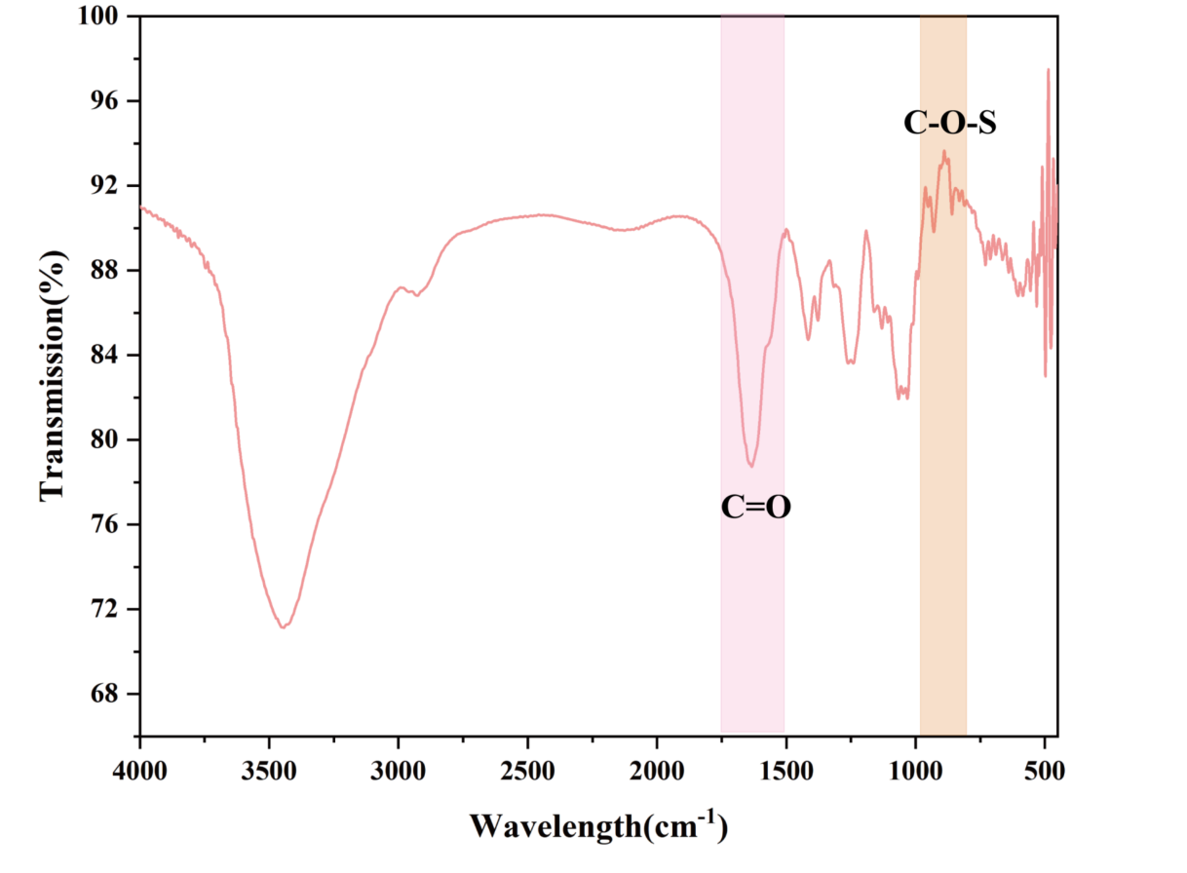
Figure S1. FTIR analysis of porcine cartilage-derived GAGs.
Figure S2. Quantitative analysis of pore size among different experimental groups.

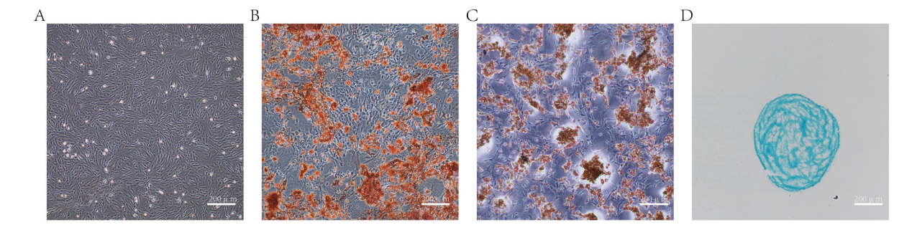
Figure S3. Morphology and differentiation ability of HUCMSCs. (A)morphology of HUCMSCs under microscope; (B) Alizarin Red staining after osteogenic induction; (C) Oil Red O staining after adipogenic induction; (D) Alcian Blue staining of cartilage pellets after chondrogenic induction.
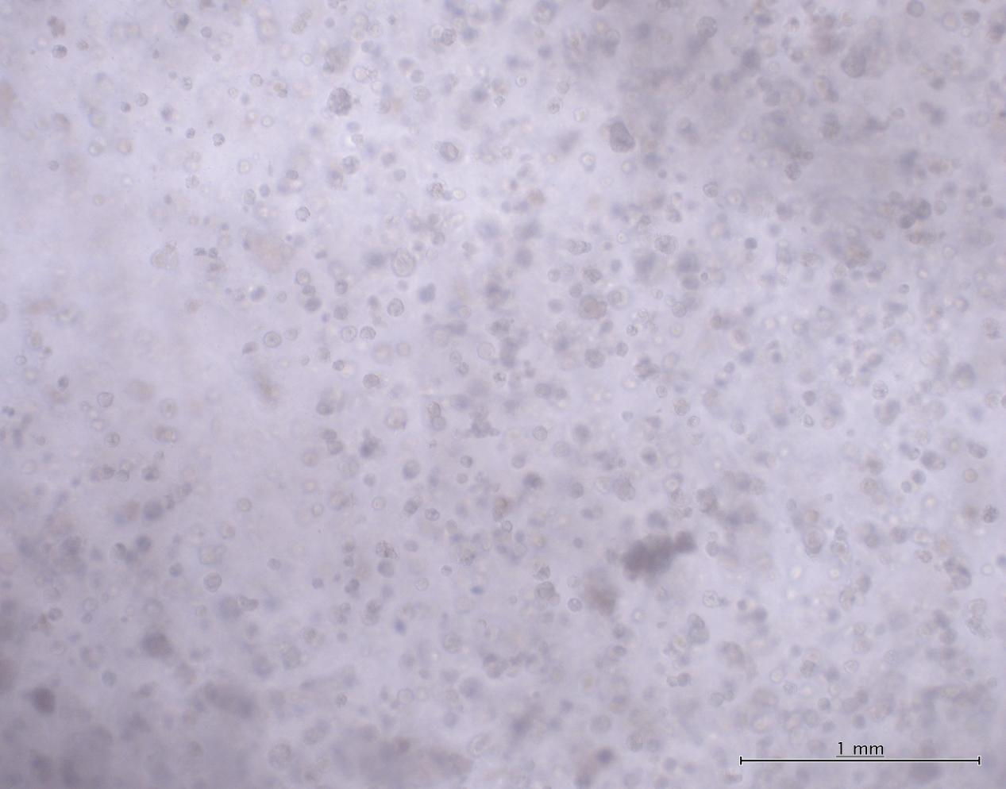
Figure S4. Representative bright-field images showing the rounded morphology of hUCMSCs in the 7:3 COP group after 21 days of chondrogenic induction.
Figure S5. Comprehensive performance evaluation of COPs.
Figure S6.Expression of FOXO1 and FOXO3 detected by RT‒PCR across groups.

Figure S7. Pathway inhibition experiments to elucidate the effect of RGH on the chondrogenic differentiation of hUCMSCs via the FOXO signaling pathway.

Figure S8. Western blot (A) and RT‒PCR (B) analysis of COLX and MMP13.

Figure S9. Western blot (A) and RT‒PCR (B) analysis of ADAMTS-4 and ADAMTS-5.

Figure S10. the RGH group achieved excellent integration with native cartilage.

Figure S11.

Table S1. Primer sequences for quantitative RT‒PCR.
Gene | Primer | Primer Sequence (5' to 3')
SOX9 | Forward | CCAGCAAGAACAAGCCACAC
SOX9 | Reverse | CTTGCCCAGAGTCTTGCTGA
COL 2A1 | Forward | GAGTGGAAGAGCGGAGACTACTG
COL 2A1 | Reverse | GTCTCCATGTTGCAGAAGACTTTCA
Aggrecan | Forward | CTAGCTGCTTAGCAGGGATAACG
Aggrecan | Reverse | TCATGTAGACCATGTAGTTGAGGTCA
COL 1 | Forward | GTGCTAAAGGTGCCAATGGT
COL 1 | Reverse | ACCAGGTTCACCGCTGTTAC
FOXO1 | Forward | TCGTCATAATCTGTCCCTACACA
FOXO1 | Reverse | CGGCTTCGGCTCTTAGCAAA
FOXO3 | Forward | CGGACAAACGGCTCACTCT
FOXO3 | Reverse | GGACCCGCATGAATCGACTAT
GAPDH | Forward | CAAGAAGGTGGTGAAGCAGG
GAPDH | Reverse | CACTGTTGAAGTCGCAG

Table S2. International Cartilage Repair Society (ICRS) macroscopic evaluation guidelines.
ICRS Cartilage Repair Assessment |  | Points
Degree of defect repair | At level with surrounding cartilage | 4
Degree of defect repair | 75% repair of defect depth | 3
Degree of defect repair | 50% repair of defect depth | 2
Degree of defect repair | 25% repair of defect depth | 1
Degree of defect repair | 0% repair of defect depth | 0
Integration to border zone | Complete integration with surrounding cartilage | 4
Integration to border zone | Demarcating border <1 mm | 3
Integration to border zone | 3/4 of graft integrated, 1/4 with a notable border >1 mm wide | 2
Integration to border zone | 1/2 of graft integrated with surrounding cartilage, 1/2 with a notable border >1 mm | 1
Integration to border zone | From no contact to 1/4 of graft integrated with surrounding cartilage | 0
Macroscopic appearance | Intact smooth surface | 4
Macroscopic appearance | Fibrillated surface | 3
Macroscopic appearance | Small, scattered fissures or cracks | 2
Macroscopic appearance | Several, small or few but large fissure | 1
Macroscopic appearance | Total degeneration of grafted area | 0
Overall repair assessment | Grade I: normal | 12
Overall repair assessment | Grade II: nearly normal | 11–8
Overall repair assessment | Grade III: abnormal | 7–4
Overall repair assessment | Grade IV: severely abnormal | 3–1

Table S3. Modified O’Driscoll score system.
Characteristic | Grading | Score
I. Hyaline cartilage | 80%-100% | 8
I. Hyaline cartilage | 60%-80% | 6
I. Hyaline cartilage | 40%-60% | 4
I. Hyaline cartilage | 20%-40% | 2
I. Hyaline cartilage | 0%-20% | 0
II. Structural characteristics
A. Surface irregularity | Smooth and intact | 2
A. Surface irregularity | Fissures | 1
A. Surface irregularity | Severe disruption, fibrillation | 0
B. Structural integrity | Normal | 2
B. Structural integrity | Slight disruption, including cysts | 1
B. Structural integrity | Severe lack of integration | 0
C. Thickness | 100% of normal adjacent cartilage | 2
C. Thickness | 50%-100% or thicker than normal | 1
C. Thickness | 0%-50% | 0
D. Bonding to adjacent cartilage | Bonded at both ends of graft | 2
D. Bonding to adjacent cartilage | Bonded at one end/partially both ends | 1
D. Bonding to adjacent cartilage | Not bonded | 0
III. Freedom from cellular changes of degeneration | Normal cellularity, no cluster | 2
III. Freedom from cellular changes of degeneration | Slight hypocellularity, <25% chondrocyte clusters | 1
III. Freedom from cellular changes of degeneration | Moderate hypocellularity, >25% clusters | 0
IV. Freedom from degenerate changes in adjacent cartilage | Normal cellularity, no clusters, normal staining | 3
IV. Freedom from degenerate changes in adjacent cartilage | Normal cellularity, mild clusters, moderate staining | 2
IV. Freedom from degenerate changes in adjacent cartilage | Mild or moderate hypocellularity, slight staining | 1
IV. Freedom from degenerate changes in adjacent cartilage | Severe hypocellularity, slight staining | 0
V. Reconstitution of subchondral bone | Complete reconstitution | 2
V. Reconstitution of subchondral bone | >50% reconstitution | 1
V. Reconstitution of subchondral bone | ≤50% reconstitution | 0
VI. Bonding of repair cartilage to de novo subchondral bone | Complete and uninterrupted | 2
VI. Bonding of repair cartilage to de novo subchondral bone | <100% but >50% reconstitution | 1
VI. Bonding of repair cartilage to de novo subchondral bone | <50% complete | 0
VII. Safranin O staining | >80% homogenous positive stain | 2
VII. Safranin O staining | 40%-80% homogenous positive stain | 1
VII. Safranin O staining | <40% homogenous positive stain | 0
Total score |  | Max. 27

