Supporting Information

Orchestrating Cell Cycle Arrest and Innate Immune Sensing for Synergistic Radiotherapy and Immunotherapy against Non-Small Cell Lung Cancer
Lukuan You^{a,1}, Zhuang Chen^{b,c,1,}*, Jiayi Bei^{d,1}, Can Cui^{b}, Yinmei Xuª, Yankan Fuª, Yifan Ren^{e}, Bo Chen^{d,}*, Zhongliang Wang^{b,}*, and Jianxiong Li^{a,}*
ª Senior Department of Oncology, Chinese PLA General Hospital, Beijing 100039, China
^{b} Lab of Molecular Imaging and Translational Medicine (MITM), Engineering Research Center of Molecular & Neuro-imaging Ministry of Education, School of Life Science and Technology, Xidian University, Xi’an 710126, Shaanxi, P. R. China
^{c} School of Life and Health Sciences, Hainan University, Haikou 570228, P. R. China
^{d} Department of Breast Surgery, the First Hospital of China Medical University, Shenyang, Liaoning 110001, P. R. China
^{e} School of Medicine, Nankai University, Tianjin 300074, China
¹ These authors contributed equally
* Correspondence: chenzhuang@xidian.edu.cn; bochen@cmu.edu.cn; wangzl@xidian.edu.cn; 301301ljx@sina.com.

Figure S1. Hydrodynamic size distribution of GSK@BSA-MnO₂ nanoparticles.

Figure S2. Fourier-transform infrared (FTIR) spectra of free GSK461364 (purple line), BSA-MnO₂ nanocarrier (green line), and drug-loaded GSK@BSA-MnO₂ nanoparticles (blue line). The appearance of characteristic sharp absorption peaks of GSK461364 (e.g., at 2937, 1309, and 1168 cm⁻¹) in the spectrum of GSK@BSA-MnO₂, which are absent in the blank BSA-MnO₂ spectrum, confirms the successful loading of the drug onto the nanocarrier.

Figure S3. Rapid release behavior of GSK461364 from the GSK@BSA-MnO₂ nanosystem under TME-mimicking conditions. (A) Time-dependent UV-Vis absorbance spectra of the released GSK461364 in PBS (pH 7.4) containing 10 mM GSH at 37 °C. (B) The corresponding cumulative release curve of GSK461364 over time. The absorbance at 1440 min was used to represent the 100% theoretical maximum release following complete nanoparticle degradation. Data are presented as mean ± SD (n = 3).

Figure S4. Time-dependent cellular uptake of ICG@GSK@BSA-MnO₂ nanoparticles observed by confocal laser scanning microscopy (CLSM).

Figure S5. Concentration-dependent cellular internalization of ICG@GSK@BSA-MnO₂ nanoparticles evaluated by flow cytometry. (A) Representative flow cytometry histograms of LLC cells treated with different concentrations of ICG@GSK@BSA-MnO₂ (0, 100, 200, and 400 μg/mL). The vertical dashed line represents the reference standard aligned with the peak of the control group (0 μg/mL) to indicate the rightward shift of fluorescence. (B) Quantitative statistical analysis of the Mean Fluorescence Intensity (MFI) corresponding to panel A. Data are presented as mean ± SD (n = 3). ****p < 0.0001 (analyzed by one-way ANOVA).

Figure S6. Expanded in vitro cytotoxicity evaluation. Relative cell viabilities of a normal cell line (Beas-2B) and an expanded panel of tumor cell lines (LLC, 4T1, A549, and CT26) after incubation with varying concentrations of GSK@BSA-MnO₂ for 24 h. Cell viability was measured by MTT assay. Data are presented as mean ± SD (n = 3).

Figure S7. Quantitative analysis of the expression levels of G2/M phase-related proteins. Relative protein expression of p-PLK1, Cyclin B1, and CDK1 in LLC cells after incubation with different formulations for 24 h (G1: PBS, G2: free GSK461364, G3: BSA-MnO₂, G4: GSK@BSA-MnO₂). The grayscale intensities of the target protein bands were normalized to the corresponding internal control (β-actin). Data are presented as mean ± SD (n = 3 independent biological replicates). Statistical significance was calculated using One-way ANOVA followed by Tukey's post hoc test (* p < 0.05, ** p < 0.01, **** p < 0.0001, ns = not significant).

Figure S8. In vitro Western blot analysis and quantification of γ-H2AX expression.
(A) Original, unedited raw scans with visible molecular weight markers (top) and the corresponding inverted, cropped images (bottom) from three independent biological replicates evaluating γ-H2AX protein levels. β-actin was utilized as an internal loading control.(B) Quantitative analysis of relative γ-H2AX protein expression normalized to β-actin based on the three biological replicates. Data are presented as mean $±$ SD (n = 3). **p < 0.01, ****p < 0.0001, and ns indicates not significant. Treatment groups are defined as follows: G1 (PBS), G2 (GSK461364), G3 (BSA-MnO₂), and G4 (GSK@BSA-MnO₂) without irradiation; G5 (PBS), G6 (GSK461364), G7 (BSA-MnO₂), and G8 (GSK@BSA-MnO₂) with 6 Gy X-ray irradiation.

Figure S9. Flow cytometric analysis of intracellular ROS. (A) Representative flow cytometry histograms showing the fluorescence intensity of the ROS probe (DCFH-DA) across different treatment groups. (B) Quantitative analysis of the mean fluorescence intensity (MFI). G1-G4: non-irradiated groups (PBS, GSK461364, BSA-MnO₂, GSK@BSA-MnO₂); G5-G8: irradiated groups with 6 Gy X-rays (PBS, GSK461364, BSA-MnO₂, GSK@BSA-MnO₂). Data are mean ± SD (n = 3). Statistical significance was analyzed by one-way ANOVA (**p < 0.01; ns, not significant).

Figure S10. Representative images of clonogenic survival assays at varying radiation doses. Cells were pre-treated with different formulations and subsequently exposed to 2, 4, or 8 Gy of X-ray irradiation. The numbers below each representative plate indicate the number of surviving colonies over the initial number of seeded cells. CFE denotes Colony Formation Efficiency (%). Due to the increased lethality at higher radiation doses, the initial cell seeding density was proportionally scaled up (2,000 cells for 2 Gy; 4,000 cells for 4 Gy; and 40,000 cells for 8 Gy) to ensure statistically reliable colony counts. Treatment groups are defined as follows: G1 (PBS), G2 (GSK461364), G3 (BSA-MnO₂), and G4 (GSK@BSA-MnO₂).

Figure S11. In vitro cell apoptosis assay. (A) Flow cytometry analysis of tumor cell apoptosis using Annexin V-FITC/PI dual staining after various treatments. (B) Quantitative analysis of the total apoptotic cell percentage. Treatment groups: G1 = PBS, G2 = GSK461364, G3 = BSA-MnO₂, G4 = GSK@BSA-MnO₂ (without irradiation); G5 = PBS, G6 = GSK461364, G7 = BSA-MnO₂, G8 = GSK@BSA-MnO₂ (with 6 Gy X-ray irradiation). Data are presented as mean ± SD (n = 3). Statistical significance was determined by one-way ANOVA (*p < 0.05, ****p < 0.0001).

Figure S12. Quantitative evaluation of cell-surface Calreticulin (CRT) exposure by flow cytometry. (A) Representative flow cytometry pseudocolor plots showing the expression of CRT in LLC cells after various treatments (G1-G8). (B) Statistical analysis of the percentage of CRT-positive cells (CRT+ %).(C) Quantitative analysis of the mean fluorescence intensity (MFI) of CRT across different groups. Data are presented as mean ± SD (n = 3). ****$p<0.0001$, ns = not significant, analyzed by one-way ANOVA. (Treatment groups are defined as follows: G1 (PBS), G2 (GSK461364), G3 (BSA-MnO₂), and G4 (GSK@BSA-MnO₂) without irradiation; G5 (PBS), G6 (GSK461364), G7 (BSA-MnO₂), and G8 (GSK@BSA-MnO₂) with 6 Gy X-ray irradiation.)

Figure S13. Quantification of Western blot analysis for STING pathway–related signaling proteins. The specific treatments for each designated group are explicitly defined as follows: G1 = PBS, G2 = free GSK461364, G3 = BSA-MnO₂, and G4 = GSK@BSA-MnO₂ (all without X-ray irradiation); G5 = PBS, G6 = free GSK461364, G7 = BSA-MnO₂, and G8 = GSK@BSA-MnO₂ (all treated with 6 Gy X-ray irradiation). Data are presented as mean ± SD (n = 3 independent biological replicates). Statistical significance was calculated using One-way ANOVA (*p < 0.05, **p < 0.01, ***p < 0.001, ns = not significant).

Figure S14. In vivo biodistribution and tumor targeting capability.
(A) Representative in vivo fluorescence images of tumor-bearing mice captured at pre-determined time points (0.5, 2, 6, 12, 24, and 48 h) post-intravenous injection of ICG-labeled nanoparticles. (B) Ex vivo fluorescence images of major excised organs (H: heart, Li: liver, S: spleen, Lu: lung, K: kidney) collected at 0.5, 12, 24, and 48 h post-injection. (C) Corresponding semi-quantitative analysis of the mean fluorescence intensity (MFI) at the tumor sites over time based on the in vivo images. (D) Quantitative region-of-interest (ROI) fluorescence analysis of the major organs at different time points based on the ex vivo images. All quantitative data are presented as mean ± SD (n = 3 independent animals per time point).

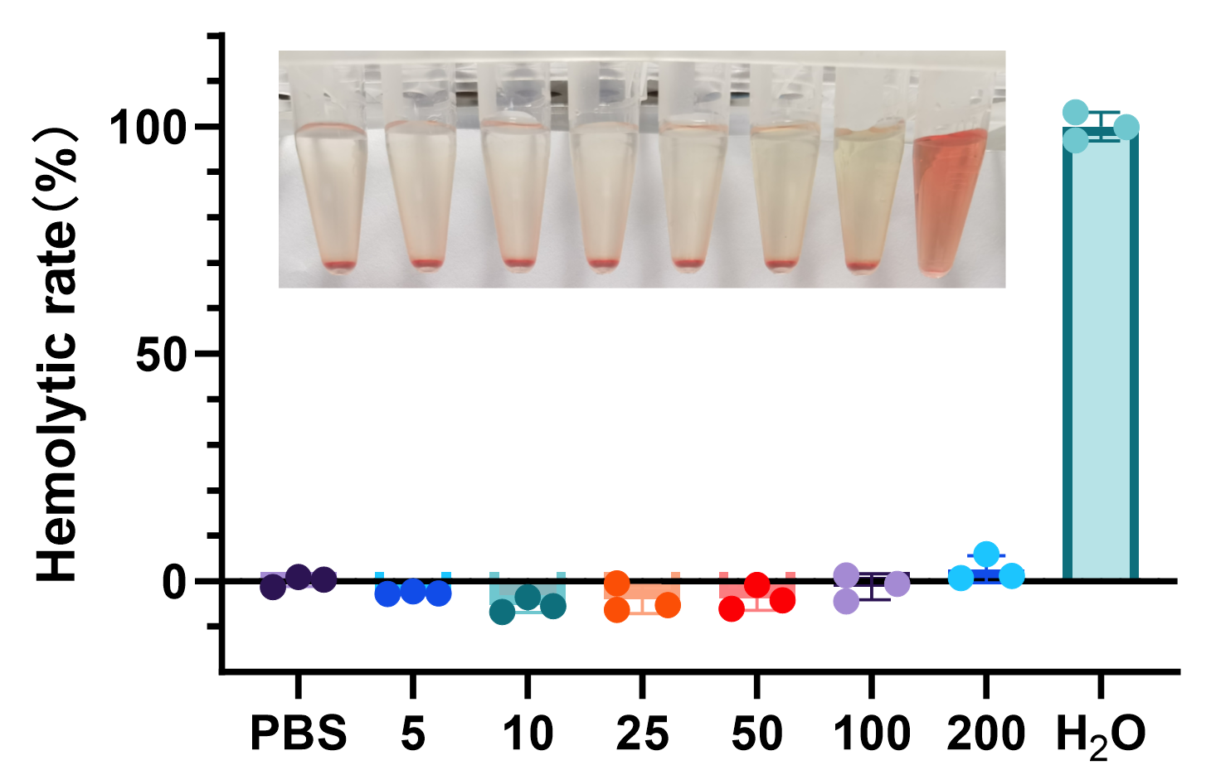
Figure S15. In vitro hemolysis assay of GSK@BSA-MnO₂ nanoparticles for evaluating blood compatibility at different concentrations.

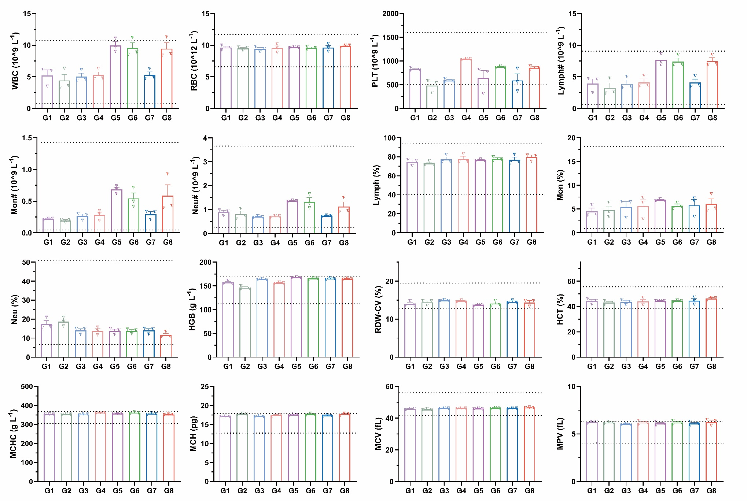
Figure S16. Routine hematological analysis of mice in different treatment groups after therapy to assess potential effects on the hematological system.

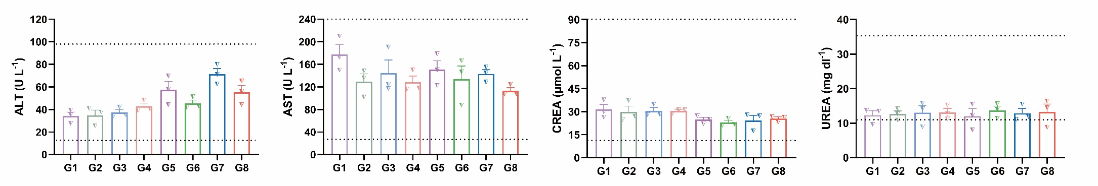
Figure S17. Serum biochemical analysis of hepatic and renal function in mice after different treatments. Serum levels of ALT, AST, CRE, and BUN were detected to evaluate the potential hepatic and renal biotoxicity of the nanoformulation.

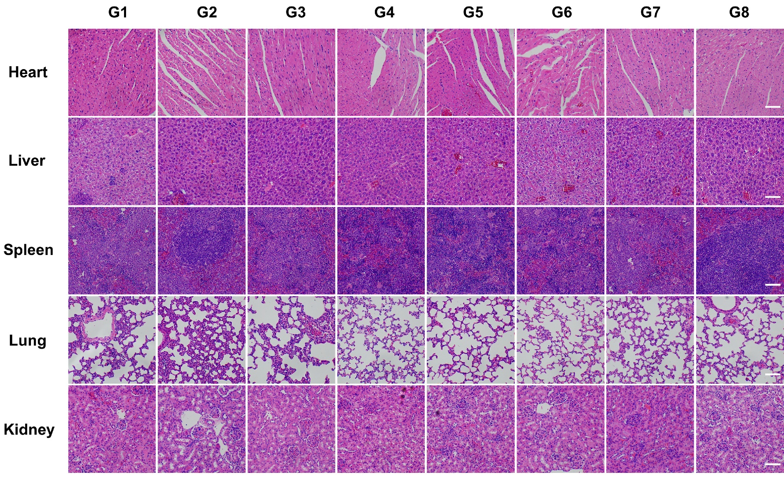
Figure S18. Histological examination of major organs in mice after treatment using H&E staining. H&E staining was performed on organs (heart, liver, spleen, lung, kidney) from mice in different treatment groups to assess the potential histopathological effects of the treatments. (Scale bar = 100 μm).

Figure S19. In vivo validation of cell cycle arrest. (A) Western blot analysis and (B) corresponding quantitative analysis of G2/M phase-related proteins (p-PLK1, Cyclin B1, and CDK1) in tumor tissues post-treatment. β-actin was used as the loading control. Treatment groups ($n=3$): G1 (PBS), G2 (RT), G3 (RT + Free GSK461364), and G4 (RT + GSK@BSA-MnO₂). Statistical significance was calculated using One-way ANOVA followed by Tukey's post hoc test. Data are presented as mean ± SD. *p < 0.05, **p < 0.01, ***p < 0.001, ns = not significant.

Figure S20. In vivo activation of the cGAS-STING signaling pathway. (A) Western blot analysis and (B) corresponding quantitative analysis of the relative phosphorylation levels (ratio of phosphorylated to total protein) of TBK1, IRF3, and STING in tumor tissues. Vinculin was used as the loading control. Treatment groups ($n=3$): G1 (PBS), G2 (GSK@BSA-MnO₂), G3 (RT), and G4 (RT + GSK@BSA-MnO₂). Statistical significance was calculated using One-way ANOVA followed by Tukey's post hoc test. Data are presented as mean ± SD. *p < 0.05, **p < 0.01, ***p < 0.001, ns = not significant.

Figure S21. In vivo secretion of downstream cytokines. ELISA quantification of (A) IFN-β and (B) CXCL10 levels in the tumor microenvironment following different treatments. Treatment groups ($n=3$): G1 (PBS), G2 (GSK@BSA-MnO₂), G3 (RT), and G4 (RT + GSK@BSA-MnO₂). Statistical significance was calculated using One-way ANOVA followed by Tukey's post hoc test. Data are presented as mean ± SD. **p < 0.01, ***p < 0.001, ****p < 0.0001, ns = not significant.

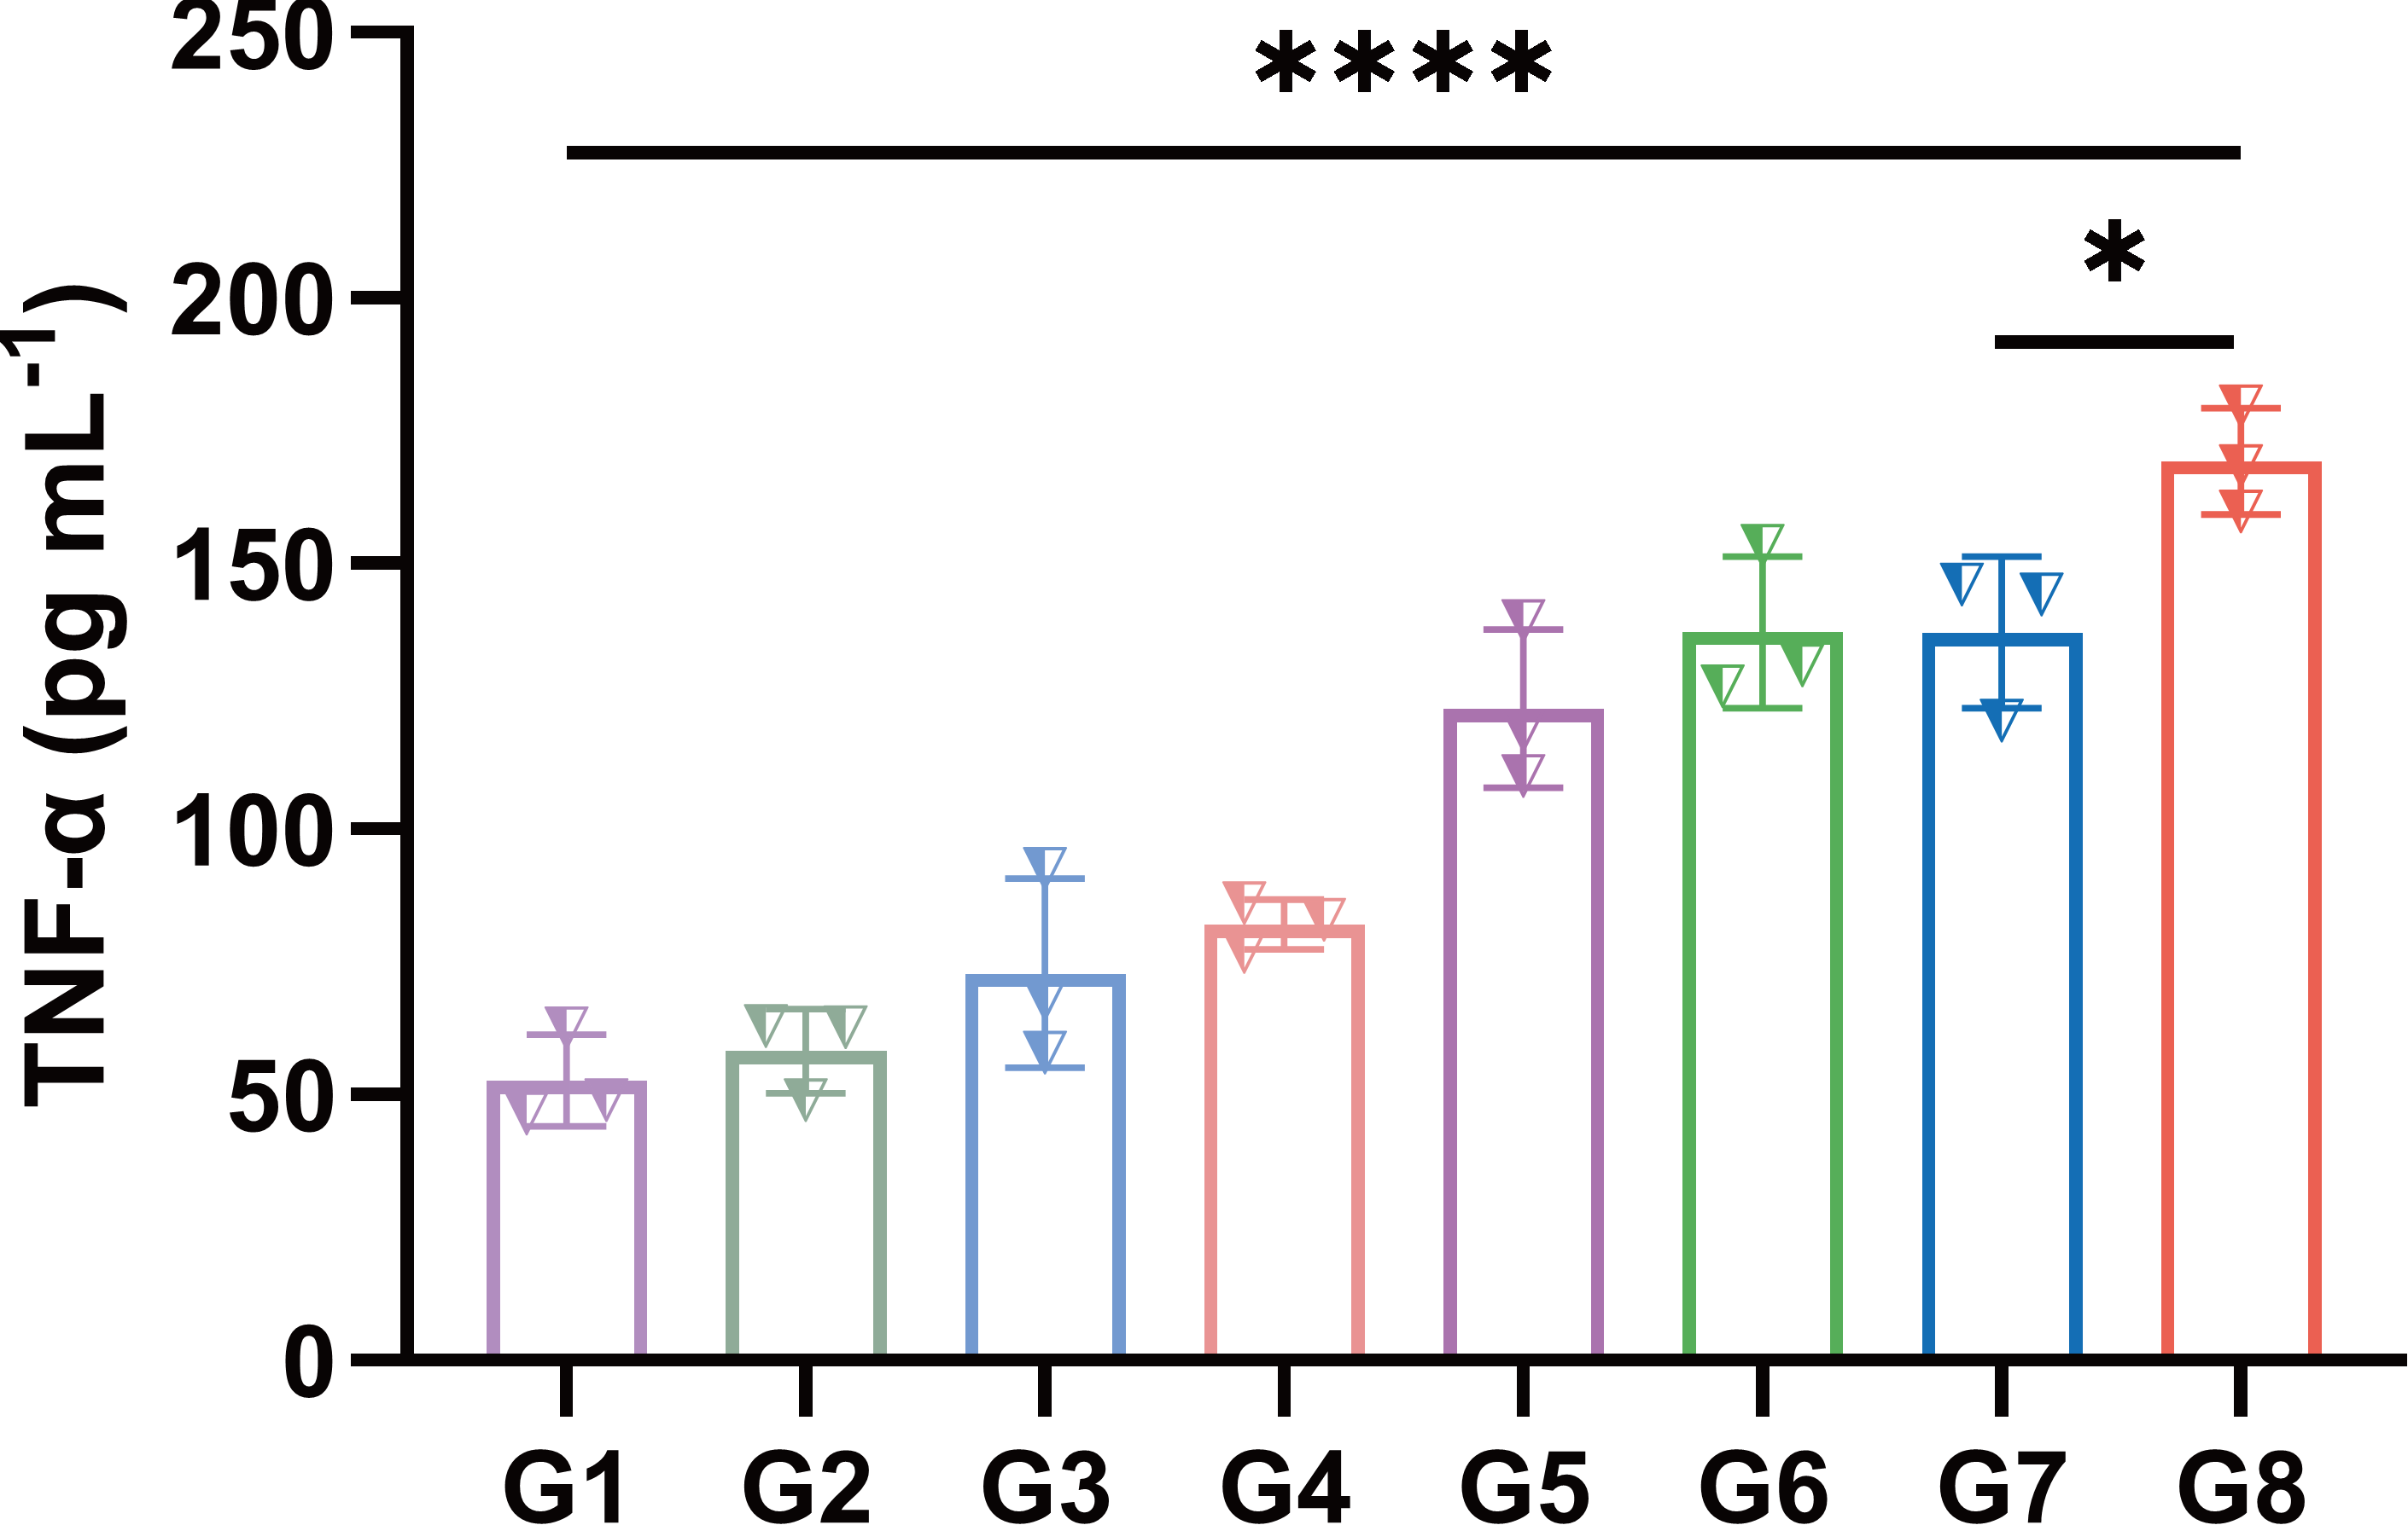
Figure S22. Quantitative ELISA analysis of the systemic pro-inflammatory cytokine TNF-α secreted in the serum of mice following diverse treatments. Data are presented as mean ± SD (n = 3 per group). Statistical significance was analyzed by one-way ANOVA. *p < 0.05, **p < 0.01, ***p < 0.001, ****p < 0.0001; ns, not significant.

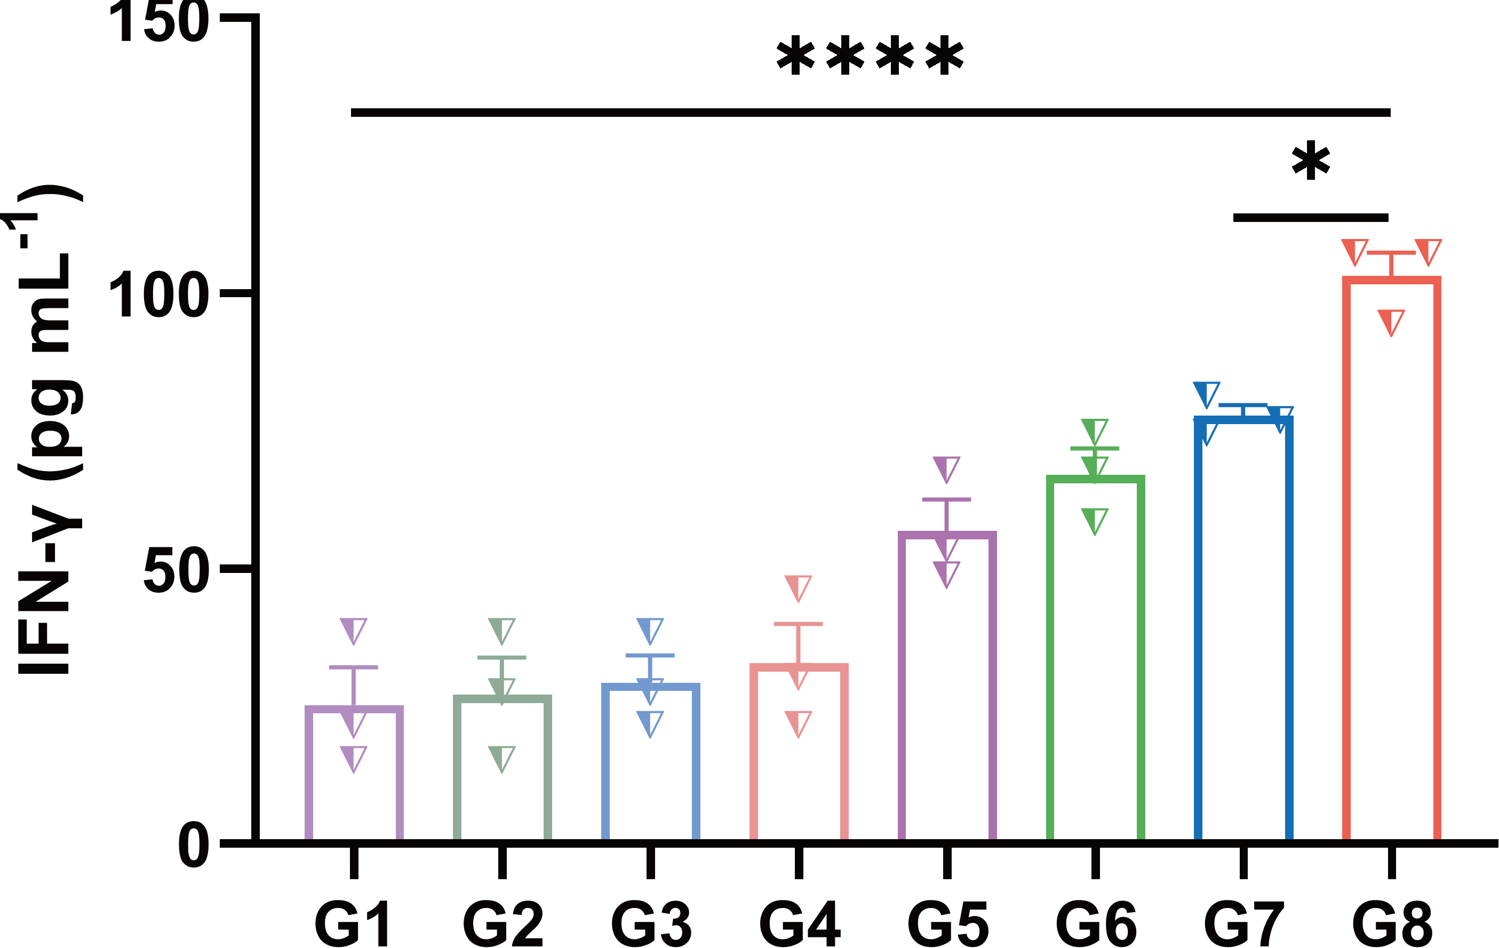

Figure S23. Quantitative ELISA analysis of the systemic pro-inflammatory cytokine IFN-γ secreted in the serum of mice following diverse treatments. Data are presented as mean ± SD (n = 3 per group). Statistical significance was calculated via one-way ANOVA, *p < 0.05, **p < 0.01, ***p < 0.001, ****p < 0.0001; ns, not significant.
Figure S24. Original, unedited Western blot images for in vitro cellular experiments. (A) Original, unedited raw scans with visible molecular weight markers (top) and the corresponding inverted, cropped images (bottom) from three independent biological replicates for in vitro cell cycle-related proteins (p-PLK1, Cyclin B1, CDK1, and β-actin), corresponding to main Figure 3C. (B) Original, unedited raw scans with visible molecular weight markers (top) and the corresponding inverted, cropped images (bottom) from three independent biological replicates for in vitro cGAS-STING pathway proteins, corresponding to main Figure 4G. Treatment groups are defined as follows: G1 (PBS), G2 (GSK461364), G3 (BSA-MnO₂), and G4 (GSK@BSA-MnO₂) without irradiation; G5 (PBS), G6 (GSK461364), G7 (BSA-MnO₂), and G8 (GSK@BSA-MnO₂) with 6 Gy X-ray irradiation.

Figure S25. Representative hierarchical gating strategies for all flow cytometry analyses. Across all independent experiments, cellular debris was first excluded based on forward and side scatter (FSC-A vs. SSC-A), followed by doublet discrimination (FSC-A vs. FSC-H) to gate exclusively on single cells. (A) Gating strategy for the measurement of intracellular ROS levels using the DCFH-DA probe (FITC channel). (B) Gating strategy for cell apoptosis analysis using Annexin V-FITC and PI co-staining.(C) Gating strategy for assessing calreticulin (CRT) membrane exposure; dead cells were excluded (Live gating) before evaluating CRT signals. (D) Gating strategy for mature dendritic cells (DCs) in tumor-draining lymph nodes; single cells were first gated for CD11c⁺, followed by the evaluation of CD80 and CD86 co-expression. (E) Gating strategy for spleen memory T cells; single cells were primarily gated for CD8⁺, followed by the quadrant analysis of CD44 and CD62L populations. (F) Gating strategy for tumor-infiltrating T lymphocytes; the general lymphocyte population was selected, gated for CD3⁺ T cells, and subsequently analyzed for CD4 and CD8 expression. (Note: Cell cycle analysis was performed directly on single cells using the built-in cell cycle modeling module in FlowJo software without requiring further sub-population gating).

