S1. GO-BP enrichment analysis of ligands involved in the crosstalk between proximal tubular (PT) cells and macrophages. (a) GO-BP enrichment analysis of ligands derived from PT cells that act on monocyte-macrophages. (b) GO-BP enrichment analysis of ligands derived from monocyte-macrophages that act on PT cells.
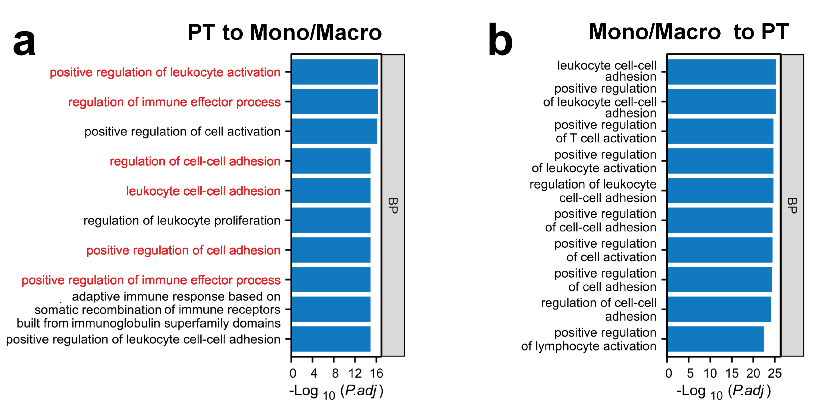

S2. IHC staining of CD80 in human kidney tissues. (a) Representative IHC images of CD80. (b) Quantification of CD80 intensity (n=3). *, P < 0.05.

S3.Upregulated macrophage chemokines in AKI-related transcriptomes. (a) Upregulated macrophage chemokines in cisplatin-induced injured HK-2 cells (GSE246133). (b) Upregulated macrophage chemokines in in TNFα-induced induced HK-2 cells (GSE254359). (c) Upregulated macrophage chemokines in the kidney tissue of cisplatin-induced (CP) AKI mice (GSE165100). (d) Upregulated macrophage chemokines in the kidney tissue of Ischemia-Reperfusion-induced (IR) AKI mice (GSE267650). (e) Upregulated macrophage chemokines in PT cells of AKI patients with undefined-cause (GSE210622).

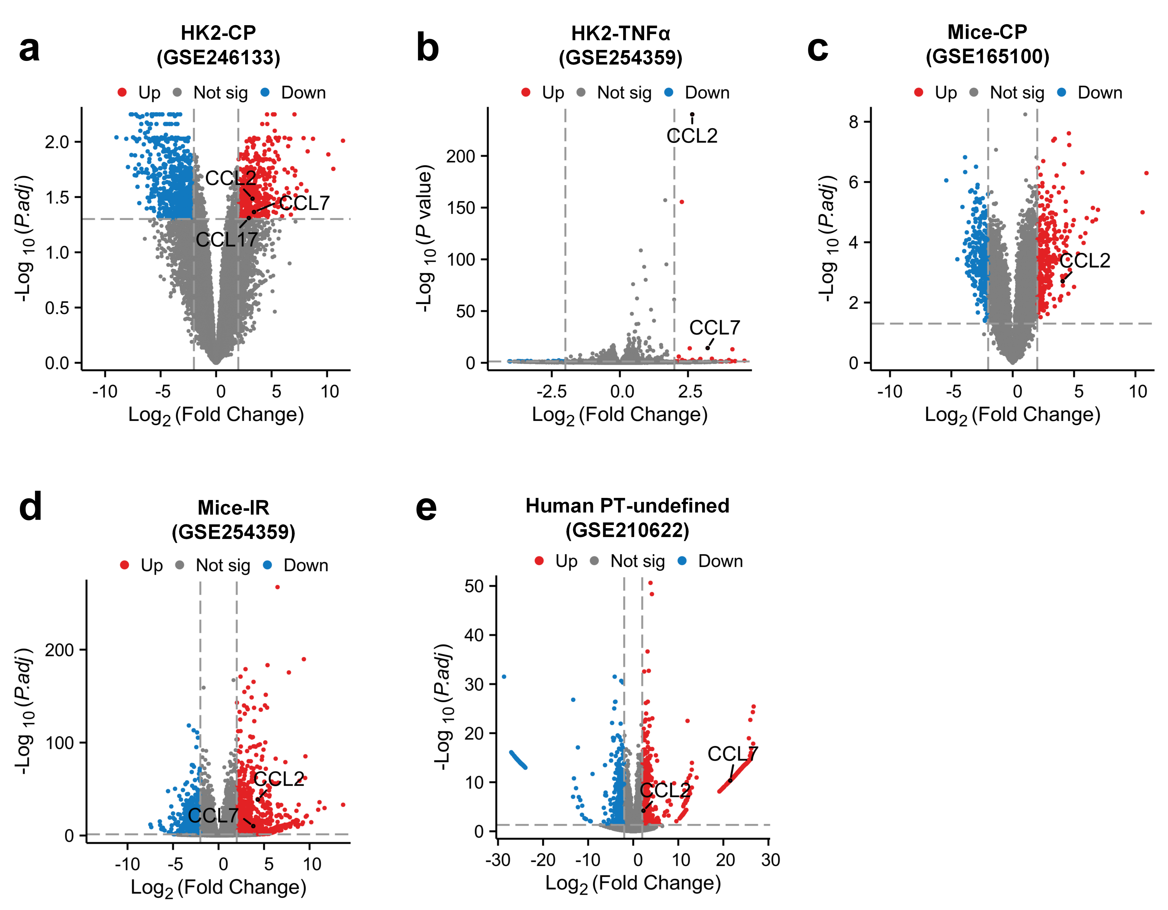

S4.Detection of CCL2 in the culture supernatant of HK-2 cells. ****, P< 0.0001.

S5. Validation of CCR2 overexpression. (a) qPCR analysis of CCR2 on the CCR2-RAW cells and RAW264.7 cells (n=6). (b,c) Representative western blot images and quantification of CCR2 protein levels inCCR2-RAW cells and RAW264.7 cells.****, P< 0.0001.

S6.Mass spectrometry results of cell membrane extracts.

S7.Determination results of drug loading capacity (a) and encapsulation efficiency (b).*, P < 0.05; **, P < 0.01; ***, P < 0.001; ****, P < 0.0001.

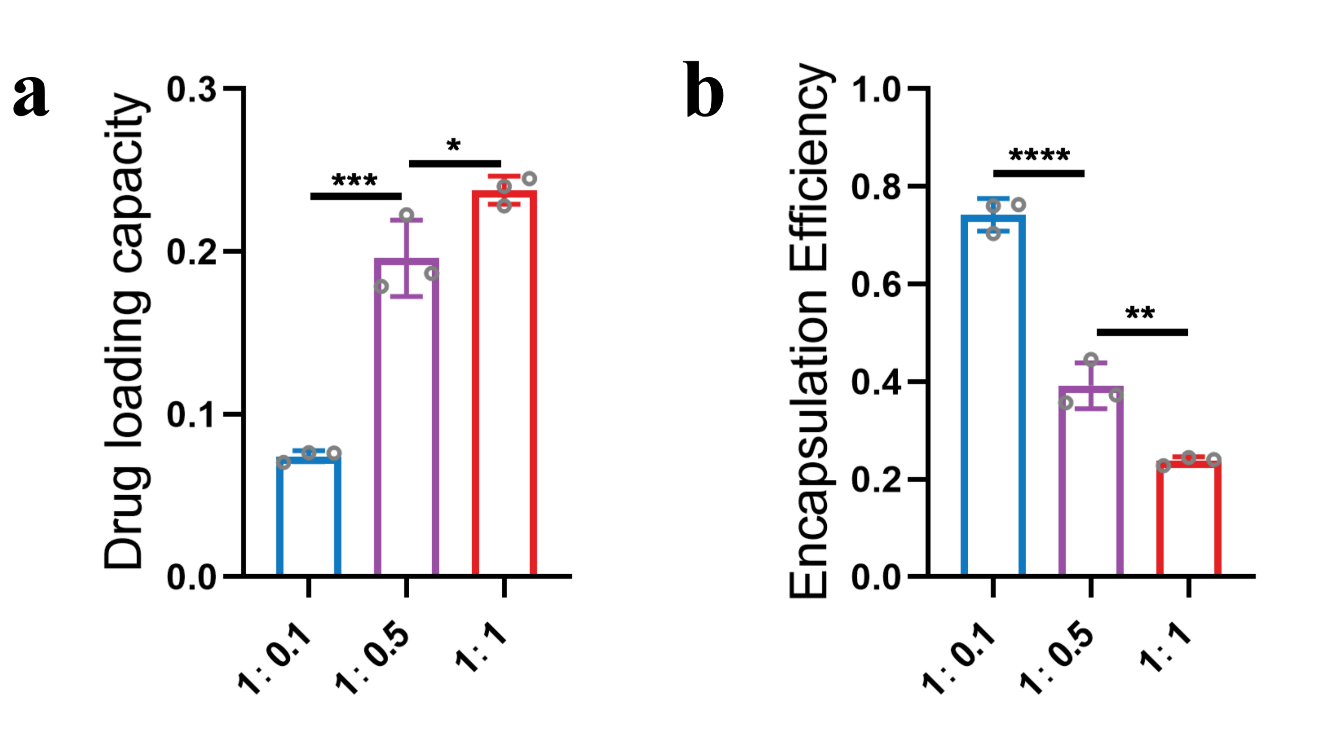

S8.Free NAD⁺ concentration.**, P < 0.01; ****, P < 0.0001.
S9. Spectrum curve of normal saline (NS), NAD⁺, CM2c, and N@CM2c.

S10.Cellular uptake of N@CM2c. (a) Representative fluorescence images of Dil-labled N@CM2c in HK-2 cells and RAW264.7 cells. (b) Quantification of the mean red fluorescence intensity per cell. ***，P<0.001.
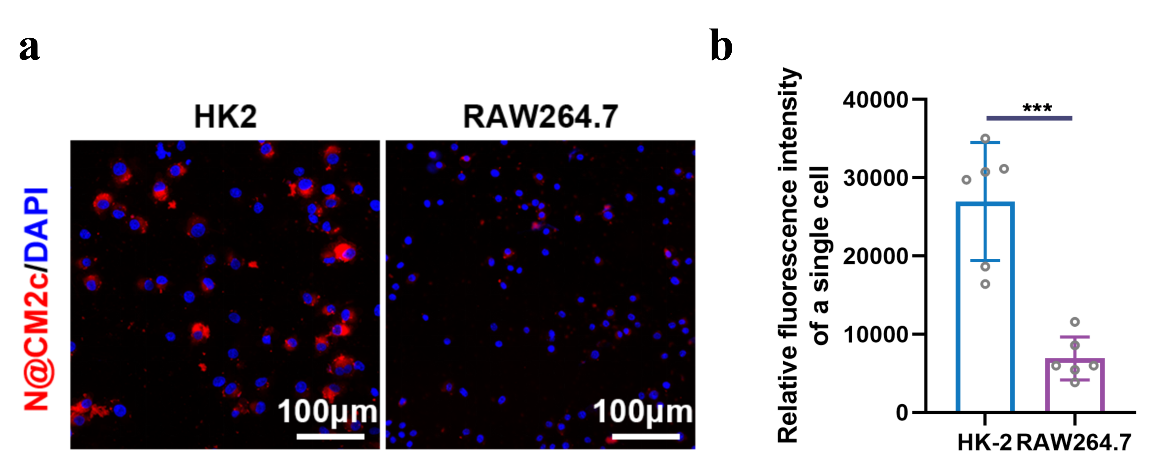

S11. Colocalization of N@CM2c and CCL2 in mouse renal tissues. (a) Representative fluorescence images of Cy5-labeled N@CM2c with AF488 labeled CCL2 in frozen mouse kidney sections. (b) Relative fluorescence intensity within the area outlined by white dashed lines in panel (a).
S12.Detection results of NAD⁺ and NAD⁺/NADH levels in mice kidney tissue (n=6).*, P < 0.05; **, P < 0.01; ***, P < 0.001; ****, P < 0.0001; ns, not significant.

S13.Detection results of NAD⁺ and NAD⁺/NADH levels in HK-2 cells (n=6).*, P < 0.05; **, P < 0.01; ***, P < 0.001; ****, P < 0.0001; ns, not significant.

S14. Detection results of NAD⁺ and NAD⁺/NADH levels in RAW264.7 cells (n=6).**, P < 0.01.

S15.Therapeutic effect of N@CM2c on ischemia-reperfusion-induced AKI in mice. (a,b) BUN and Scr levels in mice from different treatment groups. *, P < 0.05; ****, P < 0.0001; ns, not significant. (c) Representative images showing H&E staining and PAS staining in mouse kidney tissue. The blue arrows point to detached epithelial cells and casts, while green arrows point to significantly dilated renal tubules.
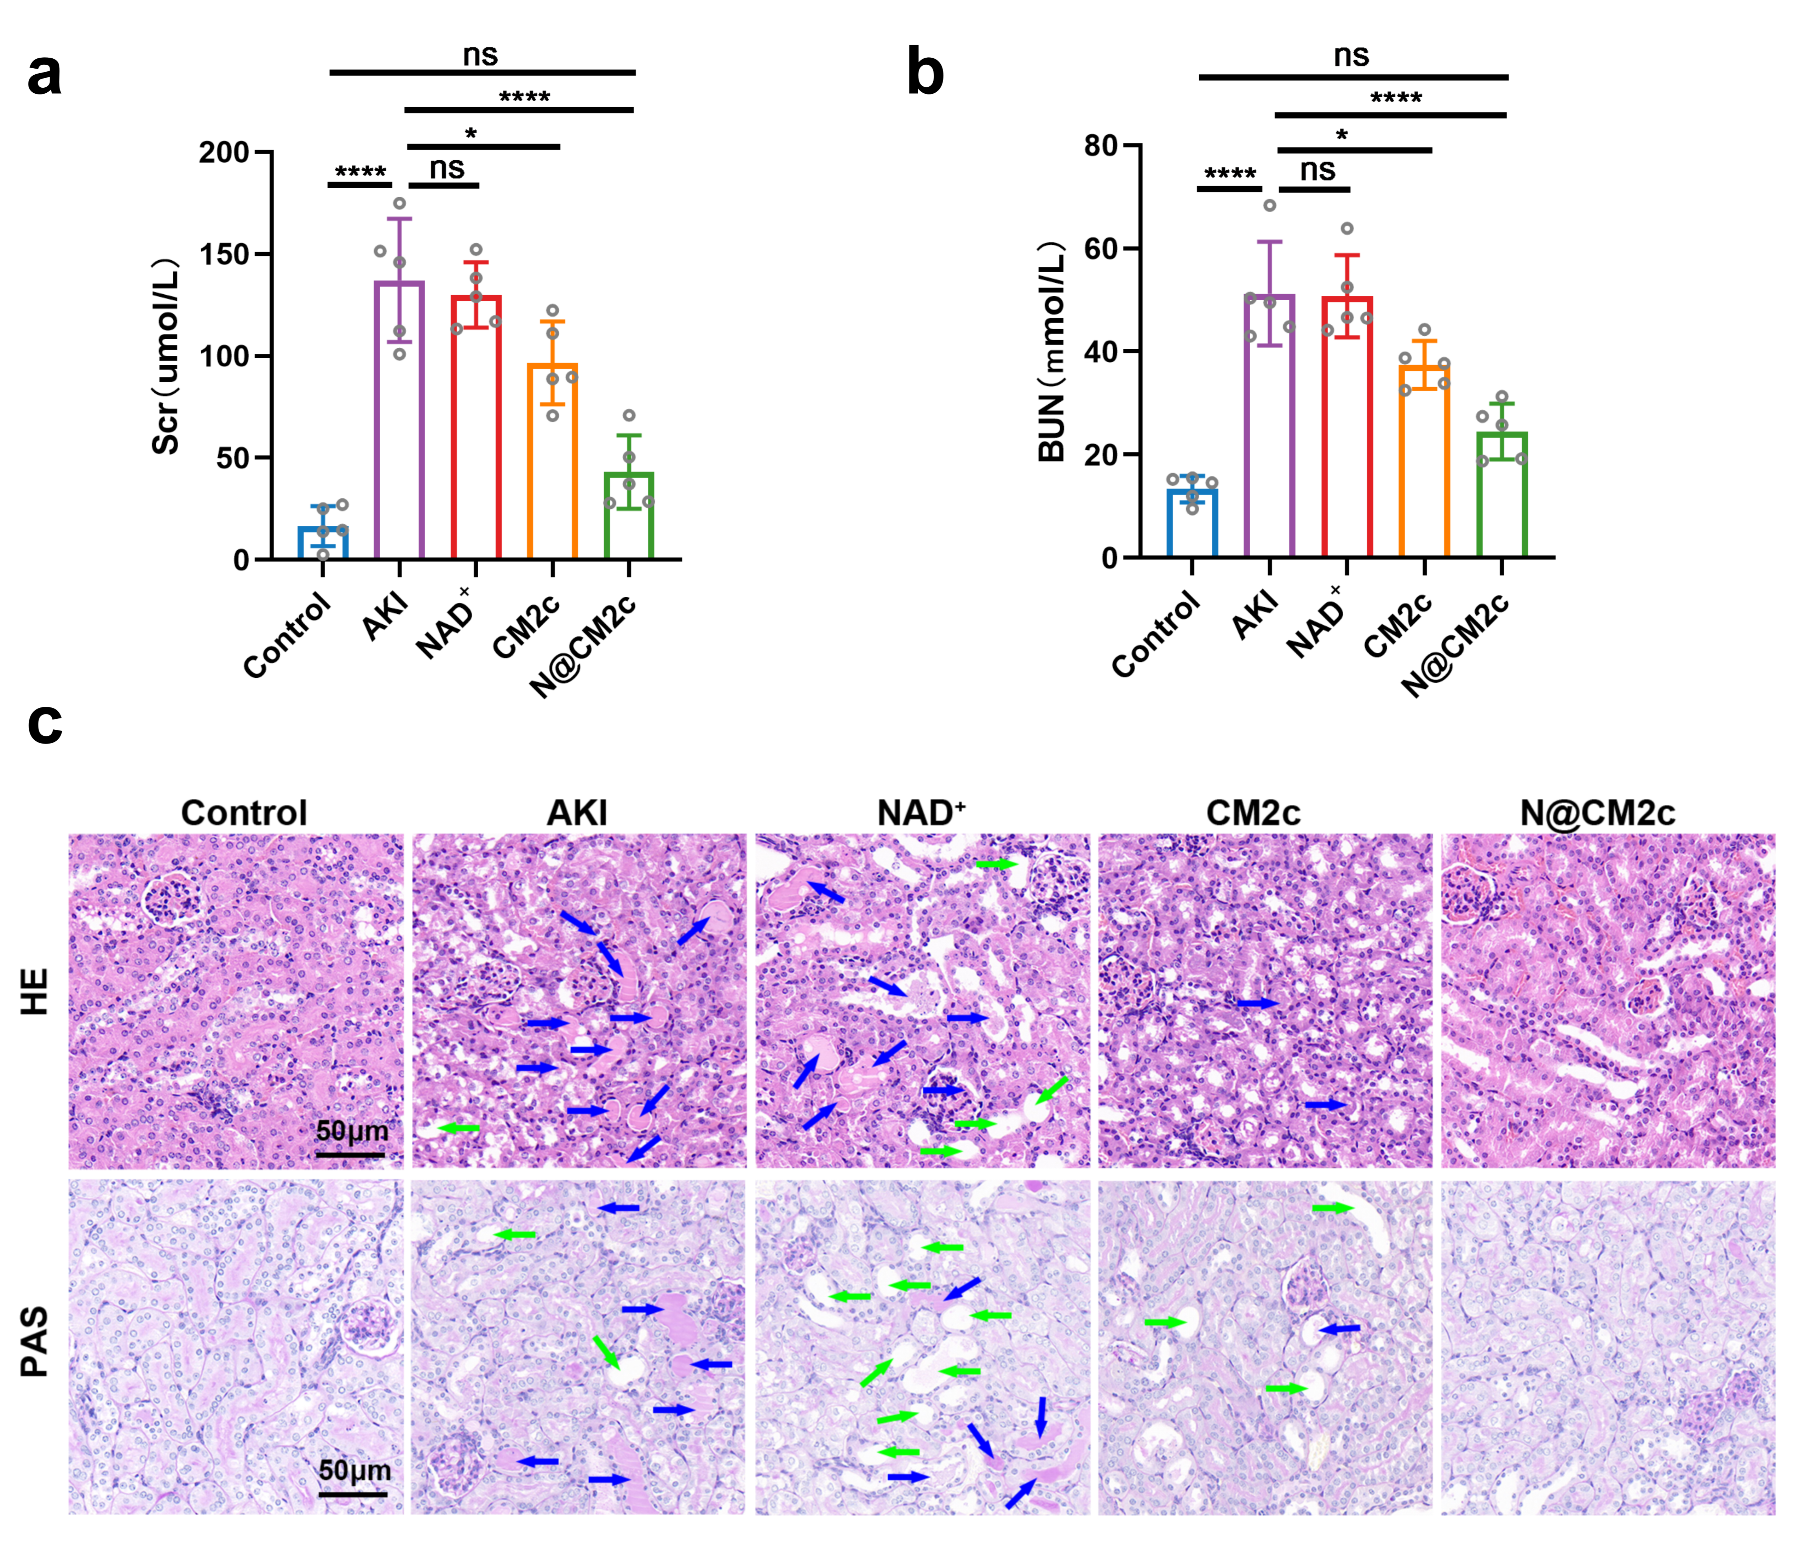

S16.Heat map of DEGs in mice kidney tissue.

S17.The expression features of DEGs in mice celltypes (Data were obtained from Mouse Cell Atlas,MCA3.0).
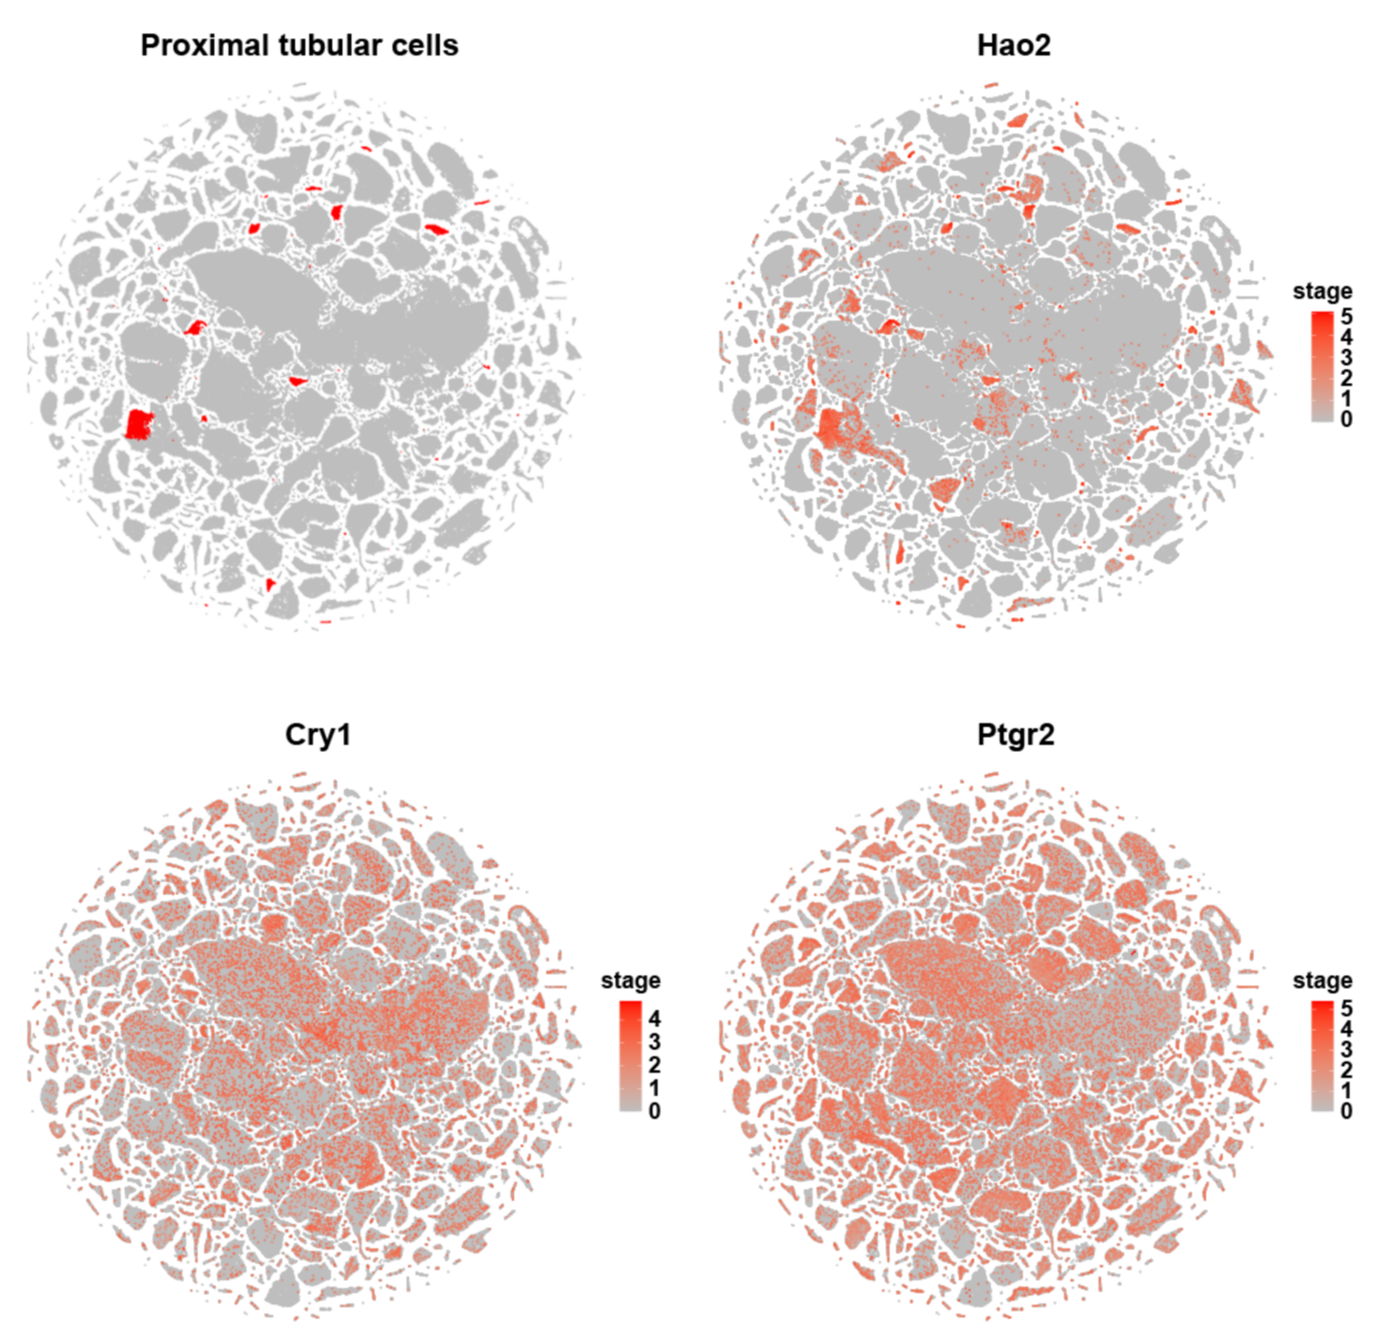

S18.The relative expression levels of HAO2 in human celltypes (Data were obtained from Human Protein Atlas).
S19.The expression features of DEGs in major celltypes of human kidney (Data were obtained from GEO database,GSE210622).

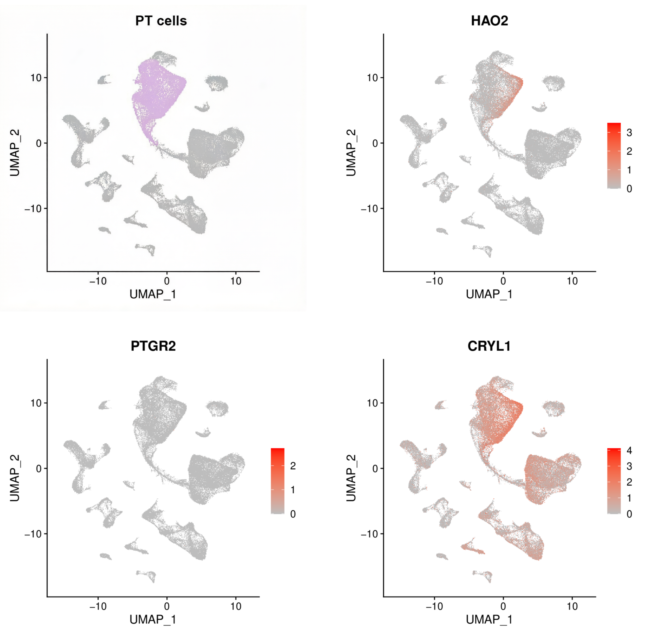

S20. N@CM2c promotes the expression of HAO2. (a) qPCR analysis of HAO2 in HK-2 cells. (b,c). Representative western blot images and quantification of HAO2 in HK-2 cells. *, P < 0.05; ***, P < 0.001; ****, P< 0.0001. ns, not significant.

S21. The binding modes between HAO2 and fatty acids. (a) The binding mode of HAO2 and Lauric Acid. (b) The binding mode of HAO2 and Linoleic Acid. (c) The binding mode of HAO2 and Myristic Acid. (d) The binding mode of HAO2 and Palmitic acid. (e) The binding mode of HAO2 and Elaidic acid. (f).The binding mode of HAO2 and Stearic acid.

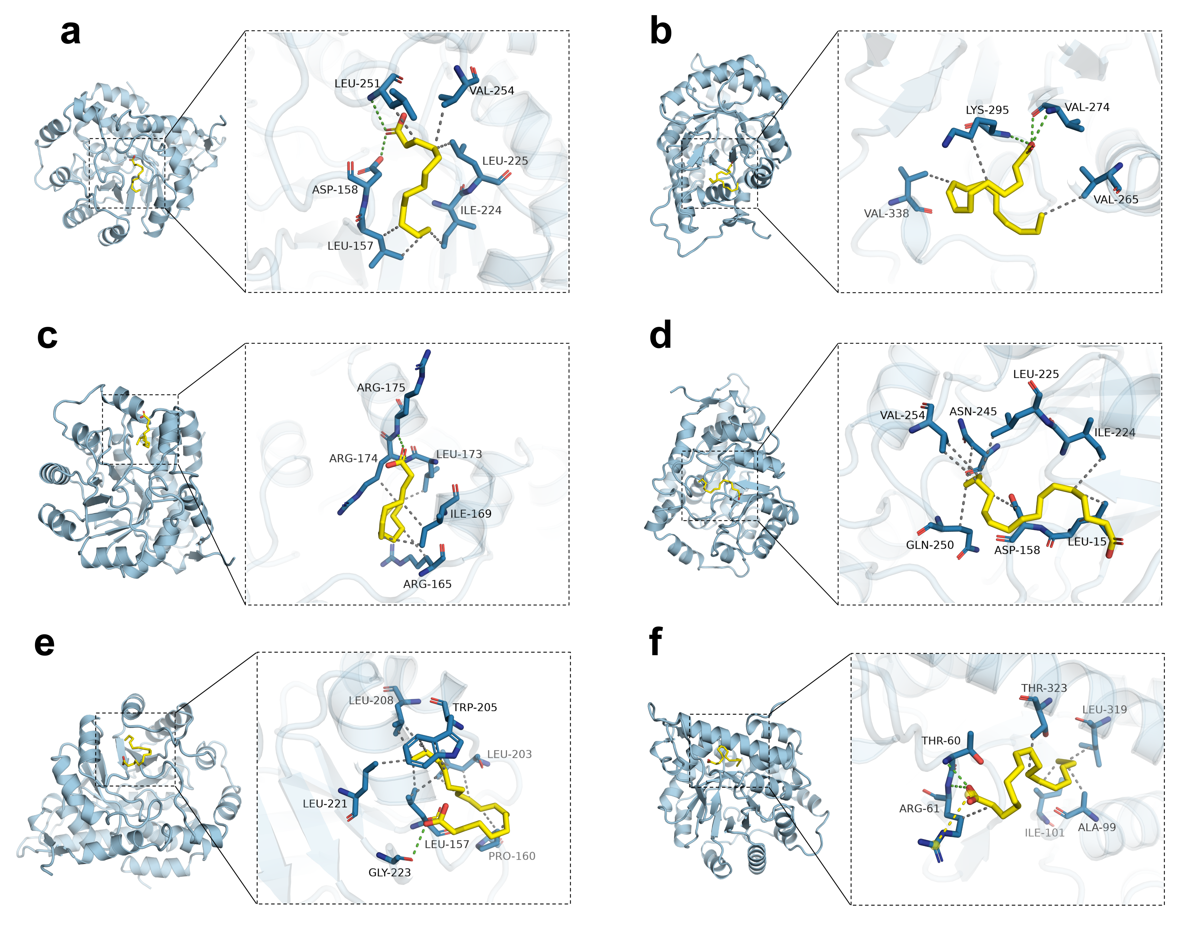

S22.Representative Cellular Thermal Shift Assay images and summary of HAO2 in HK-2 cells (n=3). DMSO, Dimethyl Sulfoxide. AA, Arachidonic Acid.

S23.Effects of HAO2 knockdown on free fatty acids and the TLR4 signaling pathway.(a) Representative western blot images of TLR4 and HAO2 in HK-2 cells. (b) Quantification of HAO2 protein levels (n=3). (c) Relative free fatty acid levels in HK-2 cells (n=5). (d) ATP levels in HK-2 cells (n=6). (e) Quantification of TLR4 protein levels (n=3). (f) IL-1β levels in HK-2 cell culture supernatant (n=6). (g) IL-6β levels in HK-2 cell culture supernatant (n=6). *, P < 0.05; **, P < 0.01; ***, P < 0.001; ****, P < 0.0001; ns, not significant.

S24. Detection of macrophage markers in mice kidney tissue. (a) Representative immunofluorescence images of CD86 and CD206 in kidney tissue of mice (n=4). (b) Quantification of relative fluorescence intensity of CD86. (c) Quantification of relative fluorescence intensity of CD206. (d) Detection of CD206 expression in single-cell suspensions of mouse renal tissue by flow cytometry. (e) Statistical analysis for CD206-positive cell proportion.*, P < 0.05; **, P < 0.01; ***, P < 0.001; ****, P < 0.0001; ns, not significant.

S25.Effects of nanovesicles derived from different macrophage membranes on macrophage polarization markers. (a) Representative western blot images showing iNOS and Arg1 protein expression levels in RAW264.7 cells. (b) Quantification of Arg1 protein levels (n=3). (c) Quantification of iNOS protein levels (n=3). *, P < 0.05; **, P < 0.01; ***, P < 0.001; ****, P < 0.0001; ns, not significant.

S26.Heat map of DEGs in raw264.7 cells.

S27.Detection results of IL-1β and IL-6 in raw264.7 cell culture supernatant (n=6). *, P < 0.05; **, P < 0.01; ***, P < 0.001; ****, P < 0.0001.

S28.Detection of signature proteins for macrophage phenotypes. (a) Representative western blot images of iNOS and Arg1 in RAW264.7 cells. (b) Quantification of iNOS protein levels (n=3). (c) Quantification of Arg1 protein levels (n=3).*, P < 0.05; **, P < 0.01.

S29. Effects of NAD⁺ on M2 macrophage polarization following SIRT6 knockdown. (a) Representative western blot images of CD206, Arg1, and SIRT6 in RAW264.7 cells. (b) Quantification of CD206 protein levels (n=3). (c) Quantification of Arg1 protein levels (n=3). (d) Quantification of SIRT6 protein levels (n=3). *, P < 0.05; **, P < 0.01; ***, P < 0.001; ****, P < 0.0001; ns, not significant.

Table S1. Macrophage chemokines obtained from the UniProt database.
Entry | Gene Names | Reviewed
P51671 | CCL11，SCYA11 | Reviewed
Q92583 | CCL17，SCYA17，TARC | Reviewed
P55774 | CCL18，AMAC1，DCCK1，MIP4，PARC，SCYA18 | Reviewed
P13500 | CCL2，MCP1，SCYA2 | Reviewed
O00585 | CCL21，SCYA21，UNQ784/PRO1600 | Reviewed
O00626 | CCL22，MDC，SCYA22 A-152E5.1 | Reviewed
O15444 | CCL25，SCYA25，TECK | Reviewed
P80098 | CCL7，MCP3，SCYA6，SCYA7 | Reviewed
Q6UXB2 | CXCL17，VCC1，UNQ473/PRO842 | Reviewed
Q96LR4 | TAFA4，FAM19A4 | Reviewed
Q7Z5A7 | TAFA5，FAM19A5，UNQ5208/PRO34524 | Reviewed

Table S2. Docking score between HAO2 and pro-inflammatory fatty acids.
Target name | Ligand name | Docking score (kcal/mol)
HAO2 | Arachidonic Acid | -5.853
HAO2 | Palmitic acid | -4.979
HAO2 | Elaidic acid | -4.684
HAO2 | Lauric Acid | -4.081
HAO2 | Myristic Acid | -4.009
HAO2 | Linoleic Acid | -3.908
HAO2 | Stearic acid | -3.524

Table S3. Antibodies.
Antibody | Application | Dilution ratio | Catalog | Source
Arginase-1 | WB | 1：10000 | A25808 | Abclonal
BAX | IF | 1:200 | ab263897 | Abcam
CCL2 | IHC | 1:100 | A7277 | Abclonal
CCR2 | WB  IF  FL | 1:1000  1:250  1:600 | ab273050 | Abcam
CD68 | IHC | 1:100 | GB113109-100 | Servicebio
CD80 | IHC | 1:500 | A16039SP | Abclonal
CD86 | IF | 1:100 | A1199SP | Abclonal
CD206 | IF | 1:200 | MA5-16871 | Invitrogen
CD206 | WB | 1:5000 | A21014 | Abclonal
HAO2 | WB  IHC | 1:500  1:100 | ab229817 | Abcam
iNOS | WB | 1:1000 | A3774 | Abclonal
KIM-1 | WB | 1:500 | ab233720 | Abcam
KIM-1 | IHC | 1:50 | PA5-98302 | Invitrogen
MerTK | WB | 1:1000 | ab300136 | Abcam
MerTK | FL  IF | 1:200  1:200 | 14-5751-82 | Invitrogen
SIRT6 | WB | 1:500 | A7416 | Abclonal
TLR4 | WB | 1:1000 | A5258 | Abclonal
β-Actin | WB | 1:80000 | AC026 | Abclonal
β-Tublin | WB | 1:5000 | AC008 | Abclonal
AF488 | IF | 1:250 | A-11008 | Invitrogen
AF546 | IF | 1:250 | A-11035 | Invitrogen
AF647 | IF | 1:500 | A-21247 | Invitrogen

Table S4. Baseline clinical characteristics of enrolled patients
Patient ID | Group | Primary Disease | Gender | Age  (years) | weight  (kg) | Serum creatinine  (μmol/L) | eGFR  (mL/min/1.73m²)
C01 | Control | Renal cell carcinoma  (adjacent non-tumor) | Male | 58 | 62 | 75 | 96.1
C02 | Control | Renal cell carcinoma  (adjacent non-tumor) | Female | 62 | 65 | 68 | 75.2
C03 | Control | Renal cell carcinoma  (adjacent non-tumor) | Male | 45 | 78 | 80 | 102.1
A01 | AKI | Drug-induced AKI | Male | 64 | 58 | 325 | 16.4
A02 | AKI | Drug-induced AKI | Female | 19 | 62 | 186 | 27.7
A03 | AKI | Drug-induced AKI | Male | 67 | 72 | 352 | 14.6
A04 | AKI | lupus nephritis | Female | 31 | 68 | 238 | 18.9
A05 | AKI | IgA nephropathy | Male | 53 | 71 | 310 | 18.8
Control group (Mean ± SD) |  |  |  | 55.0 ± 8.9 | 68.3 ± 7.6 | 74.3 ± 6.0 | 91.3 ± 14.3
AKI group (Mean ± SD) |  |  |  | 46.8 ± 21.0 | 66.2 ± 5.5 | 282.2 ± 64.2 | 19.3 ± 5.0

