Supplementary Materials for
Co‑Assembled Nanoparticles for Treatment of Chronic Musculoskeletal Pain by Reprogramming Neuro‑Immune Crosstalk and Redox Homeostasis
Xiaoning Gao^{1, †}, Yan Liu^{1, †}, Zhuo Sun¹, Xiaoke Li¹, Siqin Zhang²,
Bo Zhang^{3,} *, Hongchang Guo^{4,} *, Jun Kang^{1,} *
¹ School of Life Sciences, Tianjin University, 92 Weijin Road, Nankai District, Tianjin 300072, China.
² China Telecom Cloud Technology Co., Ltd, No.33, Xitucheng Road, Haidian District, Beijing 100010, China.
³ Institute for TCM-X, MOE Key Laboratory of Bioinformatics, Bioinformatics Division, BNRist, Department of Automation, Tsinghua University, No.30 Shuangqing Road, Haidian District, Beijing 100084, China.
⁴ Department of Cardiovascular Surgery, Beijing Anzhen Hospital, Capital Medical University, Beijing, China.

* Corresponding authors:
Corresponding author: Jun Kang, jun.kang@tju.edu.cn;
Corresponding author: Hongchang Guo, guohongchang@ccmu.edu.cn.
Corresponding author: Bo Zhang, zhangbo.2007@tsinghua.org.cn;

† These authors contributed equally to this work.

This PDF file includes:
Supplementary Figures. S1 to S11
Supplementary Tables. S1 to S2

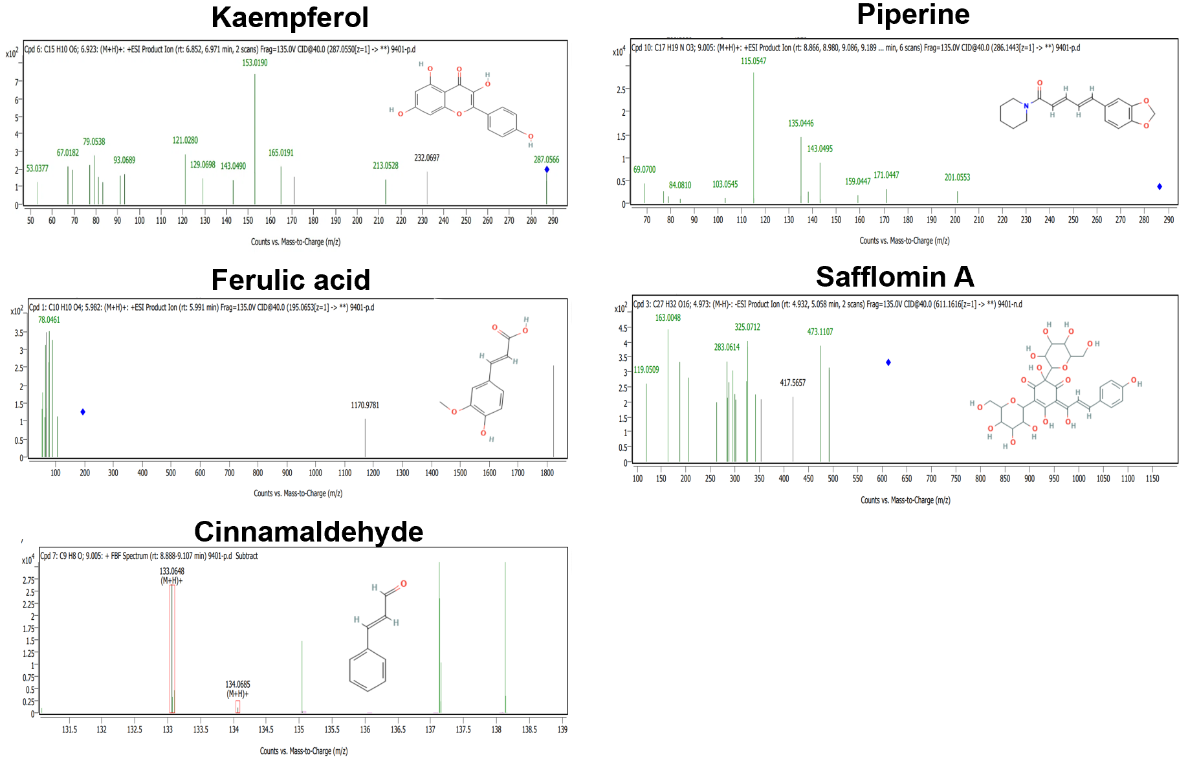
Supplementary Figures:
Fig. S1. The MS/MS spectra of five key components identified in TLQT NPs.
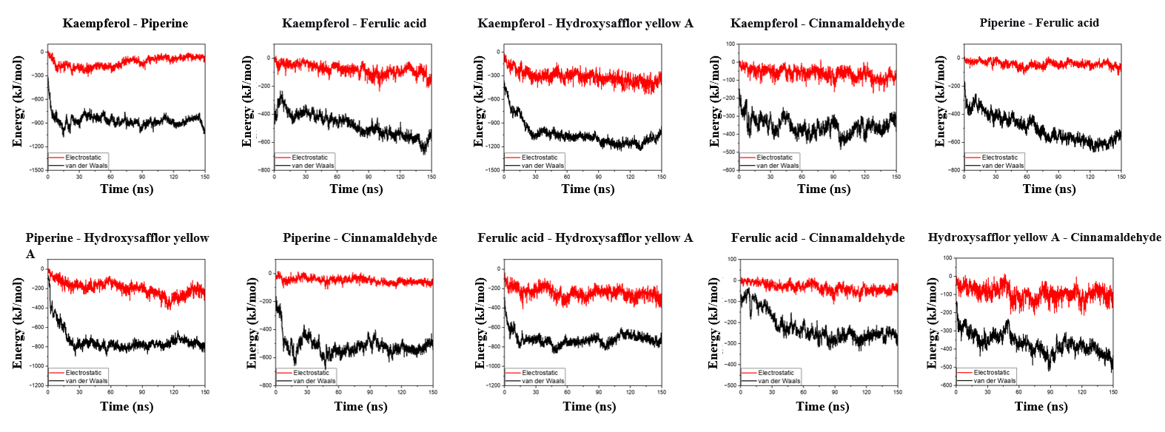
Fig. S2. The interaction energies between different molecules in the simulation system. Red: electrostatic interaction energy; Black: van der Waals interaction energy.

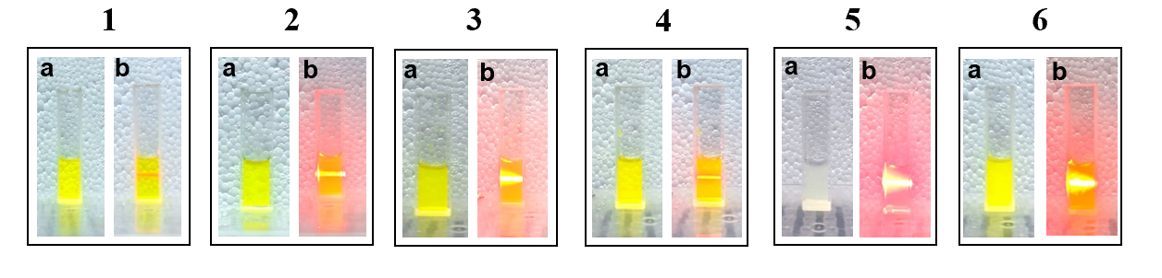
Fig. S3. The morphology and Tyndall effect of co-assembled nanoparticles with different compositions. Composition of the six formulations (1–6) used for co-assembly. Formulation 1 contained all five components (kaempferol, piperine, ferulic acid, safflomin A, and cinnamaldehyde). Formulations 2, 3, 4, 5, and 6 were prepared by omitting kaempferol, piperine, ferulic acid, safflomin A, and cinnamaldehyde, respectively.
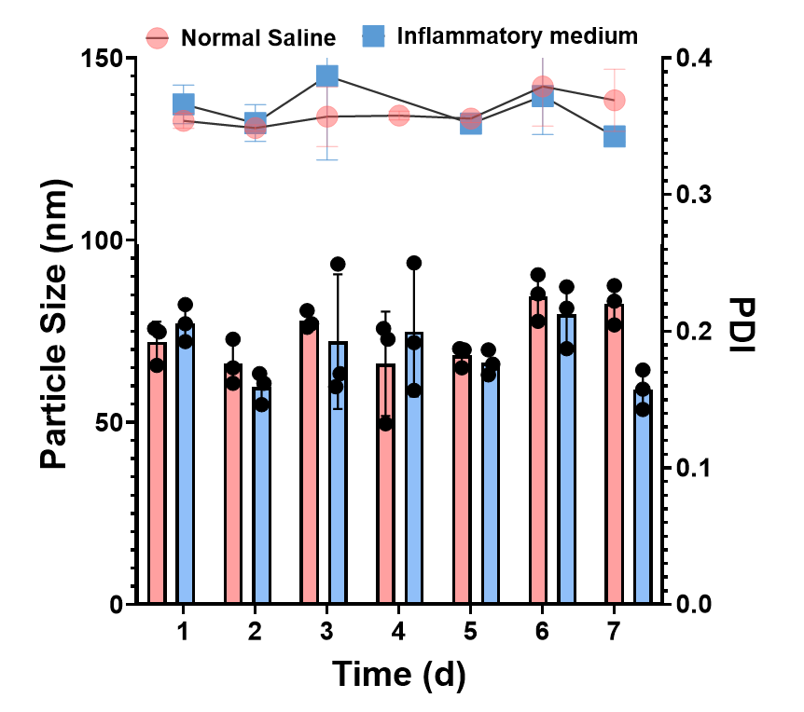
Fig. S4. Hydrodynamic diameter and Polydispersity Index (PDI) of TLQT-NPs in normal saline (red) and inflammatory medium with IL-1β and TNF-α (blue) over 7 days.

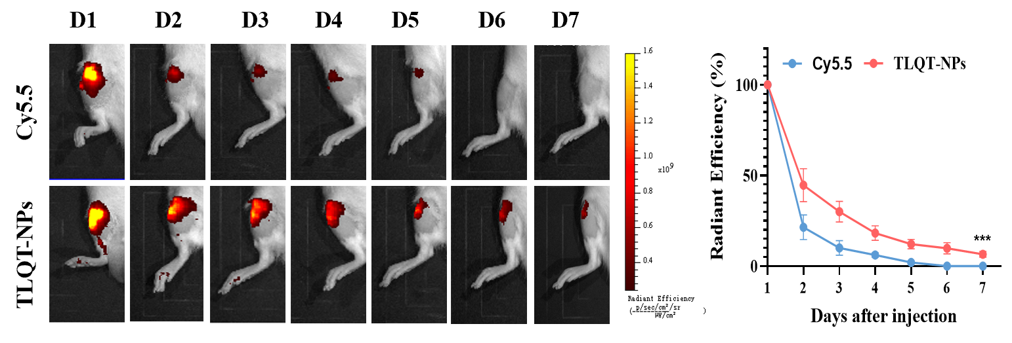
Fig. S5. Representative IVIS images within 7 days after a single intra-articular injection of free Cy5.5 or Cy5.5-labeled TLQT-NPs into SD rat joints. Color scale, relative radiant efficiency (Left). Quantitative analysis of normalized time‑course fluorescence radiant efficiency in rat knee joints over 7 days (Right).
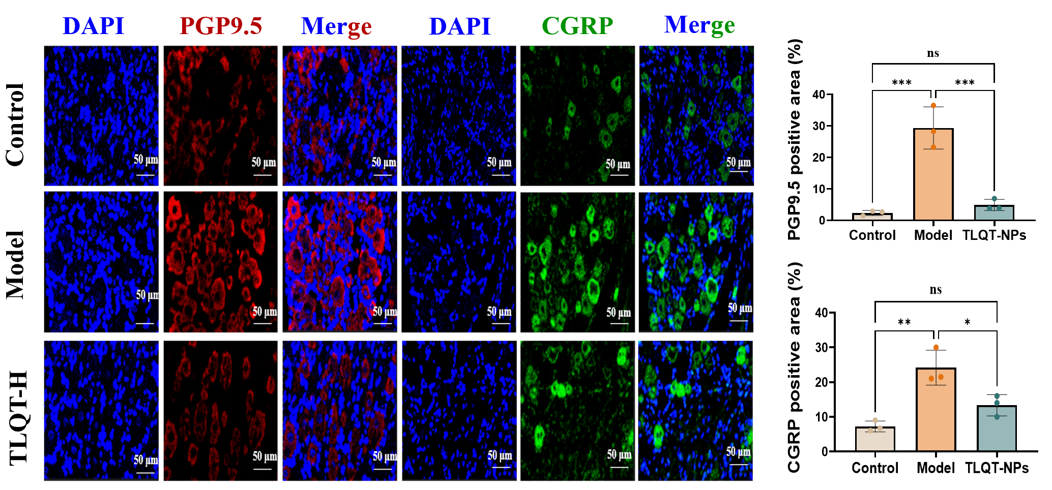
Fig. S6. Representative immunofluorescence images of rat dorsal root ganglia (left) showing PGP9.5 (red), CGRP (green) and DAPI (blue); scale bar = 50 μm. Quantification of positive area (%) for PGP9.5 and CGRP was shown on the right. Data were shown as mean ± SD, one‑way ANOVA.

Fig. S7. Heatmap showed DEGs decreased in the model group and elevated after TLQT NPs treatments.
Fig. S8. Heatmap showed DEGs elevated in the model group and decreased after TLQT NPs treatments.

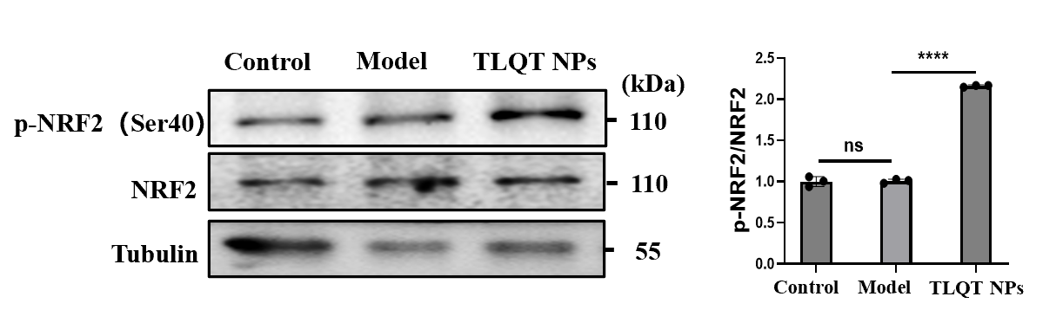
Fig. S9. Western blotting to detect the effects of TLQT-NPs on NRF2 Ser40 phosphorylation in joint tissues (Left). Semi‑quantitative analysis of p‑NRF2/NRF2 ratios (Right). Data were presented as mean ± SD (n = 3). ns, not significant. ****p < 0.0001(one-way ANOVA).
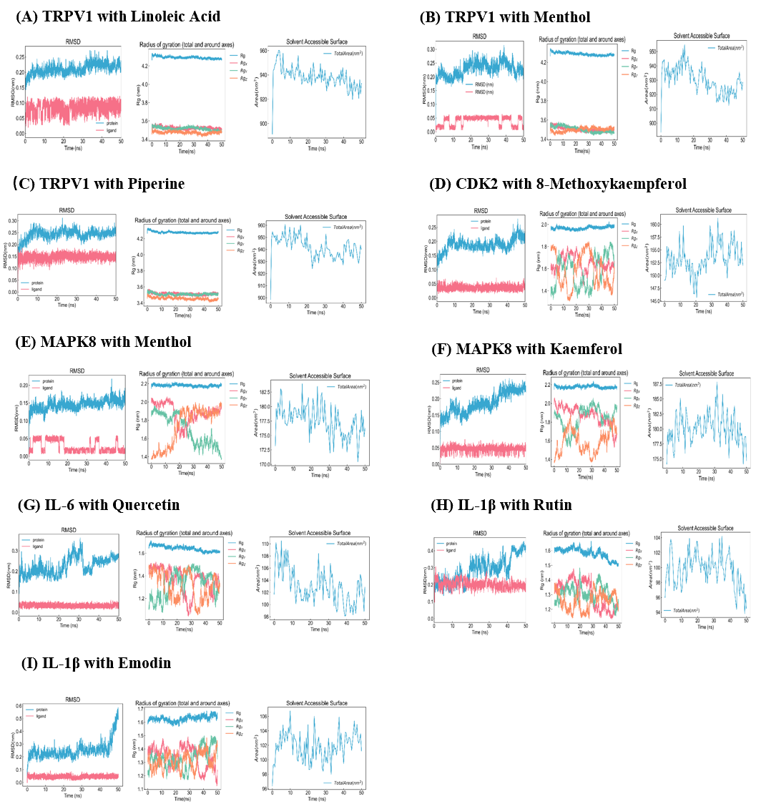
Fig. S10 MD trajectory analyses for protein–ligand complexes (50 ns). Each panel (A–I) shows three plots for the indicated target–ligand pair: left, RMSD; middle, radius of gyration (Rg) and right, solvent accessible surface area (SASA).
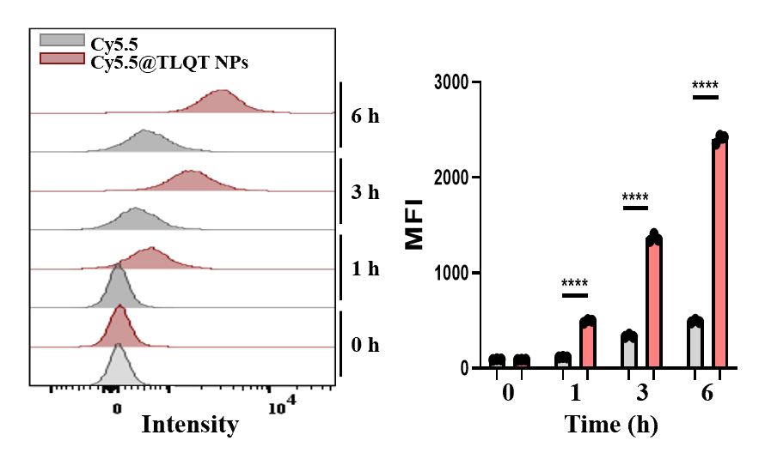
Fig. S11. Flow cytometry histograms (left) show intracellular fluorescence intensity of BMDCs incubated with free Cy5.5 (gray) or Cy5.5@TLQT‑NPs (red) for 0, 1, 3 and 6 h. Quantification of mean fluorescence intensity (MFI, right) demonstrated significantly greater and time‑dependent uptake of Cy5.5@TLQT‑NPs than free dye. Data were presented as mean ± SD (n = 3). ns, not significant. ****p < 0.0001(one-way ANOVA).

Table S1. Co-assembly formulations for omission experiments
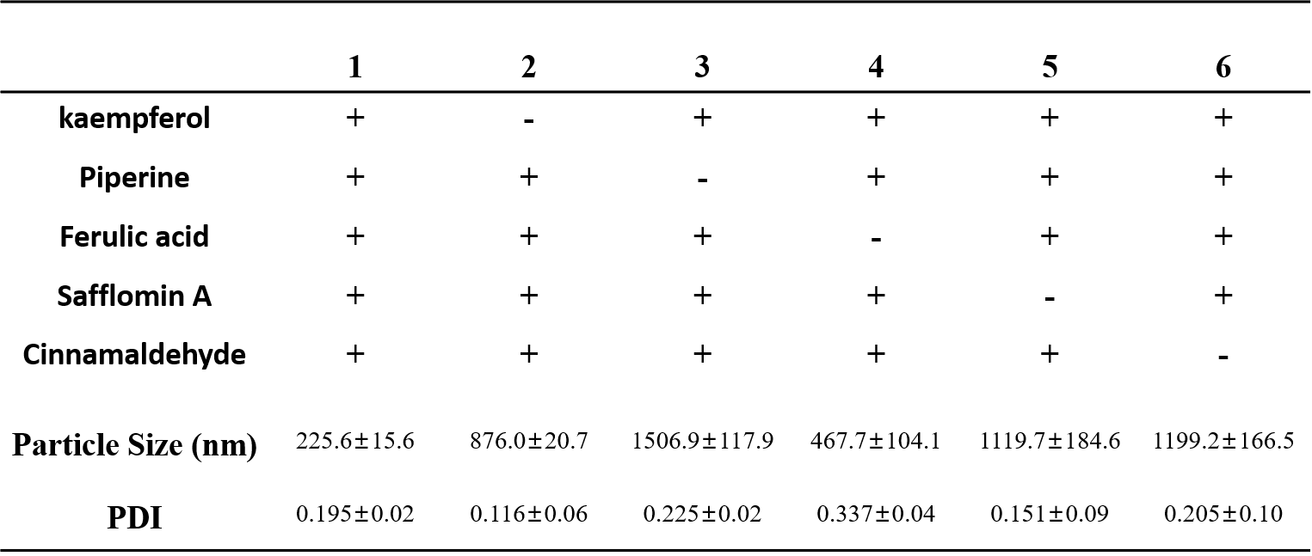

Table S2. Docking affinity (kcal/mol) of target–ligand complexes
Target | Drug | Molecular | Affinity (kcal/mol)
TRPV1 | RG | linoleic Acid | -6.1
TRPV1 | BHN | menthol | -5.6
TRPV1 | BJ | piperine | -8.7
CDK2 | GJ | 8-Methoxykaempferol | -8.5
MAPK8 | BHN | menthol | -5.1
MAPK8 | HH、SN、DX | kaempferol | -9.1
IL-6 | HH、HJ | quercetin | -6.5
IL-1β | HH | rutin | -7.4
IL-1β | HH | emodin | -7.0

