Synthesis, preclinical evaluation, and the first-in-human study of [¹⁸F]AlF-NOTA-FZSR for neuroendocrine neoplasms compared with [⁶⁸Ga]Ga-DOTA-NOC and [⁶⁸Ga]Ga-DOTA-TATE
Xuwei Liu^{a,b†}, Panli Li^{a†}, Junyan Xu^{a†}, Fengsheng Zhangª, Xiaoping Xuª, Jianping Zhangª, Simin Heª, Ying Qiaoª, Zhengwen Huangª, Jie Chen^{f*}, Jindian Li^{a,c,d,e*} and Shaoli Song^{a*}

ª Department of Nuclear Medicine, Fudan University Shanghai Cancer Center, Shanghai 200032, P.R. China; Department of Oncology, Shanghai Medical College and Center for Biomedical Imaging, Fudan University, Shanghai 200032, P. R. China; Center for Biomedical imaging, Fudan University, Shanghai, China; Shanghai Engineering Research Center of Molecular Imaging Probes, Shanghai 200032, P. R. China; Key Laboratory of Nuclear Physics and Ion-beam Application (MOE), Fudan University, Shanghai, China; Department of Nuclear Medicine, Shanghai Proton and Heavy Ion Center. Shanghai, China;
^{b} Wuxi School of Medicine, Jiangnan University, Wuxi, China;
^{c} State Key Laboratory of Complex, Severe, and Rare Diseases, Beijing 102602, China;
^{d} The State Key Laboratory of Oral Diseases, Sichuan 610041, China;
^{e} State Key Laboratory of Metabolic Dysregulation & Prevention and Treatment of Esophageal Cancer (Zhengzhou University), Zhengzhou 450000, China;
^{f} Center of Neuroendocrine Tumour, Fudan University Shanghai Cancer Center, Shanghai, China;
*Address correspondence to: shaoli-song@163.com; jindianli99@126.com; chen0jie@hotmail.com
†These authors contribute equally to this work.

Supplementary Figures
Figure S1 Schematic diagram of the synthesis steps for NOTA-SLPV and NOTA-FZSR.
Figure S2 Mass spectrum characterization of the probes after DOTA/NOTA modification.
Figure S3 A screenshot of the Trasis interface showing the installation diagram for the tubing kit on the miniAiO.
Figure S4 Properties of the [⁶⁸Ga]Ga-DOTA-SLP1, [⁶⁸Ga]Ga-DOTA-SLP2, [⁶⁸Ga]Ga-DOTA-SLP2P, [⁶⁸Ga]Ga-DOTA-SLP3, and [⁶⁸Ga]Ga-DOTA-SLP4.
Figure S5 Schematic representation of 2D and 3D molecular docking.
Figure S6 Figure S6 NOTA-FZSR affinity experiment. A Cellular uptake of [⁶⁸Ga]Ga-NOTA-FZSR in AR42J cells with and without receptor blocking. B Micro-PET/CT blocking study of [⁶⁸Ga]Ga-NOTA-FZSR in AR42J xenograft-bearing mice
Figure S7 The distribution of patient organ.
Supplementary Tables
Table.S1 Partition coefficient and pharmacokinetic analysis.
Equipment
The ⁶⁸Ge-⁶⁸Ga generator was obtained from Eckert & Ziegler (Berlin, Germany). The radiopharmaceuticals were analyzed by High-performance liquid chromatography (HPLC).
The imaging studies were performed on an Inveon PET/CT (Siemens Medical Solutions) and reconstructed using Inveon Research (Siemens Medical Solutions). Radioactivity was measured with a γ-counter (Shanghai Nuclear Institute Rihuan Optoelectronic Instrument Co., Ltd, SN-6110).
Synthesis Steps of NOTA-SLPV
The peptide sequence of NOTA-SLPV is NOTA-DPhe-Cys-Tyr-DTrp-Lys-Thr-Cys-Val(Cys2 & Cys7 Bridge. The materials required for synthesis included Fmoc-D-Phe-OH, Fmoc-Cys(Trt)- OH, Fmoc-Tyr(tBu)-OH, Fmoc-D-Trp(Boc)-OH, Fmoc-Lys(Boc)-OH, Fmoc-Thr(tBu)-OH, Fmoc-Val-Wang Resin, and NOTA-bis(tBu)ester.
Reaction condition: room temperature
Experimental steps: solid-phase peptide synthesis (SPPS)
Fmoc-Val-Wang Resin
↓ 1
Fmoc-Cys (Trt)-Val-Wang Resin
↓ 1
Fmoc-Thr(tBu)-Cys(Trt)-Val-Wang Resin
↓ 1
……
↓ 1
NOTA (tBu)2-DPhe-Cys(Trt)-Tyr(tBu)-DTrp(Boc)-Lys(Boc)-Thr(tBu)-Cys(Trt)-Val-Wang Resin
↓ cleavage of the peptide from the resin
NOTA-DPhe-Cys-Tyr-DTrp-Lys-Thr-Cys-Val-OH
↓ disulphide bond
NOTA-DPhe-Cys-Tyr-DTrp-Lys-Thr-Cys-Val (Cys2 & Cys7 Bridge)

Solid-phase peptide synthesis
a. Fmoc-Val-Wang Resin was selected as the starting resin. The resin was placed in a reaction column and allowed to swell in DMF for 1–2 h, after which the solvent was drained.
b. An appropriate amount of deprotection solution was added to the reaction column, and the mixture was agitated under nitrogen bubbling for 30 min. The solution was then drained.
c. Fmoc-Cys(Trt)-OH was weighed at 3 equiv. relative to the reaction scale, and the required molar equivalent of HBTU was weighed separately for subsequent use.
d. After deprotection, the resin was washed with DMF under nitrogen bubbling for 2 min, followed by removal of the solvent by filtration. This washing procedure was repeated six times.
e. The pre-weighed protected amino acid Fmoc-Cys(Trt)-OH and HBTU were added to the reaction column in the order specified by the peptide sequence. An appropriate amount of DMF was then added as the solvent, and the reaction mixture was agitated under nitrogen bubbling for 30 min.
f. Washing after coupling: The solution in the reaction column was drained, and an appropriate amount of DMF was added to wash the resin. The resin was agitated under nitrogen bubbling for 2 min, and the solvent was then drained. This washing step was repeated three times.
g. Approximately 10–20 resin beads were transferred into a small test tube, followed by the addition of the color test reagent. The tube was then heated in a dry bath at 110 °C for 3 min.
After heating, the color change was observed. If the solution turned blue and the resin beads appeared discolored and opaque, the reaction was considered incomplete, and the coupling reaction needed to be repeated. If the solution appeared pale yellow and the resin beads were colorless and transparent, the reaction was considered complete, and the next amino acid could be coupled.
The above steps b-f were repeated according to the peptide sequence until the linear peptide was fully assembled and the final building block, NOTA-bis(tBu) ester, was coupled. Finally, the resin was washed with DMF, followed by methanol washing and drying under suction, to afford the resin-bound peptide.

Cleavage: The dried resin was transferred into a suitable glass container, followed by the addition of an appropriate amount of freshly prepared cleavage cocktail. The mixture was then incubated in a thermostatic shaker at 25 °C for 2 h with shaking.
Filtration: The resin beads were removed by filtration through a sintered-glass funnel, and the filtrate was transferred into a centrifuge tube. Six- to eight-fold volumes of anhydrous diethyl ether were then added with continuous stirring to precipitate the peptide. The resulting white solid was collected as the crude peptide product.
Washing: The centrifuge tube was sealed and centrifuged at 4000 rpm for 3 min. After centrifugation, the supernatant was discarded, and an appropriate amount of anhydrous diethyl ether was added. The precipitate was thoroughly mixed with a glass rod and centrifuged again. This washing procedure was repeated five times.
Drying: After washing five times, the peptide precipitate was placed in a vacuum desiccator and dried under vacuum for 24 h. The resulting white powder was obtained as the crude peptide product, weighed, and reserved for further purification.
Disulfide bond formation: The crude peptide was dissolved in a water/acetonitrile mixture, and the solution was acidified with acetic acid. Iodine in methanol was then added to oxidize the peptide and promote intramolecular disulfide bond formation. After oxidation, vitamin C was added to quench the excess iodine until the solution became colorless. The reaction mixture was analyzed by mass spectrometry to confirm completion of oxidation. After confirmation, the product was purified to obtain the target peptide.
Synthesis Steps of NOTA-FZSR
The peptide sequence of NOTA-FZSR is NOTA-DPhe-Cys-Tyr-DTrp-Lys-Thr-Cys-DPhe(Cys2 & Cys7 Bridge). The materials required for synthesis included Fmoc-D-Phe-OH, Fmoc-Cys(Trt)- OH, Fmoc-Tyr(tBu)-OH, Fmoc-D-Trp(Boc)-OH, Fmoc-Lys(Boc)-OH, Fmoc-Thr(tBu)-OH, Fmoc-D-Phe-Wang Resin, NOTA-bis(tBu)ester.
Reaction condition: room temperature
Experimental steps: solid-phase peptide synthesis (SPPS)
Fmoc-D-Phe-Wang Resin
↓1
Fmoc-Cys(Trt)-D-Phe-Wang Resin
↓1
Fmoc-Thr(tBu)- Cys(Trt)-D-Phe-Wang Resin
↓1
……
↓1
NOTA(tBu)2-DPhe-Cys(Trt)-Tyr(tBu)-DTrp(Boc)-Lys(Boc)-Thr(tBu)-Cys(Trt)-D-Phe-Wang Resin
↓ cleavage of the peptide from the resin
NOTA-DPhe-Cys-Tyr-DTrp-Lys-Thr-Cys-D-Phe-OH
↓ disulphide bond
NOTA-DPhe-Cys-Tyr-DTrp-Lys-Thr-Cys-D-Phe(Cys2 & Cys7 Bridge)

Solid-phase peptide synthesis
a. Fmoc-Val-Wang Resin was selected as the starting resin. The resin was placed in a reaction column and allowed to swell in DMF for 1–2 h, after which the solvent was drained.
b. An appropriate amount of deprotection solution was added to the reaction column, and the mixture was agitated under nitrogen bubbling for 30 min. The solution was then drained.
c. Fmoc-Cys(Trt)-OH was weighed at 3 equiv. relative to the reaction scale, and the required molar equivalent of HBTU was weighed separately for subsequent use.
d. After deprotection, the resin was washed with DMF under nitrogen bubbling for 2 min, followed by removal of the solvent by filtration. This washing procedure was repeated six times.
e. The pre-weighed protected amino acid Fmoc-Cys(Trt)-OH and HBTU were added to the reaction column in the order specified by the peptide sequence. An appropriate amount of DMF was then added as the solvent, and the reaction mixture was agitated under nitrogen bubbling for 30 min.
f. Washing after coupling: The solution in the reaction column was drained, and an appropriate amount of DMF was added to wash the resin. The resin was agitated under nitrogen bubbling for 2 min, and the solvent was then drained. This washing step was repeated three times.
g. Approximately 10–20 resin beads were transferred into a small test tube, followed by the addition of the color test reagent. The tube was then heated in a dry bath at 110 °C for 3 min.
After heating, the color change was observed. If the solution turned blue and the resin beads appeared discolored and opaque, the reaction was considered incomplete, and the coupling reaction needed to be repeated. If the solution appeared pale yellow and the resin beads were colorless and transparent, the reaction was considered complete, and the next amino acid could be coupled.
The above steps b-f were repeated according to the peptide sequence until the linear peptide was fully assembled and the final building block, NOTA-bis(tBu) ester, was coupled. Finally, the resin was washed with DMF, followed by methanol washing and drying under suction, to afford the resin-bound peptide.

Cleavage: The dried resin was transferred into a suitable glass container, followed by the addition of an appropriate amount of freshly prepared cleavage cocktail. The mixture was then incubated in a thermostatic shaker at 25 °C for 2 h with shaking.
Filtration: The resin beads were removed by filtration through a sintered-glass funnel, and the filtrate was transferred into a centrifuge tube. Six- to eight-fold volumes of anhydrous diethyl ether were then added with continuous stirring to precipitate the peptide. The resulting white solid was collected as the crude peptide product.
Washing: The centrifuge tube was sealed and centrifuged at 4000 rpm for 3 min. After centrifugation, the supernatant was discarded, and an appropriate amount of anhydrous diethyl ether was added. The precipitate was thoroughly mixed with a glass rod and centrifuged again. This washing procedure was repeated five times.
Drying: After washing five times, the peptide precipitate was placed in a vacuum desiccator and dried under vacuum for 24 h. The resulting white powder was obtained as the crude peptide product, weighed, and reserved for further purification.
Disulfide bond formation: The crude peptide was dissolved in a water/acetonitrile mixture, and the solution was acidified with acetic acid. Iodine in methanol was then added to oxidize the peptide and promote intramolecular disulfide bond formation. After oxidation, vitamin C was added to quench the excess iodine until the solution became colorless. The reaction mixture was analyzed by mass spectrometry to confirm completion of oxidation. After confirmation, the product was purified to obtain the target peptide.
Peptide sequence
Octreotide: DPhe-Cys-Phe-DTrp-Lys-Thr-Cys-Threoninol (Disulfide bridge: Cys2-Cys7)
DOTA-SLP1: DOTA-Phe-Cys-Tyr-Trp-Lys-Asp-Cys-Asp (Cys2 & Cys7 Bridge)
DOTA-SLP2: DOTA-Phe-Cys-Tyr-2-Nal-Lys-Asp-Cys-Asp (Cys2 & Cys7 Bridge)
DOTA-SLP2P: DOTA-Phe-Cys-Tyr-2-Nal-Nepsilon-Acetyl-Lys-Asp-Cys-Asp (Cys2 & Cys7 Bridge)
DOTA-SLP3: DOTA-Phe-Cys-2-Nal-2-Nal-Lys-Asp-Cys-Asp (Cys2 & Cys7 Bridge)
DOTA-SLP4: DOTA-2-Nal-Cys-2-Nal-2-Nal-Lys-Asp-Cys-Asp (Cys2 & Cys7 Bridge)
NOTA-SLPdF: IBU-Lys(NOTA)-Asp1-2-Nal-2-Nal-Lys-Asp-Dap1-Asp (Asp1&Dap1 Amide bond-mediated cyclization)
NOTA-SLPV: NOTA-DPhe-Cys-Tyr-DTrp-Lys-Thr-Cys-Val (Cys2 & Cys7 Bridge)
NOTA-FZSR: NOTA-DPhe-Cys-Tyr-DTrp-Lys-Thr-Cys-DPhe (Cys2 & Cys7 Bridge)
AllinOne®
The precursor was obtained by adjusting a mixture of 200 µg NOTA-FZSR, in 200 µL buffer solution (pH = 4, 200 µL of 0.1 mol/L acetic acid buffer solution and 5 µL of 10 mg/mL sodium ascorbate solution) and 600 µL of anhydrous acetonitrile and 5 µL of 5 mg/mL aluminum chloride (AlCl₃·6H₂O) solution.¹⁸F fluoride was product by cyclotron (Siemens RDS Cyclotron) and then was transferred to the module of AllinOne® (TRASIS) and trapped on a Sep-Pak light Accel plus anion exchange cartridge. ¹⁸F⁻ was obtained by washing the QMA column with 0.45 mL of saline (0.9% NaCl). The ¹⁸F fluoride containing eluate was transferred to the reactor. The mixture heated to 100 °C for 15 min. Then, the mixture was diluted with 2ml of DDW through a C18 column, and washed with 20 ml DDW to remove free ¹⁸F⁻ fluoride and unreacted ¹⁸FAlF²⁺. The product was eluted with 3 mL of 50% ethanol. After dilution with 4 mL of sodium chloride solution, the target product of [¹⁸F]AlF-NOTA-FZSR tide was filtered through a 0.22 μm aseptic filter membrane. The final drug product solution was used for quality control.
Patient information
[¹⁸F]AlF-NOTA-FZSR and [⁶⁸Ga]Ga-DOTA-NOC
Patient 1 was a 58-year-old woman with a history of grade 1 neuroendocrine tumor (NET) of the liver who underwent surgery 1 month prior to PET imaging. The PET examination suggested possible lymph node metastasis in the hepatic hilar region, with high somatostatin receptor (SSTR) expression and an SSTR-RADS score of 5. Immunohistochemical analysis showed strong SSTR2 expression (3+) and positive SSTR5 expression (+).
Patient 2 was a 42-year-old woman with grade 2 pancreatic neuroendocrine tumor (NET) and liver metastases diagnosed 1 year prior to PET imaging. She subsequently received octreotide acetate treatment, CAPTEM chemotherapy (capecitabine plus temozolomide), and surufatinib therapy. PET imaging revealed a mass in the pancreatic head involving the adjacent duodenum and multiple liver metastases, all of which showed high SSTR expression and were classified as SSTR-RADS 5. Immunohistochemical analysis showed strong SSTR2 expression (3+) and negative SSTR5 expression (−).
Patient 3 was a 75-year-old man diagnosed with neuroendocrine carcinoma (NEC) of the right lung with multiple liver and bone metastases approximately 3 months prior to PET imaging. He subsequently received EC chemotherapy. PET imaging revealed a right pulmonary neuroendocrine tumor with multiple liver and bone metastases. The lesions were classified as SSTR-RADS 3D and showed no detectable SSTR expression, whereas high [¹⁸F]FDG uptake was observed. SSTR2 immunohistochemical staining was not performed for this patient.
Patient 4 was a 57-year-old man with a history of grade 2 duodenal neuroendocrine tumor (NET) who underwent surgery approximately 6 years prior to PET imaging. He subsequently received octreotide acetate treatment for 6 months. Liver metastases were identified 3 years prior to the current examination and were initially left untreated. Recent follow-up imaging indicated disease progression. PET imaging revealed multiple liver metastases after surgery for duodenal NET, with SSTR-RADS score of 5. Immunohistochemical analysis showed strong SSTR2 expression (3+) and moderate SSTR5 expression (2+).
Patient 5 was a 73-year-old woman with a history of grade 2 rectal neuroendocrine tumor (NET) who had undergone surgery without subsequent adjuvant therapy. She presented with abnormal bowel habits. PET imaging revealed multiple presacral lymph node and liver metastases after surgery for rectal NET, with SSTR-RADS score of 5. SSTR2 immunohistochemical staining was not performed for this patient.
[¹⁸F]AlF-NOTA-FZSR and [⁶⁸Ga]Ga-DOTA-TATE
Patient 6 was a 38-year-old woman with a history of grade 3 pancreatic neuroendocrine tumor (NET) who underwent surgery approximately 1 year prior to PET imaging. No adjuvant therapy was administered after surgery. Immunohistochemical analysis showed strong SSTR2 expression (3+) and weak-to-moderate SSTR5 expression (1–2+). PET imaging revealed liver metastases after surgery for pancreatic NET. The lesions showed no significant SSTR expression and were classified as SSTR-RADS 3D.
Patient 7 was a 64-year-old man with a history of grade 2 neuroendocrine tumors (NETs) of the stomach and pancreas and multiple endocrine neoplasia type 1 (MEN1) syndrome. Immunohistochemical analysis showed strong SSTR2 expression (3+) and weak SSTR5 expression (1+). PET imaging revealed nodular lesions in the pancreatic head and tail, both classified as SSTR-RADS 5, as well as a metastatic lesion in the left hepatic lobe, classified as SSTR-RADS 5. A gastric body NET was also identified and classified as SSTR-RADS 3D.
Patient 8 was a 42-year-old man with a history of metastatic grade 2 neuroendocrine tumor (NET) of the liver diagnosed approximately 2 years prior to PET imaging. He had previously received everolimus and TACE. Recent follow-up imaging indicated disease progression. Immunohistochemical analysis showed moderate SSTR2 expression (2+) and no SSTR5 expression (0). PET imaging revealed multiple hepatic metastases and multiple retroperitoneal and mesenteric lymph node metastases, with heterogeneous increased somatostatin receptor expression. The lesions were classified as SSTR-RADS 3A or SSTR-RADS 5.
Patient 9 was a 47-year-old woman with a history of grade 2 rectal neuroendocrine tumor (NET) with pelvic lymph node and liver metastases diagnosed approximately 3 months prior to PET imaging. Immunohistochemical analysis showed moderate SSTR2 expression (2+). PET imaging revealed a NET lesion in the anterior wall of the rectum, classified as SSTR-RADS 5. Liver and bone metastases were identified and classified as SSTR-RADS 3A. Bilateral pelvic wall lymph node metastases were also suspected and classified as SSTR-RADS 3D.
Patient 10 was a 56-year-old man initially diagnosed with grade 1 pancreatic neuroendocrine tumor (NET). Immunohistochemical analysis showed strong SSTR2 expression (3+) and weak SSTR5 expression (1+). PET imaging revealed a slightly hypodense lesion in the pancreatic tail with increased TATE uptake, which was considered consistent with NET. The lesion showed high somatostatin receptor expression and was classified as SSTR-RADS 5.
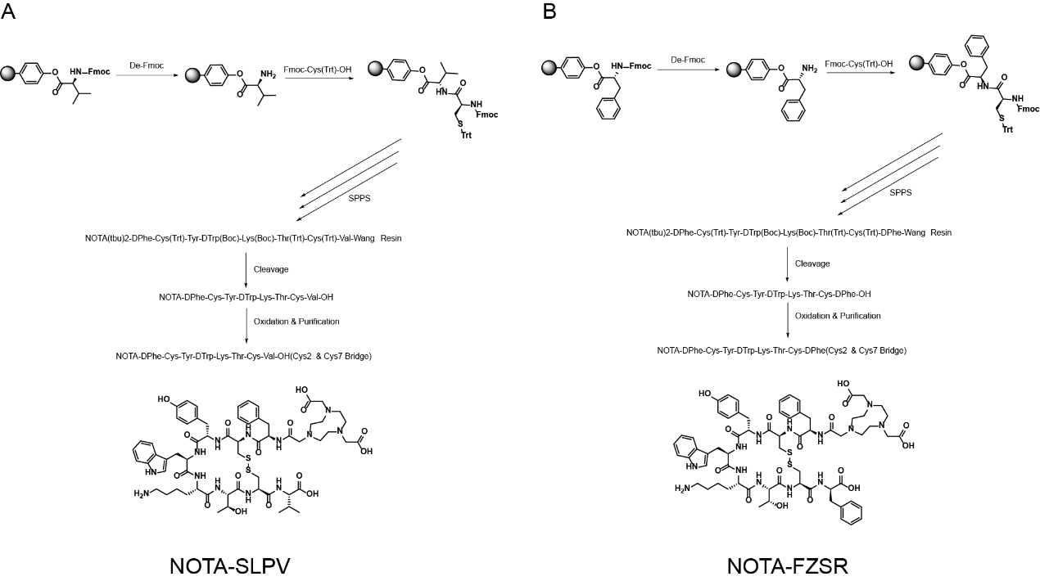
Figure S1 Schematic diagram of the synthesis steps for NOTA-SLPV and NOTA-FZSR.

Figure S2 Mass spectrum characterization of the probes after DOTA/NOTA modification.

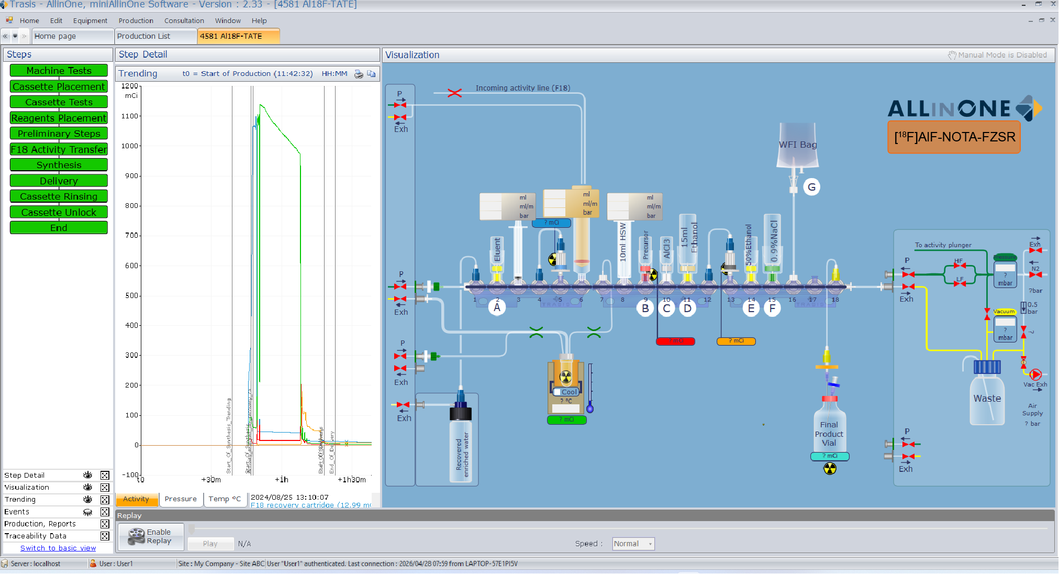
Figure S3 A screenshot of the Trasis interface showing the installation diagram for the tubing kit on the miniAiO.

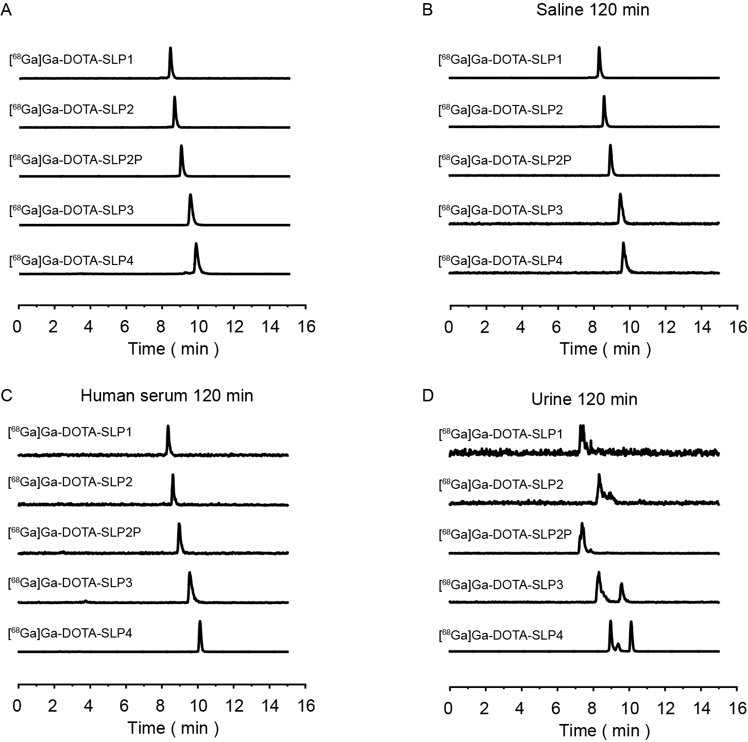
Figure S4 Properties of the [⁶⁸Ga]Ga-DOTA-SLP1, [⁶⁸Ga]Ga-DOTA-SLP2, [⁶⁸Ga]Ga-DOTA-SLP2P, [⁶⁸Ga]Ga-DOTA-SLP3, and [⁶⁸Ga]Ga-DOTA-SLP4. A Radio-HPLC characterization of [⁶⁸Ga]Ga-DOTA-SLP1, [⁶⁸Ga]Ga-DOTA-SLP2, [⁶⁸Ga]Ga-DOTA-SLP2P, [⁶⁸Ga]Ga-DOTA-SLP3, and [⁶⁸Ga]Ga-DOTA-SLP4; B-D Stability of [⁶⁸Ga]Ga-DOTA-SLP1, [⁶⁸Ga]Ga-DOTA-SLP2, [⁶⁸Ga]Ga-DOTA-SLP2P, [⁶⁸Ga]Ga-DOTA-SLP3, and [⁶⁸Ga]Ga-DOTA-SLP4 in vitro and in vivo.

Figure S5 Schematic representation of 2D and 3D molecular docking. A DOTA-TATE; B DOTA-NOC; C NOTA-FZSR.

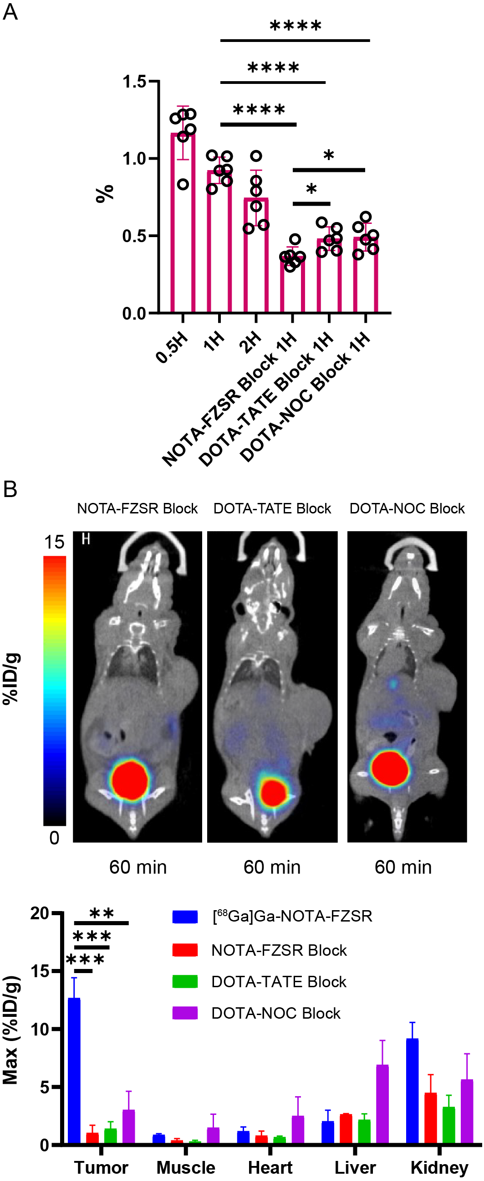
Figure S6 NOTA-FZSR affinity experiment. A Cellular uptake of [⁶⁸Ga]Ga-NOTA-FZSR in AR42J cells with and without receptor blocking. B Micro-PET/CT blocking study of [⁶⁸Ga]Ga-NOTA-FZSR in AR42J xenograft-bearing mice
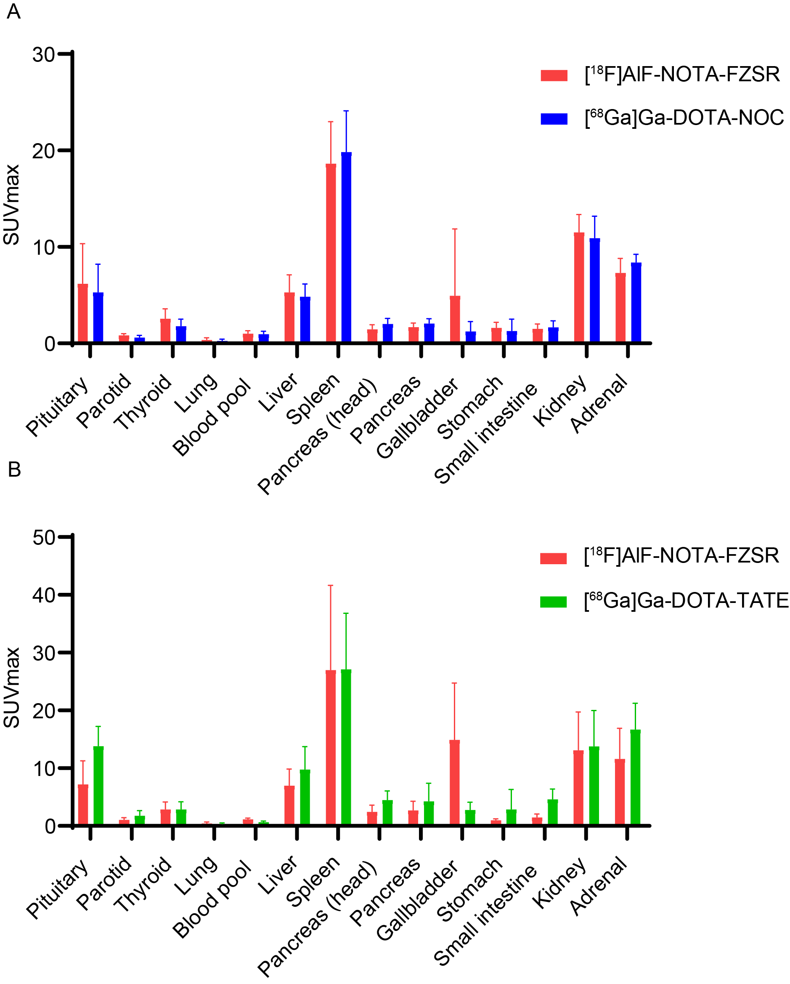
Figure S7 The distribution of patient organ. A Head-to-Head Comparison of [¹⁸F]AlF-NOTA-FZSR and [⁶⁸Ga]Ga-DOTA-NOC; B Head-to-Head Comparison of [¹⁸F]AlF-NOTA-FZSR and [⁶⁸Ga]Ga-DOTA-TATE.

 | Log P | Log D_{7.4} | t_{1/2 Z}
[⁶⁸Ga]Ga-DOTA-SLP1 | -4.08 ± 0.20 | -2.83 ± 0.09 | 18.66 ± 3.30 min
[⁶⁸Ga]Ga-DOTA-SLP2 | -3.61 ± 0.12 | -4.24 ± 0.27 | 14.28 ± 2.16 min
[⁶⁸Ga]Ga-DOTA-SLP2P | -2.20 ± 0.06 | -4.49 ± 0.34 | 16.38 ± 4.62 min
[⁶⁸Ga]Ga-DOTA-SLP3 | -3.01 ± 0.08 | -2.61 ± 0.06 | 39.3 ± 2.82 min
[⁶⁸Ga]Ga-DOTA-SLP4 | -2.07 ± 0.14 | -2.01 ± 0.16 | 67.5 ± 7.98 min
[⁶⁸Ga]Ga-NOTA-SLPV | -2.49 ± 0.22 | -2.73 ± 0.08 | 14.1 ± 1.44 min
[⁶⁸Ga]Ga-NOTA-SLPdF | -0.71 ± 0.14 | -1.41 ± 0.12 | 192 ± 48.66 min
[⁶⁸Ga]Ga-NOTA-FZSR | -1.42 ± 0.03 | -1.74 ± 0.04 | 18.24 ± 1.26 min
[¹⁸F]AlF-NOTA-FZSR | -1.47 ± 0.02 | -1.53 ± 0.03 | 19.38 ± 1.62 min
Table. S1 The partition coefficient and pharmacokinetic analysis of the probes.

