Supporting Information
Simultaneous Broad-Spectrum Antibacterial and Regenerative Therapy for Diabetic Wounds Using Sonosensitive Peptide Composite Hydrogel
Yao Lin^{1#}, Baicheng Xing^{1#}, Xiong Zhang^{1#}, Guanghua Lu^{2#}, Huaiyuan Zhang^{3#}, Yuxin Zhang¹, Xingchao Wang¹, Ziyan Zhang¹, Zhong Wang⁴, Ying Zhang⁵, Yong Gao¹, Chunrui Yang¹, Junyan Zhang ^{6*}, Wenyu Qiao^{3*}, Yufeng Zhou^{1*}

1 State Key Laboratory of Ultrasound in Medicine and Engineering, Chongqing Medical University, Chongqing, 400016, China
2 Department of Orthopedics, Shanghai Tenth People's Hospital, School of Medicine, Tongji University, Shanghai, 200072, China
3 Department of Orthopedics, Jinshan Hospital, Fudan University, Shanghai 201508, China.
4 Department of Neurology, The Fourth Affiliated Hospital of Nanjing Medical University, Nanjing, 210031, China
5 The Central Hospital of Wuhan, Tongji Medical College, Huazhong University of Science and Technology, Wuhan, 430014, China
6 Department of Emergency and Critical Disease, Songjiang Research Institute, Shanghai Key Laboratory of Emotions and Affective Disorders, Songjiang Hospital Affiliated to Shanghai Jiao Tong University, Shanghai, 201600, China

Supporting figures
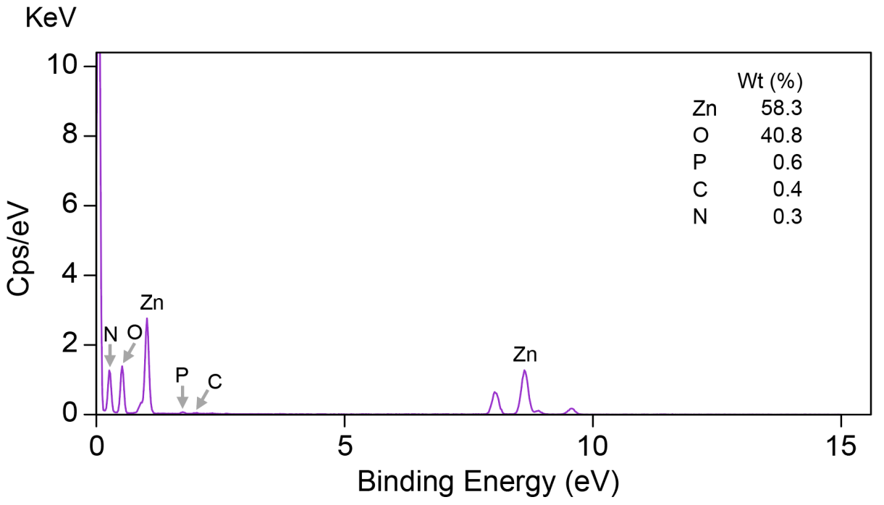
Figure S1. Representative energy dispersive X-ray spectroscopy of FFRK8@ZnO₂ from three independent experiments.

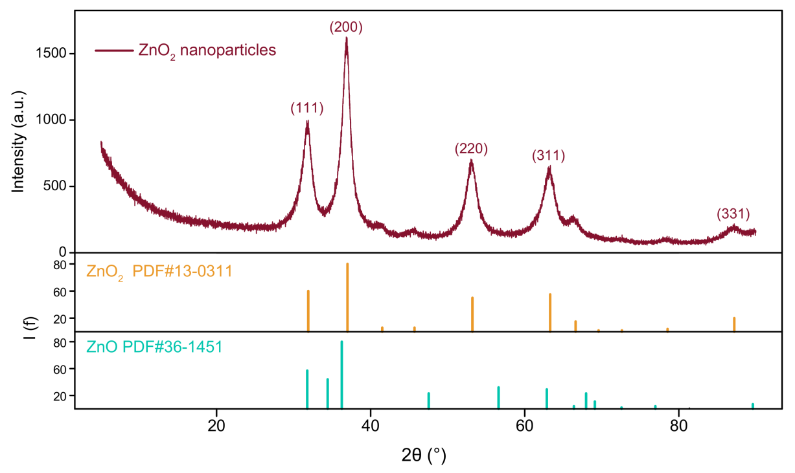
Figure S2. XRD pattern of ZnO₂ nanoparticles compared with the standard diffraction data of ZnO₂ and ZnO.

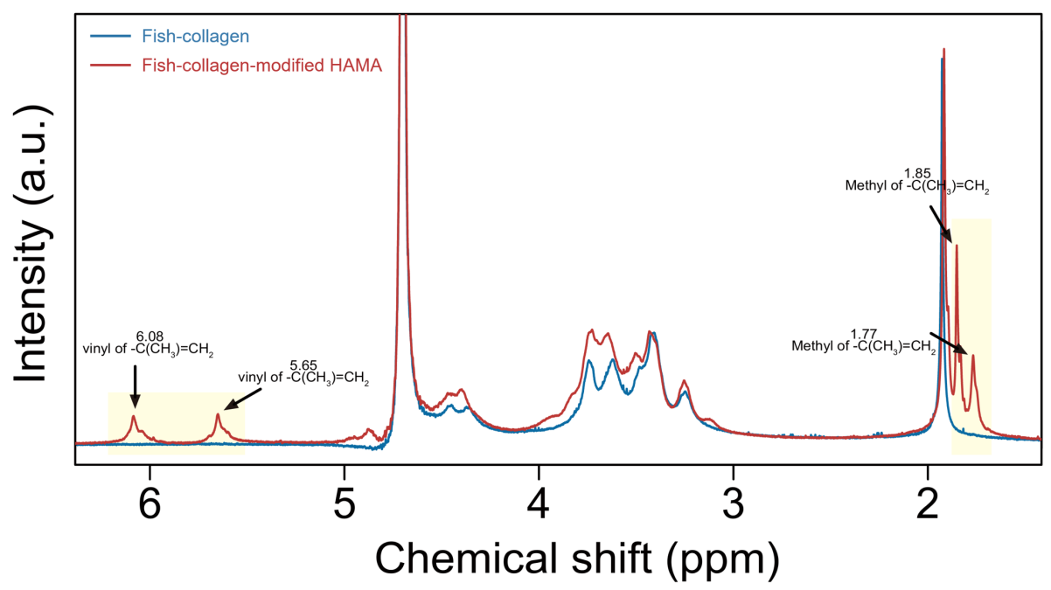
Figure S3. ¹H NMR spectra of fish-collagen and fish-collagen-modified HAMA.

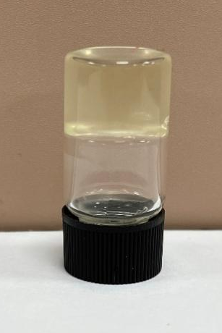
Figure S4. Solid form of FFRK8@ZnO₂@fHAMA

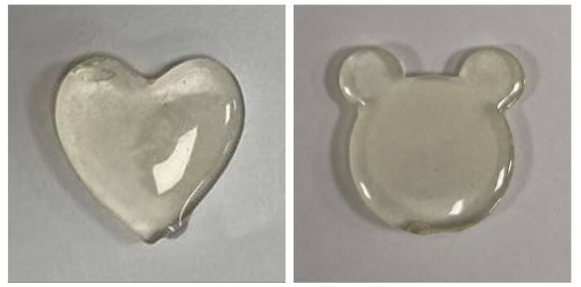
Figure S5. The plasticity of FFRK8@ZnO₂@fHAMA

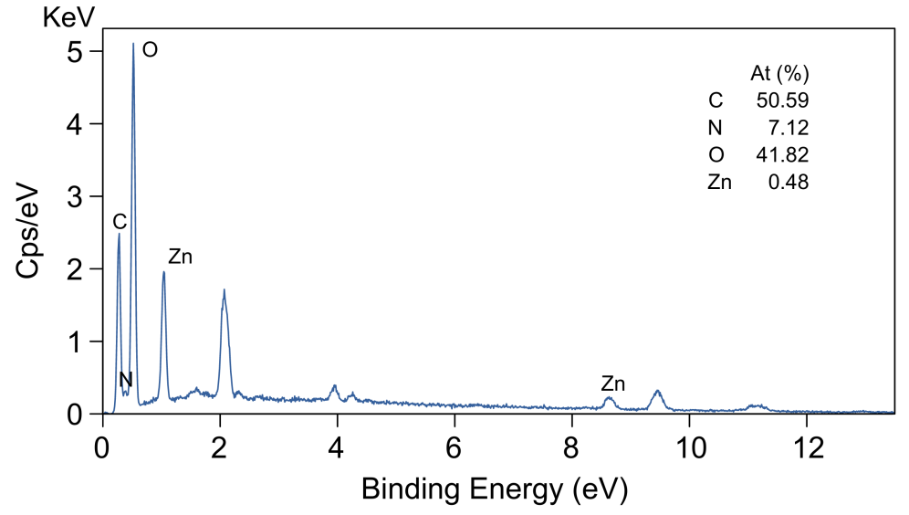
Figure S6. Representative energy dispersive X-ray spectroscopy of FFRK8@ZnO₂@fHAMA from three independent experiments.

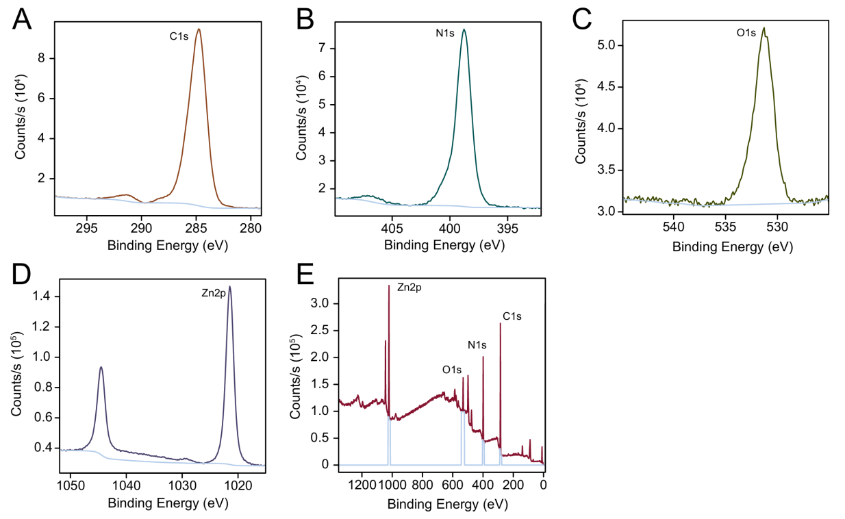
Figure S7. Representative XPS spectrum of the corresponding C (A), N (B), O (C), Zn (D) elements and FFRK8@ZnO₂@fHAMA (E) composites from three independent experiments.

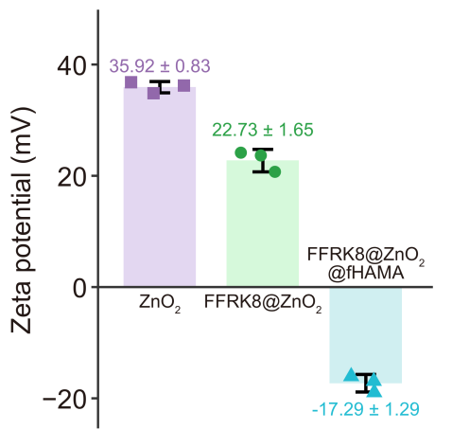
Figure S8. Zeta potentials of ZnO₂, FFRK8@ZnO₂, and FFRK8@ZnO₂@fHAMA.

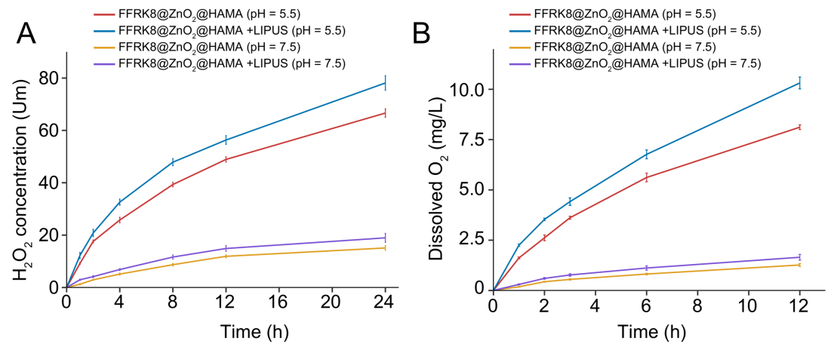
Figure S9. Release curves of H₂O₂ (A) and O₂ (B) from FFRK8@ZnO₂@fHAMA with or without LIPUS-activation under different pH conditions (pH = 7.5 and 5.5). Initial liquid is degassed water.

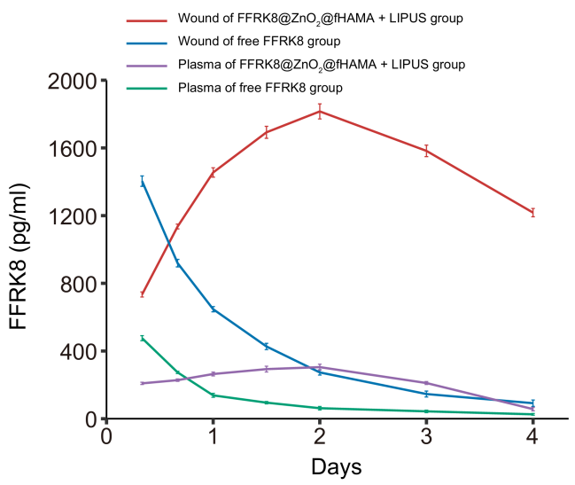
Figure S10. FFRK8 concentration-time profiles in rats wound area and plasma after treated of free FFRK8 or FFRK8@ZnO₂@fHAMA (n = 3). The data are presented as means ± SD.

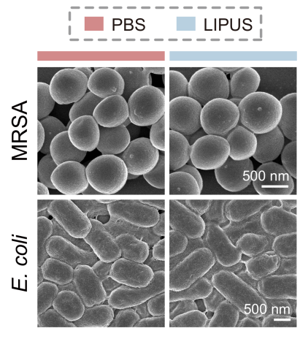
Figure S11. SEM images of MRSA and E. coli with PBS or LIPUS treatment for 4 h at 37℃. Representative images were from 3 independent experiments. Scale bar, 500 nm.

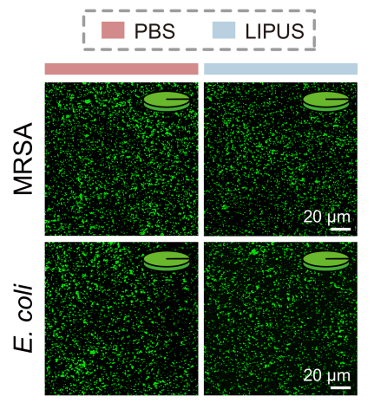
Figure S12. Representative MRSA and E. coli live/dead staining images and relative quantitative pie chart (upper right of each image) after PBS or LIPUS treatments. Live bacteria stained with SYTO 9 (green) and dead bacteria stained with PI (red), respectively. Scale bar, 20 μm.

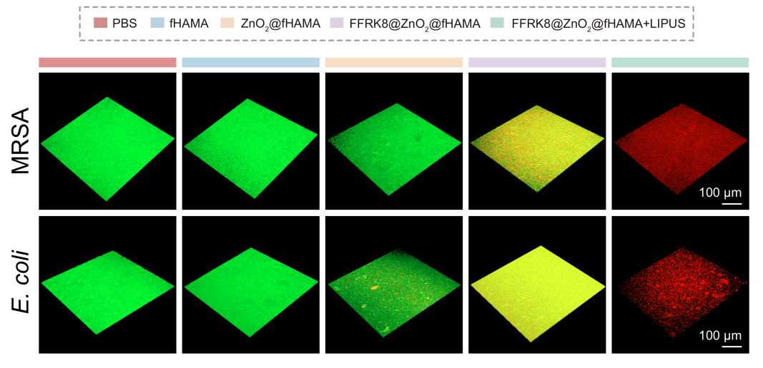
Figure S13. MRSA and E. coli live/dead fluorescence staining images of biofilms after different treatments, respectively. Scale bar, 100 μm.

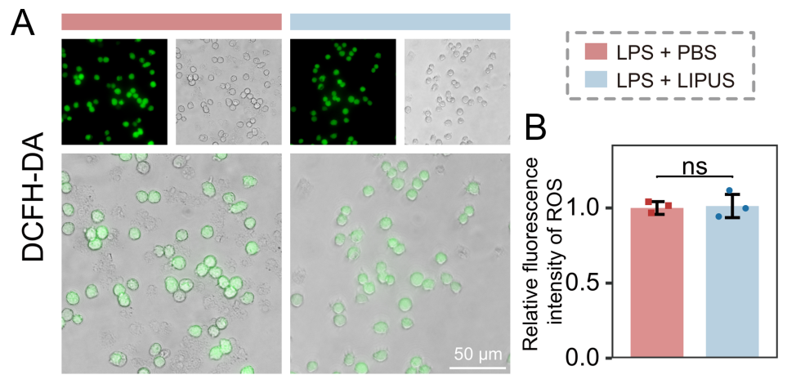
Figure S14. Confocal images (A) and relative quantification (B) of intracellular oxidative stress-associated ROS in RAW 264.7 macrophages with PBS or LIPUS treatment (n = 3). Scale bar, 50 μm. The data are presented as mean ± SD.

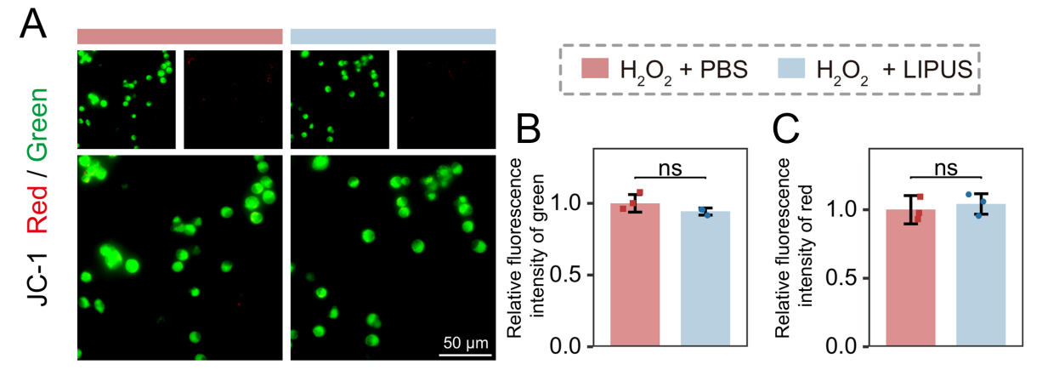
Figure S15. JC-1 immunofluorescence (A) and relative quantification analysis (B, C) of mitochondrial membrane potential in RAW 264.7 cells with PBS or LIPUS treatment (n = 3). Scale bar, 50 μm. The data are presented as mean ± SD.

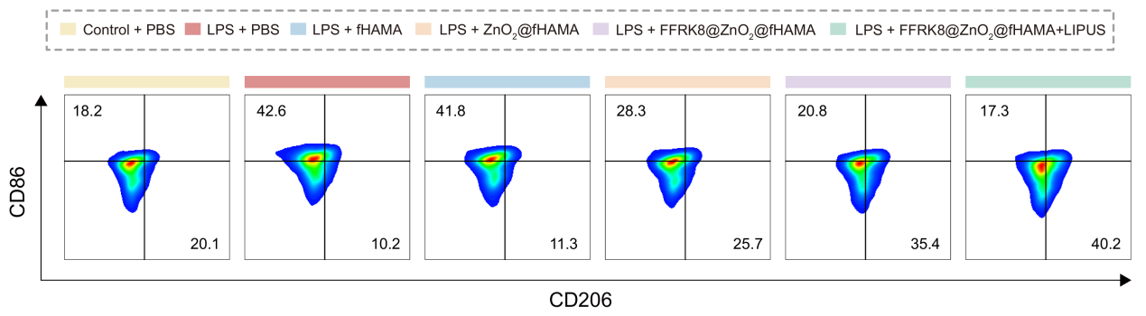
Figure S16. Flow cytometric analysis of macrophage polarization markers CD86 and CD206 in bone marrow-derived macrophages (BMDMs) after different treatments (n = 3), respectively.

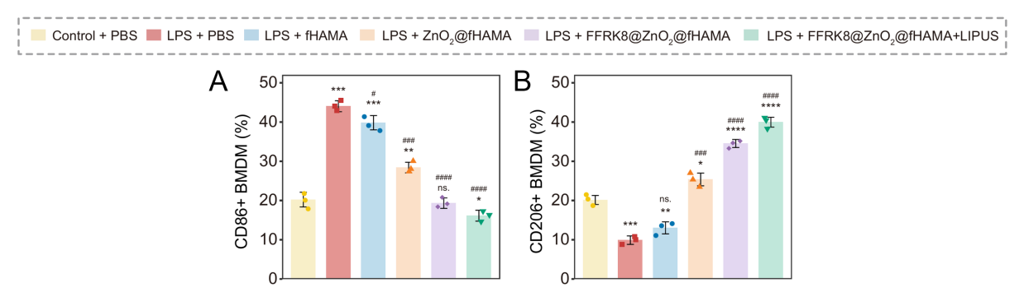
Figure S17. Quantitative analysis of flow cytometry of CD86 (A) and CD206 (B) in BMDM (n = 3). The data are presented as mean ± SD. *p < 0.05, **p < 0.01, ***p < 0.001, ****p < 0.0001 indicate significant differences compared with the Control + PBS group, while #p < 0.05, ##p < 0.01, ###p < 0.001, ####p < 0.0001 indicate significant differences compared with the LPS + PBS group.

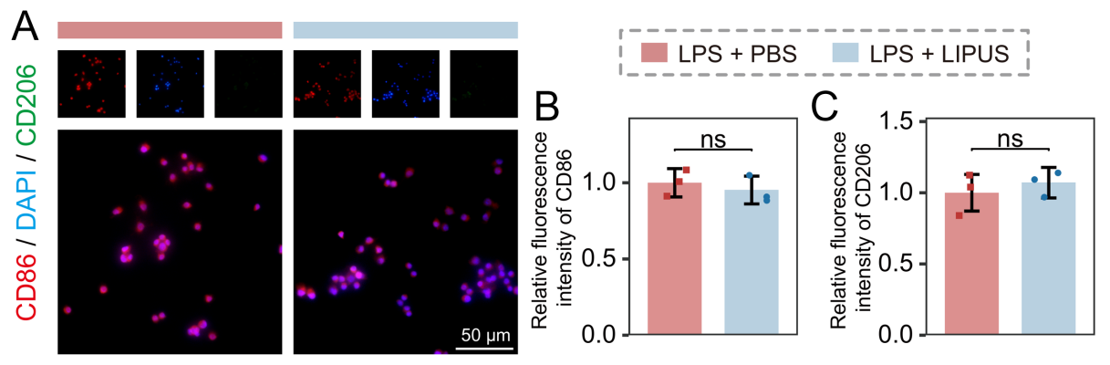
Figure S18. Immunofluorescence staining (A) and quantification of CD86 (B) and CD206 (C) in LPS-incubated RAW264.7 cells with PBS or LIPUS treatment (n = 3). Scale bar, 50 μm. The data are presented as mean ± SD.

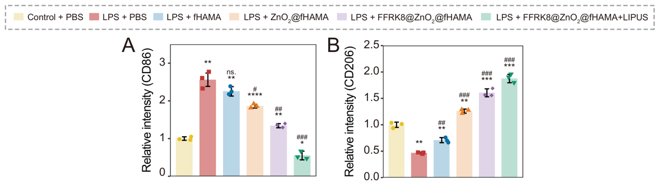
Figure S19. Western blot analysis of gray-value-determination for target protein CD86 (A) and CD206 (B) (n = 3). The data are presented as mean ± SD. *p < 0.05, **p < 0.01, ***p < 0.001, ****p < 0.0001 indicate significant differences compared with the Control + PBS group, while #p < 0.05, ##p < 0.01, ###p < 0.001, ####p < 0.0001 indicate significant differences compared with the LPS + PBS group.

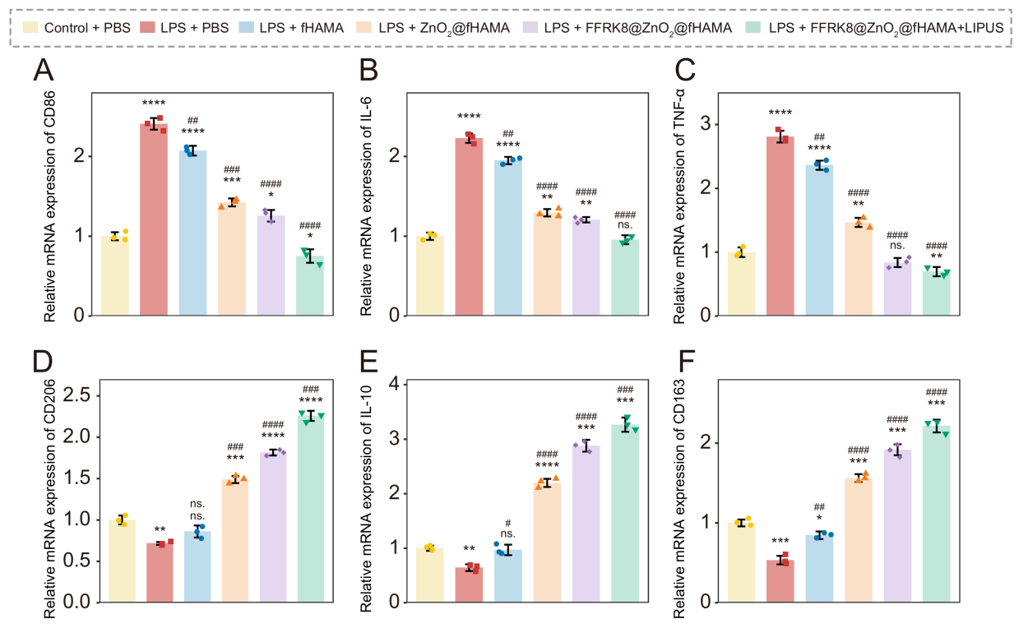
Figure S20. The mRNA levels of inflammatory targets in macrophages, including CD86 (A), IL-6 (B), TNF-α (C), CD206 (D), IL-10 (E), and CD163 (F) under different treatment conditions, evaluated via RT-qPCR analysis (n = 3). The data are presented as mean ± SD. *p < 0.05, **p < 0.01, ***p < 0.001, ****p < 0.0001 indicate significant differences compared with the Control + PBS group, while #p < 0.05, ##p < 0.01, ###p < 0.001, ####p < 0.0001 indicate significant differences compared with the LPS + PBS group.

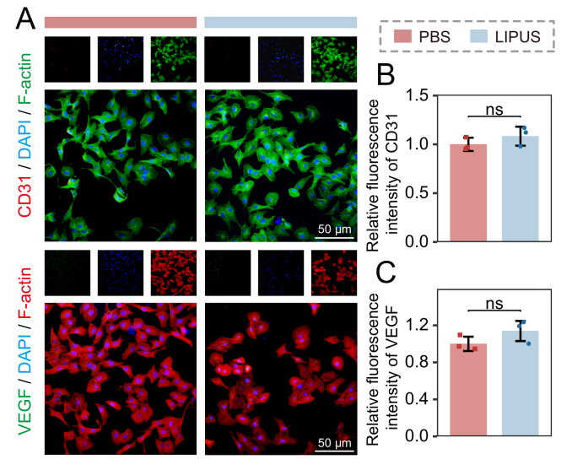
Figure S21. Immunofluorescence staining (A) and relative quantification of CD31 (B) and VEGF (C) in HUVEC under PBS or LIPUS treatment (n = 3). Scale bar, 50 μm. The data are presented as mean ± SD.

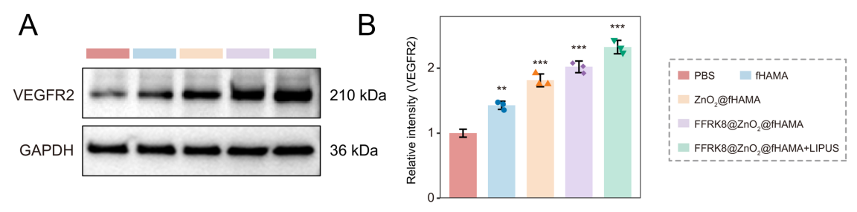
Figure S22. (A) Western blot analysis of VEGFR2 protein isolated from HUVECs treated with different materials, respectively. (B)Western blot analysis of gray-value-determination for target protein VEGFR2 (n = 3). The data are presented as mean ± SD. **p < 0.01, ***p < 0.001 indicate significant differences compared with the PBS group

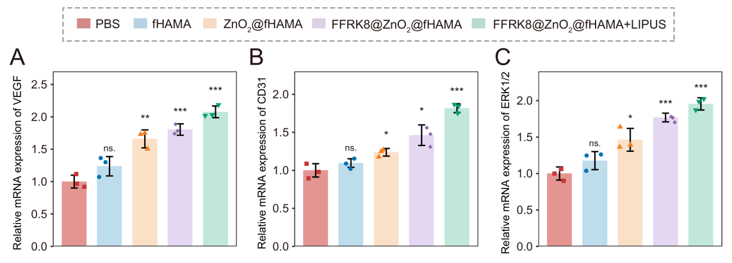
Figure S23. The mRNA levels of angiogenesis targets in HUVECs, including VEGF (A), CD31 (B), and ERK1/2 (C) under different treatment conditions, evaluated via RT-qPCR analysis (n = 3). The data are presented as mean ± SD. *p < 0.05, **p < 0.01, ***p < 0.001 indicate significant differences compared with the PBS group.

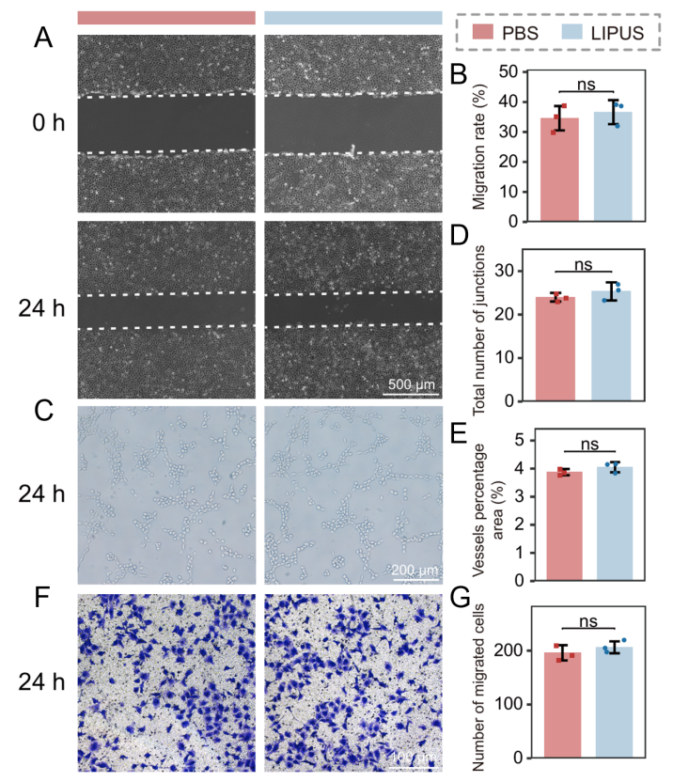
Figure S24. Representative migration images (A) and relative quantification (B) of HUVECs under PBS or LIPUS treatment for 0 h and 24 h (n = 3). Scale bar, 500 μm. Representative images of HUVECs tube formation assay (C) and quantitative analysis of total number of junctions (D) and vessel area percentage (E) (n = 3). Scale bar, 200 μm. Representative Transwell assays images (F) and quantification (G) of HUVECs after PBS or LIPUS treatment (n = 3). Scale bar, 100 μm. The data are presented as mean ± SD.

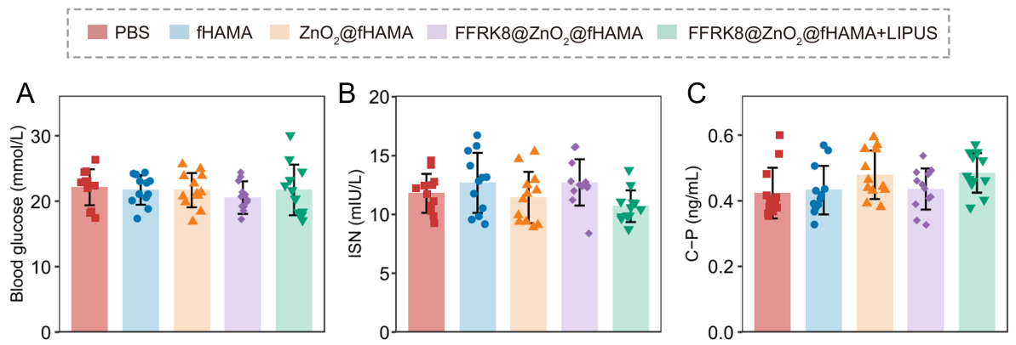
Figure S25. After constructing the animal model by STZ combined with high-fat and high-sugar diet, the evaluation indicators for the model's effectiveness include blood glucose (A), insulin (B) and C-peptide (C) levels. The data are presented as mean ± SD.

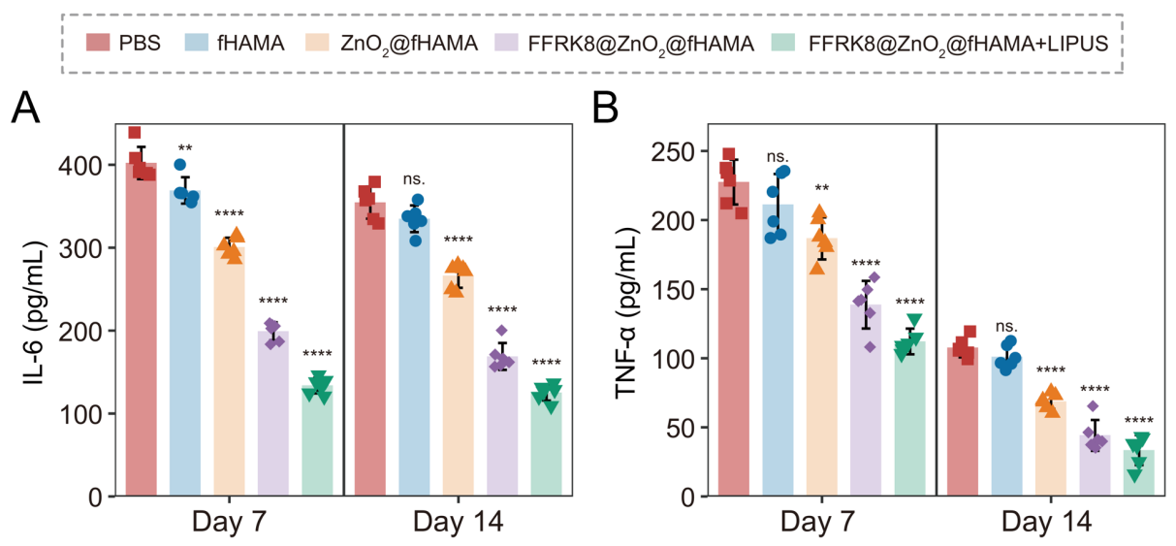
Figure S26. ELISA analysis of IL-6 (A) and TNF-α (B) from the wound tissue lysates extracted at day 7 and day 14 of MRSA-infected diabetic full-thickness dorsal wound. The data are presented as mean ± SD. *p < 0.05, **p < 0.01, ***p < 0.001, ****p < 0.0001 indicate significant differences compared with the PBS (control) group.

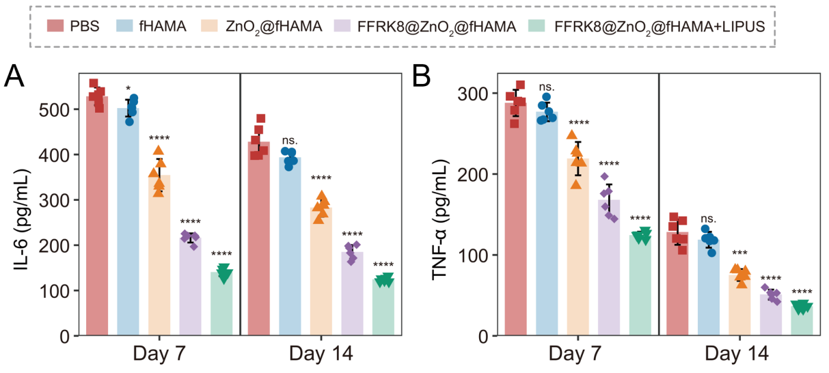
Figure S27. ELISA analysis of IL-6 (A) and TNF-α (B) from the wound tissue lysates extracted at day 7 and day 14 of E. coli-infected diabetic distal limb wound. The data are presented as mean ± SD. *p < 0.05, **p < 0.01, ***p < 0.001, ****p < 0.0001 indicate significant differences compared with the PBS (control) group.

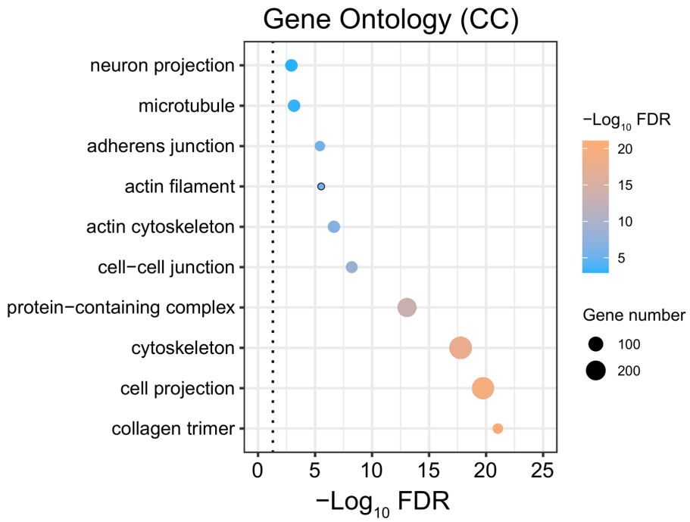
Figure S28. Gene Ontology (GO) enrichment analysis of cellular component (CC) for common DEGs of two models between untreated and FFRK8@ZnO₂@fHAMA+US group.

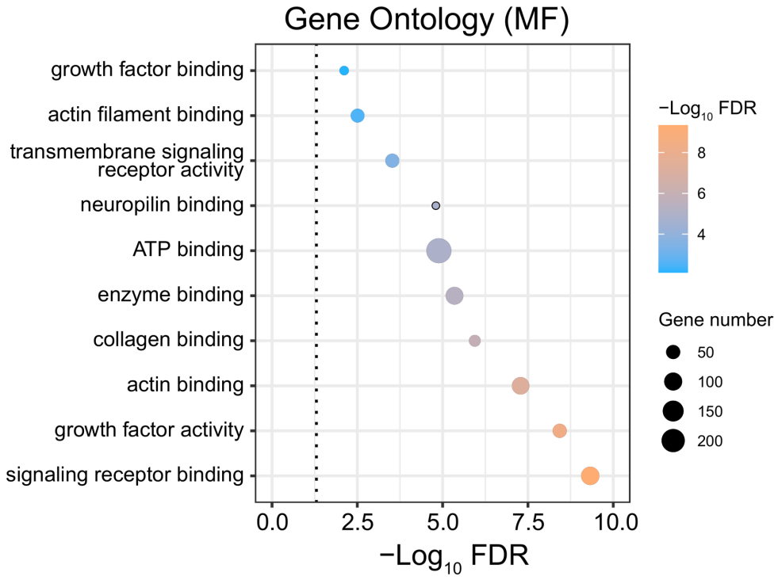
Figure S29. GO enrichment analysis of molecular function (MF) for common DEGs of two models between untreated and FFRK8@ZnO₂@fHAMA+LIPUS group.

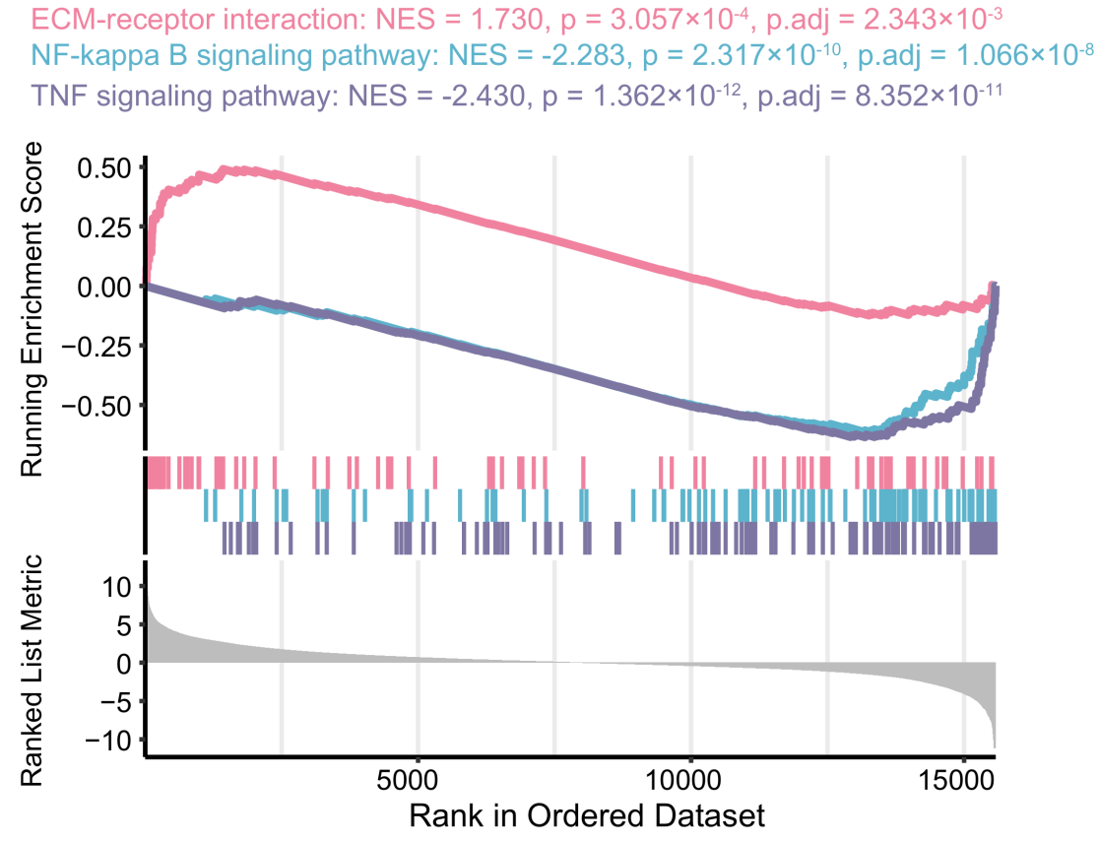
Figure S30. Gene set enrichment analysis (GSEA) in KEGG databases of the DEGs in E. coli-infected diabetic distal limb wound models.

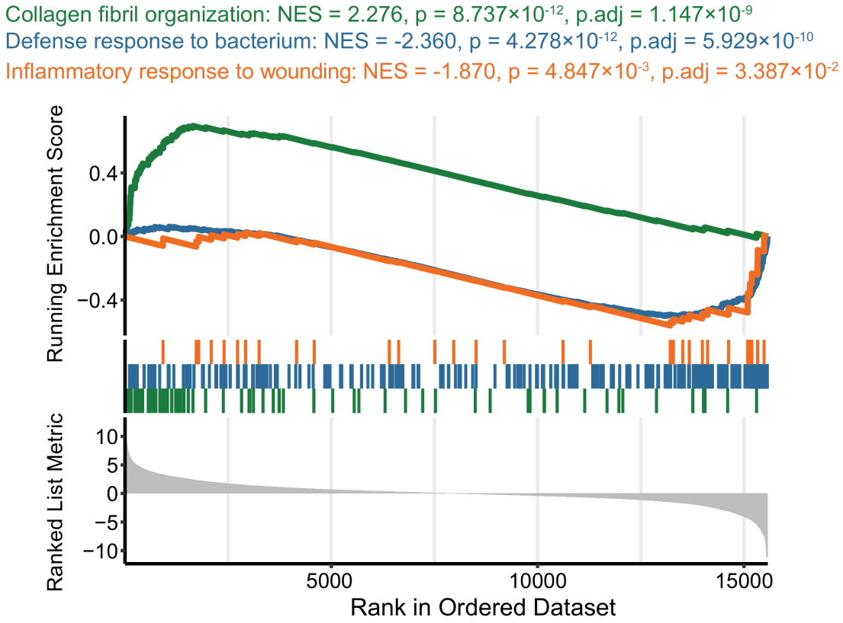
Figure S31. GSEA in GO databases of the DEGs in E. coli-infected diabetic distal limb wound models.

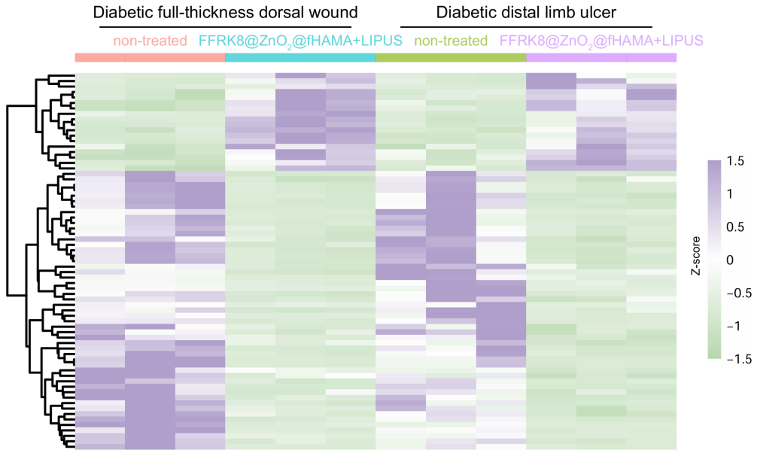
Figure S32. Heatmap represents relative expression of differential metabolites in different samples.

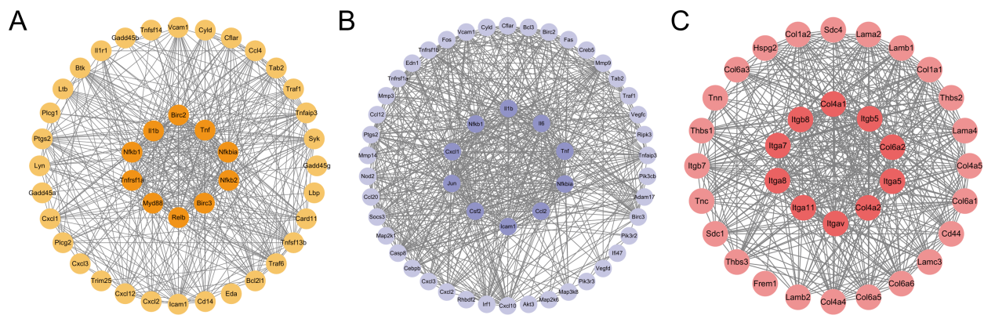
Figure S33. The gene–gene interaction network for enriched genes in NF-kappa B signaling pathway (A), TNF signaling pathway (B) and ECM-receptor interaction (C), analyzed by the STRING database. Each node represents a gene (hub-genes were in the middle).

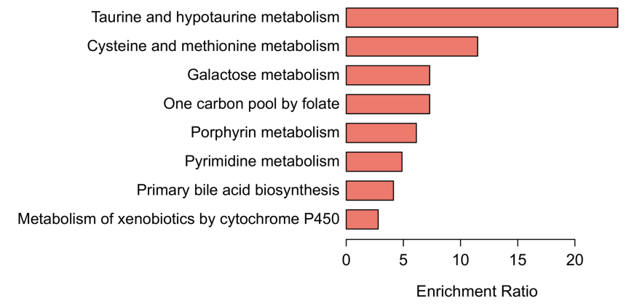
Figure S34. The KEGG enrichment pathways of differential metabolites.

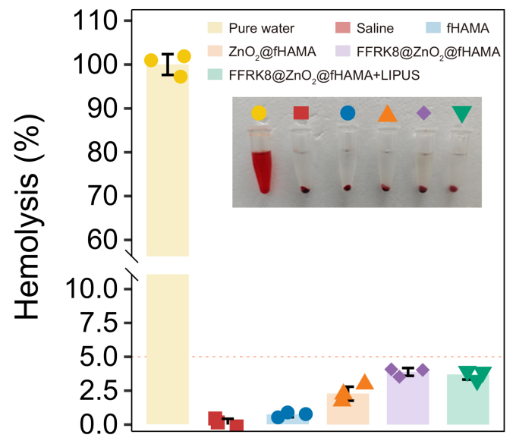
Figure S35. Hemolysis assay of different treatment (n = 3). The data are presented as mean ± SD.

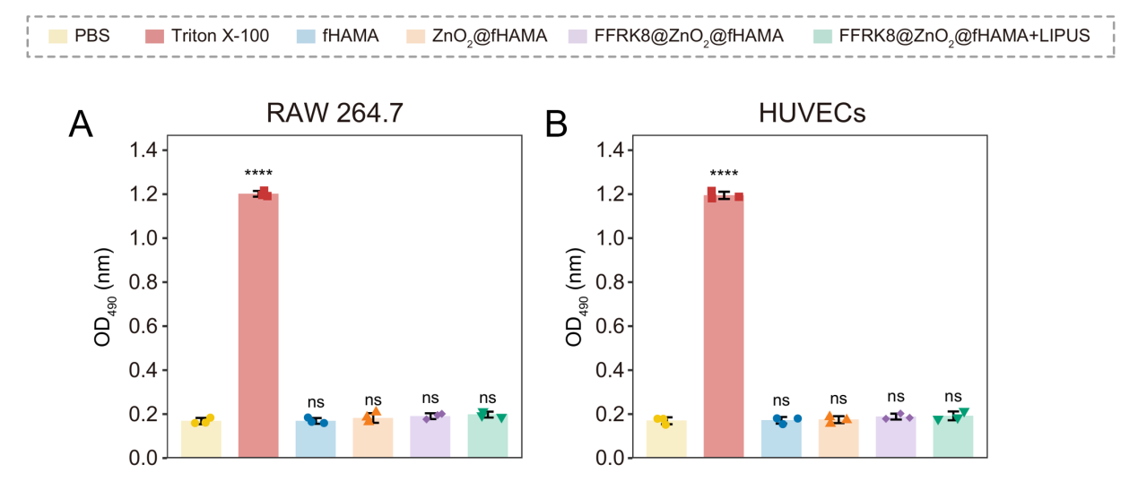
Figure S36. Lactate dehydrogenase (LDH) assay of different treatment (n = 3). The data are presented as mean ± SD. ****p < 0.0001 indicate significant differences compared with the PBS (control) group.

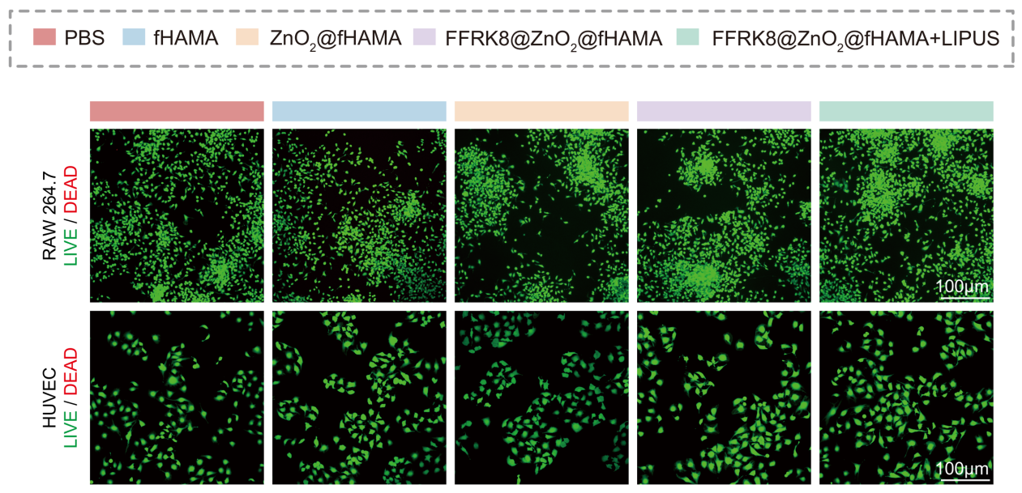
Figure S37. Representative RAW 264.7 macrophages and HUVEC live/dead staining images after different treatments (n = 3).

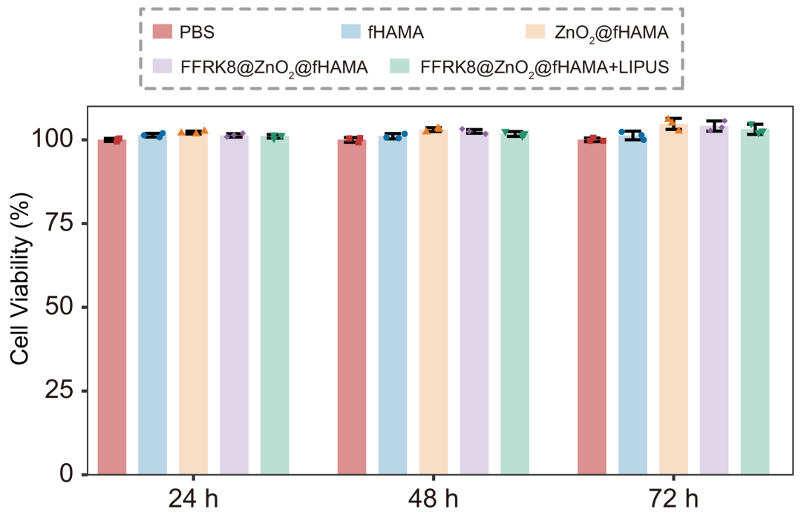
Figure S38. Cell viability of RAW 264.7 macrophages treated with different concentrations of FFRK8@ZnO₂@fHAMA and ultrasound, measured by CCK-8 assay (n = 3). The data are presented as mean ± SD.

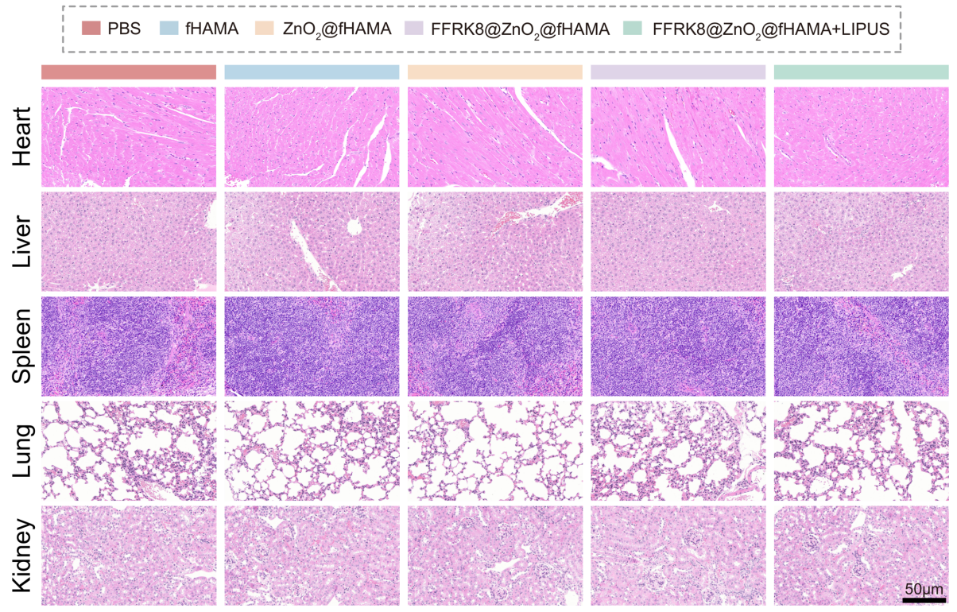
Figure S39. Representative H&E-stained sections of major organs from healthy rats in different treatment groups for 14 days from six independent experiments.

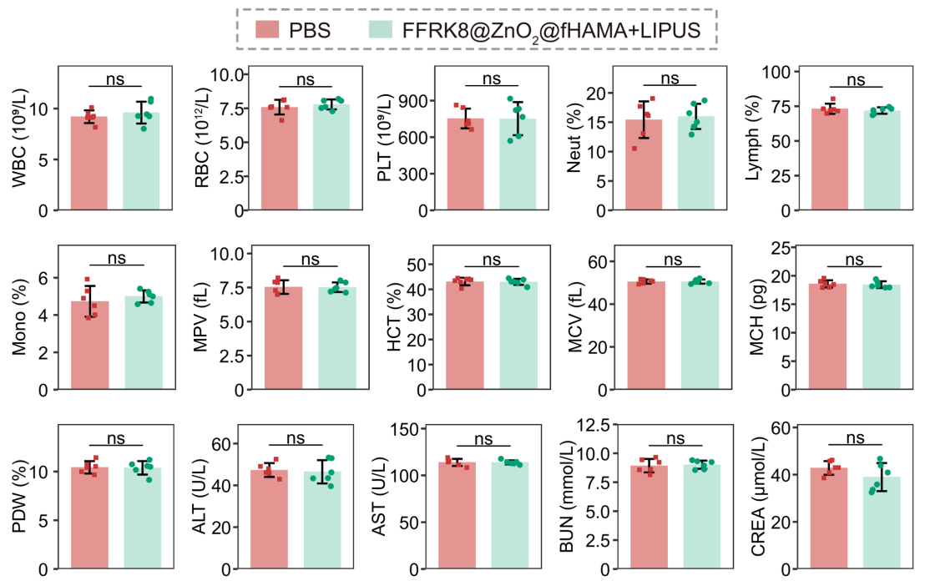
Figure S40. The blood routine examinations (WBC, RBC, PLT, Neut, Lymph, Mono, MPV, HCT, MCV, MCH and PDW) and blood biochemistry examinations (ALT, AST, BUN, and CREA) of healthy rats administered with FFRK8@ZnO₂@fHAMA+LIPUS for 14 days (n = 6). The data are presented as mean ± SD.

Supporting table
Table S1. Primer sequences used for RT-qPCR

Gene | Forward Primer (5’ to 3’) | Reverse Primer (5’ to 3’)
CD86 | ATATGACCGTTGTGTGTGTTCTGGA | AGGGCCACAGTAACTGAAGCTGTAA
IL-6 | TAGTCCTTCCTACCCCAATTTCC | TTGGTCCTTAGCCACTCCTTC
TNF-α | ACCACGCTCTTCTGTCTACT | AGGAGGTTGACTTTCTCCTG
CD206 | ATGGATTGCCCTGAACAGCA | TGTACCGCACCCTCCATCTA
IL-10 | CTGGACAACATACTGCTAACCG | GGGCATCACTTCTACCAGGTAA
CD163 | ACATAGATCATGCATCTGTCATTTG | CATTCTCCTTGGAATCTCACTTCTA
CD31 | CAGAGCCAGCATTGTGACCAGTC | CAAGGCGGCAATGACCACTC
VEGF | GGAGAGGAGCCCGCCAAGG | GCAGTAAAGCCAGGGTCCAGTG
ERK1/2 | GACTCCTACCTGAAGCATAC | TCCTTGACACGCAGAATG

