Unifying Gibberellin Pathway Modulation, Anti-Biofilm, and Foliar Adhesion in a Stimuli-Responsive Supramolecular Complex for Plant Growth Promotion and Bacterial Disease Control
Qingtian Ji, ¹ Jiamu Liu, ¹ B. Marambe, ² Barana C. Jayawardana, ³ Linhong Jin, ¹ Gefei Hao, ¹ Peiyi Wang ^{1,} *

¹ State Key Laboratory of Green Pesticide, Key Laboratory of Green Pesticide and Agricultural Bioengineering, Ministry of Education, Center for Research and Development of Fine Chemicals of Guizhou University, Guiyang, 550025, China.
² Department of Crop Science, Faculty of Agriculture, University of Peradeniya, Peradeniya 20400, Sri Lanka.
³ Department of Animal Science, Faculty of Agriculture, University of Peradeniya, Peradeniya 20400, Sri Lanka.
* Corresponding author E-mail: pywang@gzu.edu.cn; pywang888@126.com (P.-Y. Wang).
Content
1. Materials and Methods. 4
1.1. Instruments and Chemicals. 4
1.2. Synthesis of the target molecule 4-(10-((5-(4-fluorophenyl)-1,3,4-oxadiazol-2-yl)thio)decyl)-4-methylmorpholin-4-ium bromide (OM). 4
1.3. Preparation of Supramolecular Complex OM@CB[7]. 5
1.4. Encapsulation Efficiency Determination by Dialysis Method. 5
1.5. Aqueous Solubility of OM. 6
1.6. The Assembly Morphology of OM and OM@CB[7] Complex were Characterized by TEM. 6
1.7. The Self-Assembly Morphology of OM was Characterized by SEM. 6
1.8. Droplet impact and bounce experiment on rice leaves. 6
1.9. Contact Angle on Rice Leaves. 7
1.10. Surface Tension. 7
1.11. Retention Amount. 7
1.12. Rainfastness Experiment. 7
1.13. SEM Observation of Retention on Rice Leaf Surfaces. 8
1.14. Toxicity Assay for Earthworms. 8
1.15. Toxicity Assay for Zebrafish. 8
1.16. In Vitro Cytotoxicity Assay Against HepG2 Cells. 9
1.17. Degradation of Drugs (OM and OM@CB[7]+AD) on Rice Leaves. 9
1.18. Biosafety Assessment of Supramolecular Release Systems on Soil Microorganisms. 10
1.19. Cumulative Phytotoxicity Experiment. 10
1.20. Seed Germination Experiment. 11
1.21. Determination of rice yield-related panicle traits. 11
1.22. Transcriptome Sequencing and Analysis. 11
1.23. Paclobutrazol (PAC) inhibition verification assay for GA-dependent OM@CB[7] bioactivity. 11
1.24. Gibberellin quantification. 12
1.25. In Vitro Antibacterial Bioassay (Turbidimeter Test). The 13
1.26. Growth Status of Bacteria Within Biofilms. 13
1.27. Growth Status of Bacteria Outside Biofilms. 13
1.28. Observation of Biofilms by Confocal Laser Scanning Microscopy (CLSM). 13
1.29. Disruption of Preformed Biofilms from Rice Leaves. 14
1.30. Time-Course Analysis of Xoo Colonization in Rice Under Sequential OM@CB[7]+AD Pretreatment. 14
1.31. Observe the status of treated Xoo using a fluorescence microscope. 15
1.32. Zeta Potential Measurement. 15
1.33. Determination of ROS. 15
1.34. Oxidase activity assay of treated Xoo. 16
2. ¹H NMR, ¹³C NMR, ¹⁹F NMR and HRMS spectra of the target molecule OM (Figures S1 to S4). 17
3. Primer sequences of representative genes for RT-qPCR. 19
4. Biological Activity Assay of OM in Vitro. 22
5. Self-assembly Mechanism of the target molecule OM. 22
6. Aqueous Solubility of OM and Encapsulation Efficiency of OM@CB [7]. 24
7. Fabrication of Stimuli-responsive Supramolecular Complex OM@CB[7]. 25
8. Spermine-Triggered Competitive Displacement Assay (¹H NMR). 26
9. Field Application Potential: Leaf Retention and Rainfastness of OM@CB[7]. 26
10. Statistical Analysis of Survival Rates in Danio Rerio (Zebrafish) and Earthworms. 27
11. Comparative Acute Toxicity (96-h LC₅₀) of Different Formulations to Zebrafish. 27
12. Cytotoxicity parameters of different formulations in HepG2 cells. 28
13. Residue Degradation Behavior of OM@CB[7] Supramolecular Sustained-Release System on Rice Leaves. 28
14. Impacts of OM@CB[7]+AD on Soil Microbial Communities and Ecological Function. 30
15. Determination of Enzyme Activities in Seedling Leaves Post OM@CB[7] Treatment. 34
16. OM@CB[7] improves yield-associated panicle traits in rice. 35
17. Differential Transcriptomic Analysis of OM@CB[7]-treated Seedlings. 37
18. Gibberellin Contents in Rice Leaves after OM@CB[7] Treatment. 39
19. Paclobutrazol abolishes the growth-promoting effect of OM@CB[7]. 40
20. Disease grading scale for rice bacterial leaf blight. 41
21. In vivo activity against rice bacterial blight: Quantitative efficacy assessment with expanded replicates. 41
22. Biofilm Content of Mature Xoo Biofilms Treated with AD, CB[7], and AD@CB[7]. 42
23. Eradication of preformed mature Xoo biofilms on rice leaves by treatment with OM@CB[7] + AD. 42
24. Inhibitory effect of OM@CB[7] + AD on in planta colonization of Xoo. 43
25. Antibacterial Mechanism. 43
26. Comparison with Advanced Nanoformulations. 44

1. Materials and Methods.
1.1. Instruments and Chemicals. Carbon disulfide, 4-fluorobenzohydrazide, 4-methylmorpholine, 1,10-dibromodecane and other chemicals were purchased through commercial channels. NMR spectrum determination was implemented on a Bruker Biospin-AG-400 apparatus (BRUKEROPTICS, Switzerland). Calorimetric titration was performed by a MicroCol ITC200 instrument (Britain). TEM images were acquired by a FEI Talos F200C electron microscope (FEI, U.S.A.) operating at a voltage of 200 kV. SEM (scanning electron microscope) images were visualized using FEI Nova NanoSEM 450. The Zeta potential and particle size analyzer (DelsaNanoC, Beckman. Coulter, Inc., U.S.A.) was used to study the antibacterial mechanism. The living organism experiment was fulfilled in an intelligent artificial climate box (RXZ-436C, Ningbo Jiangnan Instrument Factory, China). The antibacterial plate experiment was completed in a biochemical incubator (SPX-250B-Z, Shanghai Boxun Industy & Commerce Co, Ltd. Medical Equipment Factory, China); High Performance Liquid Chromatography (HPLC) analysis were carried out with Wooking K2025 HPLC system. CAT Content Assay Kit (BC0205), SOD Content Assay Kit (BC0175), and ROS Content Assay Kit (CA1410) were all obtained fromBejing Solarbio Science & Technology Co., Ltd. gPCR SYBR Green (No Rox) (11201ES08)and Bacterial RNA Extraction Kit (19301ES50) were purchased from Yeasen, Shanghai,China.
1.2. Synthesis of the target molecule 4-(10-((5-(4-fluorophenyl)-1,3,4-oxadiazol-2-yl)thio)decyl)-4-methylmorpholin-4-ium bromide (OM). The structure was characterized by NMR and HRMS, the specific data and synthetic routes refer to supporting information and Scheme S1 [1-4].
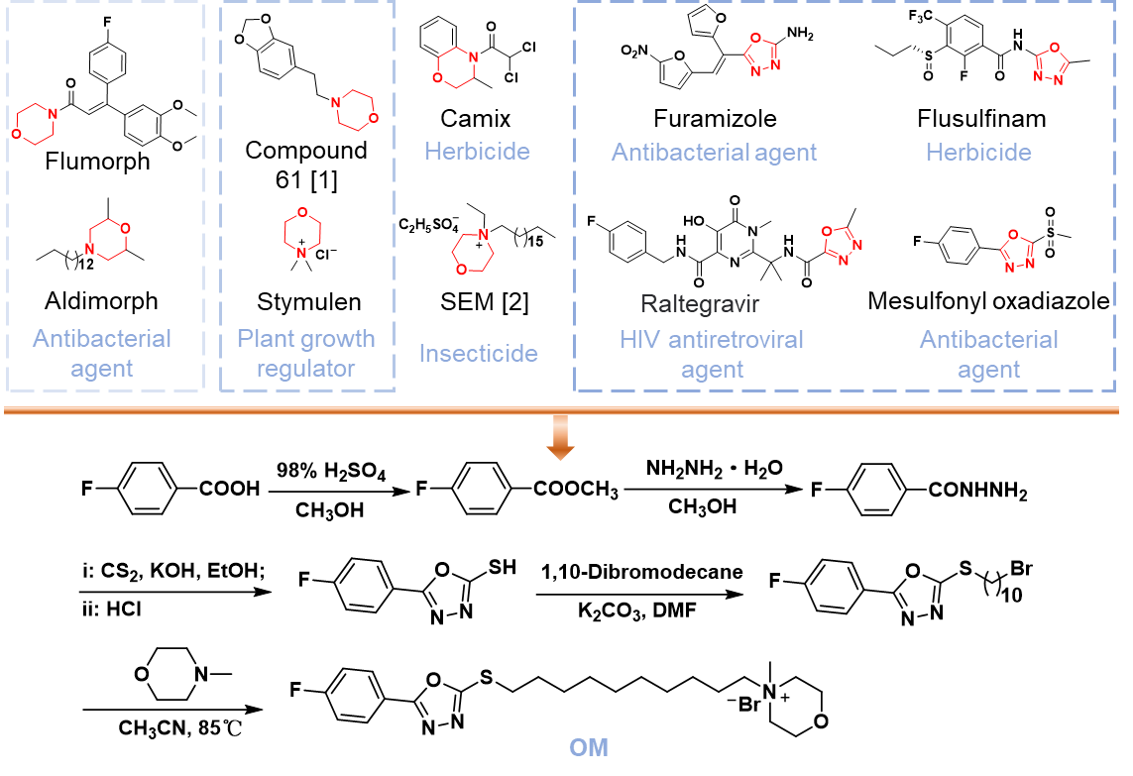
Scheme S1. Synthetic route for the target molecule OM.
1.3. Preparation of Supramolecular Complex OM@CB[7]. In this experiment, the supramolecular complex OM@CB[7] was prepared by a simple method. Generally, OM (6.0 mg, 11.6 μM) and CB[7] (13.5 mg, 11.6 μM) were dissolved in 30 mL aqueous solution. Then, the binary complex OM@CB[7] was obtained by ultrasound for 30 minutes.
1.4. Encapsulation Efficiency Determination by Dialysis Method. The encapsulation efficiency (EE) of OM@CB[7] was determined by equilibrium dialysis combined with high-performance liquid chromatography (HPLC). Freshly prepared OM@CB[7] aqueous solution (1 mg mL⁻¹, 1.0 mL) was placed in a dialysis bag (molecular weight cut‑off = 1000 Da) and immersed in 50 mL of ultrapure water under magnetic stirring. To remove unencapsulated free OM and achieve dialysis equilibrium, the external dialysate was replaced with fresh ultrapure water twice at intervals of 4 h, followed by an additional 16 h of equilibration. Subsequently, the final dialysate (50 mL) was collected and concentrated to 10 mL by lyophilization for HPLC analysis. HPLC was performed on a C18 column (4.6 × 250 mm, 5 μm) using an isocratic mobile phase of methanol/water (80:20, v/v) containing 0.1% (v/v) trifluoroacetic acid (TFA) at a flow rate of 1.0 mL min⁻¹. The column temperature was maintained at 26 °C, the detection wavelength was 200 nm, and the injection volume was 10 μL. The concentration of free OM (retention time = 4.558 min) was quantified using a standard calibration curve (R² = 0.9985). All measurements were performed in triplicate. The EE was calculated according to the following equation:
$$\text{EE (\%)} \text{= }\frac{{\text{m}}_{\text{total }}\text{- }{\text{m}}_{\text{free }}}{{\text{C}}_{\text{total}}}\text{×100}$$
where m_{total} represents the total mass of OM initially added, and m_{free} corresponds to the mass of unencapsulated free OM determined from the equilibrium dialysate. The calculated average encapsulation efficiency of OM@CB[7] was 98.72%, indicating efficient host–guest inclusion and only a negligible fraction of free residual OM.
1.5. Aqueous Solubility of OM. The shake-flask method was used to determine equilibrium solubility. Excess drug powder was dispersed in ultrapure water and shaken at 25 °C. Samples were collected at scheduled time points, centrifuged and filtered through 0.22 μm membranes. The absorbance was measured by UV-visible spectrophotometry, and concentrations were calculated via the standard curve. Dissolution equilibrium was achieved after 12 h. The equilibrium solubility was defined as the stable concentration from 12 h to 24 h. All tests were carried out in triplicate.
1.6. The Assembly Morphology of OM and OM@CB[7] Complex were Characterized by TEM. A total of 5 μL above-mentioned OM or OM@CB[7] solution (concentration: 200 μg mL⁻¹) was directly added onto the commercial copper grids coated by supportive formvar films for 15 mins. Then, a dry filter paper was used to soak up the excess solution from one side. After that, the sample was stained with 0.1 wt% phosphotungstic acid and subsequently dried at room temperature before TEM imaging on a FEI Talos F200C electron microscope at 200 kV.
1.7. The Self-Assembly Morphology of OM was Characterized by SEM. The 200 μL OM in methanol was added drop by drop to 1.8 mL deionized water and stirred at a low speed for 10 mins to make it fully mixed. Then, after methanol was volatilized at room temperature, we took 500 μL onto monocrystalline silicon. After 5 min, the excess liquid was absorbed on one side with filter paper. After the sample was completely dried and sprayed gold, the microstructure was observed by FEI Nova NanoSEM 450.
1.8. Droplet impact and bounce experiment on rice leaves. The dynamic effects of droplets on rice leaves were recorded with an i-SPEED 220 high-speed camera at 2000 frames per second. Water, CB[7], OM@CB[7], OM droplets (conc. 200 μg mL⁻¹) were dropped with a syringe having an inner diameter of 0.25 mm, and the video was processed and parameters were obtained using the i-SPEED Suite software at droplet heights of 35 cm (for impact) and 12 cm (for bounce).
1.9. Contact Angle on Rice Leaves. The droplets of water, CB[7], OM, and OM@CB[7] at 200 μg mL⁻¹ was dropped onto the rice leaves and the contact angle was measured by the angle method.
1.10. Surface Tension. The surface tension of water, CB[7], OM, and OM@CB[7] solutions (200 μg mL⁻¹) was measured using the pendant drop method. A droplet was formed at the tip of a stainless‑steel needle (inner diameter ~0.5 mm) using a micro‑syringe. The droplet image was captured by a high‑resolution camera and analyzed with drop‑shape analysis software (based on the Young–Laplace equation) to determine the surface tension. Each solution was measured at least 3 times, and the average values were reported. All measurements were performed at room temperature (25 ± 1 °C) after equilibrating the droplet for 30 s to ensure stability.
1.11. Retention Amount. The rice leaves were cut into circular pieces of equal size (radius, 5 mm), and the initial weight was measured and recorded. Then the leaves were immersed into water, CB[7], OM, and OM@CB[7] solutions (200 μg mL⁻¹) for 30 s, carefully removed vertically, and suspended prudentially vertical removing, and suspending for 20 s till no liquid droplets fell. The leaves were promptly weighed again to evaluate the liquid holding capacity (LHC). Each measurement was performed for 10 times in this case, and the LHC was obtained by the equation:
$$\text{LHC = }\frac{{\text{M}}_{\text{t}}-{\text{M}}_{\text{0}}}{\text{S}}$$
Where M₀ and M_{t} represented the weight of leaves before and after immersion, as for S meant the area of testing leaves.
1.12. Rainfastness Experiment. Rice leaves were excised into uniform circular discs with a diameter of 10 mm. Blank leaf samples were ultrasonically extracted with 2 mL methanol for 30 min, then supplemented with 0.10 g MgSO₄ and 0.02 g NaCl. The mixture was vortexed for 5 min and centrifuged at 5000 rpm for 5 min. Afterwards, 1.5 mL supernatant was transferred and purified with 10 mg primary secondary amine (PSA) and 8 mg graphitized carbon black (GCB). Following 1 min vortexing and 2 min standing, the solution was centrifuged at 10000 rpm for 5 min. A set of matrix-matched OM standard solutions ranging from 2.5 to 30 μg mL⁻¹ was prepared using the purified supernatant. All samples were filtered through 0.22 μm organic membranes and analyzed by high-performance liquid chromatography (HPLC) under the following optimized conditions: C18 column (4.6 × 250 mm, 5 μm); mobile phase, methanol-water (75:25, v/v) containing 0.1% (v/v) trifluoroacetic acid (TFA); isocratic elution; flow rate, 1.0 mL min⁻¹; column temperature, 32 °C; detection wavelength, 254 nm; injection volume, 10 μL. The calibration curve was established based on the peak area of OM (Rt = 5.484 - 5.521 min ).
For rainfastness evaluation, identical leaf discs were mounted on glass slides. Each disc was uniformly treated with 50 μL test solution (OM, OM@CB[7] alone, OM@CB[7]+AD, or pre-mixed OM@CB[7]/AD) at 1 μg μL⁻¹, yielding an initial deposition dosage of 50 μg (active ingredient OM). After complete surface drying, slides were positioned at a 60° inclination in a simulated rainfall chamber and exposed to rainfall at 30 mm/h for 10 min, with a total precipitation of 5 mm. The treated leaves were air-dried at ambient temperature, minced into ~2 mm fragments, and subjected to ultrasonic extraction using 2 mL methanol. Subsequent pretreatment procedures were consistent with those described above. A 1 mL portion of purified supernatant was filtered and analyzed by HPLC. The retention rate (R) was calculated as:
$$\text{R}\text{ = }\frac{\text{C×2}}{\text{50}} \text{× 100\%}$$
where C represents the residual drug concentration (μg mL⁻¹), 2 denotes the volume of extraction solvent (mL), and 50 corresponds to the initial deposited amount of OM (μg). All assays were conducted in three independent replicates.
1.13. SEM Observation of Retention on Rice Leaf Surfaces. The leaves were cut into regular pieces and adhered to conductive tape after gently cleaning without breaking. Subsequently, the OM and OM@CB[7] solutions (200 μg mL⁻¹) were sprayed evenly onto the foliage and dried at room temperature. Following two rounds of water rinsing, the leaves were air-dried at room temperature in a clean environment. Finally, the surface morphology of rice leaves and retention morphology of different drug treatments on leaves were recorded by SEM.
1.14. Toxicity Assay for Earthworms. To evaluate the toxicity of OM@CB[7] and other agents (water, OM, AD, CB[7], AD@CB[7], and OM@CB[7] + AD) to soil organisms, adult earthworms serving as model animals were exposed to agent solutions at the concentration of 200 μg mL⁻¹. Following a 48 h exposure period, the growth conditions and mortality rate of earthworms were recorded. Each component was subjected to three biological replicates.
1.15. Toxicity Assay for Zebrafish. To evaluate the toxicity of OM@CB[7] and other agents (OM, AD, CB[7], AD@CB[7], and OM@CB[7] + AD) to aquatic organisms, adult red zebrafish (Danio rerio) were selected as aquatic model organisms for 96 h acute toxicity assays. The adult zebrafish were exposed to a series of gradient concentrations of each test agent solution, with pure distilled water set as the blank control group. Zebrafish were randomly distributed into each experimental and control group, with 10 individuals per group. All zebrafish were maintained under standard experimental conditions without feeding throughout the 96 h exposure period. The mortality of zebrafish in each group was continuously recorded at 24 h, 48 h, 72 h, and 96 h post-exposure. All experiments were performed in triplicate for biological repetition. The 96 h median lethal concentration (LC₅₀) values and regression parameters were calculated via probit regression analysis to quantitatively assess the acute toxic effect of each agent on zebrafish.
1.16. In Vitro Cytotoxicity Assay Against HepG2 Cells. The cytotoxic effects of all formulations were evaluated using the MTT assay with the human hepatocellular carcinoma cell line HepG2. Briefly, HepG2 cells were seeded into 96‑well plates at a density of 5 × 10 cells per well and cultured in complete medium for 24 h to allow cell adherence. Subsequently, the original medium was replaced with fresh medium containing a series of concentrations of free OM, CB[7], AD, AD@CB[7], and OM@CB[7]+AD (OM and CB[7] were pre-incubated for 10 min, followed by the addition of equimolar AD), respectively. After 24 h of continuous incubation, 20 μL of MTT solution (5 mg mL⁻¹) was added to each well, and the cells were incubated for another 4 h. The supernatant was then discarded, and formazan crystals were fully dissolved using 150 μL of DMSO. The absorbance at 490 nm was measured via a microplate reader, and cell mortality was calculated relative to the blank control group. The half‑maximal lethal concentration (LC₅₀) values were determined via probability unit (Probit) nonlinear regression analysis in SPSS based on dose–cell mortality response curves to quantitatively evaluate cellular cytotoxicity of different formulations. Each component was subjected to three biological replicates.
1.17. Degradation of Drugs (OM and OM@CB[7]+AD) on Rice Leaves. A series of stock solutions of OM with various concentrations (40, 20, 10, 5, 2.5, 1.25 and 0.625 µg·mL⁻¹) were prepared to establish the standard curve based on concentration and peak area (C18 column (4.6 × 250 mm, 5 μm); mobile phase, methanol-water (75:25, v/v) containing 0.1% (v/v) trifluoroacetic acid (TFA); isocratic elution; flow rate, 1.0 mL min⁻¹; column temperature, 32 °C; detection wavelength, 254 nm; injection volume, 10 μL; Rt = 5.484 - 5.521 min). The degradation of OM and OM@CB[7]+AD (An equimolar amount of AD was sprayed onto the leaf surfaces after the OM@CB[7] deposit had completely dried) on rice leaves was evaluated using HPLC analysis over a 14-day period. OM and OM@CB[7]+AD solutions (200 µg·mL⁻¹) were uniformly applied to rice leaves. Treated plants were cultured in incubator at 28°C and 90% relative humidity. At predefined intervals (0, 1, 2, 4, 6, 8, 10, 12 and 14 days), leaf samples (5.00 ± 0.01 g) were excised and stored at -20°C. Adding 25 mL methanol to eacch sample, extraction efficiency was enhanced by high-speed shake for 20 min (2500 rpm). Then 2 g of NaCl and 2 g of MgSO4 were added, followed by vortex mixing (2500 rpm, 3 min) and centrifugation (8000 rpm, 5 min). The supernatant (1.0 mL) was further purified using 10 mg PSA and 8 mg GCB, vortexed for 3 min, and filtered through a 0.22 μm organic filter membrane prior to HPLC analysics. Degradation rates were calculated using the formula:
$$\text{Degradation rate} \text{= }\frac{{\text{C}}_{\text{0}}\text{-}{\text{C}}_{\text{t}}}{{\text{C}}_{\text{0}}}\text{×100\%}$$
Where C₀ was the initial compound concentration on 0 day after spray, and C_{t} denoted the concentration at each subsequent time point (1, 2, 4, 6, 8, 10, 12, 14 days). All assays were conducted in three independent replicates.
1.18. Biosafety Assessment of Supramolecular Release Systems on Soil Microorganisms. Soil samples were collected from Huaxi District, Guiyang, Guizhou, China. Prior to the experiment, the soils were pre‑conditioned in a thermostatic incubator at 20 °C and 80 % relative humidity for 14 days. After preconditioning, a subsample (10.0 g) was taken to adjust the moisture content to 40 % of the saturated water holding capacity (SWHC) using distilled water, and the remaining soil was then spiked with OM@CB[7] +AD at concentrations of 0 (control), 0.6, and 6 mg kg⁻¹ dry soil, and each treatment was performed in triplicate. The spiked soils were thoroughly mixed, and distilled water was added to bring the moisture level to 40 - 60 % of field capacity. Then, all well‑mixed soils were transferred to plastic cups and incubated at 20 °C in the dark. Moisture loss was compensated by periodic addition of distilled water to maintain the initial weight throughout the incubation. After 14 days, 2 g subsamples were collected from each treatment and stored at -80 °C until further analysis. Total genomic DNA was extracted from these subsamples, and the hypervariable regions of the 16S rRNA gene were amplified and sequenced on an Illumina HiSeq or MiSeq platform. The resulting sequences were processed using bioinformatics pipelines for taxonomic assignment and characterization of the microbial community composition.
1.19. Cumulative Phytotoxicity Experiment. In this experiment, 20 mL of OM@CB[7], OM@CB[7]+AD (AD was uniformly sprayed on the leaves after treating rice with OM@CB[7] for 20 min), OM, CB[7], AD, AD@CB[7], AD@CB[7]+OM and the control group (sprayed water) were sprayed on the rice plants (seed variety: Fengyouxianzhan, grown for 7 weeks ) separately, and sprayed again every 24 hours for three consecutive days. The state of the plants was observed and photographed after seven days. The effective concentration was 200 μg mL⁻¹.
1.20. Seed Germination Experiment. Firstly, the seeds were soaked in water overnight. Secondly, added 10 mL of medicated liquid (OM@CB[7], OM@CB[7]+AD, OM, CB[7], AD, water) to the petridish with 30 rice seeds, and each treatment was conducted with three replicates. Thirdly, the seeds were grown in incubators (28 °C, 90% RH) and the drug liquid was changed daily for seven days. Finally, germination rate, root length, and stem length were measured. The effective concentration is 200 μg mL⁻¹.
1.21. Determination of rice yield-related panicle traits. Uniform flowering-stage rice (Oryza sativa cv. Fengyou Xiangzhan) was randomly divided into CK (water) and OM@CB[7] (200 μg mL⁻¹). Plants were foliar-sprayed once every 2 d, and panicle samples were harvested after continuous 14 d of treatment. From six biological replicates per group, one plant with three random panicles was collected. Grains were classified into filled and unfilled grains by water flotation (floating = unfilled grain; sinking = filled grain) to calculate filled grain number and seed setting rate. Filled grains were dried at 55 °C for 72 h for per-panicle grain weight measurement.
For 1000-grain weight: pooled filled grains from all six replicates were dried, homogenized and quartered; four independent 1000-grain subsamples were randomly weighed as technical replicates.
1.22. Transcriptome Sequencing and Analysis. Uniformly grown rice seedlings were selected and sprayed with 30 mL of OM@CB[7] solution (treatment group, 200 μg mL⁻¹) and water (control group), respectively. After 3 days of cultivation, rice leaves were harvested, immediately frozen in liquid nitrogen, and stored at -80 ℃ for subsequent total RNA extraction. Transcriptome analysis was performed following the procedures of total RNA extraction and quality control, mRNA enrichment and library construction, library quality assessment and sequencing, data quality control and read mapping, gene expression quantification and differential expression analysis, as well as functional enrichment and bioinformatics analysis. Sequencing was entrusted to Glbizzia Biosciences Co., Ltd., Beijing 102609, China.
1.23. Paclobutrazol (PAC) inhibition verification assay for GA-dependent OM@CB[7] bioactivity. Uniform three-leaf-one-heart rice seedlings (Fengyouxiangzhan) were randomly grouped and subjected to a single foliar spray with water (CK), OM@CB[7] (200 μg mL⁻¹), PAC (30 mg L⁻¹), or mixed OM@CB[7]+PAC solution, respectively. 14 days after one-time application, all seedlings were photographed, and root length, stem length, fresh weight, dry weight and leaf chlorophyll content were determined.
1.24. Gibberellin quantification. Rice seedlings at the three-leaf‑one‑heart stage were sprayed with water (control) or OM@CB[7] solution (200 μg mL⁻¹). Leaf samples were collected after 3 days with three biological replicates per treatment, immediately frozen in liquid nitrogen, and stored at -80 °C until use. Frozen leaf tissue (1.0 g) was ground to powder in liquid nitrogen (50 Hz, 1 min). Aliquots (0.2 g) were mixed with 10 μL of internal standard (1 ng μL⁻¹) and 1.5 mL of extraction solvent (methanol/water/formic acid, 79.9:20:0.1, v/v/v). The mixture was ultrasonicated for 30 min and kept at 4 °C for 16 h. After centrifugation (12,000 rpm, 5 min), the supernatant was collected. The residue was re‑extracted with 1 mL methanol, and the combined supernatants were concentrated to dryness. The residue was redissolved in 70 μL of 80% aqueous methanol, filtered through a 0.22 μm organic membrane, and subjected to UPLC‑MS/MS analysis.
UPLC separation was performed on an ExionLC AC system equipped with a HYPERSIL GOLD C18 column (3 μm, 2.1 mm × 100 mm) at 40 °C. The mobile phase consisted of 0.1% formic acid in water (A) and acetonitrile (B) at a flow rate of 0.3 mL min⁻¹. A gradient elution was applied: 0 - 2 min, 90% A; 2 - 6 min, 90%→10% A; 6 - 8 min, 10% A; 8 - 8.1 min, 10%→90% A; 8.1 - 10 min, 90% A. The injection volume was 1.0 μL.
Mass spectrometry was conducted on a TRIPLE QUAD 4500 system with an ESI source in MRM mode. Source parameters: collision gas 9 psi, curtain gas 30 psi, ion source gas 1/2 at 50/55 psi, ion spray voltage ±5500 V (positive/negative), source temperature 550 °C. Gibberellins were identified by comparing retention times and characteristic ion transitions with authentic standards, and quantified using external calibration curves. The content was calculated as:
$$\text{Content (ng/g)} \text{= }\frac{\text{c }\text{×} \text{V}}{\text{m }\text{×} \text{d}}$$
where c is the sample concentration (μg mL⁻¹), V is the redissolution volume (70 μL), m is the sample weight (0.2 g), and d is the dilution factor (here d =1).
1.25. In Vitro Antibacterial Bioassay (Turbidimeter Test). The drug (OM) was evaluated the antibacterial activities against Xoo by turbidimeter test. Briefly, 40 μL bacteria solution (OD_{595 nm} = 0.6) was added into 5 mL nutrient broth containing various concentrations of the test compound. Then, all the prepared samples were cultured in shaker (180 rpm, 28 °C) for approximately 48 hours until the turbidity of negative control (an equivalent DMSO) reached 0.6 (OD_{595 nm}). The turbidity corrected value was OD_{bacterial wilt} − OD_{no bacterial wilt}. The final growth inhibiting rate (I) could be obtained by I (%) = (C − T)/C × 100 (C and T were the corrected turbidity values of negative control and tested samples, respectively). The correlative EC₅₀ values could be calculated out by the SPSS 17.0 software according to the inhibiting rates at different concentrations. Each experiment was repeated three times.
1.26. Growth Status of Bacteria Within Biofilms. To each well of the 96-well plate containing mature biofilms (Xoo), 200 μL of drug-loaded PBS was added, while the control group received only 200 μL of PBS. Additionally, equimolar AD was added into another group of OM@CB[7] after 60 mins (OM@CB[7] + AD). After incubation at 28 °C for 10 hours, the PBS in each well was removed, and 200 μL of PBS was added to thoroughly resuspend the bacteria within the biofilms. A 100 μL aliquot of the bacterial suspension was then subjected to serial dilution to 10⁴-fold. A 100 μL portion of the dilution with bacteria was spread on the solid NB agar plate, and the colonies formed after 3 days incubation at 28 °C and photographed. The concentration of the drugs were 30 μg mL⁻¹. Each component was subjected to three biological replicates.
1.27. Growth Status of Bacteria Outside Biofilms. Add 200 μL of drug-loaded PBS to each well of the 96-well plate containing mature biofilms (Xoo), while the control group receives only 200 μL of PBS; Additionally, equimolar AD was added into another group of OM@CB[7] after 60 mins (OM@CB[7] + AD). After incubation at 28°C for 10 hours, aspirate the treated solution from each well into a 2 mL centrifuge tube, followed by serial dilution with PBS to 10⁴-fold. A 100 μL portion of the dilution with bacteria was spread on the solid NB agar plate, and the colonies formed after 3 days incubation at 28 °C and photographed. The concentration of the drugs were 30 μg mL⁻¹.
1.28. Observation of Biofilms by Confocal Laser Scanning Microscopy (CLSM). A 1 cm×1 cm conductive glass piece was placed in each 12-well plate well, and 3 mL bacterial culture medium (OD_{595 nm} = 0.1) was added. After 48-hour cultivation, the bacterial suspension was removed, and 1 mL PBS was used to rinse residual medium. Next, 1 mL drug-loaded PBS was added to treatment wells, with 1 mL PBS alone for controls, followed by 10-hour incubation at 28 °C. After incubation, PBS was removed, and wells were rinsed twice with 1 mL PBS. Then 0.1% AO solution was added for 10 minutes; after discarding, 0.01% PI solution was added for another 10 minutes. Following staining removal, wells were rinsed twice with 1 mL PBS. Finally, bacterial status on the conductive glass was observed via confocal laser scanning microscopy. The concentration of the drugs were 30 μg mL⁻¹. Each component was subjected to three biological replicates.
1.29. Disruption of Preformed Biofilms from Rice Leaves. Surface‑sterilized rice leaf discs (1 cm × 1 cm) obtained with a sterile biopsy punch were immersed in 75% (v/v) ethanol for 30 s, rinsed with sterile distilled water, air‑dried, and placed individually into 24‑well plates. Each disc was inoculated with 3 mL of Xoo suspension adjusted to an OD_{595nm} of 0.1 and incubated at 28 °C for 48 h. The bacterial suspension was then carefully removed, and the discs were washed three times with 1 mL of phosphate‑buffered saline (PBS, pH = 7.4) before adding 1 mL of PBS containing either the test compound or vehicle control (without drug). After a 10‑h static incubation at 28 °C, the solution was aspirated, and the leaf discs were transferred to a new 24‑well plate, washed once with 1 mL of sterile water, and stained with 1 mL of 0.1% (w/v) crystal violet for 10 min. The dye was removed, and the discs were rinsed four times with 1 mL of sterile water, air‑dried, and then immersed in 1 mL of 95% (v/v) ethanol to elute the retained crystal violet. The absorbance of 200 µL of the eluate was measured at 570 nm (OD_{570 nm}). Three independent biological replicates were performed for each treatment.
1.30. Time-Course Analysis of Xoo Colonization in Rice Under Sequential OM@CB[7]+AD Pretreatment. Uniform and healthy rice seedlings at the tillering stage were divided into a water control group and an OM@CB[7]+AD combined treatment group (with an effective concentration of 200 μg mL⁻¹). For the sequential composite treatment, rice leaves were first evenly sprayed with OM@CB[7] solution, and after natural air-drying for 20 min, they were subsequently sprayed with AD solution. Twenty-four hours after pretreatment, the leaves were inoculated with Xoo at an optical density of OD_{595nm} = 0.2 using the leaf-clipping method, and all plants were maintained under high‑humidity conditions. Leaf tissues within 2 cm surrounding the inoculated wounds were harvested at 0, 24, 48, and 72 h post inoculation. Samples were surface‑sterilized with 75% ethanol for 10 - 15 s and rinsed twice with sterile 0.85% NaCl solution to remove epiphytic microbes. After being blotted dry with sterile filter paper, 1 g of fresh leaf tissue was aseptically homogenized in 10 mL of sterile 0.85% NaCl solution, and then 100 μL of the homogenate was subjected to serial 10‑fold dilution. The diluted suspensions were plated onto NB solid medium containing 50 μg mL⁻¹ streptomycin and incubated at 28 °C in darkness for 72 h. Only plates with 30 - 300 colonies were counted, and the in planta Xoo colonization levels were quantified as colony‑forming units per gram of fresh leaf tissue (CFU g⁻¹). All experiments were performed with three independent biological replicates to ensure reliability and reproducibility of the results.
1.31. Observe the status of treated Xoo using a fluorescence microscope. Take 1 mL of logarithmic-phase pathogenic bacteria culture (OD_{595 nm} = 1.0), mix thoroughly with drugs, and incubate at 37 ℃ (or the pathogen’s optimal growth temperature) for 10 hours. Centrifuge at 8000 rpm for 5 minutes, discard the supernatant without disturbing the precipitate, then resuspend the bacteria with 500 μL of sterile PBS (10 mM, pH 7.2 - 7.4) by gentle pipetting. Add 10 μL of 0.1% PI staining solution, mix rapidly, and incubate in the dark at room temperature for 10 minutes (PI is light-sensitive). Finally, spot 5 μL of the treated suspension onto a glass slide, spread it into a thin layer, dry at 37℃, and observe the pathogen status via a fluorescence microscope. The other group the Xoo treated with OM@CB[7] complex was incubated at 28 °C for 60 mins, and then AD was added into the bacteria solution. The concentration of the drugs were 30 μg mL⁻¹.
1.32. Zeta Potential Measurement. The Xoo suspensions (200 μL, OD_{595 nm}=1.0) were added into 800 μL sterile water containging OM, OM@CB[7] complex (dosage: 30 μg mL⁻¹) and the negative control group without any treated. Additionally, 30 μg mL⁻¹ AD was added into another group of OM@CB[7] after incubated 60 min. After incubating these samples at 28 ℃ for 10 hours and then tested for zeta potential measurement.
1.33. Determination of ROS. Intracellular reactive oxygen species (ROS) levels were quantified using a commercial ROS assay kit (Beyotime, China). Xoo cells were harvested during the logarithmic phase, and resuspended in PBS to an optical density OD_{595 nm} = 0.1. Bacterial suspensions were then treated with drugs (AD, CB[7], AD@CB[7], OM, OM@CB[7], and OM@CB[7] + AD), and the control group only bacterial suspensions. All samples were incubated in a shaking incubator at 28 °C and 180 rpm for 10 h. Following incubation, cells were collected by centrifugation, washed twice with sterile water, and then resuspended in sterile water. 100 μL of the bacterial solution and 1 μL of the DCFH-DA probe (10 mM) were mixed and incubated at 28 °C in the dark for 20 min. Fluorescence intensity was measured by fluorescence spectrophotometer (Ex = 488 nm). The other group the Xoo treated with OM@CB[7] complex was incubated at 28 °C for 60 mins, and then AD was added into the bacteria solution.
1.34. Oxidase activity assay of treated Xoo. After treatment with drugs (AD, CB[7], AD@CB[7], OM, OM@CB[7], and OM@CB[7] + AD) for 10 h, Xoo cells were collected following the same method as described in the ROS assay. Bacteria were disrupted using ultrasonication (3 s pulse, 10 s interval, 60 cycles), followed by centrifugation at 8000 g for 10 min at 4 °C. The retained supernatants were carried to be the tested samples. Catalase (CAT) and superoxide dismutase (SOD) activities were determined using commercial assay kits (Solarbio, China) according to the manufacturer's instructions. The other group the Xoo treated with OM@CB[7] complex was incubated at 28 °C for 60 min, and then AD was added into the bacteria solution. The concentration of the drugs were 30 μg mL⁻¹. Each component was subjected to three biological replicates.

2. ¹H NMR, ¹³C NMR, ¹⁹F NMR and HRMS spectra of the target molecule OM (Figures S1 to S4).
Yellow solid, 92.9%, m.p.: 149.9-150.9 °C; ¹H NMR (400 MHz, CDCl₃) δ 9.04-8.94 (m, 2H, phenyl-2,6), 8.22-8.14 (m, 2H, phenyl-3,5), 5.16-4.98 (m, 4H, morpholinyl-3,5), 4.91-4.76 (m, 4H, morpholinyl-2,6), 4.66-4.60 (m, 2H, morpholinyl-N-CH₂-), 4.56 (s, 3H, morpholinyl-N-CH₃), 4.27 (t, J = 7.4 Hz, 2H, -S-CH₂-), 2.86-2.78 (m, 4H, 2CH₂), 2.49-2.38 (m, 4H, 2CH₂), 2.36-2.22 (m, 8H, 4CH₂); ¹³C NMR (101 MHz, CDCl₃) δ 166.1, 164.9, 163.5, 129.0, 120.0, 116.6, 65.7, 60.9, 59.9, 47.4, 32.7, 29.3, 29.2, 29.2, 28.9, 28.5, 26.3, 22.0; ¹⁹F NMR (376 MHz, CDCl₃) δ -106.8; HRMS (ESI) [M-Br]: C₃₂H₃₆FN₃O₂S⁺: 436.2429, found: 436.2427.
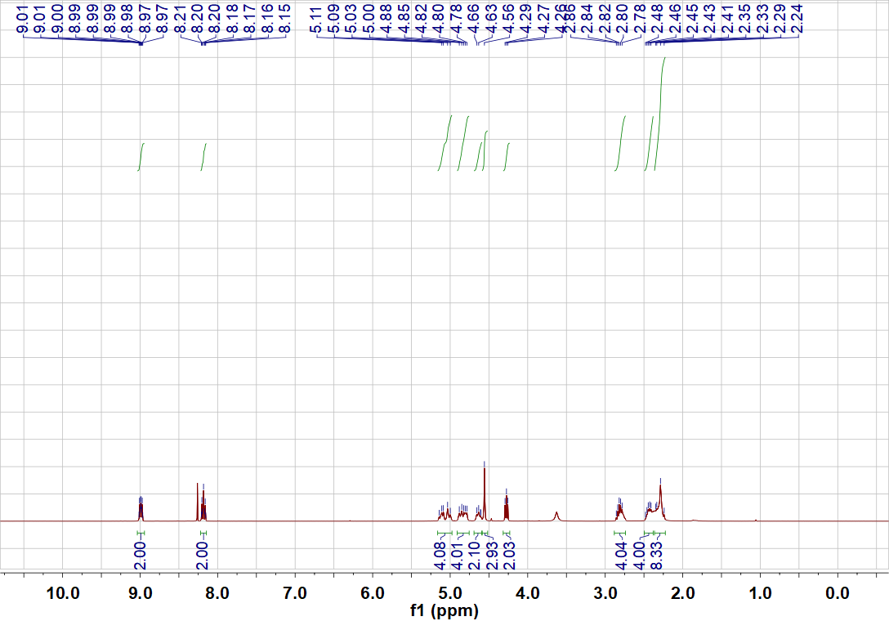
Figure S1. ¹H NMR Spectrum (CDCl₃, 400 MHz) of the target molecule OM.

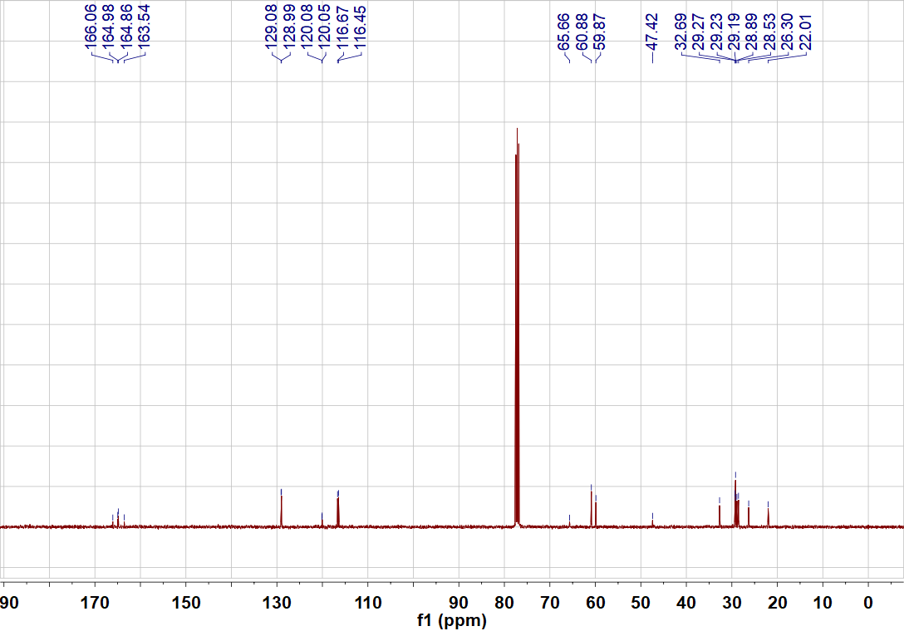
Figure S2. ¹³C NMR Spectrum (CDCl₃, 101 MHz) of the target molecule OM.
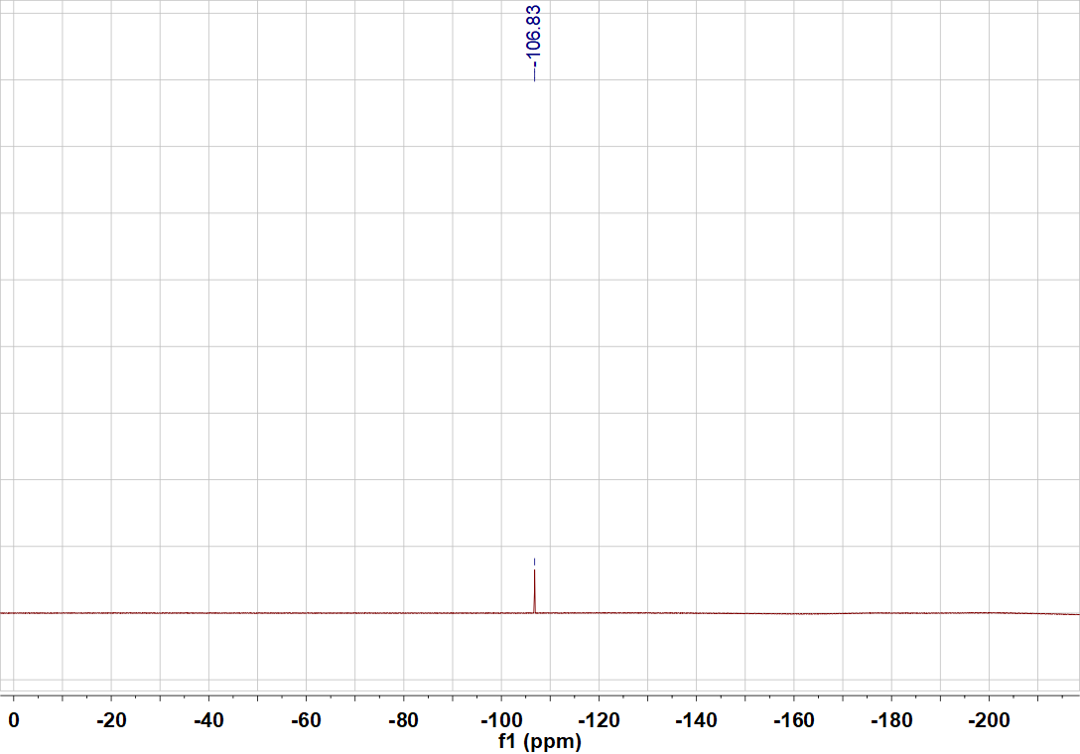
Figure S3. ¹⁹F NMR Spectrum (CDCl₃, 376 MHz) of the target molecule OM.
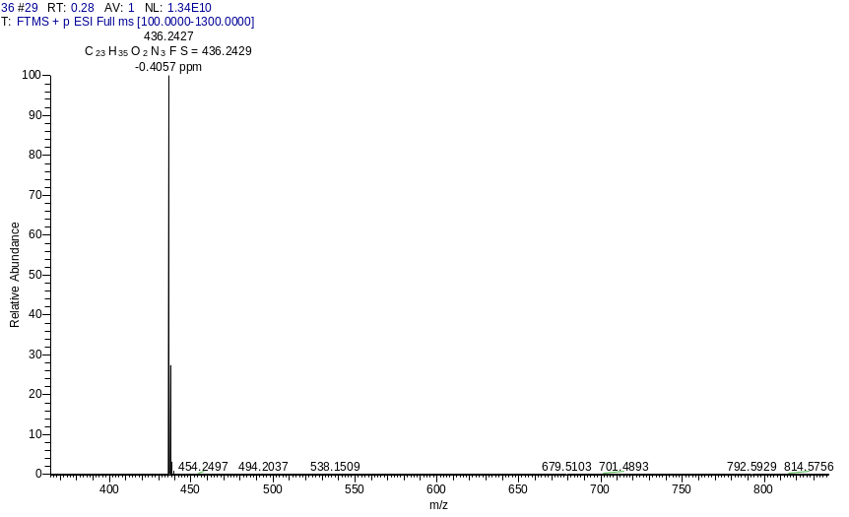
Figure S4. HRMS spectrum of the target molecule OM.

3. Primer sequences of representative genes for RT-qPCR.
Table S1. Primer sequences and standard curve parameters for qRT-PCR analysis of rice gibberellin biosynthetic genes.
Type | Gene | Fw (5'→3') | Rv (5'→3') | Amp. (bp) | Sl. | R² | Eff. (%)
T | OsGGPS1 | GCCGACAAGGCCACTTACCC | GCTGCCTGTAGGCGATGAACC | 128 | -3.5232 | 0.998 | 92.24
T | OsCPS | CCTCAGGGACAAGTGGGT | GCCTCAAGGTACAGGTCGT | 112 | -3.5017 | 0.998 | 93.00
T | OsKAO | TGATGAGCGGGCTGATGC | GCGATGACAAGGGAGACTATG | 112 | -3.5037 | 0.995 | 92.94
T | OsGA3ox1 | AGGCAAGGGCATCCTACA | GCAAGTCGTCCTCGGTCA | 106 | -3.4937 | 0.999 | 93.30
T | OsIspH | ATGGACGGGTTGGTGAGG | TGACGGTTGGGTTGTGGA | 109 | -3.4483 | 0.997 | 94.98
T | OsDXS | TGCTCGTAGGAGGGAACAGG | GAGCGGCTTGCAGAAACG | 115 | -3.4324 | 0.998 | 95.59
T | OsHMGCS | GAGCCTTATTCAGGTTTGT | TATTCCCGACTTGTTTCG | 112 | -3.4754 | 0.998 | 93.57
T | OsKS | AACTGTTGCTCCTGTGGG | CGATCTTCCGAATGTGAAT | 118 | -3.4656 | 0.998 | 94.33
R | OsEF1α | GGTGTCATCAAGCCTGGTATGG | CACGCTTGAGATCCTTAACCGC | 110 | -3.4543 | 0.995 | 95.84
Type T, target gene; Type R, reference gene. Fw, forward primer; Rv, reverse primer; Amp., amplicon length; Sl., slope of standard curve; Eff., amplification efficiency. OsEF1α was selected as the stable housekeeping gene for relative expression normalization.
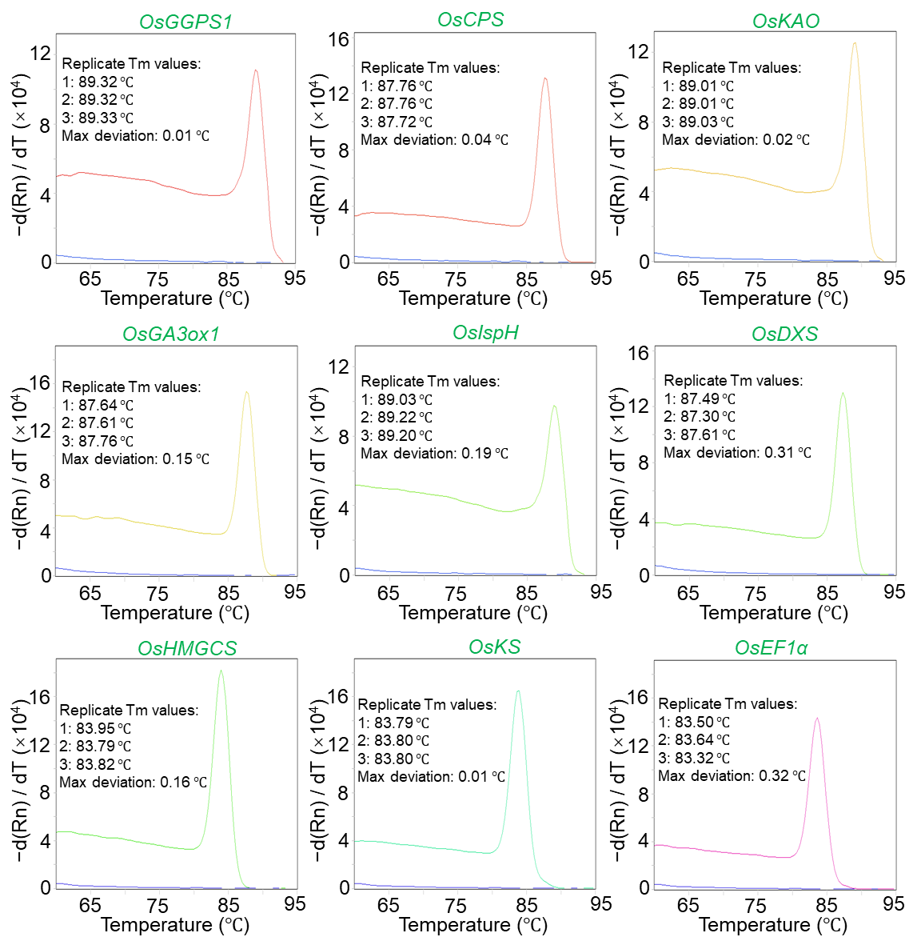
Figure S5. Melting curve analysis of amplification products from OsGGPS1, OsCPS, OsKAO, OsGA3ox1, OsIspH, OsDXS, OsHMGCS, OsKS and OsEF1α (three technical replicates per gene); The y-axis represents −d(Rn) / dT (×10⁴), the negative first derivative of normalized reporter fluorescence; Each target gene (colored curve) showed a single symmetric melting peak with replicate Tm deviation less than 0.5 °C, and no-template controls (blue lines) displayed flat baselines without non-specific signals, verifying the high specificity of all primer pairs.

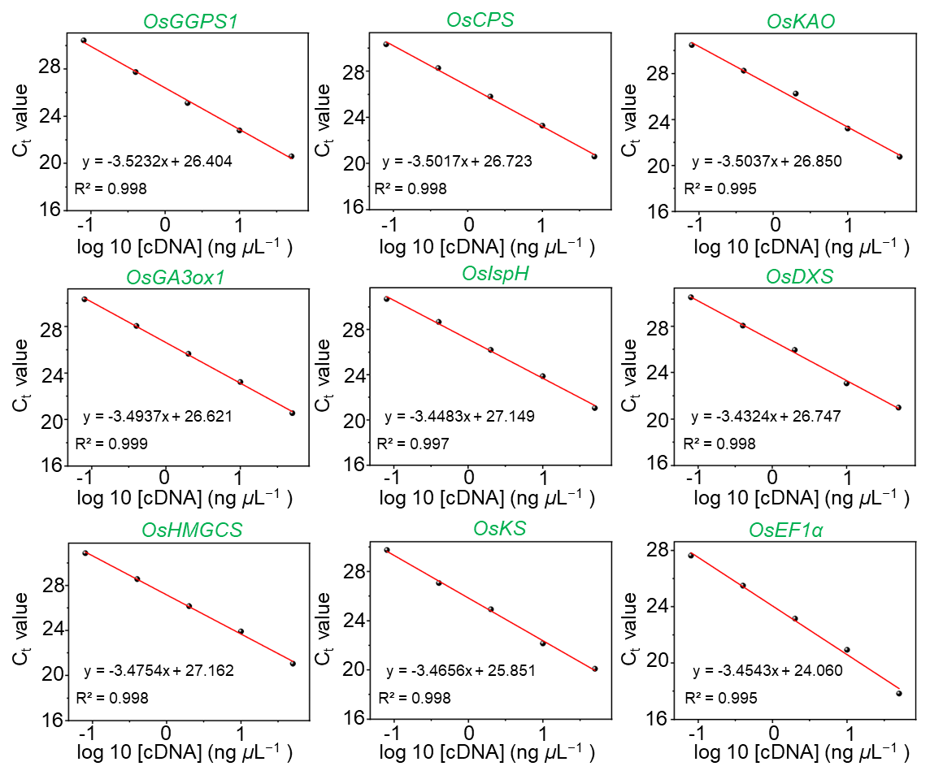
Figure S6. qRT-PCR standard curves for rice gibberellin biosynthetic target genes (OsGGPS1, OsCPS, OsKAO, OsGA3ox1, OsIspH, OsDXS, OsHMGCS and OsKS) and the reference gene OsEF1α (three technical replicates per gene). The x-axis corresponds to log₁₀-transformed cDNA concentration (ng μL⁻¹), and the y-axis represents cycle threshold (Ct) values. Linear regression equations and the coefficient of determination (R²) for each gene are presented in their respective subplots. All standard curves were constructed using a five-fold serial dilution gradient of rice cDNA templates to calculate the amplification efficiency of each primer pair.

Table S2. Expression stability verification of OsEF1α between control and OM@CB[7] treatment groups.
Group | Rep. 1 | Rep. 2 | Rep. 3 | Mean Ct ± SD | Ct range | CV (%) | P value (t-test)
Control | 18.95 | 18.57 | 18.76 | 18.76 ± 0.19 | 18.57–18.95 | 1.0 | 0.590
OM@CB[7] treatment | 18.80 | 18.78 | 18.92 | 18.83 ± 0.08 | 18.78–18.92 | 0.4 | 0.590
Each Ct value of biological replicates (Rep. 1-3) is the average of three technical replicates. Mean ± SD, Ct range and CV are all calculated based on three biological replicates (n = 3 per group). CV, coefficient of variation. An independent samples t-test was used for inter-group comparison. p > 0.05 indicates no statistically significant expression difference.

4. Biological Activity Assay of OM in Vitro.
Table S3. In vitro antibacterial activity of OM against pathogen Xoo.
Compd. | Inhibition (%) |  | Regression equation | r | EC₅₀ (µg mL ⁻¹)
Compd. | 50 (µg mL ⁻¹) | 20 (µg mL ⁻¹) | Regression equation | r | EC₅₀ (µg mL ⁻¹)
OM | 100 | 100 | y=10.8x-4.20 | 0.98 | 7.22±0.23
BT | 70.7 | 0 | y=4.78x-2.37 | 0.95 | 34.7±2.2
TC | 19.0 | 0 | y=2.68x+0.11 | 0.91 | 67.5±3.6

5. Self-assembly Mechanism of the target molecule OM.
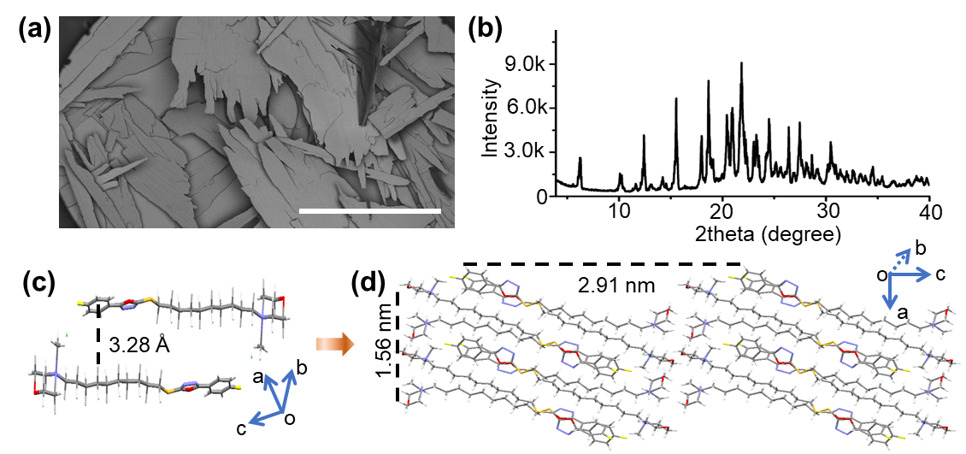
Figure S7. (a) SEM images of microstructures assembled from OM in water, the concentration is 5 mM, scale bar is 500 μm; (b) The X-ray powder diffraction pattern of the assemblies of OM; (c) A dimer of OM driven by the CH-π interaction with a distance of 3.28 Å; (d) A two-storied packing view of single crystal structures of OM, oxygen atoms are presented in red, nitrogen atoms in blue, hydrogen atoms in white, sulphur atoms in orange, fluorine atoms in yellow, and bromine atoms in green.
Table S4. Crystal data and structure refinement for OM.
Compound | OM
Formula | C₂₃H₃₅BrFN₃O₂S
Fw | 516.51
Crystal system | Triclinic
Space group | P-1
a (Å) | 8.90(3)
b (Å) | 10.07(3)
c (Å) | 29.13(8)
α (°) | 97.57(3)
β (°) | 92.15(4)
γ (°) | 98.35(3)
V (Å³) | 2555(13)
Z | 4
Calculated density (Mg×cm⁻³) | 1.343
F (000) | 1080
Reflections | 13026
collected/unique | 8872 [R(int) = 0.0391]
Goodness-of-fit on F² | 1.038
Final R indices | R1 = 0.0494
[I >2σ(I)] | wR2 = 0.0883
R indices (all data) | R1 = 0.1011, wR2 = 0.0958

6. Aqueous Solubility of OM and Encapsulation Efficiency of OM@CB [7].
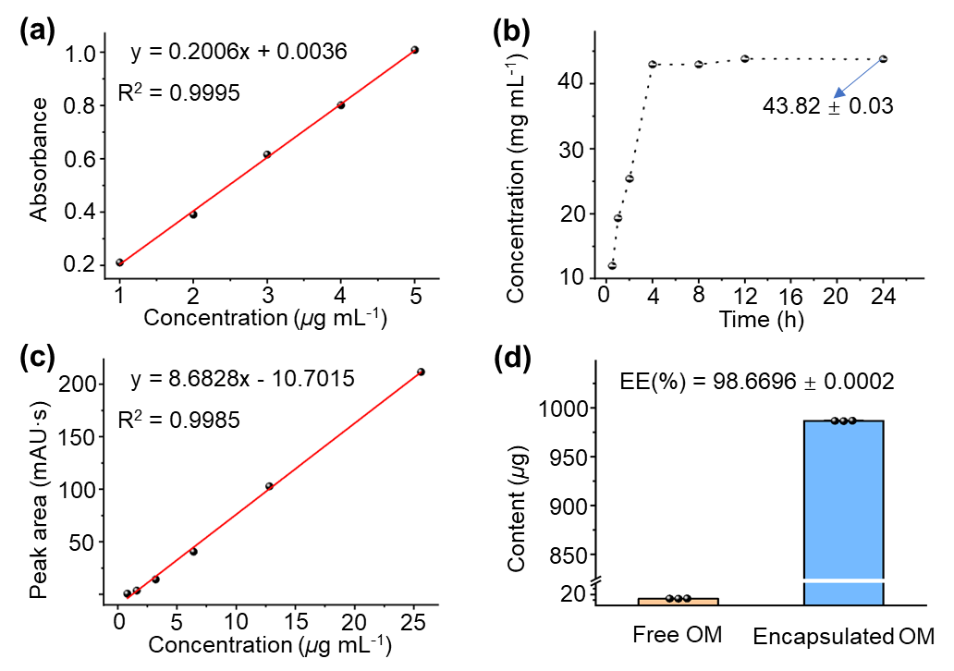
Figure S8. (a) UV-Vis absorbance calibration curve of OM; (b) Time-dependent dissolution equilibrium profile of free OM in aqueous solution; (c) HPLC peak area calibration curve of OM; (d) Distribution of free (leaked) and encapsulated (retained) OM, and the encapsulation efficiency (EE) of OM@CB[7] supramolecular complexes; Data are presented as mean ± standard error (SD, n = 3).

7. Fabrication of Stimuli-responsive Supramolecular Complex OM@CB[7].
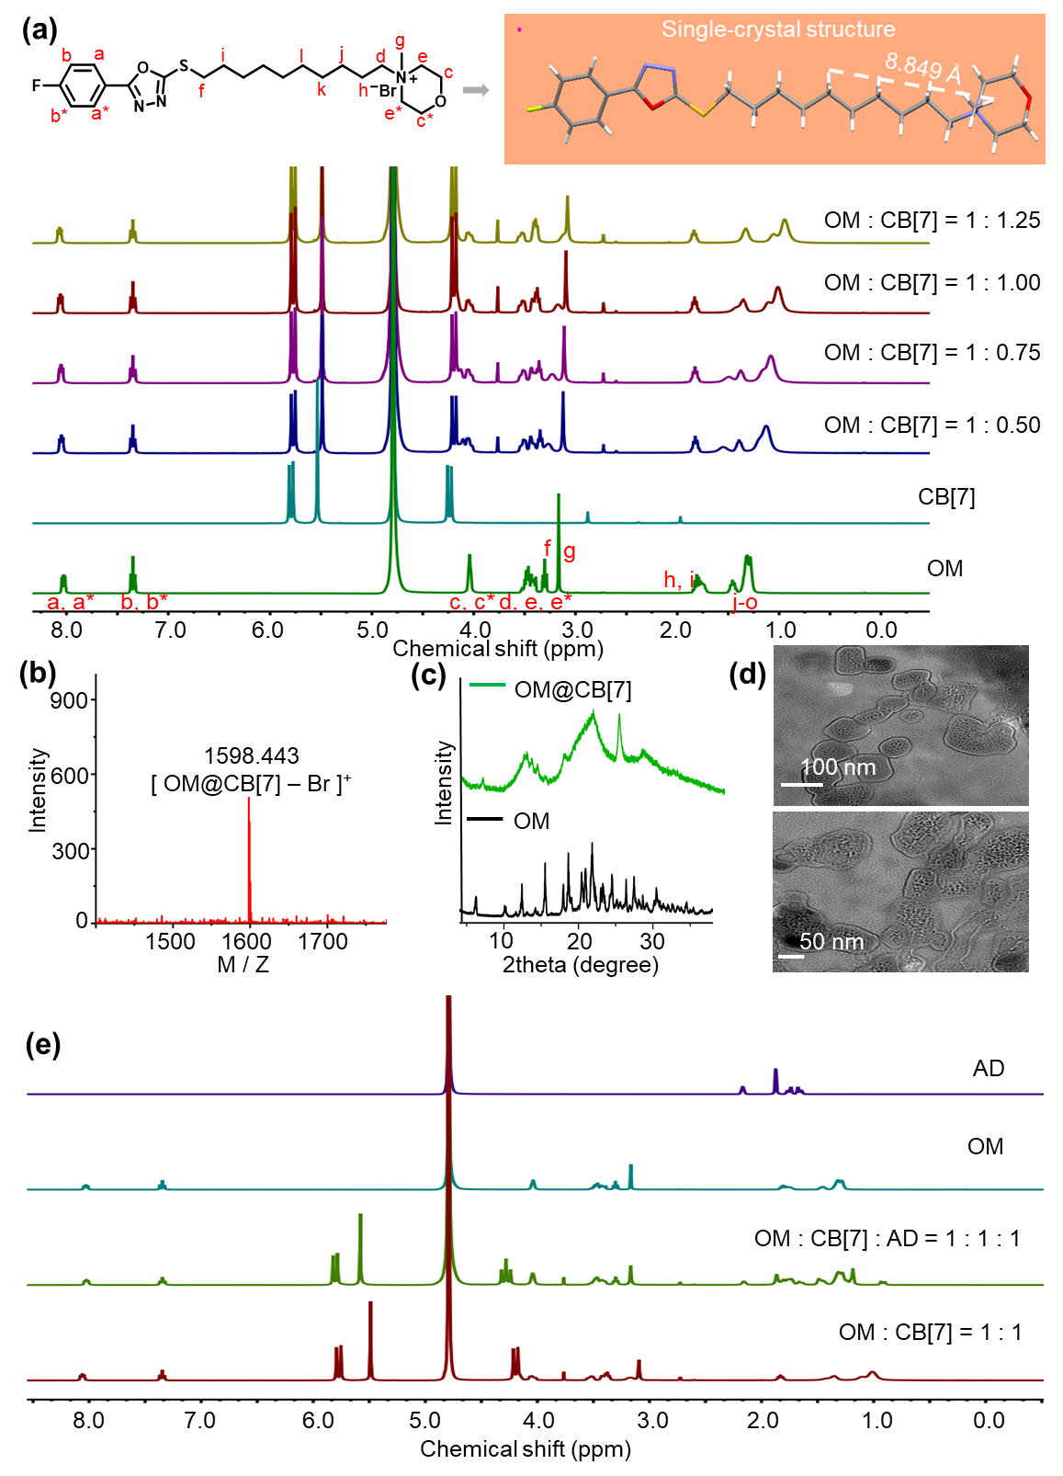
Figure S9. (a) ¹H NMR spectra of OM (3.0 mM), CB[7], and OM@CB[7] with different molar ratios (1:0.5, 1:0.75, 1:1, 1:1.25) in D₂O; (b) The MALDI-TOF MS spectrum of OM@CB[7] complex; (c) X-ray powder diffraction patterns of OM and OM@CB[7] assemblies; (d) TEM images of complex OM@CB[7] in water (conc. 0.4 mM, molar ratio, 1:1); (e) ¹H NMR spectra of compound OM (3.0 mM), OM@CB[7] (molar ratio, 1:1), AD, and adding AD to OM@CB[7] (molar ratio, 1:1:1) in D₂O.

8. Spermine-Triggered Competitive Displacement Assay (¹H NMR).
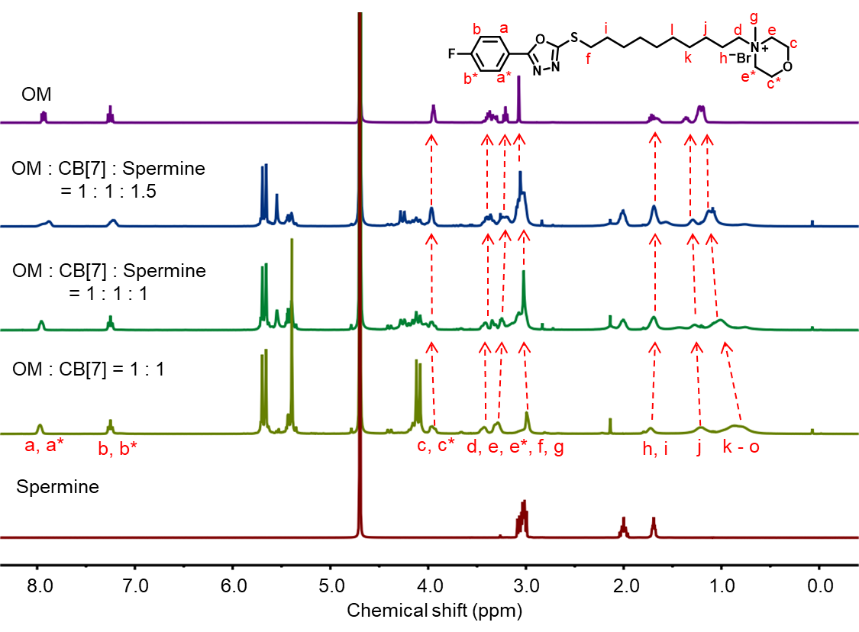
Figure S10. ¹H NMR spectra of compound OM (3.0 mM), OM@CB[7] (molar ratio, 1:1), Spermine, and adding Spermine to OM@CB[7] (molar ratio, 1:1:1/1.5) in D₂O.

9. Field Application Potential: Leaf Retention and Rainfastness of OM@CB[7].
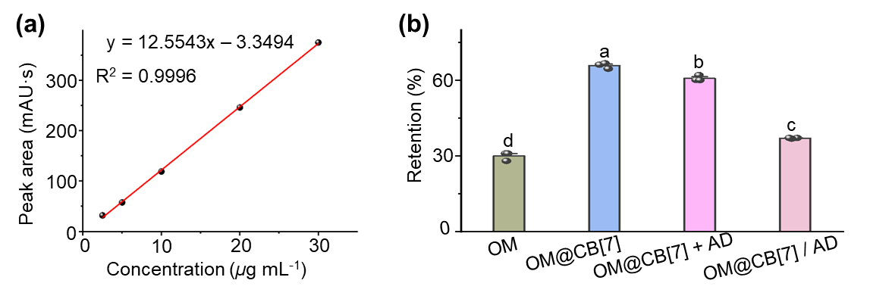
Figure S11. Matrix-matched calibration curve for OM and rainfastness of different formulations on rice leaves; (a) Calibration curve of OM in rice leaf extract matrix from 2.5 to 30 μg mL⁻¹, exhibiting excellent linearity (R² = 0.9996); (b) Retention rates of free OM, OM@CB[7], OM@CB[7]+AD, and pre-mixed OM@CB[7]/AD on rice leaves after simulated rainfall (30 mm h⁻¹, 5 mm total, 60° inclination); Different lowercase letters indicate statistically significant differences at p < 0.05 (one-way ANOVA followed by Tukey’s post-hoc test). Data are presented as mean ± standard error (SD, n = 3).

10. Statistical Analysis of Survival Rates in Danio Rerio (Zebrafish) and Earthworms.
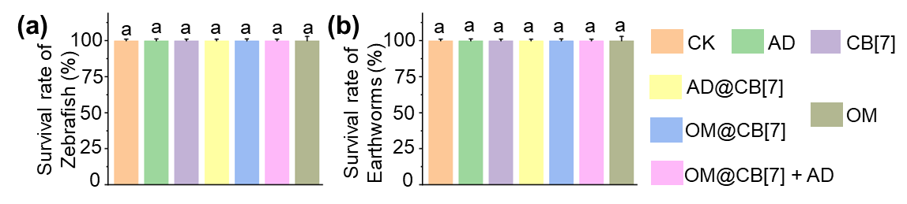
Figure S12. Statistical analysis of survival rates in zebrafish (a) and earthworms (b); Statistical differences among groups were determined by one-way ANOVA followed by Tukey’s post-hoc test at p < 0.05; Different lowercase letters denote significant differences; Error bars represent mean ± SD (n = 3).

11. Comparative Acute Toxicity (96-h LC₅₀) of Different Formulations to Zebrafish.
Table S5 Acute toxicity (96-h LC₅₀) of different formulations to zebrafish.
Compd. | Regression equation | R² | 96-h LC₅₀ (µg mL⁻¹)
AD | y=3.36 x – 1.17 | 0.99 | 69.1±4.7^{b}
CB[7] | - | - | >200ª
AD@CB[7] | - | - | >200ª
OM | y=25.7 x – 25.1 | 0.97 | 14.8±0.2^{d}
OM@CB[7] | y=12.6 x – 14.2 | 0.96 | 33.7±2.8^{c}
OM@CB[7]+AD | y=27.5 x – 27.9 | 0.91 | 15.6±0.2^{d}
Note. Statistical differences among groups were determined by one-way ANOVA followed by Tukey’s post-hoc test at p < 0.05; Different lowercase letters denote significant differences; Error bars represent mean ± SD (n = 3).

12. Cytotoxicity parameters of different formulations in HepG2 cells.
Table S6. Cytotoxicity parameters of different formulations in HepG2 cells derived from probit regression analysis.
Compd. | Cell viability at 1000 μg·mL⁻¹ (%) ¹ | Probit regression equation ² | R² | LC₅₀  (µg mL⁻¹) | 95% Confidence interval (µg mL⁻¹)
AD | - | y=1.90 x – 4.35 | 0.94 | 220.50 | 129.05 - 362.14
CB[7] | 100±0.0 | - | - | >1000 | -
AD@CB[7] | 74.4±2.3 | - | - | >1000 | -
OM | - | y=0.67 x – 0.93 | 0.95 | 24.24 | 19.38 – 30.64
OM@CB[7] | - | y=1.12 x – 2.04 | 0.92 | 69.10 | 27.18 – 146.20
OM@CB[7]+AD | - | y=1.01 x – 1.46 | 0.91 | 29.92 | 10.40 - 55.83
Note. All parameters were calculated based on 24 h MTT assay data via probit regression analysis; En dash (–) indicates that this test was not performed; R² epresents the goodness of fit of probit regression models.
¹ Data are presented as mean ± SD (n =3) of three replicate wells.
² In the equation, y represents the probit value of cell mortality, and x represents the log₁₀-transformed concentration (μg mL⁻¹).

13. Residue Degradation Behavior of OM@CB[7] Supramolecular Sustained-Release System on Rice Leaves.
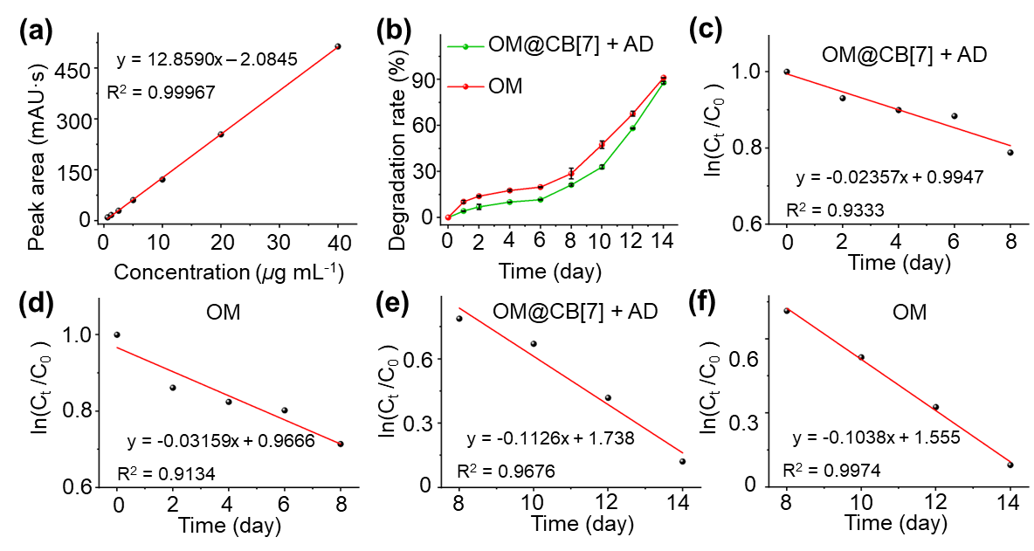
Figure S13. (a) Standard calibration curves of OM generated from HPLC peak areas at various concentrations (40, 20, 10, 5, 2.5, 1.25, and 0.625 µg·mL⁻¹); (b) Degradation profiles of OM and OM@CB[7] (200 μg·mL⁻¹) on rice leaves over storage periods of 0, 1, 2, 4, 6, 8, 10, 12 and 14 days, measured by HPLC; Data are presented as mean ± SE (n = 3); (c - f) Segmented linear fitting of ln(C_{t} /C₀) versus cultivation time over 0 - 8 d and 8 - 14 d to characterize stage-wise foliar dissipation kinetics of OM@CB[7]+AD and free OM.

Table S7. Segmented foliar residue dissipation kinetic parameters of free OM and OM@CB[7]+AD.
Formulation | Early stage (0–8 d) |  | Late stage (8–14 d)
Formulation | k / d⁻¹ | t _{1/2} / d | k / d⁻¹ | t _{1/2} / d
Free OM | 0.03159 | 21.94 | 0.1038 | 6.68
OM@CB[7]+AD | 0.02357 | 29.40 | 0.1126 | 6.15
Note: k = first-order residue dissipation rate constant; t _{1/2} = foliar residue dissipation half-life. Parameters were derived from segmented linear fitting of ln(C_{t} /C₀) against cultivation time. These values describe total residue attenuation under growth light (including photochemical degradation and minor physical loss) instead of pure photolytic parameters. Non-zero intercepts were attributed to slight initial pesticide loss during sampling and extraction.

14. Impacts of OM@CB[7]+AD on Soil Microbial Communities and Ecological Function.
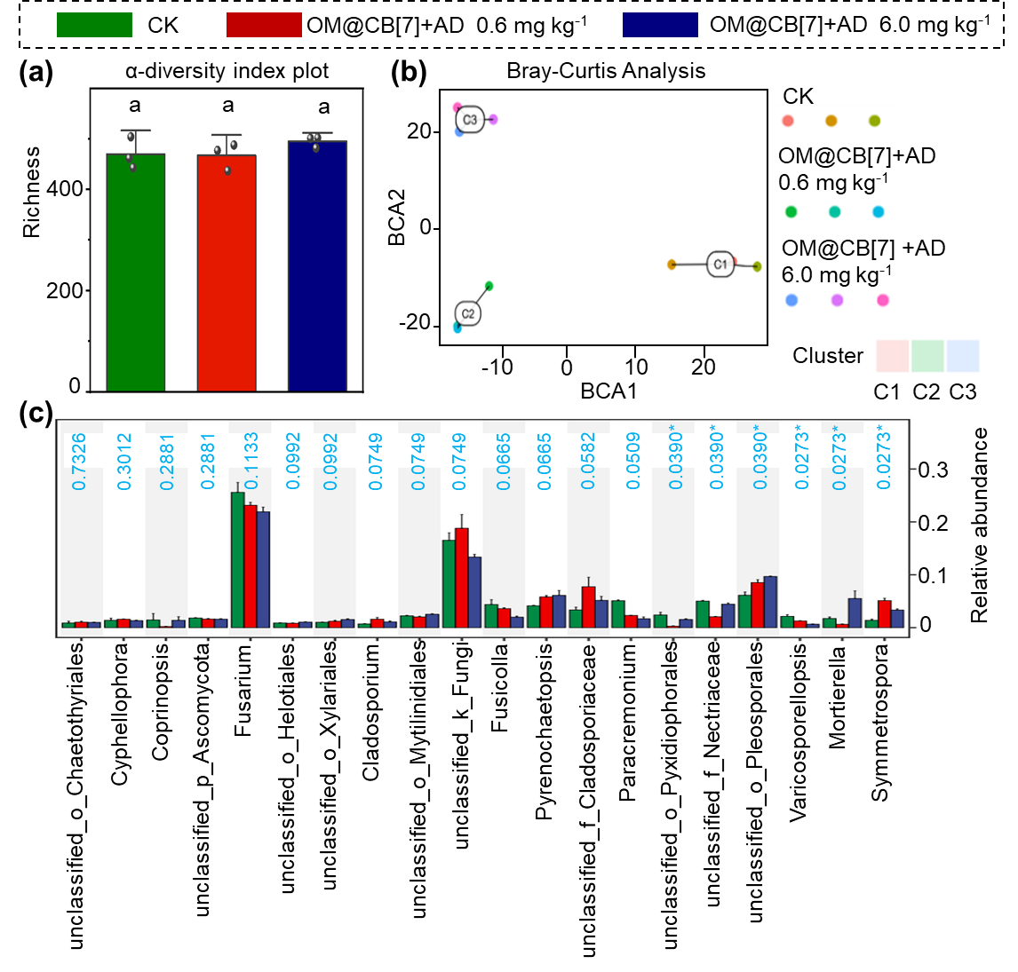
Figure S14. Fungal community profiles in soil under OM@CB[7] + AD treatments at 0.0, 0.6, and 6.0 mg kg⁻¹. (a) Richness index of α-diversity. Statistical differences among groups were determined by one-way ANOVA followed by Tukey’s post-hoc test at p < 0.05; Same lowercase letters denote no-significant differences; Error bars represent mean ± SD (n = 3); (b) Bray-Curtis-based β-diversity ordination; (c) Relative abundance of the top 20 fungal genera; The blue font represents the p value, and when p < 0.05, it indicatesa significant difference. Statistical differences between the groups were determined using the Kruskal-Wallis test. Error bars represent means ± standard error (SE). pvalues for each group comparison are displayed in blue. p < 0.05 indicates a statistically significant difference between the groups. n.s. denotes no significance. The experiments were conducted with a minimum of three replicates, and the sample size for each data point is specified within the respective figure. Source data are provided as a Source Data file.
As shown in Figure S14, application of OM@CB[7] + AD did not significantly alter the fungal richness index; however, ordination analysis based on Bray–Curtis distances revealed clear differentiation among fungal communities across treatments, indicating that this agent reshaped the overall community structure. Further analysis at the genus level showed that OM@CB[7] + AD concentration‑dependently inhibited the pathogenic Fusarium and significantly enriched beneficial saprotrophic fungi such as Mortierella, demonstrating its selective suppression of pathogens and favourable ecological safety for native non‑target fungal communities.
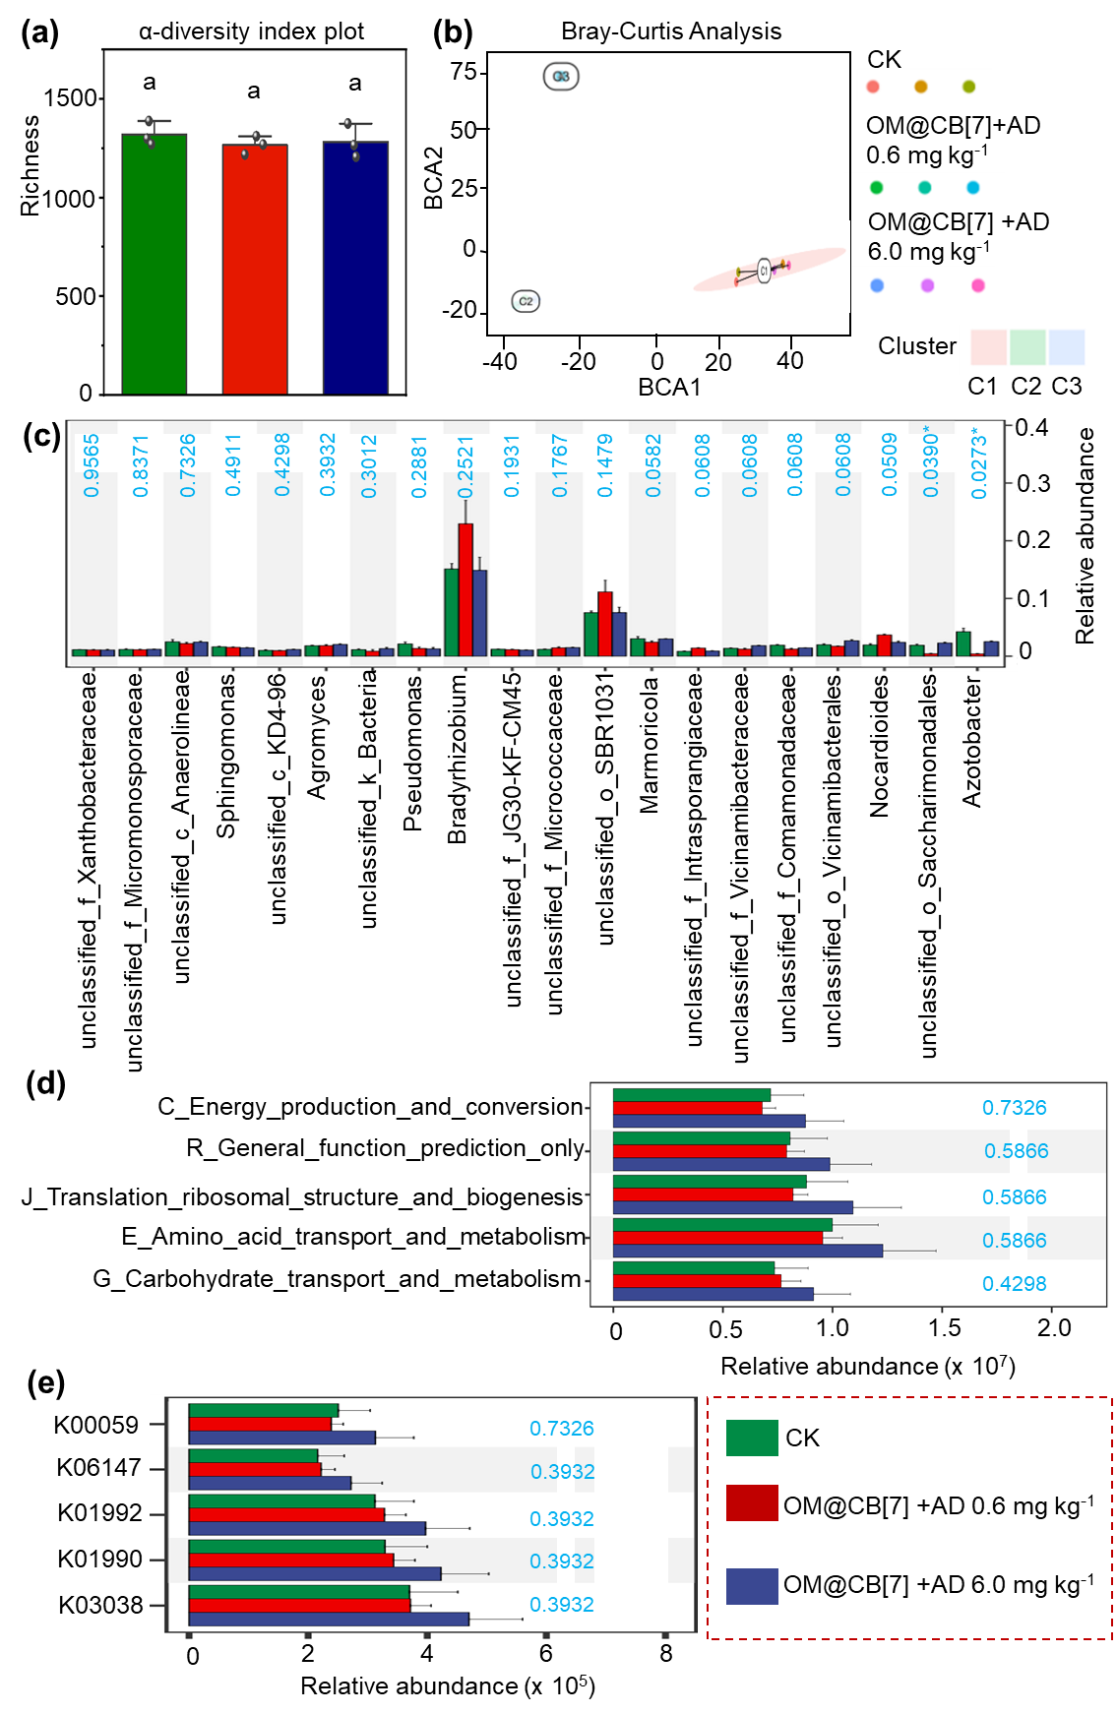
Figure S15. Soil bacterial community composition and functional profiles under OM@CB[7] + AD treatments at 0.0, 0.6, and 6.0 mg kg⁻¹. (a) Richness index of α-diversity. Statistical differences among groups were determined by one-way ANOVA followed by Tukey’s post-hoc test at p < 0.05; Same lowercase letters denote no-significant differences; Error bars represent mean ± SD (n = 3); (b) Bray-Curtis-based β-diversity ordination; (c) Relative abundance of the top 20 bacterial genera; (d) Relative abundance of dominant COG functional categories; (e) Relative abundance of core energy-metabolism functional genes. The blue font represents the p value, and when p < 0.05, it indicatesa significant difference. Statistical differences between the groups were determined using the Kruskal-Wallis test. Error bars represent means ± standard error (SE). pvalues for each group comparison are displayed in blue. p < 0.05 indicates a statistically significant difference between the groups. n.s. denotes no significance. The experiments were conducted with a minimum of three replicates, and the sample size for each data point is specified within the respective figure. Source data are provided as a Source Data file.
As shown in Figure S15, OM@CB[7] + AD application at 0.6 and 6.0 mg kg⁻¹ exerted no significant influence on bacterial Richness, indicating that the compound did not damage the overall α-diversity of indigenous soil bacteria. Bray-Curtis ordination revealed obvious separation of bacterial communities across treatments, demonstrating that OM@CB[7] + AD reshaped bacterial community assembly without eliminating dominant native genera such as Sphingomonas and Pseudomonas. At the genus level, only a small fraction of rare taxa including Azotobacter showed significant abundance variation, while most core bacterial populations remained stable. Functional prediction based on COG categories showed that high-dose OM@CB[7] + AD elevated the abundance of genes related to energy production, amino acid and carbohydrate metabolism. Key energy-metabolism KEGG genes were consistently enriched with the rising concentration of OM@CB[7] + AD. Collectively, OM@CB[7] + AD exhibited favorable biosafety to soil bacterial communities and moderately activated bacterial metabolic functions.

15. Determination of Enzyme Activities in Seedling Leaves Post OM@CB[7] Treatment.
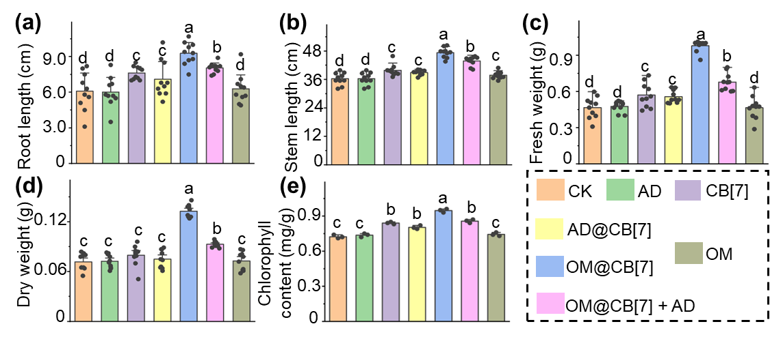
Figure S16. Statistical analysis of root length (a), stem length (b), fresh weight (c), dry weight (d), and leaf chlorophyll content (e) of seedling-stage rice 14 days after treatment with components (30 mL, 200 μg mL⁻¹); Statistical differences among groups were determined by one-way ANOVA followed by Tukey’s post-hoc test at p < 0.05; Different lowercase letters denote significant differences; Error bars represent mean ± SE (n = 10).

16. OM@CB[7] improves yield-associated panicle traits in rice.
Table S8. Raw data of filled and unfilled grains and yield-related indexes of rice panicles.
Treatment | Biological Replicate | Panicle ID | Filled grains | Unfilled grains | Seed Setting Rate per panicle (%) | Grain weight per panicle (g)
CK | 1 | 1-1 | 154 | 166 | 48.1% | 3.101
CK | 1 | 1-2 | 107 | 78 | 57.8% | 1.875
CK | 1 | 1-3 | 80 | 63 | 55.9% | 1.368
CK | 2 | 2-1 | 121 | 100 | 54.8% | 1.689
CK | 2 | 2-2 | 161 | 90 | 64.1% | 2.765
CK | 2 | 2-3 | 121 | 109 | 52.6% | 2.787
CK | 3 | 3-1 | 103 | 100 | 50.7% | 2.015
CK | 3 | 3-2 | 117 | 123 | 48.8% | 1.989
CK | 3 | 3-3 | 115 | 100 | 53.5% | 1.893
CK | 4 | 4-1 | 103 | 88 | 53.9% | 1.789
CK | 4 | 4-2 | 113 | 85 | 57.1% | 1.976
CK | 4 | 4-3 | 104 | 128 | 44.8% | 1.800
CK | 5 | 5-1 | 111 | 99 | 52.9% | 1.876
CK | 5 | 5-2 | 137 | 94 | 59.3% | 1.457
CK | 5 | 5-3 | 113 | 103 | 52.3% | 1.868
CK | 6 | 6-1 | 125 | 105 | 54.3% | 2.156
CK | 6 | 6-2 | 169 | 113 | 59.9% | 3.013
CK | 6 | 6-3 | 104 | 110 | 48.6% | 1.902
OM@CB[7] | 1 | 1-1 | 116 | 96 | 54.7% | 2.583
OM@CB[7] | 1 | 1-2 | 140 | 104 | 57.4% | 2.880
OM@CB[7] | 1 | 1-3 | 180 | 130 | 58.1% | 3.987
OM@CB[7] | 2 | 2-1 | 210 | 107 | 66.2% | 4.343
OM@CB[7] | 2 | 2-2 | 135 | 71 | 65.5% | 3.338
OM@CB[7] | 2 | 2-3 | 179 | 85 | 67.8% | 4.043
OM@CB[7] | 3 | 3-1 | 130 | 126 | 50.8% | 2.938
OM@CB[7] | 3 | 3-2 | 126 | 177 | 41.6% | 2.391
OM@CB[7] | 3 | 3-3 | 129 | 56 | 69.7% | 2.691
OM@CB[7] | 4 | 4-1 | 121 | 110 | 52.4% | 2.637
OM@CB[7] | 4 | 4-2 | 111 | 89 | 55.5% | 2.318
OM@CB[7] | 4 | 4-3 | 103 | 79 | 56.6% | 2.154
OM@CB[7] | 5 | 5-1 | 130 | 90 | 59.1% | 2.843
OM@CB[7] | 5 | 5-2 | 168 | 83 | 66.9% | 3.663
OM@CB[7] | 5 | 5-3 | 159 | 84 | 65.4% | 3.456
OM@CB[7] | 6 | 6-1 | 199 | 102 | 66.1% | 4.018
OM@CB[7] | 6 | 6-2 | 109 | 88 | 55.3% | 2.401
OM@CB[7] | 6 | 6-3 | 128 | 99 | 56.4% | 2.806
Note: Treatment：CK = water control; OM@CB[7] = 200 μg mL⁻¹ OM@CB[7] foliar treatment.
Biological Replicate：6 independent biological replicates were set for each treatment, with 3 panicles randomly collected from each replicate plant.
Seed Setting Rate：Calculated as (Filled Grains / (Filled Grains + Unfilled Grains)) × 100%.

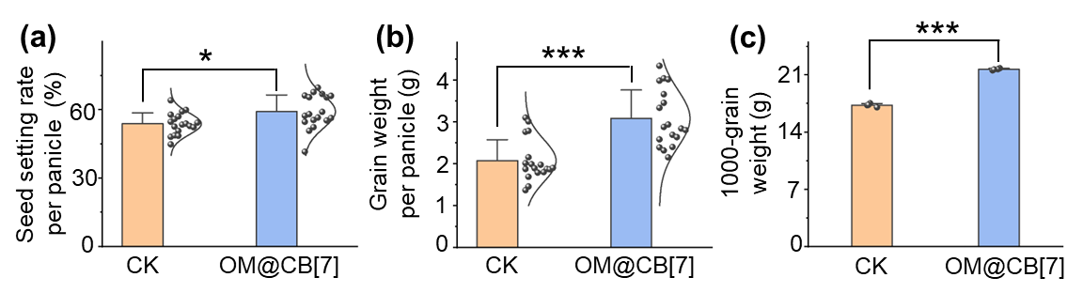
Figure S17. Effects of foliar OM@CB[7] application on rice yield-related traits at flowering stage; (a) Seed setting rate per panicle; (b) Grain weight per panicle; (c) 1000-grain weight; Bars denote mean ± SD, black scattered dots represent individual measured values, and violin outlines reflect data probability distribution. Statistical analysis was performed using unpaired two-tailed Student’s t-test; Error bars represent mean ± SE (n = 18 (a, b) or 4 (c)); Asterisks indicate significant differences versus the untreated control: *p < 0.05, ***p < 0.001.

17. Differential Transcriptomic Analysis of OM@CB[7]-treated Seedlings.
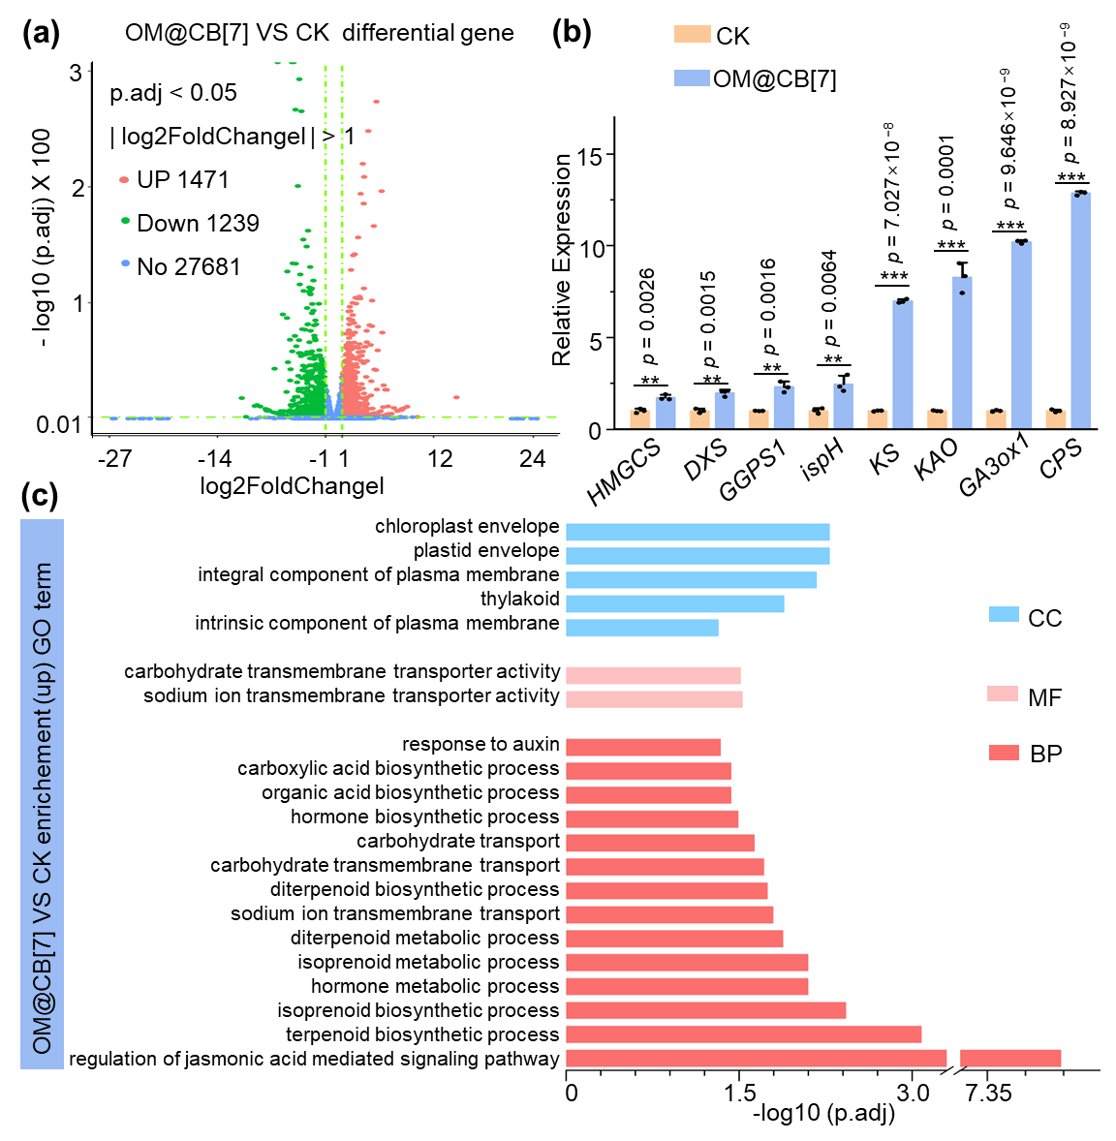
Figure S18. (a) Volcano plot of differentially expressed genes between CK (blank control group) and OM@CB[7] (experimental group); (b) Relative expression levels of genes in CK (yellow) and OM@CB[7]-treated (blue) rice seedlings; Columns represent the relative expression of HMGCS, DXS, GGPS1, ispH, KS, KAO, GA3ox1, and CPS in water-treated control (CK, orange columns) and OM@CB[7]-treated (blue columns) rice seedlings; Error bars represent the standard deviation (SD) of biological replicates (n = 3). Statistical significance was assessed by a two-tailed Student's t-test, assuming normality and homogeneity of variance were satisfied; Asterisks indicate significant differences versus the untreated control: *p < 0.05, **p < 0.01, ***p < 0.001; (c) GO analysis of upregulated genes after treatmented with OM@CB[7] (CC: Cellular Component, MF: Molecular Function, BP: Biological Process, p.adjust < 0.05).
Table S9. Significantly enriched GO terms of upregulated differentially expressed genes (p.adjust < 0.05; BP: Biological Process; CC: Cellular Component; MF: Molecular Function).
NO. | ONTOLOGY | ID | Description (term name) | p.adjust
1 | BP | GO:2000022 | regulation of jasmonic acid mediated signaling pathway | 3.28E-08
2 | BP | GO:0016114 | terpenoid biosynthetic process | 0.000841
3 | BP | GO:0006721 | terpenoid metabolic process | 0.00234
4 | BP | GO:0009611 | response to wounding | 0.002886
5 | BP | GO:0008299 | isoprenoid biosynthetic process | 0.003795
6 | CC | GO:0009941 | chloroplast envelope | 0.00525
7 | CC | GO:0009526 | plastid envelope | 0.00525
8 | MF | GO:0003714 | transcription corepressor activity | 0.005808
9 | CC | GO:0044436 | obsolete thylakoid part | 0.006782
10 | CC | GO:0031977 | thylakoid lumen | 0.006782
11 | CC | GO:0005887 | integral component of plasma membrane | 0.006782
12 | BP | GO:0006720 | isoprenoid metabolic process | 0.008076
13 | BP | GO:0042445 | hormone metabolic process | 0.008076
14 | BP | GO:0006814 | sodium ion transport | 0.008225
15 | BP | GO:0015979 | photosynthesis | 0.012092
16 | BP | GO:0019748 | secondary metabolic process | 0.012092
17 | CC | GO:0009579 | thylakoid | 0.01301
18 | BP | GO:0016101 | diterpenoid metabolic process | 0.013264
19 | BP | GO:0035725 | sodium ion transmembrane transport | 0.016242
20 | BP | GO:0016122 | xanthophyll metabolic process | 0.018185
21 | BP | GO:0016102 | diterpenoid biosynthetic process | 0.0182
22 | BP | GO:0009966 | regulation of signal transduction | 0.0195
23 | BP | GO:0034219 | carbohydrate transmembrane transport | 0.0195
24 | BP | GO:0023051 | regulation of signaling | 0.0236
25 | BP | GO:0080167 | response to karrikin | 0.0236
26 | BP | GO:0008643 | carbohydrate transport | 0.0236
27 | BP | GO:0016108 | tetraterpenoid metabolic process | 0.0236
28 | BP | GO:0016116 | carotenoid metabolic process | 0.0236
29 | BP | GO:0044550 | secondary metabolite biosynthetic process | 0.0240
30 | BP | GO:0010646 | regulation of cell communication | 0.0242
31 | BP | GO:0046148 | pigment biosynthetic process | 0.0285
32 | MF | GO:0015081 | sodium ion transmembrane transporter activity | 0.0299
33 | MF | GO:0004497 | monooxygenase activity | 0.0299
34 | MF | GO:0015144 | carbohydrate transmembrane transporter activity | 0.0310
35 | BP | GO:0042446 | hormone biosynthetic process | 0.0326
36 | BP | GO:0019684 | photosynthesis, light reaction | 0.0374
37 | BP | GO:0016053 | organic acid biosynthetic process | 0.0374
38 | BP | GO:0046394 | carboxylic acid biosynthetic process | 0.0374
39 | BP | GO:1901264 | carbohydrate derivative transport | 0.0413
40 | BP | GO:0010817 | regulation of hormone levels | 0.0413
41 | BP | GO:0009694 | jasmonic acid metabolic process | 0.0420
42 | MF | GO:0008028 | monocarboxylic acid transmembrane transporter activity | 0.0425
43 | BP | GO:0042742 | defense response to bacterium | 0.0457
44 | BP | GO:0009733 | response to auxin | 0.0464
45 | BP | GO:0042435 | indole-containing compound biosynthetic process | 0.0482
46 | CC | GO:0031226 | intrinsic component of plasma membrane | 0.0482
47 | BP | GO:0042214 | terpene metabolic process | 0.0491
48 | BP | GO:0009813 | flavonoid biosynthetic process | 0.0491

18. Gibberellin Contents in Rice Leaves after OM@CB[7] Treatment.
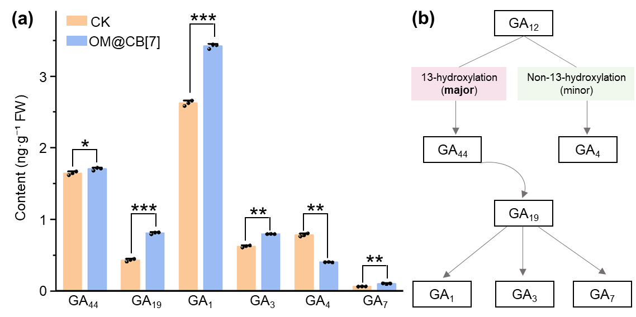
Figure S19. Endogenous gibberellin accumulation and biosynthetic pathway regulation in rice seedlings after OM@CB[7] application; (a) Relative contents of GA₁, GA₃, GA₄, GA₇, GA₁₉ and GA₄₄ determined by LC-MS/MS; (b) Simplified model of GA biosynthetic pathways in rice. The upstream precursor GA₁₂ diverges into two competing pathways; Data are presented as mean ± SD (n = 3 biological replicates); Statistical analysis was performed using one-way ANOVA followed by Tukey's post-hoc test; Asterisks indicate significant differences versus the untreated control: *p < 0.05, **p < 0.01, ***p < 0.001.

19. Paclobutrazol abolishes the growth-promoting effect of OM@CB[7].
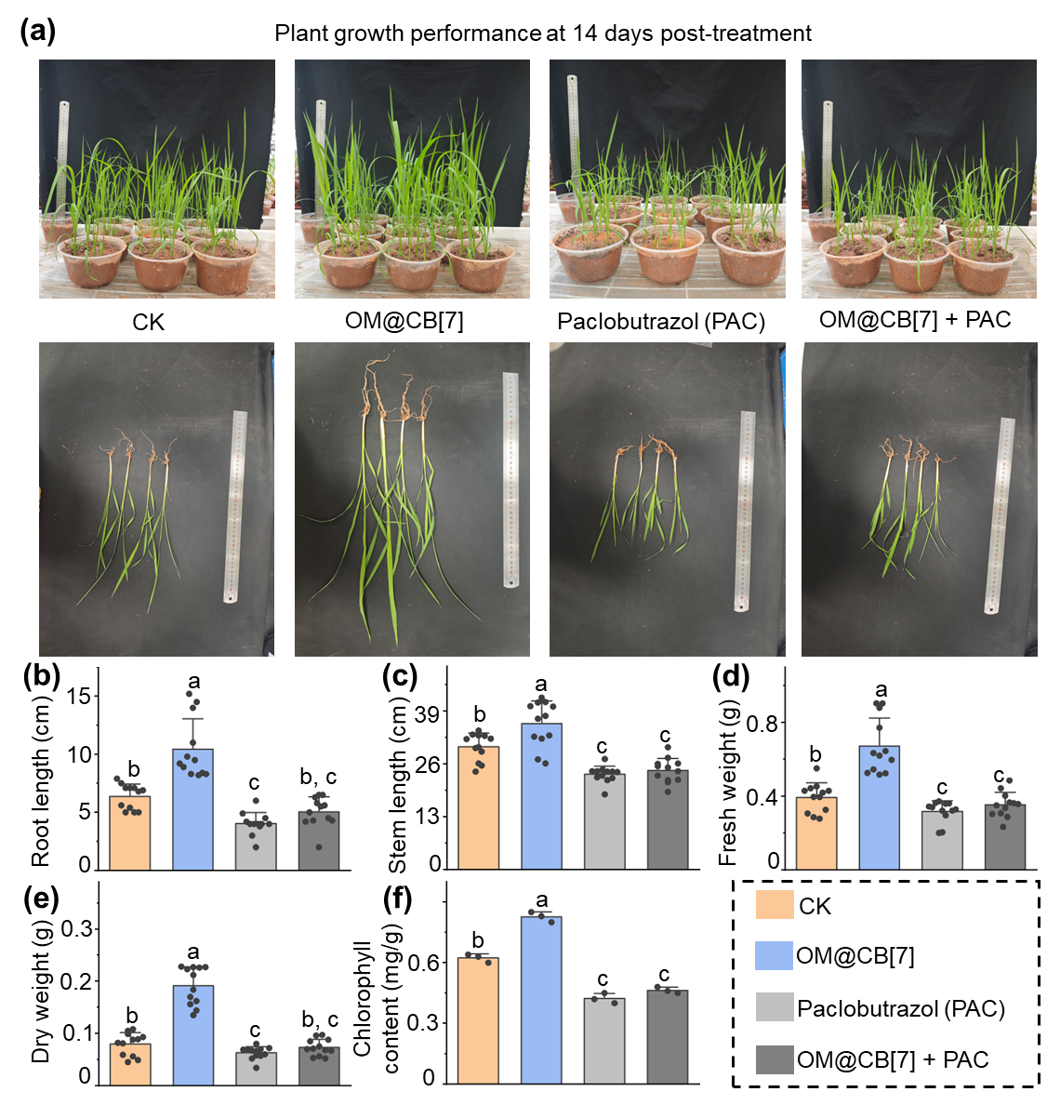
Figure S20. PAC-based inhibition assay verifying GA-dependent growth promotion of OM@CB[7] in rice. (a) Representative plant morphology after 14-day treatments with OM@CB[7], PAC, and OM@CB[7]+PAC. (b – f) Quantification of root length (b), stem length (c), fresh weight (d), dry weight (e) and chlorophyll content (f); Data are presented as mean ± SD (n = 12 for b-e, n = 3 for f); Statistical analysis was performed using one-way ANOVA with Tukey’s test, different lowercase letters indicate p < 0.05.

20. Disease grading scale for rice bacterial leaf blight.
Table S10. Disease grading scale for rice bacterial leaf blight
Grade | Representative Value | Symptom Description
0 | 0 | No visible lesion on the inoculated leaf, completely healthy
1 | 1 | Lesion length accounts for less than 5% of the total leaf length
3 | 3 | Lesion length accounts for 6% to 10% of the total leaf length
5 | 5 | Lesion length accounts for 11% to 20% of the total leaf length
7 | 7 | Lesion length accounts for 21% to 50% of the total leaf length
9 | 9 | Lesion length accounts for more than 50% of the total leaf length, or the whole leaf withers and dies

21. In vivo activity against rice bacterial blight: Quantitative efficacy assessment with expanded replicates.
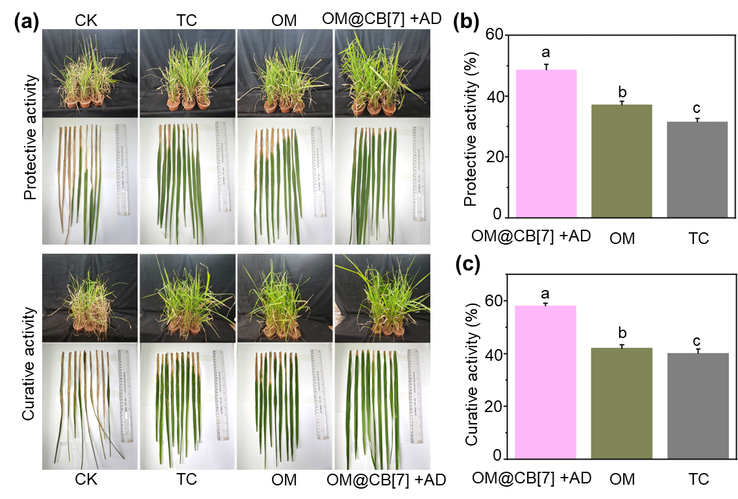
Figure S21. In vivo activity against rice bacterial blight. Treatments: OM and AD‑triggered OM@CB[7] (all at 200 μg mL⁻¹ effective components). Thiodiazole copper as positive control. Molar ratios: OM@CB[7] = 1:1; OM@CB[7]+AD = 1:1:1. Statistical analysis was performed using one-way ANOVA with Tukey’s test, different lowercase letters indicate p < 0.05.

22. Biofilm Content of Mature Xoo Biofilms Treated with AD, CB[7], and AD@CB[7].
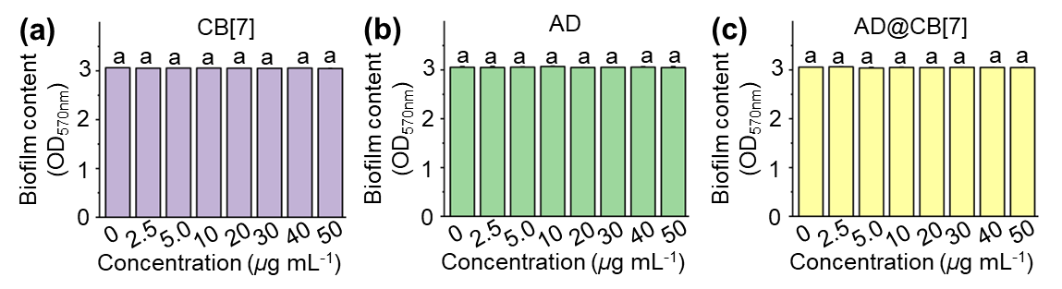
Figure S22. Statistical analysis of biofilm content following CB[7], AD and AD@CB[7] treatments; Statistical analysis was performed using one-way ANOVA with Tukey’s test, different lowercase letters indicate p < 0.05. Error bars indicate the mean ± SE.

23. Eradication of preformed mature Xoo biofilms on rice leaves by treatment with OM@CB[7] + AD.
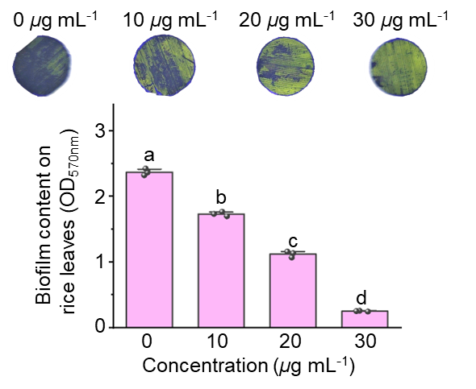
Figure S23. OM@CB[7]+AD efficiently eradicates mature preformed Xoo biofilms on rice leaves in a concentration-dependent manner; Statistical analysis of biofilm content after OM@CB[7]+AD treatments; Statistical analysis was performed using one-way ANOVA followed by Tukey’s post-hoc test; Different lowercase letters indicate significant differences at p < 0.05; Error bars indicate the mean ± SE.

24. Inhibitory effect of OM@CB[7] + AD on in planta colonization of Xoo.
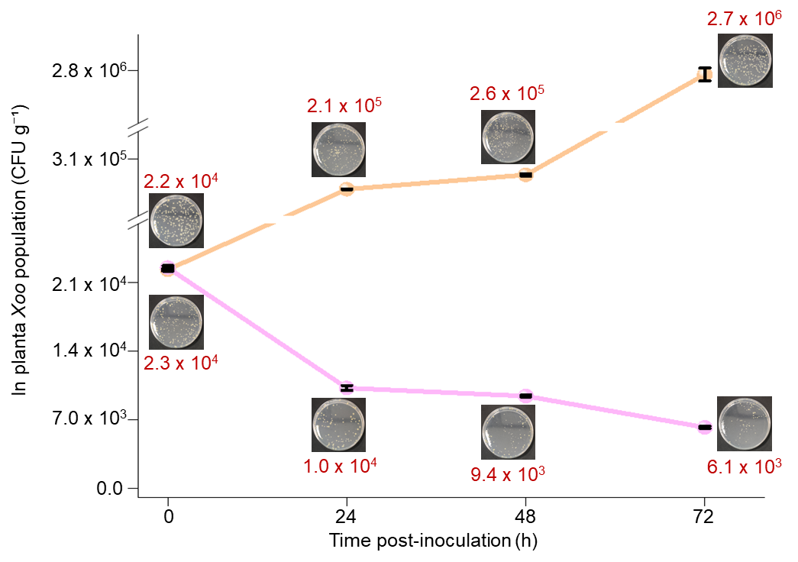
Figure S24. Changes in viable bacterial counts of Xoo in rice leaves of control group and OM@CB[7]+AD (200 μg mL⁻¹) treatment group at different inoculation times; Error bars indicate the mean ± SD.

25. Antibacterial Mechanism.
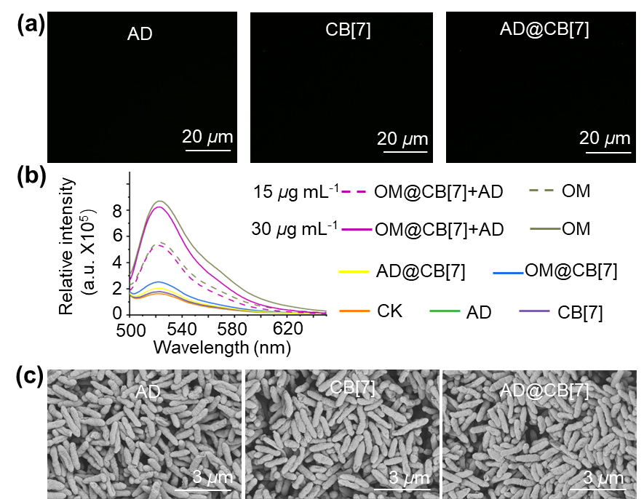
Figure S25. (a) Fluorescent photographs of Xoo treated with PI under the same condition of antibacterial experiments; The drug concentration was 30 µg mL⁻¹; (b) ROS accumulation in Xoo monitored by the ROS detection kit after co-incubation with AD, CB[7], AD@CB[7], OM@CB[7], OM@CB[7] + AD, and OM (conc. 15 and 30 µg mL⁻¹), both before and after ultraviolet light exposure, Ex = 488 nm; (c) Morphological studies of Xoo treated with different ingredients at 30 µg mL⁻¹.

26. Comparison with Advanced Nanoformulations.
Table S11. Comparative foliar interfacial behaviors and in vivo control efficacy of OM@CB[7] with state-of-the-art nanoformulations.
Nanoformulation | Carrier category | Rice leaf contact angle (°) | Liquid holding capacity (mg·cm⁻²) | Xoo control efficacy (200 μg mL⁻¹) | Preparation complexity | References
OM@CB[7]  (This work) | Cucurbit[7]uri | 84.5 | 17.1 | 55.2% | Simple
HM@BZA-DCMC | Polysaccharide polymeric | 131.7 | - | 44.2% | Moderate | [5]
3a@β-CD | β- cyclodextrin | 82.0 | - | 51.2% | Simple | [6]
SCLMs/Bromo | silica-cross-linked micelles | - | - | 69.6% | Complex | [7]
^{SNP}PECs | Mesoporous silica core and polysaccharide shell | 88.3 | 10.8 | 87% | Complex | [8]

To further highlight the practical merits of OM@CB[7], we systematically compared its foliar interfacial performance and disease control capacity with prevailing nanoformulations (Table S11). Contact angle serves as a core metric for wettability, where smaller values indicate stronger leaf adhesion. Though 3a@β-CD (82.0°) exhibits marginally superior wettability, OM@CB[7] (84.5°) outperforms the reviewer-specified silica ^{SNP}PECs (88.3°) and polysaccharide HM@BZA-DCMC (131.7°); the extremely high contact angle of HM@BZA-DCMC leads to severe droplet runoff on rice leaves. In terms of liquid holding capacity, OM@CB[7] records 17.1 mg·cm⁻², far surpassing SNP PECs (10.8 mg·cm⁻²), while other counterparts lack this critical retention data. Despite SNP PECs reaching 87% blight control, its weak leaf retention and complex multi-preparation restrict field utility. Root-oriented SCLMs/Bromo (69.6% efficacy) is unsuitable for foliar application. Our OM@CB[7] attains 55.2% control efficiency, higher than HM@BZA-DCMC and 3a@β-CD, and relies on facile one-step assembly. Collectively, OM@CB[7] integrates balanced wettability, maximum leaf retention and easy fabrication, showing comprehensive advantages for rice foliar spray over silica, polysaccharide and cyclodextrin nanocarriers.
References
[1] Zhang, J.; Peng, Z.; Wang, G. Inhibition of enzymatic browning in fresh-cut potatoes by 1,3,4-oxadiazole-2-thiol analogs and elucidation of their tyrosinase inhibition mechanism. Food Chem. 2025; 492: 145632.
[2] Tuo, X.; Yang, J.; Zhang, Y.; Wang, P.; Mastinu, A. Synthesis of N-Methylmorpholinium Derivatives Possessing a 1,3,4-Oxadiazole Core as Feasible Antibacterial Agents against Plant Bacterial Diseases. J. Chem. 2021; 2021: 1–10.
[3] Kourounakis, A. P.; Xanthopoulos, D.; Tzara, A. Morpholine as a privileged structure: A review on the medicinal chemistry and pharmacological activity of morpholine containing bioactive molecules. Med. Res. Rev. 2019; 40: 709–752.
[4] Petrushkina, E. A.; Zakharkin, L. I. Synthesis of New Plant Growth Regulators, Isomeric 1-(Dimethyloctyl)- and 1-Alkylpiperidinium and -morpholinium Halides by Telomerization of Isoprene with Secondary Amines. Russ. J. Gen. Chem. 2003; 73: 1653–1657.
[5] Liu, H.; Wang, G.; Zhang, J.; Luo, R.; Ding, Y.; Xiang, H.; et al. Construction of a pH-responsive sodium carboxymethyl cellulose-based Schiff base as a sustainable nanocarrier for enhanced disease control. Chem. Eng. J. 2026; 533: 174747.
[6] Yang, J.; Ye, H. J.; Xiang, H. M.; Zhou, X.; Wang, P. Y.; Liu, S. S.; et al. Photo‐Stimuli Smart Supramolecular Self‐Assembly of Azobenzene/β‐Cyclodextrin Inclusion Complex for Controlling Plant Bacterial Diseases. Adv. Funct. Mater. 2023; 33: 2303206.
[7] Cai, Y.; Mu, W.; Ding, W.; Peng, J.; Zhao, L.; Zhou, Y. Silica Cross-Linked Micelles as Pesticide Nanocarriers for Effective Treatment of Xanthomonas oryzae pv Oryzae Infection. ACS Appl. Nano Mater. 2025; 8: 13360–13371.
[8] Sangwan, A.; Kumar, N.; Kaur, G.; Singh, N. Smart Silica Nanocomposites Activating Plant Defenses via Enhanced Biomolecule Deposition on Superhydrophobic Monocot Surfaces. J. Agric. Food Chem. 2025; 73: 30123–30135.

