Additional Information
Synchronized CD73 Blockade and STING Activation via an Ultrahigh-Payload Antibody–Polymer Conjugate for Breast Cancer Immunotherapy
Naimeng Liu^{1†}, Xiangyu Wang^{1†}, Wenxiang Zhang^{1†}, Juan Wu^{1†}, Kan Yonemori², Baranova Madina Petrovna³, Li Chen¹, Guofeng Ji⁴, Zhongzhao Wang^{1*}, Xiangyi Kong^{1*}, Jing Wang^{1*}

¹Department of Breast Surgical Oncology, National Cancer Center/National Clinical Research Center for Cancer/Cancer Hospital, Chinese Academy of Medical Sciences and Peking Union Medical College, Beijing 100021, China.
²Department of Medical Oncology, National Cancer Center Hospital (NCCH); Department of Experimental Therapeutics, NCCH; Rare Cancer Center, National Cancer Center, Tsukiji 5-1-1, Chuo-ku, Tokyo, Japan
³Department of Skin and Breast Tumor, University Clinical Hospital No. 4 affiliated with the First Moscow State Medical University named after I.M. Sechenov, Moscow, Russia Federation.
⁴Department of General Surgery, Xuanwu Hospital, Capital Medical University, Beijing 100053, China

†These authors contributed equally to this article.
*Corresponding authors:
Jing Wang, Department of Breast Surgical Oncology, National Cancer Center/National Clinical Research Center for Cancer/Cancer Hospital, Chinese Academy of Medical Sciences and Peking Union Medical College, Beijing, 100021, China (E-mail: wangjing@cicams.ac.cn)
Xiangyi Kong, Department of Breast Surgical Oncology, National Cancer Center/National Clinical Research Center for Cancer/Cancer Hospital, Chinese Academy of Medical Sciences and Peking Union Medical College, Beijing, 100021, China (E-mail: kongxiangyikxy@gmail.com)
Zhongzhao Wang, Department of Breast Surgical Oncology, National Cancer Center/National Clinical Research Center for Cancer/Cancer Hospital, Chinese Academy of Medical Sciences and Peking Union Medical College, Beijing, 100021, China (E-mail: wangzhongzhao206@sina.com)

Keywords: CD73, Breast cancer, STING agonist, Antibody–polymer conjugate, Cancer immunotherapy
Fig. S1 STING activation induces CD73 upregulation in vivo. A) Typical flow cytometry plots illustrating the proportion of CD73⁺ cells in tumor tissues. B) Statistical results of percentages for CD73⁺ cells in tumor tissues. Data are presented as mean ± SD. *p < 0.05.
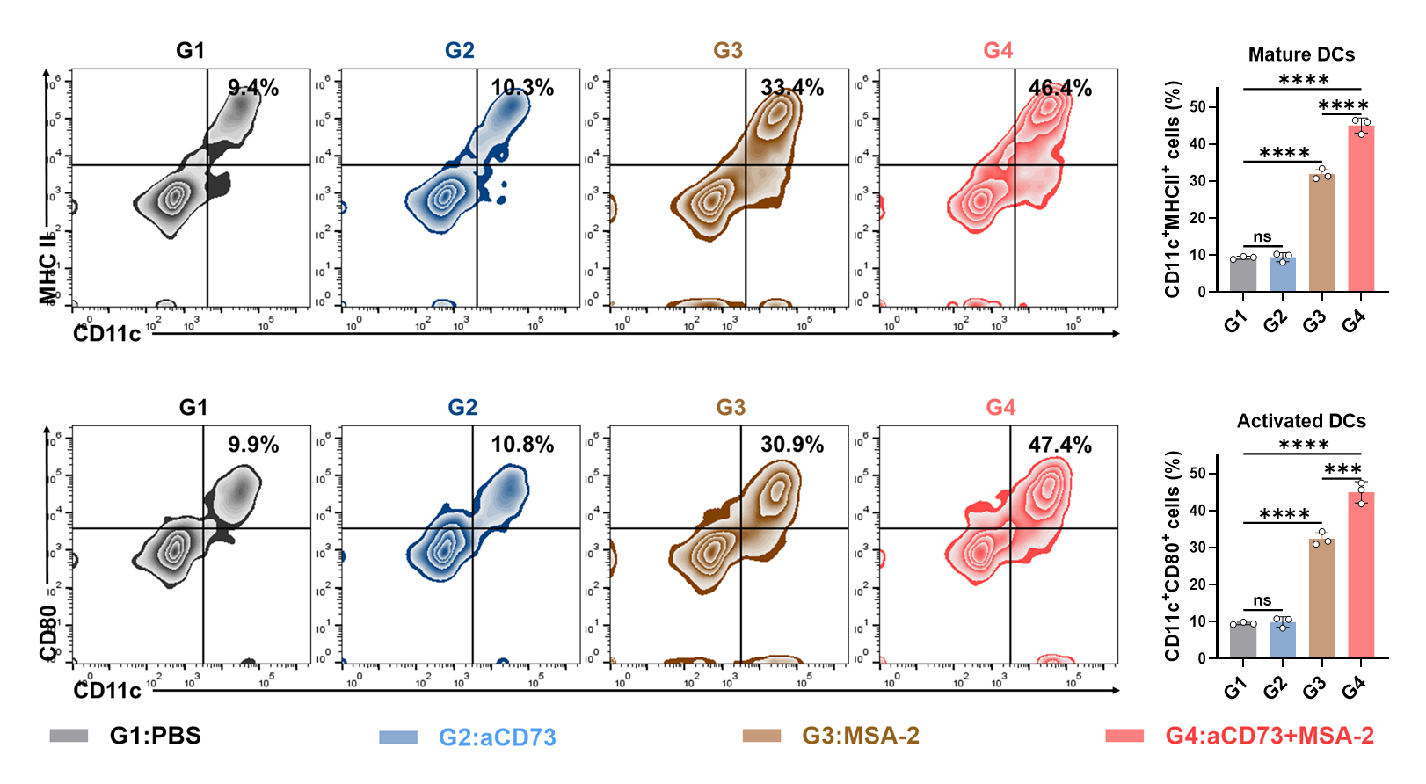
Fig. S2 The expression of MHC-II and CD80/CD86 on the surface of BMDCs after incubation for 4 h with conditioned medium from 4T1 cells treated with PBS (G1), αCD73 (G2), MSA-2 (G3), or αCD73 + MSA-2 (G4), as analyzed by flow cytometry (n = 3). Data are presented as mean ± SD. ***p < 0.001 and ****p < 0.0001.
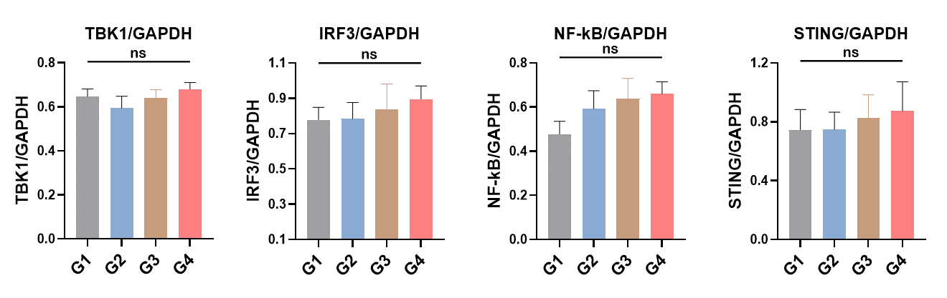
Fig. S3 Corresponding densitometric quantification of STING signaling proteins isolated from BMDCs.
Fig. S4 ¹H NMR spectrum of poly(_{L}-glutamic acid) (PLG) in D₂O.

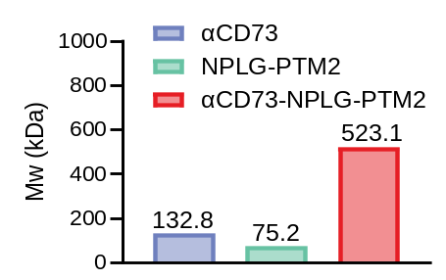
Fig. S5 Molecular weights of αCD73, NPLG-PTM2, and αCD73-NPLG-PTM2 determined by AF4-MALS. The marked increase in molecular weight after conjugation confirmed the successful conjugation of NPLG-PTM2 to the antibody.
Fig. S6 Orthogonal UV-Vis/BCA assessment of the average payload-to-antibody ratio. (A-B) UV-Vis absorption spectra of MSA-2 and TK-MSA-2 at the indicated concentrations in PBS. Both compounds show a characteristic peak at 330 nm. (C) The αCD73 spectrum demonstrates negligible absorbance at 330 nm. (D-E) Corresponding standard curves at 330 nm for MSA-2 and TK-MSA-2 (R² > 0.996). (F) The A280 standard curve of αCD73 is shown for spectral characterization; the αCD73 concentration used for payload-to-antibody ratio calculation was independently determined by the BCA protein assay.
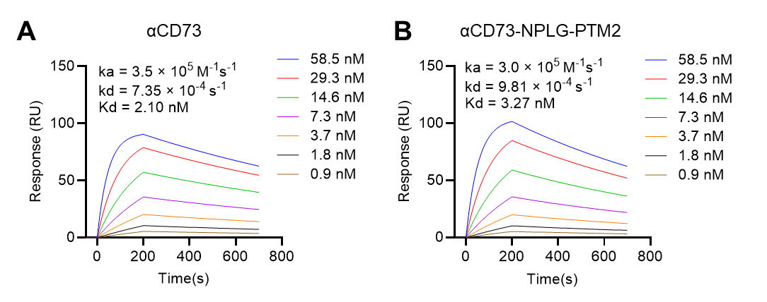
Fig. S7 SPR analysis of the binding of free αCD73 (A) and αCD73-NPLG-PTM2 (B) to CD73. Both retained high-affinity binding with comparable equilibrium dissociation constants (Kd = 2.10 nM and 3.27 nM, respectively), indicating preserved antigen recognition after conjugation.
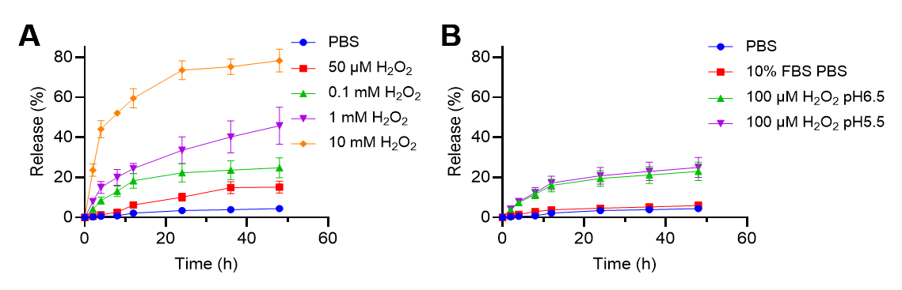
Fig. S8 ROS-responsive release of MSA-2 from NPLG-PTM2. (A) H₂O₂ concentration-dependent release (PBS, 50 μM, 0.1 mM, 1 mM, and 10 mM H₂O₂). (B) Release under conditions mimicking systemic circulation (PBS and PBS + 10% FBS, pH 7.4) versus the tumor microenvironment (100 μM H₂O₂ at pH 6.5 and pH 5.5). Data are presented as mean ± SD (n = 3).
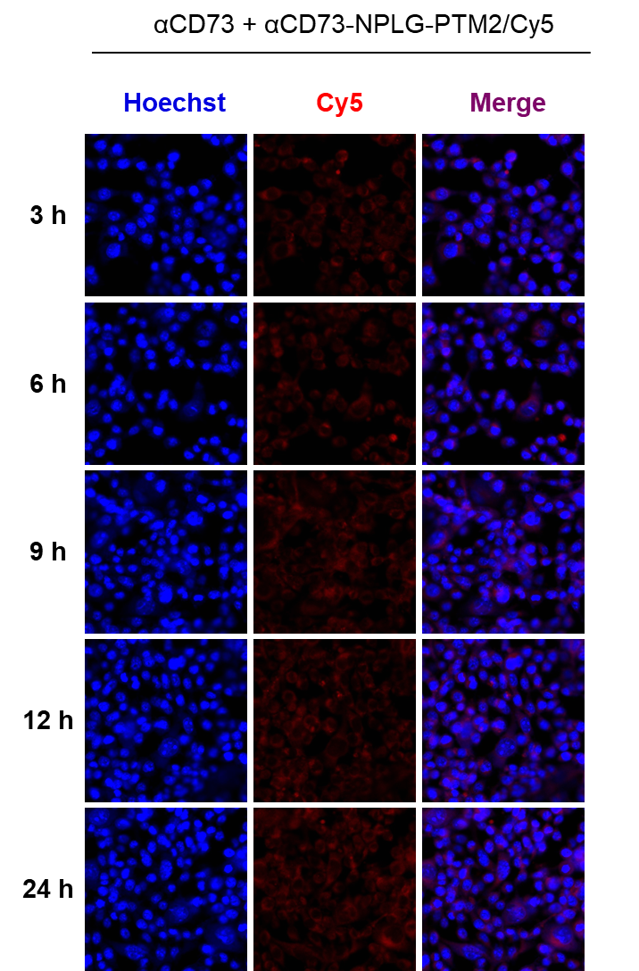
Fig. S9 Qualitative competitive blocking assay supporting CD73-dependent uptake. Representative confocal laser scanning microscopy images of E0771 cells treated with αCD73-NPLG-PTM2/Cy5 after pre-incubation with excess free αCD73.

Fig. S10 In vivo whole-body fluorescence imaging of 4T1 tumor-bearing mice after intravenous injection of IgG-NPLG-PTM2/Cy5 or αCD73-NPLG-PTM2/Cy5. (A) Representative whole-body fluorescence images at 2, 4, 12, and 24 h post-injection. (B) Quantification of tumor fluorescence intensity at the corresponding time points (n = 3). Data are presented as mean ± SD. **p < 0.01, ***p < 0.001, ****p < 0.0001.
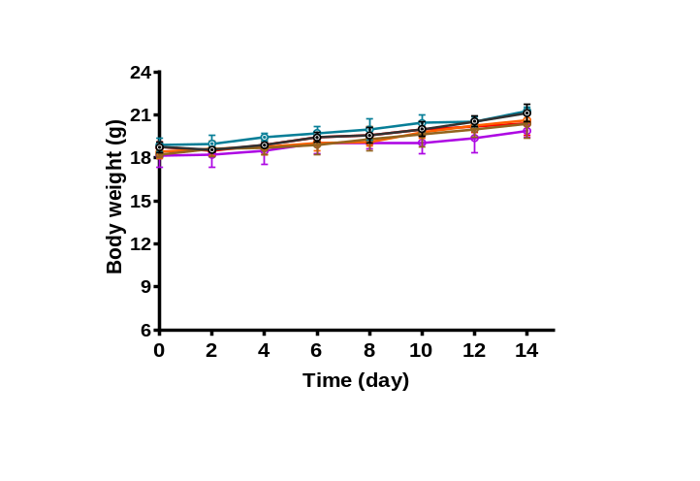
Fig. S11 Body-weight changes of mice after the indicated treatments in the E0771 subcutaneous tumor model (n = 5).
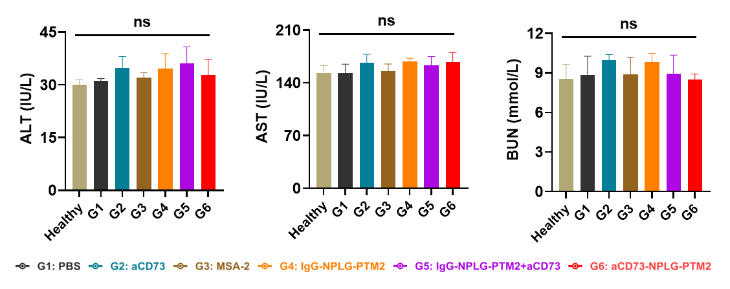
Fig. S12 The serum levels of alanine aminotransferase (ALT), aspartate aminotransferase (AST), and blood urea nitrogen (BUN) in different treatment groups and healthy group (n = 3).
Fig. S13 Representative H&E-stained sections of major organs from mice after the indicated treatments. Scale bar: 100 μm.
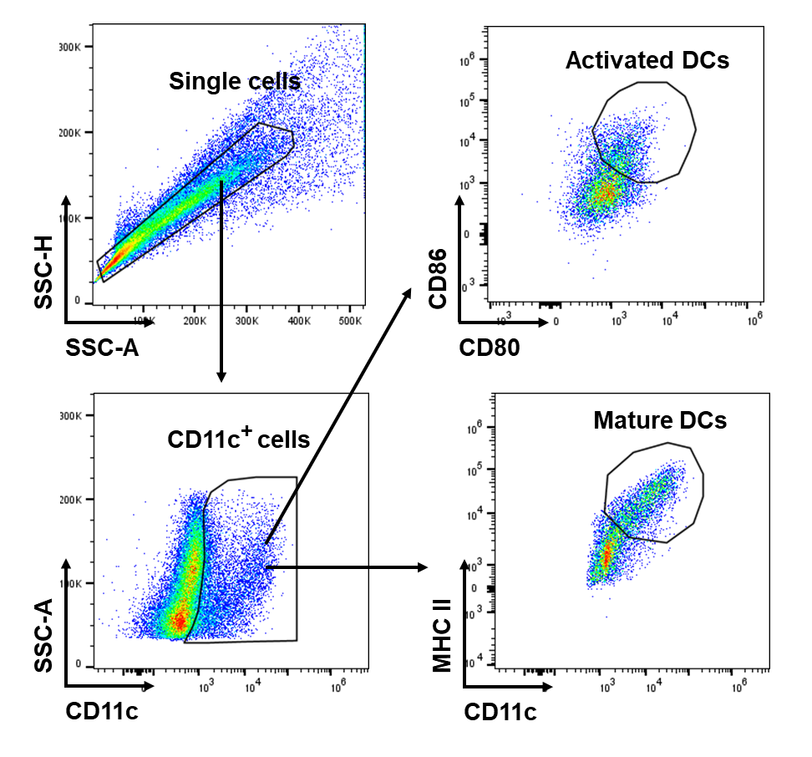
Fig. S14 Gating strategy for MHC II⁺ and CD80⁺CD86⁺ DC cells.
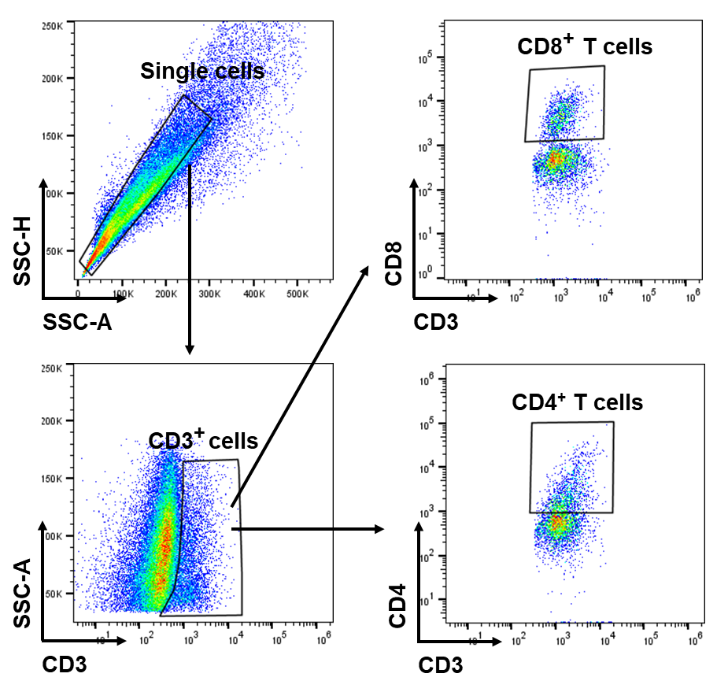
Fig. S15 Gating strategy for CD4⁺ and CD8⁺ T cells.
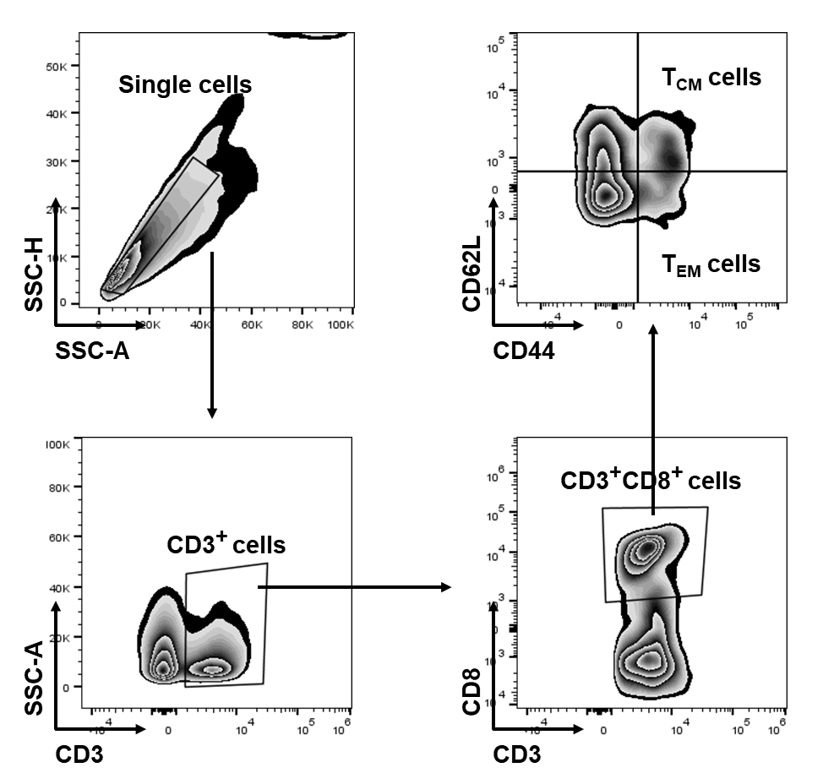
Fig. S16 Gating strategy for central memory T (T_{CM}) cells and effector memory T (T_{EM}) cells in the spleen.
Fig. S17 The serum level of IL-12 and TNF-α cytokines after various treatments.
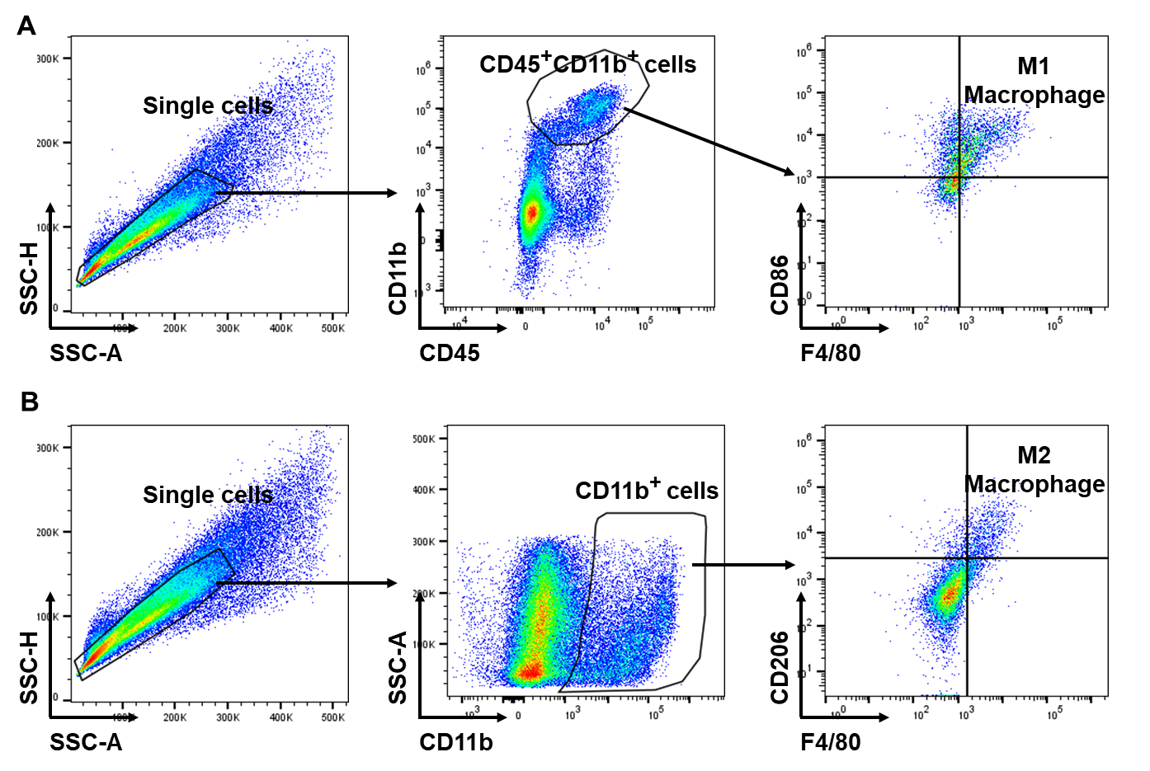
Fig. S18 Gating strategy for M1 and M2 macrophages.

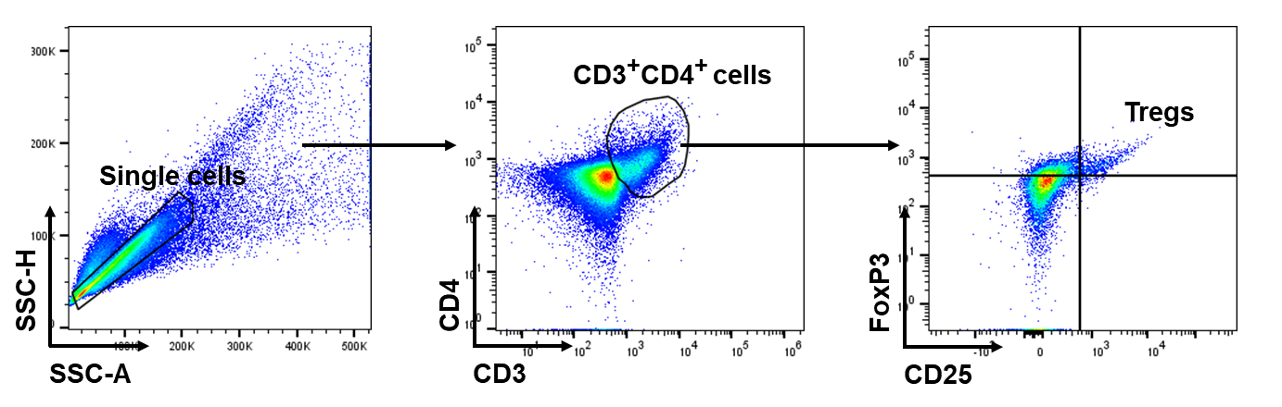
Fig. S19 Gating strategy for Tregs.

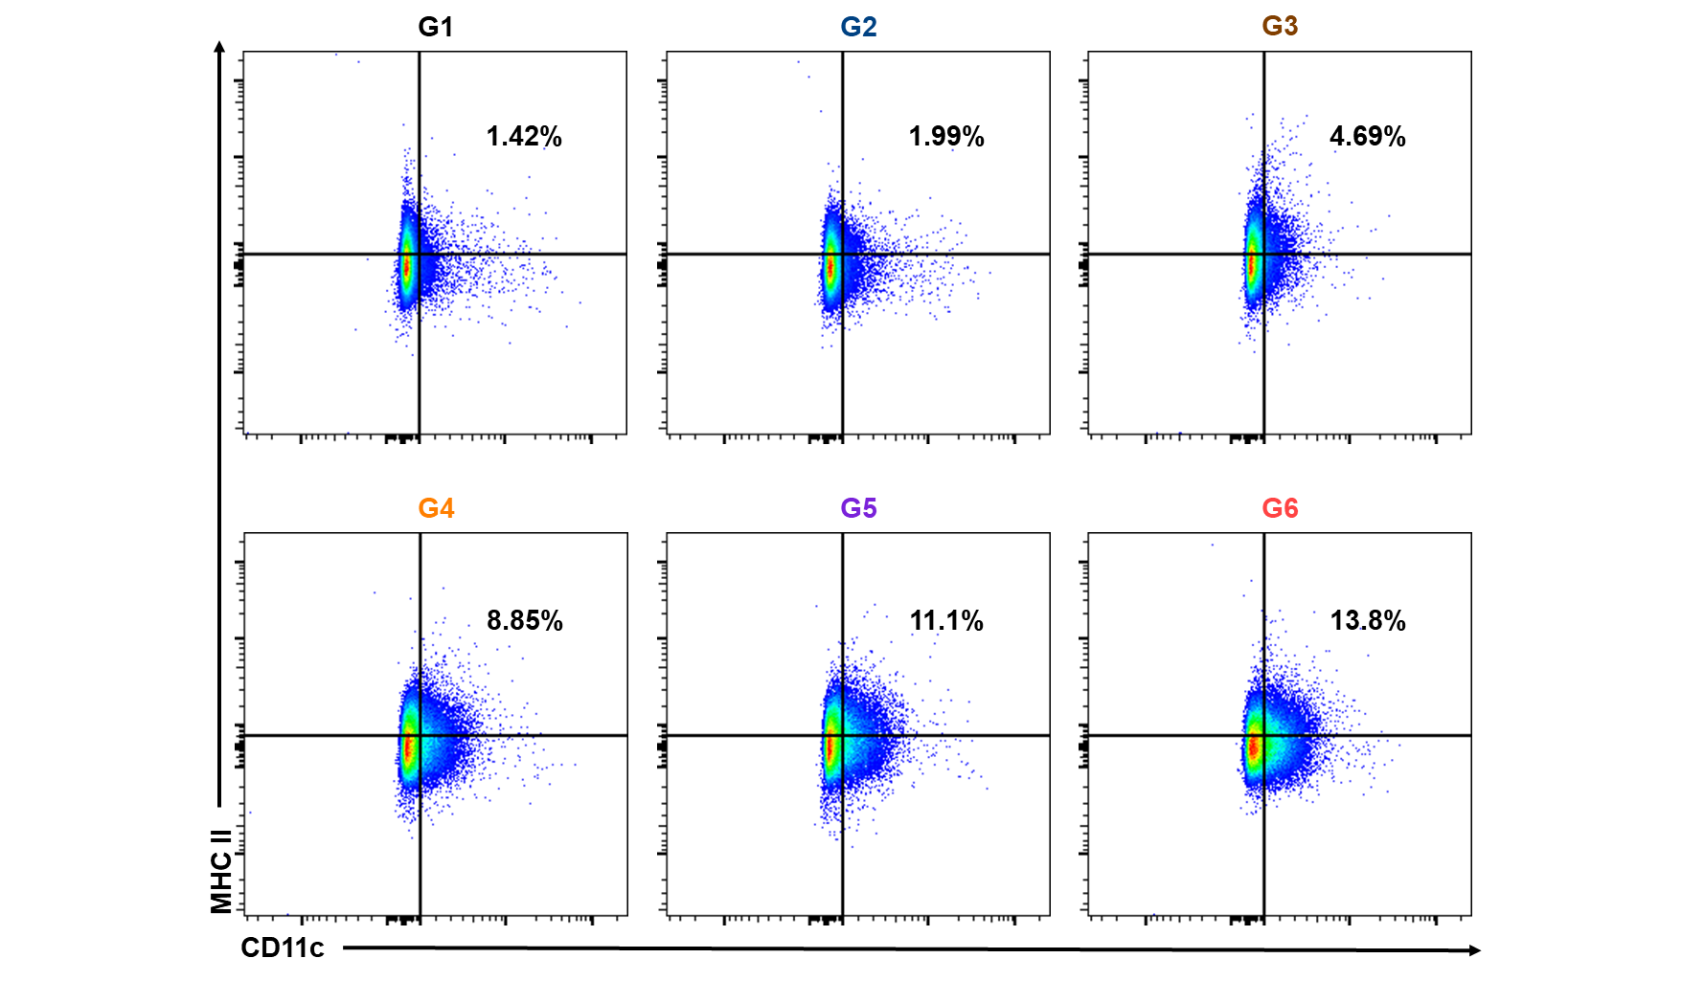
Fig. S20 The representative ﬂow cytometric quantification of intratumoral infiltrating CD11c⁺MHC II⁺ DCs.

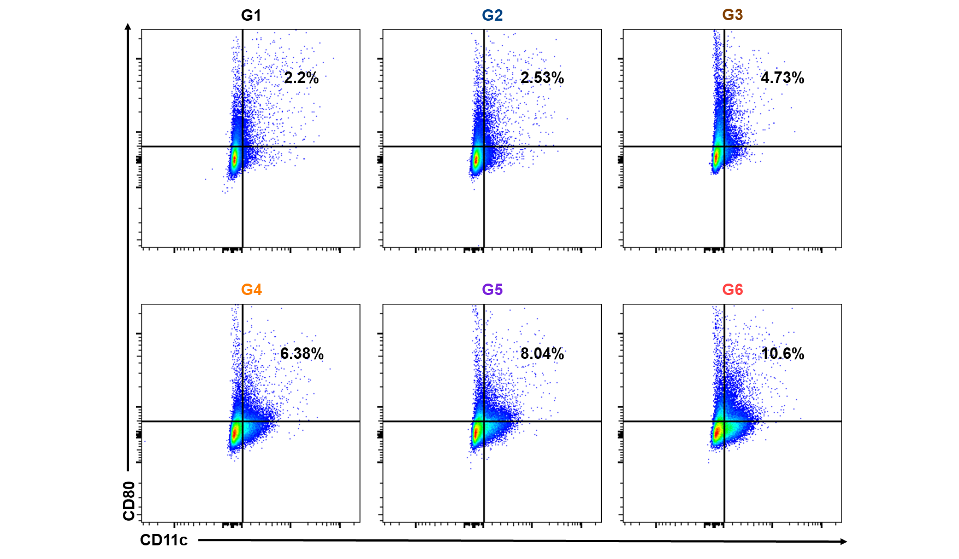
Fig. S21 The representative ﬂow cytometric quantification of intratumoral infiltrating CD11c⁺CD80⁺ DCs.
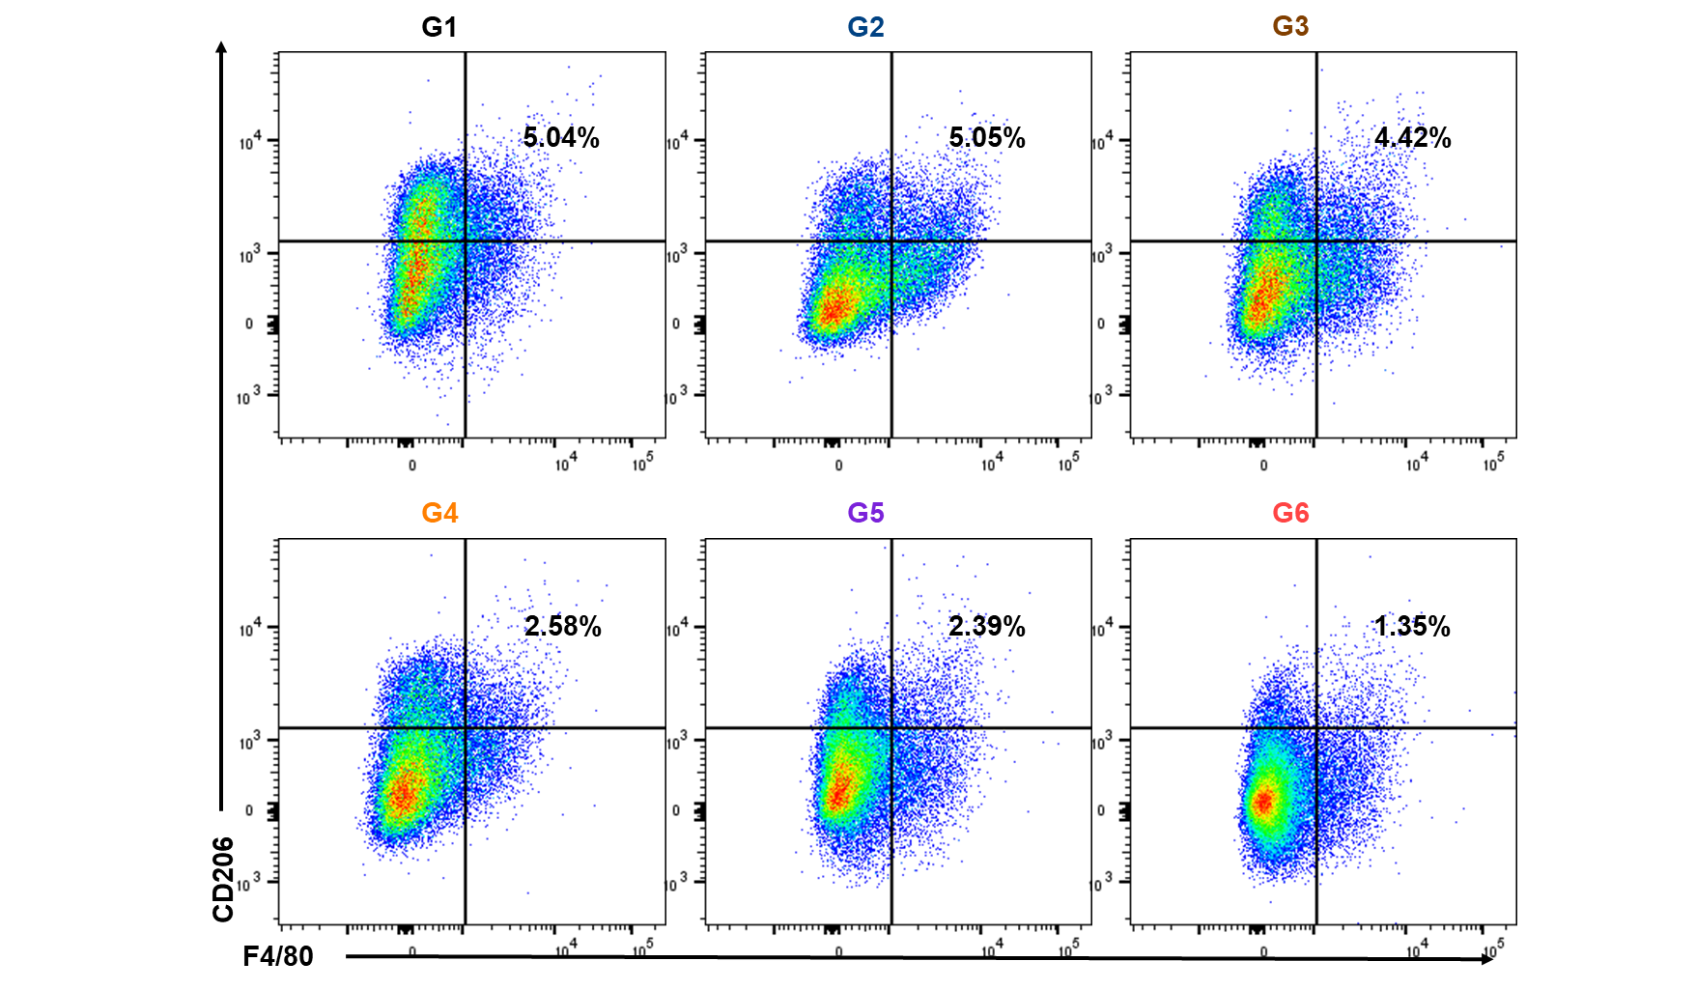
Fig. S22 The representative ﬂow cytometric quantification of intratumoral infiltrating M2 macrophages.
Fig. S23 The serum level of IL-12, IL-6 and TNF-α cytokines after various treatments.
Fig. S24 In vivo tumor re-challenge experiment. (A) Re-challenge tumor growth curves of naive and αCD73-NPLG-PTM2-treated mice (n = 5). (B) Survival curves of mice after tumor re-challenge (n = 5).

