Supplementary materials
Supplementary Fig. 1. Establishment and evaluation of the OVX mice model. a, Schematic Diagram of bilateral ovariectomy. b, Surgical images of bilateral ovariectomy and macroscopic view of the ovaries. c, H&E staining of resected ovaries.
Supplementary Fig. 2. Causal relationship of migrasomes-related genes on the risk of osteoporosis. a,e Funnel plots for the overall heterogeneity of the effect of TSPAN4 (a) and NDST1 (e) on the risk of osteoporosis. b,f Scatter plots of the causal effect of TSPAN4 (b) and NDST1 (f) on the risk of osteoporosis. The slope of each line represents the causal estimate. c,g Forest plots of the causal effect of each SNP related to TSPAN4 (c) or NDST1 (g) on the risk of osteoporosis. The red line represents the results of MR Egger and inverse variance weighted (IVW). d,h Leave-one-out plots of the causal effect of TSPAN4 (d) and NDST1 (h) on the risk of osteoporosis when removing SNPs one by one. Beta, the effect size of the exposure on outcome.
Supplementary Fig. 3. Determine the safe concentration range of Yoda1 through the CCK8 assay. All data are presented as mean ± SD (n = 6, biological replicates). Statistical analysis was performed using one-way ANOVA. ns: not significant different. P > 0.05, *P < 0.05, **P < 0.01.
Supplementary Fig. 4. Identification of BMSCs. a, Alizarin red staining of BMSCs induced to undergo osteogenic differentiation. Scale bar, 100 µm. b, Oil red O staining of BMSCs induced to undergo adipogenic differentiation. Scale bar, 50 µm. c, Alcian blue staining of BMSCs induced to undergo adipogenic differentiation. Scale bar, 100 µm. d, Results of surface markers of BMSCs detected by flow cytometry.
Supplementary Fig. 5. Schematic diagram of migrasomes purification. When cells reached 50% - 60% confluence, 3 μM Yoda1 was added. After 6 h, the supernatant was removed, cells were washed twice with PBS, digested with 0.25% trypsin, and collected in 50 ml centrifuge tubes after digestion termination. Cells were centrifuged at 1000 × g for 10 min to remove cell bodies, followed by centrifugation at 4000 × g for 30 min to remove cell debris. Collected supernatant was first filtered through a 0.45 μm filter, then the filter was inverted and squeezed with a syringe containing PBS to collect the filtrate. The filtrate was centrifuged at 3000 g for 5 min in a 100 kDa ultrafiltration tube to collect. The collected migrasomes were stored at -80 ℃.
Supplementary Fig. 6. Characterization of Piezo1-activated bone marrow mesenchymal stem cells-derived extracellular vesicles (EVs-Yoda1) and comparison with Mig-Yoda1 in terms of osteogenic potential. a, Comparing the differences in protein contents between EVs-Yoda1 and Mig-Yoda1 generated from the same number of cells (n = 5, biological replicates). b, Transmission electron microscopy (TEM) image of EVs-Yoda1. c, The size distribution of EVs-Yoda1. d-e, Alkaline phosphatase (ALP) staining and quantitative analysis results for MC3T3-E1 following 7 days of culture under varied conditions (n = 5, biological replicates). f-g, Alizarin red S (ARS) staining and quantitative analysis results for MC3T3-E1 after 14 days of culture under different settings (n = 5, biological replicates). All data are presented as mean ± SD. Statistical analysis was performed using one-way ANOVA. *P < 0.05, **P < 0.01, ***P < 0.001, ****P < 0.0001.
Supplementary Fig. 7. Quality control of proteomic analysis and KEGG string diagrams. a, Principal component analysis (PCA) clustering plot of different samples. b, Box plot of different samples. c, Heatmap of the pearson correlation. d, String diagram is used to visualize KEGG pathways.

Supplementary Fig. 8. MC3T3-E1 (a) and HUVECs (b) uptake WGA (red)-labeled Mig and Mig-Yoda1 in vitro.

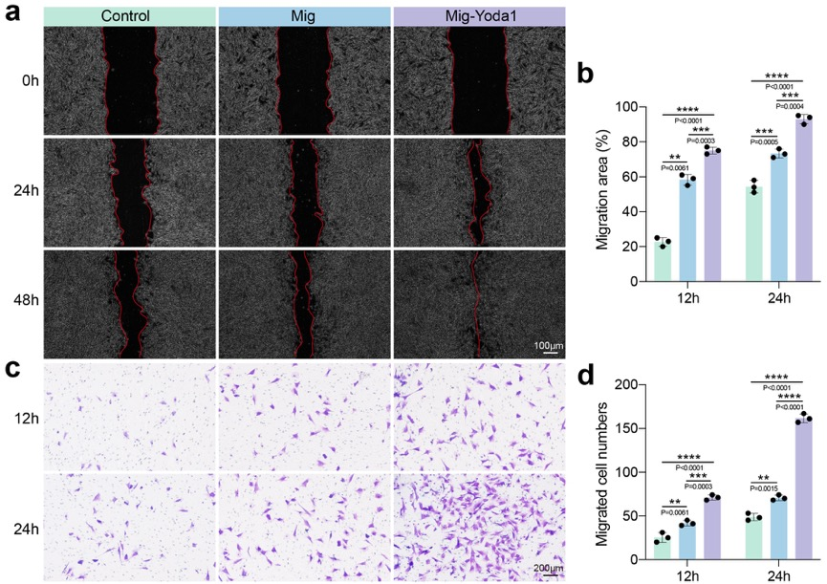
Supplementary Fig. 9. In vitro evaluation of Mig-Yoda1 on MC3T3-E1 migration capacity. a, Representative images showing the scratch areas at 0, 24 and 48 h under different treatments. The red lines are the edges of the cell migration. b, Quantitative analysis of the scratch closure rate (n = 3, biological replicates). c, Assessment of the migratory activity of MC3T3-E1 at 12 and 24 h under different treatments by transwell assay. d, Quantitative analysis of the cell migration rate (n = 3, biological replicates). All data are presented as mean ± SD. Statistical analysis was performed using one-way ANOVA. **P < 0.01, ***P < 0.001, ****P < 0.0001.

Supplementary Fig. 10. Bar plots display the effects of Mig-Yoda1 on the mRNA expression levels of angiogenesis-related genes (CD31: a, VEGF: b, HIF-1α: c, BFGF: d) in HUVECs in vitro (n = 3, biological replicates). All data are presented as mean ± SD. Statistical analysis was performed using one-way ANOVA. *P < 0.05, **P < 0.01, ***P < 0.001, ****P < 0.0001.

Supplementary Fig. 11. The bar plots show that the semi-quantitative analysis of red/green fluorescence ratio in JC-1 staining (a) and fluorescence intensity of MitoSOX (b), respectively (n = 3, biological replicates). All data are presented as mean ± SD. Statistical analysis was performed using one-way ANOVA. *P < 0.05, **P < 0.01, ***P < 0.001, ****P < 0.0001.
Supplementary Fig. 12. The representative image of the biodistribution of Mig-Yoda1.
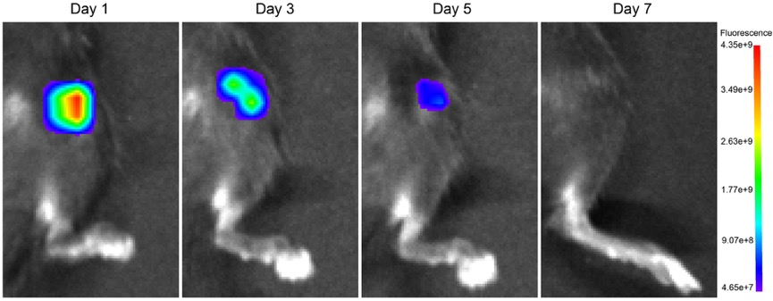
Supplementary Fig. 13. The representative image of retention of Mig-Yoda1 in vivo.
Supplementary Fig. 14. a, Immunofluorescence staining of CD31 after treatment in different groups. b, Quantitative analysis of CD31 positive staining areas (n = 5 biological replicates). All data are presented as mean ± SD. n are biological replicates and independent animals. Statistical analysis was performed using one-way ANOVA. ns: not significant different. ****P < 0.0001.
Supplementary Fig. 15. In vivo biosafety evaluation of Mig-Yoda1. a, Histopathological evaluation of major organs (heart, liver, spleen, lung, kidney, brain, and muscle) after different treatments. Scale bar, 50 μm. b, Blood biochemical parameters at 7 days post-treatment. (n = 5 biological replicates). All data are presented as mean ± SD. n are biological replicates and independent animals. Statistical analysis was performed using one-way ANOVA. ns: not significant different.

Supplementary Table 1
Symbol | Description | Category | Uniprot ID
ITGB1 | Integrin Subunit Beta 1 | Protein Coding | P05556
ITGA5 | Integrin Subunit Alpha 5 | Protein Coding | P08648
EOGT | EGF Domain Specific O-Linked N-Acetylglucosamine Transferase | Protein Coding | Q5NDL2
CPQ | Carboxypeptidase Q | Protein Coding | Q9Y646
PIGK | Phosphatidylinositol Glycan Anchor Biosynthesis Class K | Protein Coding | Q92643
NDST1 | N-Deacetylase And N-Sulfotransferase 1 | Protein Coding | P52848
TSPAN4 | Tetraspanin 4 | Protein Coding | O14817
EPCIP | Exosomal Polycystin 1 Interacting Protein | Protein Coding | Q9NYP8
PKD2 | Polycystin 2, Transient Receptor Potential Cation Channel | Protein Coding | Q13563
PKD1 | Polycystin 1, Transient Receptor Potential Channel Interacting | Protein Coding | P98161

Supplementary Table 2
Gene | Sequence (5'→ 3')
Mouse GAPDH | Forward primer: AGGTCGGTGTGAACGGATTTG  Reverse primer: TGTAGACCATGTAGTTGAGGTCA
Mouse Piezo1 | Forward primer: TCATCATCCTTAACCACATGGTG  Reverse primer: TGAAGACGATAGCTGTCATCCA
Mouse NDST1 | Forward primer: TGCCAGTGTGTTTTCTCTCG  Reverse primer: ATGGCTGTTAGTGGGACAGG
Mouse TSPAN4 | Forward primer: CGTCAAGTACCTCATGTTC  Reverse primer: ACGGGAAGGAAGAGGAC
Mouse OCN | Forward primer: GCAGCTTGGTGCACACCTAG  Reverse primer: GGAGCTGCTGTGACATCCAT
Mouse OPN | Forward primer: AGTGAGGGTTAAGCAGGAATAC  Reverse primer: CAGACTAAGCTAAGAGCCCAAA
Mouse BMP2 | Forward primer: CCAGGTTAGTGACTCAGAACAC  Reverse primer: TCATCTTGGTGCAAAGACCTGC
Mouse OSX | Forward primer: TGGAGAGGGAAAGGGATTCT  Reverse primer: GAAATCTACGAGCAAGGTCTCC
Mouse COL1 | Forward primer: GCTCCTCTTAGGGGCCACT  Reverse primer: CCACGTCTCACCATTGGGG
Human GAPDH | Forward primer: GCAAAGTGGAGATTGTTGCCAT  Reverse primer: CCTTGACTGTGCCGTTGAATTT
Human CD31 | Forward primer: GTGCTCTATGCAAGCCTCCA  Reverse primer: TTCGAGGTGGTGCTGATGTC
Human VEGF | Forward primer: GTGAGGTTTGATCCGCATGAT  Reverse primer: GACCCTGGCTTTACTGCTGTA
Human HIF-1α | Forward primer: GGGAGATCTGGGGACAGGAGGATCGCC  Reverse primer: GGGAAGCTCATAAAAAACTTTAGATTC
Human BFGF | Forward primer: CTCACGTGGCACCAGTGGAT  Reverse primer: CACAGAGGATGAATAGTAGC

