Supporting Information for

Core-Shell Au@HOF nanoradiosensitizers activate potent immunogenic cell death for enhanced radio–radiodynamic–immunotherapy
Bo Wang,^{1†} Qingming Xiang,^{2†} Baiyi Luo,¹ Yu Zhao,¹ Junyang Chen,¹ Yingling Xie,¹ Yu Xu,³* Jian Tian^{1,4}*
¹ Department of Cardiovascular Surgery, Zhongnan Hospital of Wuhan University, School of Pharmaceutical Sciences, Wuhan University, Wuhan 430071, China.
² Department of Radiation and Medical Oncology, Hubei Provincial Clinical Research Center for Cancer, Hubei Key Laboratory of Tumor Biological Behaviors, Zhongnan Hospital of Wuhan University, Wuhan, 430071, China.
³ Department of Pulmonary Oncology, Hubei Province Cancer Clinical Study Center, Hubei Key Laboratory of Tumor Biological Behaviors, Zhongnan Hospital of Wuhan University, Wuhan 430071, China.
⁴ State Key Laboratory of Metabolism and Regulation in Complex Organisms, College of Life Sciences, Wuhan University, Wuhan 430071, China.
† These authors have contributed equally to this work
* Corresponding author. Email: xuyu@whu.edu.cn (Y. Xu); jian.tian@whu.edu.cn (J. Tian).
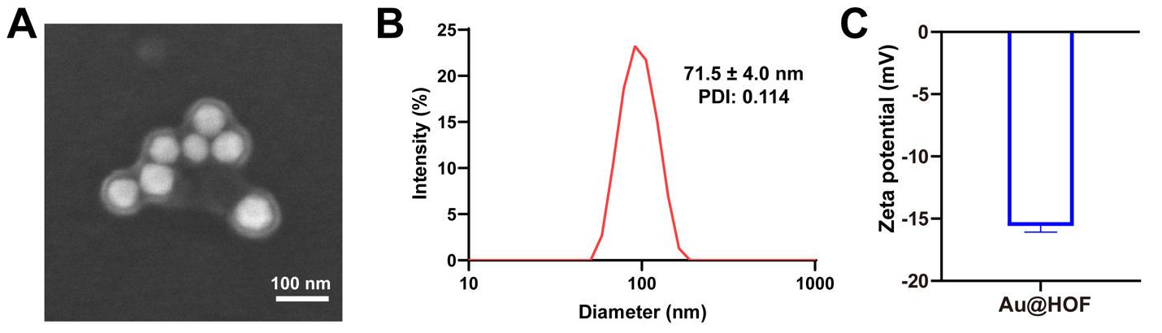
Figure S1. (A) SEM image of Au@HOF. (B) Hydrodynamic diameter of Au@HOF measured by DLS. (C) Zeta potential of Au@HOF.
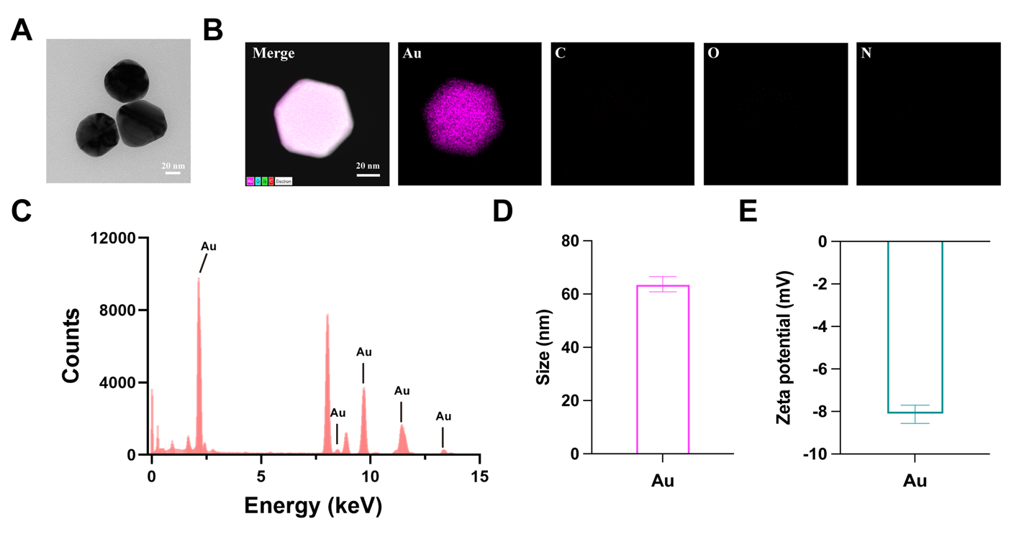
Figure S2. (A) TEM image of Au NPs. (B) EDS elemental mapping analyses of Au NP. (C) Elemental dispersed spectrum of Au NPs. (D) Particle size of Au in H₂O. (E) Zeta potential of Au.
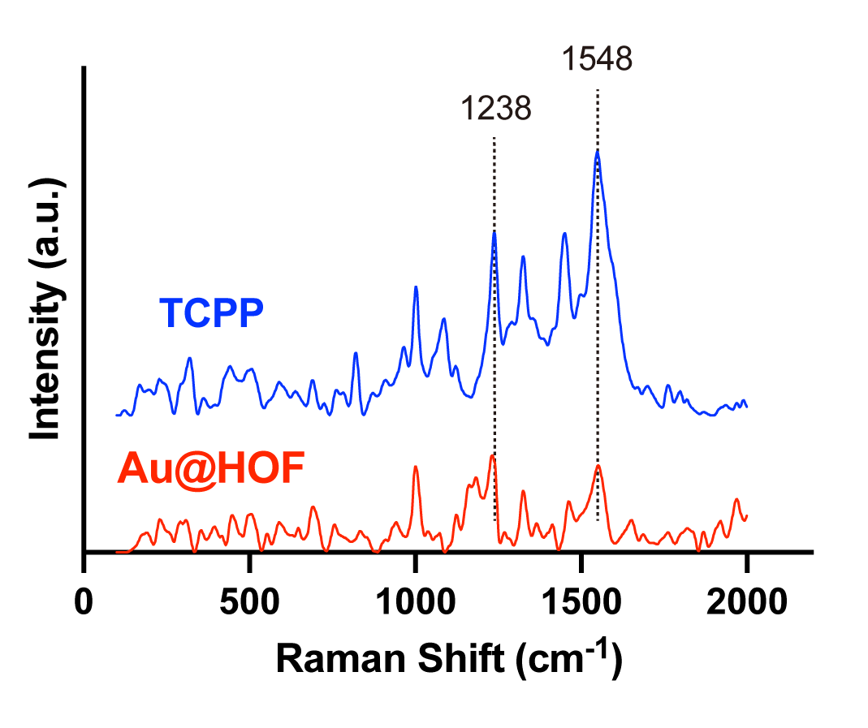
Figure S3. FT-Raman spectra of TCPP and Au@HOF.
Figure S4. Elemental dispersed spectrum of Au@HOF.
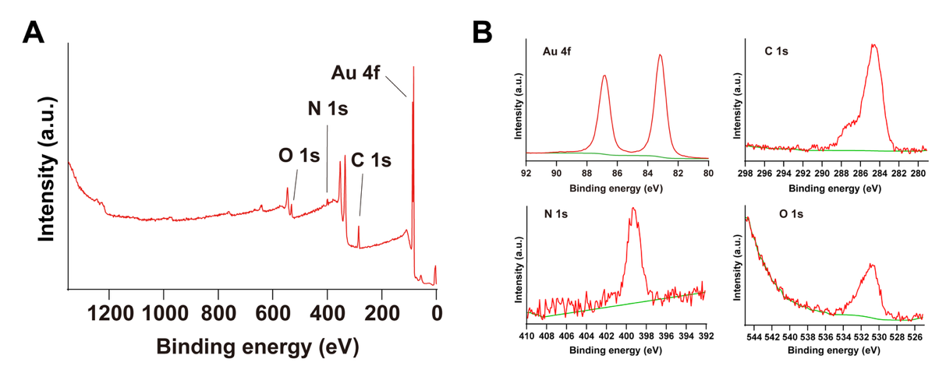
Figure S5. (A) XPS spectrum of Au@HOF. (B) XPS spectra of Au 4f, C 1s, N 1s, and O 1s.
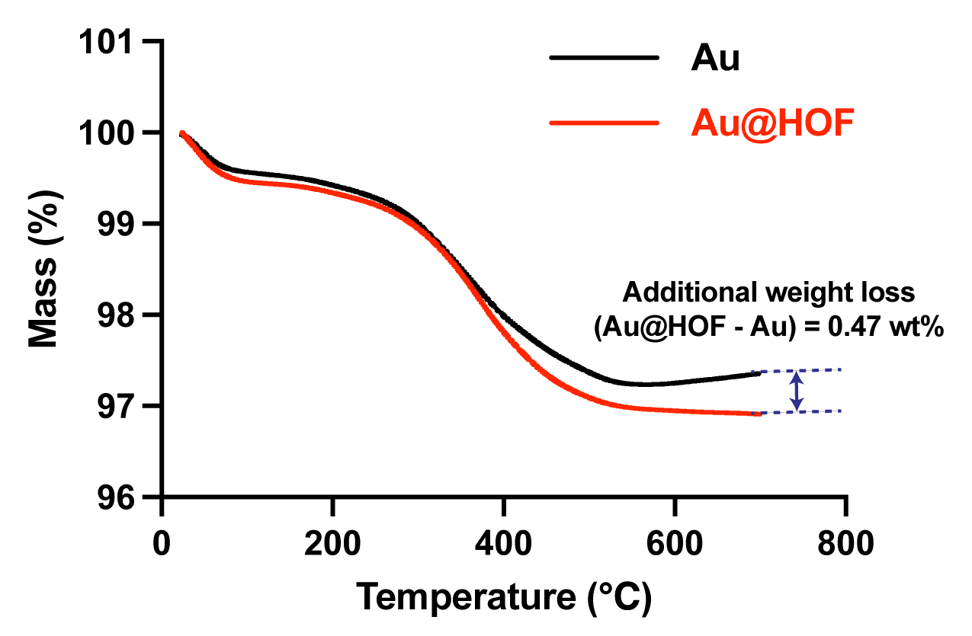
Figure S6. The thermogravimetric analysis of Au and Au@HOF NPs.
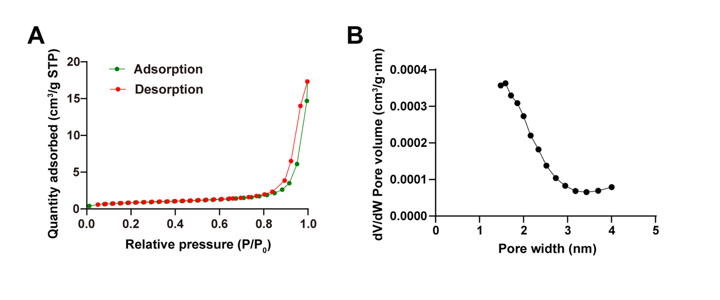
Figure S7. (A) N₂ adsorption and desorption isotherms of Au@HOF. (B) Pore size distribution of Au@HOF.
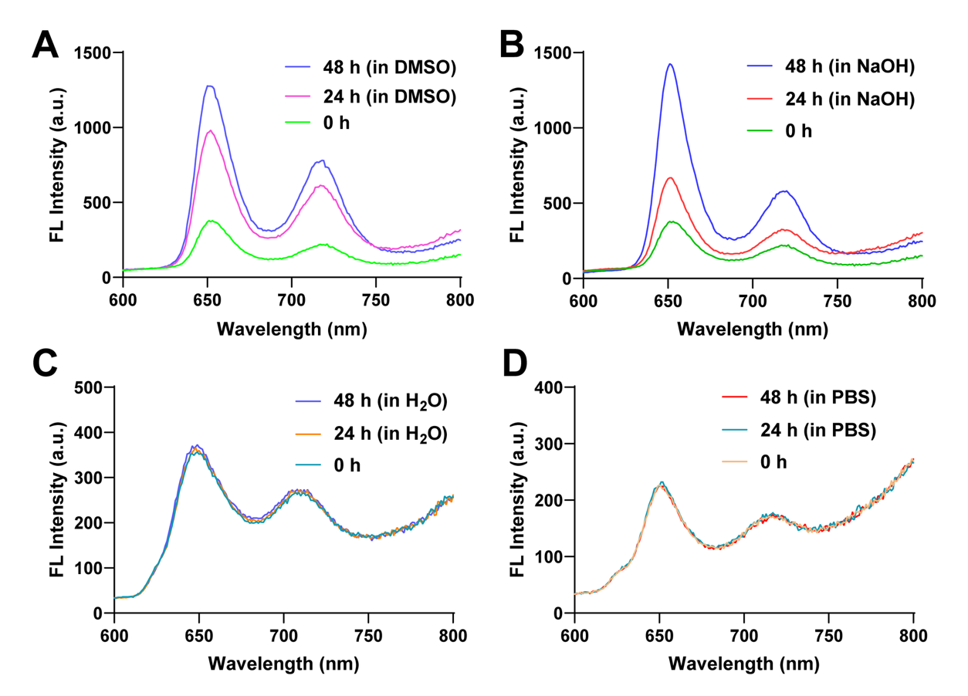
Figure S8. Fluorescence emission spectra of Au@HOF NPs incubated in (A) DMSO, (B) NaOH, (C) H₂O, and (D) PBS solutions with excitation at 420 nm.
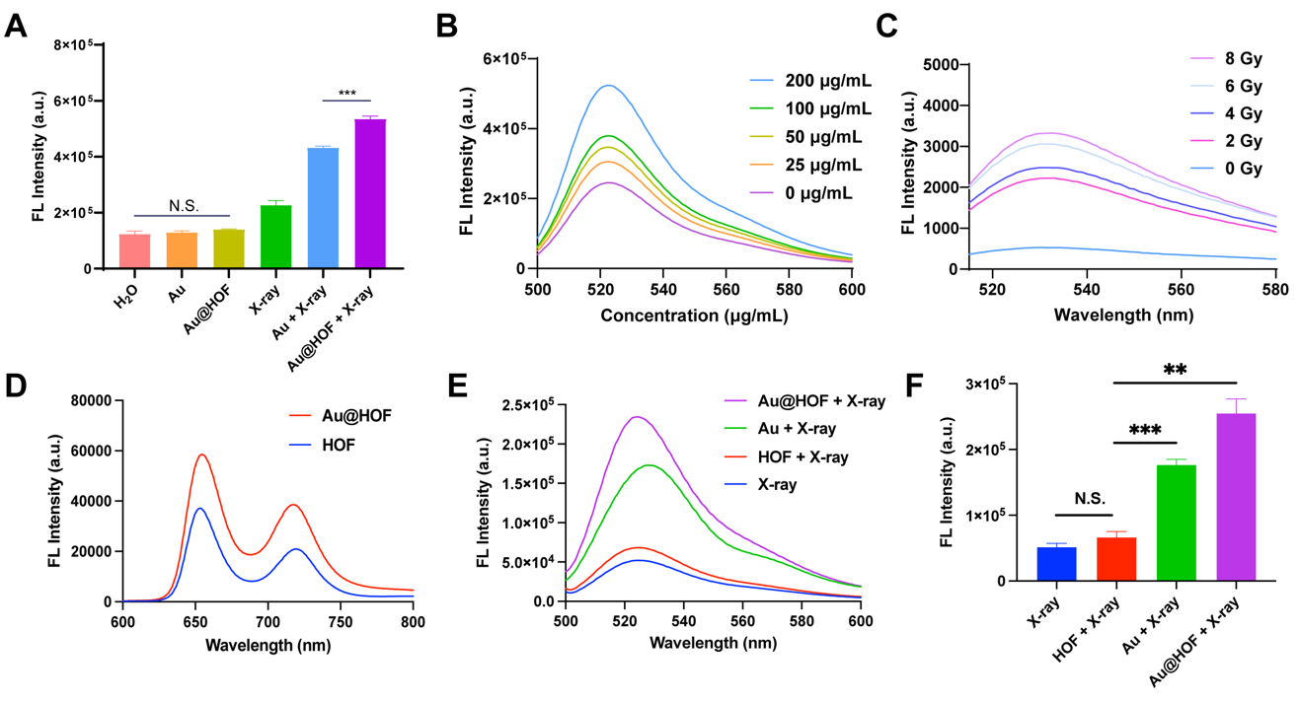
Figure S9. (A) ROS detection statistics by DCFH-DA probes with different treatments. (B) ROS detection by DCFH-DA probes with different concentrations of Au@HOF under 6 Gy X-ray irradiation. (C) ¹O₂ detection by SOSG with various doses of X-ray. (D) Fluorescence emission spectrum of HOF and Au@HOF under 420 nm excitation. (E) ROS detection by DCFH-DA probes with different treatments (X-ray, HOF + X-ray, Au + X-ray, and Au@HOF + X-ray). (F) ROS detection statistics by DCFH-DA probes with different treatments (X-ray, HOF + X-ray, Au + X-ray, and Au@HOF + X-ray).
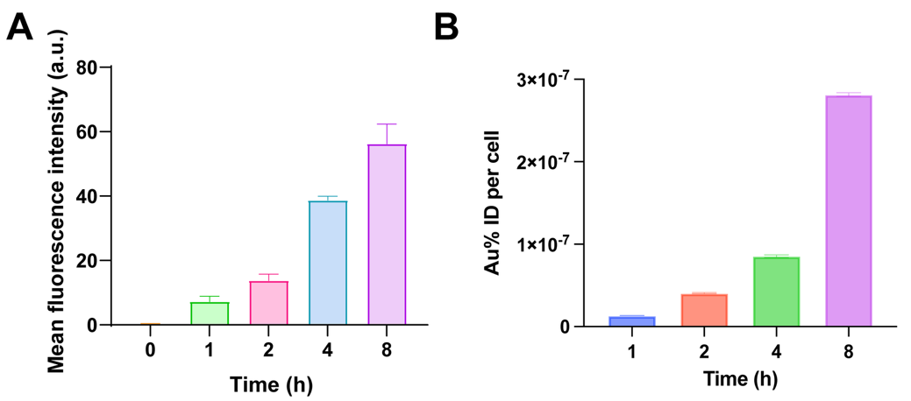
Figure S10. (A) Mean fluorescence intensity of Au@HOF cellular uptake. (B) ICP analysis of substantial Au content in CT26 cells following incubation with Au NPs.
Figure S11. Relative fluorescence intensity of ROS using DCFH-DA as the probe after different treatments.
Figure S12. Hemocompatibility after treatments with different concentrations of Au@HOF.
Figure S13. Serum biochemical index in mice after treatment with PBS or Au@HOF + X-ray.
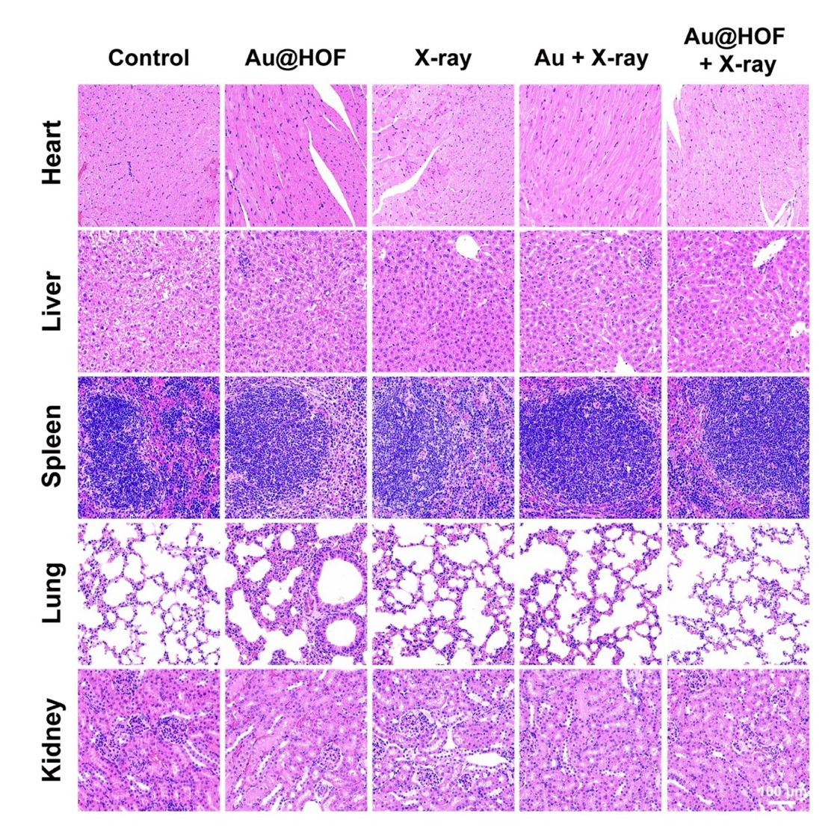
Figure S14. H&E staining of the heart, liver, spleen, lung, and kidney with different treatments.
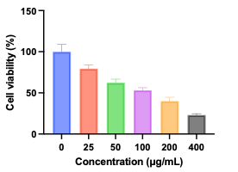
Figure S15. Cell viability of HCT116 cells treated with different concentrations of Au@HOF under 6 Gy X-ray irradiation.

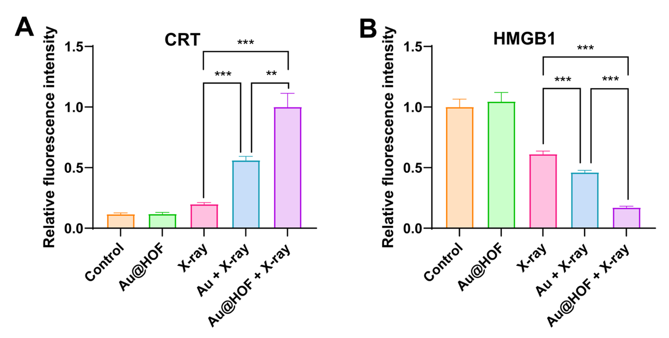
Figure S16. Corresponding relative fluorescence intensity of (A) CRT and (B) HMGB1 in different treatment groups.
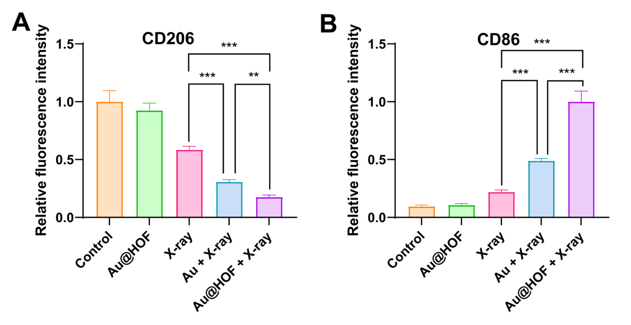
Figure S17. Corresponding relative fluorescence intensity of (A) CD206 and (B) CD86 in different treatment groups.
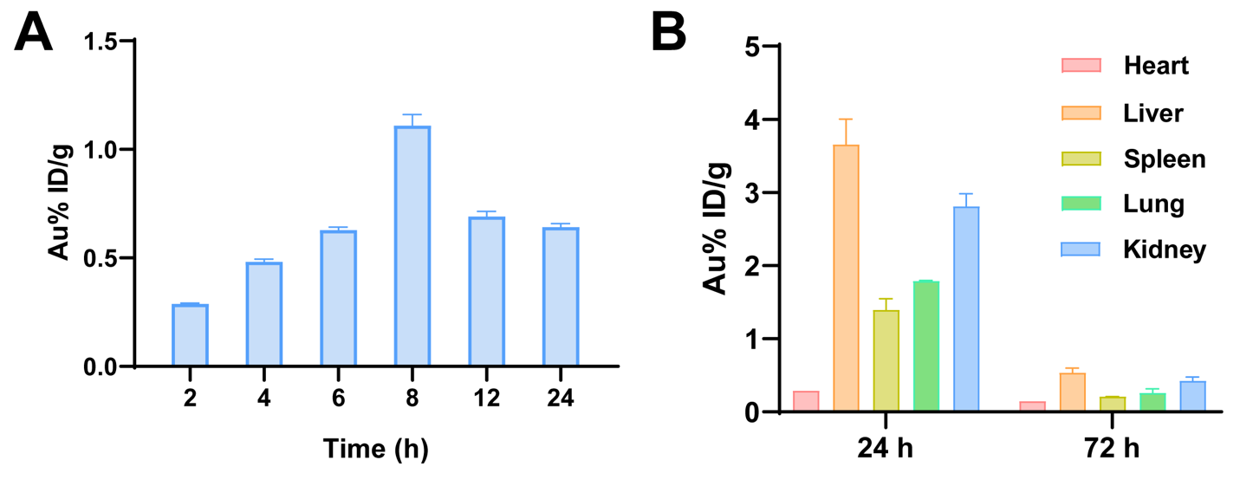
Figure S18. (A) Tumor accumulation of Au@HOF in mice at 2, 4, 6, 8, 12, and 24 h after intravenous injection. (B) The distribution of Au@HOF in major organs at 24 and 72 h after intravenous injection.
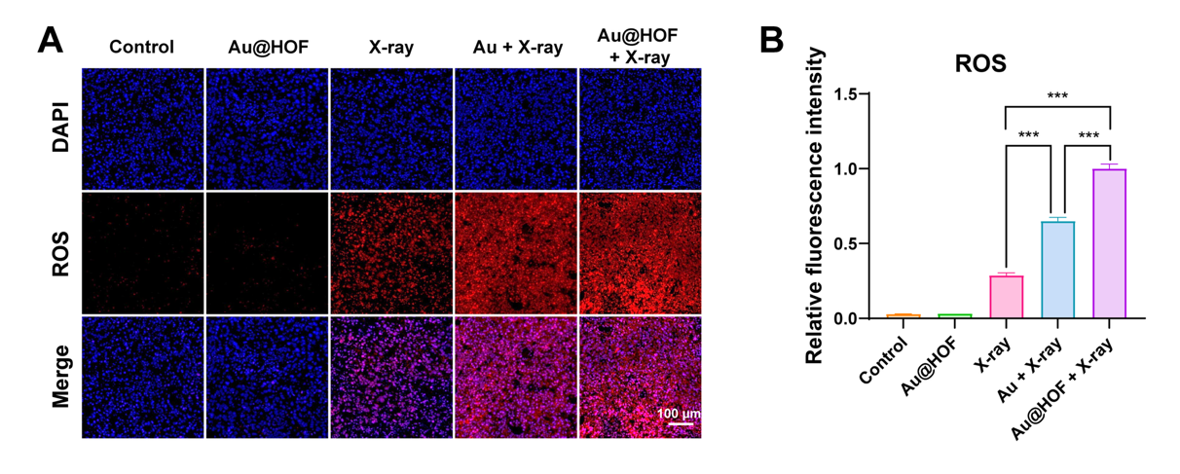
Figure S19. (A) Fluorescence staining images and (B) corresponding relative fluorescence intensity of ROS in tumor tissues after different treatments.
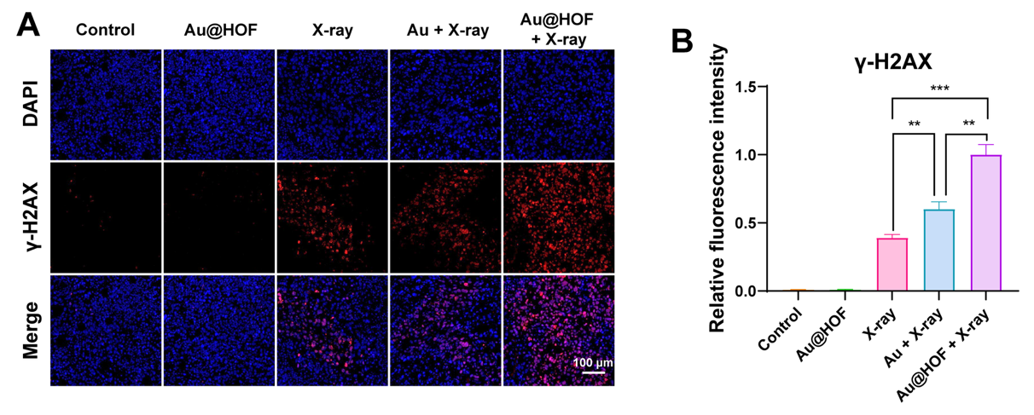
Figure S20. (A) Fluorescence staining images and (B) corresponding relative fluorescence intensity of γ-H2AX in tumor tissues after different treatments.
Figure S21. Individual tumor growth curves of the mice in each treatment group.
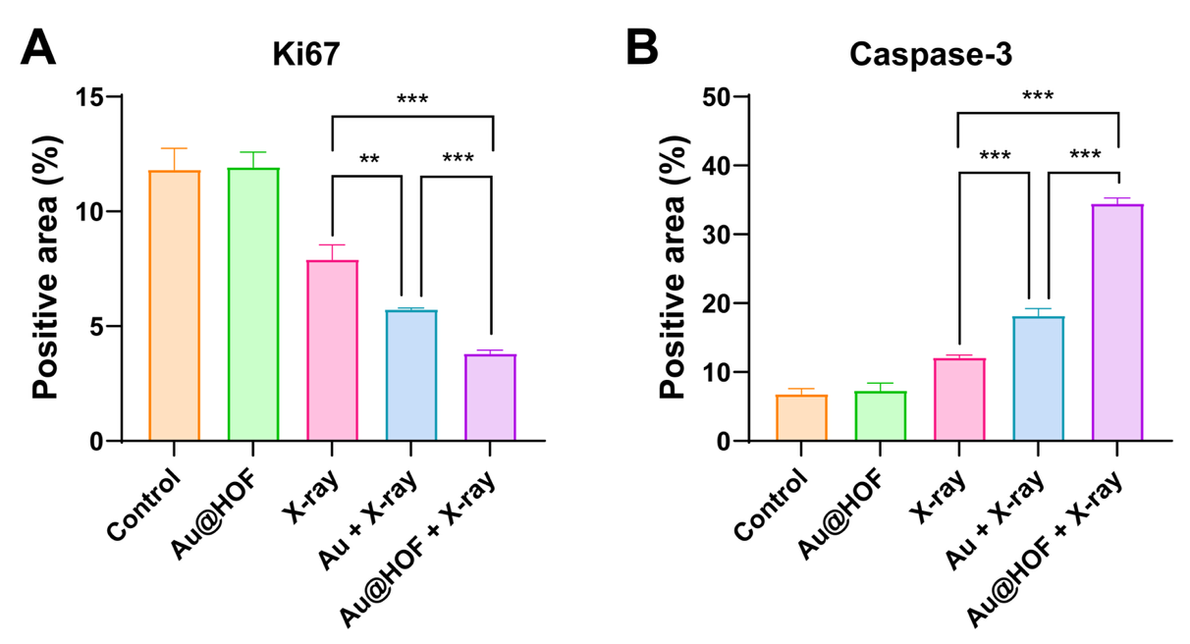
Figure S22. Positive area of (A) Ki67 and (B) Caspase-3 after different treatments.
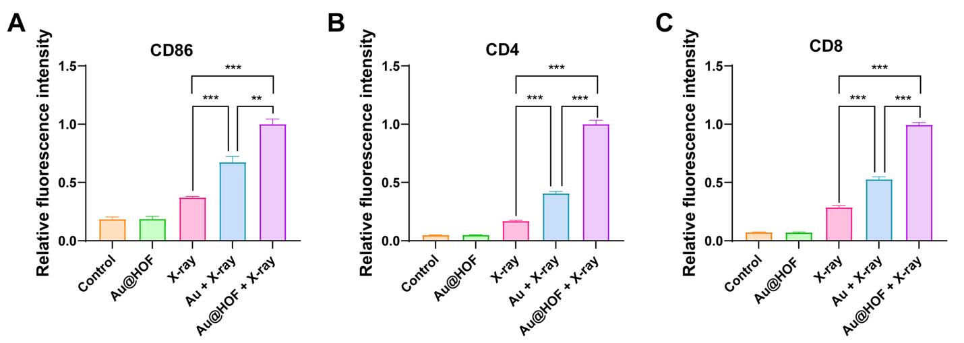
Figure S23. Corresponding relative fluorescence intensity of (A) CD86, (B) CD4, and (C) CD8 in different treatment groups.
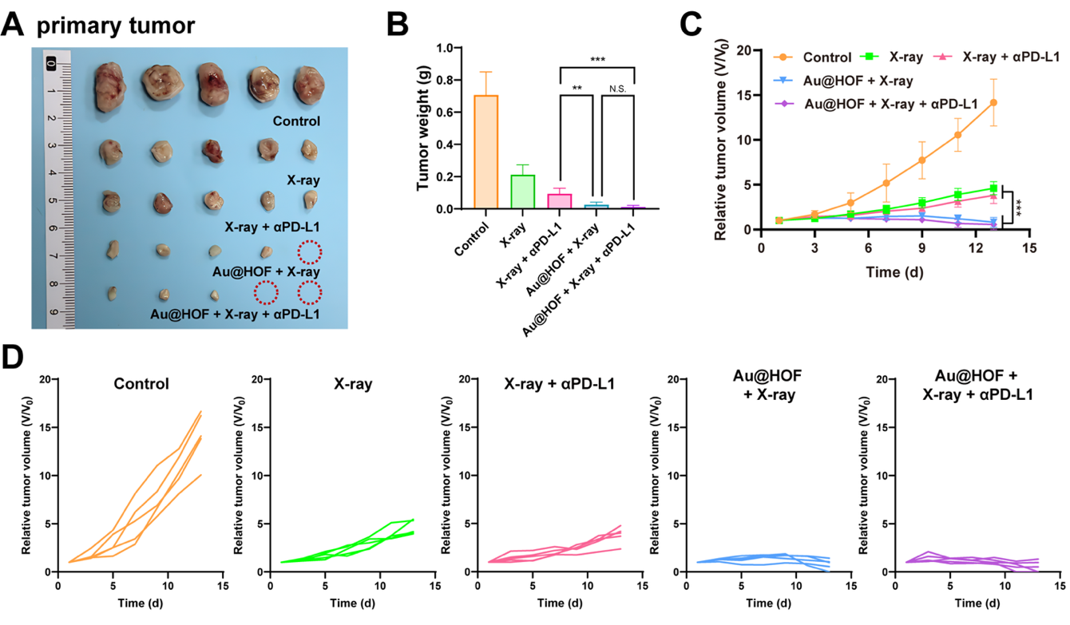
Figure S24. (A) Photograph of primary tumors from each treatment group. (B) Primary tumor weights on day 14 for each group. (C) Primary tumor volume of mice in each group. (D) Individual primary tumor growth curves of the mice in each group.

Figure S25. Individual distant tumor growth curves of the mice in each treatment group.
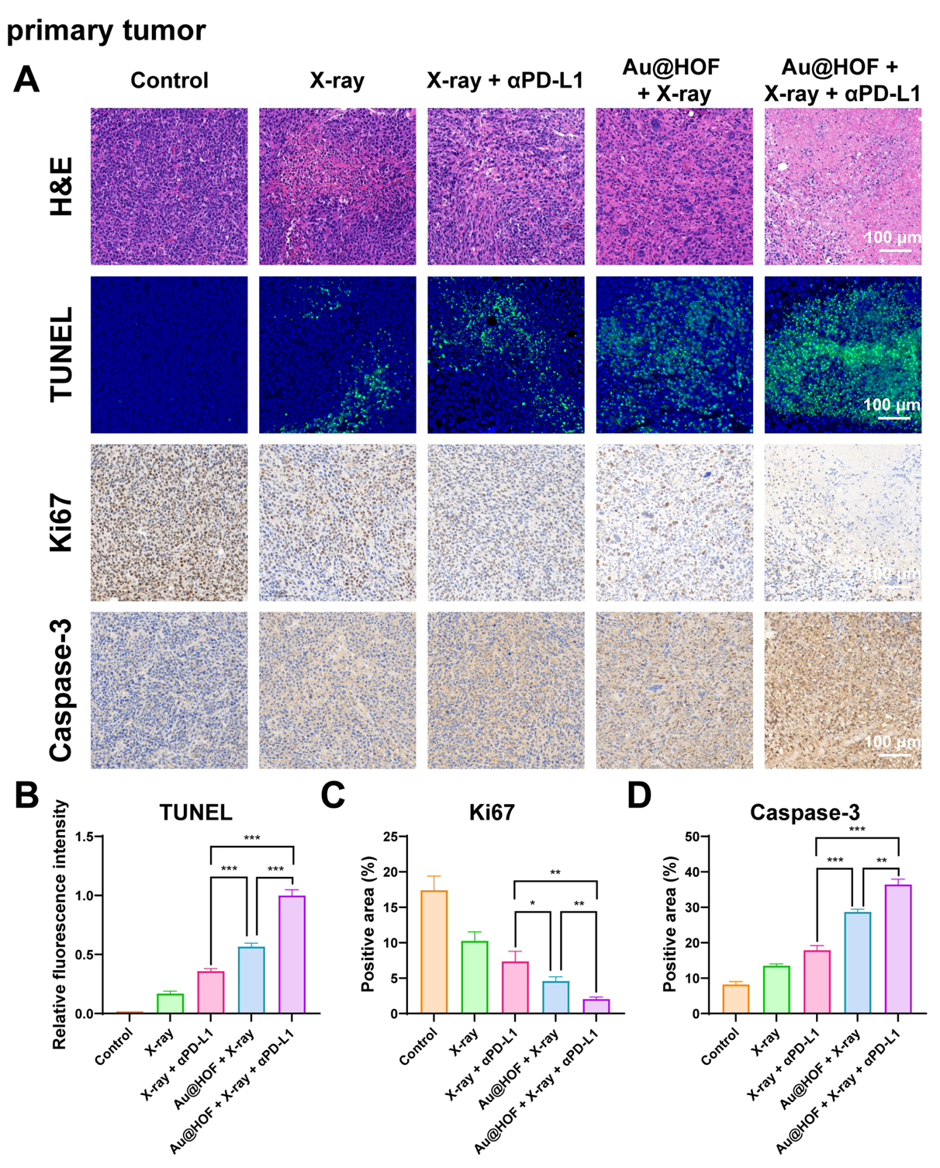
Figure S26. (A) Representative H&E staining images, immunofluorescence images (TUNEL), and immunohistochemical images (Ki67, Caspase-3) of primary tumors from each treatment group. (B) Relative fluorescence intensity of TUNEL. Positive area of (C) Ki67 and (D) Caspase-3.
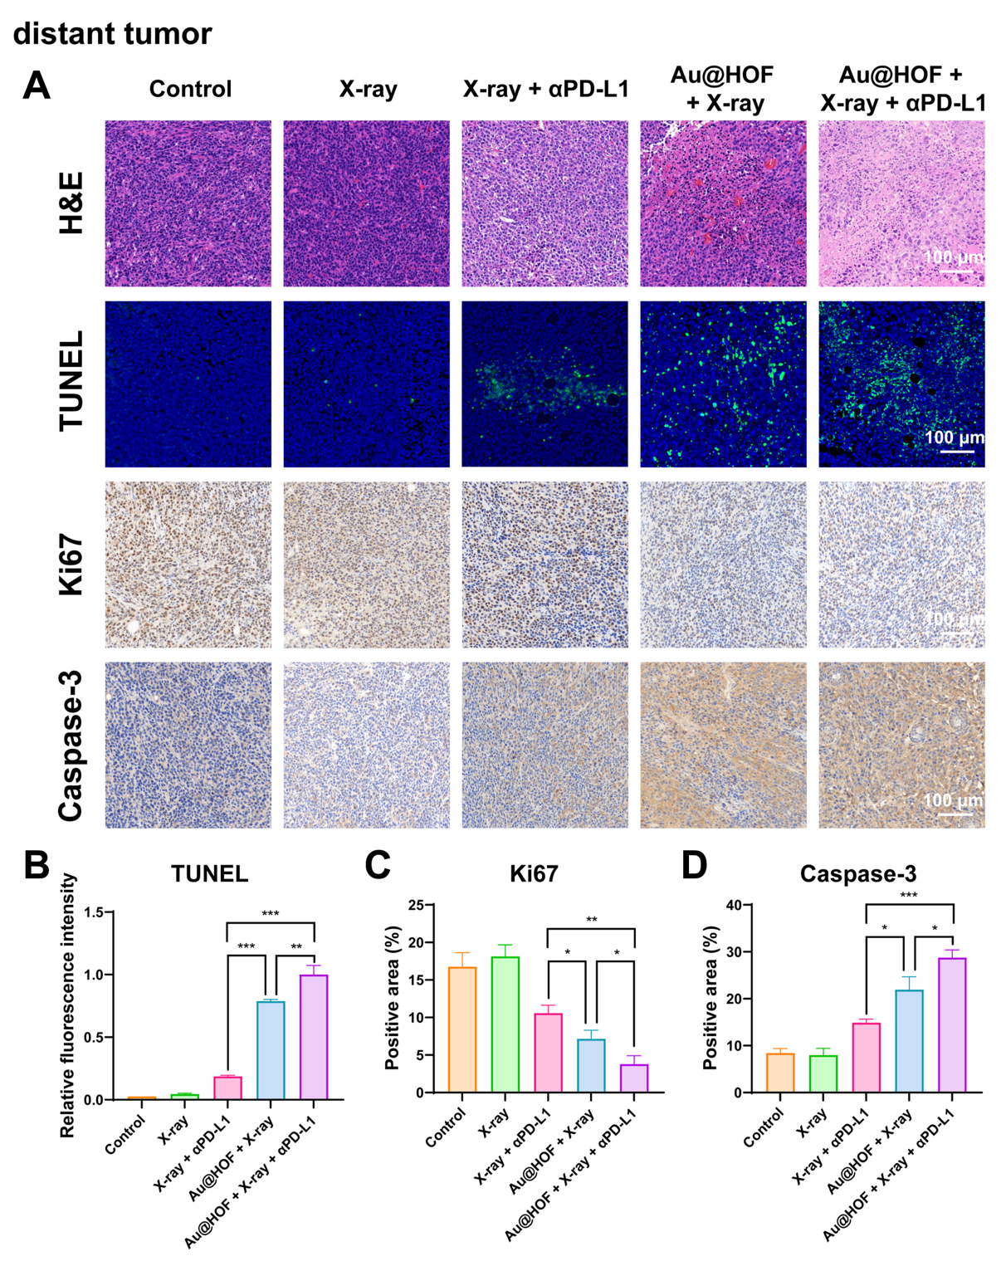
Figure S27. (A) Representative H&E staining images, immunofluorescence images (TUNEL), and immunohistochemical images (Ki67, Caspase-3) of distant tumors from each treatment group. (B) Relative fluorescence intensity of TUNEL. Positive area of (C) Ki67 and (D) Caspase-3.
Figure S28. Image of the lungs of different treatment groups.

Figure S29. Flow cytometry analysis of macrophage infiltration in primary tumors of different treatment groups.
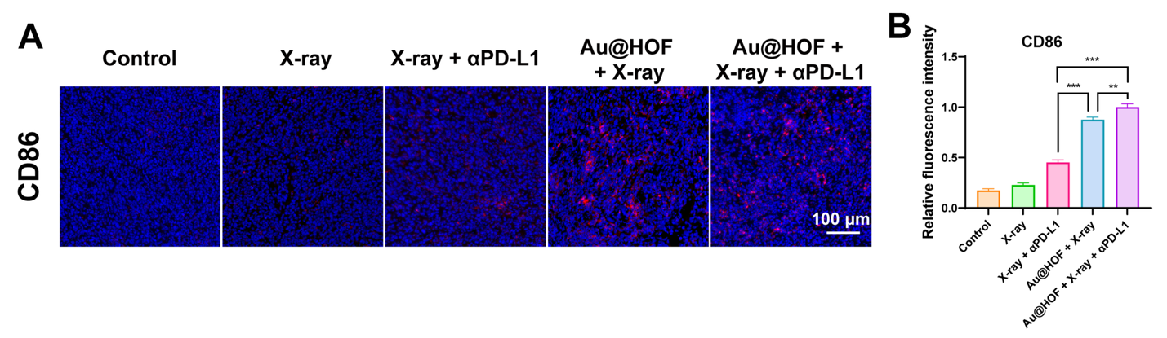
Figure S30. (A) Immunofluorescence staining images of CD86 in primary tumors of different treatment groups. (B) Corresponding relative fluorescence intensity of CD86 in primary tumors of each group.
Figure S31. Corresponding relative fluorescence intensity of CD86 in distant tumors of different treatment groups.
Figure S32. Flow cytometry analysis of CD3 CD4 T cells and CD3 CD8 T cells infiltration in primary tumors of different treatment groups.
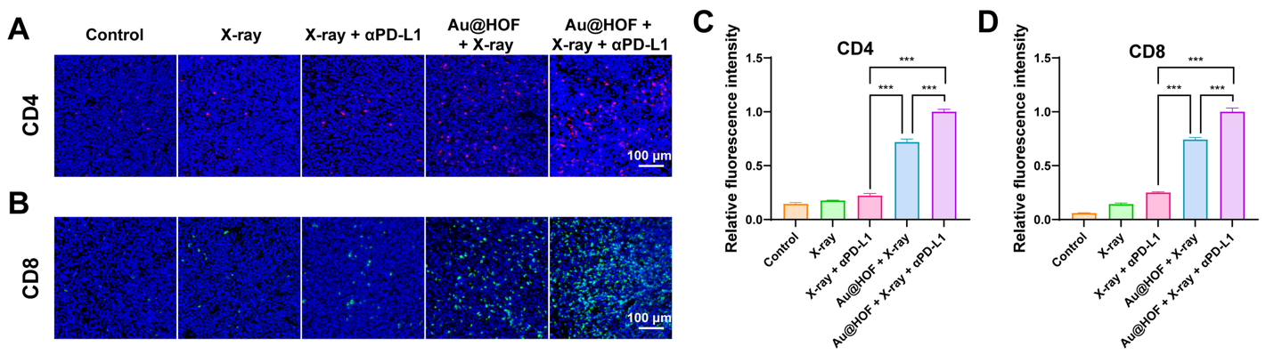
Figure S33. Immunofluorescence staining images of (A) CD4 and (B) CD8 in primary tumors of each treatment group. Corresponding relative fluorescence intensity of (C) CD4 and (D) CD8 in primary tumors of each treatment group.
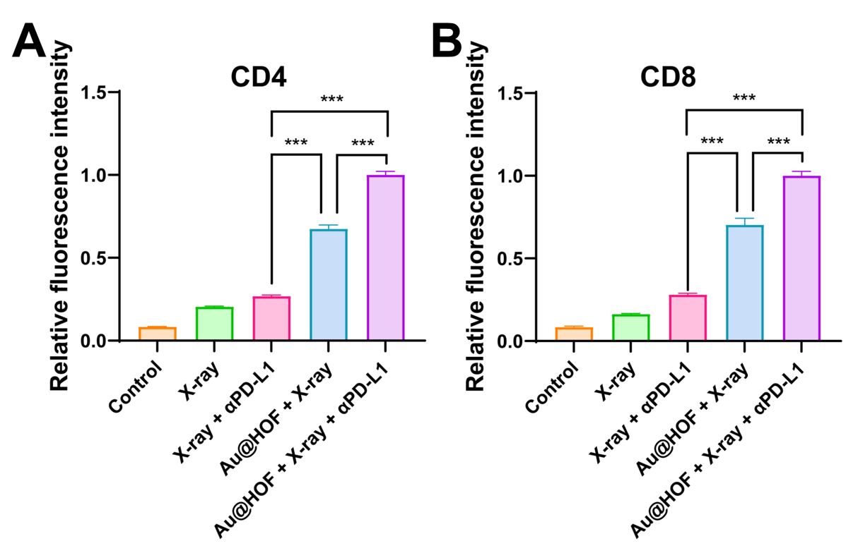
Figure S34. Corresponding relative fluorescence intensity of (A) CD4 and (B) CD8 in distant tumors of different treatment groups.
Figure S35. Corresponding relative fluorescence intensity of CD86 in spleens.
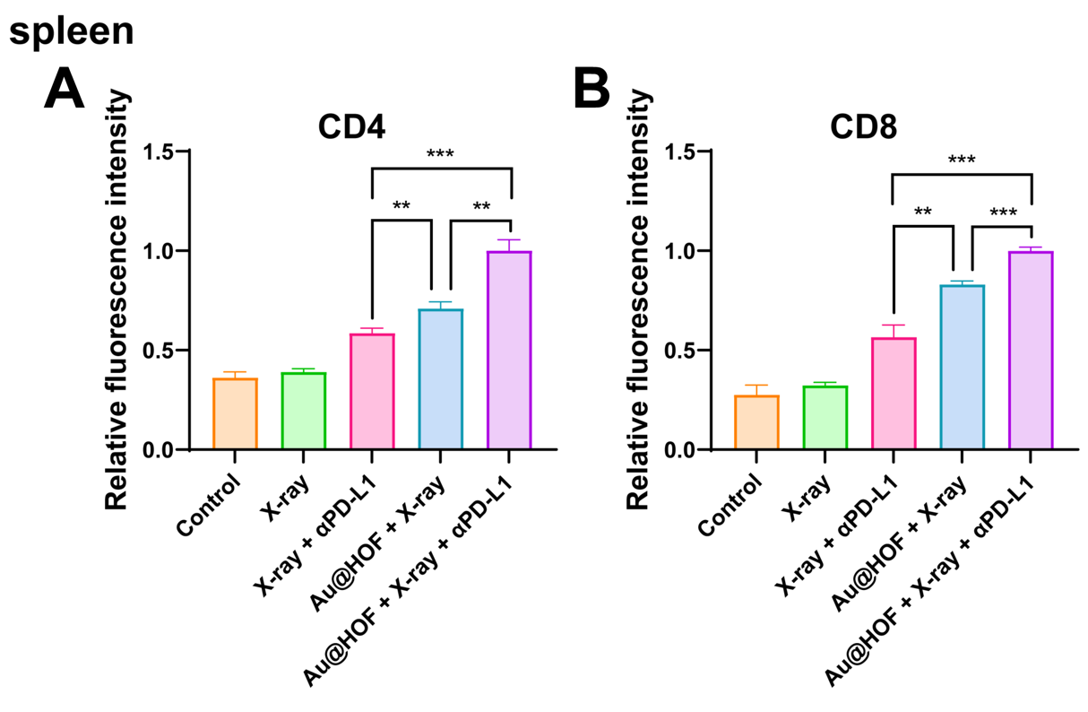
Figure S36. Corresponding relative fluorescence intensity of (A) CD4 and (B) CD8 in spleens.
Figure S37. Immunofluorescence staining images of (A) CD25, (B) CD69 and (C) IFN-γ in distant tumors of each treatment group. Corresponding relative fluorescence intensity of (D) CD25, (E) CD69 and (F) IFN-γ in distant tumors of each treatment group.
Figure S38. Immunofluorescence staining images of (A) CD25, (B) CD69 and (C) IFN-γ in spleens of each treatment group. Corresponding relative fluorescence intensity of (D) CD25, (E) CD69 and (F) IFN-γ in spleens of each treatment group.
Figure S39. Corresponding relative fluorescence intensity of PD-L1 in spleens.
Figure S40. (A) Tumor photograph of the distant tumors. (B) Distant tumor weights on day 14 for each group. (C) Growth curves of distant tumors after different treatments. (D) Body weights of mice in each group. Immunofluorescence staining images of (E) CD8, (F) CD69 and (G) IFN-γ in distant tumors of each treatment group. Corresponding relative fluorescence intensity of (H) CD8, (I) CD69 and (J) IFN-γ in distant tumors of each treatment group.

