Microarray Chip Based on Surface-Enhanced Raman Scattering-Chiral Anisotropy for Ultrasensitive Detection of Aβ42 as an Alzheimer’s Disease-Associated Serum Biomarker
Zixun Wang¹, Yinan Wang², Caili Bi³, Yangfan Zhou³, Tao Zhu³, Xing Jin^{2*}

¹The First School of Clinical Medicine, Faculty of Medicine, Yangzhou University, Yangzhou, 225003, PR China.
²Department of Laboratory Medicine, The Affiliated Hospital of Yangzhou University, Yangzhou University, Yangzhou, 225009, PR China
³School of Basic Medical Sciences & School of Public Health, Faculty of Medicine, Yangzhou University, Jiangsu Key Laboratory of Integrated Traditional Chinese and Western Medicine for Prevention and Treatment of Senile Diseases, Yangzhou, 225001, PR China
* To whom correspondence should be addressed:Xing Jin jinxing6691@163.com

S1.Effect of structural asymmetry factor on simulated chiral response
To quantitatively evaluate the dependence of the simulated molecular response on structural chirality, the structural asymmetry factor g was introduced as a parameter describing the strength of the chiral response. The effective chiral coupling parameter ξ was scaled according to ξ = ξref|g|/0.1, where ξref represents the reference coupling parameter corresponding to g = 0.1. The central calculation adopted ξref = 10.25. The simulated gSERS and the response-based discrimination metric were then calculated under different g conditions. When g = 0, the simulated gSERS was approximately 0 and the response-based discrimination metric was 50.0%, indicating the absence of chiral discrimination in the model. As g increased, both the calculated gSERS and the response-based discrimination metric exhibited a monotonic increasing trend. At g = 0.1, gSERS reached 0.7011 and the response-based discrimination metric reached 67.5%. Further sensitivity analysis with ξref ranging from 6 to 10.25 showed that, within the examined parameter range, the monotonic increasing trend of the simulated differential response with increasing g remained consistent (Figure S1).
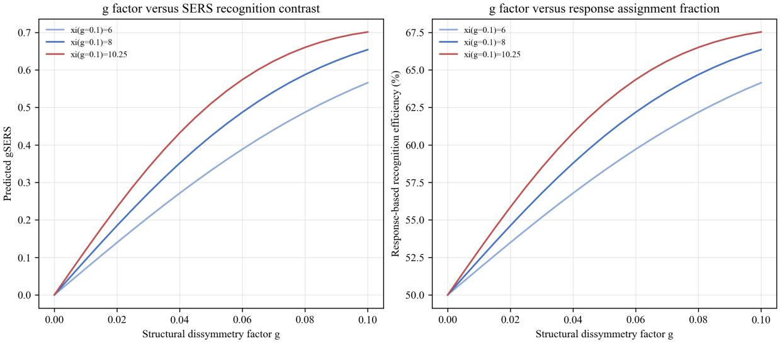Figure S1. Relationship between the g-factor and the simulated recognition response

S2.cleaning of D-CG NP array
To minimize background interference arising from residual surface species, the D-CG NP array was subjected to treatment with 0.1 M KI solution. Owing to the strong adsorption affinity of I⁻ for the Au surface, they competitively displace the residual ligands, yielding a clean, low-background SERS detection interface (Figure S2A).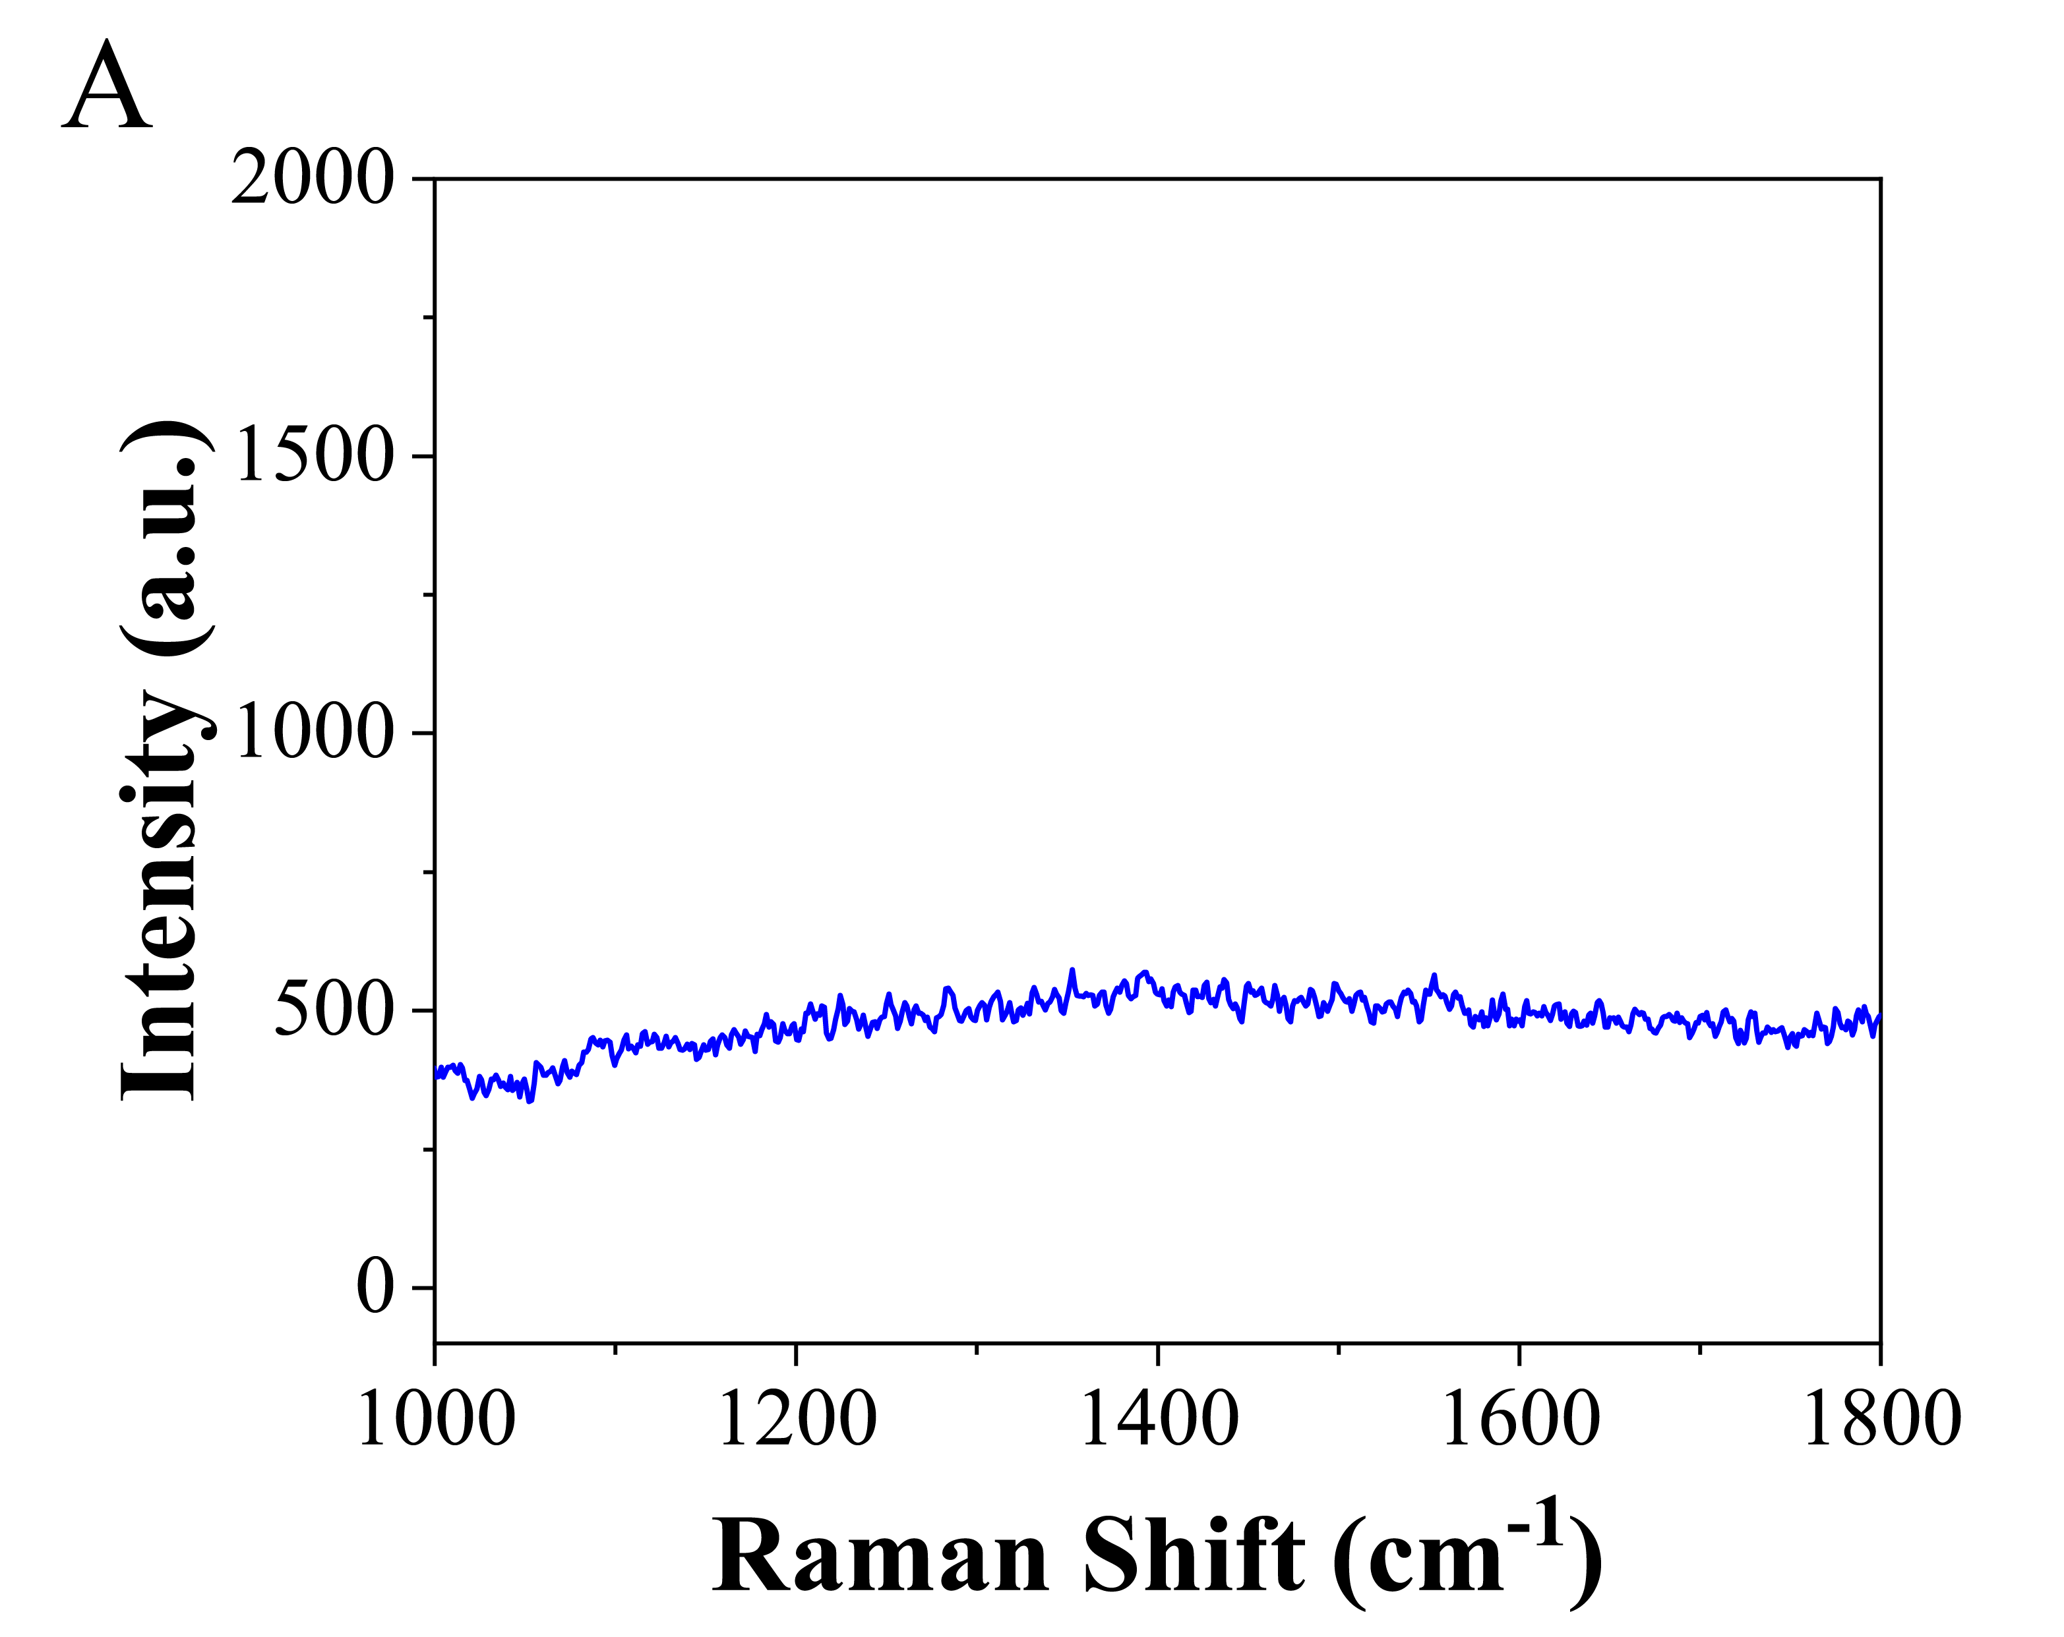
Figure S2. (A) SERS spectra obtained from D-CN NP arrays treated with a 0.1 M KI solution

S3.Simulation of Electromagnetic Field Distribution of CG NPs
Finite-difference time-domain (FDTD) simulations were conducted to analyze the electromagnetic field distributions of both isolated and arrayed CG NPs across the X–Y, X–Z, and Y–Z planes. By integrating electric field intensity contour maps with morphological outlines, the roles of the chiral structures and array arrangements of CG NPs in enhancing the SERS effect were elucidated. The electromagnetic field distributions of individual L-CG NPs and D-CG NPs in the X–Y plane are illustrated in Figures 3A and 3D, respectively, revealing concentrated fields in the core contour regions with asymmetric lobed features. For L/D-CG NP dimers, the electromagnetic field distributions in the X–Z plane are presented in Figures 3B and 3E, while those in the Y–Z plane are shown in Figures 3C and 3F. Due to plasmonic coupling between adjacent CG NPs, notable electromagnetic field enhancement is observed at interparticle gaps and contact interfaces. Notably, the spatial distribution of these high-field regions exhibits significant chirality-dependent variations. These findings demonstrate that large-area, high-density CG NP arrays, fabricated via self-assembly at the oil-water interface, exhibit pronounced SERS enhancement effects.
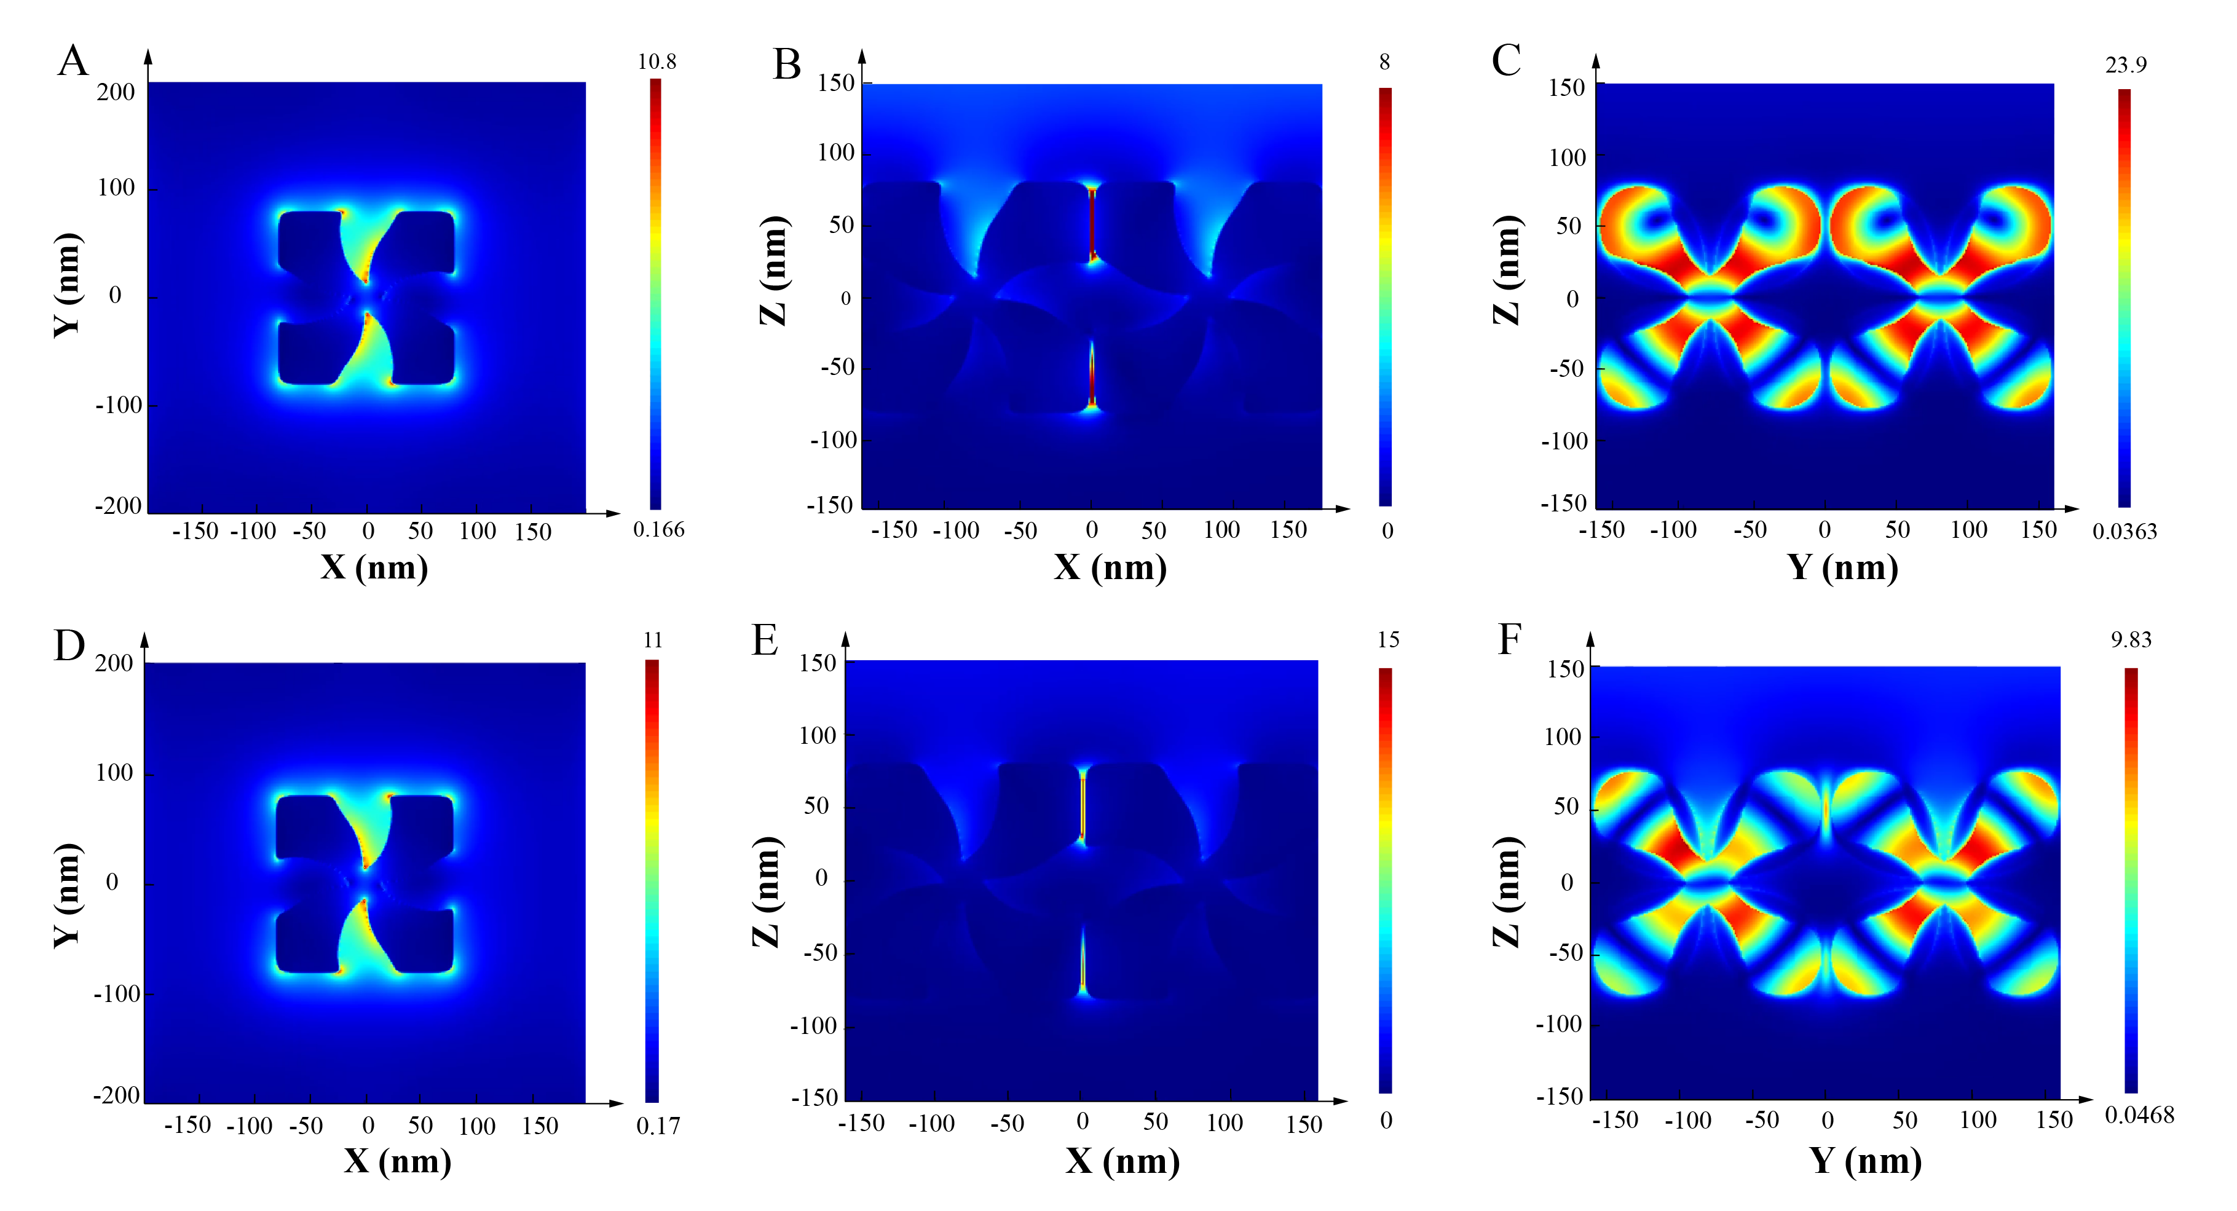
Figure S3. (A) Electromagnetic field intensity distribution of a single L-CG NP (X–Y plane); (B) electromagnetic field intensity distribution of L-CG NP dimers (X–Z plane); (C) electromagnetic field intensity distribution of L-CG NP dimers (Y–Z plane); (D) electromagnetic field intensity distribution of a single D-CG NP (X–Y plane); (E) electromagnetic field intensity distribution of D-CG NP dimers (X–Z plane); (F) electromagnetic field intensity distribution of D-CG NP dimers (Y–Z plane).
S4. Extended FDTD simulation analysis
To further distinguish the chiral-related contribution from conventional electromagnetic SERS enhancement, we analyzed the near-field characteristics of the mirror-symmetric L-CG and D-CG nanostructures under 785 nm linearly polarized excitation, consistent with the experimental conditions. As shown in Figure S4, within the top 1% hotspot region of the 1 nm shell outside the gold surface, the average and peak |E|⁴ ratios of D-CG to L-CG were 0.9956 and 0.9949, respectively, indicating that the two mirror-symmetric chiral substrates possess essentially equivalent conventional electromagnetic enhancement capability. Therefore, the observed difference in Aβ42 SERS response cannot be simply attributed to differences in hotspot density or overall local electromagnetic field enhancement intensity.
Further analysis of the complex electric and magnetic near fields revealed that the two mirror-symmetric structures exhibit opposite local polarization characteristics (Figures S7). The hotspot-weighted ellipticities of L-CG and D-CG were +9.94 × 10⁻⁴and −9.97 × 10⁻⁴, respectively, corresponding to optical chirality densities of +4.34 × 10⁴ and −4.31 × 10⁴ relative field units. These results indicate that, despite linearly polarized excitation, the two chiral nanostructures can still generate local near fields with opposite chiral characteristics, providing an electromagnetic basis for chirality-dependent modulation of molecular response by the local chiral electromagnetic environment. (Figures S5 and S6)
Based on the above complex E/H near-field data, we further introduced an effective chiral polarizability model to perform a parametric analysis of the influence of local chirality, molecular anisotropy, and molecular orientation on the Raman response. In this model, s = +1 and s = −1 represent two opposite branches of effective chiral response and do not correspond to two enantiomeric conformations of Aβ42 that have been experimentally separated or directly determined. Within the strictly defined top 1% hotspot region of the 1 nm shell outside the gold surface, the D-CG/L-CG response ratio for the positive response branch was 2.0683, whereas the L-CG/D-CG response ratio for the opposite response branch was 2.0908, giving an average matched/mismatched response ratio of 2.0796. Meanwhile, when the sign of the molecular chiral response term in the model was reversed, the preferred substrate also shifted from D-CG to L-CG. These calculations demonstrate that, on the basis of nearly identical conventional |E|⁴ enhancement of the two mirror-symmetric structures, the oppositely signed local chiral near fields can produce differential modulation of the effective molecular Raman response. This predicted trend is consistent with the experimental result that D-CG NPs exhibited a stronger SERS response toward Aβ42. For the central mapping ξref = 10.25, increasing the structural g factor from 0 to 0.1 increased gSERS from approximately 0 to 0.7011 and the response-based recognition efficiency from 50.0% to 67.5%, as shown in Figure S8.

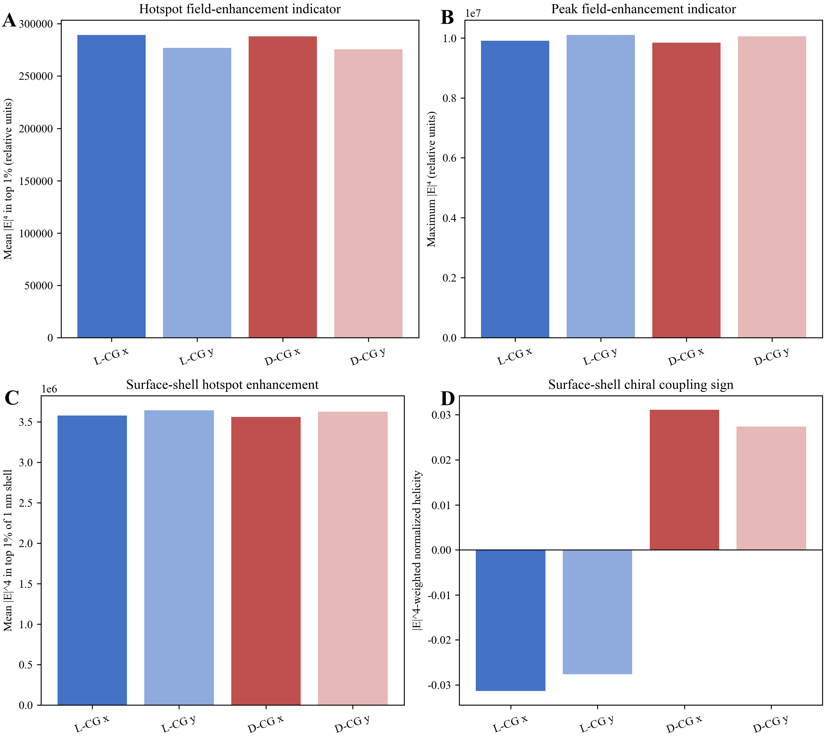
Figure S4. Field-enhancement and surface-shell comparison
Comparison of the |E|⁴ field-enhancement indicators under x- and y-linearly polarized excitation and the corresponding 1 nm outer surface-shell metrics for L-CG and D-CG. (A) Mean |E|⁴ in the top 1% hotspot region; (B) peak |E|⁴; (C) mean |E|⁴ in the top 1% of the 1 nm shell; (D) |E|⁴-weighted normalized helicity.
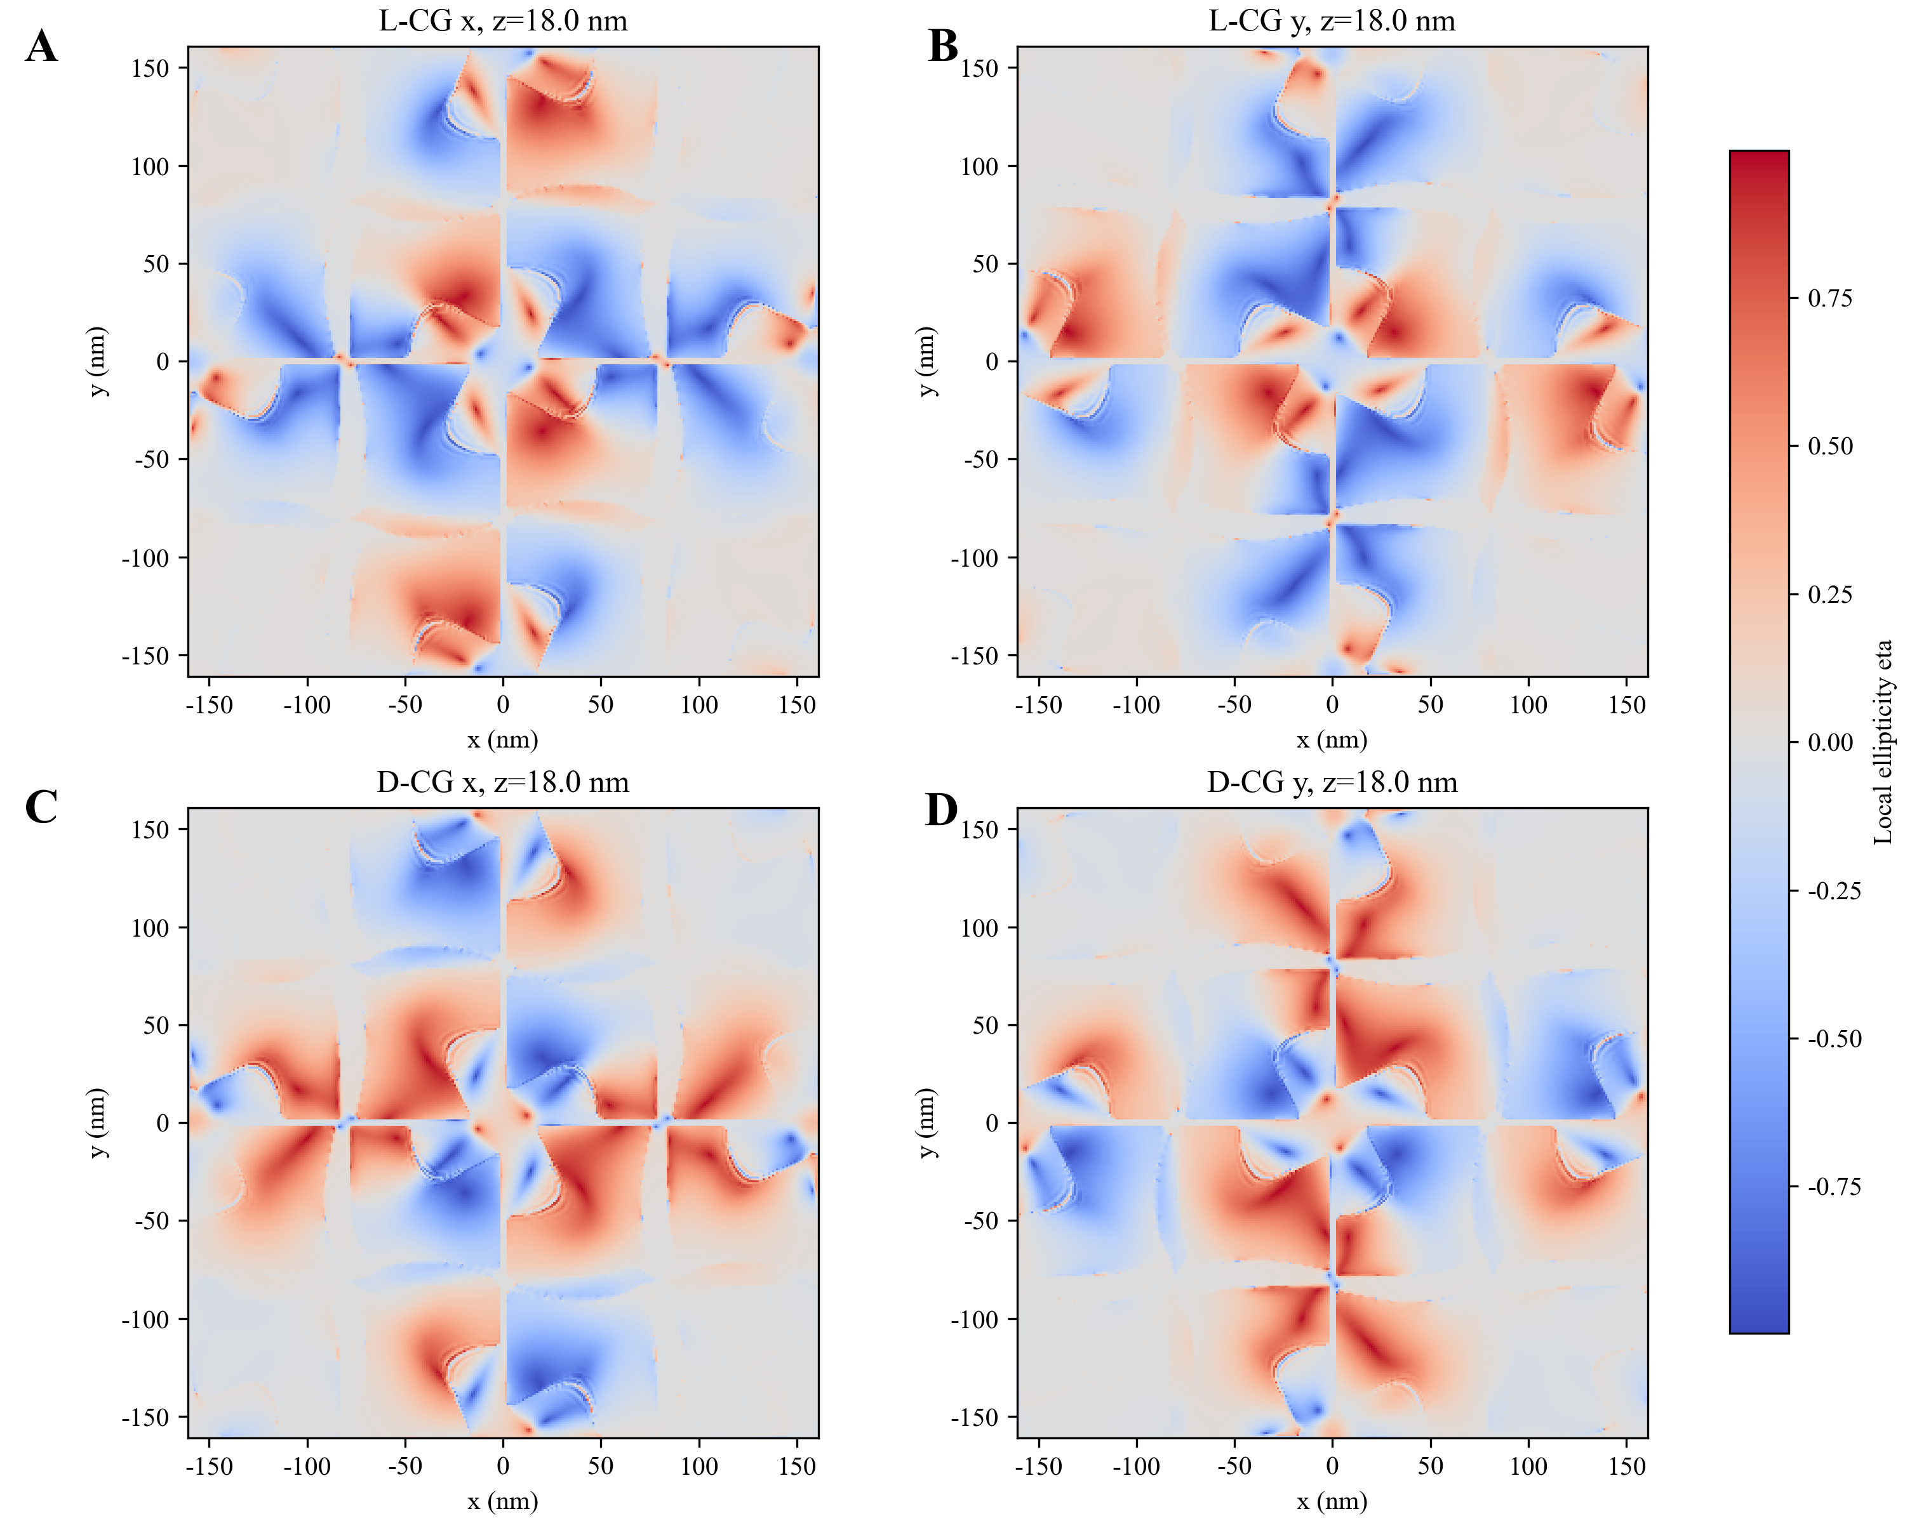
Figure S5. Spatial distribution of local polarization ellipticity
Local ellipticity η at z = 18.0 nm under 785 nm linearly polarized excitation: (A) L-CG with x polarization; (B) L-CG with y polarization; (C) D-CG with x polarization; (D) D-CG with y polarization.
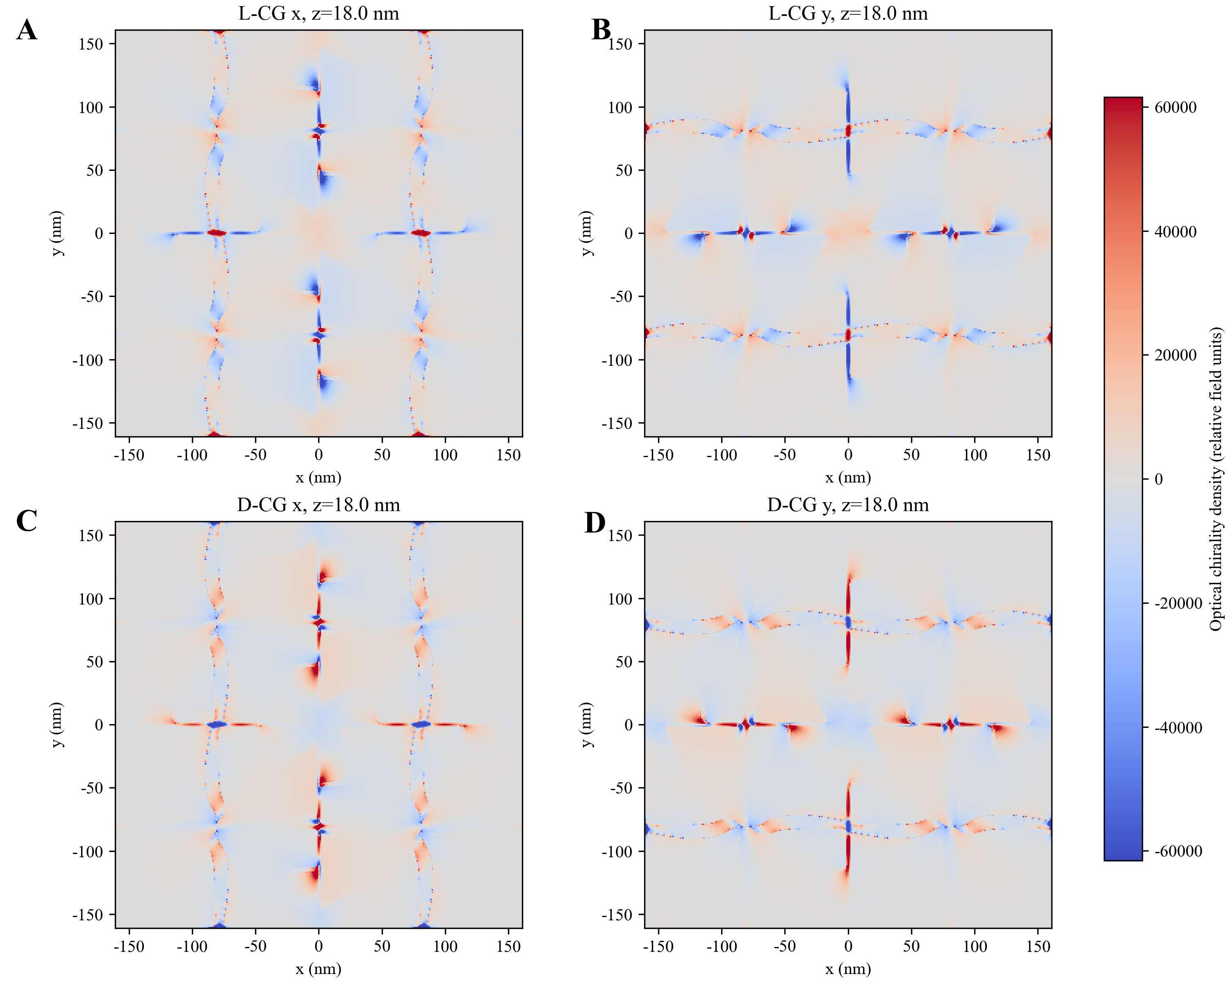
Figure S6. Spatial distribution of optical chirality density
Optical chirality density at z = 18.0 nm under 785 nm linearly polarized excitation: (A) L-CG with x polarization; (B) L-CG with y polarization; (C) D-CG with x polarization; (D) D-CG with y polarization.
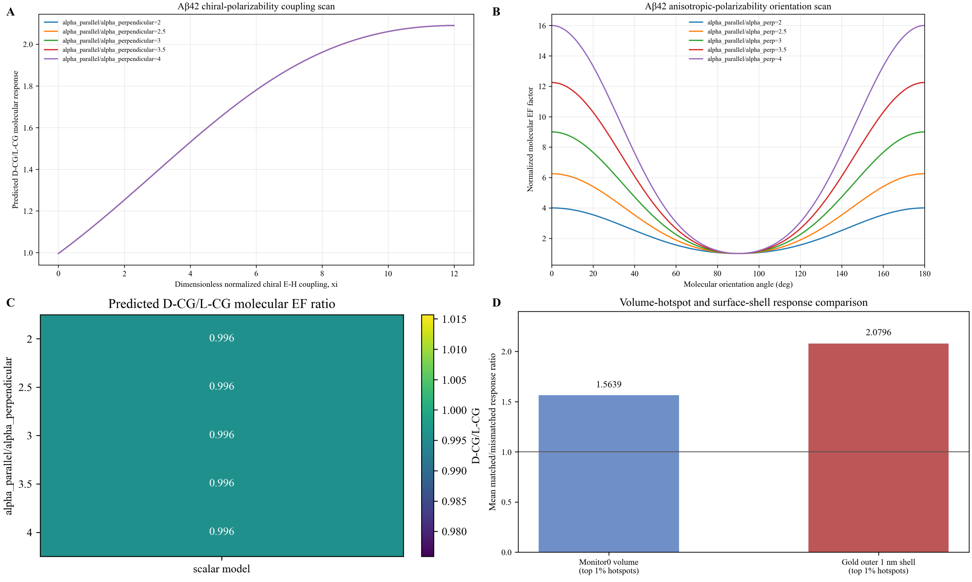
Figure S7. Effective chiral-polarizability model analysis for Aβ42
Effective chiral-polarizability model analysis for Aβ42. (A) Predicted D-CG/L-CG molecular response ratio as a function of normalized chiral E-H coupling ξ for α∥/α⊥ = 2-4; (B) orientation-dependent normalized molecular enhancement factor for the scanned anisotropy ratios; (C) baseline D-CG/L-CG ratio across anisotropy settings; (D) comparison of the volume-hotspot and 1 nm outer-surface-shell statistical definitions, yielding ratios of 1.5639 and 2.0796, respectively.

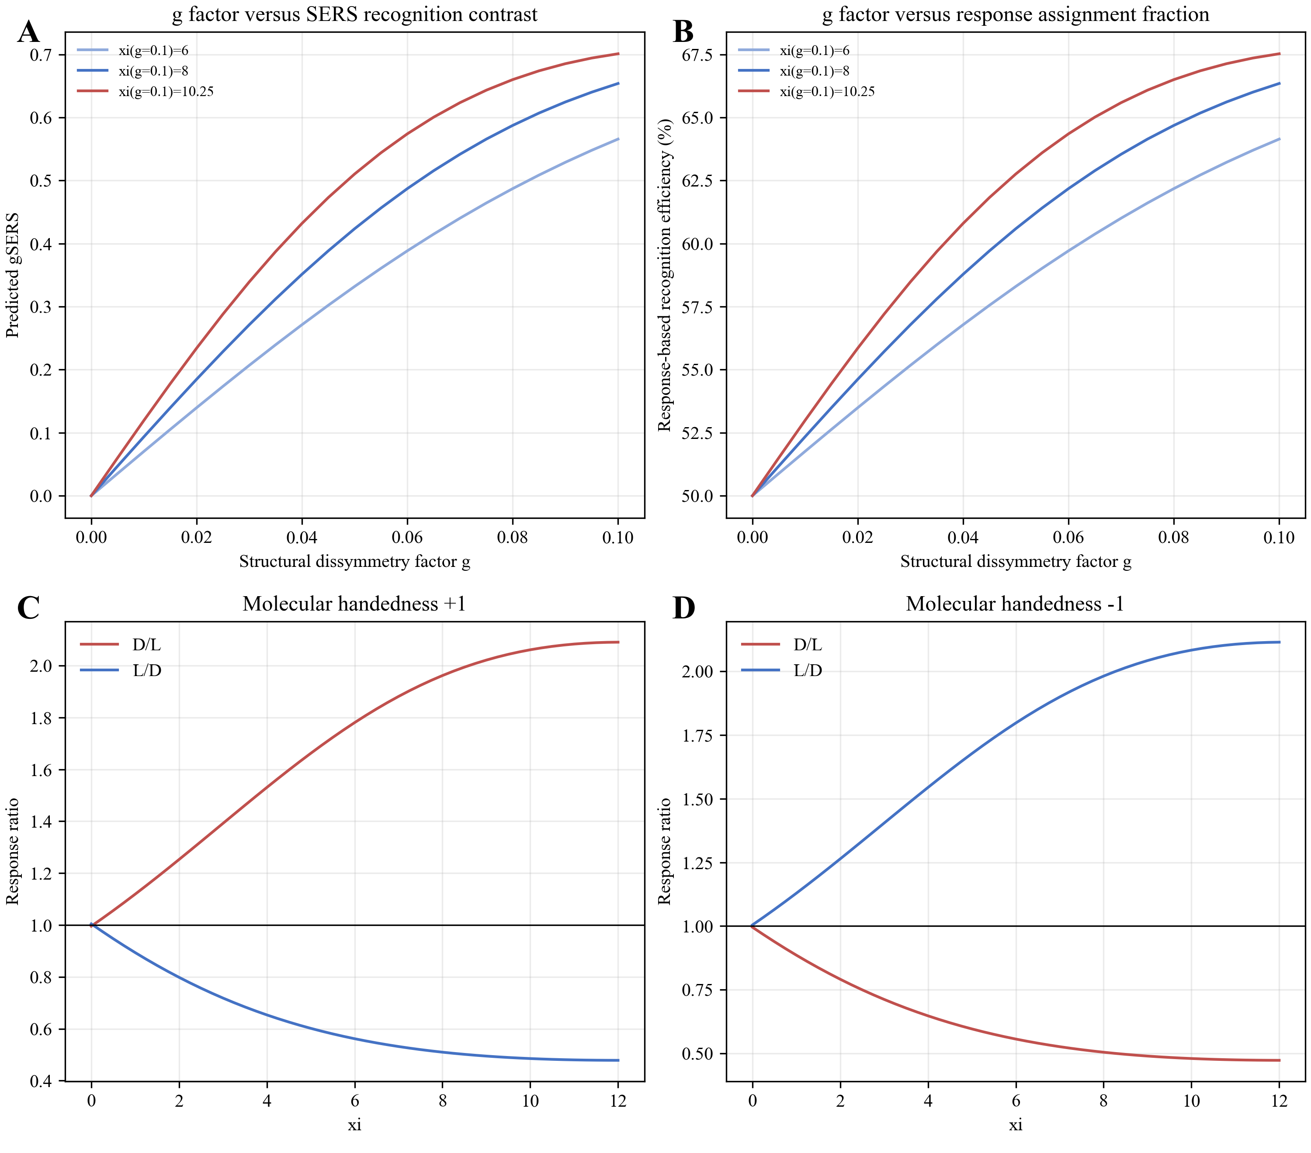
Figure S8. g factor and recognition-direction analysis
Quantitative relationship between the structural dissymmetry factor g and the model-based recognition response. (A) Predicted gSERS; (B) response-based recognition efficiency; (C) response ratios for molecular handedness +1; (D) response ratios for molecular handedness -1. The lower panels show reversal of the preferred substrate after inversion of the effective molecular chiral response.

S5. Confirmation of the origin of the 1322 cm⁻¹ characteristic peak
To further verify the origin of the 1322 cm⁻¹ characteristic peak and exclude background interference, we supplemented Raman spectra of pure Aβ42 and compared the signal intensities at 1322 cm⁻¹ among CG NPs, CG NPs with serum matrix, and CG NPs with Aβ42. As shown in Figure S10A, pure Aβ42 exhibited a characteristic response near 1322 cm⁻¹ that was significantly higher than the other peaks, and CG NPs and CG NPs with serum matrix produced signals at this wavenumber far below that of CG NPs with Aβ42(Figure S10B), indicating that their contribution to the detection signal was negligible. Therefore, the main enhanced response at 1322 cm⁻¹ can be attributed to Aβ42-related molecular vibrations, and this peak was selected as the characteristic peak for subsequent quantitative analysis.

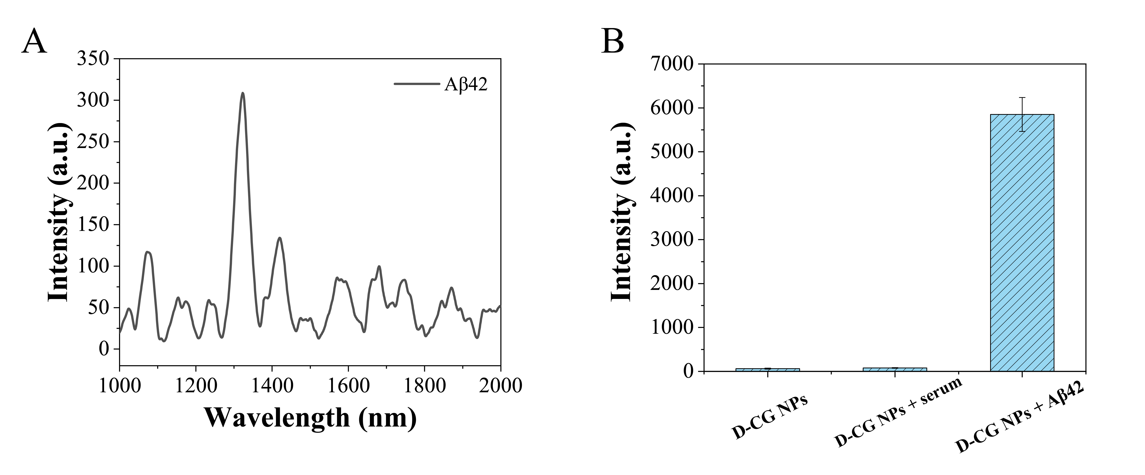
Figure S9. (A) Raman spectrum of pure Aβ42 standard. (B) Comparison of signal intensities at 1322 cm⁻¹ among CG NPs, CG NPs with serum matrix, and CG NPs with Aβ42.
S6. Evaluation of anti-interference capability
Furthermore, we evaluated the anti-interference capability of the SERS microarray chip in a complex serum environment. The SERS signal intensities at 1322 cm⁻¹ were compared among a Blank group containing only the SERS substrate without Aβ42, a group containing Aβ42 alone, and groups containing Aβ42 together with physiologically relevant interferents: kynurenine (Kyn, 10 μM), dopamine (DA, 10 μM), glucose (Glc, 5 mM), urea (5 mM), albumin (40 mg/mL), and IgG (10 mg/mL) (Figure S10). These interferents are common endogenous components in serum that may coexist with Aβ42 and potentially affect the acquisition of Raman signals. The concentrations of glucose, urea, albumin, and IgG were set to simulate the physiological levels of high-abundance proteins in serum, thereby more realistically reflecting the complex serum matrix environment, whereas Kyn and DA were used at concentrations higher than their normal physiological serum levels to rigorously evaluate the anti-interference capability of the chip. The results showed that no obvious characteristic signal was observed at 1322 cm⁻¹ in the Blank group, confirming that the peak response at this position originated from Aβ42. Compared with the Aβ42-alone control group, after the addition of kynurenine, dopamine, glucose, urea, albumin, or IgG, the p-values for the SERS signal intensity at 1322 cm⁻¹ were 0.58181, 0.96371, 0.85631, 0.52637, 0.84333, and 0.64326, respectively, all > 0.05, indicating no statistically significant differences. The inter-group relative standard deviation was 6.08%. These results demonstrate that the chiral microarray chip sensor possesses good anti-interference capability for Aβ42 detection in a complex serum environment containing multiple physiologically relevant interferents.

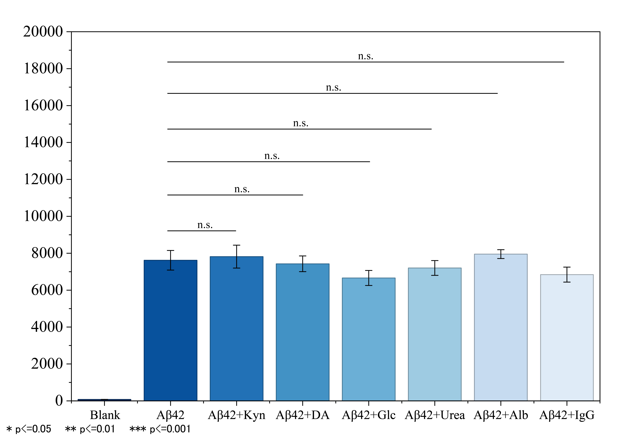
Figure S10. SERS intensity at 1322 cm⁻¹ for Blank, Aβ42 alone, and Aβ42 with interferents.
S7.
Table S1. Concentrations of Aβ42 determined by SERS using the proposed sensing system and by ELISA in AD rats at different stages (Day 0, Day 5, Day 10, Day 15).
Day | Sample | SERS (pg/ml) | ELISA (pg/ml)
Day 0 | 1 | 9.17 | 7.71
Day 0 | 2 | 5.82 | 6.53
Day 0 | 3 | 13.58 | 12.04
Day 0 | 4 | 2.65 | 4.49
Day 0 | 5 | 8.13 | 9.45
Day 0 | 6 | 11.74 | 13.89
Day 5 | 1 | 29.36 | 31.67
Day 5 | 2 | 10.5 | 18.71
Day 5 | 3 | 31.14 | 26.71
Day 5 | 4 | 25.53 | 21.44
Day 5 | 5 | 21.86 | 17.56
Day 5 | 6 | 14.42 | 22.94
Day 10 | 1 | 82.89 | 98.06
Day 10 | 2 | 96.26 | 85.71
Day 10 | 3 | 101.82 | 78.36
Day 10 | 4 | 91.15 | 98.36
Day 10 | 5 | 86.61 | 79.71
Day 10 | 6 | 98.52 | 84.36
Day 15 | 1 | 124.94 | 136.06
Day 15 | 2 | 123.52 | 134.36
Day 15 | 3 | 136.56 | 151.71
Day 15 | 4 | 127.62 | 124.36
Day 15 | 5 | 116.15 | 138.71
Day 15 | 6 | 114.27 | 132.06
S8.Clinical samples
To further evaluate the detection reliability of the established method in complex serum matrices, we performed independent LOD validation using serum samples from different healthy individuals. Six serum samples from different healthy individuals were selected, and a high-concentration Aβ42 stock solution (10⁴ pg/mL) was first added to each sample, followed by serial dilution to obtain Aβ42 concentrations ranging from 10³ to 10⁻¹ pg/mL. SERS spectra were recorded at each concentration under the same experimental conditions, and the detection limit was calculated separately for each serum sample. The results showed that the LOD obtained from the six independent serum samples was 16.60 ± 0.35 fg mL⁻¹, with an RSD of 2.09% and a 95% confidence interval of 16.32-16.88 fg mL⁻¹, indicating good repeatability and statistical stability of the platform in serum matrices (Figure S11A). As shown in Figures S11B and S11C, we performed six independent repeated measurements on the same serum samples from a healthy individual and an AD patient. The RSD was 6.14% for the healthy sample and 7.53% for the AD patient sample, indicating good repeatability of the method in clinical samples. As shown in Figure S11D, we used the SERS microarray chip to analyze clinical serum samples from 30 healthy controls and 30 AD patients. In parallel, ELISA was used for validation. As shown in Figure S11E, linear regression analysis between the SERS and ELISA results revealed a strong positive correlation (R² = 0.943), indicating a strong linear association between the two methods. We further performed Bland–Altman analysis based on the paired SERS and ELISA measurements (Figure S11F). The results showed a mean bias of 1.325 between the two methods, with 95% limits of agreement ranging from -12.381 to 15.531, and most of the measurement results fell within the limits of agreement, providing preliminary evidence for the detection of Aβ42 in human serum samples using the proposed platform.
Figure S11. (A) Repeatability validation of the LOD based on clinical serum samples; (B) Repeatability for healthy-control serum samples; (C) Repeatability for serum samples from AD patients; (D) Detection results of Aβ42 in serum samples from 30 healthy controls and 30 AD patients; (E) Correlation analysis between SERS and ELISA measurement results; (F) Bland–Altman agreement analysis of SERS and ELISA measurement results.

