Supporting Information
Regulation of Gut Microbial Dysbiosis and Inflammatory Microenvironment by GQD-Derived Nanoparticles for the Treatment of Colitis-Associated Osteoporosis
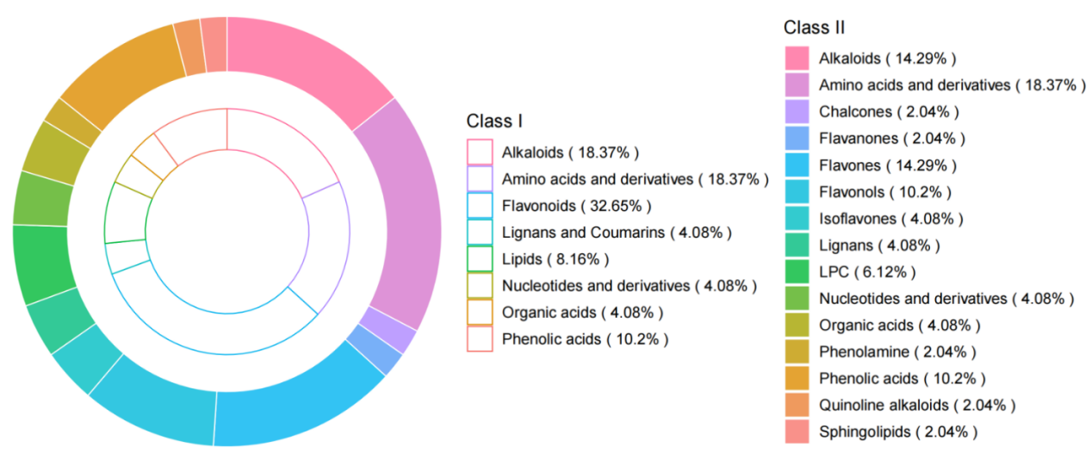
Fig. S1. Plant analogous widely targeted metabolomics analysis of GQD_NPs. Hierarchical classification of metabolites identified in GQD_NPs by widely targeted plant metabolomics. The inner ring represents class I metabolite categories, while the outer ring shows the corresponding class II subclasses.

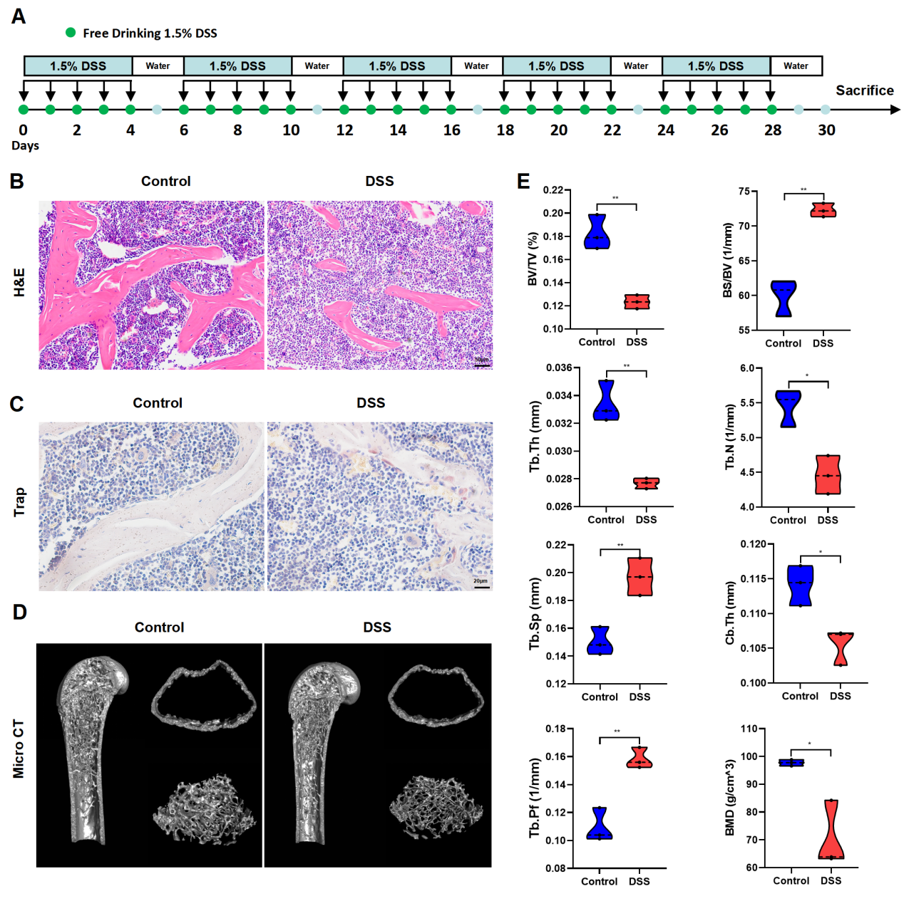
Fig. S2. Chronic colitis induces osteoporosis in mice. (A) Schematic timeline of the experimental protocol. (B) Representative H&E staining of the distal femur. Scale bar = 50 μm. (C) Representative TRAP staining of the femur. Osteoclasts on the trabecular surface were positively stained (purple-red) Scale bar = 20 μm. (D-E) Representative Micro CT images and quantitative analysis of femoral bone parameters. Data are presented as mean ± SD. *P < 0.05, **P < 0.01, ***P < 0.001, ns: not significant.
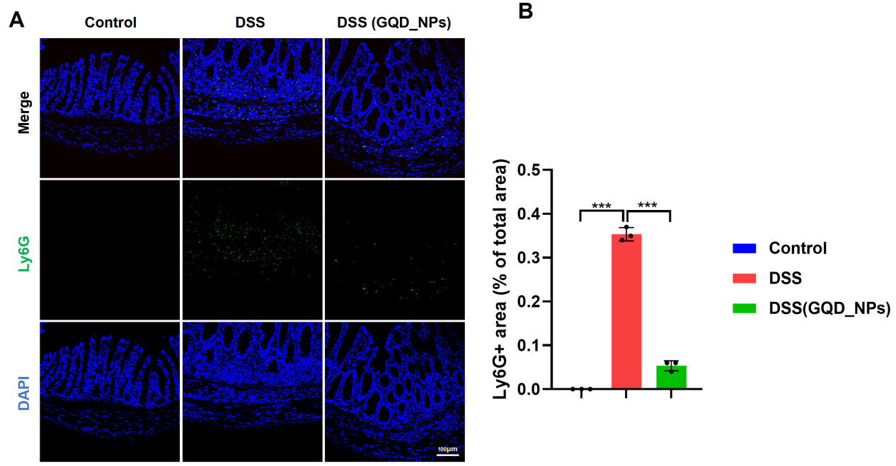
Fig. S3. GQD_NPs inhibits colonic immune cell infiltration in DSS-induced chronic colitis. (A) Representative immunofluorescence staining of Ly6G (green) in colon tissues. Scale bar = 100 μm. (B) Quantitative analysis of Ly6G-positive area as a percentage of total tissue area. Data are presented as mean ± SD. *P < 0.05, **P < 0.01, ***P < 0.001 ; ns: not significant.
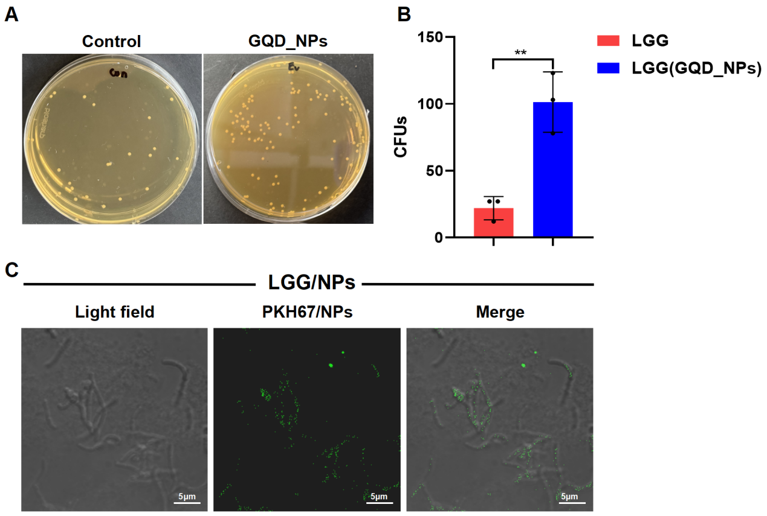
Fig. S4. Effects of GQD_NPs on the growth of LGG. (A) Representative images of CFU assays showing LGG colonies on agar plates. (B) Quantitative analysis of LGG CFUs. (C) GQD_NPs were taken up by LGG. (Scale bar = 5 μm). Data are presented as mean ± SD. *P < 0.05, **P < 0.01, ***P < 0.001 ; ns: not significant.
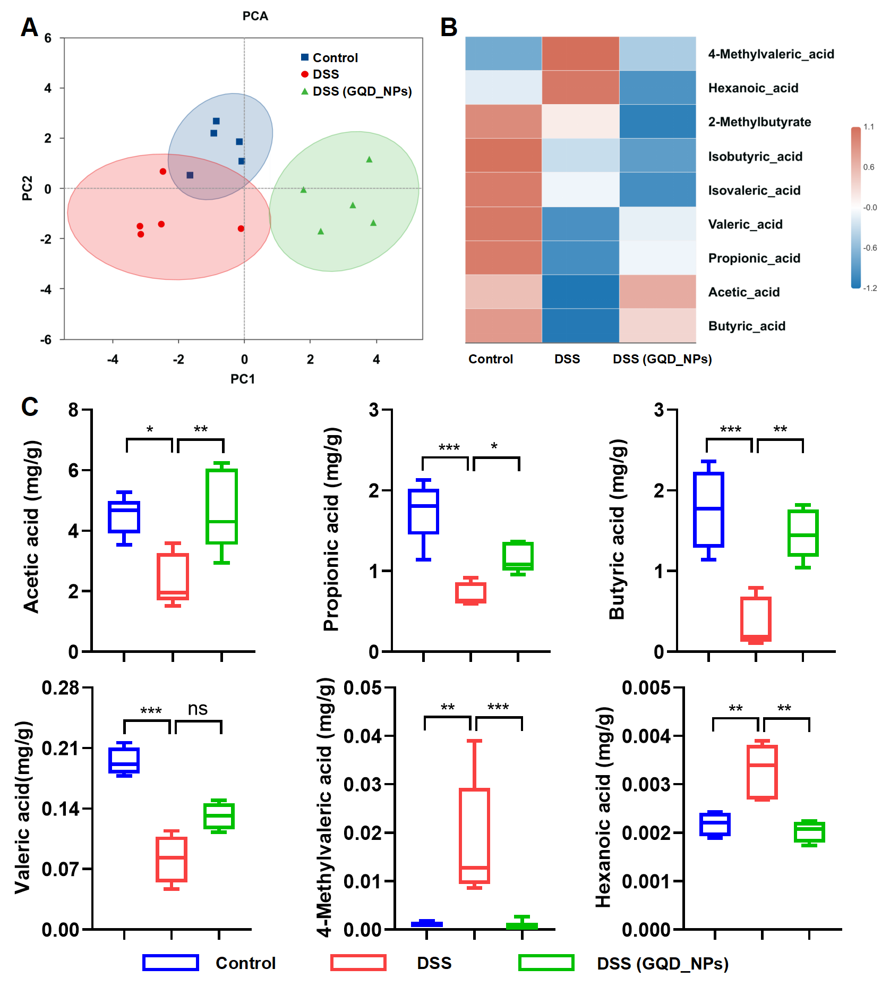
Fig. S5. GQD_NPs restore fecal short-chain fatty acid profiles in chronic colitis mice. (A) PCA score plot depicting the separation of fecal SCFAs metabolic profiles. (B) Heatmap visualization of the relative abundance of key SCFAs in fecal samples. (C) Quantitative analysis of key SCFAs showing significant differences. Data are presented as mean ± SD. *P < 0.05, **P < 0.01,, ***P < 0.001 ; ns: not significant.
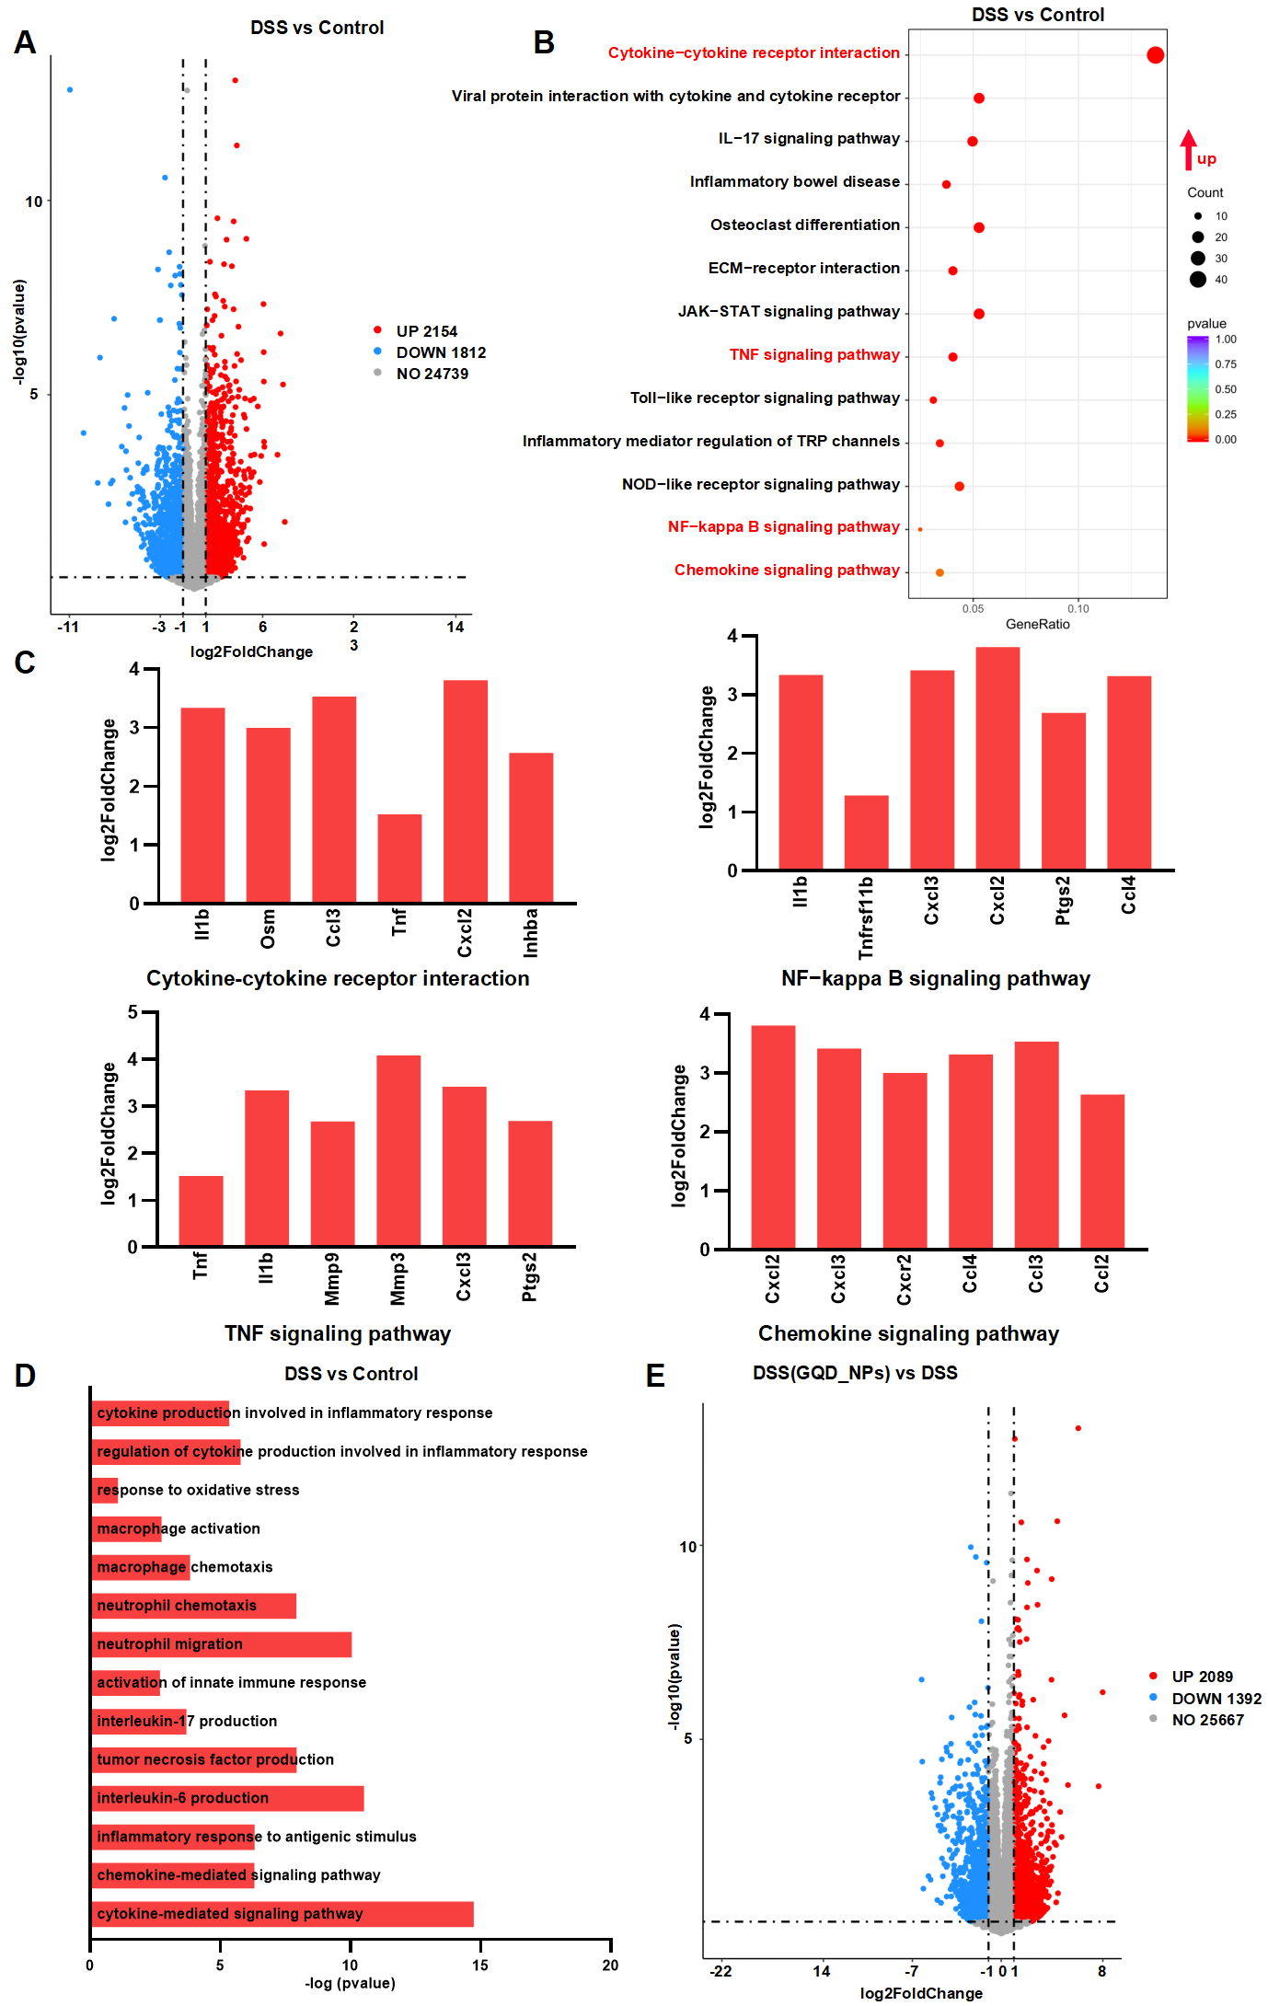
Fig. S6. Transcriptomic profiling of colon tissues in DSS-induced colitis mice. (A) Volcano plot of differentially expressed genes (DEGs) in the DSS vs control. (B) KEGG pathway enrichment analysis. (C) Key genes within the four core pathways.(D) GO biological process enrichment analysis. (E) Volcano plot of DEGs in the DSS+GQD-NPs vs. DSS.
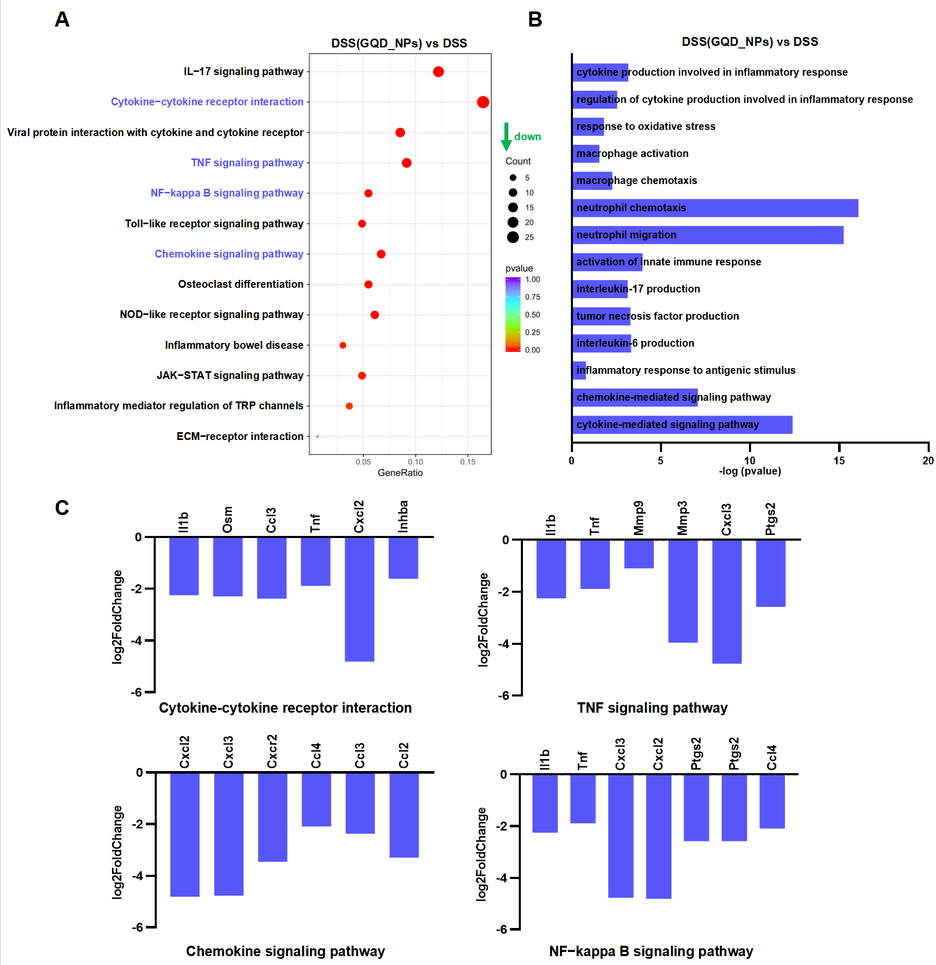
Fig. S7. GQD_NPs treatment reverses the activation of core inflammatory signaling pathways in the colon tissues. (A) KEGG pathway enrichment analysis of significantly downregulated genes in colon tissues from DSS-induced colitis mice treated with GQD_NPs. (B) GO biological process enrichment analysis of downregulated genes. (C) Key genes within the four core pathways.

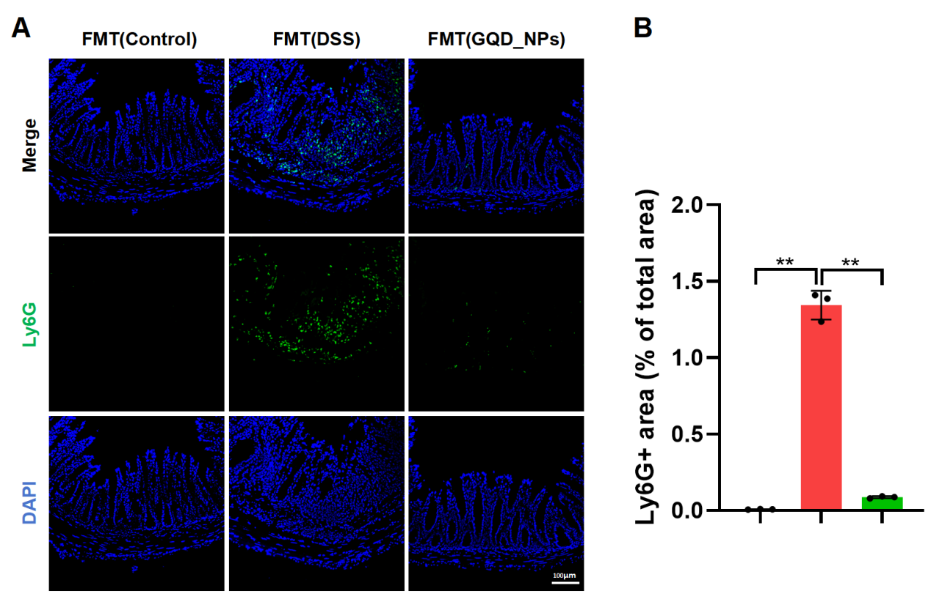
Fig. S8. FMT from GQD_NPs‑treated mice reduces colonic neutrophil infiltration in DSS‑induced colitis. (A) Representative immunofluorescence staining of Ly6G (green) in colon tissues. Scale bar = 100 μm. (B) Quantitative analysis of Ly6G‑positive area as a percentage of total tissue area. Data are presented as mean ± SD. *P < 0.05, **P < 0.01, ***P < 0.001; ns, not significant.

