Supplementary information
Table S1. Encapsulation efficiency and drug loading content of nanovaccines
Encapsulation efficiency % | Drug loading content %
26.69% | 10.63%

Table S2. The loading efficiency of drug modification to bacterial surface was determined by HPLC.
αOX40 LE% |  | R848 LE%
28.60% | 37.80%

Table S3. Characterization of the neoantigen nanoparticle DSPE-PEG₂₀₀₀-ME2
Size (nm) | PDI | Encapsulation efficiency (%) | Drug loading content (%) | Zeta potential(mV)
41.13 ± 0.44 | 0.29 ± 0.4 | 26.69 ± 2.86 | 10.63 ± 2.20 | -19.03 ± 0.5

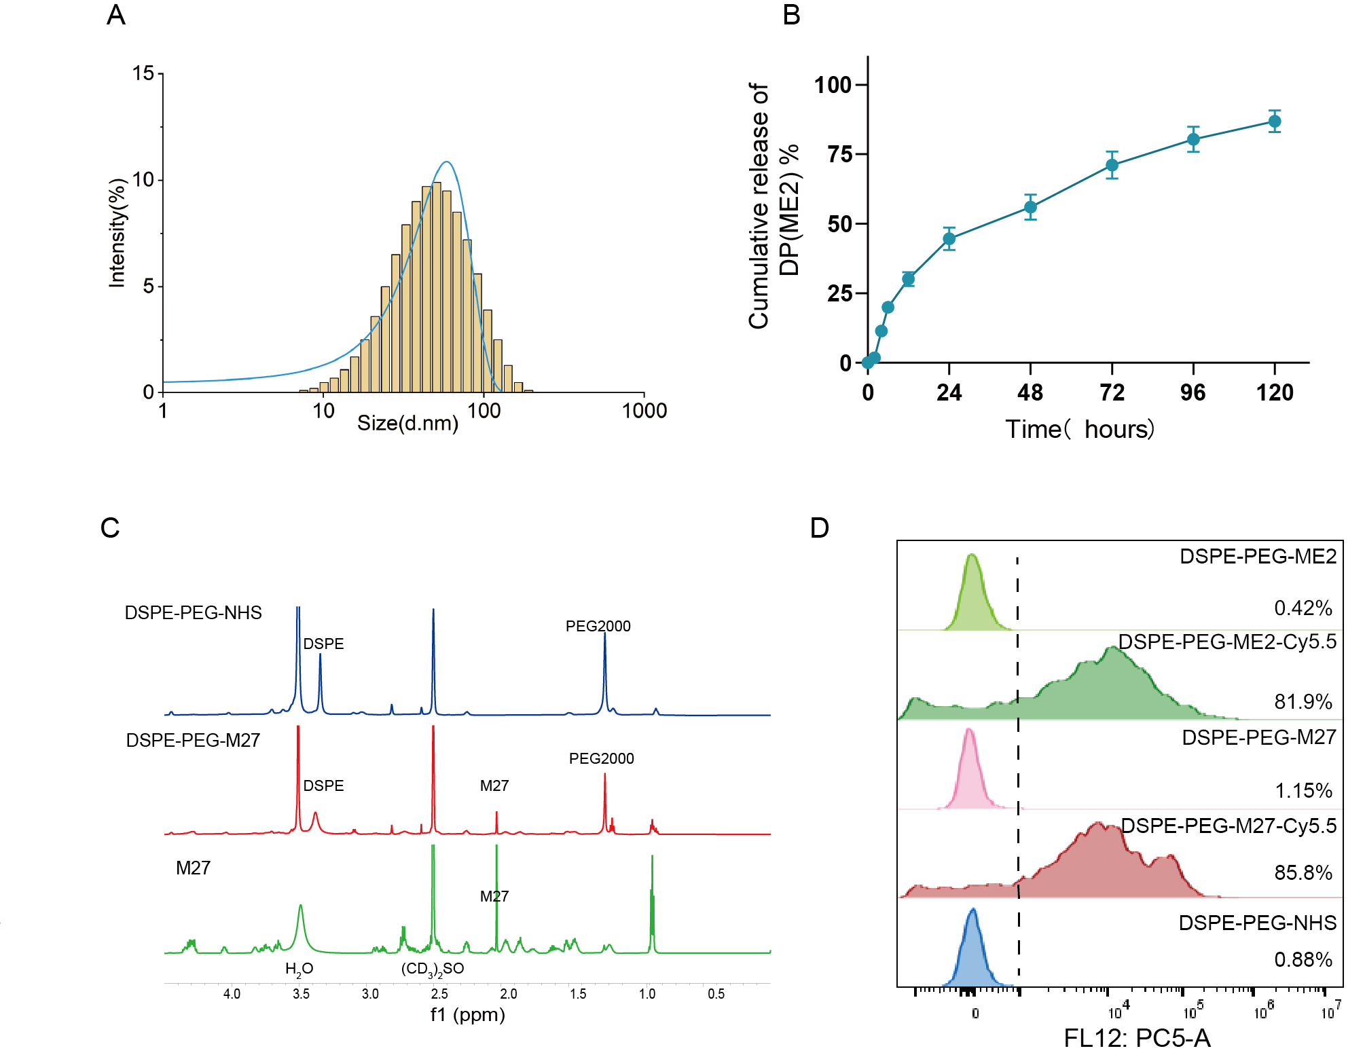
Fig. S1. Characterization of the nanovaccine and hydrogel formulation. (A) Hydrodynamic diameter distribution of the nanovaccine measured by dynamic light scattering (DLS). Data are presented as mean ± SEM (n = 3). (B) In vitro cumulative release profiles of DSPE-PEG₂₀₀₀-ME2 and V@OR from 20% (w/v) P407 hydrogel. Data are presented as mean ± SEM (n = 3). (C) ¹H NMR spectra of DSPE-PEG₂₀₀₀-NHS, DSPE-PEG₂₀₀₀-M27, and the M27 peptide, confirming the successful conjugation of the neoantigen peptide to DSPE-PEG₂₀₀₀. (D) Representative flow cytometry analyses of Cy5.5-labeled DSPE-PEG₂₀₀₀-M27 and DSPE-PEG₂₀₀₀-ME2 nanovaccines. DSPE-PEG₂₀₀₀-M27-Cy5.5 and DSPE-PEG₂₀₀₀-ME2-Cy5.5 exhibited 85.8% and 81.9% fluorescence-positive populations, respectively, which were markedly higher than those of the corresponding unlabeled controls, further confirming the successful conjugation and stable incorporation of both neoantigen peptides into the nanovaccine formulation.
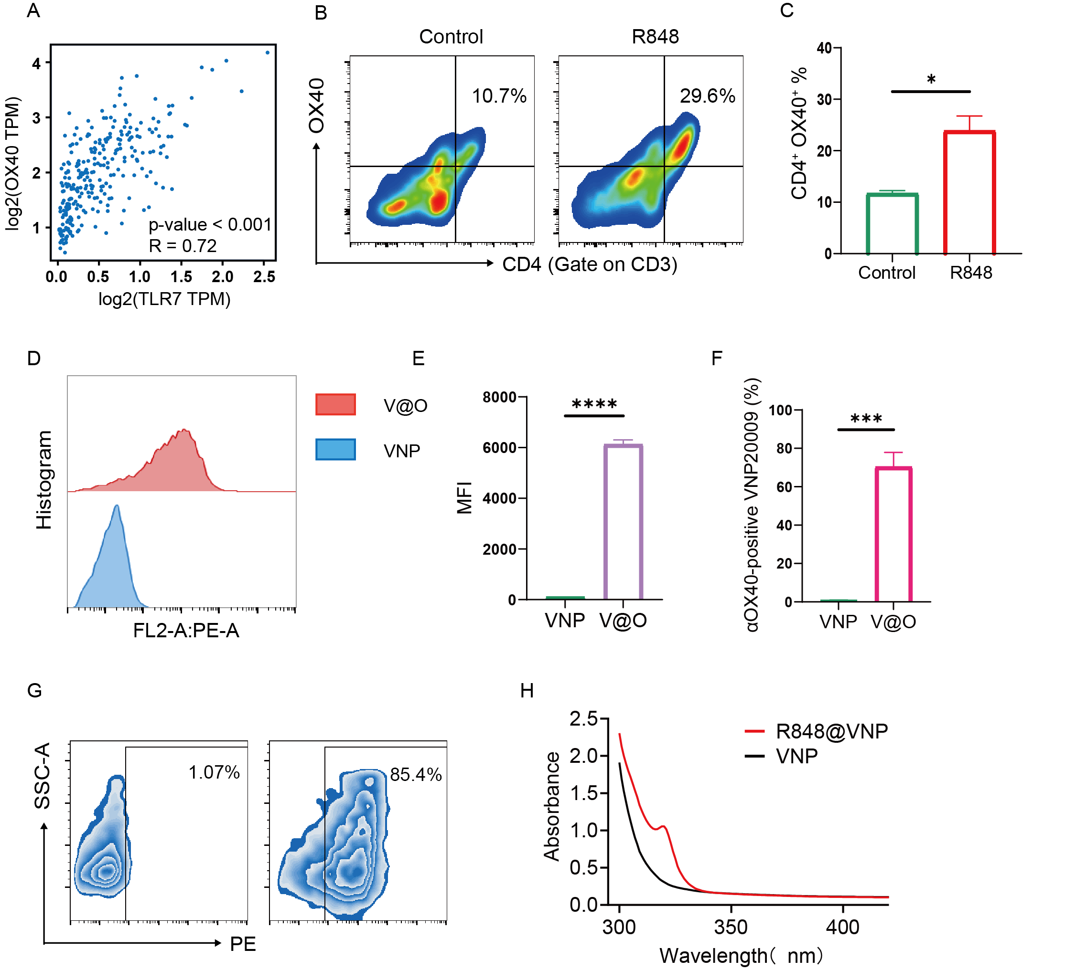

Fig. S2. Resiquimod upregulates OX40 expression and enables the construction of αOX40 and R848 engineered VNP20009. (A) Correlation analysis between TLR7 and OX40 expression in colon adenocarcinoma (COAD) using the GEPIA2 online database. (B) Representative flow cytometry plots showing OX40 expression in tumor-infiltrating CD3⁺CD4⁺ T cells 48 h after intratumoral administration of NS or R848. (C) Quantitative analysis of the percentage of OX40⁺ cells within the CD3⁺CD4⁺ T cell population. (D) Representative flow cytometry histograms showing αOX40 expression on unmodified VNP20009 (VNP) and αOX40-engineered VNP20009 (V@O). (E) Quantitative analysis of the mean fluorescence intensity (MFI) of αOX40 on bacterial surfaces. (F) Quantification of the percentage of αOX40-positive VNP20009 determined by flow cytometry (mean ± SEM, n = 3). (G) Representative flow cytometry plots showing αOX40-positive bacterial populations following surface engineering. (H) UV-Vis absorption spectra of unmodified VNP20009 (VNP) and R848-modified VNP20009 (R848@VNP). The characteristic absorption peak at approximately 320 nm confirms the successful conjugation of R848 onto the bacterial surface. Data are presented as mean ± SEM (n = 3). Statistical significance was analyzed using an unpaired two-tailed Student’s t-test. *p < 0.05, ***p < 0.001, ****p < 0.0001.

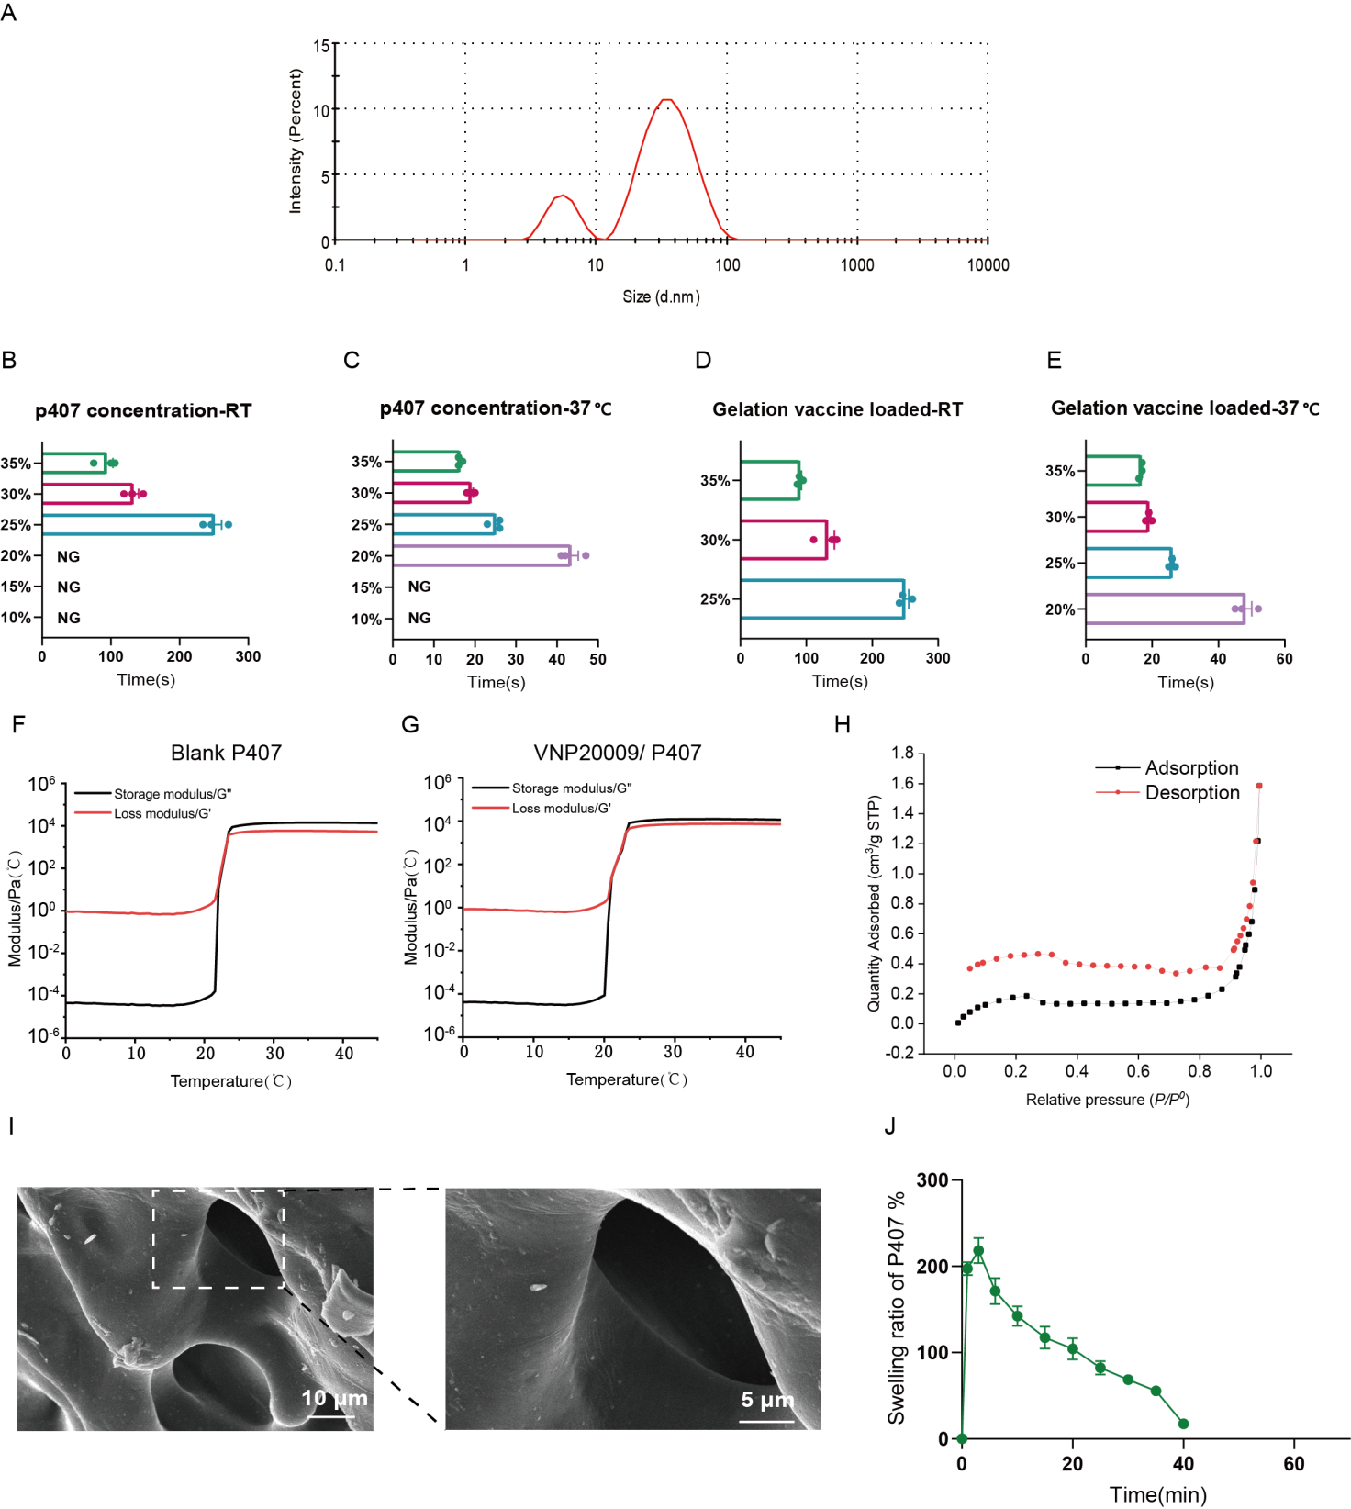

Fig. S3. Preparation and physicochemical characterization of nanovaccine and VNP20009-loaded P407 hydrogel. (A) The representative histogram for the micelle (5 wt%) via dynamic light scattering. (B-E) Time to gelation under different conditions. (B) Blank P407 gel at RT. (C) Blank P407 gel at 37 ℃. (D) V@OR+DP loaded P407 at RT. (E) V@OR+DP loaded P407 at 37 ℃. Temperature-dependent rheological characterization of blank P407 hydrogel (F) and VNP20009/P407 hydrogel (G). Storage modulus (G′) and loss modulus (G″) were measured from 4 ℃ to 45 ℃ to determine the sol-gel transition behavior and lower critical solution temperature (LCST). (H) Nitrogen adsorption–desorption isotherms and pore size distribution of the lyophilized hydrogel. (I) V@OR loaded P407 hydrogel and representative images of V@OR in P407 hydrogel (Manifested by the arrows, the scale bar is 5 μm). (J) Swelling profile of P407 hydrogel in PBS.

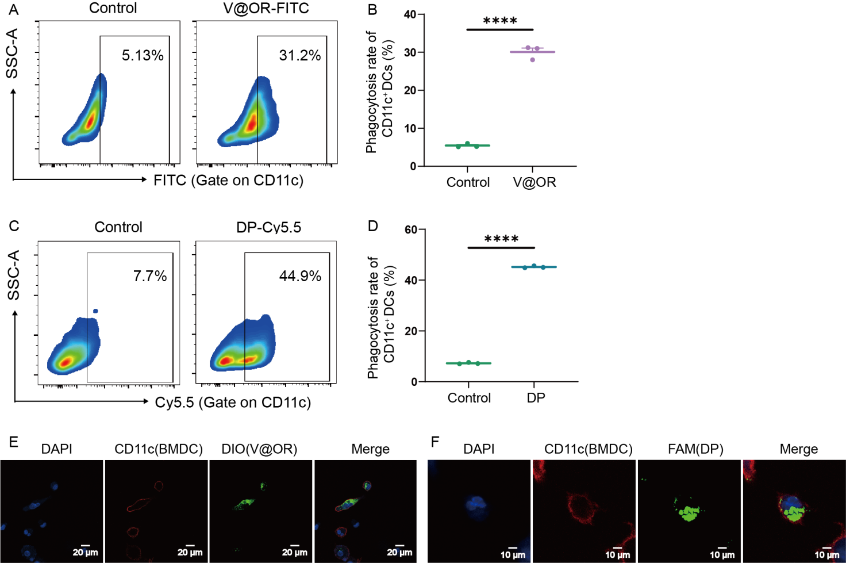

Fig. S4. Uptake of V@OR and DP by bone marrow-derived dendritic cells (BMDCs). (A) Representative flow cytometry plots showing the uptake of FITC-labeled V@OR (V@OR-FITC) by BMDCs. Cells were gated on CD11c⁺ BMDCs, and the percentage of FITC-positive cells is indicated. (B) Quantitative analysis of V@OR uptake efficiency in CD11c⁺ BMDCs. (C) Representative flow cytometry plots showing the uptake of Cy5.5-labeled DP (DP-Cy5.5) by BMDCs. Cells were gated on CD11c⁺ BMDCs, and the percentage of Cy5.5-positive cells is indicated. (D) Quantitative analysis of DP uptake efficiency in CD11c⁺ BMDCs. (E) Representative confocal laser scanning microscopy (CLSM) images showing the internalization of DiO-labeled V@OR (green) by BMDCs stained with anti-CD11c antibody (red). Nuclei were stained with DAPI (blue). Scale bar = 20 μm. (F) Representative CLSM images showing the internalization of FAM-labeled DP (green) by BMDCs stained with anti-CD11c antibody (red). Nuclei were stained with DAPI (blue). Scale bar = 10 μm. Data are presented as mean ± SEM (n = 3). Statistical significance was analyzed using an unpaired two-tailed Student’s t-test. ****p < 0.0001.

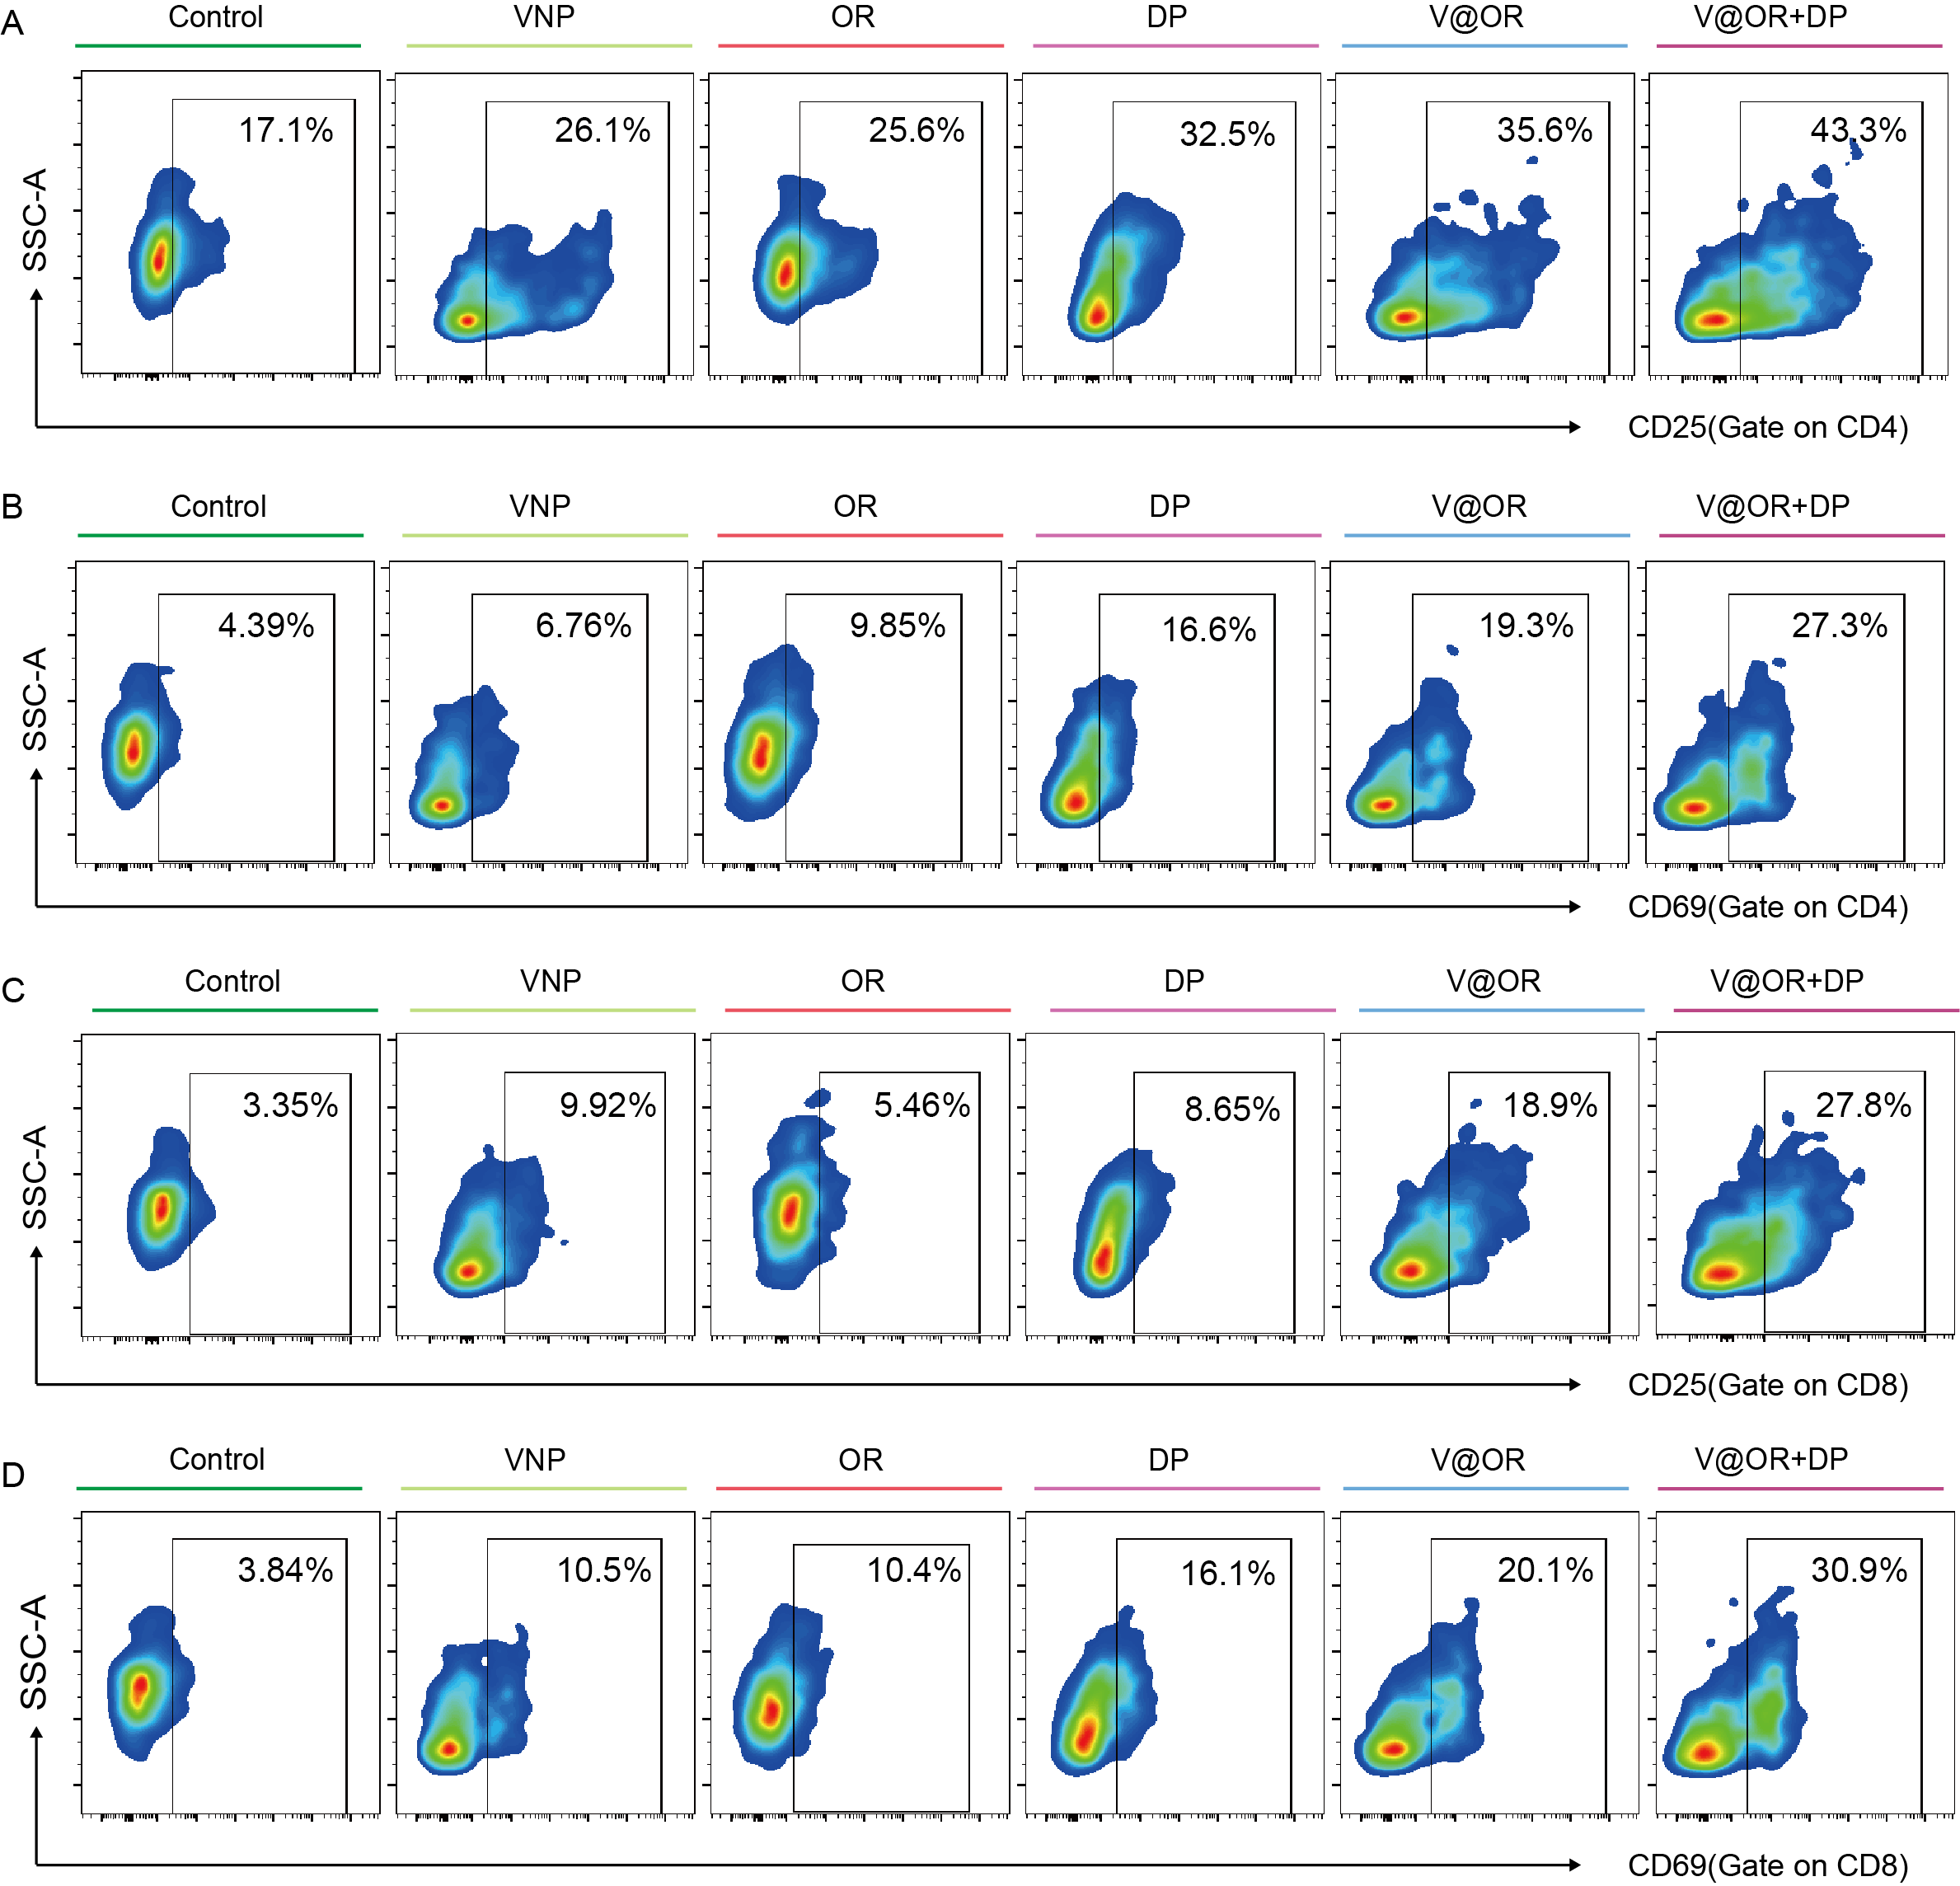
Fig. S5. Representative flow cytometry plots corresponding to the quantitative results shown in Fig. 2E-H. (A) CD25 expression in CD4⁺ T cells. (B) CD69 expression in CD4⁺ T cells. (C) CD25 expression in CD8⁺ T cells. (D) CD69 expression in CD8⁺ T cells. T cells were collected after treatment with VNP, OR, DP, V@OR, or V@OR+DP and analyzed by flow cytometry. Percentages of CD25⁺ or CD69⁺ cells within the CD4⁺ or CD8⁺ T cell populations are indicated in each representative plot.

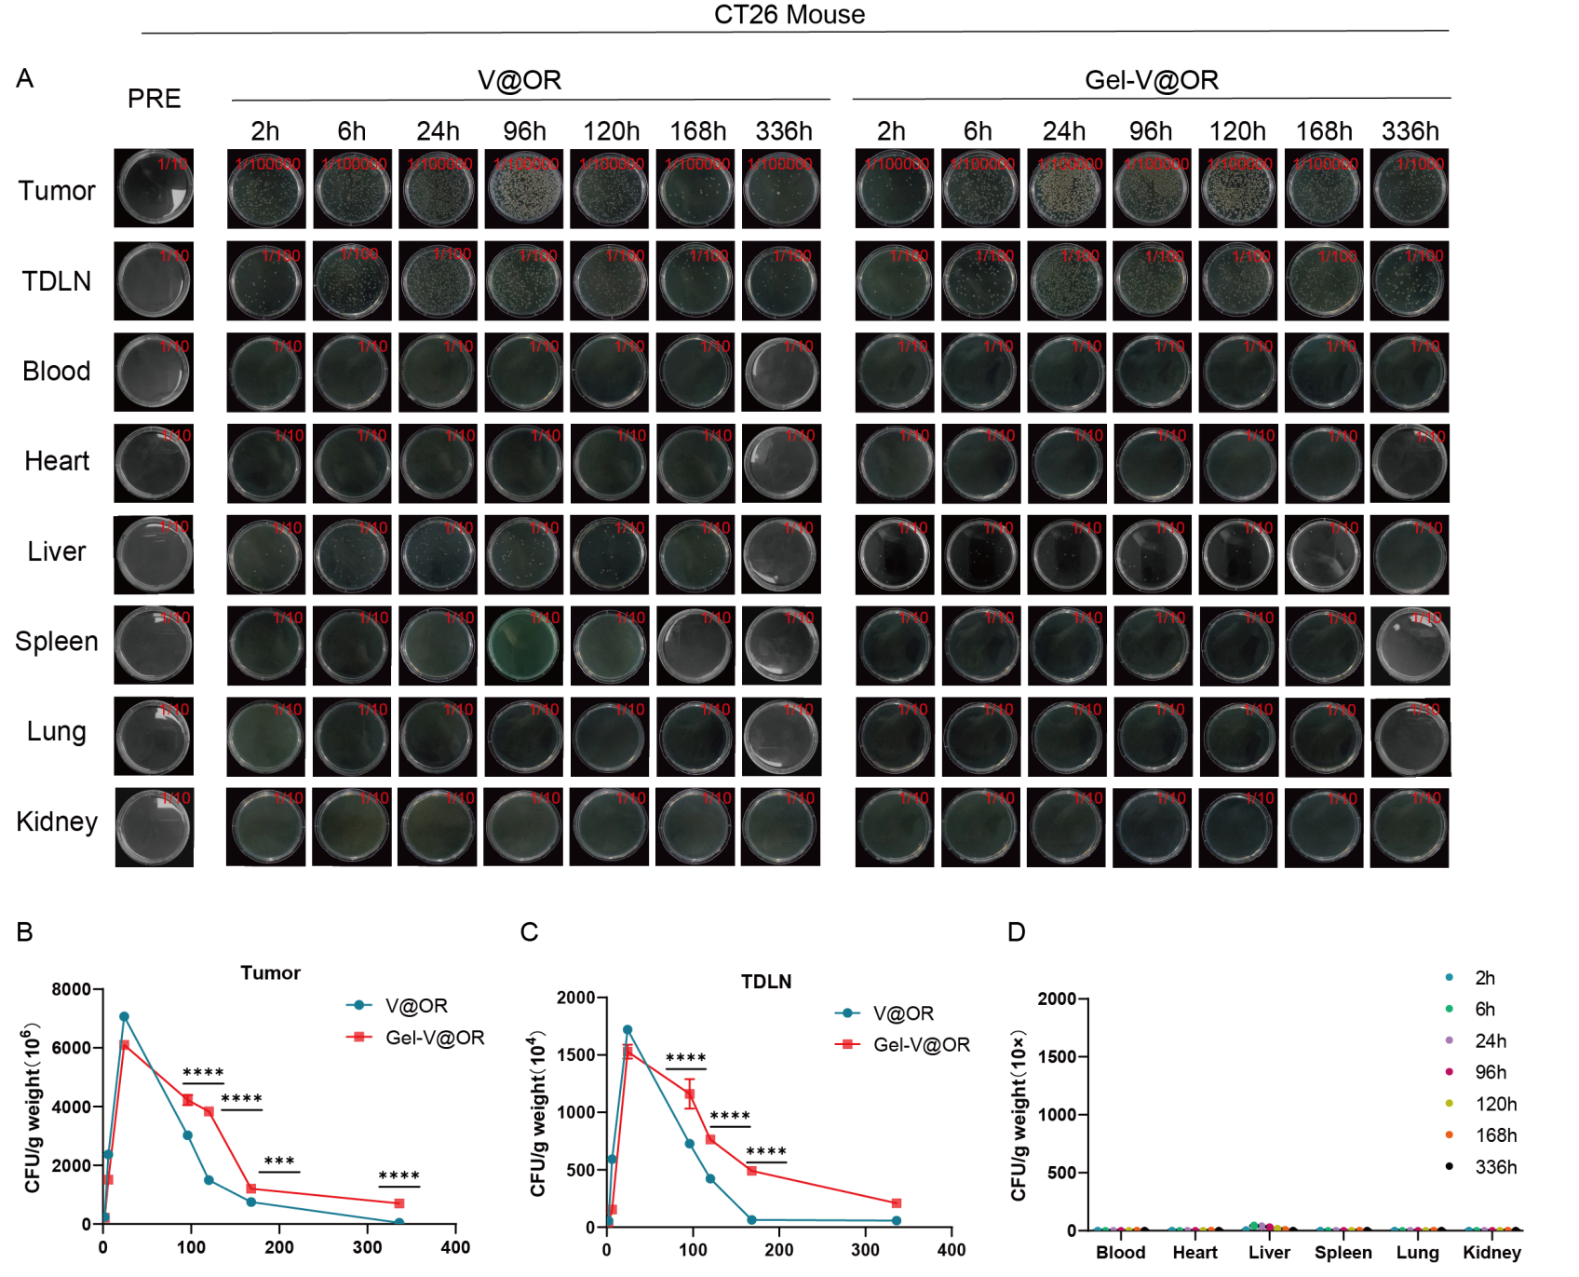
Fig. S6. In vivo biodistribution and clearance kinetics of engineered VNP20009. (A) Representative colony photographs showing the temporal distribution of V@OR and Gel-V@OR in tumors, tumor-draining lymph nodes (TDLNs), blood, and major organs (heart, liver, spleen, lung, and kidney) following intratumoral administration in CT26 tumor-bearing mice. Tissue samples were harvested at the indicated time points, homogenized, serially diluted, and cultured on selective agar plates. (B, C) Quantitative CFU analyses demonstrating bacterial persistence within tumors (B) and TDLNs (C). Encapsulation within the P407 hydrogel prolonged bacterial retention at both sites compared with free V@OR. (D) Quantitative CFU analyses of blood and major organs at different time points, showing minimal systemic dissemination and progressive bacterial clearance over time. Bacteria were largely confined to tumors and TDLNs and were effectively eliminated from peripheral tissues at later time points. Data are presented as mean ± SEM (n = 3 biologically independent mice). Statistical significance was determined using two-way ANOVA with multiple-comparison correction. ***p < 0.001, ****p < 0.0001.

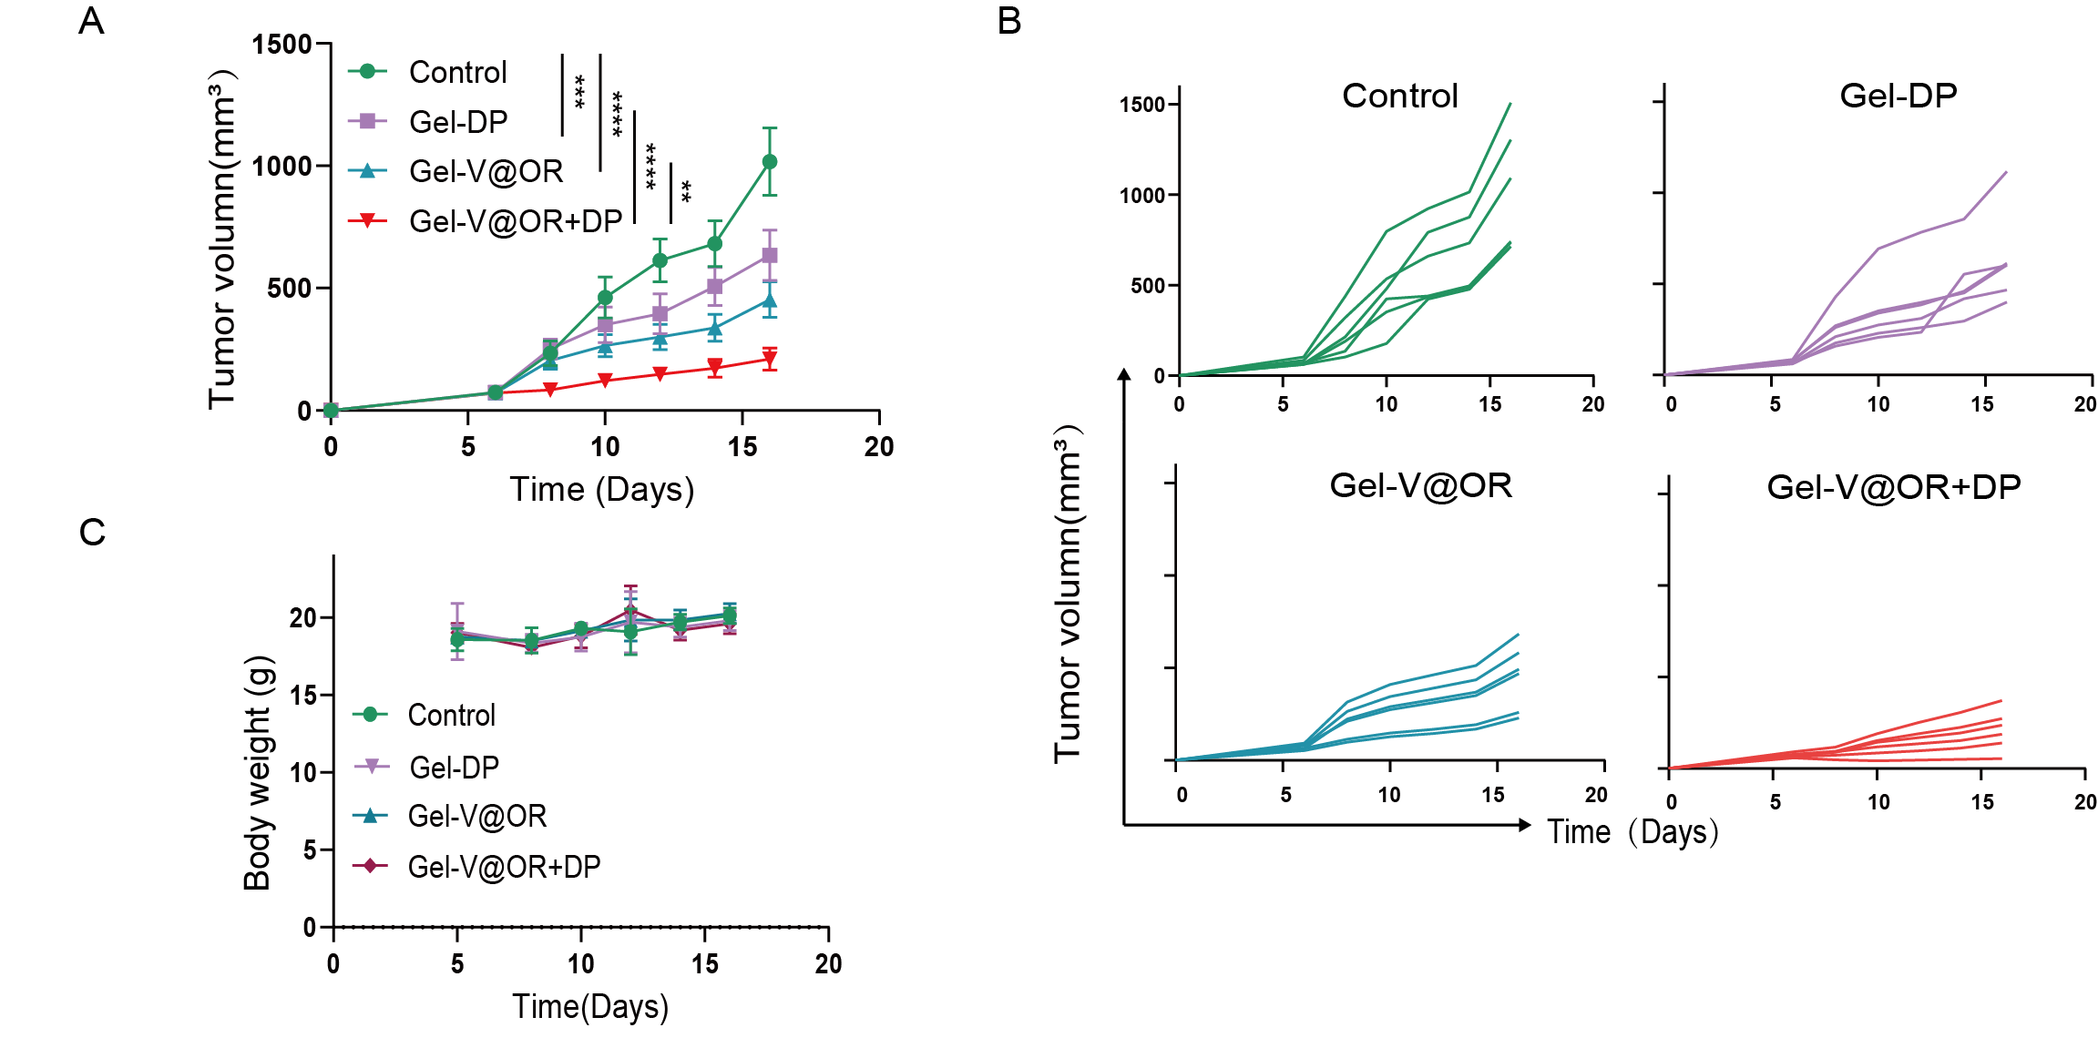
Fig. S7. Biosafety of Gel-V@OR+DP in a subcutaneous B16 tumor model. (A) Tumor growth kinetics in mice receiving different treatments: NS, Gel-V@OR, Gel-DP, and Gel-V@OR+DP. Treatments (100 μL per dose) were administered peritumorally when tumors reached approximately 100 mm³. Data are presented as mean ± SEM (n = 6). Statistical analysis was performed using two-way ANOVA followed by Tukey’s multiple comparisons test. (B) Individual tumor growth curves for each mouse in different treatment groups. (C) Body weight changes during the 16-day treatment period (mean ± SEM).
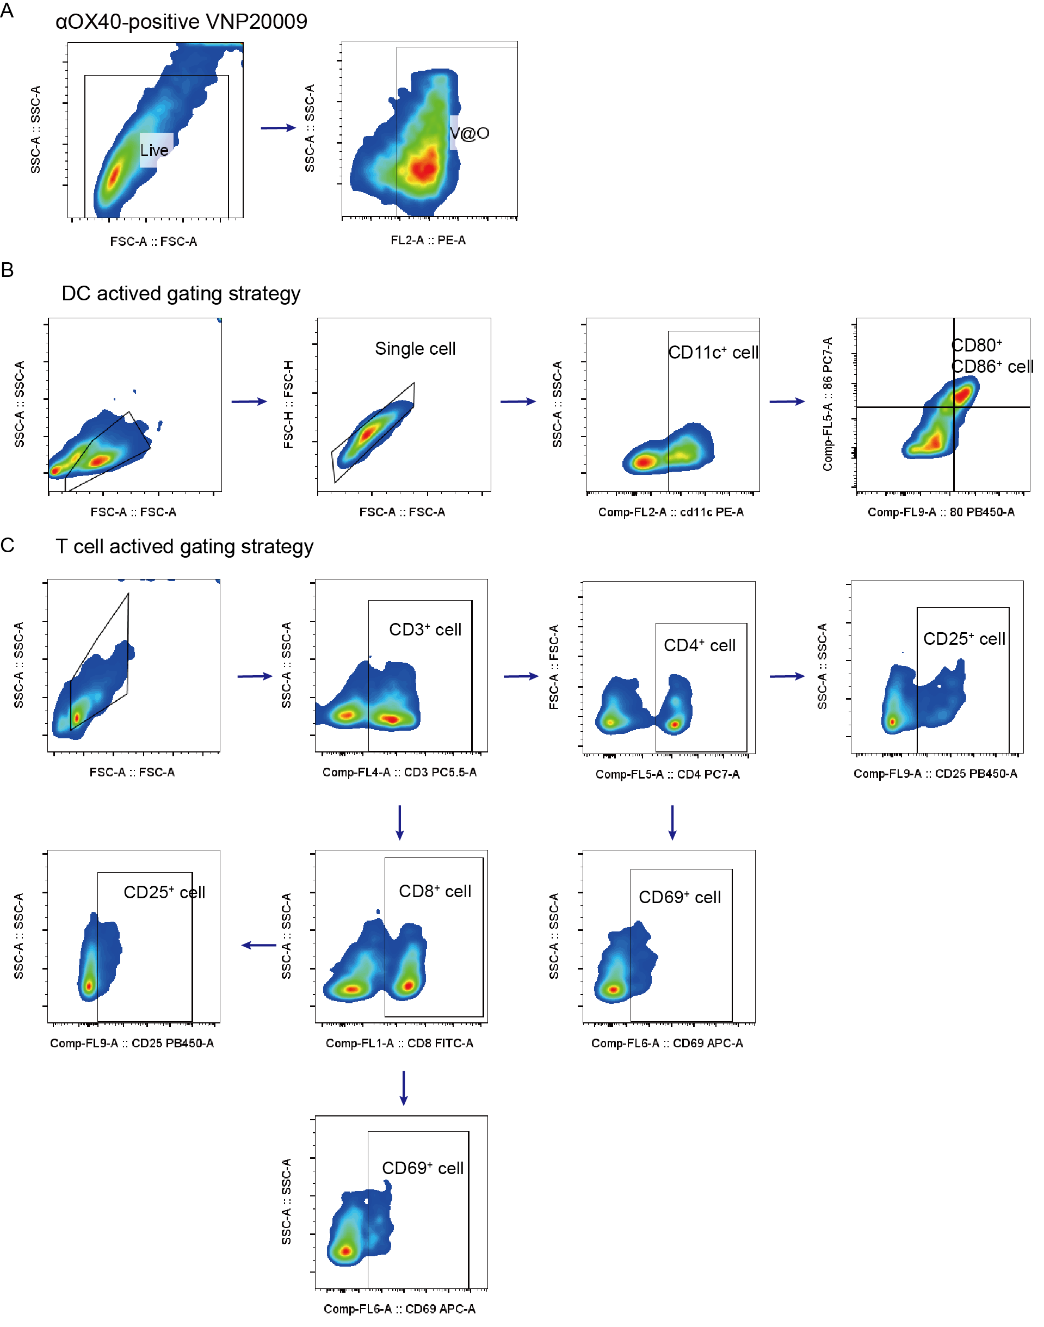
Fig. S8. Representative flow cytometry gating strategies for bacterial characterization, dendritic cell uptake, and T cell activation analyses. (A) Gating strategy used for Fig. S2G. (B) Gating strategy used for Fig. 2A. (C) Gating strategy for Fig. 2E-H.

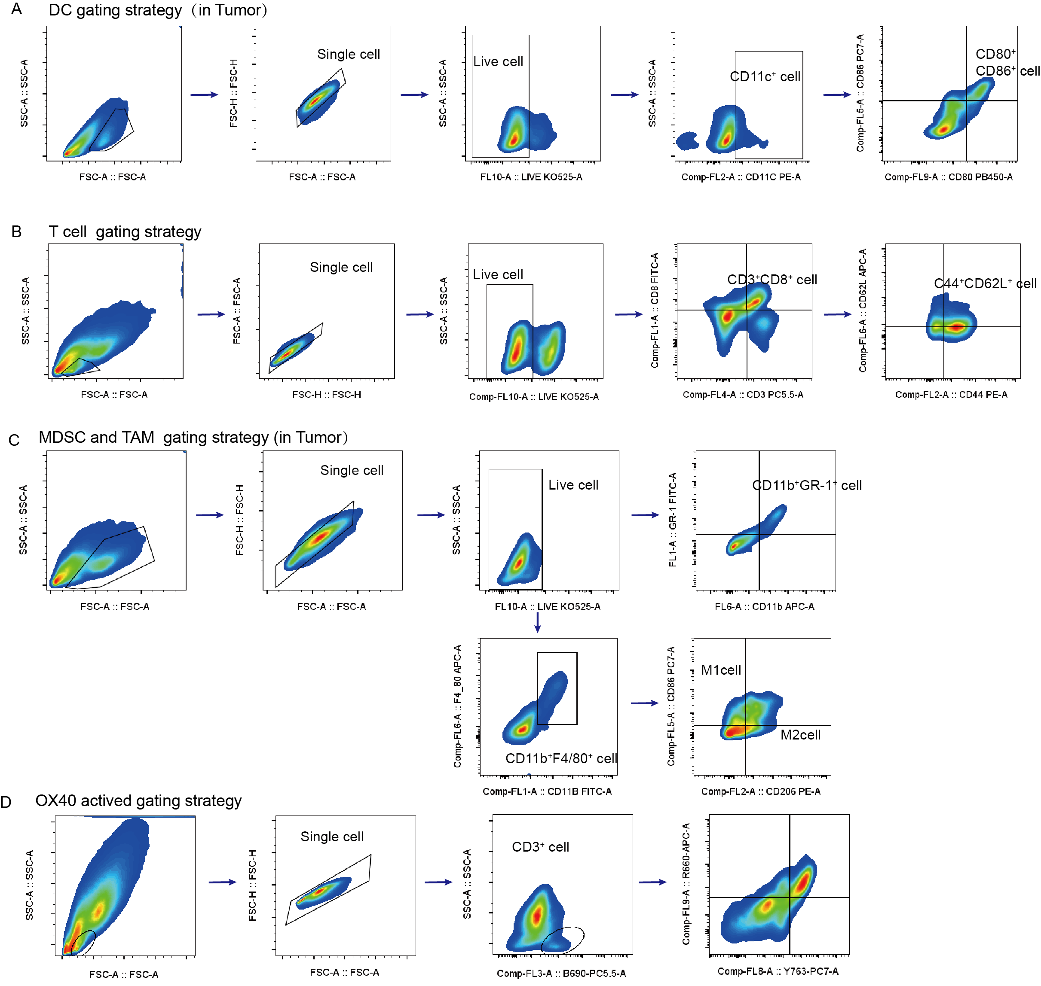
Fig. S9. Representative flow cytometry gating strategies for tumor immune cell infiltration and memory T cell analyses. (A) Gating strategy for Fig. 5A and 7A. (B) Gating strategy used for Fig. 5D, 5F, 7D, 7F and 7I. (C) Gating strategy used for Fig. 5G, 5H, 7G, and 7L. (D) Gating strategy used for Fig. S2B.

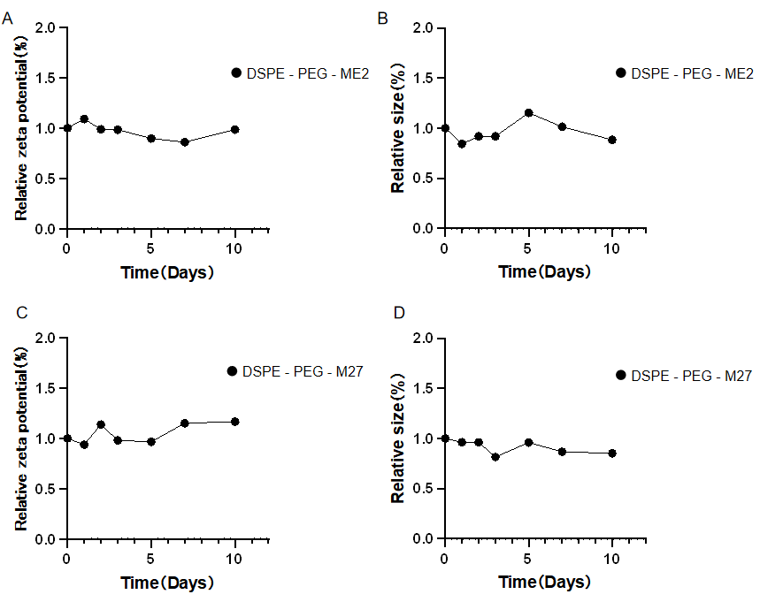
Fig. S10. Stability of DP nanovaccines in PBS. (A, C) Relative changes in zeta potential of DSPE-PEG₂₀₀₀-ME2 (A) and DSPE-PEG₂₀₀₀-M27 (C) nanoparticles during incubation in PBS for 10 days. (B, D) Relative changes in hydrodynamic diameter of DSPE-PEG₂₀₀₀-ME2 (B) and DSPE-PEG₂₀₀₀-M27 (D) nanoparticles during incubation in PBS for 10 days. Values were normalized to the corresponding measurements at day 0.

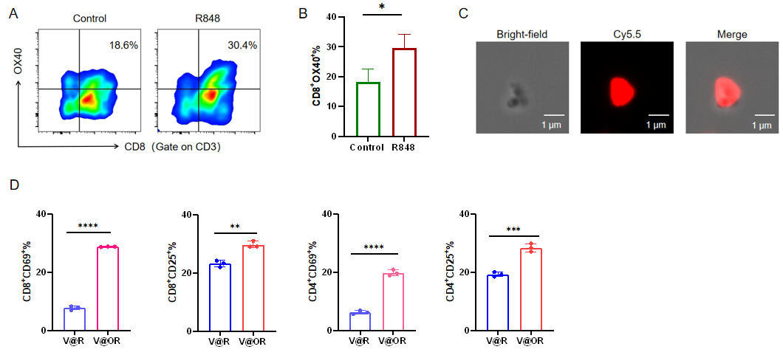
Fig. S11. OX40 upregulation on CD8⁺ T cells, bacterial integrity validation, and functional verification of αOX40 surface modification. (A) Representative flow cytometry plots showing OX40 expression in tumor-infiltrating CD3⁺CD8⁺ T cells 48 h after intratumoral administration of NS or R848. (B) Quantitative analysis of the percentage of OX40⁺ cells within the CD3⁺CD8⁺ T cell population. (C) Representative immunofluorescence image of V@O (Cy5.5-labeled αOX40). Scale bar = 1 μm. (D) Quantitative analysis of CD25⁺ and CD69⁺ proportions in CD4⁺ and CD8⁺ T cells following co-culture with V@R (R848-loaded VNP20009 without αOX40 conjugation) or V@OR (VNP20009 co-modified with R848 and αOX40).Data are presented as mean ± SEM (n = 3). Statistical significance was analyzed using an unpaired two-tailed Student’s t-test. *p < 0.05, **p < 0.01.

Catalog numbers for all antibodies used in this study The catalog numbers, clones, and sources of all antibodies are listed as follows:
Antibodies were purchased from BD Biosciences or BioLegend and diluted in 1:100 :
Antibody name | Catalog Number | Company
Anti-mouse CD11c (PE) | 557401 | BD Biosciences
Anti-mouse CD80 (BV421) | 562611 | BD Biosciences
Anti-mouse CD86 (PE-Cy7) | 560582 | BD Biosciences
Anti-mouse CD3e (PerCP-Cy5.5) | 551163 | BD Biosciences
Anti-mouse CD8a (FITC) | 553030 | BD Biosciences
Anti-mouse CD4 (PE/Cyanine7) | 100422 | BioLegend
Anti-mouse CD25 (BV421) | 562606 | BD Biosciences
Anti-mouse CD69 (APC) | 560689 | BD Biosciences
Anti-mouse CD44 (PE) | 553134 | BD Biosciences
Anti-mouse CD62L (APC) | 553152 | BD Biosciences
Anti-mouse F4/80 (APC) | 566787 | BD Biosciences
Anti-mouse CD206 (PE) | 568273 | BD Biosciences
Anti-mouse CD11b (FITC) | 553310 | BD Biosciences
Anti-mouse CD11b (APC) | 561690 | BD Biosciences
Anti-mouse Gr-1 (FITC) | 108406 | BioLegend

Table S4. The catalog numbers and sources of all antibodies

