Supporting Information

Ultrasound-activated hollow FeOOH/MnO₂ nanocatalysts for tumor barrier disruption and synergistic sonodynamic-ferroptosis therapy

Fangying Yu,^{a,1} Yihe Qiu,^{b,1} Shanshan Xiang,^{b} Shuaifei Wang,^{c} Jianping Zhu,^{c} Haiya Lou,ª Fan Xia,^{c,*} Shiyan Li^{a,*}

ª Department of Ultrasound in Medicine, Sir Run Run Shaw Hospital, School of Medicine, Zhejiang University, Hangzhou, 310016, China
^{b} College of Pharmaceutical Sciences, Zhejiang University, Hangzhou, 310058, China
^{c} Department of Pharmacy, Sir Run Run Shaw Hospital, School of Medicine, Zhejiang University, Hangzhou, 310016, China

* Corresponding Authors:
Fan Xia: fanxia@zju.edu.cn
Shiyan Li: lishiyan@zju.edu.cn

¹ These authors contributed equally to this work.

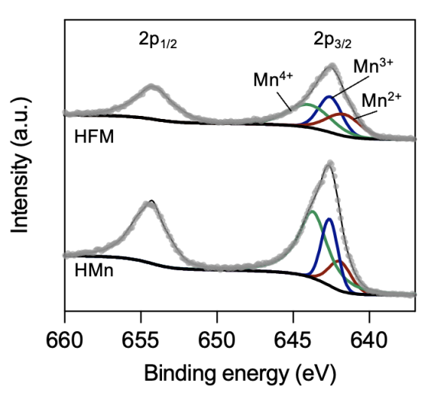
Figure S1. High-resolution Mn 2p XPS spectra of HFM and HMn.

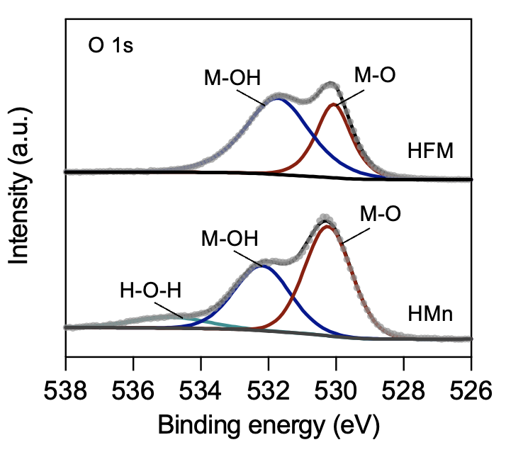
Figure S2. High-resolution O 1s XPS spectra of HFM and HMn.

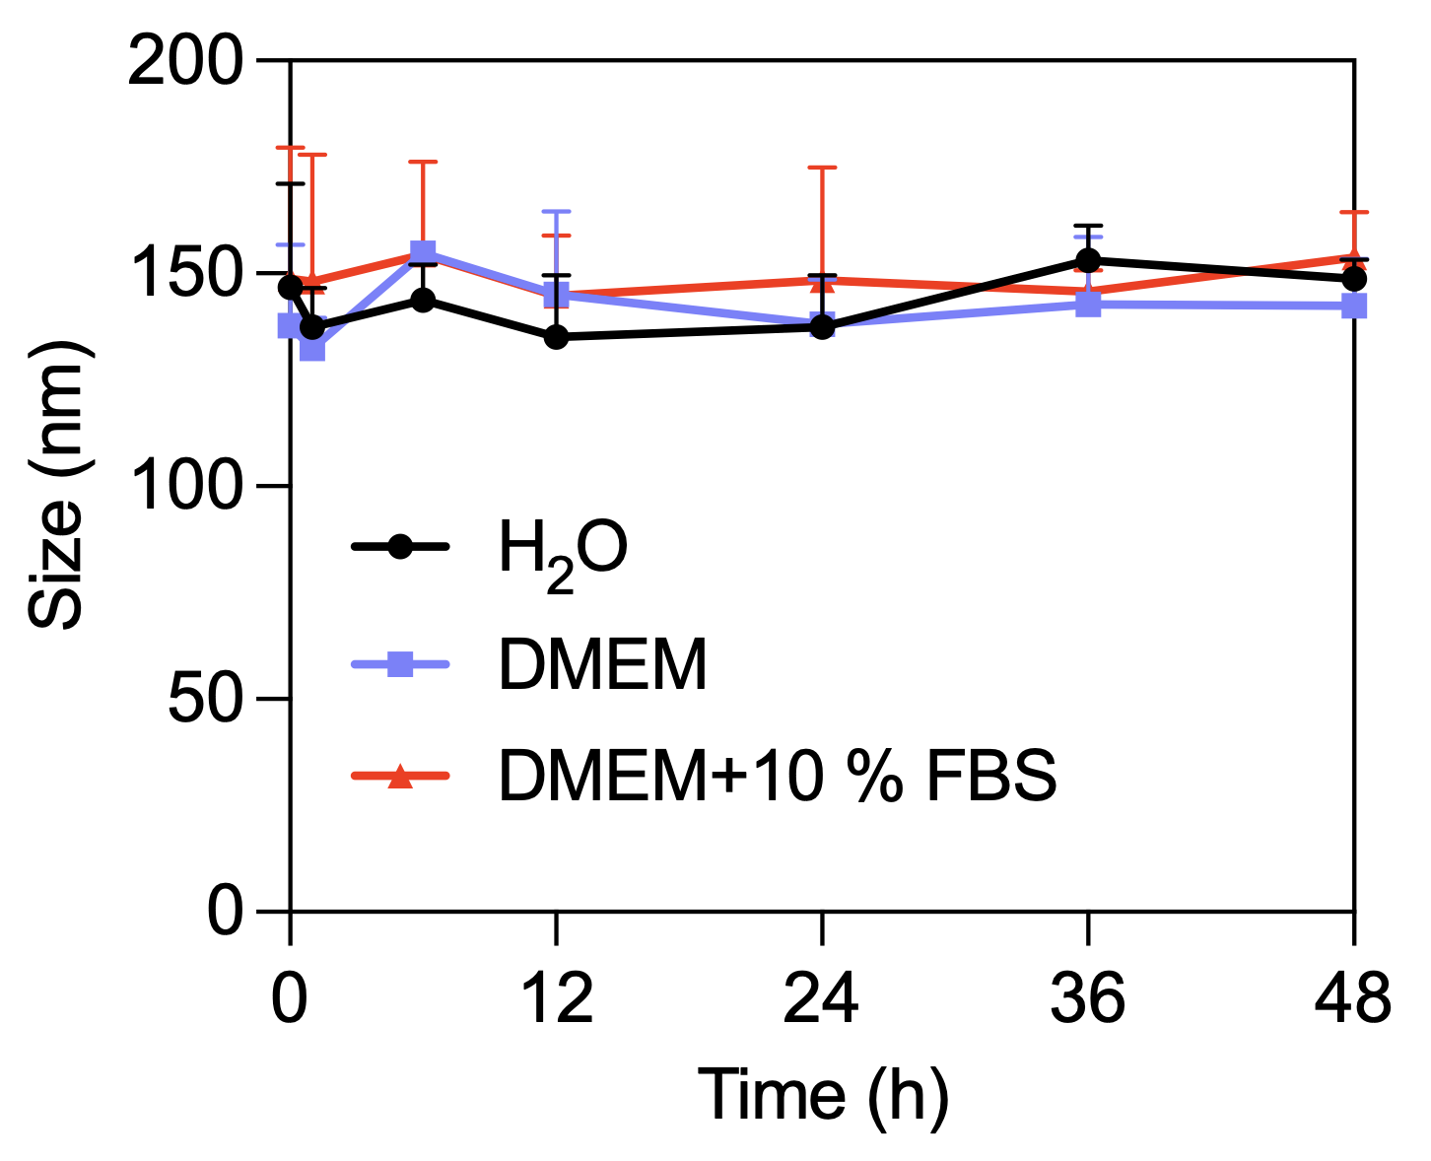
Figure S3. Hydrodynamic diameters of HFM at different time points after incubation in distilled water, DMEM, and DMEM containing 10% FBS (Data are presented as means ± SD, n = 3).

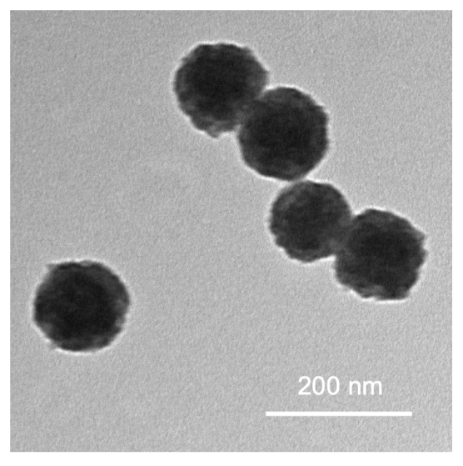
Figure S4. TEM image of SFM.

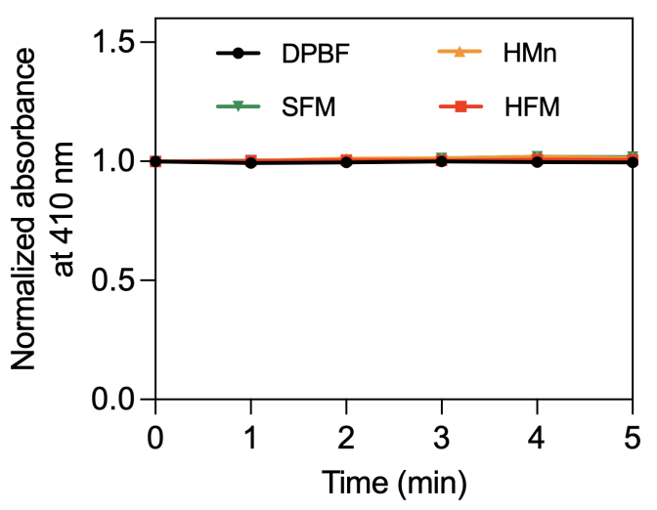
Figure S5. Normalized absorption changes at 410 nm of DPBF in the presence of HMn, SFM, and HFM.

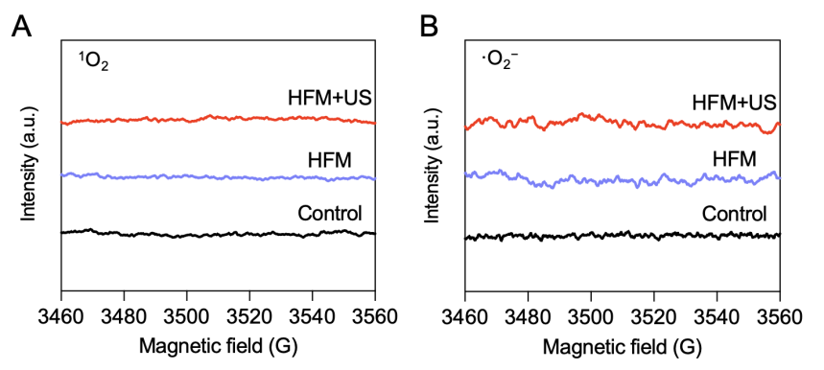
Figure S6. ESR spectra of the mixture of (A) TEMP and (B) BMPO under different conditions after US stimulation (1 MHz, 1.5 W/cm², 50% duty cycle, 3 min).

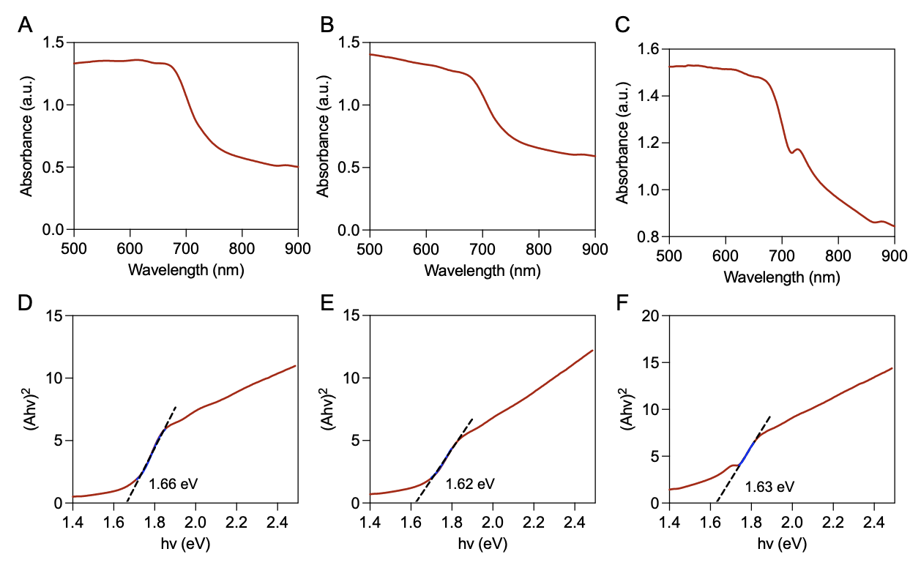
Figure S7. UV-vis diffuse reflectance spectra of (A) HMn, (B) SFM, and (C) HFM. Calculated band gap patterns based on UV-vis diffuse reflectance spectra of (D) HMn, (E) SFM, and (F) HFM.

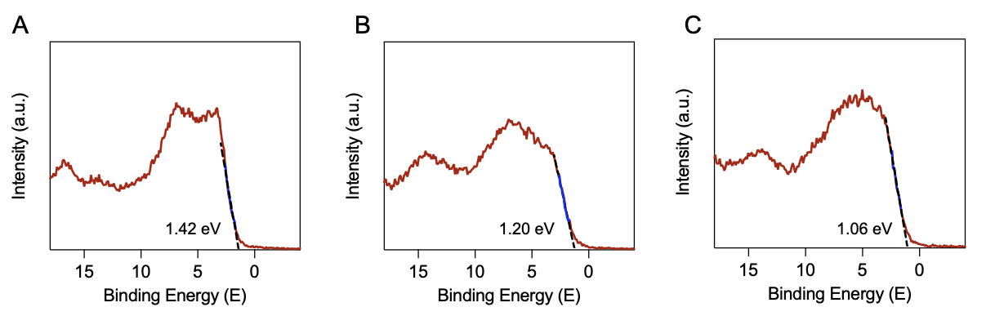
Figure S8. XPS valence band spectra of (A) HMn, (B) SFM, and (C) HFM.

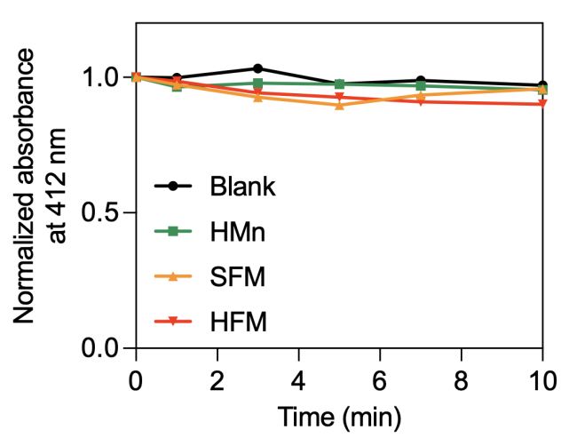
Figure S9. Normalized absorption changes at 412 nm of DTNB and GSH in the presence of HMn, SFM, and HFM.

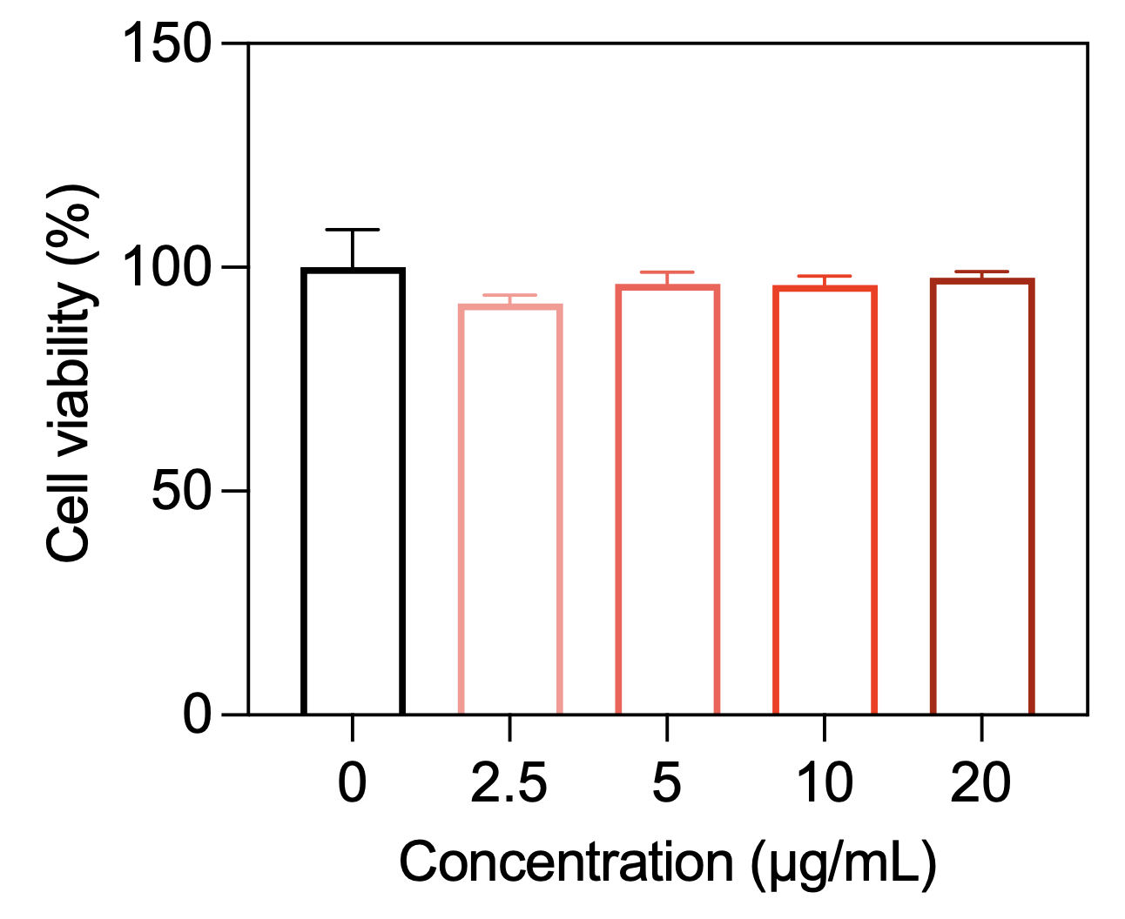
Figure S10. Cell viabilities of 4T1 tumor cells after treated with HMn (Data are presented as means ± SD, n = 4).
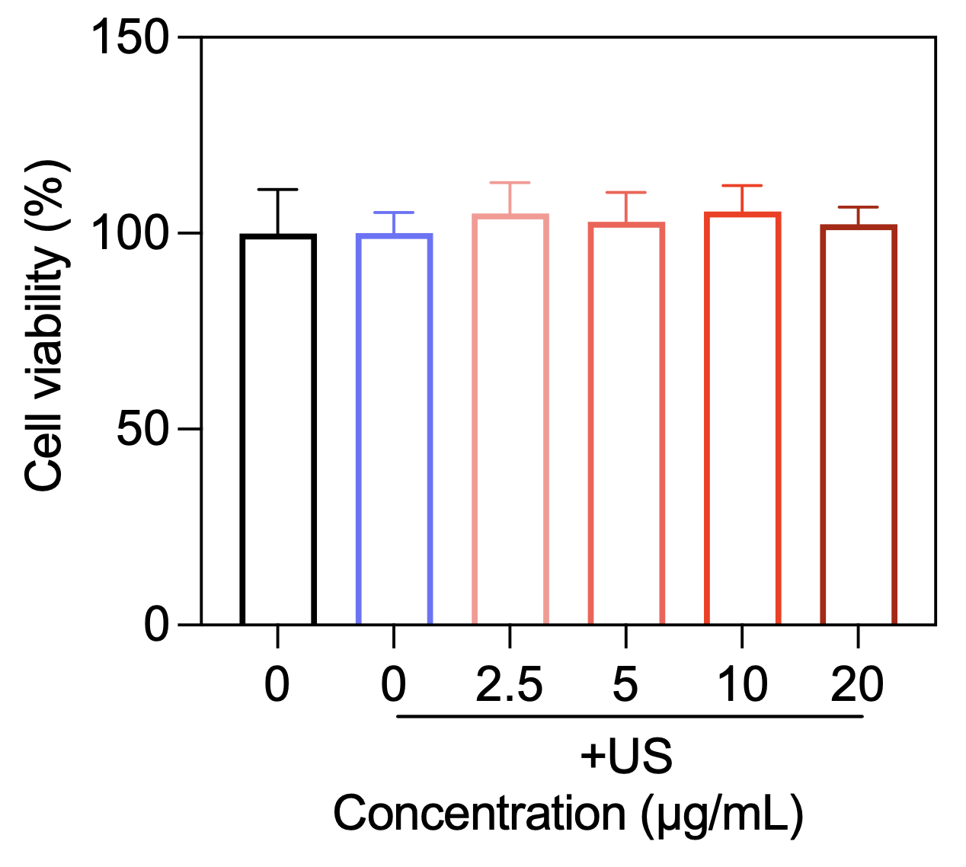
Figure S11. Cell viabilities of 4T1 tumor cells after treated with SFM + US (Data are presented as means ± SD, n = 4).

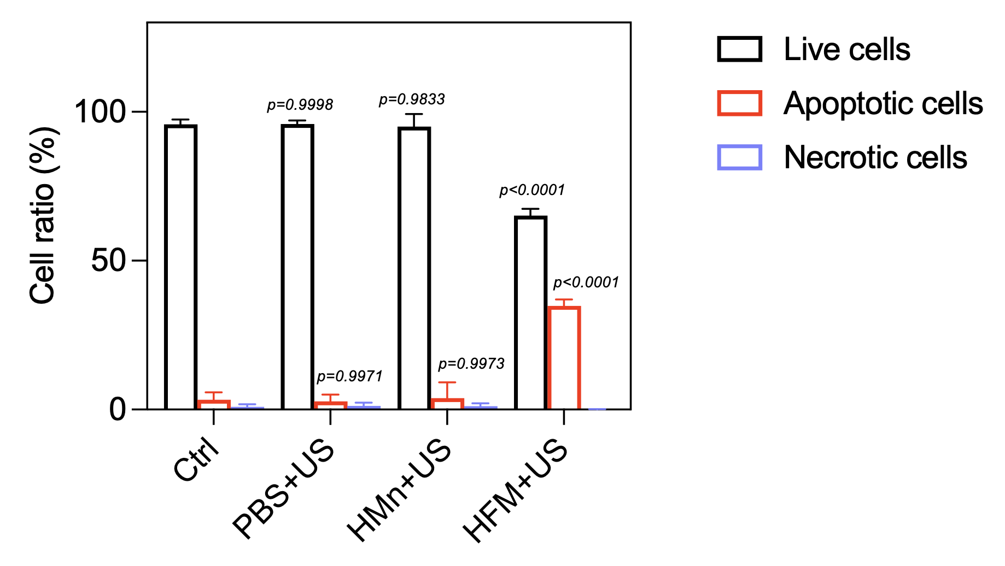
Figure S12. Quantitative analysis of the ratio of live, apoptotic, and necrotic 4T1 tumor cells after different treatments (Data are presented as means ± SD, n = 3).

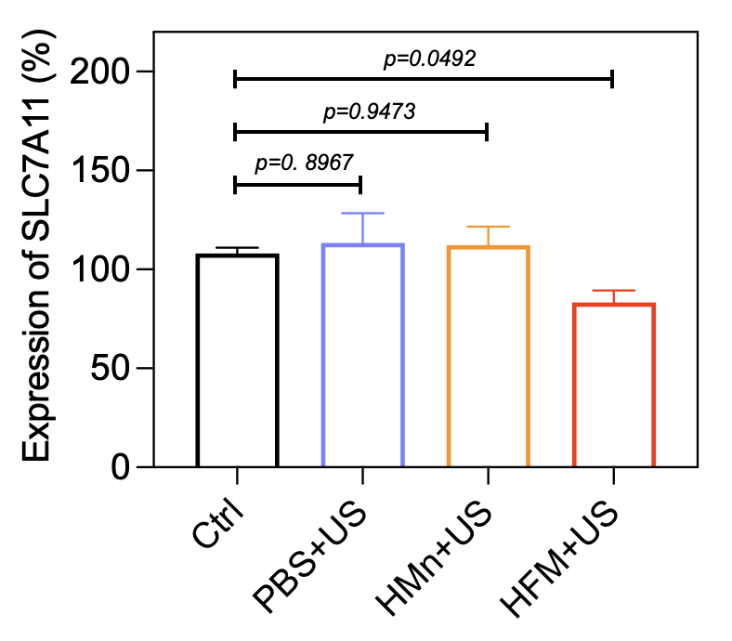
Figure S13. SLC7A11 mRNA levels in 4T1 tumor cells after different treatments measured by real-time PCR (Data are presented as means ± SD, n = 3).

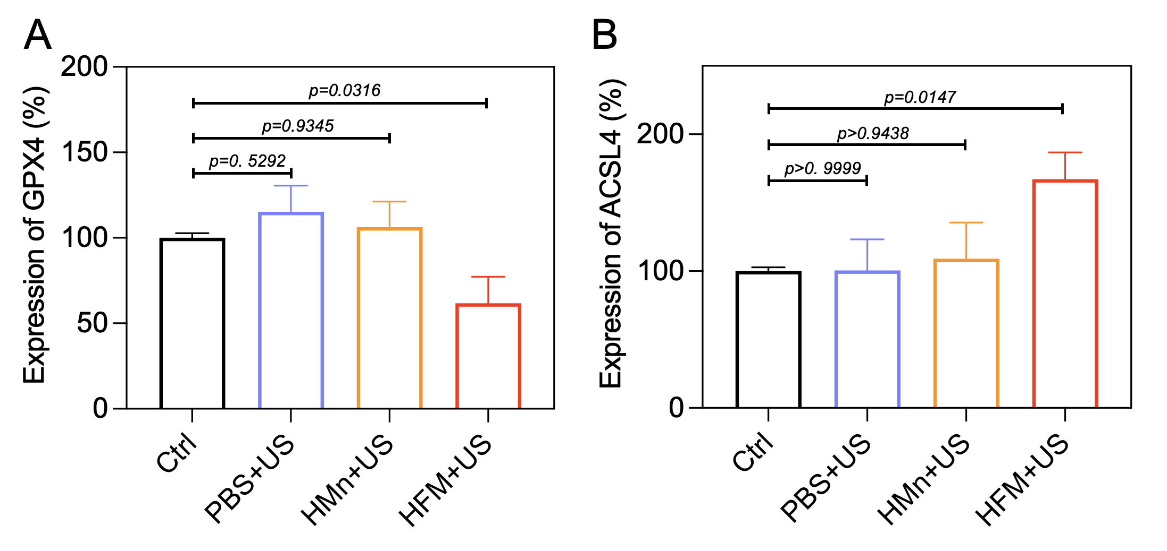
Figure S14. Quantitative densitometric analysis of (A) GPX4 and (B) ACSL4 protein expression levels corresponding to the Western blot in Figure 3J (Data are presented as means ± SD, n = 3).

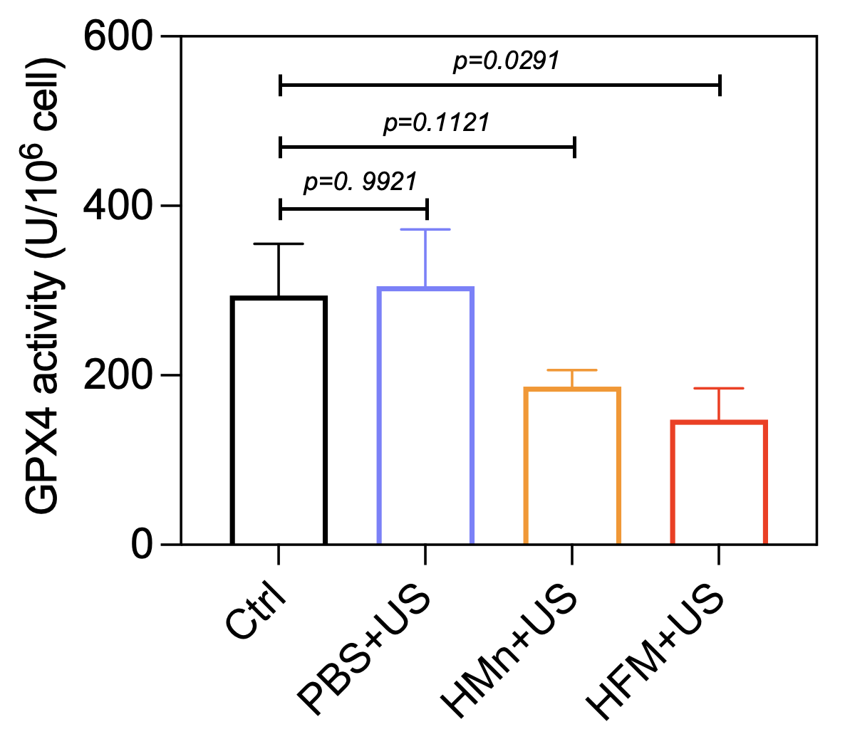
Figure S15. Cellular GPX4 enzymatic activity in 4T1 tumor cells after different treatments (Data are presented as means ± SD, n = 3).

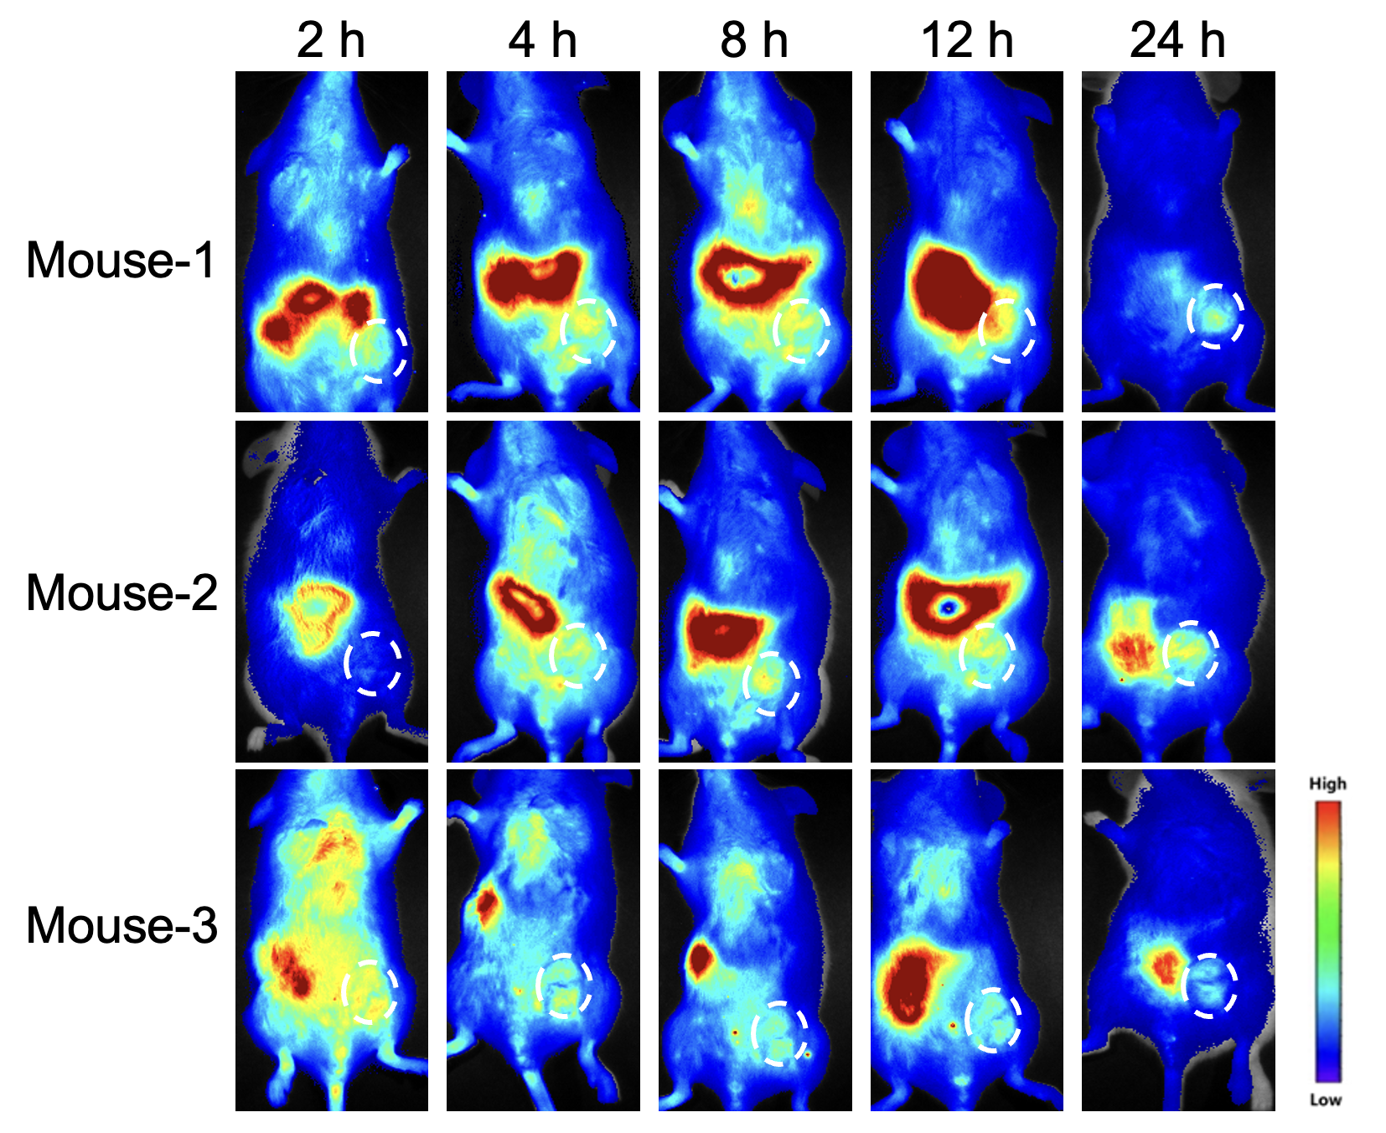
Figure S16. Fluorescence signal of HFM in 4T1 tumor-bearing mice at different time points after intravenously injection.

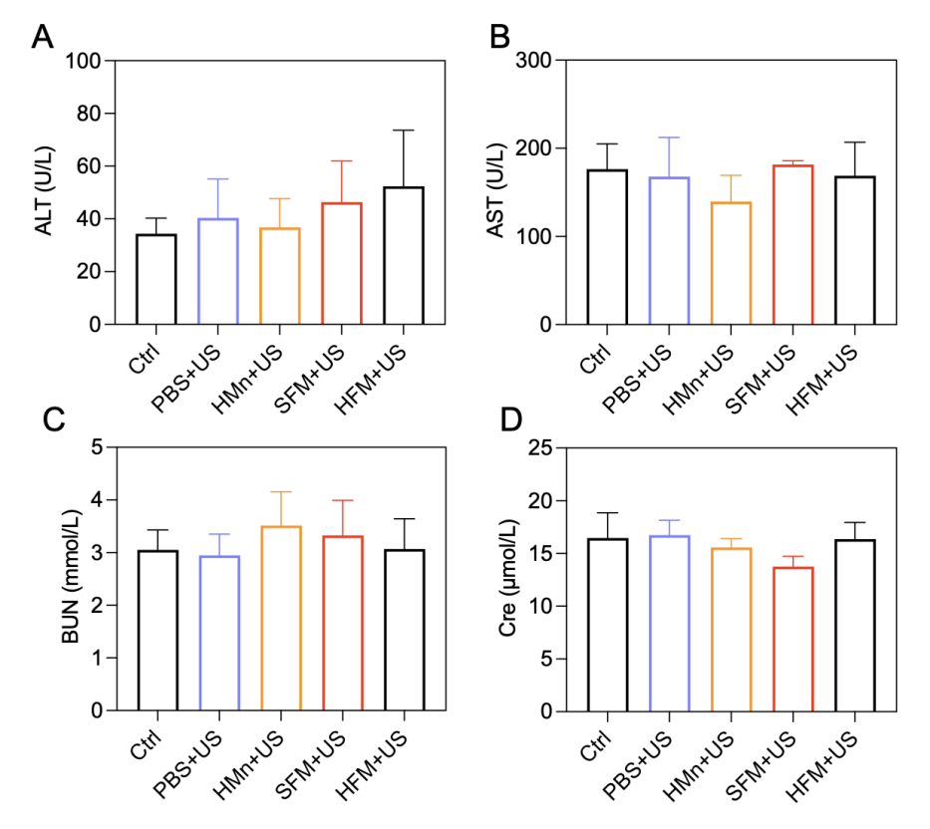
Figure S17. Serum (A) ALT, (B) AST, (C) BUN, and (D) Cre levels of 4T1 tumor-bearing mice after different treatments (Data are presented as means ± SD, n = 5).

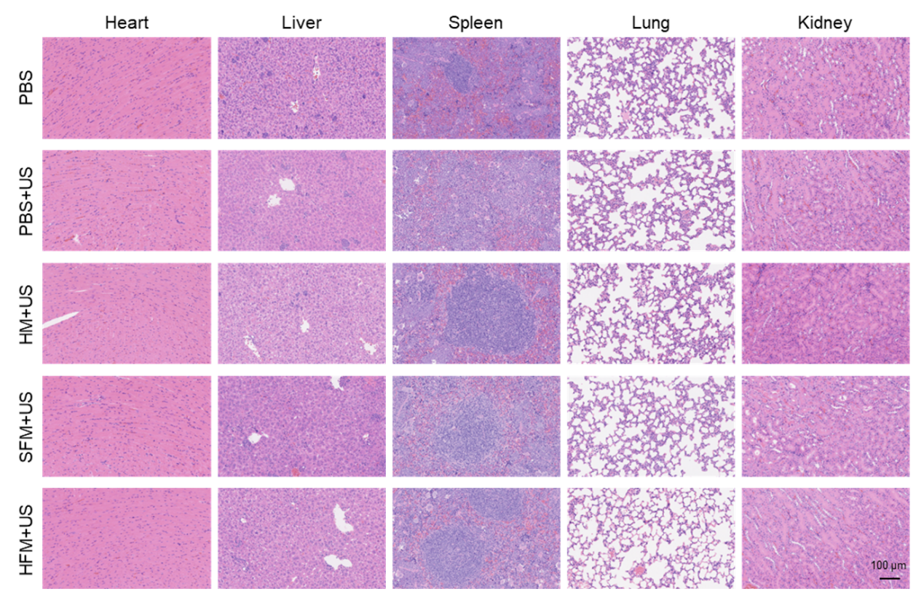
Figure S18. H&E staining of major organs (heart, liver, spleen, lung, and kidney) from 4T1 tumor-bearing mice after different treatments.

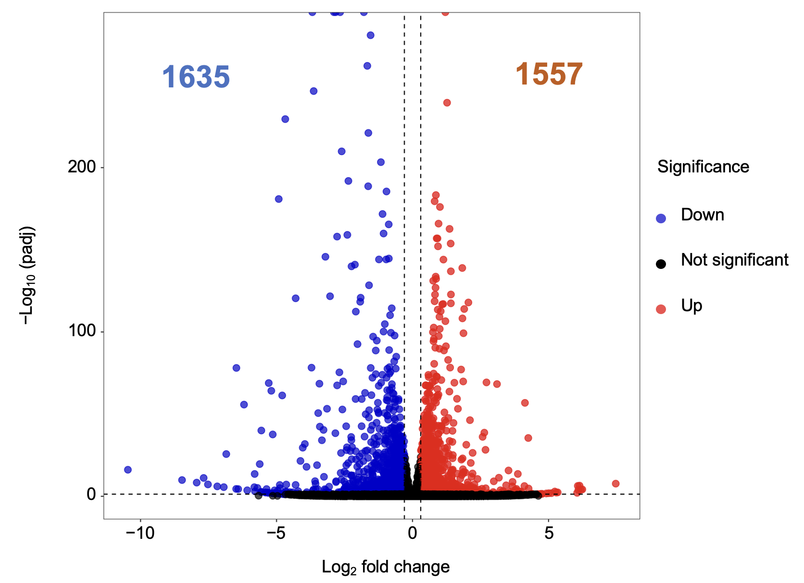
Figure S19. Volcano plot showing 3192 differentially expressed genes in isolated 4T1 tumors from PBS+US and HFM+US groups (|log₂ (fold change) | ≥ 0.3, p < 0.05).

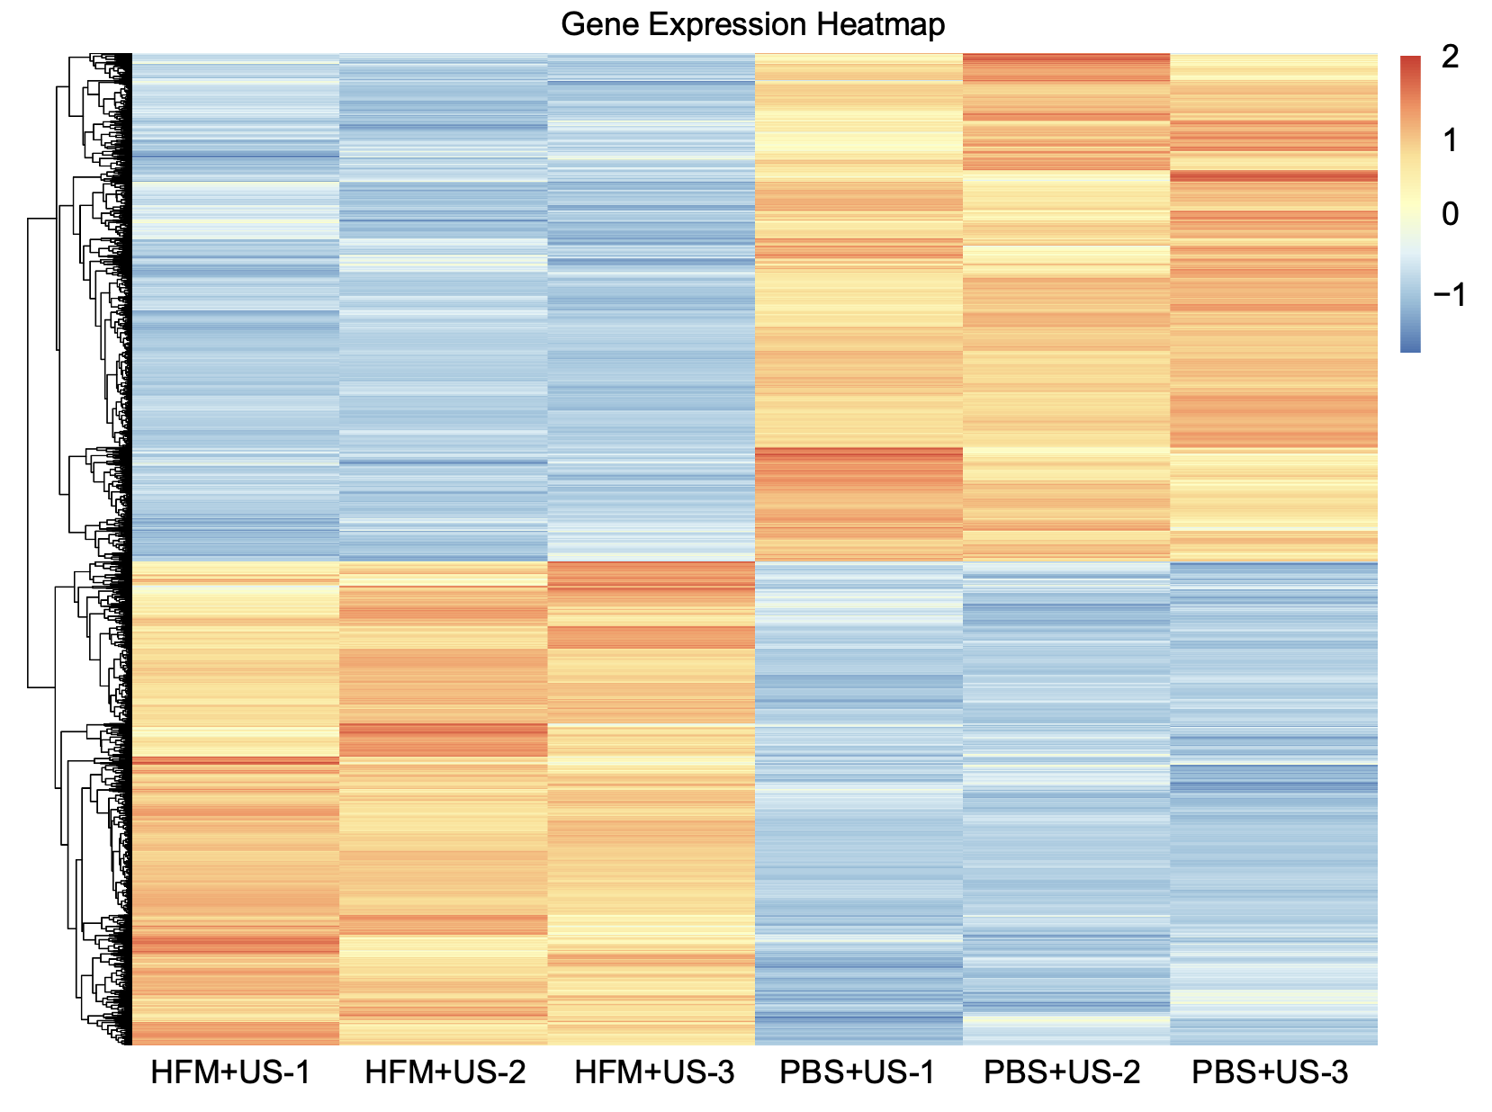
Figure S20. Gene expression heatmap of differentially expressed genes in isolated 4T1 tumors from different groups.

Table S1. The gene-specific primers sequences for qPCR.
Primer name | Forward sequences | Reverse sequences
GAPDH | GGTGAAGGTCGGTGTGAACG | CTCGCTCCTGGAAGATGGTG
GPX4 | ACAAGAACGGCTGCGTGGTGAA | GCCACACACTTGTGGAGCTAGA
ACSL4 | GCTATCTCCTCAGACACACCGA | AGGTGCTCCAACTCTGCCAGTA
SLC7A11 | TCCTGCTTTGGCTCCATGAACG | AGAGGAGTGTGCTTGCGGACAT

