Supplementary data
Supplementary Figure 1. Validation of miRNA mimic transfection efficiency in BoMac cells. (A) Transfection of Cy3-labeled bta-miR-149-5p mimic (22 pmol) for 24 h, with transfection efficiency confirmed by qRT-PCR (normalized to U6) and fluorescence microscopy. (B) Validation of bta-miR-1307 mimic (22 pmol, 24 h) transfection by qRT-PCR (normalized to U6). Data are presented as mean ± SEM from three independent experiments. Statistical significance was determined using a two-tailed Student’s t-test (A, B). *** p < 0.001 compared with the indicated control group. ns, not significant.
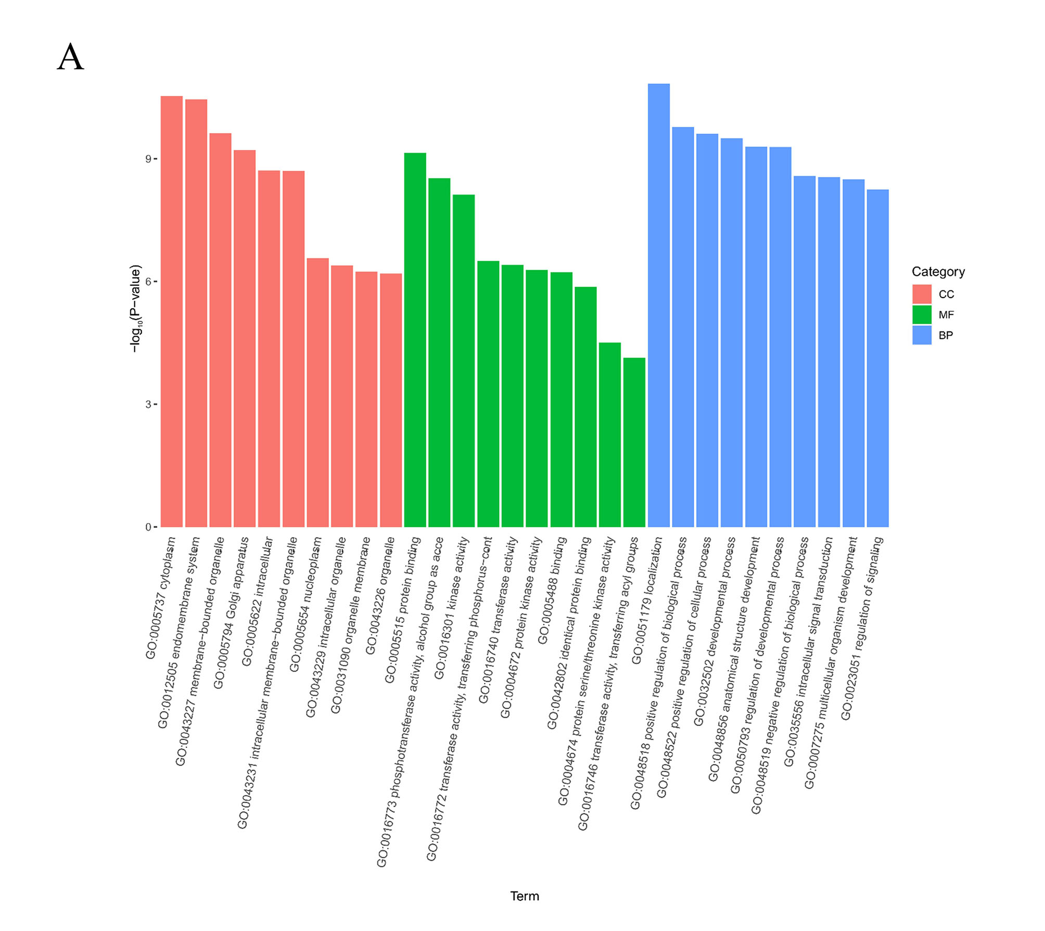
Supplementary Figure 2. Bioinformatic analyses of bta-miR-149-5p target pathways. (A) GO enrichment analysis of predicted bta-miR-149-5p target genes.
Supplementary Figure 3. Screening of the optimal p38-MAPK-targeting siRNA. (A) Western blot analysis of p38-MAPK protein expression after transfection with three siRNAs (10 nM).
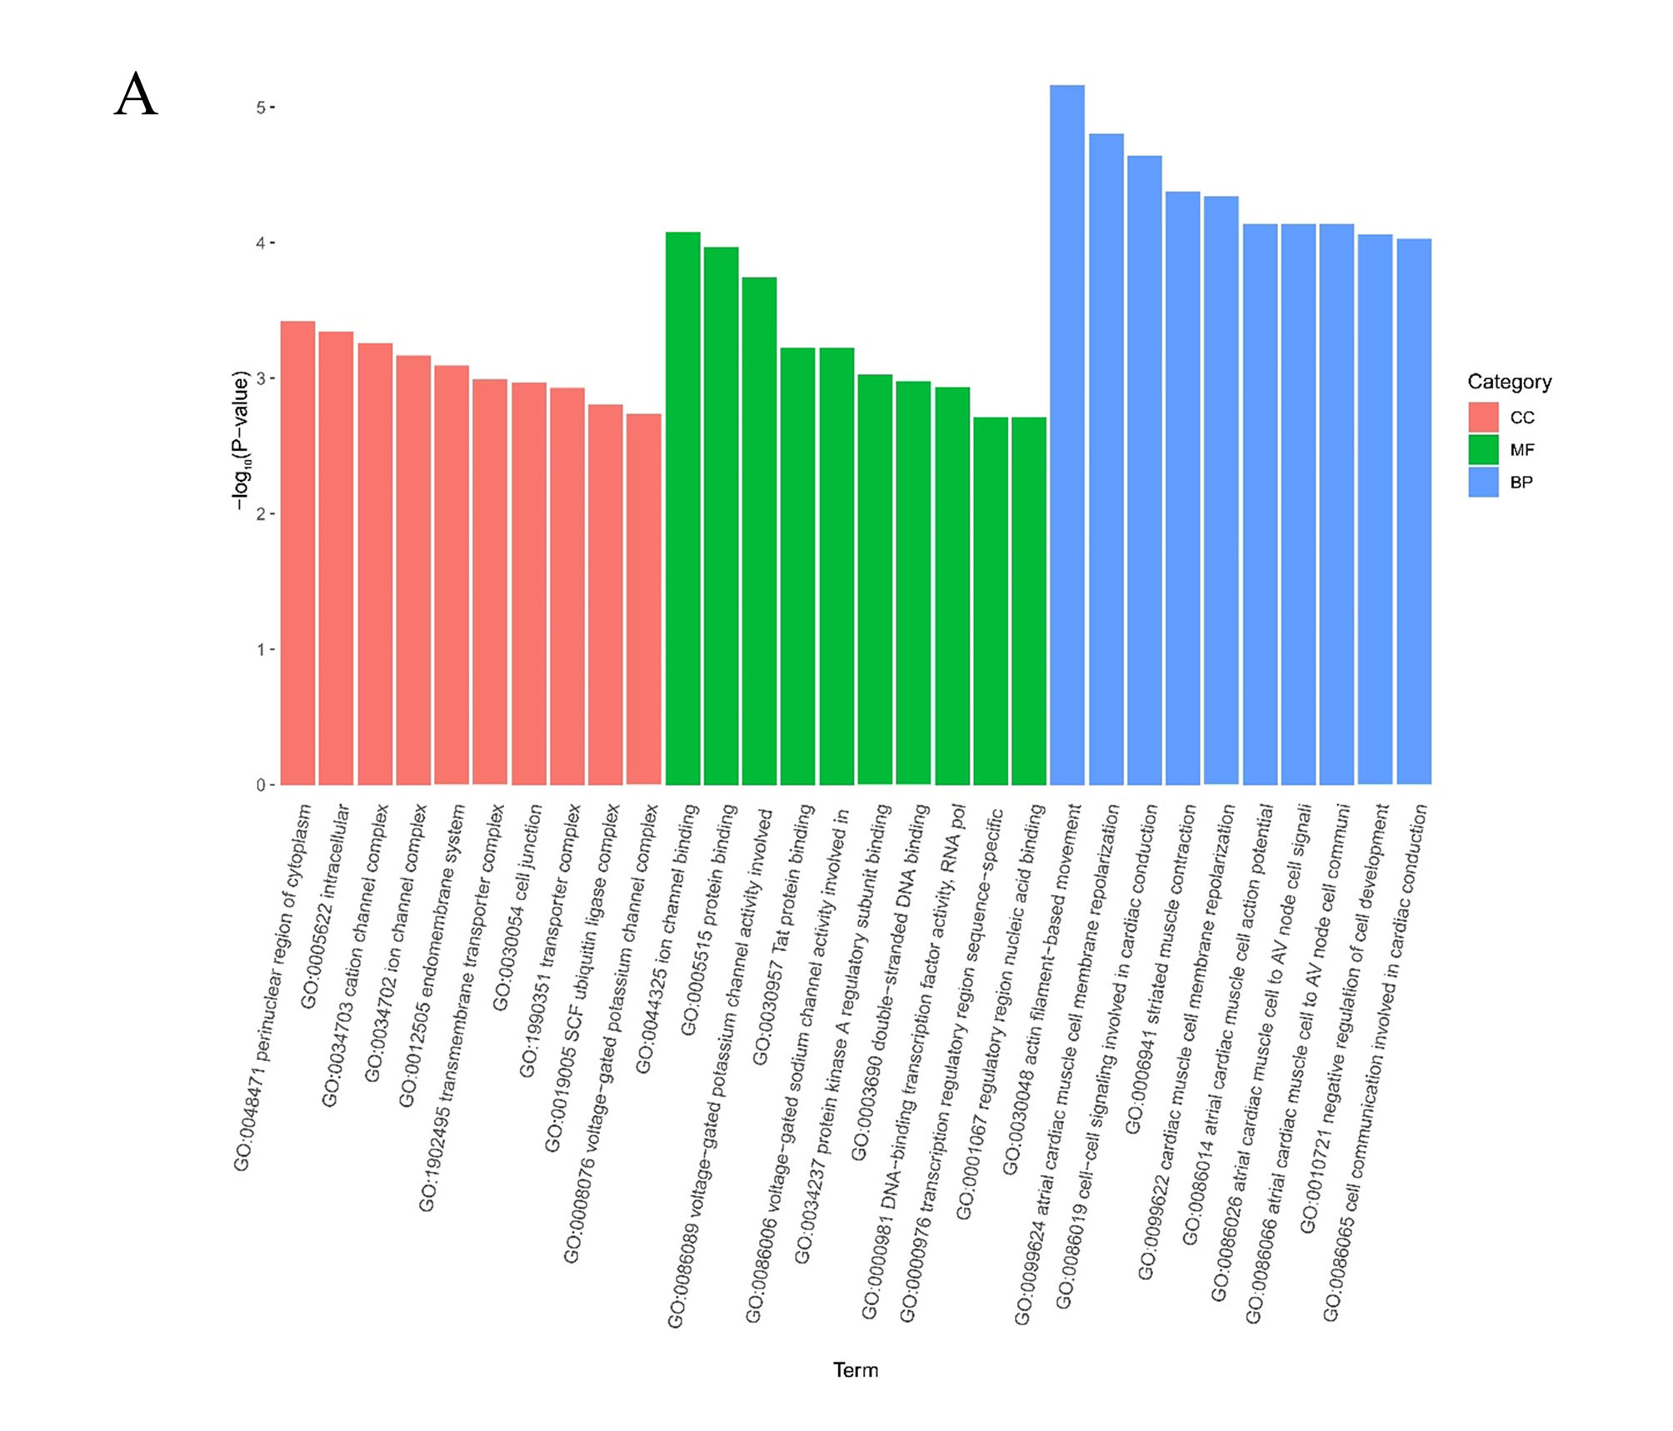
Supplementary Figure 4. Bioinformatic analyses of bta-miR-1307 target pathways. (A) GO enrichment analysis of predicted bta-miR-1307 target genes.

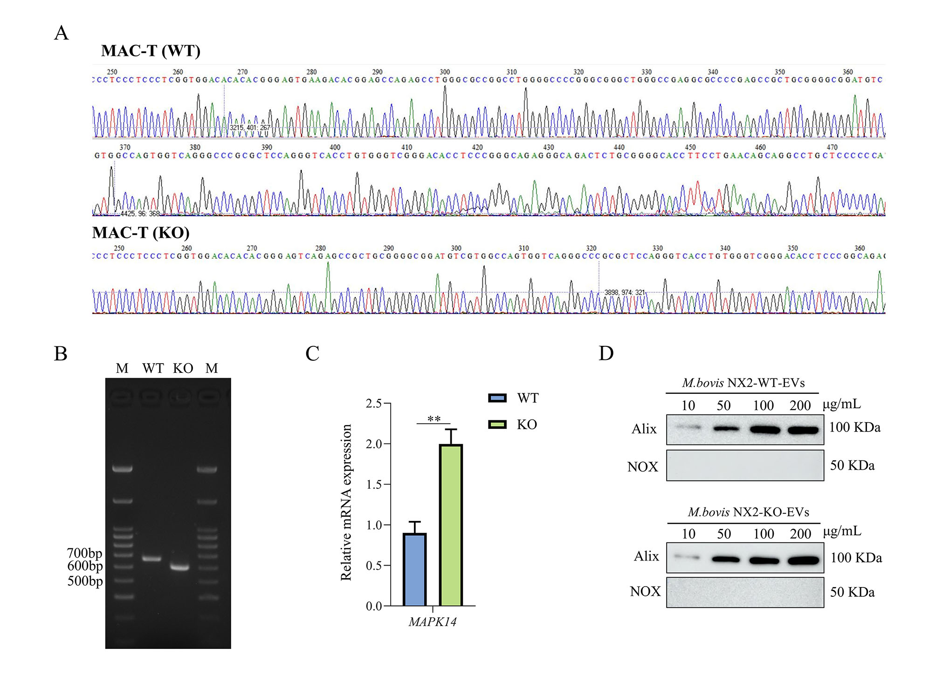
Supplementary Figure 5. Validation of miR-149-5p knockout and its functional consequences. (A) Results of Sanger sequencing confirming miR-149-5p knockout in MAC-T cells. (B) Representative agarose gel electrophoresis of genotyping PCR products showing a 63 bp size difference between wild-type (WT) and miR-149-5p knockout (KO) MAC-T clones. (C) Relative mRNA expression of MAPK14 in WT and KO cells, as determined by qRT-PCR (normalized to GAPDH). (D) Western blot analysis of Alix and NOX in purified EV lysates. Data are presented as mean ± SEM from three independent biological experiments (n = 3). Statistical significance was determined using a two-tailed Student’s t-test. ** p < 0.01 compared with the indicated control group. ns, not significant.

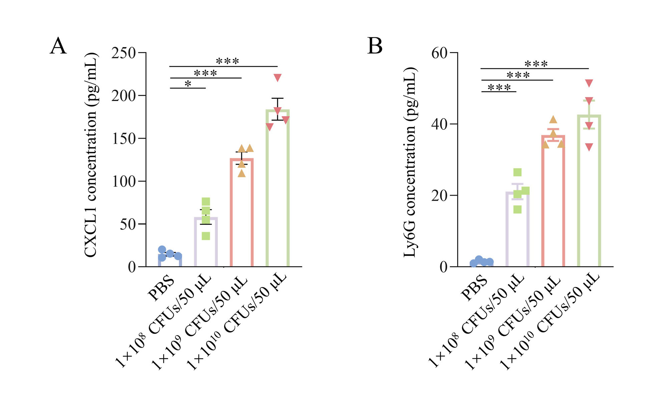
Supplementary Figure 6. Dose-dependent production of CXCL1 and Ly6G upon M. bovis NX2 challenge. (A) CXCL1 and (B) Ly6G levels in mammary tissues quantified by ELISA. Data are presented as mean ± SEM from three independent biological experiments (n = 4 mice per group). Statistical significance was determined using one-way ANOVA followed by Tukey’s multiple comparisons test. *p < 0.05, **p < 0.01, and ***p < 0.001 compared with the indicated groups. ns, not significant.
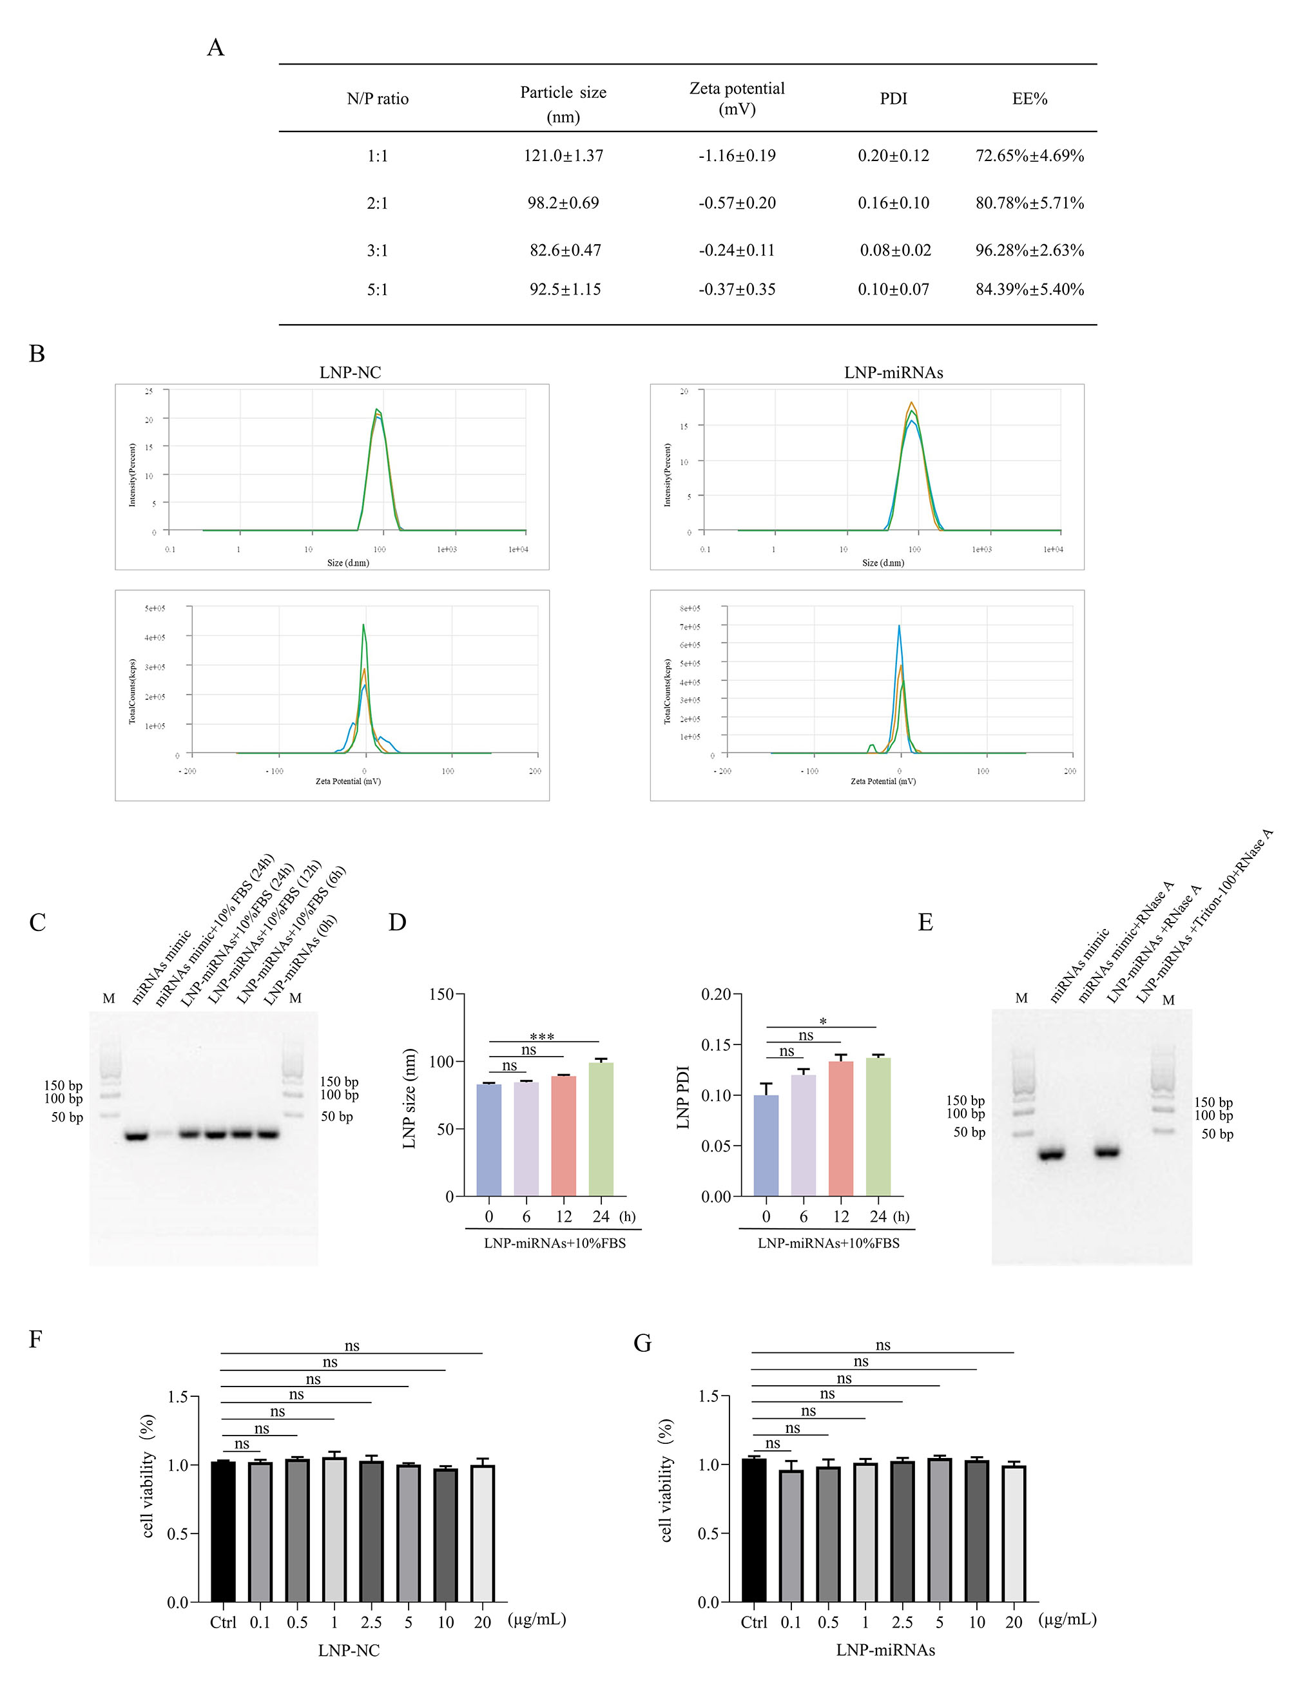
Supplementary Figure 7. Physicochemical characterization and functional evaluation of miRNA-loaded LNPs. (A) Optimization of LNP formulations with varying N/P ratios (1:1, 2:1, 3:1, and 5:1), characterized by particle size, zeta potential, PDI, and miRNA encapsulation efficiency (EE%). (B) Representative DLS profiles showing the hydrodynamic particle size distribution and zeta potential distribution of LNP-NC and LNP-miRNAs. (C) Agarose gel electrophoresis analysis of the integrity of miRNA mimics encapsulated within LNPs after incubation with 10% FBS at 37 °C for 0, 6, 12, and 24 h. (D) Time-dependent changes in hydrodynamic particle size and PDI of LNP-miRNAs during incubation with 10% FBS at 37 °C, as determined by DLS. (E) Agarose gel electrophoresis analysis of RNase A-mediated degradation of free miRNA mimics and LNP-encapsulated miRNA mimics in the presence or absence of Triton X-100-mediated LNP disruption. (F, G) Cytotoxicity evaluation of LNP-NC (F) and LNP-miRNAs (G) at different concentrations in BoMac cells using the MTT assay. Data are presented as mean ± SEM from three independent biological experiments (n = 3). Statistical significance was determined using one-way ANOVA followed by Tukey’s multiple comparisons test. *p < 0.05, **p < 0.01, and ***p < 0.001 compared with the indicated groups. ns, not significant.
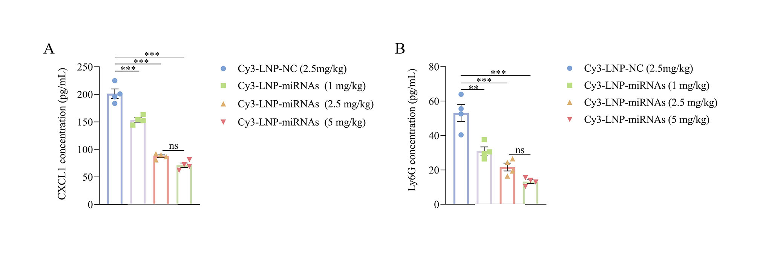
Supplementary Figure 8. Dose-dependent inhibitory effects of LNP-mediated bta-miR-149-5p and bta-miR-1307 co-delivery on CXCL1 and Ly6G levels in vivo. (A) CXCL1 and (B) Ly6G levels in mammary tissues quantified by ELISA. Data are presented as mean ± SEM from three independent biological experiments (n = 4 mice per group). Statistical significance was determined using one-way ANOVA followed by Tukey’s multiple comparisons test. *p < 0.05, **p < 0.01, and ***p < 0.001 compared with the indicated groups. ns, not significant.

