Table S 2: Results of statistic evaluation ( Student´s test) and six pair-wise comparisons of 2D gels separating proteins of B. fibrisolvens 3071 grown on four different substrates (I – glucose, II - xylan, III xylan+glucose, 4 – xylose).
(Spot numbering in this table doesn´t correspond to the number of spot in Figure 4
I vs. II |  | I vs. III |  | I vs. IV |  | II vs. III |  | II vs. IV |  | III vs. IV
spot | T-test | spot | T-test | spot | T-test | spot | T-test | spot | T-test | spot | T-test
11 | 0,067 | 11 | 0,455 | 1 | 0,238 | 1 | 0,059 | 53 (pouze v IV) | 0,286 | 10 | 0,173
1 | 0,501 | 2 | 0,336 | 10 | 0,057 | 10 | 0,262 | 1 | 0,707 | 1 | 0,530
22 | 0,097 | 1 | 0,422 | 22 | 0,263 | 2 | 0,269 | 10 | 0,531 | 11 | 0,045
21 | 0,131 | 10 | 0,070 | 21 | 0,286 | 11 | 0,913 | 2 | 0,484 | 2 | 0,277
20 | 0,890 | 20 | 0,014 | 20 | 0,975 | 20 | 0,514 | 20 | 0,487 | 58 | 0,407
19 | 0,020 | 19 | 0,003 | 14 | 0,723 | 14 | 0,611 | 54 | 0,073 | 14 | 0,341
14 | 0,576 | 14 | 0,514 | 11 | 0,388 | 19 | 0,592 | 11 | 0,182 | 4 | 0,325
11 | 0,722 | 4 | 0,075 | 19 | 0,212 | 4 | 0,233 | 14 | 0,194 | 3 | 0,004
4 | 0,535 | 3 | 0,421 | 18 | 0,346 | 46 | 0,808 | 19 | 0,029 | 19 | 0,006
3 | 0,969 | 5 | 0,030 | 17 | 0,891 | 47 | 0,129 | 4 | 0,268 | 5 | 0,052
5 | 0,042 | 18 | 0,147 | 16 | 0,049 | 3 | 0,041 | 3 | 0,324 | 15 | 0,060
6 | 0,181 | 17 | 0,209 | 6 | 0,078 | 5 | 0,588 | 12 | 0,132 | 24 | 0,404
7 | 0,678 | 16 | 0,102 | 38 | 0,047 | 18 | 0,408 | 13 | 0,449 | 57 | 0,202
8 | 0,677 | 15 | 0,070 | 39 | 0,300 | 17 | 0,408 | 7 | 0,020 | 18 | 0,626
9 | 0,745 | 25 | 0,493 | 37 | 0,042 | 16 | 0,128 | 8 | 0,033 | 17 | 0,279
12 | 0,377 | 12 | 0,019 | 40 | 0,443 | 48 | 0,960 | 9 | 0,845 | 16 | 0,218
13 | 0,392 | 13 | 0,293 | 41 | 0,545 | 49 | 0,217 | 37 | 0,088 | 53(only IV) | 0,174
15 | 0,027 | 7 | 0,298 | 7 | 0,303 | 50 | 0,246 | 55 | 0,051 | 6 | 0,310
16 | 0,041 | 8 | 0,302 | 8 | 0,088 | 15 | 0,092 | 39 | 0,395 | 38 | 0,548
17 | 0,655 | 9 | 0,439 | 9 | 0,274 | 13 | 0,958 | 38 | 0,528 | 39 | 0,501
18 | 0,182 | 17 | 0,243 | 23 | 0,185 | 7 | 0,861 | 6 | 0,601 | 37 | 0,535
23 | 0,543 | 6 | 0,228 | 43 | 0,268 | 8 | 0,142 | 5 | 0,141 | 7 | 0,162
24 | 0,039 | 26 | 0,171 | 42 | 0,554 | 9 | 0,579 | 15 | 0,052 | 8 | 0,066
 |  | 27 | 0,122 | 13 | 0,461 | 37 | 0,118 | 18 | 0,183 | 9 | 0,033
 |  | 28 | 0,028 | 12 | 0,114 | 51 | 0,324 | 17 | 0,034 | 20 | 0,010
 |  | 29 | 0,114 | 4 | 0,395 | 52 | 0,554 | 16 | 0,228 | 13 | 0,358
 |  | 30 | 0,774 | 3 | 0,131 | 6 | 0,449 | 24 | 0,041 | 59 | 0,092
 |  | 31 | 0,049 | 30 | 0,346 |  |  | 57 | 0,842 | 60 | 0,403
 |  | 32 | 0,084 | 15 | 0,434 |  |  |  |  | 31 | 0,946
 |  | 33 | 0,117 | 44 | 0,112
 |  | 34 | 0,129 | 45 | 0,452
 |  | 35 | 0,156 | 46 | 0,346
 |  | 36 | 0,040

Comparison of 2D gels
Comparison I vs. II
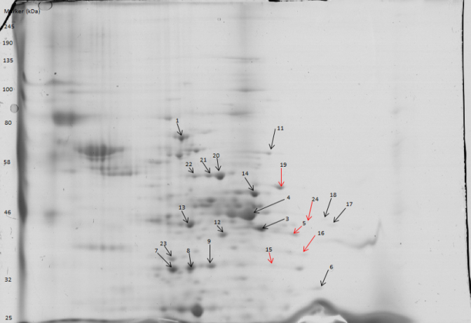
Figure 1: 2D gel separation of proteins of B.fibrisolvens 3071 cultivated on glucose (I)
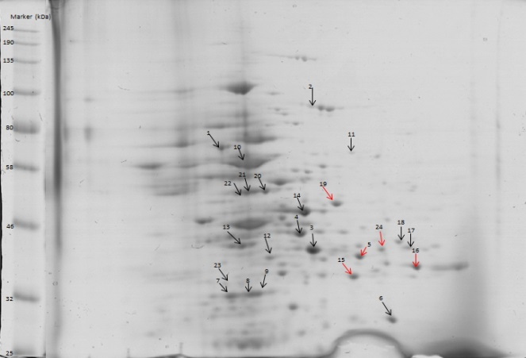
Figure 2: 2D gel separation of proteins of B.fibrisolvens 3071 cultivated on xylan (II)
Comparison I vs. III
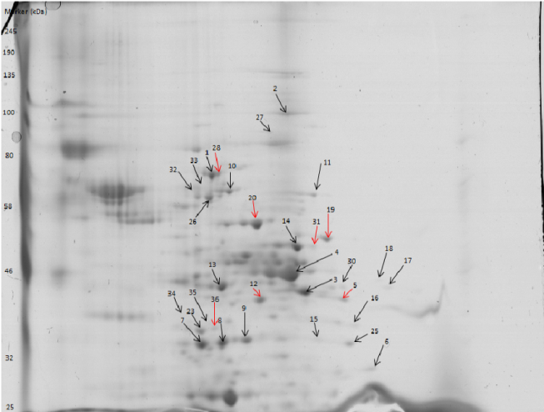
Figure 3: 2D gel separation of proteins of B.fibrisolvens 3071 cultivated on glucose (I)
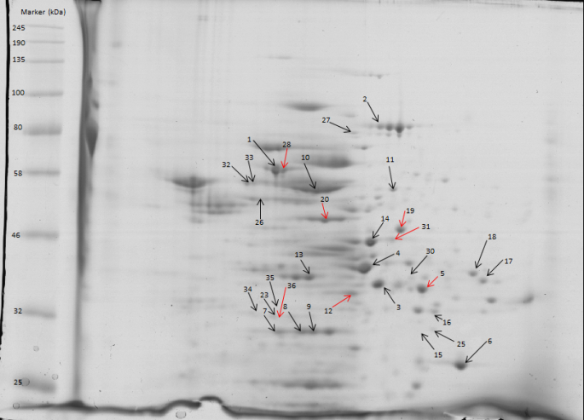
Figure 4: 2D gel separation of proteins of B.fibrisolvens 3071 cultivation on xylan+glucose (III)
Comparison I vs. IV
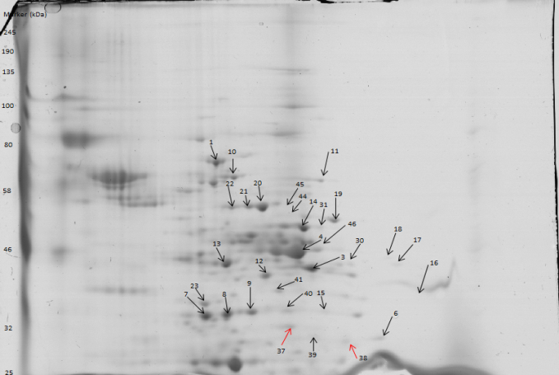
Figure 5: 2D gel separation of proteins of B.fibrisolvens 3071 cultivated on glucose (I)
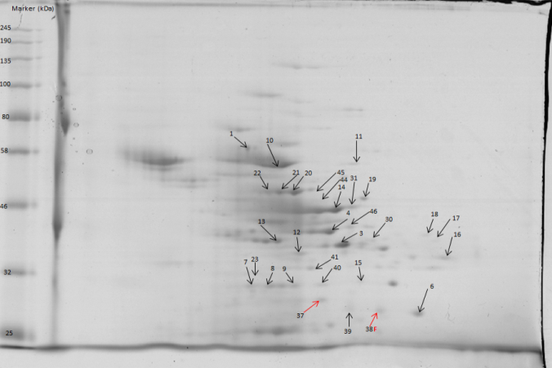
Figure 6: 2D gel separation of proteins of B.fibrisolvens 3071 cultivated on xylose (IV)
Comparison II vs. III
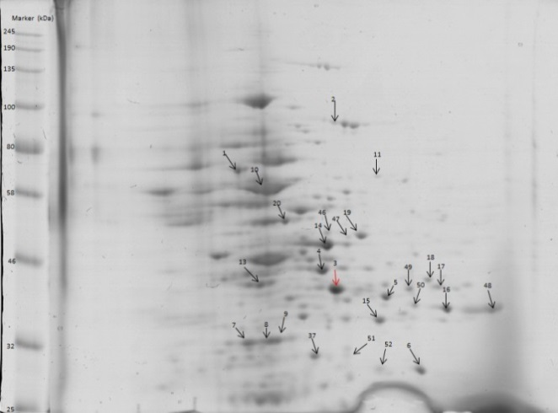
Figure 7: 2D gel separation of proteins of B.fibrisolvens 3071 cultivated on xylan (II)
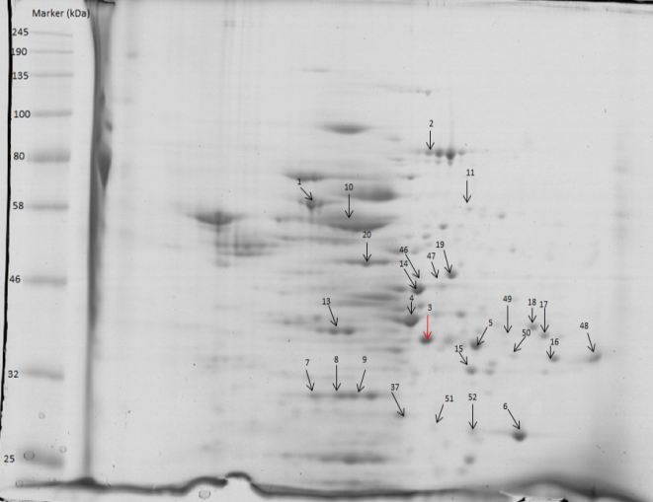
Figure 8: 2D gel separation of proteins of B.fibrisolvens 3071 on xylan+glucose (III)
Comparison II vs. IV
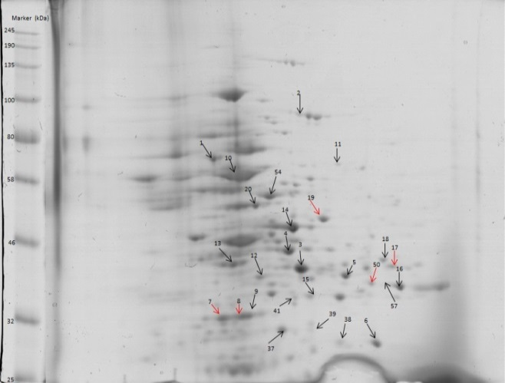
Figure 9: 2D gel separation of proteins of B.fibrisolvens 3071 cultivated on xylan (II)
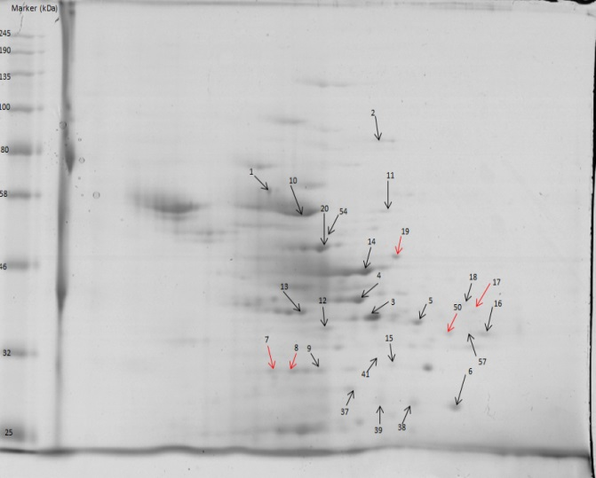
Figure 10: 2D gel separation of proteins of B.fibrisolvens 3071 cultivate on xylose (IV)
Comparison III vs. IV
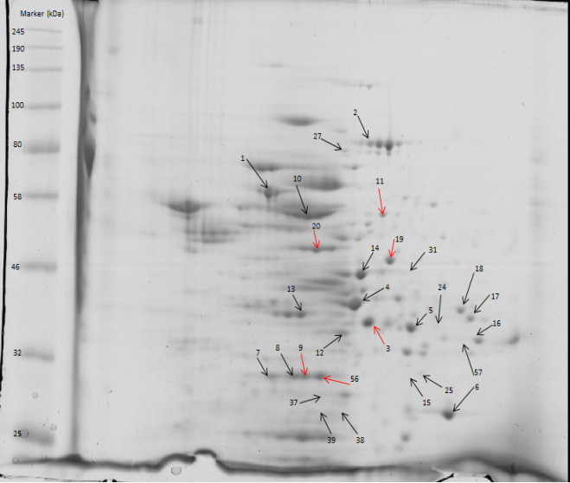
Figure 11: 2D gel separation of proteins of B.fibrisolvens 3071 cultivated on xylan+glucose (III)
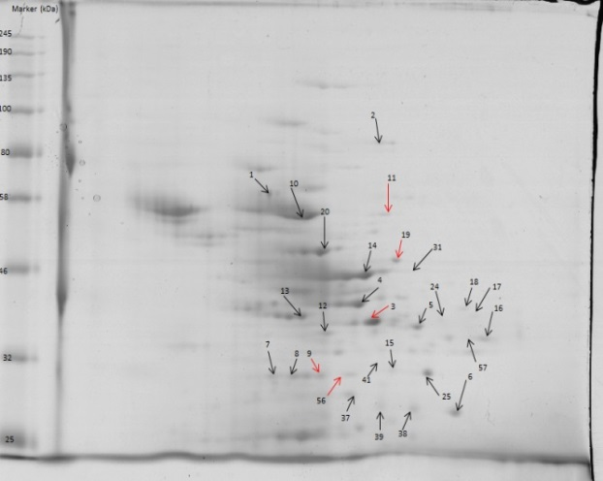
Figure 12: 2D gel separation of proteins of B.fibrisolvens 3071 cultivated on xylose (IV)

