Comparison of False-Discovery Rate of Various Decoy Databases
Supporting Information

Sangjeong Lee¹, Heejin Park^{1,*}, Hyunwoo Kim^{2,*}
¹ Department of Computer Science, Hanyang University, Seoul 06978, Republic of Korea
² Research Data Sharing Center, Korea Institute of Science and Technology Information, Daejeon 34141, Republic of Korea

Email:
Sangeong Lee: othertics@hanyang.ac.kr
Heejin Park: hjpark@hanyang.ac.kr
Hyunwoo Kim: pardess@kisti.re.kr

*Corresponding author.
Heejin Park, Email: hjpark@hanyang.ac.kr
Hyunwoo Kim, Email: pardess@kisti.re.kr

Supplementary Table 1. The number of MS/MS spectra of the each data set
 | Number of MS/MS spectra
A549 | 514,912
GAMG | 625,351
HEK293 | 624,108
HeLa | 543,763
HepG2 | 511,958
Jurkat | 571,069
K562 | 454,612
LnCap | 639,927
MCF7 | 640,530
RKO | 502,079
U2OS | 641,214
HEK293 24 Fraction | 1,121,149
Saccharomyces cerevisiae Elite | 39,444
Saccharomyces cerevisiae 2DLC | 63,031

Supplementary Table 2. The number of Known and Novel PSMs.
6FT | Known |  | Novel
HEK293 3 Replicate | Without correction factor | With  correction factor | Without correction factor | With  correction factor
Reverse | 372647 | 372647 | 399 | 399
Pseudo Reverse | 372536 | 372536 | 449 | 449
De Bruijn | 372710 | 372710 | 445 | 445
Shuffle | 351629 | 372093 | 410 | 423
Pseudo Shuffle | 350817 | 371880 | 146 | 146

6FT | Known |  | Novel
HEK293 24 Fraction | Without correction factor | With  correction factor | Without correction factor | With  correction factor
Reverse | 464578 | 464578 | 335 | 335
Pseudo Reverse | 464293 | 464293 | 342 | 342
De Bruijn | 464712 | 464712 | 423 | 423
Shuffle | 413747 | 464714 | 406 | 417
Pseudo Shuffle | 410382 | 464017 | 109 | 109

6FT | Known |  | Novel
S. cerevisiae Elite | Without correction factor | With  correction factor | Without correction factor | With  correction factor
Reverse | 21086 | 21086 | 28 | 28
Pseudo Reverse | 21162 | 21162 | 23 | 23
De Bruijn | 21554 | 21554 | 31 | 31
Shuffle | 21401 | 21600 | 20 | 27
Pseudo Shuffle | 20741 | 20806 | 23 | 25

6FT | Known |  | Novel
S. cerevisiae 2DLC | Without correction factor | With  correction factor | Without correction factor | With  correction factor
Reverse | 24806 | 24806 | 84 | 84
Pseudo Reverse | 24680 | 24680 | 37 | 37
De Bruijn | 24779 | 24779 | 107 | 107
Shuffle | 24895 | 25087 | 89 | 99
Pseudo Shuffle | 24529 | 24641 | 53 | 96

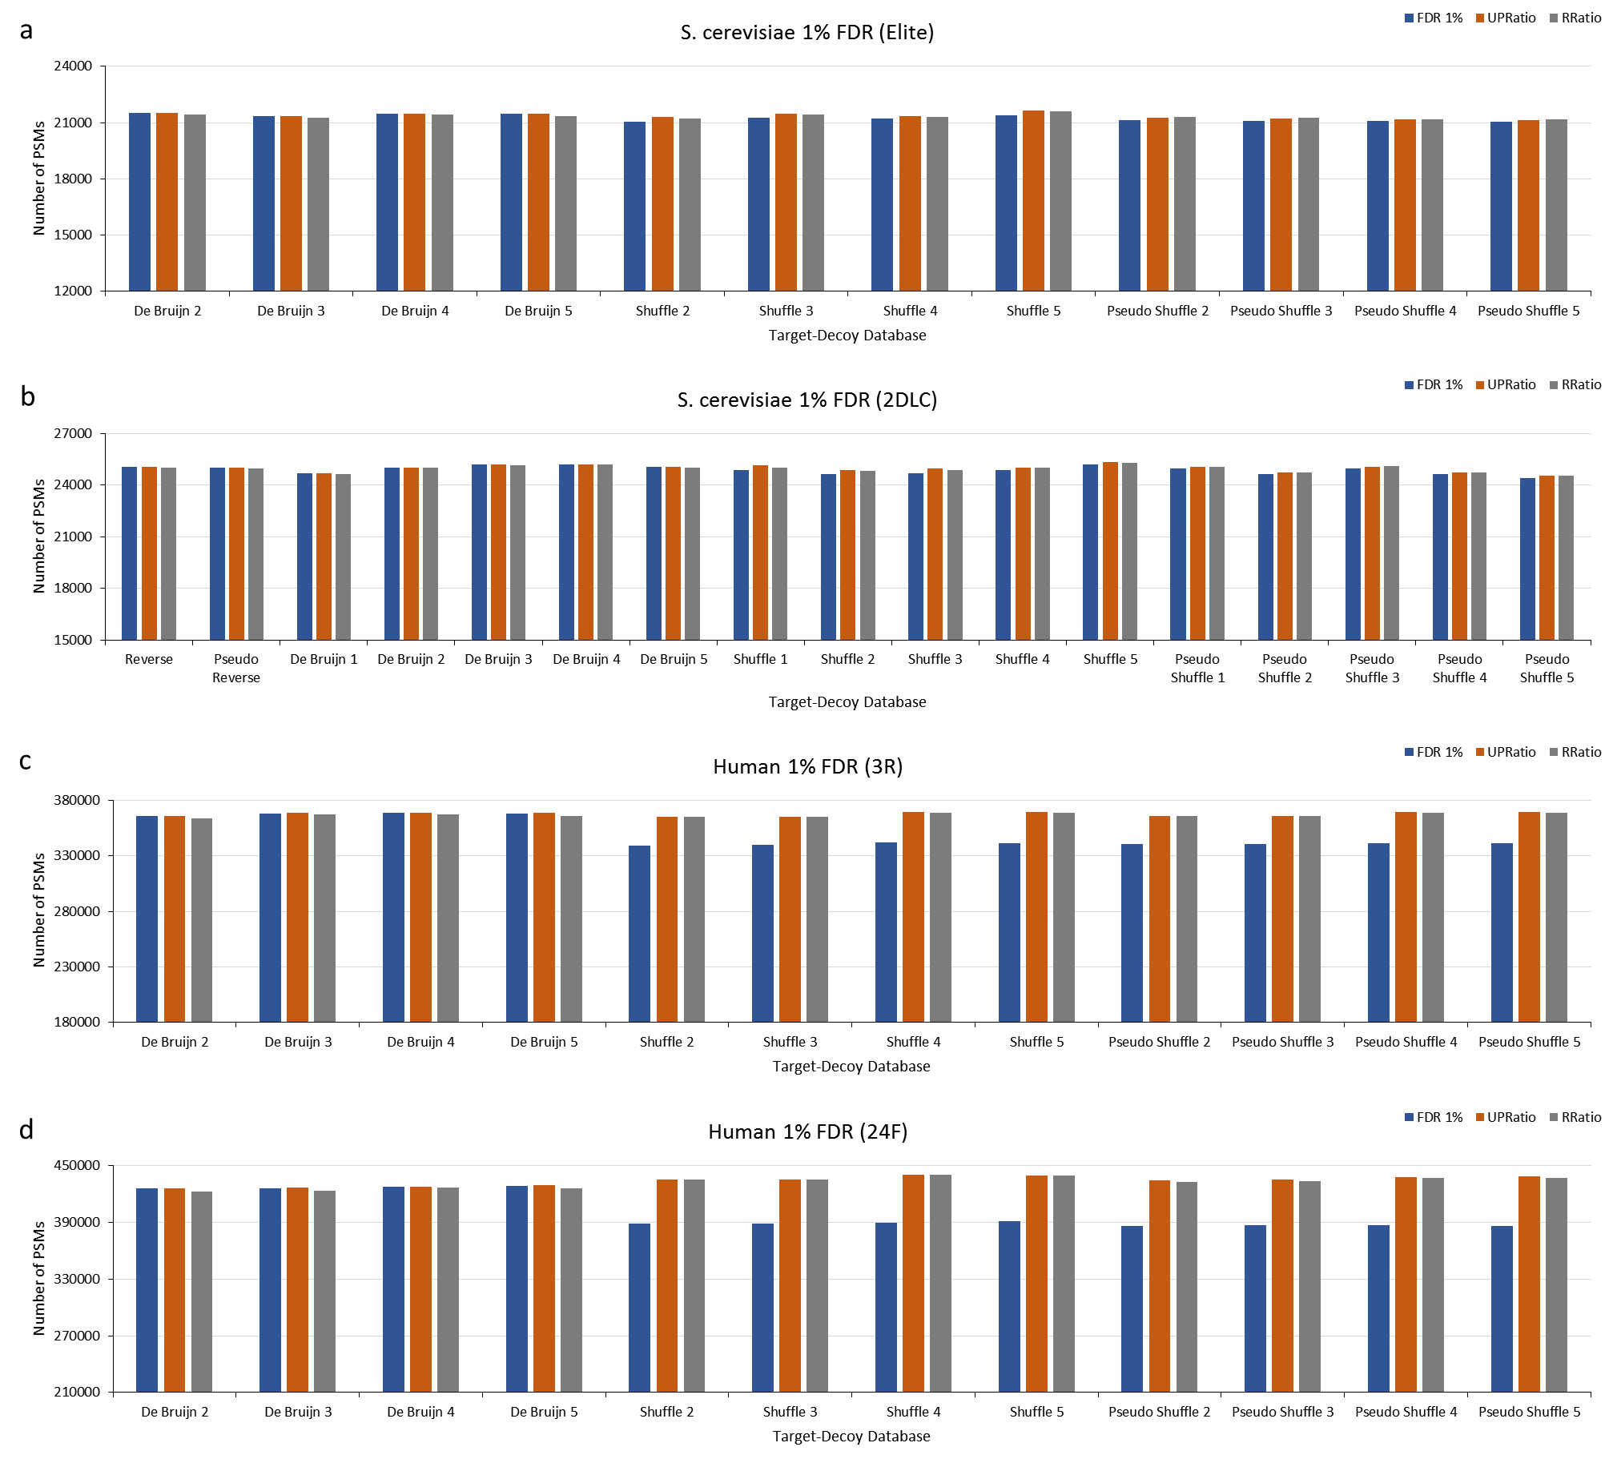
Supplementary Figure 1. Comparison of the numbers of PSMs of various databases. The blue bars show the numbers of PSMs for 1% FDR without the correction factor. The orange bars show the numbers of PSMs for 1% FDR using Factor 2. The gray bars show the numbers of PSMs for 1% FDR using Factor 1. (a) The UniProt S. cerevisiae protein database and the S. cerevisiae Elite dataset. (b) The UniProt S. cerevisiae protein database and the S. cerevisiae 2DLC dataset. (c) The UniProt human protein database and the HEK293 3-replicate dataset. (d) The UniProt human protein database and the HEK293 24-fraction dataset.

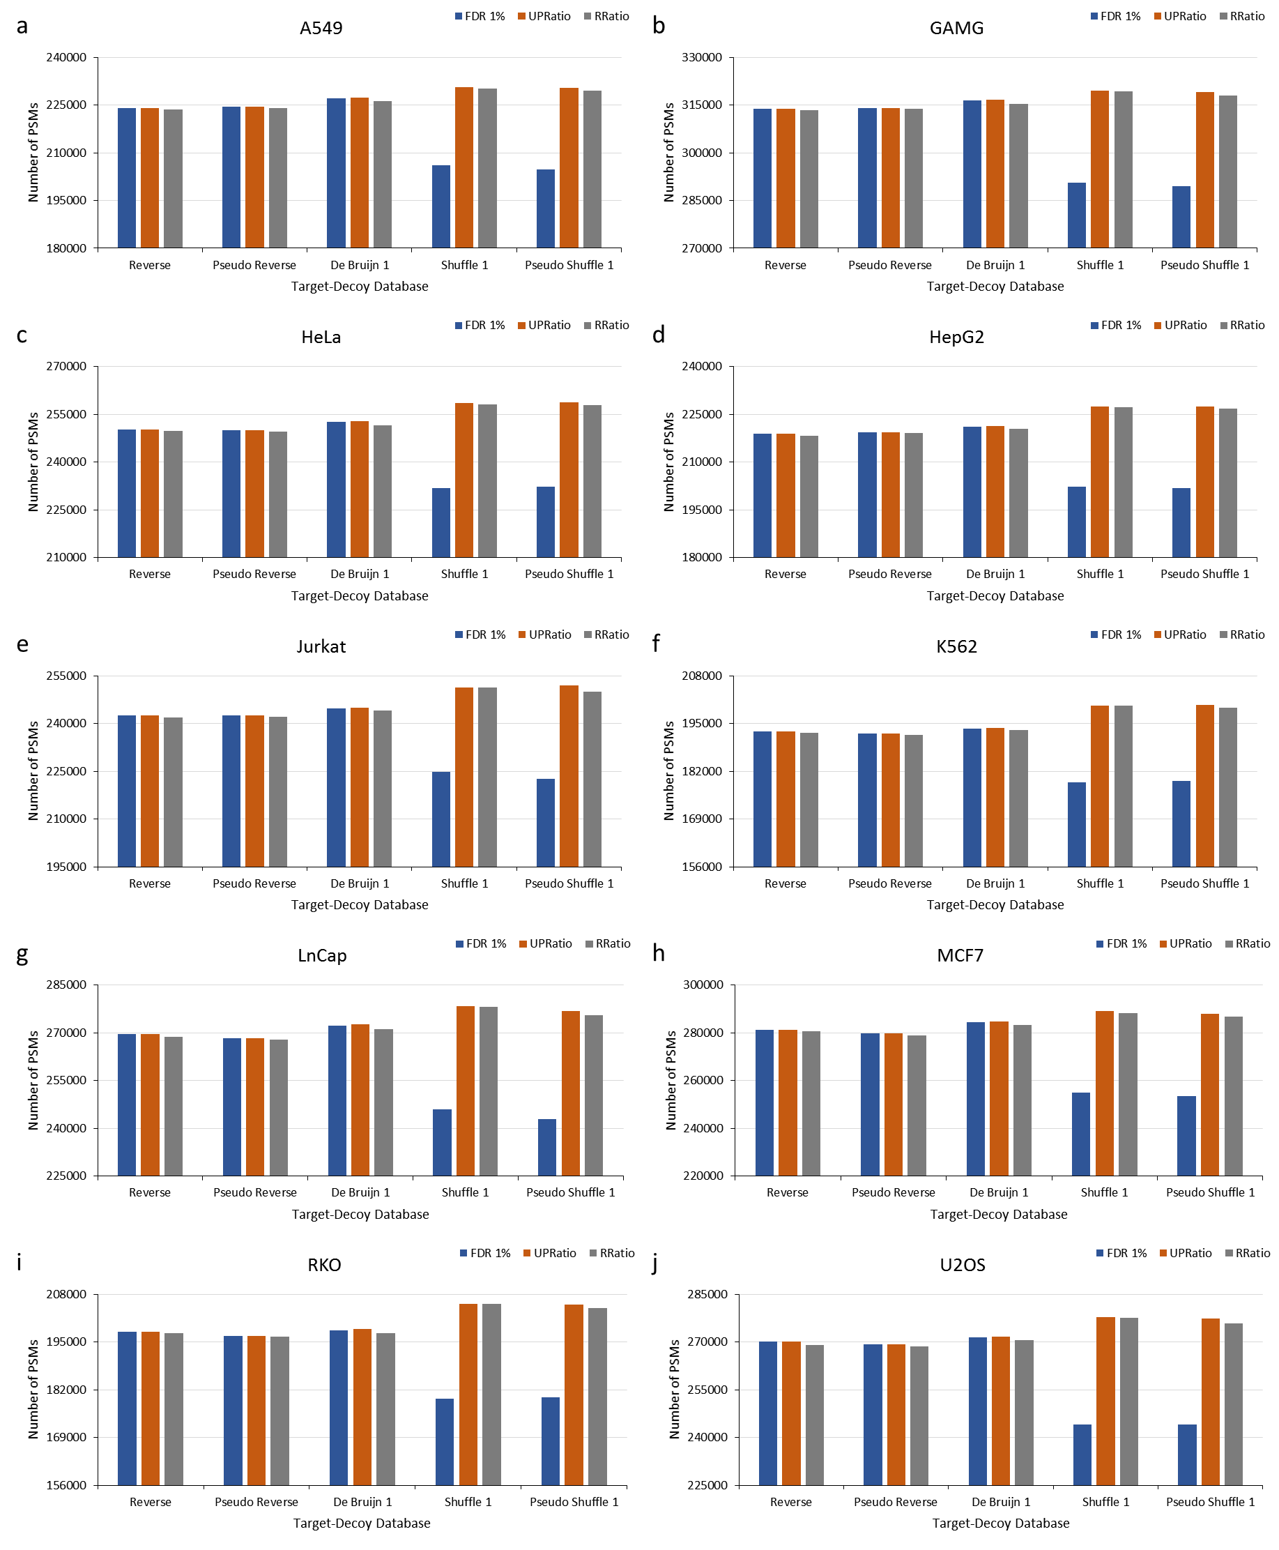
Supplementary Figure 2. Comparison of the numbers of PSMs of various databases. The blue bars show the numbers of PSMs for 1% FDR without the correction factor. The orange bars show the numbers of PSMs for 1% FDR using Factor 2. The gray bars show the numbers of PSMs for 1% FDR using Factor 1. All databases use the UniProt human protein database. (a) A549 dataset. (b) GAMG dataset. (c) HeLa dataset. (d) HepG2 dataset. (e) JurKat dataset. (f) K562 dataset. (g) LnCap dataset. (h) MCF7 dataset. (i) RKO dataset. (j) U2OS dataset.

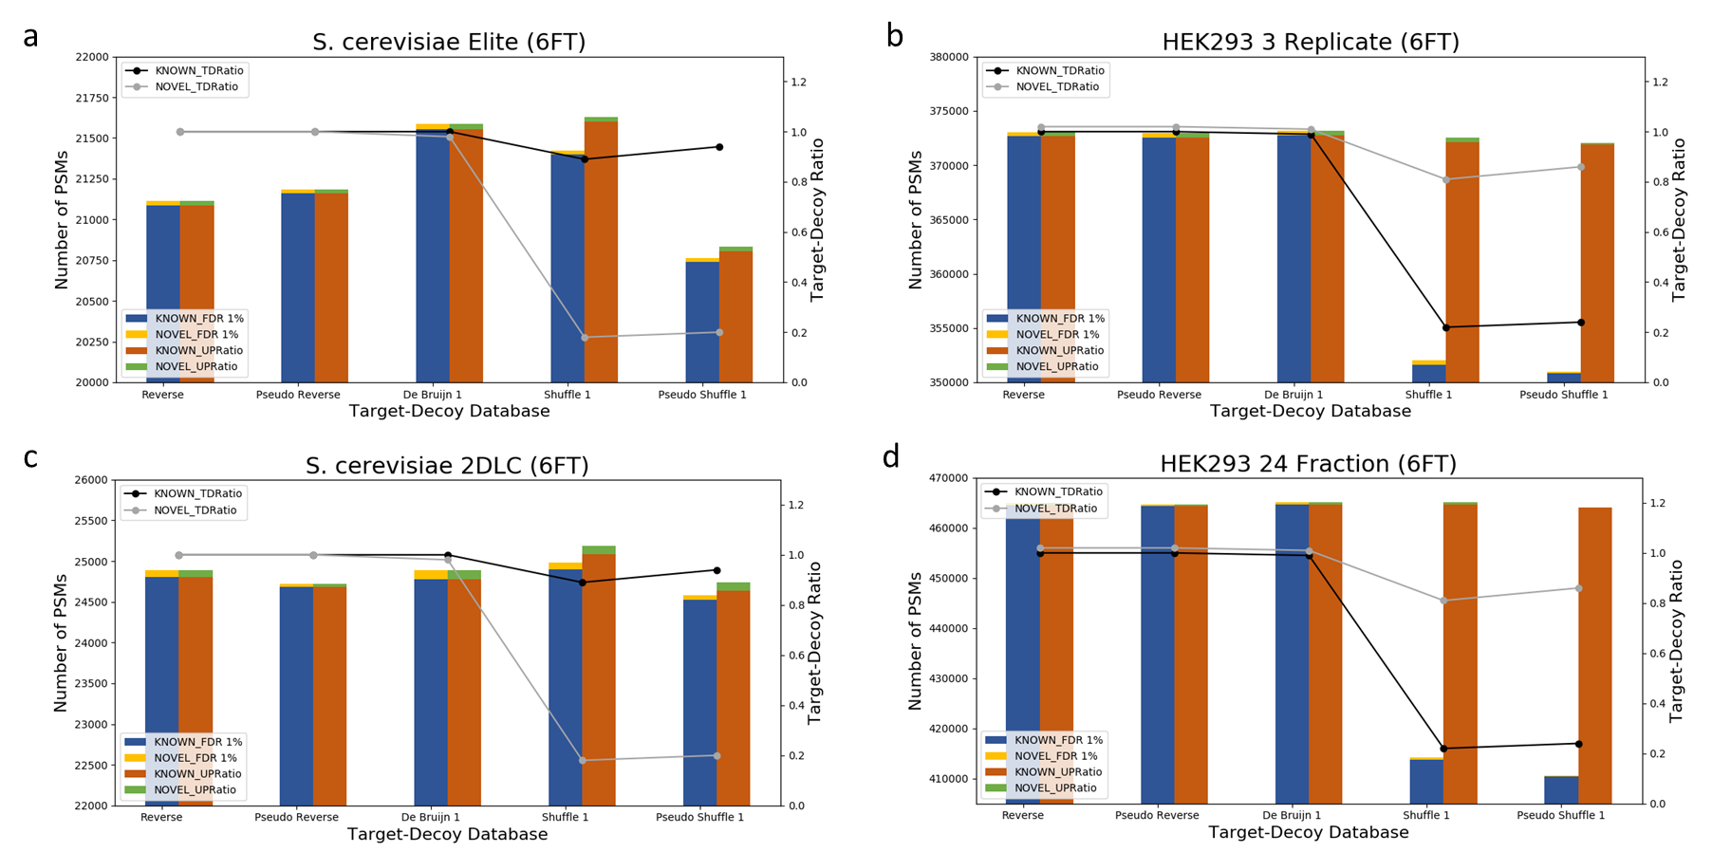
Supplementary Figure 3. Comparison of the numbers of PSMs of various databases. The blue bars show the numbers of PSMs for 1% FDR without the correction factor. The red bars show the numbers of known PSMs for 1% FDR using Factor 2. The yellow bars show the numbers of novel PSMs for 1% FDR without the correction factor. The green bars show the numbers of novel PSMs for 1% FDR using Factor 2. The black and gray line show the ratio of target and decoy unique peptides ratio of known and novel database, respectively. (a) The S. cerevisiae six frame translation protein database and S. cerevisiae Elite dataset. (b) The human six frame translation protein database and the HEK293 3-Replicate dataset. (c) The S. cerevisiae six frame translation protein database and S. cerevisiae 2DLC dataset. (d) The human six frame translation protein database and the HEK293 24-Fraction dataset.

