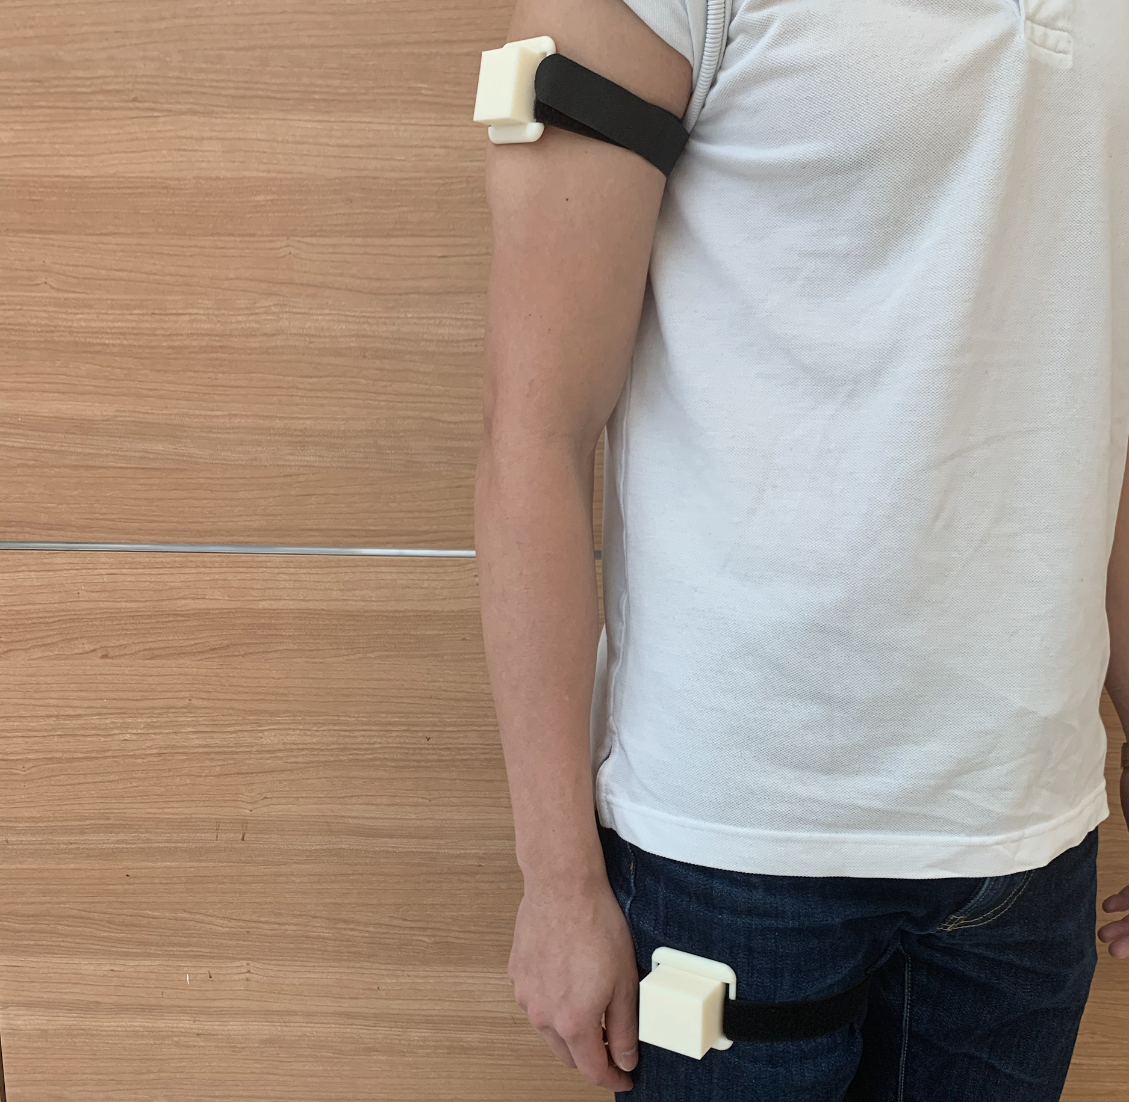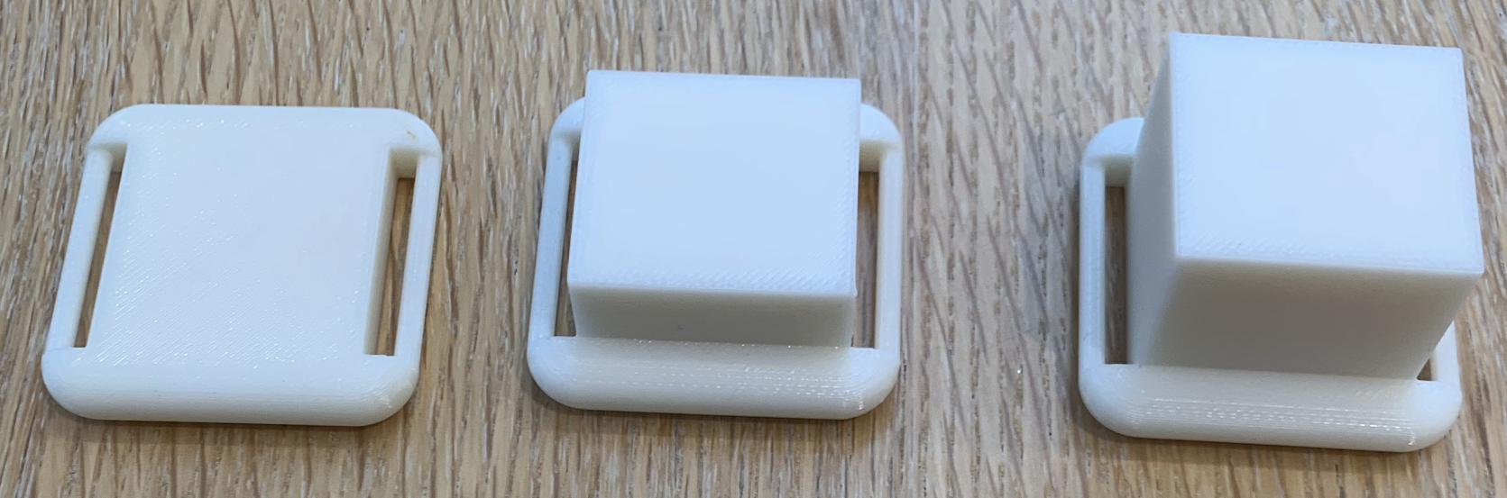
Supplementary Figure 1. Non-functional prototypes presented during the semi-structured interview. Top: The prototypes were presented to each participant and strapped to shoulder and thigh sites to mimic the tactile experience of wearing an automated overdose reversal device. Bottom: Each prototype was a 1”x1”x1/8” volume with an additional 0.5” height for the medium-sized prototype and an additional 1” height for the large-sized prototype.

