Additional file 1. Frequencies of what liked about using JUUL by week 6 trajectory
Panel A. Full sample
Notes. The “Use Anywhere” theme is unique to the Lx/San Diego sample.

Panel B. African American sample
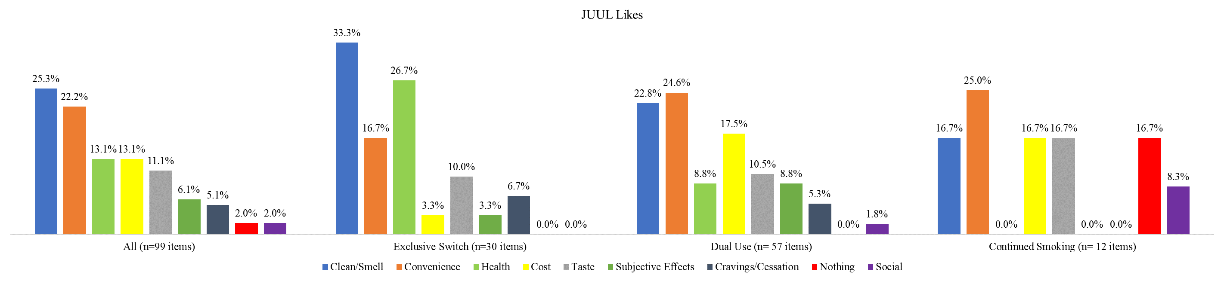
Panel C. Latinx sample
