Additional file 2. Frequencies of what helped with switching to JUUL by week 6 trajectory
Panel A. Full sample

Notes. The “Practice” and “Subjective Experience” themes are unique to the African American/Kansas City sample. The “Flavor”, “Smell”, and “Other” themes are unique to the Latinx/San Diego sample.

Panel B. African American sample
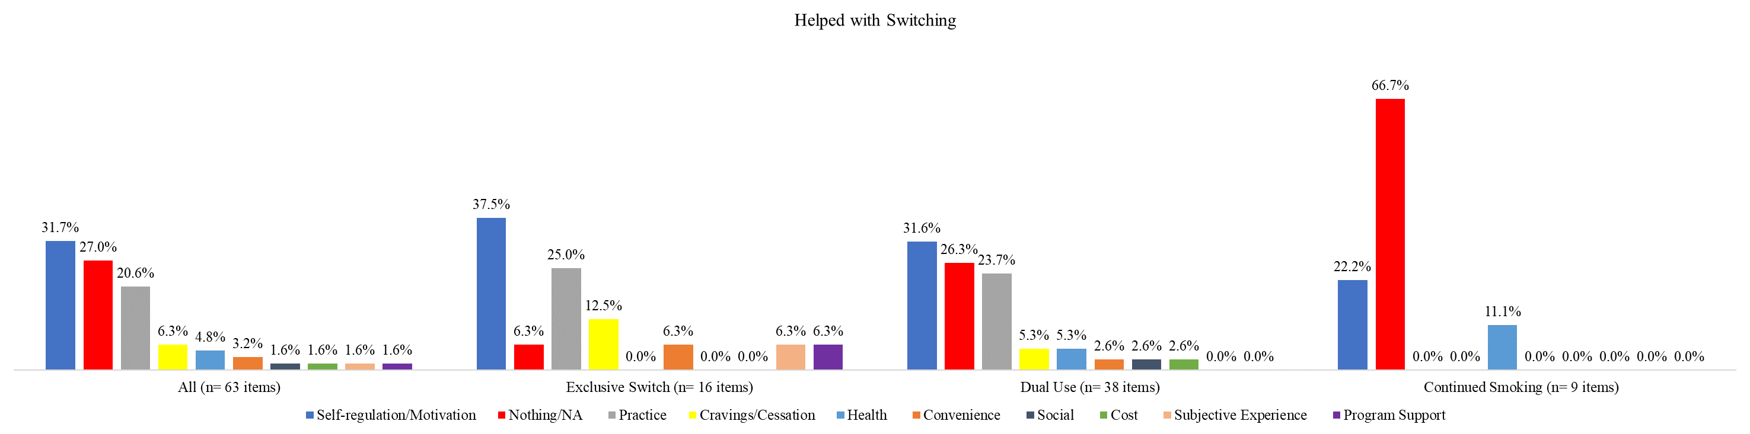

Panel C. Latinx sample
