Additional file 3. Frequencies of what did not like about using JUUL by week 6 trajectory
Panel A. Full sample

Notes. The “Inconvenience”, “Shape”, “Taste”, and “Learning to Use” themes are unique to the African American/Kansas City sample. The “User Issues”, “Mechanical Issues-Battery”, “Comparability”, “Nicotine Exposure”, and “Cost” themes are unique to the Latinx/San Diego sample.

Panel B. African American sample
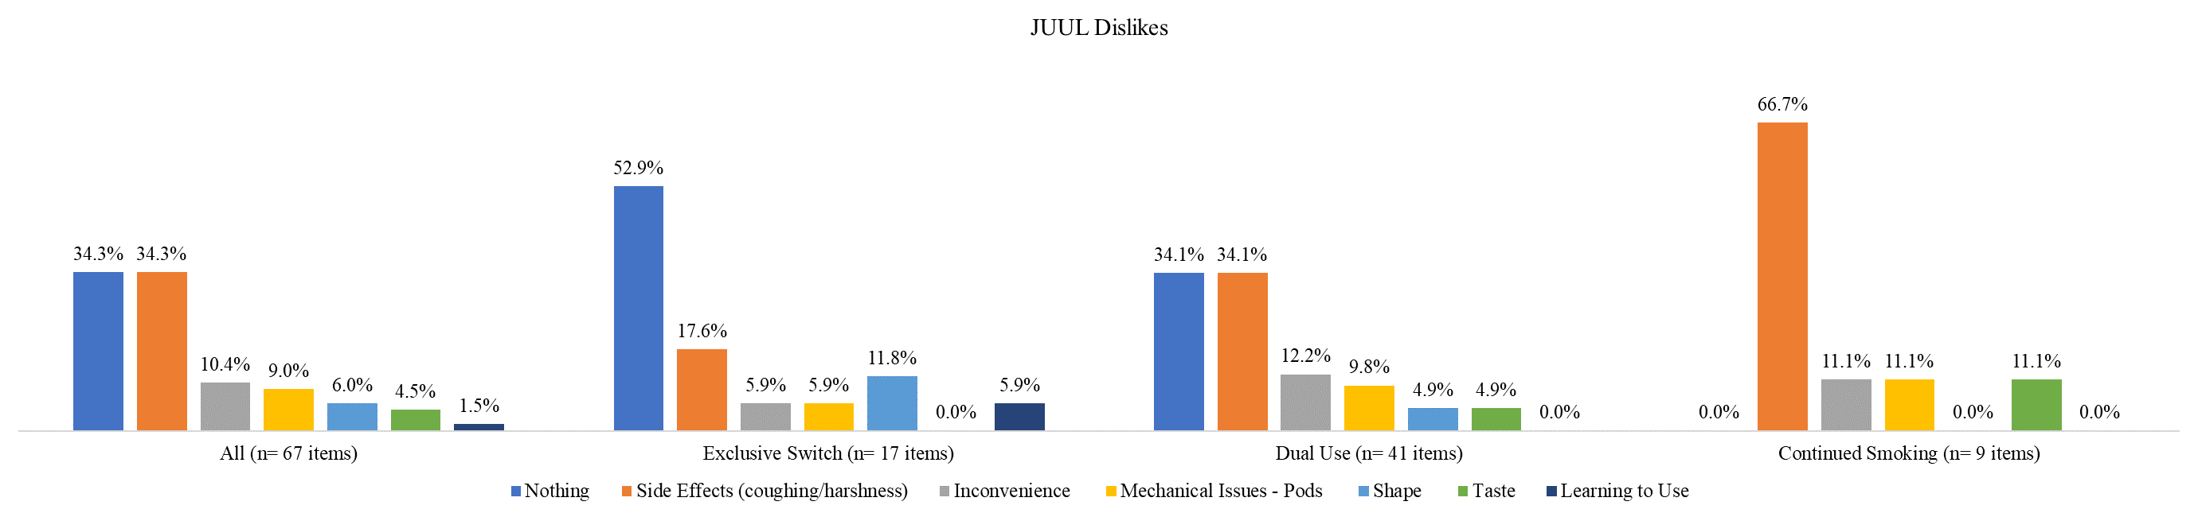

Panel C. Latinx sample
