Additional file 4. Frequencies of what made switching to JUUL difficult by week 6 trajectory
Panel A. Full sample

Notes. The “Taste”, “Readiness to Quit”, “Strength/Nicotine Intensity”, “Mechanical Issues-Pods”, and “Learning to Use” themes are unique to the African American/Kansas City sample. The “User Issues”, “Cravings for Cigarettes”, “Social”, and “Cost” themes are unique to the Latinx/San Diego sample.

Panel B. African American sample
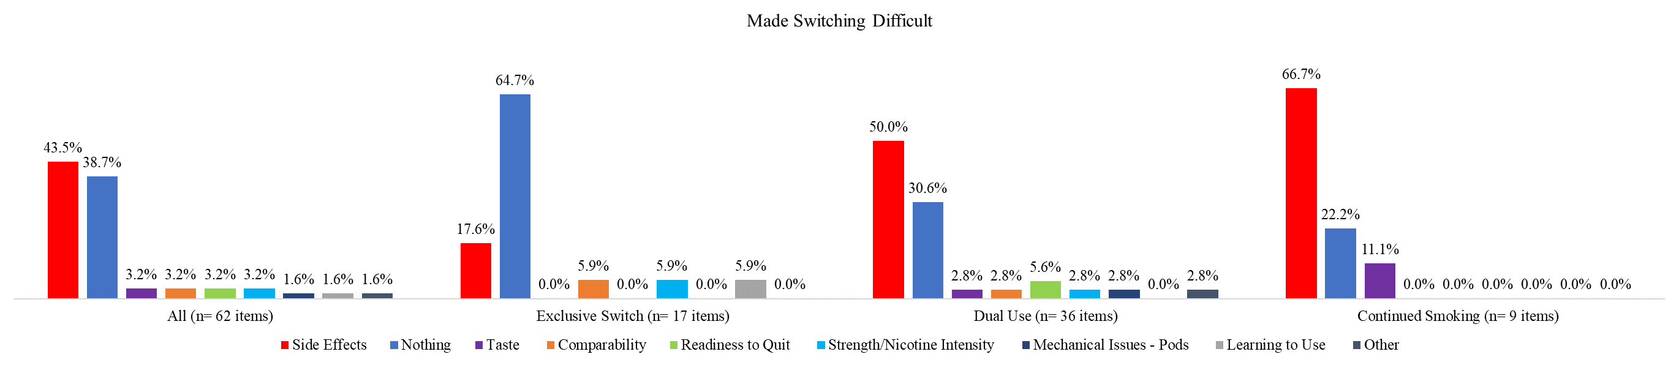

Panel C. Latinx sample