Additional file 6. Frequencies of why continue using JUUL
Panel A. All
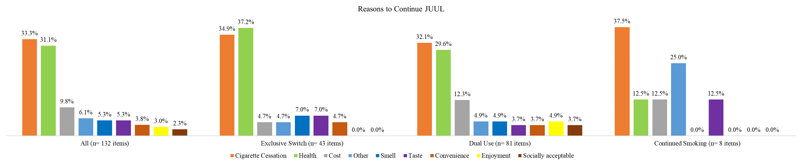
Panel B. African American sample
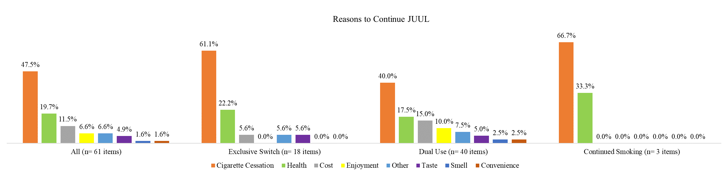
Panel C. Latinx sample
