Additional file 7. Frequencies of comparability of JUUL to other methods to quit cigarettes
Panel A. All
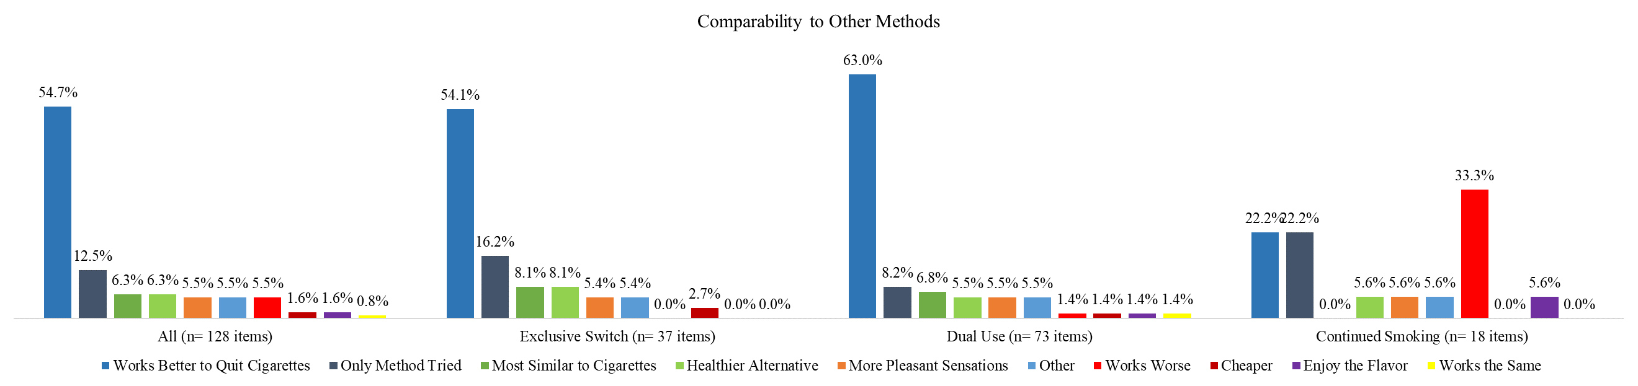
Panel B. African American sample
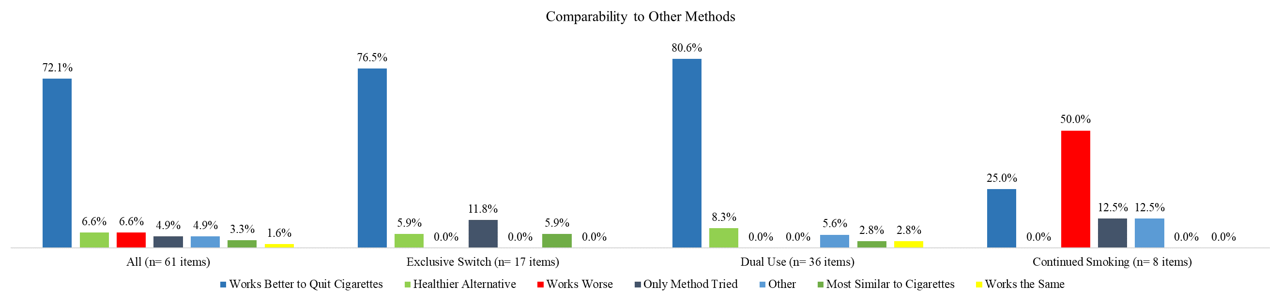
Panel C. Latinx sample
