Title Page

Title: A Longitudinal Study of Naloxone Opioid Overdose Awareness and Reversal Training for First-Year Medical Students: Specific Elements Require Reinforcement

Authors: Reena K. Sandhu¹, Michael V. Heller¹, Jack Buckanavage¹, Benjamin Haslund-Gourley¹, Joshua Leckron¹, Brady Kupersmith¹, Nathaniel C. Goss¹, Kyle Samson¹, and Annette B. Gadegbeku²

Institutional Affiliation:
¹Drexel University College of Medicine, Philadelphia, Pennsylvania, USA. ²Department of Family, Community & Preventive Medicine, Drexel University College of Medicine, Philadelphia, Pennsylvania, USA.

Corresponding Author: Reena K. Sandhu, rks75@drexel.edu

Supplemental Figure 1

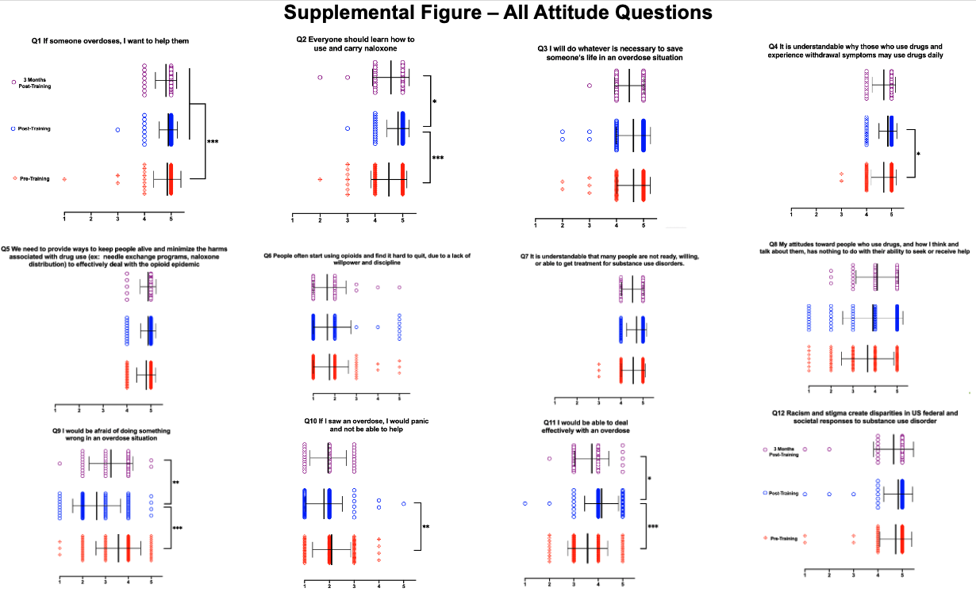

Supplemental Table 1

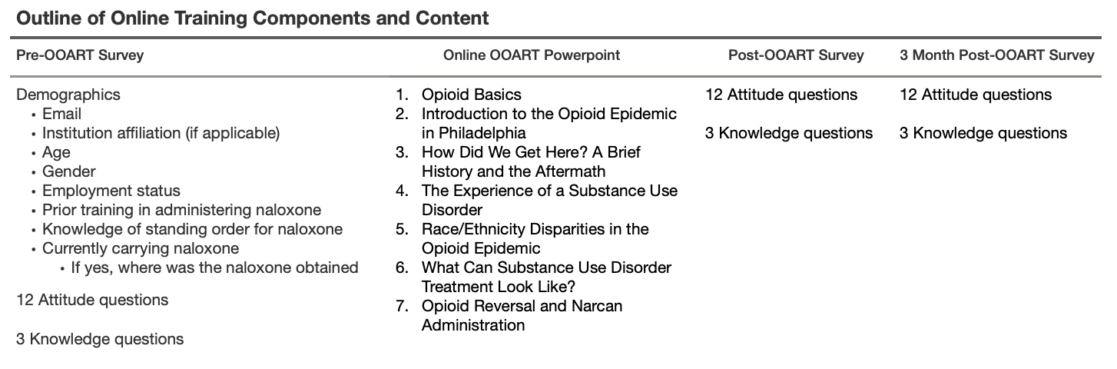

Supplemental Table 2

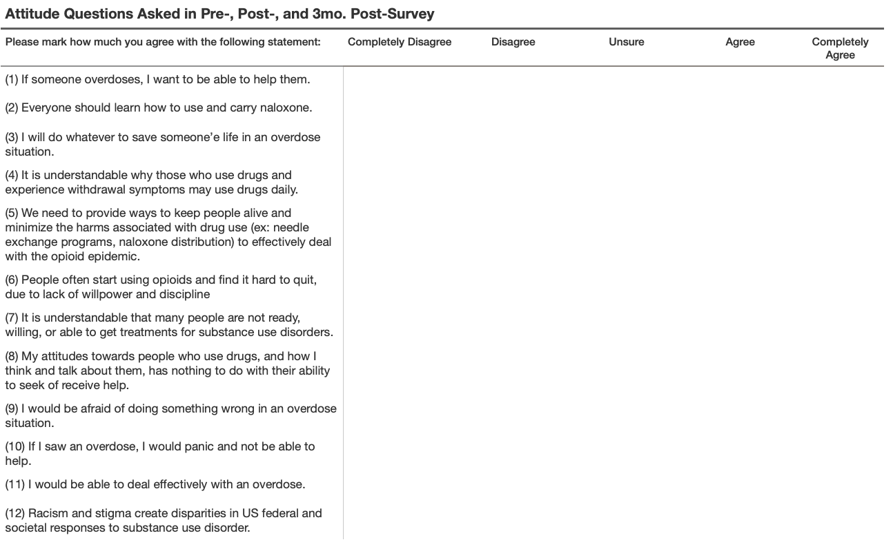

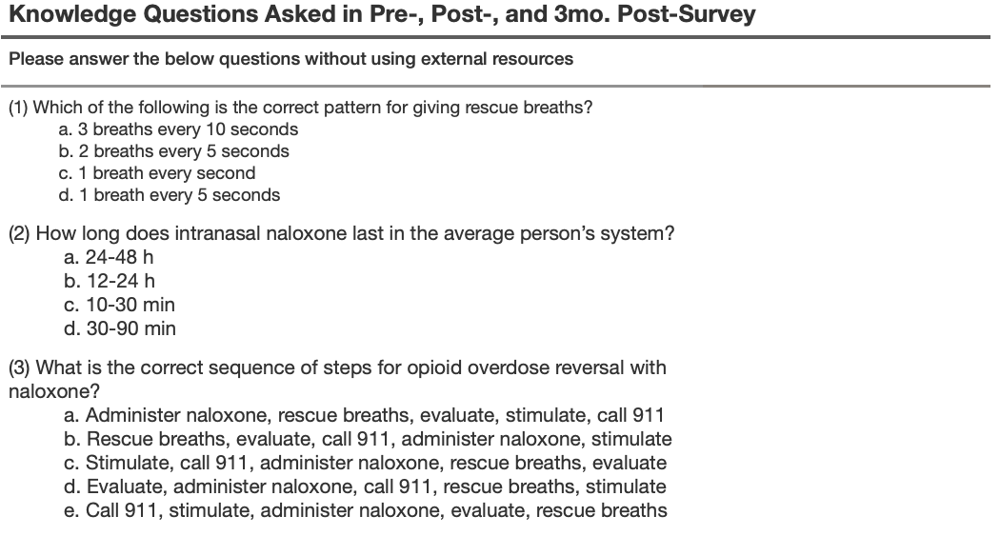
Supplemental Table 3

