Assessment of two brands of fentanyl test strips with 251 synthetic opioids reveals “blind spots” in detection capabilities

Kathleen L. Hayes, Marya Lieberman

Supporting Information
Table S1: limit of detection for 251 compounds screened in this study 2
Figure S1: structures of non-fentanyl synthetic opioids excluded from structure analysis 8
Figure S2: Structures of synthetic precursors, intermediates, and impurities included in structure study (A) and excluded from structure study (B) 9
Table S2: 217 fentanyl analogs and fentanyl-related compounds included in structure study and their specific modifications 10
Table S3: modifications that cause non-detection for both BTNX and DanceSafe FTS 21
Table S4: modifications that cause non-detection for DanceSafe FTS without any co-occurring modifications 21
Figure S3: UpSet plot of all compounds that are not detectable by DanceSafe FTS 25
Figure S4: Carbonyl modifications that do NOT cause non-detects for DanceSafe (on their own, without any co-occurring modifications) 26
Figure S5: UpSet plot of co-modifications that cause non-detection for BTNX FTS (including compounds ND by DanceSafe as well) 27
Figure S6: Phenethyl modifications that inhibit BTNX detection 28
Figure S7: Phenethyl modifications that do not inhibit BTNX detection 30
Figure S8: left: N-(2C-B) Fentanyl (top) and N-(2C-C) Fentanyl (bottom) are detectable by BTNX FTS; right: structurally similar compounds N-(DOB) fentanyl (top) and N-(DOC) fentanyl (bottom) and N-(2C-I) Fentanyl (right) are not detectable by BTNX FTS 31

Table S1: limit of detection for 251 compounds screened in this study
Compound | BTNX limit of detection (ng/mL) | DanceSafe limit of detection (ng/mL)
Fentanyl analogs
(±)-cis-3-methyl Butyryl fentanyl | 2,000 | 20,000
(±)-cis-3-methyl Fentanyl | 2,000 | 2,000
(±)-cis-3-methyl Norfentanyl | ND | 200
(±)-cis-3-methyl Thiofentanyl | 2,000 | 2,000
(±)-cis-Isofentanyl | ND | 2,000
(±)-trans-3-methyl Fentanyl | 2,000 | 200
(±)-trans-3-methyl Thiofentanyl | 2,000 | 200
2,2,3,3-tetramethyl-Cyclopropyl fentanyl | 20,000 | ND
2,3-Benzodioxole fentanyl | 2,000 | ND
2',3'-dimethoxy Fentanyl | 2,000 | 200
2,3-seco-Fentanyl | 20,000 | ND
2',4'-dimethoxy Fentanyl | ND* | 200
2',5'-dimethoxy Fentanyl | 20,000 | 200
2',6'-dimethoxy Fentanyl | 20,000 | 200
2'-fluoro ortho-Fluorofentanyl | 2,000 | 2,000
2'-Fluorofentanyl | 2,000 | 200
2'-methyl Acetyl fentanyl | 200 | 2,000
2'-methyl Fentanyl | 2,000 | 200
3',4'-dimethoxy Fentanyl | ND | 200
3',5'-dimethoxy Fentanyl | ND | 2,000
3'-fluoro ortho-Fluorofentanyl | 2,000 | 200
3'-Fluorofentanyl | 2,000 | 200
3'-methyl Acetyl fentanyl | 200 | 2,000
3'-methyl Fentanyl | 2,000 | 200
4-Anilino-1-Boc-piperidine | ND | ND
4'-fluoro, para-fluoro (±)-trans-3-methyl Fentanyl | 2,000 | 2,000
4'-Fluorofentanyl | 2,000 | 200
4'-methyl Acetyl fentanyl | 200 | 2,000
4'-methyl Fentanyl | 2,000 | 200
4-methyl Fentanyl | 2,000 | 2,000
4-Phenyl fentanyl | ND* | ND
Acetyl fentanyl | 200 | 2,000
Acetyl norfentanyl | 20,000 | 20,000
Acrylfentanyl | 2,000 | 200
Alfentanil | ND | 20,000
Benzodioxole fentanyl | 2,000 | ND
Benzyl Acrylfentanyl | 2,000 | 2,000
Benzyl Carfentanil | ND | ND
Benzyl fentanyl | 2,000 | 200
Butyryl fentanyl | 200 | 200
Butyryl norfentanyl | 20,000 | 200
Carfentanil | 2,000 | ND
Crotonyl fentanyl | 2,000 | 200
Cyclobutyl fentanyl | 2,000 | 200
Cyclohexyl fentanyl | 2,000 | ND
Cyclopentenyl fentanyl | 2,000 | 20,000
Cyclopentyl fentanyl | 2,000 | ND
Cyclopropaneacetyl fentanyl | 2,000 | 2,000
Cyclopropyl fentanyl | 2,000 | 200
Despropionyl 2'-fluoro ortho-Fluorofentanyl | ND | ND
Despropionyl meta-Methylfentanyl | ND | ND
Despropionyl ortho-Fluorofentanyl | ND | ND
Despropionyl para-Fluorofentanyl | ND | ND
Ethoxyacetyl fentanyl | 200 | ND*
Fentanyl | 200 | 200
Fentanyl Carbamate | 2,000 | 200
Fentanyl Methyl Carbamate | 2,000 | 200
FIBF | 2,000 | ND
Furanyl fentanyl | 2,000 | 20,000
Furanyl fentanyl 3-furancarboxamide isomer | 2,000 | 200
Furanyl norfentanyl | 20,000 | 2,000
Furanylethyl fentanyl | 2,000 | 200
Heptanoyl fentanyl | 20,000 | ND
Hexanoyl fentanyl | 20,000 | ND
Isobutyryl fentanyl | 2,000 | ND
Isovaleryl fentanyl | 2,000 | ND
meta-fluoro Acrylfentanyl | 2,000 | 2,000
meta-fluoro Furanyl fentanyl | 2,000 | 2,000
meta-fluoro Methoxyacetyl fentanyl | 200 | 2,000
meta-fluoro Valeryl fentanyl | 2,000 | ND
meta-Fluorobutyryl fentanyl | 2,000 | 2,000
meta-Fluorofentanyl | 2,000 | 200
meta-Fluoroisobutyryl fentanyl | 2,000 | ND
meta-methoxy Furanyl fentanyl | 2,000 | ND*
meta-methyl Acetyl fentanyl | 200 | 20,000
meta-methyl Cyclopropyl fentanyl | 2,000 | 200
meta-methyl Furanyl fentanyl | 2,000 | 20,000
meta-methyl Methoxyacetyl fentanyl | 200 | 20,000
meta-Methylfentanyl | 2,000 | 2,000
Methacrylfentanyl | 2,000 | 20,000
Methoxyacetyl fentanyl | 200 | 2,000
N-(2,5-DMA) Fentanyl | 2,000 | 200
N-(2-APB) Fentanyl | 20,000 | 200
N-(2C-B) Fentanyl | 20,000 | 2,000
N-(2C-B-fly) Fentanyl | ND | 2,000
N-(2C-C) Fentanyl | 20,000 | 2,000
N-(2C-D) Fentanyl | ND | 200
N-(2C-E) Fentanyl | ND | 2,000
N-(2C-G) Fentanyl | ND | 200
N-(2C-I) Fentanyl | ND* | 2,000
N-(2C-iP) Fentanyl | ND | 2,000
N-(2C-N) Fentanyl | ND | 200
N-(2C-P) Fentanyl | ND | 20,000
N-(2C-T) Fentanyl | ND | 200
N-(2C-T-2) Fentanyl | ND | 200
N-(2C-T-4) Fentanyl | ND | 2,000
N-(2C-T-7) Fentanyl | ND | 2,000
N-(2C-TFM) Fentanyl | ND | 2,000
N-(3,4,5-TMA) Fentanyl | ND | 200
N-(3C-B-fly) Fentanyl | ND | 200
N-(3-ethylindole) Norfentanyl | 2,000 | 200
N-(6-APB) Fentanyl | 2,000 | 200
N-(6-APDB) Fentanyl | 2,000 | 200
N-(DOB) Fentanyl | ND | 2,000
N-(DOBU) Fentanyl | ND | 2,000
N-(DOC) Fentanyl | ND | 200
N-(DOET) Fentanyl | ND | 2,000
N-(DOI) Fentanyl | ND | 2,000
N-(DOM) Fentanyl | ND | 200
N-(MDA) Fentanyl | 2,000 | 200
N-(Phentermine) Fentanyl | 2,000 | 200
N,N-Dimethylamido-despropionyl fentanyl | 200 | 2,000
N-benzyl Furanyl norfentanyl | 2,000 | 20,000
N-benzyl para-fluoro Cyclopropyl norfentanyl | 2,000 | 2,000
N-benzyl para-fluoro Norfentanyl | 2,000 | 200
N-Benzyl phenyl norfentanyl | 2,000 | ND
N-methyl Cyclopropyl norfentanyl | 2,000 | 200
N-methyl Norcarfentanil | ND | ND
N-methyl Norfentanyl | 2,000 | 200
Norcarfentanil | ND | ND
Norfentanyl | 20,000 | 200
Norsufentanil | ND | 2,000
Ocfentanil | 200 | 20,000
ortho-fluoro Acrylfentanyl | 2,000 | 2,000
ortho-fluoro Furanyl fentanyl | 2,000 | 20,000
ortho-fluoro Valeryl fentanyl | 2,000 | ND
ortho-Fluorobutyryl fentanyl | 2,000 | 2,000
ortho-Fluorofentanyl | 2,000 | 2,000
ortho-Fluoroisobutyryl fentanyl | 2,000 | ND
ortho-isopropyl Furanyl fentanyl | 20,000 | ND
ortho-methoxy Butyryl fentanyl | 2,000 | ND*
ortho-methoxy Furanyl fentanyl | 2,000 | ND*
ortho-methyl Acetyl fentanyl | 2,000 | 20,000
ortho-methyl Acrylfentanyl | 2,000 | 2,000
ortho-methyl Cyclopropyl fentanyl | 2,000 | 200
ortho-methyl Furanyl fentanyl | 2,000 | 20,000
ortho-methyl Methoxyacetyl fentanyl | 200 | 20,000
ortho-methyl Phenyl fentanyl | 2,000 | ND
ortho-Methylfentanyl | 2,000 | 200
para-Bromofentanyl | 2,000 | 200
para-chloro Acrylfentanyl | 2,000 | 200
para-chloro Cyclobutyl fentanyl | 2,000 | 2,000
para-chloro Cyclopentyl fentanyl | ND* | ND
para-chloro Cyclopropyl fentanyl | 2,000 | 2,000
para-chloro Furanyl fentanyl | 2,000 | 20,000
para-chloro Furanyl fentanyl 3-furancarboxamide | 20,000 | 2,000
para-chloro Methoxyacetyl fentanyl | 2,000 | 2,000
para-chloro Valeryl fentanyl | 20,000 | ND*
para-Chloroacetyl fentanyl | 200 | 2,000
para-Chlorobutyryl fentanyl | 2,000 | 200
para-Chlorofentanyl | 2,000 | 200
para-Chloroisobutyryl fentanyl | 2,000 | ND*
para-fluoro 4-ANBP | ND | ND
para-fluoro Acrylfentanyl | 2,000 | 2,000
para-fluoro Crotonyl fentanyl | 2,000 | 200
para-fluoro Cyclopentyl fentanyl | 2,000 | ND
para-fluoro Cyclopropyl fentanyl | 2,000 | 200
para-fluoro Furanyl fentanyl | 2,000 | 2,000
para-fluoro Furanyl fentanyl 3-furancarboxamide | 2,000 | 200
para-fluoro Methoxyacetyl fentanyl | 200 | 2,000
para-fluoro Tetrahydrofuran fentanyl | 200 | ND
para-fluoro Valeryl fentanyl | 2,000 | ND*
para-Fluoroacetyl fentanyl | 200 | 2,000
para-Fluorobutyryl fentanyl | 2,000 | 200
para-Fluorofentanyl | 200 | 200
para-hydroxy Butyryl fentanyl | 2,000 | 200
para-methoxy Acetyl fentanyl | 2,000 | ND
para-methoxy Acrylfentanyl | 2,000 | ND
para-methoxy Butyryl fentanyl | 2,000 | ND
para-methoxy Furanyl fentanyl | 2,000 | ND
para-methoxy Methoxyacetyl fentanyl | 2,000 | ND
para-methoxy Tetrahydrofuran fentanyl | 2,000 | ND
para-methoxy Valeryl fentanyl | 20,000 | ND
para-Methoxyfentanyl | 2,000 | ND*
para-methyl Acetyl fentanyl | 200 | 20,000
para-methyl Acrylfentanyl | 2,000 | 20,000
para-methyl Butyryl fentanyl | 2,000 | 20,000
para-methyl Cyclopentyl fentanyl | 20,000 | ND
para-methyl Cyclopropyl fentanyl | 2,000 | 20,000
para-methyl Furanyl fentanyl | 2,000 | ND*
para-methyl Isobutyryl fentanyl | 2,000 | ND
para-methyl Methoxyacetyl fentanyl | 200 | 20,000
para-methyl Tetrahydrofuran fentanyl | 2,000 | ND
para-Methylfentanyl | 2,000 | 2,000
para-Toluoyl fentanyl | 20,000 | ND
Phenoxyacetyl fentanyl | 2,000 | ND
Phenyl fentanyl | 2,000 | ND
Phenylacetyl fentanyl | 2,000 | ND
Pivaloyl fentanyl | 2,000 | ND
Remifentanil | ND | ND
Remifentanil Acid | ND | ND
Senecioylfentanyl | 2,000 | 20,000
Sufentanil | 20,000 | 20,000
Tetrahydrofuran fentanyl | 200 | ND
Tetrahydrofuran fentanyl 3-tetrahydrofurancarboxamide | 200 | 2,000
Tetrahydrothiophene fentanyl | 2,000 | ND
Thienyl fentanyl | 2,000 | 200
Thiofentanyl | 2,000 | 200
Thiophene fentanyl | 2,000 | 2,000
Thiophene fentanyl 3-thiophenecarboxamide | 2,000 | ND*
Tigloyl fentanyl | 2,000 | ND
Valeryl fentanyl | 2,000 | 20,000
α'-methoxy Fentanyl | 200 | ND
α-methyl Acetyl fentanyl | 200 | 2,000
α'-methyl Butyryl fentanyl | 2,000 | ND
α-methyl Butyryl fentanyl | 2,000 | 200
α-methyl Fentanyl | 2,000 | 200
α-methyl Thiofentanyl | 2,000 | 200
β-hydroxy Fentanyl | 200 | 200
β-Hydroxythioacetylfentanyl | 200 | 2,000
β-Hydroxythiofentanyl | 200 | 200
β-methyl Acetyl fentanyl | 2,000 | 2,000
β-methyl Fentanyl | 2,000 | 200
β'-Phenyl fentanyl | 20,000 | ND
Synthetic precursors, intermediates, impurities
4-Anilino-1-benzylpiperidine | ND | ND
4-Anilinopiperidine | ND | ND
4-Piperidone | ND | ND†
N-Benzyl-4-piperidone | ND | ND†
NPP | ND | ND†
4-ANPP | ND | ND
Non-fentanyl synthetic opioids
2-fluoro MT-45 | ND* | ND
2-fluoro Viminol | ND† | ND
2-methyl AP-237 | ND† | ND
3,4-Ethylenedioxy U-47700 | ND† | ND
3,4-Ethylenedioxy U-51754 | ND† | ND
3,4-Methylenedioxy U-47700 | ND† | ND
4-phenyl U-51754 | ND | ND
AH 7921 | ND | ND
AP-237 | ND† | ND†
AP-238 | ND† | ND†
Brorphine | ND† | ND†
Etonitazene | ND† | ND
Isopropyl U-47700 | ND | ND
Isotonitazene | ND† | ND
Metonitazene | ND† | ND
MT-45 | ND | ND
N,N-didesmethyl U-47700 | ND† | ND
N-desmethyl U-47700 | ND† | ND
N-methyl U-47931E | ND† | ND
O-Desmethyl-cis-tramadol | ND† | ND
Piperidylthiambutene | ND† | ND
Propyl U-47700 | ND† | ND
Tianeptine | ND† | ND
U-47700 | ND† | ND
U-47931E | ND† | ND
U-48520 | ND | ND
U-48753E | ND† | ND
U-48800 | ND† | ND
U-49900 | ND† | ND
U-50488 | ND† | ND
U-51754 | ND† | ND

* denotes lots gave discordant results; † denotes only 1 lot from each brand was tested, due to low supply

Figure S1: structures of non-fentanyl synthetic opioids excluded from structure analysis
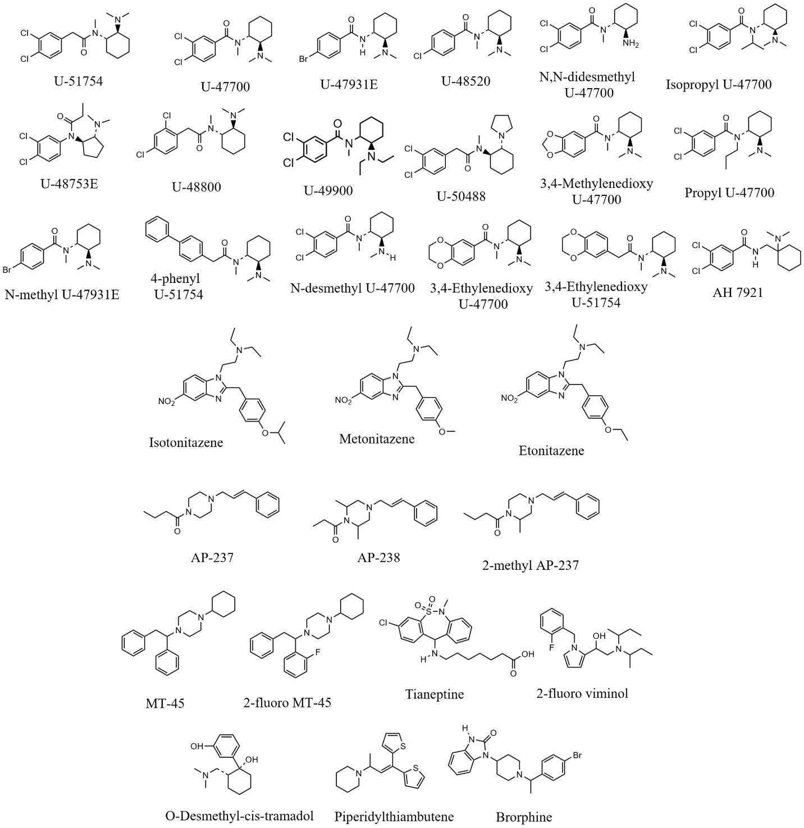

Figure S2: Structures of synthetic precursors, intermediates, and impurities included in structure study (A) and excluded from structure study (B)
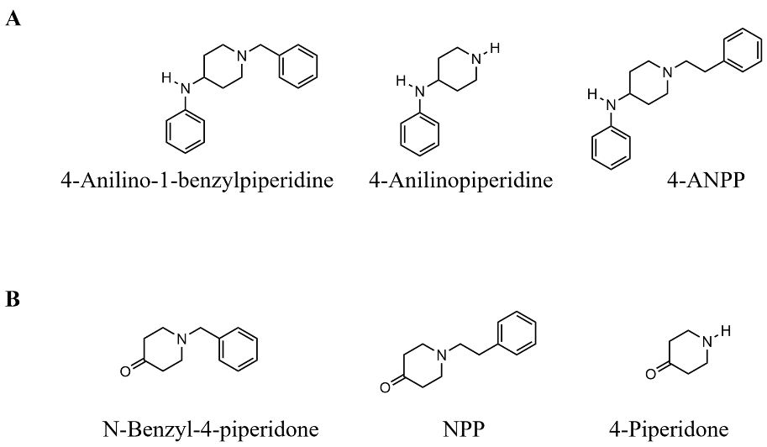

Table S2: 217 fentanyl analogs and fentanyl-related compounds included in structure study and their specific modifications
Compound | BTNX LOD (ng/mL) | DanceSafe LOD (ng/mL) | Phenethyl | Piperidine | Aniline | Carbonyl | # mods
2,2,3,3-tetramethyl-Cyclopropyl fentanyl | 20,000 | ND |  |  |  | 2,2,3,3-tetramethyl cyclopropyl replacement | 1
2,3-Benzodioxole fentanyl | 2,000 | ND |  |  |  | 2,3-benzodioxole substitution | 1
Furanyl fentanyl 3-furancarboxamide isomer | 2,000 | 200 |  |  |  | 3-furancarboxamide replacement | 1
para-chloro Furanyl fentanyl 3-furancarboxamide | 20,000 | 2,000 |  |  | para-chloro substitution | 3-furancarboxamide replacement | 2
para-fluoro Furanyl fentanyl 3-furancarboxamide | 2,000 | 200 |  |  | para-fluoro substitution | 3-furancarboxamide replacement | 2
Tetrahydrofuran fentanyl 3-tetrahydrofurancarboxamide | 200 | 2,000 |  |  |  | 3-tetrahydrofurancarboxamide replacement | 1
Thiophene fentanyl 3-thiophenecarboxamide | 2,000 | ND* |  |  |  | 3-thiophene replacemet | 1
2'-methyl Acetyl fentanyl | 200 | 2,000 | 2'-methyl substitution |  |  | acetyl replacement | 2
3'-methyl Acetyl fentanyl | 200 | 2,000 | 3'-methyl substitution |  |  | acetyl replacement | 2
4'-methyl Acetyl fentanyl | 200 | 2,000 | 4'-methyl substitution |  |  | acetyl replacement | 2
Acetyl norfentanyl | 20,000 | 20,000 | H replacement |  |  | acetyl replacement | 2
β-Hydroxythioacetylfentanyl | 200 | 2,000 | thio replacement; β-Hydroxy substitution |  |  | acetyl replacement | 2
α-methyl Acetyl fentanyl | 200 | 2,000 | α-methyl substitution |  |  | acetyl replacement | 2
β-methyl Acetyl fentanyl | 2,000 | 2,000 | β-methyl substitution |  |  | acetyl replacement | 2
Acetyl fentanyl | 200 | 2,000 |  |  |  | acetyl replacement | 1
meta-methyl Acetyl fentanyl | 200 | 20,000 |  |  | meta-methyl substitution | acetyl replacement | 2
ortho-methyl Acetyl fentanyl | 2,000 | 20,000 |  |  | ortho-methyl substitution | acetyl replacement | 2
para-Chloroacetyl fentanyl | 200 | 2,000 |  |  | para-chloro substitution | acetyl replacement | 2
para-Fluoroacetyl fentanyl | 200 | 2,000 |  |  | para-fluoro substitution | acetyl replacement | 2
para-methoxy Acetyl fentanyl | 2,000 | ND |  |  | para-methoxy substitution | acetyl replacement | 2
para-methyl Acetyl fentanyl | 200 | 20,000 |  |  | para-methyl substitution | acetyl replacement | 2
Benzyl Acrylfentanyl | 2,000 | 2,000 | benzyl replacement |  |  | acryl replacement | 2
Acrylfentanyl | 2,000 | 200 |  |  |  | acryl replacement | 1
meta-fluoro Acrylfentanyl | 2,000 | 2,000 |  |  | meta-fluoro substitution | acryl replacement | 2
ortho-fluoro Acrylfentanyl | 2,000 | 2,000 |  |  | ortho-fluoro substitution | acryl replacement | 2
ortho-methyl Acrylfentanyl | 2,000 | 2,000 |  |  | ortho-methyl substitution | acryl replacement | 2
para-chloro Acrylfentanyl | 2,000 | 200 |  |  | para-chloro substitution | acryl replacement | 2
para-fluoro Acrylfentanyl | 2,000 | 2,000 |  |  | para-fluoro substitution | acryl replacement | 2
para-methoxy Acrylfentanyl | 2,000 | ND |  |  | para-methoxy substitution | acryl replacement | 2
para-methyl Acrylfentanyl | 2,000 | 20,000 |  |  | para-methyl substitution | acryl replacement | 2
Benzodioxole fentanyl | 2,000 | ND |  |  |  | benzodioxole substitution | 1
(±)-cis-3-methyl Butyryl fentanyl | 2,000 | 20,000 |  | cis-3-methyl substitution |  | butyryl replacement | 2
Butyryl norfentanyl | 20,000 | 200 | H replacement |  |  | butyryl replacement | 2
α-methyl Butyryl fentanyl | 2,000 | 200 | α-methyl substitution |  |  | butyryl replacement | 2
Butyryl fentanyl | 200 | 200 |  |  |  | butyryl replacement | 1
meta-Fluorobutyryl fentanyl | 2,000 | 2,000 |  |  | meta-fluoro substitution | butyryl replacement | 2
ortho-Fluorobutyryl fentanyl | 2,000 | 2,000 |  |  | ortho-fluoro substitution | butyryl replacement | 2
para-Chlorobutyryl fentanyl | 2,000 | 200 |  |  | para-chloro substitution | butyryl replacement | 2
para-Fluorobutyryl fentanyl | 2,000 | 200 |  |  | para-fluoro substitution | butyryl replacement | 2
para-hydroxy Butyryl fentanyl | 2,000 | 200 |  |  | para-hydroxy substitution | butyryl replacement | 2
para-methyl Butyryl fentanyl | 2,000 | 20,000 |  |  | para-methyl substitution | butyryl replacement | 2
ortho-methoxy Butyryl fentanyl | 2,000 | ND* |  |  | ortho-methoxy substitution | butyryl replacment | 2
para-methoxy Butyryl fentanyl | 2,000 | ND |  |  | para-methoxy substitution | butyryl replacment | 2
Fentanyl Carbamate | 2,000 | 200 |  |  |  | carbamate replacement | 1
Crotonyl fentanyl | 2,000 | 200 |  |  |  | crotonyl replacement | 1
para-fluoro Crotonyl fentanyl | 2,000 | 200 |  |  | para-fluoro substitution | crotonyl replacement | 2
Cyclobutyl fentanyl | 2,000 | 200 |  |  |  | cyclobutyl replacement | 1
para-chloro Cyclobutyl fentanyl | 2,000 | 2,000 |  |  | para-chloro substitution | cyclobutyl replacement | 2
Cyclohexyl fentanyl | 2,000 | ND |  |  |  | cyclohexyl replacement | 1
Cyclopentenyl fentanyl | 2,000 | 20,000 |  |  |  | cyclopentenyl replacement | 1
Cyclopentyl fentanyl | 2,000 | ND |  |  |  | cyclopentyl replacement | 1
para-fluoro Cyclopentyl fentanyl | 2,000 | ND |  |  | para-fluoro substitution | cyclopentyl replacement | 2
para-methyl Cyclopentyl fentanyl | 20,000 | ND |  |  | para-methyl substitution | cyclopentyl replacement | 2
para-chloro Cyclopentyl fentanyl | ND* | ND |  |  | para-chloro substitution | cyclopenyl replacement | 2
Cyclopropaneacetyl fentanyl | 2,000 | 2,000 |  |  |  | cyclopropaneacetyl replacement | 1
N-methyl Cyclopropyl norfentanyl | 2,000 | 200 | H replacement |  |  | cyclopropyl replacement | 2
Cyclopropyl fentanyl | 2,000 | 200 |  |  |  | cyclopropyl replacement | 1
N-benzyl para-fluoro Cyclopropyl norfentanyl | 2,000 | 2,000 | benzyl replacement |  | para-fluoro substitution | cyclopropyl replacement | 3
meta-methyl Cyclopropyl fentanyl | 2,000 | 200 |  |  | meta-methyl substitution | cyclopropyl replacement | 2
ortho-methyl Cyclopropyl fentanyl | 2,000 | 200 |  |  | ortho-methyl substitution | cyclopropyl replacement | 2
para-chloro Cyclopropyl fentanyl | 2,000 | 2,000 |  |  | para-chloro substitution | cyclopropyl replacement | 2
para-fluoro Cyclopropyl fentanyl | 2,000 | 200 |  |  | para-fluoro substitution | cyclopropyl replacement | 2
para-methyl Cyclopropyl fentanyl | 2,000 | 20,000 |  |  | para-methyl substitution | cyclopropyl replacement | 2
Ethoxyacetyl fentanyl | 200 | ND* |  |  |  | ethoxyacetyl replacement | 1
Furanyl fentanyl | 2,000 | 20,000 |  |  |  | furanyl repalcement | 1
N-benzyl Furanyl norfentanyl | 2,000 | 20,000 | benzyl replacement |  |  | furanyl replacement | 2
Furanyl norfentanyl | 20,000 | 2,000 | H replacement |  |  | furanyl replacement | 2
meta-fluoro Furanyl fentanyl | 2,000 | 2,000 |  |  | meta-fluoro substitution | furanyl replacement | 2
meta-methoxy Furanyl fentanyl | 2,000 | ND* |  |  | meta-methoxy substitution | furanyl replacement | 2
meta-methyl Furanyl fentanyl | 2,000 | 20,000 |  |  | meta-methyl substitution | furanyl replacement | 2
ortho-fluoro Furanyl fentanyl | 2,000 | 20,000 |  |  | ortho-fluoro substitution | furanyl replacement | 2
ortho-isopropyl Furanyl fentanyl | 20,000 | ND |  |  | ortho-isopropyl substitution | furanyl replacement | 2
ortho-methoxy Furanyl fentanyl | 2,000 | ND* |  |  | ortho-methoxy substitution | furanyl replacement | 2
ortho-methyl Furanyl fentanyl | 2,000 | 20,000 |  |  | ortho-methyl substitution | furanyl replacement | 2
para-chloro Furanyl fentanyl | 2,000 | 20,000 |  |  | para-chloro substitution | furanyl replacement | 2
para-fluoro Furanyl fentanyl | 2,000 | 2,000 |  |  | para-fluoro substitution | furanyl replacement | 2
para-methoxy Furanyl fentanyl | 2,000 | ND |  |  | para-methoxy substitution | furanyl replacement | 2
para-methyl Furanyl fentanyl | 2,000 | ND* |  |  | para-methyl substitution | furanyl replacement | 2
4-Anilino-1-Boc-piperidine | ND | ND | tert-butyl acetate replacement |  |  | H replacement | 2
4-Anilinopiperidine | ND | ND | H replacement |  |  | H replacement | 2
4-Anilino-1-benzylpiperidine | ND | ND | Benzyl replacement |  |  | H replacement | 2
4-ANPP | ND | ND |  |  |  | H replacement | 1
Despropionyl 2'-fluoro ortho-Fluorofentanyl | ND | ND | 2'-fluoro substitution |  | ortho-fluoro substitution | H replacement | 3
para-fluoro 4-ANBP | ND | ND | benzyl replacement |  | para-fluoro substitution | H replacement | 3
Despropionyl meta-Methylfentanyl | ND | ND |  |  | meta-methyl substitution | H replacement | 2
Despropionyl ortho-Fluorofentanyl | ND | ND |  |  | ortho-fluoro substitution | H replacement | 2
Despropionyl para-Fluorofentanyl | ND | ND |  |  | para-fluoro substitution | H replacement | 2
Heptanoyl fentanyl | 20,000 | ND |  |  |  | heptanoyl replacment | 1
Hexanoyl fentanyl | 20,000 | ND |  |  |  | hexanoyl replacement | 1
Isobutyryl fentanyl | 2,000 | ND |  |  |  | isobutyryl replacement | 1
FIBF | 2,000 | ND |  |  | para-fluoro substitution | isobutyryl replacement | 2
meta-Fluoroisobutyryl fentanyl | 2,000 | ND |  |  | meta-fluoro substitution | isobutyryl replacement | 2
ortho-Fluoroisobutyryl fentanyl | 2,000 | ND |  |  | ortho-fluoro substitution | isobutyryl replacement | 2
para-Chloroisobutyryl fentanyl | 2,000 | ND* |  |  | para-chloro substitution | isobutyryl replacement | 2
para-methyl Isobutyryl fentanyl | 2,000 | ND |  |  | para-methyl substitution | isobutyryl replacement | 2
Isovaleryl fentanyl | 2,000 | ND |  |  |  | isobvaleryl replacement | 1
Methoxyacetyl fentanyl | 200 | 2,000 |  |  |  | methoxyacetyl replacement | 1
meta-fluoro Methoxyacetyl fentanyl | 200 | 2,000 |  |  | meta-fluoro substitution | methoxyacetyl replacement | 2
meta-methyl Methoxyacetyl fentanyl | 200 | 20,000 |  |  | meta-methyl substitution | methoxyacetyl replacement | 2
Ocfentanil | 200 | 20,000 |  |  | ortho-fluoro substitution | methoxyacetyl replacement | 2
ortho-methyl Methoxyacetyl fentanyl | 200 | 20,000 |  |  | ortho-methyl substitution | methoxyacetyl replacement | 2
para-chloro Methoxyacetyl fentanyl | 2,000 | 2,000 |  |  | para-chloro substitution | methoxyacetyl replacement | 2
para-fluoro Methoxyacetyl fentanyl | 200 | 2,000 |  |  | para-fluoro substitution | methoxyacetyl replacement | 2
para-methoxy Methoxyacetyl fentanyl | 2,000 | ND |  |  | para-methoxy substitution | methoxyacetyl replacement | 2
para-methyl Methoxyacetyl fentanyl | 200 | 20,000 |  |  | para-methyl substitution | methoxyacetyl replacement | 2
Fentanyl Methyl Carbamate | 2,000 | 200 |  |  |  | methyl carbamate replacement | 1
Methacrylfentanyl | 2,000 | 20,000 |  |  |  | methylacryl replacement | 1
N,N-Dimethylamido-despropionyl fentanyl | 200 | 2,000 |  |  |  | N,N-Dimethylamido-despropionyl replacement | 1
para-Toluoyl fentanyl | 20,000 | ND |  |  |  | para-toluoyl replacement | 1
Phenoxyacetyl fentanyl | 2,000 | ND |  |  |  | phenoxyacetyl replacement | 1
N-Benzyl phenyl norfentanyl | 2,000 | ND | benzyl replacement |  |  | phenyl replacement | 2
Phenyl fentanyl | 2,000 | ND |  |  |  | phenyl replacement | 1
ortho-methyl Phenyl fentanyl | 2,000 | ND |  |  | ortho-methyl substitution | phenyl replacement | 2
Phenylacetyl fentanyl | 2,000 | ND |  |  |  | phenylacetyl replacement | 1
Pivaloyl fentanyl | 2,000 | ND |  |  |  | pivaloyl replacement | 1
Senecioylfentanyl | 2,000 | 20,000 |  |  |  | Senecioyl replacement | 1
Tetrahydrofuran fentanyl | 200 | ND |  |  |  | tetrahydrofuran replacement | 1
para-fluoro Tetrahydrofuran fentanyl | 200 | ND |  |  | para-fluoro substitution | tetrahydrofuran replacement | 2
para-methoxy Tetrahydrofuran fentanyl | 2,000 | ND |  |  | para-methoxy substitution | tetrahydrofuran replacement | 2
para-methyl Tetrahydrofuran fentanyl | 2,000 | ND |  |  | para-methyl substitution | tetrahydrofuran replacement | 2
Tetrahydrothiophene fentanyl | 2,000 | ND |  |  |  | tetrahydrothiophene replacement | 1
Thiophene fentanyl | 2,000 | 2,000 |  |  |  | thiophene replacement | 1
Tigloyl fentanyl | 2,000 | ND |  |  |  | tigloyl replacemet | 1
Valeryl fentanyl | 2,000 | 20,000 |  |  |  | valeryl replacement | 1
meta-fluoro Valeryl fentanyl | 2,000 | ND |  |  | meta-fluoro substitution | valeryl replacement | 2
ortho-fluoro Valeryl fentanyl | 2,000 | ND |  |  | ortho-fluoro substitution | valeryl replacement | 2
para-chloro Valeryl fentanyl | 20,000 | ND* |  |  | para-chloro substitution | valeryl replacement | 2
para-fluoro Valeryl fentanyl | 2,000 | ND* |  |  | para-fluoro substitution | valeryl replacement | 2
para-methoxy Valeryl fentanyl | 20,000 | ND |  |  | para-methoxy substitution | valeryl replacement | 2
α'-methoxy Fentanyl | 200 | ND |  |  |  | α'-methoxy substitution | 1
α'-methyl Butyryl fentanyl | 2,000 | ND |  |  |  | α'-methyl butyryl replacement | 1
β'-Phenyl fentanyl | 20,000 | ND |  |  |  | β'-phenyl substitution | 1
(±)-cis-3-methyl Fentanyl | 2,000 | 2,000 |  | (±)-cis-3-methyl substitution |  |  | 1
(±)-trans-3-methyl Fentanyl | 2,000 | 200 |  | (±)-trans-3-methyl substitution |  |  | 1
Norsufentanil | ND | 2,000 | H replacement | 4-methoxymethyl substitution |  |  | 2
Alfentanil | ND | 20,000 | modified tetrazole replacement | 4-methoxymethyl substitution |  |  | 2
Sufentanil | 20,000 | 20,000 | thio replacement | 4-methoxymethyl substitution |  |  | 2
Benzyl Carfentanil | ND | ND | benzyl replacement | 4-methyl acetate substitution |  |  | 2
Norcarfentanil | ND | ND | H replacement | 4-methyl acetate substitution |  |  | 2
Remifentanil | ND | ND | methyl propionate replacement | 4-methyl acetate substitution |  |  | 2
N-methyl Norcarfentanil | ND | ND | methyl replacement | 4-methyl acetate substitution |  |  | 2
Remifentanil Acid | ND | ND | propionic acid | 4-methyl acetate substitution |  |  | 2
Carfentanil | 2,000 | ND |  | 4-methyl acetate substitution |  |  | 1
4-methyl Fentanyl | 2,000 | 2,000 |  | 4-methyl substitution |  |  | 1
2,3-seco-Fentanyl | 20,000 | ND |  | broekn ring |  |  | 1
(±)-cis-Isofentanyl | ND | 2,000 | benzyl replacement | cis-3-methyl substitution |  |  | 2
(±)-cis-3-methyl Norfentanyl | ND | 200 | H replacement | cis-3-methyl substitution |  |  | 2
(±)-cis-3-methyl Thiofentanyl | 2,000 | 2,000 | thio replacement | cis-3-methyl substitution |  |  | 2
(±)-trans-3-methyl Thiofentanyl | 2,000 | 200 | thio replacement | trans-3-methyl substitution |  |  | 2
N-(6-APDB) Fentanyl | 2,000 | 200 | 2,3-dihydrobenzofuran replacement; α-methyl substitution |  |  |  | 1
2',3'-dimethoxy Fentanyl | 2,000 | 200 | 2',3'-dimethoxy substitution |  |  |  | 1
2',4'-dimethoxy Fentanyl | ND* | 200 | 2',4'-dimethoxy substitution |  |  |  | 1
N-(2,5-DMA) Fentanyl | 2,000 | 200 | 2',5'-dimethoxy subsitution; α-methyl substitution |  |  |  | 1
2',5'-dimethoxy Fentanyl | 20,000 | 200 | 2',5'-dimethoxy substitutio |  |  |  | 1
N-(2C-G) Fentanyl | ND | 200 | 2',5'-dimethoxy; 3',4'-dimethyl substitution |  |  |  | 1
N-(2C-B) Fentanyl | 20,000 | 2,000 | 2',5'-dimethoxy; 4'-bromo substitution |  |  |  | 1
N-(DOB) Fentanyl | ND | 2,000 | 2',5'-dimethoxy; 4'-bromo substitution; α-methyl substitution |  |  |  | 1
N-(DOBU) Fentanyl | ND | 2,000 | 2',5'-dimethoxy; 4'-butyryl substitution; α-methyl substitution |  |  |  | 1
N-(2C-C) Fentanyl | 20,000 | 2,000 | 2',5'-dimethoxy; 4'-chloro substitution |  |  |  | 1
N-(2C-E) Fentanyl | ND | 2,000 | 2',5'-dimethoxy; 4'-ethyl substitution |  |  |  | 1
N-(DOET) Fentanyl | ND | 2,000 | 2',5'-dimethoxy; 4'-ethyl substitution; α-methyl substitution |  |  |  | 1
N-(2C-T-2) Fentanyl | ND | 200 | 2',5'-dimethoxy; 4'-ethyl sulfide substitution |  |  |  | 1
N-(DOI) Fentanyl | ND | 2,000 | 2',5'-dimethoxy; 4'-iodo substitution; α-methyl substitution |  |  |  | 1
N-(2C-iP) Fentanyl | ND | 2,000 | 2',5'-dimethoxy; 4'-isopropyl substitution |  |  |  | 1
N-(2C-T-4) Fentanyl | ND | 2,000 | 2',5'-dimethoxy; 4'-isopropyl sulfide substitution |  |  |  | 1
N-(2C-D) Fentanyl | ND | 200 | 2',5'-dimethoxy; 4'-methyl substitution |  |  |  | 1
N-(2C-T) Fentanyl | ND | 200 | 2',5'-dimethoxy; 4'-methyl sulfide substitution |  |  |  | 1
N-(2C-N) Fentanyl | ND | 200 | 2',5'-dimethoxy; 4'-nitro substitution |  |  |  | 1
N-(2C-T-7) Fentanyl | ND | 2,000 | 2',5'-dimethoxy; 4'-propyl sulfide substitution |  |  |  | 1
N-(2C-TFM) Fentanyl | ND | 2,000 | 2',5'-dimethoxy; 4'-trifluoromethyl substitution |  |  |  | 1
2',6'-dimethoxy Fentanyl | 20,000 | 200 | 2',6'-dimethoxy substitutio |  |  |  | 1
2'-Fluorofentanyl | 2,000 | 200 | 2'-fluoro substitution |  |  |  | 1
2'-methyl Fentanyl | 2,000 | 200 | 2'-methyl substitution |  |  |  | 1
N-(3,4,5-TMA) Fentanyl | ND | 200 | 3',4',5'-trimethoxy substitution; α-methyl substitution |  |  |  | 1
3',4'-dimethoxy Fentanyl | ND | 200 | 3',4'-dimethoxy substitution |  |  |  | 1
3',5'-dimethoxy Fentanyl | ND | 2,000 | 3',5'-dimethoxy substitution |  |  |  | 1
N-(DOC) Fentanyl | ND | 200 | 3',5'-dimethoxy; 4'-chloro substitution; α-methyl substitution |  |  |  | 1
N-(2C-I) Fentanyl | ND* | 2,000 | 3',5'-dimethoxy; 4'-iodo substitution |  |  |  | 1
N-(DOM) Fentanyl | ND | 200 | 3',5'-dimethoxy; 4'-methyl substitution; α-methyl substitution |  |  |  | 1
N-(2C-P) Fentanyl | ND | 20,000 | 3',5'-dimethoxy; 4'-propyl substitution |  |  |  | 1
N-(3-ethylindole) Norfentanyl | 2,000 | 200 | 3-ethylindole replacement |  |  |  | 1
3'-Fluorofentanyl | 2,000 | 200 | 3'-fluoro substitution |  |  |  | 1
3'-methyl Fentanyl | 2,000 | 200 | 3'-methyl substitution |  |  |  | 1
N-(2C-B-fly) Fentanyl | ND | 2,000 | 4-bromo-2,3,6,7-tetrahydrobenzo[1,2-b:4,5-b']difuran replacement |  |  |  | 1
N-(3C-B-fly) Fentanyl | ND | 200 | 4-bromo-2,3,6,7-tetrahydrobenzo[1,2-b:4,5-b']difuran replacement; α-methyl substitution |  |  |  | 1
4'-Fluorofentanyl | 2,000 | 200 | 4'-fluoro substitution |  |  |  | 1
4'-methyl Fentanyl | 2,000 | 200 | 4'-methyl substitution |  |  |  | 1
N-(MDA) Fentanyl | 2,000 | 200 | benzodioxole replacement; α-methyl substitution |  |  |  | 1
N-(2-APB) Fentanyl | 20,000 | 200 | benzofuran replacement; α-methyl substitution |  |  |  | 1
N-(6-APB) Fentanyl | 2,000 | 200 | benzofuran replacement; α-methyl substitution |  |  |  | 1
Benzyl fentanyl | 2,000 | 200 | benzyl replacement |  |  |  | 1
Furanylethyl fentanyl | 2,000 | 200 | furanylethyl replacement |  |  |  | 1
Norfentanyl | 20,000 | 200 | H replacement |  |  |  | 1
N-methyl Norfentanyl | 2,000 | 200 | methyl replacement |  |  |  | 1
Thienyl fentanyl | 2,000 | 200 | thienyl replacement |  |  |  | 1
Thiofentanyl | 2,000 | 200 | thio replacement |  |  |  | 1
α-methyl Thiofentanyl | 2,000 | 200 | thio replacement; α-methyl substitution |  |  |  | 1
β-Hydroxythiofentanyl | 200 | 200 | thio replacement; β-hydroxy substitution |  |  |  | 1
N-(Phentermine) Fentanyl | 2,000 | 200 | α-dimethyl substitution |  |  |  | 1
α-methyl Fentanyl | 2,000 | 200 | α-methyl substitution |  |  |  | 1
β-hydroxy Fentanyl | 200 | 200 | β-hydroxy substitution |  |  |  | 1
β-methyl Fentanyl | 2,000 | 200 | β-methyl substitution |  |  |  | 1
Fentanyl | 200 | 200 |  |  |  |  | 0
4'-fluoro, para-fluoro (±)-trans-3-methyl Fentanyl | 2,000 | 2,000 | 4'-fluoro substitution | trans-3-methyl substitution | para-fluoro substitution |  | 3
2'-fluoro ortho-Fluorofentanyl | 2,000 | 2,000 | 2'-fluoro substitution |  | ortho-fluoro substitution |  | 2
3'-fluoro ortho-Fluorofentanyl | 2,000 | 200 | 3'-fluoro substitution |  | ortho-fluoro substitution |  | 2
N-benzyl para-fluoro Norfentanyl | 2,000 | 200 | benzyl replacement |  | para-fluoro substitution |  | 2
4-Phenyl fentanyl | ND* | ND |  |  | 4-phenyl substitution |  | 1
meta-Fluorofentanyl | 2,000 | 200 |  |  | meta-fluoro substitution |  | 1
meta-Methylfentanyl | 2,000 | 2,000 |  |  | meta-methyl substitution |  | 1
ortho-Fluorofentanyl | 2,000 | 2,000 |  |  | ortho-fluoro substitution |  | 1
ortho-Methylfentanyl | 2,000 | 200 |  |  | ortho-methyl substitution |  | 1
para-Bromofentanyl | 2,000 | 200 |  |  | para-bromo substitution |  | 1
para-Chlorofentanyl | 2,000 | 200 |  |  | para-chloro substitution |  | 1
para-Fluorofentanyl | 200 | 200 |  |  | para-fluoro substitution |  | 1
para-Methoxyfentanyl | 2,000 | ND* |  |  | para-methoxy substitution |  | 1
para-Methylfentanyl | 2,000 | 2,000 |  |  | para-methyl substitution |  | 1

Table S3: modifications that cause non-detection for both BTNX and DanceSafe FTS
Piperidine modifications
Structure | Modification | # compounds with mod | Compounds with modification
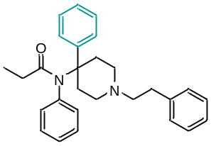 | 4-phenyl substitution | 1 | 4-Phenyl fentanyl
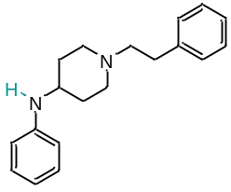 | H replacement | 7 | 4-ANPP, Despropionyl meta-Methylfentanyl, Despropionyl ortho-Fluorofentanyl, Despropionyl para-Fluorofentanyl, 4-Anilino-1-Boc-piperidine, Despropionyl 2'-fluoro ortho-Fluorofentanyl, para-fluoro 4-ANBP

Table S4: modifications that cause non-detection for DanceSafe FTS without any co-occurring modifications
Piperidine modifications
Structure | modification | # with mod | Compounds with modification
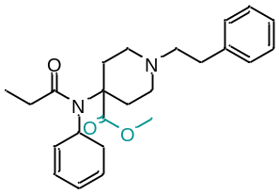 | 4-methyl acetate substitution | 6 | Carfentanil, Benzyl Carfentanil, Remifentanil, Norcarfentanil,  N-methyl Norcarfentanil,  Remifentanil Acid
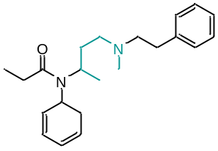 | Broken ring | 1 | 2,3-seco-Fentanyl
Aniline modifications
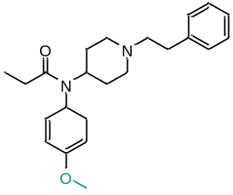 | Para-methoxy substitution | 8 | para-Methoxyfentanyl  para-methoxy Acetyl fentanyl  para-methoxy Acrylfentanyl  para-methoxy Butyryl fentanyl  para-methoxy Furanyl fentanyl  para-methoxy Methoxyacetyl fentanyl  para-methoxy Tetrahydrofuran fentanyl  para-methoxy Valeryl fentanyl
Carbonyl modifications
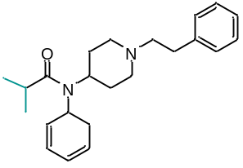 | Isobutyryl replacement | 6 | Isobutyryl fentanyl  meta-Fluoroisobutyryl fentanyl  ortho-Fluoroisobutyryl fentanyl  para-Chloroisobutyryl fentanyl  FIBF  para-methyl Isobutyryl fentanyl
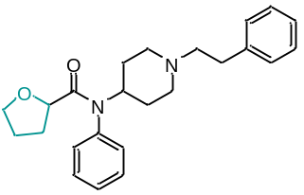 | Tetrahydrofuran replacement | 4 | Tetrahydrofuran fentanyl  para-fluoro Tetrahydrofuran fentanyl  para-methoxy Tetrahydrofuran fentanyl  para-methyl Tetrahydrofuran fentanyl
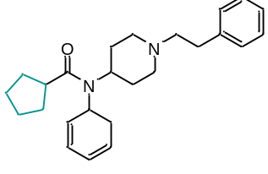 | Cyclopentyl replacement | 4 | Cyclopentyl fentanyl  para-fluoro Cyclopentyl fentanyl  para-methyl Cyclopentyl fentanyl  para-chloro Cyclopentyl fentanyl
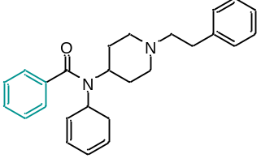 | Phenyl replacement | 2 | Phenyl fentanyl  ortho-methyl Phenyl fentanyl
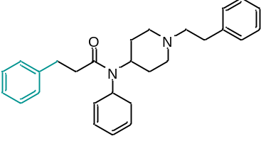 | β’-phenyl substitution | 1 | β'-Phenyl fentanyl
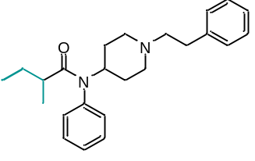 | α’-methyl butyryl replacement | 1 | α'-methyl Butyryl fentanyl
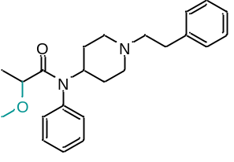 | α’-methoxy substitution | 1 | α'-methoxy Fentanyl
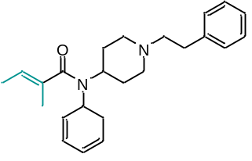 | tigloyl replacement | 1 | Tigloyl fentanyl
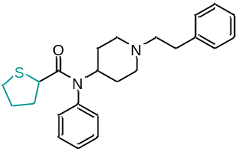 | tetrahydrothiophene replacement | 1 | Tetrahydrothiophene fentanyl
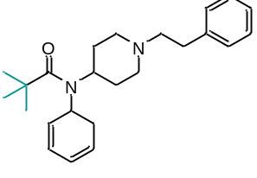 | Pivaloyl replacement | 1 | Pivaloyl fentanyl
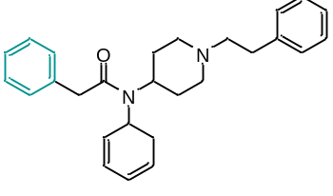 | Phenylacetyl replacement | 1 | Phenylacetyl fentanyl
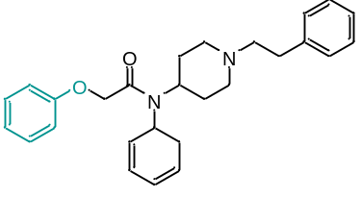 | phenoxyacetyl replacement | 1 | Phenoxyacetyl fentanyl
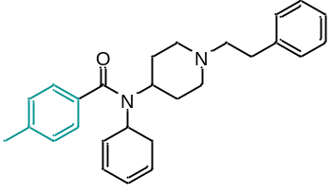 | para-toluoyl replacement | 1 | para-Toluoyl fentanyl
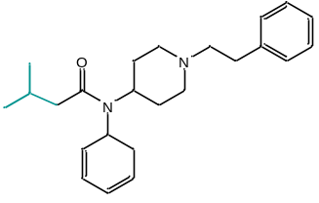 | isovaleryl replacement | 1 | Isovaleryl fentanyl
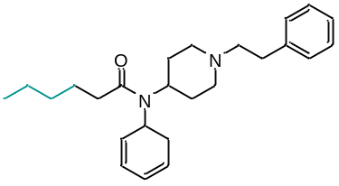 | Hexanoyl replacement | 1 | Hexanoyl fentanyl
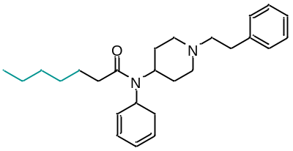 | Heptanoyl replacement | 1 | Heptanoyl fentanyl
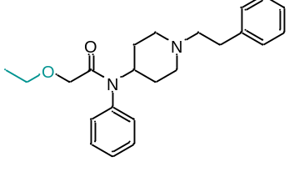 | ethoxyacetyl replacement | 1 | Ethoxyacetyl fentanyl
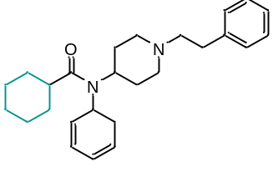 | cyclohexyl replacement | 1 | Cyclohexyl fentanyl
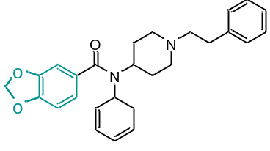 | Benzodioxole replacement | 1 | Benzodioxole fentanyl
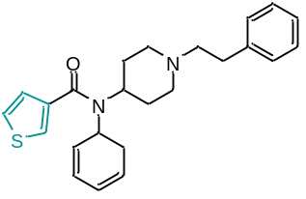 | 3-thiophene replacement | 1 | Thiophene fentanyl 3-thiophenecarboxamide
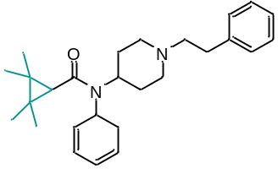 | 2,2,3,3-tetramethyl cyclopropyl replacement | 1 | 2,2,3,3-tetramethyl-Cyclopropyl fentanyl
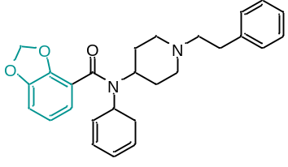 | 2,3-benzodioxole substitution | 1 | 2,3-Benzodioxole fentanyl

Figure S3: UpSet plot of all compounds that are not detectable by DanceSafe FTS
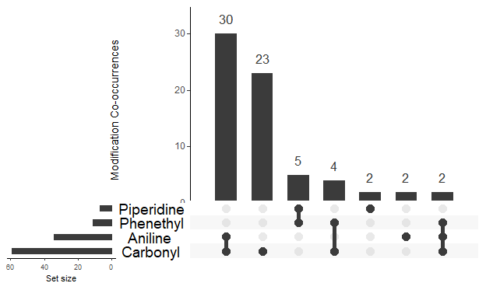

Figure S4: Carbonyl modifications that do NOT cause non-detects for DanceSafe (on their own, without any co-occurring modifications)

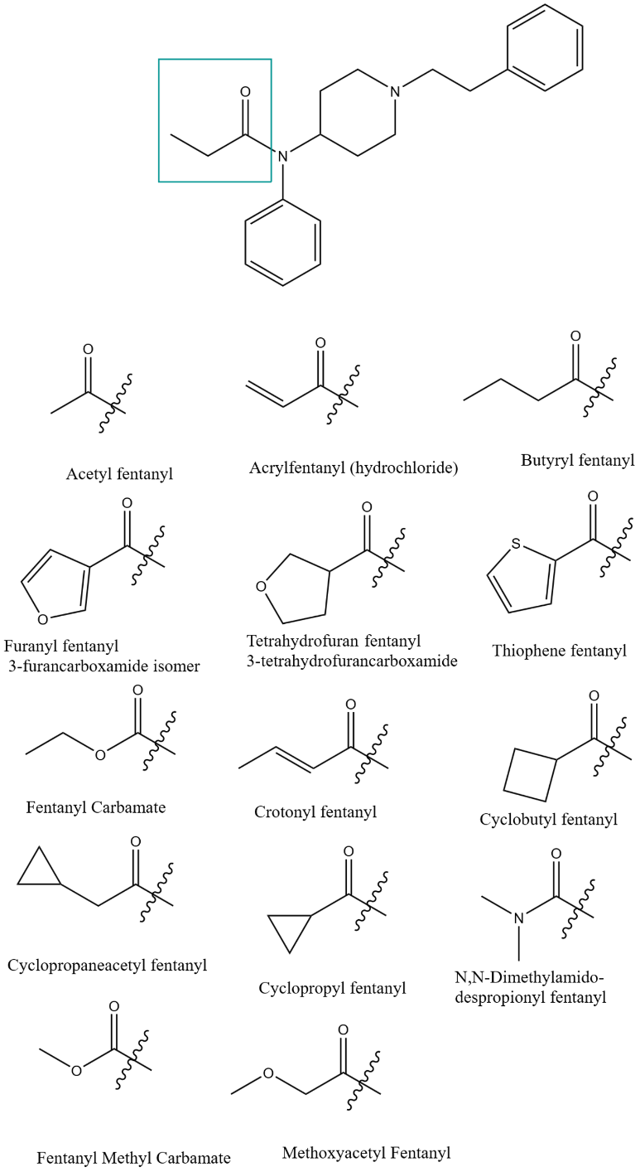

Figure S5: UpSet plot of co-modifications that cause non-detection for BTNX FTS (including compounds ND by DanceSafe as well)
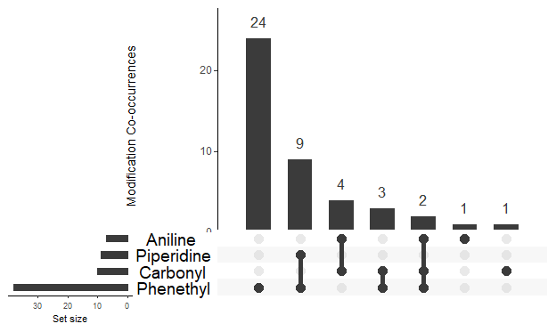

Figure S6: Phenethyl modifications that inhibit BTNX detection

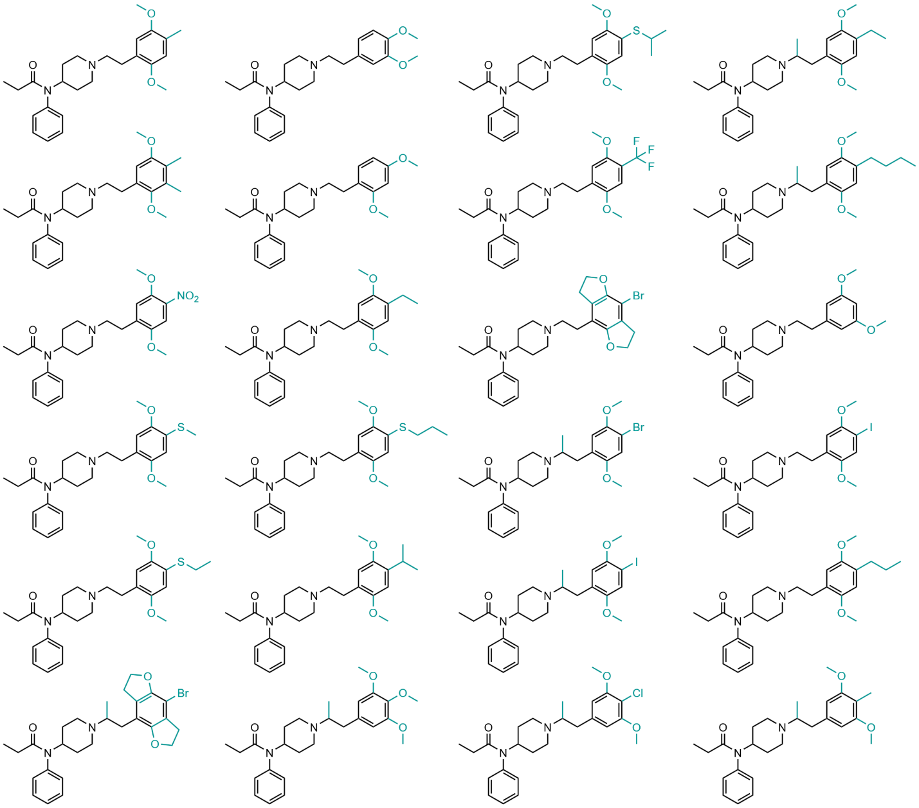

Figure S7: Phenethyl modifications that do not inhibit BTNX detection
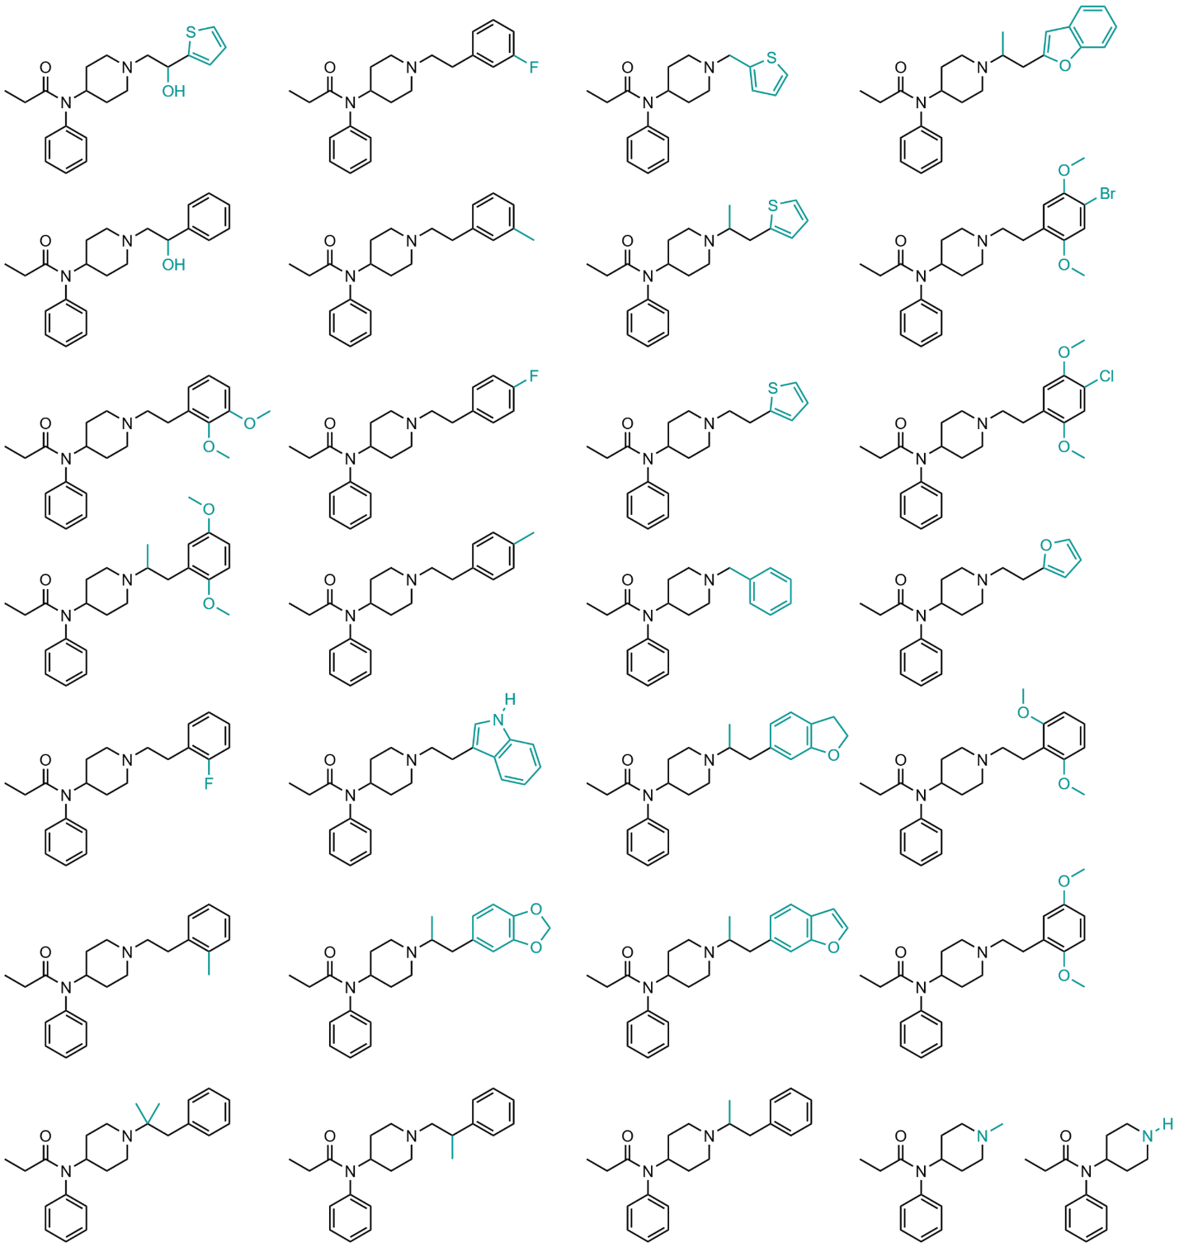

Figure S8: left: N-(2C-B) Fentanyl (top) and N-(2C-C) Fentanyl (bottom) are detectable by BTNX FTS; right: structurally similar compounds N-(DOB) fentanyl (top) and N-(DOC) fentanyl (bottom) and N-(2C-I) Fentanyl (right) are not detectable by BTNX FTS

